Quality Prediction of Carry-Over Soybean Seed

N. Indrakumar Singh* and J.S. Chauhan

Department of Seed Science & Technology, Faculty of Agriculture, HNB Garhwal University (A central university), Srinagar Garhwal, (Uk) - 246 174 (India)
E. mail: indrasst08@gmail.com
Abstract: Seed quality is essential for maximum yield establishment and optimum stand potential. Seed should only be considered for planting if it is free of weed-seed contaminants and has a high germination rate. The investigation evaluated the physical and physiological seed quality of soybean seeds (Glycine max L. Merr. Cv. PS-1092), collected from different local farm storage of Uttarakhand (India). Results showed that seed Sample D recorded the highest purity percent and imbibition with minimum days taken for seedling emergence, seed Sample B recorded the maximum germination percent, PLS value and highest seedling length. The standard germination index of the seed Sample B significantly related with seedling length, dry weight and purity percent values. High emergence percent at the first reading by seed Sample D indicated seed coats were more permeable to moisture. Thus, results can be concluded that seed Sample D was found best for use as a planting material in the onset season. But it can be suggested that the rest three seed samples can also be used as a planting material, although it may have some effect on seed productivity, as these experimental results were observed within the standard value. [Researcher. 2010; 2(3):66-69]. (ISSN: 1553-9865).

Key Words: Carry-over seed, Emergence, germination, imbibition, purity, vigour

Introduction
Evaluation of seed vigour and its relation with field seedling emergence can provide secure indicatives of seed physiological potential. The production of high quality seed results in many direct benefits to the seed consumer and seed producer. Use of high quality seed affords the seed consumer many production options; because high quality seeds better tolerate stressful planting conditions. Planting a superior seed lot usually results in a more uniform stand that allows better secondary tillage and weed or pest control. All of these factors promote earlier and more uniform emergences, which can lead to increase yield and more economic return to seed consumer. Different testing parameter’s results will provide the basic seed quality information and aid in planting decisions. Growers should conduct germination test immediately after harvest to determine if the seed is worth saving and again before planting to see if they are worth planting.
Seed quality can change dramatically during storage, so testing twice is always good (Anon, 2004). After high quality seed is planted, many environmental factors interact to determine the ability of the seed to germinate and emerge from the soil. One of the primary factors is access to moisture for the seed (McDonald & Copeland, 2004; Hartmann and Kester, 1999). High physiological potential (germination and vigour) of a given seed lot credentialed it for a superior performance in a broad range of field environmental conditions (Egli & TeKrony, 1996; Marcos Filho, 1999).
The experiment was conducted to the farmers saved soybean seed by collecting samples with an objective to predict the quality of carry-over of the same seed as a security to the farmers.

Material and Methods
Four seed samples of soybean (Glycine max L. Merr. Cv. PS-1092), collected from different local farm storage of Uttarakhand (India) denoting Sample A, Sample B, Sample C, and Sample D, representing four seed lots of the respective storage. Each sample was divided into 4 replicates to obtain reproducible results. The experiment comprised of physical purity, standard germination, pure live seed, water imbibition and vigour test.

Physical Purity Test: As per the rules of International Seed Testing Association (I.S.T.A. 2008), purity analysis sorted out three components; inert matter, other seed and pure seed. The three components for each replicate were weighed (up to two significant decimal place) by using the Digital Electronic Balance with accuracy of + 0.001g and expressed in percentage. The percentage by weight of each component is determined by dividing the weight of all the components. It is calculated as under:

Weight of Pure seed (gm)
Purity (%) = x 100
Total of weight of the entire component (gm)

Standard Germination and Emergence Test: Standard Germination Test was conducted on a 100 seeds per replicate at 25⁰C for six days in germinator by using soaked filter paper (Whatman no.1)) in petridishes. For early seedling emergence sand was taken as a substratum and seeds were sown in 2 cm depth and kept at the same temperature. Observations were recorded when the considered emerged seedlings showed well characterized apparent plumule, cotyledon and hypocotyls over the soil surface.

Pure live Seed (PLS): Pure live seed percentage represents the amount of pure seeds in a seed lot that are capable of producing seedlings. It is calculated by using the formula:

Germination %
PLS = X 100
Purity %

Water Imbibition: It enables to predict the permeability of seed coat which reduces the mean germination time. 40 seeds for each replicate were weight before imbibition in 100 ml of water for 72 hrs. Reading were taken 3 times i.e., after every 24 hrs.

Seedling Length and Dry Weight: Seeds were germinated in rolled towel paper. Ten seeds were planted in the centre of the moist towel papers in such a way that the micropyles were oriented towards bottom to avoid root twisting. The rolled towel papers were kept in the germinator at an angle of 45⁰ maintaining temperature at 25⁰C. Seedling length was taken after the completion of germination period (7 days) in randomly selected five seedlings from each replication. For dry weight determination, five randomly selected seedlings were removed and dried in an air oven at 100°C temperature for 24 hours. The dry weight (without cotyledon) for each replicate was measured.

Results and Discussion
The maximum germination percent (Figure 2), PLS and seedling length values were observed in Sample B (Table 2). Maximum purity percent, highest imbibition (Figure 1) and seedling emergence in minimum time (Figure 2) was observed in Sample D and Sample A recorded maximum (0.97 gm) dry weight of seedling. Seeds of Sample D exhibited high emergence percent at the first reading with high rate of imbibition due to the characteristic of high accessibility moisture seed coat. Similar responses have been described by McDonald & Copeland (2004).
For early seedling emergence all samples were started taking observation from the 3rd day of sowing, on the 1st day of counting Sample D and C recorded the maximum and minimum seedlings respectively. But on the final counting day of seed germination, Sample A and Sample D observed same germination percent indicating Sample D possesses high vigour. The Sample C which recorded minimum germination percent on the first count continued to show low percent till the final count exhibiting low vigour character of seed. These findings are in consistent with the observations of O'DELL et al. (1998). The result of low emergence percentage contradicts the observation of Green et al. (1965), who reported that low emergence percentages in the laboratory and field were associated with high occurrence of green cotyledons in soybean.
Sample B observed maximum germination percent, Pure Live Seed and seedling length values with high seedling dry weight indicated more vigour than any other samples which is in accordance of the reports of Egli et al. (1990), Egli & TeKrony, (1996) and Marcos Filho (1999).
The seed Sample D and Sample B were found similar quality (Table 2) as these samples recorded maximum value in the three test parameters, although, Sample D ranked the highest in seed quality as it recorded more emergence percent than Sample B. The lowest pure live seed percent in Sample D resulted in low germination percent and emergence percent showing the correlations within the test parameters for quality grading. In Sample B, the standard germination percent and pure live seed percent was observed more than the Sample D, but it failed to reveal high percent in seedling emergence which showed that it cannot withstand in unfavourable condition. Thus, results can be concluded that seed Sample D was found best for use as a planting material in the onset season. But the rest three seed samples can also be used as a planting material, although it may have some effect on seed productivity, as these experimental results were observed within the standard value.

Table 1. Coefficient of variability for the different test parameters of four samples carry-over soybean seed.

Seed Sample | Purity (%) | Imbibition | Germination (%) | Pure Live Seed (%) | Emergence (%) | Plant height (cm) | Seedling Dry Weight (gm)
A | 94.52 | 6.83 | 95.00 | 89.79 | 99.00 | 16.60 | 0.97
B | 98.15 | 6.28 | 97.00 | 95.21 | 96.00 | 17.18 | 0.94
C | 97.63 | 6.80 | 82.00 | 80.06 | 95.00 | 10.43 | 0.57
D | 98.43 | 7.29 | 96.00 | 94.49 | 99.00 | 16.45 | 0.93
SEm± | 0.902 | 0.206 | 3.523 | 3.489 | 1.030 | 1.586 | 0.094
CV % | 1.858 | 6.071 | 7.618 | 7.763 | 2.119 | 20.918 | 22.181

Table 2. Mean values of different tests of four seed samples of carry-over soybean seed arranged in decreasing order with respect to their quality.
Seed Sample | Purity (%) | Imbibition | Germination (%) | Pure Live Seed (%) | Emergence (%) | Plant height (cm) | Seedling Dry Weight (gm)
D | 98.43* | 7.29* | 96.00 | 94.49 | 99.00* | 16.45 | 0.93
B | 98.15 | 6.28 | 97.00* | 95.21* | 96.00 | 17.18* | 0.94
A | 94.52 | 6.83 | 95.00 | 89.79 | 99.00* | 16.60 | 0.97*
C | 97.63 | 6.80 | 82.00 | 80.06 | 95.00 | 10.43 | 0.57

*indicating the maximum value within the seed samples of the same parameter

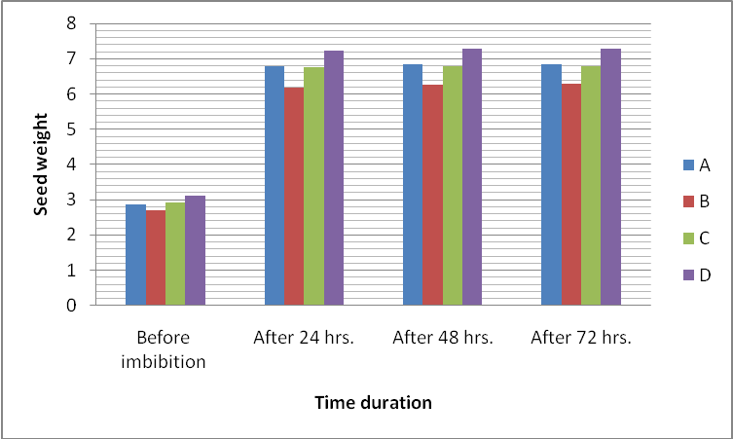
Figure 1. Rate of water imbibition by the four soybean seed samples in 3 days.

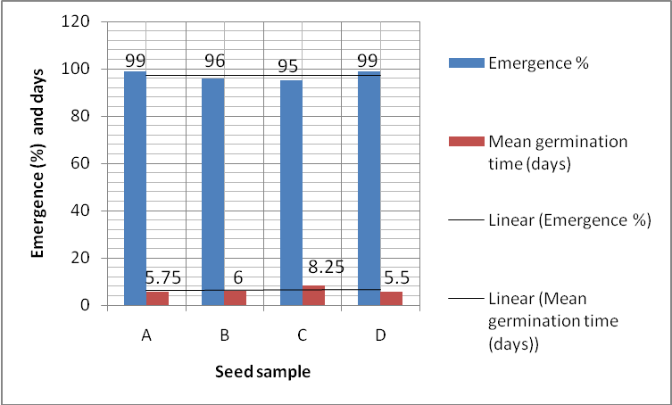
Figure 2. Seedling emergence percent with respect to mean germination time of four seed samples of soybean.

Acknowledgement
The authors would like to thank the farmers of Uttarakhand for extending cooperation and providing seed during the seed collection.

References
- Anonymous. Planting Farmer Saved Wheat Seed: Are You Really Saving Money? North Carolina Cooperative Extension Service, 2004.
- Egli, D.B., Tekrony, D.M. Seedbed conditions and prediction of field emergence of soybean seed. Prod. Agric., 1996; 9: 365-370.
- Egli, D.B., TeKrony, D.M. and Wiralaga, R.A. Effect of soybean seed vigor and size on seedling growth. Seed Tech. 1990; 14:1–12.
- Green, D.E., Pinnell, E.L., Cavannah, L.E. and Williams, L.F. Effect of planting date and maturity date on soybean seed quality. Agron. J. 1965; 57:165-168.
- Hartmann, H.T. and Kester Fred, D.E. Plant Propagation-Principles and Practices. 1999; Vol.1
- International Seed Testing Association, International Rules for Seed Testing. ISTA, Bassersdrof, CH. Switzerland, 2008.
- Marcos Filho, J. Testes de vigor: Importância e utilização. In: Krzyzanowski, F.C.; Vieira, R.D.; França Neto, J.B. (Ed.) Vigor de sementes: conceitos e testes. Londrina: ABRATES, 1999. cap.1, 1-21.
- McDonald, M.B. & Copeland, L.O. Seed Science and Technology, Laboratory Manual. 1st Ed. Pub. Scientific Publishers (India), 2004.
- O'Dell, A., Scarisbrick, D. H. and Baker, D. A. Production of Belarussian soybeans (Glycine max) in the UK: predicting time to emergence. Research Article: Crops and Soils, 1998

Date of submission: 22/03/2010

