Ethno-medico botany of some aquatic Angiospermae from
North-West Himalaya

L.R. Dangwal1, Antima Sharma1, Naveen Kumar2, C.S Rana3 & Upvan Sharma4

1Herbarium and Plant Systematic Laboratory, Department of Botany,
2School of Natural Products, Department of Chemistry,
H.N.B Garhwal Central University, SRT Campus, Badshahi Thaul, Tehri (Uttarakhand) India
3State Medicinal Plant Board Uttatrakhand, Herbal Research & Development Institute Gopeshwar, Chamoli
(Uttarakhand) India
4Department of Botany, University of Jammu, Jammu,
India
antimasharma82@gmail.com.

Abstract: North-West Himalaya has been the reservoir of enormous natural resource including vegetation wealth, natural streams as well as rivers. The large human populace with diverse life styles, beliefs, traditions and cultural heritage inhabiting Himalaya has learnt to utilize natural resources and products in various ways. The present communication pertains to the ethno-medico botanical survey of some aquatic Angiospermae of North-West Himalaya identified 38 plant species belonging to 34 genera and 28 families used by tribals and villagers to cure numerous ailments. [Researcher 2010;2(4):49-54]. (ISSN: 1553-9865).

Keywords: North-West Himalaya; Aquatic Angiospermae; Ethno-medico; Tehri.

Introduction
Himalayas one of the richest repositories of
biodiversity, comprises of five bio-geographic zones, Trans, North-west, West, Central and Eastern Himalaya (Rodgers and Panwar, 1988; Samant and Dhar, 1997), covering an area of 419873 km2 and considered as the repository of biological and cultural diversity. Northwest Himalaya is a distinct Himalayan region with a characteristic climate, geology and flora. The floristic diversity is fascinating because of species richness and diverse community structure. The diversity has evolved in time and space due to various geological and ecological changes, accompanied by speciation, isolation and competition. In the oral traditions local communities in every ecosystem from the North-west Himalayas down to the coastal plains have discovered the medical use of thousands of plants found locally in their ecosystem (Arora, 1981; Duthie,
1906). Traditionally, this treasure of knowledge has been passed on orally from generation to generation without any written document (Perumal Samy and Ignacimuthu, 2000) and is still retained by various indigenous groups around the world. The tremendous passion for the medicinal plants made the people to use them for a wide range of health related applications from a common cold to memory improvement and treatment of poisonous snake bites to a cure for muscular dystrophy and the enhancement of body's general immunity (Faulks,
1958). Medicinal plant has traditionally occupied an important position in the socio-cultural, spiritual

and medicinal arena of rural and tribal lives of India. The remarkable fact is that it is still a living tradition. This is borne out by the fact that there still exist around a million traditional, village-based carriers of herbal medicine systems in the form of traditional birth attendants, bonesetters, herbal healers and wandering monks. Apart from these specialized carriers there are millions of women and elders who have traditional knowledge of herbal-remedies and of food and nutrition.

Aquatic angiosperms are very remarkable plants due to the habitat in which they spend most of their lives. These plants include species of various conditions such as true aquatics which are free floating, submerged or emerged ones, plants which grow just on the border line between water and land surfaces and plants which generally thrive in aquatic conditions. The common habitats of aquatic Angoispermae in this area are a number of rivers, lakes, reservoirs, tanks, waterfalls, ponds, ditches and puddles. Some of these are useful for bathing, fish culture, etc., but a good number of them remain unused by human beings. The growth of large number of hydrophytes has drawn the attention of ethno-medico botanical survey of this district. So far, a systematic work on medicinal uses of these plants has not been done even if, in India, several workers have reported some hydrophytes vegetation of different parts of the

country (Subramanyam K, 1962; Mehta et al.,1972; Gupta, 1979) Some ethno-botanist conducted studies concentrating mainly on the ethno-botanical aspects of medicinal plants (Uniyal, 1968, 1977 ; Gaur and Tiwari, 1987; Gaur, 1999; Goel 1982; Tiwari, 1986; Rawat and Bhatt, 2002). The present work gives detailed information regarding the ethno-medico botany of some aquatic Angoispermae of Tehri district.

Study Area
The study was carried out in one of the
botanically interesting district of Uttarakhand (India)
is Tehri Garhwal, which sustains unique and rich vegetation in wide range of habitats from Tarai- bhabar tracts to the high range of lesser Himalaya (275-4258m. asl). It lies in between 30010’ - 300
17’N latitude and 780 18’- 780 30’E longitude in northern part of western Himalaya. It is surrounded
by the district Rudraprayag in the east, Dehradun in
the west, Uttarkashi in the north and Pauri in the south. . Nomadic tribes are Gujjars and Bhotiyas, the former dwelling in the sub-montane zones during winters and moving towards high altitude during the summer seasons. Bhotiyas less often visit to the district Tehri Garhwal.

s
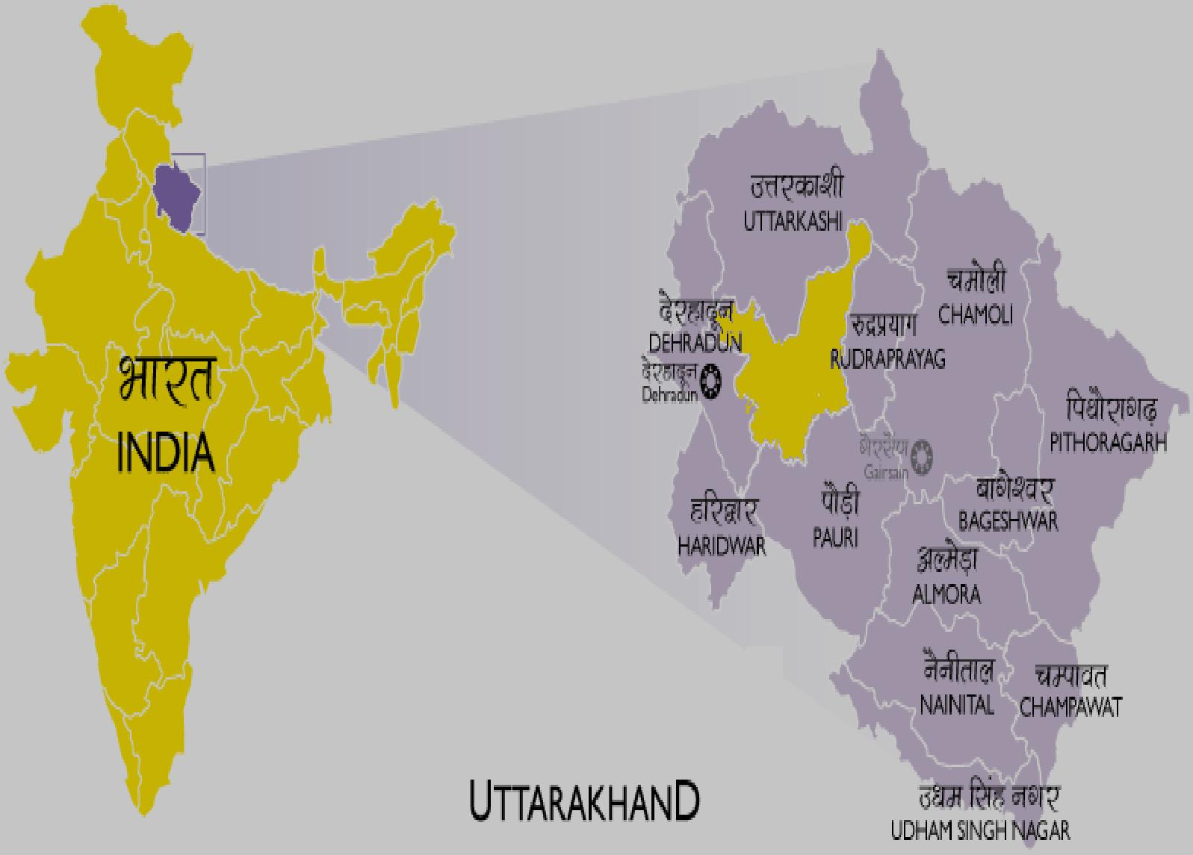

…… → Study area (Tehri Garhwal)

Figure 1. Location map for the ethnobotanical survey of the Uttarakhand, (Tehri Garhwal)

Material and Methods
An ethno-medico botanical field survey
was conducted in rural and tribal areas of Tehri district during 2008-10. The ponds and other sources of aquatic plants were visualized in different months and seasons. Ethno-medico botanical information on the medicinal uses of aquatic Angoispermae was obtained from native doctors, age old persons, farmers, herbal specialists, etc. through interview, discussion, personal contacts and observation.

Standard method of collection, preservation and maintenance of specimens in the herbarium were followed (Jain and Rao (1977), Singh and Subramanyam (2008). All the collected plant specimens were identified with the help of recent and relevant floras and confirmed after matching with the authentic specimens, housed in the Herbaria of Botanical Survey of India, Northern Circle (BSD), and Forest Research Institute (DD), Dehradun and

Garhwal University Herbarium (GUH), Srinagar Garhwal. All the collected plant specimens were deposited in the Herbarium of H.N.B Garhwal Central University, SRT Campus Botany Department Badshahi Thaul, Tehri and HNBGU, Botany Department Herbarium (GUH), Srinagar Garhwal.

Systematic Enumeration
In the following text, plant species are
arranged alphabetically with their botanical names, citations, family in brackets, available local names, voucher specimen number (HNBGC-SRT) and mode of application.

Acorus calamus L. (Araceae) Vern. Bach, HNBGC-SRT-99
The rhizome decoction (50ml) is given early in the morning to improve digestion and to prevent active diarrhoea, dysentery and fever.

Alternanthera sessilis (L.) DC. (Amaranthaceae) Vern. Gudre-saag, HNBGC-SRT-998
Warmed leaves are bandaged over the eyes to cure red eye.

Ammannia baccifera L. (Lythraceae) Vern. Dadmari, HNBGC-SRT-995
The decoction prepared from 10g of fresh leaves with 10g of Cyperus rotundus roots and 5g of fresh ginger is used for intermittent fevers. Whole plant is burned and ashes are mixed with til oil (Sesamum indicum) and applied to cure skin eruptions. Leaf infusion is given with warm water to decrease sexual desires in oxen.

Asclepias curassavica L. (Asclepiadaceae) Vern. Lalma, HNBGC-SRT-997
Latex applied on cuts and wounds, root powder causes vomiting, flowers in psycho- medicines.

Bacopa monnieri (L.) Pennell (Scrophulariaceae) Vern. Pan Brahmi, HNBGC-SRT-993
The decoction prepared from 10g of leaf powder and
2g of zinger is taken once a day for 3 days to cure flatulence in children. Roasted leaves are also applied on the stomach at bed time.

Bergia ammannioides Heyne ex Roth (Elatinaceae) HNBGC-SRT-991
Whole plant infusion is applied to cure scabies, wounds and cuts.

Centella asiatica (L.) Urban (Apiaceae) Vern. Brahma butti, HNBGC-SRT-990
Leaf decoction is given orally twice a day for 3 months to cure leprosy. Whole plant is chewed to
cure diarrhea and also act as a blood purifier. Plant powder mixed with butter is used as a brain tonic.

Ceratophyllum demersum L. (Ceratophyllaceae) Vern. Sivara, HNBGC-SRT-89 Plant paste is applied on the affected part to relief from scorpion sting.

Colocasia esculenta (L.) Schott. (Araceae) Vern. Pindalu HNBGC-SRT-855
Tuber juice mixed with the seed pulp of Abrus precatorius is rubbed twice a day for 15days to cure alopecia areata.

Commelina benghalensis L. (Commelinaceae) Vern
Kanjula, HNBGC-SRT-854
Plant juice given in dysentery and paste applied on body swelling and ache.

Debregeasia longifolia (Burm.f.) Wedd. (Urticaceae) Vern. Tusara, HNBGC-SRT-875
Plaster made from pulverized bark for bone fracture.

Debregeasia salicifolia (D. Don) Rendle (Urticaceae) Vern. Syanru, HNBGC-SRT-871
Plaster made from pulverized bark for bone fracture.

Desmostachya bipinnata (L.) Stapf (Poaceae) Vern. Doab, HNBGC-SRT-872
Believed to be Sacred.

Eclipta prostrata L. (Asteraceae) Vern. Bhangru, HNBGC-SRT-842
Leaf paste with common salt is rubbed twice a day for a fortnight to cure alopecia areata.

Echinochloa colana (L.) Link. (Poaceae) Vern. Jangli jangosa, HNBGC-SRT-895
Whole plant decoction is taken orally to promote digestion.

Epipactis veratrifolia Boissier and Hohenacker. ( Orchidaceae) Vern. Trindrya, HNBGC-SRT-853
Infusion of leaves given in intermittent fever, rhizome regarded as an aphrodisiac.

Eriocaulon quinquangulare L. (Eriocaulaceae) HNBGC-SRT- 801
Leaf decoction is gargled to cure stomachache.

Hydrilla verticillata (L. f.) Royle (Hydrocharitaceae) Vern. Jhangi, HNBGC-SRT-806
It is used in the treatment of abscesses, boils and
wounds, especially if there is debris in the wound. A dried powder of the plant is applied to cuts and wound to help accelerate healing.

Hygrophila polysperma ( Roxb.) T. Anderson
(Acanthaceae) Vern. Tamilkhan, HNBGC-SRT-804
Root, leaves and seeds used in urenogenital

Hygrophila auriculata (Schumacher) Heine
(Acanthaceae) Vern. Tamilkha, HNBGC-SRT-805
Root, leaves and seeds used in urenogenital and liver troubles.

Ipomoea aquatica Forsk. (Convolvulaceae) Vern.Kalmisak, HNBGC-SRT-807
Decoction of the aerial parts is taken orally for one month to cure piles and expel intestinal worms.

Ipomoea carnea Jacq. (Convolvulaceae) Vern. Behya, HNBGC-SRT-810
A spoonful of Leaf powder is taken daily with warm water to reduce high blood pressure.

Lemna perpusilla Torrey (Lemnaceae) Vern. Duckweed, HNBGC-SRT-811
Whole plant infusion is applied to cure scabies, wounds and cuts.

Limnophila indica (L.) Druce (Scrophulariaceae) Vern. Kuttra, HNBGC-SRT-814
Leaf juice is given twice weekly for about 6 months to cure filariasis (initial stages only). Leaf infusion is given in diarrhoea and dysentery. Fresh leaves (5g) are eaten daily for one week as a relief from flatulence and as galactagogue.

Ludwigia adscendens (L.) Hara (Onagraceae) HNBGC-SRT-813
Whole plant decoction (50ml) is taken orally once a day for a week to expel intestinal worms.

Micromeria biflora (Buch.-Ham. ex D.Don) Benth. (Lamiaceae) Vern. Banajwain, HNBGC-SRT-847
Flavour of crushed leaves inhaled in cold and sinusitis, extract of leaves with milk given in gastroenteritis.

Monochoria vaginalis (Burm.f.) Presl. (Pontederiaceae) Vern. Kuttra, HNBGC-SRT-859
About 50ml of leaf juice are taken orally, once a day for 3 days, to cure fever and cold and also to prevent excess bleeding during menstruation.

Nelumbo nucifera Gaertn. (Nelumbonaceae) Vern. Kamal, HNBGC-SRT-845
One tablespoonful of dry fruit powder is mixed with
honey and taken as a tonic. Root and flower powder (5g) is taken with warm water daily for a month as blood purifier.
Neptunia oleracea Lour. (Mimosaceae) Vern. HNBGC-SRT-842
Stem juice is instilled into the ear to cure earache. The root and stem decoction is used to cure gonorrhoea.

Nymphaea nouchali Burm.f. (Nymphaeaceae) Vern. Kanwal, HNBGC-SRT-812
Root powder (10g) is taken twice a day for a week to cure dysentery and diarrhoea.

Polygonum recumbens Royle ex Babcock
( Polygonaceae) Vern. Oglya jhar HNBGC-SRT-821
Leaf decoction is prepared from Polygonum, Eclipta prostrata, Phyllanthus amarus (equal quantities). About 20ml of this decoction are given on empty stomach once a day for a week to cure jaundice.

Phyla nodiflora (L.) Greene (Verbenaceae) Vern. Jal butti, HNBGC-SRT-822
Whole plant is shade-dried and the powder is given orally (2g) along with milk to cure fever and cold followed by cough. Paste made from the tender shoots is eaten to promote digestion and also used in post-partum treatment.

Ranunculus scleratus L. (Ranunculaceae) Vern. Chuchu, HNBGC-SRT 711
Plant wrapped with leaf of banana is slightly burnt in
the burning charcoal and the lot is applied externally to cure gout.

Rotala indica (Willd.) Koehne (Lythraceae) HNBGC-SRT-833
Leaf paste is applied on the forehead as a relief from migraine.

Rotala rotundifolia (Buch.Ham. ex D Don) Koehne (Lythraceae) HNBGC-SRT-834 Flavor of crushed leaves inhaled in cold and sinusitis, extract of leaves with milk given in gastroenteritis.

Saccharum spontaneum L. (Poaceae) Vern. Munj, HNBGC-SRT-836
Leaves used in asthma and cholera.

Scirpus articulatus L. (Cyperaceae) HNBGC-SRT-839
Whole plant paste is applied into the vagina to cure vaginal itching.

Typha angustata Bory et Chaub. (Typhaceae) Vern. Gon, Patera, HNBGC-SRT-831
Spikes are made into paste with red soil and applied to set right bone fractures. Leaf juice (25ml) is taken

early in the morning for 2 days as a relief from fever.

Vallisneria spiralis L. (Hydrocharitaceae) Vern. Eriu, HNBGC-SRT-830
Whole plant (25g) is given once a day for a week to prevent white discharge in women and as a relief from stomachache during menstruation.

Results and Discussion
The study provides information on 39 plant
species belonging to 28 families. The plant parts used for medical preparation were roots, rhizomes, bark, leaves, flower, seeds, gum and whole plants. The most frequently utilized plants parts were root, followed by leaves, bark, seed and whole plants. During the course of field investigation the plants reported from the study area were highly valuable for medicinal uses like diarrhoea, dysentery, fever, leprosy, piles, stomach complaints, arthritis, wound, , liver complaints, body swelling, tumor, malaria, skin ailments, swelling, tonic, eye diseases, urine complaints, bronchitis etc. The study provides sufficient ground to believe that the traditional medicinal practice using native medicinal plant is alive and well functioning in the study area. The promising ethno-medicinal plants are interesting and provide new medicinal plants for further ethno-pharmacological investigation on them. Such species may be utilized in the formation of new drugs after confirmation of their therapeutic efficacy
on modern parameters. Recently revival of interest towards herbal drugs because of their efficacy against different ailments invites immediate attention towards herbal protection and conservation of such valuable medicinal plants; otherwise it will be too late. A few medicinal plants need immediate cultivation so that these could be source of revenue generation amongst the local people of this region.

Conclusion
Today, though the modern civilization is at high
pedestals in the field of medicine and treatment of various ailments, these facilities have not reached to aborigines or the people who live far away from the towns, thus these societies still completely depends on the traditional methods of treatment. It has been seen that in some cases our modern sciences is not able to treat some of the chronic ailments and still depend on traditional medicinal therapy as substitute. In the present investigation it has been observed that most of the Vaidyas (Traditional Doctors) who posses this traditional knowledge have crossed more than
70-75 years. If something is not done urgently to retrieve this precious knowledge a day will come when this science will be lost irretrievably with the passing away of such people. Thus it is expected that this investigation will be helpful to conserve the heritable knowledge in the field of herbal treatment and general uses of plants in village ecosystem.

1 4 %
5 %

1 0 %

4 5 %

2 8 %
5 %

1 3 %

8 %

B a r k | L e a f | R o o t | S e e d
F r u i t | T e n d e r t w i g | O t h e r s

Figure 2. Plant parts used by peoples of Tehri Garhwal for various ailments.

Acknowledgement

The authors want to express their sincere gratitude to the people of Tehri district for sharing their Ethno-medico knowledge and also thankful to the Botanical Survey of India, Northern circle (BSD), Dehradun and Forest Research Institute, Dehradun, for providing us herbarium facilities.

Corresponding Author: Dr. L.R. Dangwal Associate Professor
Herbarium and Plant Systematic Laboratory,
Department of Botany,
H.N.B Garhwal Central University, SRT Campus, Badshahi Thaul,Tehri Uttarakhand, India.
Pin code- 249199
Telephone No:- 09412954084, 09456557239. Emails:antimasharma82@gmail.com
drlrdangwal@gmail.com

References

[1] Arora RK, (1981) Native food plants of the north eastern tribes. In: Jain S.K. (Ed.) Glimpses of Indian Ethno botany. Oxford and IBHPublishing Co., New Delhi. 91-106.
[2] Duthie JF, (1906) Orchids of North West Himalaya.
Ann. Royal Botanical Garden Calculta. 9:81-211. [3] Faulks PJ, (1958) an Introduction to Ethnobotany.
London.
[4] Gaur RD, (1999) Flora of District Garhwal:North West Himalaya (with Ethno-botanical Notes).Transmedia, Srinagar (Garhwal).
[5] Gaur, RD, and Tiwari JK, (1987). Indigenous medicinal plants of Garhwal Himalaya: an ethnobotanical study. In: Medicinal and poisonous plants of Tropics. Proc Symp. 5-35, XIV International Botanical congress Berlin, Netherlands,
39-142.
[6] Goel, AK, (1982), The Herbaceous Flora of Tehri District. Unpublished D. Phill Thesis, Garhwal University, Srinagar (Garhwal).
[7] Gupta OP, Aquatic Weeds (1979). Their menace and control. Today and Tomorrow printer and publisher Desh Bandhu Gupta Road, New Delhi, India.
[8] Jain SK and Rao RR, (1997). Field and Herbarium Methods. Today and tomorrow’s Printers and Publishers, New Delhi.
[9] Mehta I, Sharma RK, (1972) Hyacinth Contr.
J.10,16
[10] Perumal Samy R, and Ignacimuthu S, (2000) Antibacterial activity of some folklore medicinal plants used by tribals in Western Ghats of India. Journal of Ethnopharmacology 69: 63-71.
[11] Rau MA, (1961) Flowering plants and ferns of N- Garhwal. U.P. India. Bull. Bot. Surv. India
2:61-94
[12] Rawat RS, and Bhatt VK, (2002) Natures Pharmacopoeia Medicinal Plant diversity in Doon valley. Navdanya Dehradun. Uttarakhand.
[13] Rodgers WA, and Panwar HS, (1988) Planning
Wildlife Protected Area Network in India. Vol. I. Dehradun: Wildlife Institute of India.

[14] Samant SS, and Dhar U, (1997) Diversity, endemism and economic potential of wild edible plants of Indian Himalaya. Int. J. Sustain. Dev. World Ecol. 4: 179-91.

[15] Singh HB, and Subramanyam, (2008) Field manual of Herbarium Techniques NISCAIR (CSIR) New Delhi-12.
[16] Subramanyam K, (1962) Aquatic angiosperms.
Saraswathi press ltd. Acharya profullachandra Road, Calcutta, India.
[17] Tiwari JK, (1986) Ethnobotanical Study of the medicinal plants of Garwhal.Unpublished D.Phil. Thesis Garhwal University, Srinagar Garhwal.
[18] Uniyal MR, (1968) Medicinal plants of Bhagarathi Valley lying in Uttarakashi forest Division, Indian Forester, 94: 407-420.
[19] Uniyal MR, (1977) Uttarakhand Vanaushadi, Darashika CCRIMH New Delhi.

10/04/2010

