Agaricales of Sikkim Himalaya: A Review

Krishnendu Acharya, Manjula Rai, Prakash Pradhan

University of Calcutta, Kolkata, West Bengal 700019, India

krish_paper@yahoo.com

Abstract: The loss of biological diversity is a global crisis. There is hardly any region on the earth that is not facing ecological catastrophes. Sikkim Himalaya is a biologically enriched place of diverse flora and fauna because of its typical geographical situation. But as the population is increasing, socio-economic and environmental changes are going on rapidly, and the natural resources are at risk. Thus, conservation is a major concern at this moment. In the Sikkim Himalaya only a few work on Agaricales has been done after Berkley (1856). Literature survey has shown that no up to date list of Agaricales has been created from this area. In this review we have developed a diversity list of Agaricales of this region. [Researcher. 2010;2(5):29-38]. (ISSN: 1553-9865).

Key words: Agaricales, Sikkim Himalaya, Red data List, Species richness.

- Introduction
Fungi are among the most diverse, important and omnipresent groups of organisms on earth, though they have received less attention than animals and plants, therefore related studies are mostly inadequate worldwide (Hawksworth, 1991; Cannon, 1997; Rossman and Farr, 1997; Guzman, 1998; Piepenbring, 2007). Fungi have high potential for indicating the holistic natural value of a habitat in a way that integrates inputs like historical, nature management, biodiversity, and conservation aspects (Coutecuisse, 2001). Along with other microorganisms, they not only make conditions suitable for the evolution and existence of macroscopic life forms, but also continue to drive many of the ecological processes like bioremediation, biogeochemical cycle, nutrient recycling, litter decomposition, soil formation, indicating perturbation within the environment and ecosystem maintenance related to anthropogenic activities (Cibula, 1974; Hawksworth, 1991; Hawksworth, 1995; Guzman, 1998; Hunt, 1999; Pilz and Molina, 2001; Gates et al., 2005). Mycorrhizal fungi are the key functional component of a forest ecosystem where they form symbiotic associations with the roots of 75-80% of vascular plants, enabling plants towards better nutrient uptake, which is especially crucial under adverse edaphic conditions (Hawksworth, 1991; Watling, 1997; Brown et al., 2006). Furthermore, fungi (in particular the mushroom-forming species) serve as valuable food sources for numerous invertebrate and vertebrate forest inhabitants (Hawksworth, 1991; Watling, 1997). Besides that, fungi find utilization in industry, agriculture, medicine (Cowan, 2001), food industry and textiles (Molina et al., 1993; Keizer, 1998; Pilz and Molina, 2001).
Inventorisation, mapping, monitoring and habitat modeling of bioresources as well as threats to the environment due to its depletion, has come to the forefront of the public and scientific concern of late and these programs are being used as important tools in identifying and prioritizing rare species (Coutecuisse, 2001). An organism is categorized as threatened when its ecological niche is threatened. Our knowledge of the microbial diversity is so meager that we do not yet know if and when most species are threatened. Our very inability to answer the question of threatened microbial species cries out loud for the need for microbial systematists and ecologists to begin to address the exciting challenges regarding our knowledge of the extent of microbial diversity on earth (Staley, 1997). The generally accepted estimate of the number of species of fungi on earth is a conservative 1.5 million of which only 1,00,000 have so far been described (Hawksworth and Rossman, 1997). One-third of the global fungal diversity is thought to be present in India alone, although, only 50% are characterized until now (Manoharachary et al., 2005; Swapna et al., 2008).
Most of the fungal declines and extinctions are accounted for by problems deep-rooted in the fabric of modern society. We now are aware that the simple fragmentation, as well as outright destruction, of our natural areas is leading to an ever increasing decline in biodiversity worldwide (Kishbaugh and Yocam, 2000), including fungal species (Bunyard et al., 1996). However, non-biologists may be excused for questioning whether microbial diversity is really under threat. At a superficial level, microorganisms seem to be tolerant of almost any set of conditions thrown at them. Also, they appear to have reproductive potentialities to generate populations of truly astronomic number in a very little time. However, that is a superficial understanding and any beliefs that microbial species are not threatened are simply mistaken. Nearly 34 years ago the first reports concerning a decrease in fungal species diversity and the abundance of fungal fruit bodies across a wide geographic area originated in Europe (Schlumpf, 1976; Bas, 1978). The fear of mycologists and naturalists that the macrofungi were decreasing came true from the analysis of data and this awareness led to creation of Rarity, Endangerment and Distribution Data list or Red Data lists in 11 European countries in the next 15 years (Arnolds and De Vries, 1993). Attention to this phenomenon outside northern Europe was lacking until recently (Molina et al., 2001).
Considering the importance of creating a databank on the naturally occurring microbes, including fungi, in generating and maintaining the diversity at the genomic, taxonomic and ecological community levels, little work has been carried out from the Indian subcontinent. Also, in view of the fact that the North East India and the Eastern Himalayan region as one of the major biodiversity hotspots of the Indian subcontinent, no databank on the species richness and diversity of mycota are on records. Species diversity in the natural environment of a region is one of the basic requirements to estimate the richness of the habitat as well as to understand the natural structure of the ecosystems of the habitat. Also, the estimation of species diversity ensures the change in the nature of the ecosystem function and biological compositions.
The above features has already been considered and dealt with in the construction of Red Data list of IUCN. The first Red Data list of fungi appeared in 1982 and many European countries have also published or are enroute to publishing formal or informal Red Data lists. Many Red Data list are difficult to test because they are published in rather obscure journals or pamphlets. A survey of National Red Data list hopefully up to date is presented in table 1.

Table 1: National Red Data lists of macrofungi
Country | Authors | Year | No of Species
Austria  Czech Republic  Denmark  Estonia  Finland  Germany  Great Britain  Greece  Hungary  Latvia  Lithuania  Macedonia  Netherlands  Norway  Poland  Spain  Sweden  Switzerland  Ukraine  USSR (former)  Yugoslavia | Krisai  Kotlaba et al.  Vesterholt & Knudsen  Anon  Rassi et al.  Benkert et al.  Ing  Diamandis  Rimóczi  Vimba & Peterans  Kutorga et al.  Karadelev  Arnolds & van Ommering  Bendiksen et al.  Wojewoda & Lawrynowicz  Calonge  Aronsson et al.  Senn-Irlet et al.  Shelyak-Sosonkn  Borodin et al.  Ivancebic | 1999  1995  1990  1995  1992  1992  1992  2000  1998  1996  1999  2000  1996  1997  1992  1993  1995  1997  1996  1984  1998 | 542  120  898  76  325  1402  453  150  535  38  740  67  1655  831  1013  153  528  232  56  17  97

In relation to the importance of estimating biological diversity of Mycota and to understanding the factors that involve in sustenance of the community of the Eastern Himalaya region, an attempt is being made here to present the diversity of Agaricales (Mycota: Eumycota: Basidiomycotina: Hymenomycetes: Holobasidieae) of the Sikkim Himalayan region which constitute critical centers for biodiversity and endemism in Eastern Himalaya. The hills of Sikkim (7096 sq km.) and Darjeeling (3149 sq km.) constitute the Sikkim Himalayan ensemble (Figure 1). The region is surrounded by vast stretches of Tibetan plateau in North, Chumbi valley and Kingdom of Bhutan in the east and Nepal in the west. The region has hilly and sloping terrain physiography in general and over which most habitation, agricultural activity and forest cover may found. Vertical range is from 100 m amsl (foothills), through 4000 m amsl (timberline), upto 8500 m amsl (the Kanchenjunga peak). The area experiences a heavy rainfall due to its proximity with the Bay of Bengal. Pre-monsoon rain occurs in April-May and Monsoon (South-West) operates normally from the month of May and continues up to early October. Average annual rainfall varies from 2000 mm at valleys to 4000 mm at the mountain ridges. The humidity remains very high during the rainy season (85-97%). There are three identified seasons in the region, among which rain and high humidity are recurring and predominant episodes. In such a small area sharp climatic differences in different ecological zones have promoted establishment of a rich biological diversity including wide variety of fungi.

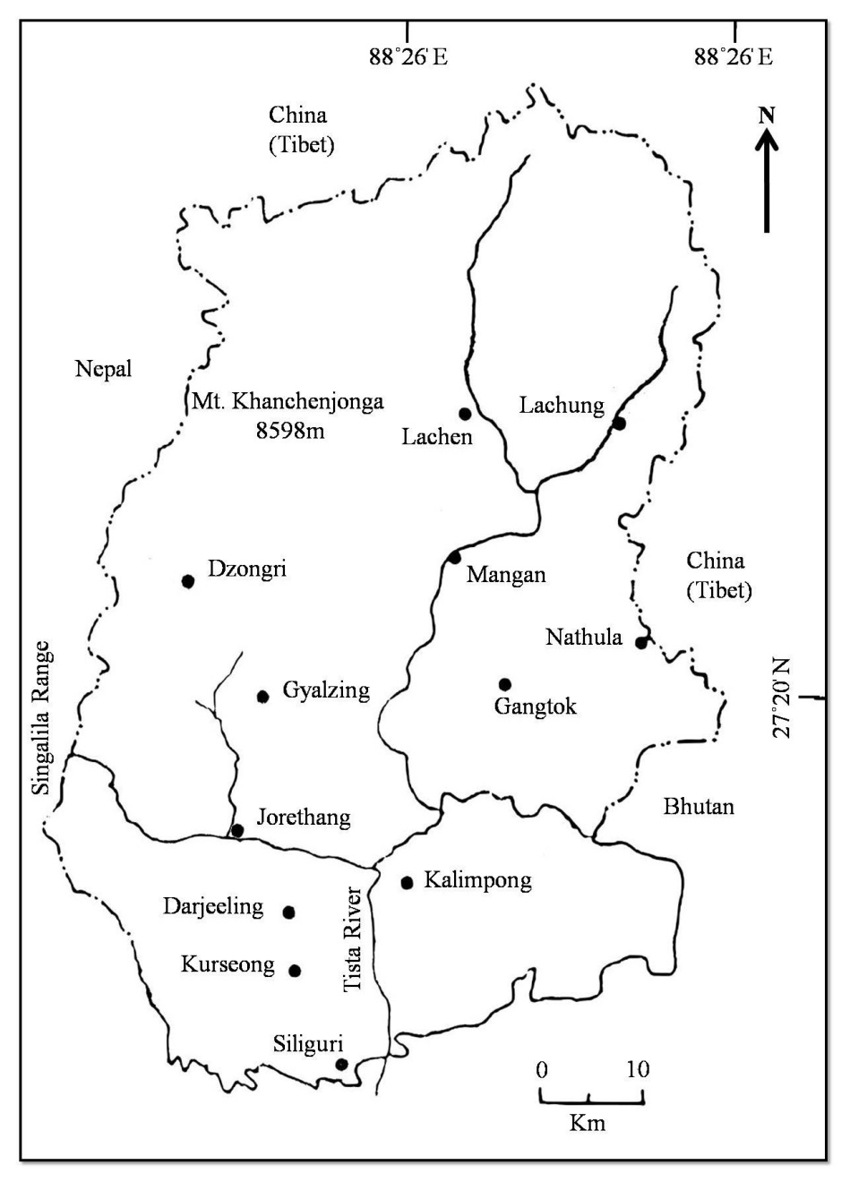
Figure 1: Sikkim Himalaya

The order Agaricales, commonly known as gill fungi contains 270 genera and around 4000 species. These include the mushrooms (the edible species) and the toad stool (the poisonous species). The order Agaricales for long had only one family, the Agaricaceae. Smith (1973) and singer (1975) have recognized 16 families in this order. Hawksworth et al., (1983) who have followed the classification of Singer (1975) in the 7th edition of the ‘Dictionary of the Fungi’ have, however, excluded Boletaceae and Russulaceae from Agaricales. General characters of Agaricales are hymenophore either lamellate or porose; if porose, the tubes are easily removed from the pileus; basidiocarp fleshy, typically monomitic, rarely dimitic. In the modern sense, the boletes are placed in their own order, the Boletales. The oldest record of the detailed survey of naturally occurring Agaricales of Sikkim Himalaya comes from the study of Berkley (1856), who listed 131 species and provided taxonomic rank and nomenclature to 90 of them. Since then, little work has been carried out on this respect. A list of genera and species reported from Sikkim Himalaya till to date presented in Table 2.

Table 2: List of Genera and Species were reported from Sikkim Himalaya

GENUS | SPECIES | HABITAT, PLACE AND AREA (References)
Agaricus L. ex Fr. | A. exaltatus Berk.  A. fulviceps Berk.  A. silvaticus Schaeff. | Clay earth banks, Darjeeling (a)  Ground, Sikkim (a)  Soil, Darjeeling (a)
Amanita (Pers. ex Fr.) S.F. Gray | A. gemmata (Fr.) Bertill.  A. muscaria var. flavivolvata (Singer) Jenkins | Darjeeling (p)  Darjeeling (p)
Amanitopsis Roze. | A. berkeleyi (Hook.f.) Sacc.  A. eriophora (Berk.) Sacc.  A. regalis (Berk.) Sacc. | Ground, Darjeeling (a)  Ground, Darjeeling (a)  Ground, Darjeeling (a)
Armillaria (Fr.) Quel | A. adelpha Berk.  A. dichupella Berk.  A. duplicata Berk  A. horrens Berk.  A. mellea Berk.  A. multicolor Berk.  A. omnituens Berk.  A. vara Berk. | Dead wood, Darjeeling (a)  Dead wood, Darjeeling (a)  Dead wood, Darjeeling (a)  Bark old tree, Darjeeling (a)  Root C. japonica, Calimpong (b).  Dead wood, Jalapahar (a)  Dead wood, Darjeeling (a)  Rotten timber, Sinchel (a)
Clitocybe (Fr.) Kummer | C. incongrua Berk.  C. laccata (Scop) Sacc. | On the ground, Jalapahar (a)  Pine wood, Sikkim (a)
Collybia (Fr.) Quel | C. antitypha Berk.  C. blandulq Berk.  C. camptopoda Berk.  C. dryophila (Bull.) Fr. var. Caespitis Berk.  C. macera Berk.  C. maculata (Alb. & Schw.) Fr.  C. napipes Hook.f. in Berk.  C. papaveracea Berk.  C. podagrosa Berk.  C. raphanipes Berk.  C. rhodella Berk.  C. stillaticia Berk.  C. triplicata Berk.  C. undabunda Berk.  C. ustipes Berk.  C. velutipes (Curt.) Fr. | Pine wood, Sikkim (a)  Wood, Darjeeling (a)  Wood, Darjeeling (a)  Amongst grass and moss, Lachen, (a)  Ground in pine wood, Sikkim. (a)  Pine wood, Lachen. (a)  Ground, Darjeeling (a)  Ground, Darjeeling (a)  Clay banks, Sinchal. (a)  Jalapahar, Darjeeling (a)  Wood, Darjeeling (a)  Dead, living tree, Jalapahar (a)  Sikkim (a)  Old timber wood, Darjeeling (a)  Ground, Darjeeling (a)  Dead wood, Darjeeling & Sikkim (a)
Coprinus (Pers. ex Fr.) S.F. Gray | C. comatus Fr.  C. disseminates (Pers. ex Fr.) S.F.Grey  C .hookeri Berk.  C. micaceous (Bull.) Fr.  C. plicatilis (Curt ex Fr.) Fr.  C. vellereus Berk | Grassy land, Darjeeling (a)  Forest floor, moist wall Darjeeling (o)  Grassy place, Jalapahar (a)  Rotten log, Darjeeling (o)  Grassy meadow, Darjeeling (o)  Dead wood & earth, Darjeeling (a)
Cortinarius S.F. Gray | C. emodensis Berk.  C. flameus Berk.  C. saniosus Fr.  C. vinosulus Sacc. | Pine wood, Lachen (a)  Pine wood, Sikim (a)  Pine wood, Sikim (a)  Pine wood, Sikim (a)
Crepidotus (Fr.) Staude | C. mollis (Schaeff.) Staude  C. variabilis (Pers.) P. Kumm. | Darjeeling (p)  Darjeeling (p)
Entoloma (Fr.) Kummer | E. cystopodium Berk.  E. euthelum Berk.  E. goliath Hook.f. | On dead leaves, twig, Darjeeling (a)  Pine wood, Sikkim (a)  Wood, Darjeeling (a)
Flammula (Fr.) Kummer | F. chrysomyces Berk.  F. flavida (Schaeff.) Fr.  F. macrophala (Berk.) Sacc.  F. phelegmatica Berk. | Dead wood, Darjeeling (a)  Pine wood, Sikkim. (c)  Tree trunk, Darjeeling (a)  Pine wood, Sikkim. (a)
Flammulina P. Karst. | F. velutipes (Curt. ex Fr.) Sing | Darjeeling (p)
Galera (Fr.) Quel. | G. burkillii Massee  G. tenera (Schaeff.) Fr.  G. vinolenta Berk. | Ground, Darjeeling (d)  Ground, Jalapahar, Darjeeling (a)  Wood in pine forest, Sikkim. (a)
Hygrophorus Fr. Kummer | H. fulvus Berk.  H. miniatus Fr. | Pine wood, Sikkim (a)  Pine wood, Lachen, Sikkim (a)
Hypholoma (Fr.) Quel | H. atrichum Berk.  H. castanophyllum Berk.  H. condensum Berk.  H. fasciculare (Huds.) Fr.  H. hemisodes Berk.  H. sublateritium (Schaeff.) Fr.  H. velutinum (Pers) Fr. | Dead timber, Darjeeling (a)  Ground, Darjeeling (a)  Ground, Darjeeling (a)  Dead wood, Darjeeling (a)  Earth Bank, Darjeeling (a)  Dead wood, Darjeeling (a)  Earthy bank, Darjeeling (a)
Laccaria Berk. & Br. | L. laccata (Scop.) Cooke. | Darjeeling (q)
Lactarius D.C. ex S.F. Gray | L .deliciosus (L.) Fr.  L. vellereus Fr. | Lachen, Sikkim (e), Darjeeling (m)  Fire wood, Sikkim (a), Darjeeling (m)
Lentinus Fr. | L. coadunatus Hook. f.  L. hepaticus Berk.  L. hookerianus Berk.  L. inquinans Berk.  L. subdulcis Berk.  L. tecomtei Fr. | Dead wood, Darjeeling (a)  Tree trunks, Darjeeling (a)  Dead wood, Darjeeling (a)  Dead wood, Sikkim. (a)  Dead wood, Darjeeling (a)  Wood, Tonglo, Sikkim (a)
Lepiota (Pers. ex Fr.) S.F. Gray | L. delicolum Berk.  L. montosa Berk. | Dead trees, Darjeeling. (a)  Ground, Sikkim. (a)
Leucoagaricus Singer | L. excoriatus (Schaeff. ex Fr.) Singer. | Ground, Darjeeling (f)
Marasmius Fr. | M. caperatus Berk.  M. consocius Berk.  M. erythropus Fr.  M. hematodes Berk.  M. irridescens Berk.  M. rotula (Scop ex Fr.) Fr. | Live &dead bush, Tonglo (a)  Dead twig, Darjeeling (a)  Ground, Darjeeling (a)  Pine twig, Sikkim. (a)  Mossy bark, Sikkim. (a)  Leaves of maple & pine wood, Sikkim (a)
Mycena (Fr.) S.F. Gray, | M. bicrenata Berk.  M. broomiana Berk.  M. colligata Berk.  M. dentosa Berk.  M. discors Berk.  M. epipterygia (Scop.) Fr.  M. flavo-miniata Berk.  M. galericulata (Scop.) Fr.  M. incommiscibilis Berk.  M. manipularis Berk.  M. myriadea Berk.  M. nubigena Berk.  M. prasia Berk.  M. puberula Berk.  M. pura (Pers.) Fr.  M. rubiaetincta Berk.  M. rufata Berk.  M. rufo-picta Berk.  M. russulina Berk.  M. xanthophylla Berk. | Roots of trees, Sikkim (a)  Rotten wood, Jalapahar (a)  Dead wood, Darjeeling (a)  Pine wood, Sikkim (a)  Pine wood, Sikkim (a)  Pine wood, Sikkim (a)  Pine wood, Sikkim (a)  Pine wood, Sikkim (a)  Pine wood, Sikkim (a)  Trunk & stump, Sinchel (a)  Dead trunk, Darjeeling (a)  Old timber, Darjeeling (a)  Ground, Tonglo (a)  Pine wood, Sikkim (a).  Pine wood, Sikkim (a), Darjeeling  Tree bark, Darjeeling (a)  Tree trunk, Darjeeling (a)  Dead wood, Darjeeling (a)  Tree trunk, Darjeeling (a)  Tree roots, Darjeeling (a)
Naucoria Fr. | N. descendens Berk.  N. scrupea Berk. | Pine wood, Sikkim (a)  Moist earth, Darjeeling (a)
Omphalia (Fr.) Staude. | O. radiatus Berk.  O. ranunculina Berk.  O. umbellifera (L) Fr. | Pine wood, Sikkim (a)  On Turf, Lahu, Sikkim (a)  Pine wood, Sikkim (a)
Oudemansiella Speg. | O. radicata (Reih ex Fr.) Singer  O. mucida (Schrd.) Hoehn. | Soil, Kurseong (g)  Sikkim (l)
Panus Fr., | P. conchatus Fr.  P. monticola Berk. | Darjeeling (a)  Ground, Tonglo (a)
Paxillus Fr. | P. chrysites Berk.  P. pinguis Hook.f.  P. sulphureus Berk. | Dead wood, Darjeeling (a)  Earth & mossy banks, Darjeeling (a)  Dead wood & Ground, Darjeeling (a)
Peniophora Cooke | Peniophora sp. | Ground, Sikkim (h)
Pholiota (Fr.) Kummer | P. aurivella (Batsch.) Fr.  P. examinans Berk.  P. microspora Berk. | Tree stump, Darjeeling (a)  Dead wood, Darjeeling. (a)  Dead wood, Darjeeling (a)
Pleurotus (Fr.) Kummer | P. anserinus Berk.  P. eous Berk.  P. hapalosclerus Berk.  P. himalayensis Thind & Waraitch.  P. ninguidus Berk.  P. placentodes Berk.  P. salignus (Pers.) Fr.  P. verrucarius Berk. | Dead wood, Darjeeling. (a)  Dead tree trunk, Sikkim (a)  Tree trunk, Darjeeling (a)  Burnt wood & Soil, Darjeeling (i)  Dead timber, Sikkim (a)  Birch wood, Sikkim (a)  Sikkim (a)  Dead wood, Darjeeling (a)
Pluteus Fr. | P. chrysoprasius Berk.  P. plumbinus Berk. | Burnt wood of Abies, Sikkim (a).  Living tree trunk, Darjeeling. (a)
Psathyra (Fr.) Quel | P. clavescens Berk.  P. flavo-grisea Berk.  P. nassa Berk. | Mossy earth, Darjeeling (a)  Dead wood, Darjeeling (a)  Dead wood, Darjeeling (a)
Psathyrella (Fr.) Quel | P. discolor Berk. | Dead timber & ground, Darjeeling (a)
Psilocybe (Fr.) P. Kumm. | P. caespiticia Berk. | Clay banks, Darjeeling (a)
Russula Pers.ex S.F. Gray | R. cinnabaarina Hook.f.  R. emetica Fr.  R. furcata Fr.  R. grossa Berk.  R. lepida Fr.  R. ochroleuca Pers. ex Fr.  R.rosacea Fr.  R. sororia (Fr.) Romell.  R. xerampelina Fr. | Clay bank, Darjeeling (a)  Clay bank, Darjeeling (a)  Clay bank, Sinchel, (a)  Darjeeling (a)  Clay bank, Darjeeling (a)  Forest floor, Darjeeling (n)  Pine wood, Lachen, Sikkim. (j)  Forest floor, Darjeeling (n)  Forest floor, Darjeeling (n)
Schizophyllum Fr. | S. commune Fr. | Dead wood, Darjeeling (a)
Stereogloeocystidium Rick | S. spadiceum (Fr.) Rick | Dead wood, Darjeeling (f)
Stropharia (Fr.) Quel. | S. aureo-fulva Berk. | Dead wood, Jalapahar (a)
Tricholoma (Fr.) Quel. | T. cremoriceps Berk. | Tree trunk, Darjeeling (a)
Tricholomopsis Singer | T. rutilans (Schaeff ex Fr.) Singh | Humicolous soil, Darjeeling (k)
Volvaria (Fr.) P. Kumm. | V. thwaitesii Hook. f. | Dead wood, Darjeeling (a)
Xerotus Hill ex Grev. | X. cantharelloides Berk. | Dead wood, Jalapahar (a)

(a) Berkeley, M.J. (1856); (b) Bakshi, B.K. et al., (1972); (c) Banerjee, S.N. (1947); (d) Massee, G. (1912); (e) Butler, E.J. and Bisby, G.R. (1931); (f) Ramakrishnan, K. and Sundaram, N.V. (1952); (g) Ghosh, R.N. et al., (1967); (h) Banerjee, S.N. (1948); (i) Thind, K.S. and Waraitch, K.S. (1971); (j) Mundkur, B.B. (1938); (k) Sarwal, B.M. (1984); (l) Rai et al., (2007); (m) Acharya et al., (2004a); (n) Acharya et al., (2004b); (o) Rai et al., (2005); (p) Acharya and Rai, (2003); (q) Rai and Acharya, (2006).

- Conclusion
The hills of Darjeeling and Sikkim (Figure 1) seem to provide a wide range of habitats for the growth of Agaricales with 151 species belonging to 42 genera (Table 2). The number of representative species under each of the 42 genera is varied with 13 genera having a single species each and the genera Mycena and Collybia, having 20 and 16 species respectively (Figure 2, Table 2). The evenness of species distribution/genera is significantly low which supports higher diversity, assemblage and distribution of species. Maximum number of genera (31) supported species richness of 1-3/genera and only two genera had more than 10 representative species which indicates higher Agaricales diversity.

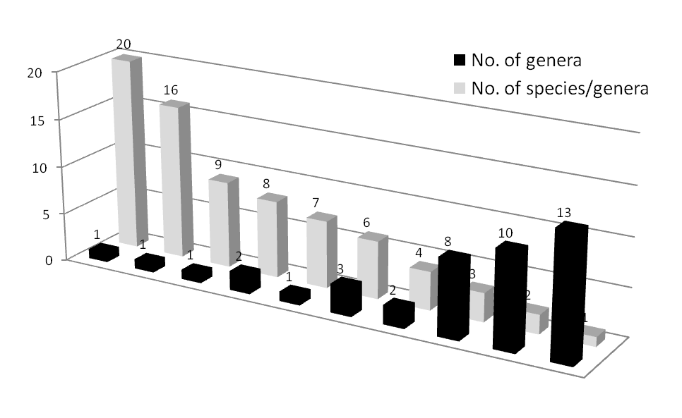

Figure 2. Species richness of Agaricales in the Sikkim Himalaya.

Correspondence to
Krishnendu Acharya
Molecular and Applied Mycology and Plant Pathology Laboratory, Department of Botany, University of Calcutta, Kolkata, West Bengal, pin-700019, India.
Email: krish_paper@yahoo.com

References
- Acharya K, Rai M. Biodiversity of Agaricales at Darjeeling town and its adjoining area. National Symposium on Assessment and Management of Bioresources, Organised by University of North Bengal and The Zoological Society. 28-30 May, 2003.
- Acharya, K., Rai, M., Rai, N.P. and Sen, S. Three new species of Russula: Addition to the macrofungi of Sikkim Himalaya. The Indian Forester. 2004b;130:953-955.
- Acharya K, Rai M, Subba J, Gurung S. Two new species of Lactarius - new report from Darjeeling, West Bengal. Indian Journal of Applied and Pure Biology. 2004a;19:63-66.
- Anon. IUCN Red List Categories. IUCN. Gland, Switzerland. 1995
- Arnolds E, De Vries B. Conservation of fungi in Europe. In: Pegler, DN Boddy L, Ing, B. Kirk, P.M. eds. Fungi in Europe: Investigation, Recording and Conservation. Royal Botanic Gardens: Kew, UK. 1993:211-230.
- Arnolds E. van Ommering G. Bedreigde en kwetsbare paddestoelen in Nederland. Toelichting op de Rode Lijst. IKC Natuurbe heer; Wageningen. 1996.
- Aronsson M, Hallingbäck T. Mattson JE. In: Rödlistade växter i Sverige, 1995. Artdatabanken. Uppsala. 1995.
- Bakshi BK, Reddy MAR, Puri YN, Singh, S. Survey of the disease of important native and exotic forest trees in India. PL-480. report FRI, Dehradun. 1972.
- Banerjee SN. Fungus flora of Calcutta and Suburbs-I. Bulletin of Botanical Society of Bengal. 1947;1:37-54.
- Banerjee SN. Some higher fungi of Sikkim Himalayas. Science and Culture. 1948;11: 444 -445.
- Bas C. Veranderingen in de Nederlandse paddestolenflora. Coolia. 1978;21: 98-104.
- Bendiksen E, Hoiland K, Brandrud TE, Jordal JB. Truete og sarbare sopparter I Norge-en kommentert Rodliste. Direktoratet for Naturforvaltning and Fungiflora. Oslo. 1997.
- Benkert D, Dörfelt H, Hardtke HJ, Hirsch G, Kreisel H, Krieglsteiner GJ, Lüderitz M, Runge H, Schmid H, Schmitt JA, Winterhoff W, Wöldecke K, Zehfuss HD. Rote Liste der gefährdeten Grosspilze in Deutschland. Deutschland Gesellschaft für Mykologie e.V. IHW-Verlag. Eching. 1992.
- Berkley MJ. Decades of Fungi, Decas 1-62, Nos. 1-620. In: Hooker’s London, Journal of Botany. 1856;3-8: 1844-1856.
- Borodin AM, Bannikov AG, Sokolov VE. eds In: Red Data Book of the USSR. Rare and Endangered Species of Animals and Plants, 2nd edition. Lesnaya Promyshlennost. Moscow. 1984.
- Brown N, Bhagwat S, Watkinson S. Macrofungal diversity in fragmented and disturbed forests of the Western Ghats of India. Journal of Applied Ecology. 2006;43(1): 11-17.
- Bunyard BA, Nicholson MS, Royse DJ. Phylogeny of the genus Agaricus inferred from restriction analysis of enzymatically amplified ribosomal DNA. Fungal Genetics and Biology. 1996;20: 243-253.
- Butler EJ, Bisby GR. The fungi of India. Imp. Council of Agaric. Res. India Sci. Monogr. I. XVII+. 1931: 237.
- Calonge FD. Hacia la confección de una lista roja de macromycetes (hongos) en la peninsula Ibriéca. Boletin de la Sociedad Micólogica de Madrid. 1993;18: 171-178.
- Cannon PF. Strategies for rapid assessment of fungal diversity. Biodiversity and Conservation. 1997;6: 669-80.
- Cibula WG. An ecological and taxonomic study of selected higher fungi in Northeastern Ohio. Biological Notes No. 7. Columbus (OH). Ohio Biological Survey. 1974.
- Coutecuisse R. Current trends and perspective for the global conservation of fungi. In: Moore D, Nauta MM, Evans SE, Rotheroe M, eds. Fungal Conservation: Issues and Solutions. British Mycological Society, Cambridge University Press, UK. 2001:7-18.
- Cowan A. In: Fungi – Life Support for Ecosystems. Essential ARB. 2001:4:1-5.
- Diamandis S. List of threatened macrofungi in Greece. European Council for the Conservation of Fungi Newsletter. 2000 ;10:12-14.
- Gates GM, Ratkowsky DA. Grove SJ. A Comparision of macrofungi in young Silvicultural regeneration and mature forest at the Warra LTER siet in the southern forests of Tasmania. Tasfor. 2005;16: 127.
- Ghosh RN, Pathak NC, Tewari I. Studies on Indian Agaricales. Indian Phytopathology. 1967;18: 360-362.
- Guzman G. Inventorying the fungi of Mexico. Biodiversity and Conservation. 1998;7: 369-84.
- Hawksworth D, Rossman AY. Where are all the undescribed fungi?. Phytopathology. 1997;87: 888-891.
- Hawksworth DL. The fungal dimension of biodiversity: magnitude, significance, and conservation. Mycological Research. 1991;6: 641-55.
- Hawksworth DL. Challenges in mycology. Mycological Research. 1995;99: 127-8.
- Hunt GA. Assessing Macrofungi of special concern for Conservation in Forested Ecosystems. In: Proc. Biology and management of species and habitats at risk. 15-19 Feb 1999, University College of the Cariboo, Kamloops. 1999;2:779.
- Ing B. A provisional Red List of British macrofungi. Mycologists. 1992;6: 124-128.
- Ivancevic B. A preliminary Red List of the macromycetes of Yugoslavia. In: Perini C, ed. Conservation of Fungi in Europe. Proceeding of the 4th meeting of European Council for Conservation of Fungi, Universita degli studi di siena. Dipartimento Biologia Ambientala. Siena, Italy. 1998: 57-61.
- Karadelev M. A preliminary Red List of macromycetes in the republic of Macedonia. European Council for the Conservation of Fungi Newsletter. 2000;10:7-11.
- Keizer GJ. The Complete Encyclopedia of Mushrooms. Rebo publishers, Netherland. 1998;268.
- Kishbaugh MA, Yocam DH. The impact of habitat fragmentation on arthropod biodiversity. American Biology Teacher. 2000;62:414-20.
- Kotlaba F, et al., In: Červena kniha ohrazenych a vzácnych druhov rastlin a zivičichov ČR a SR 4. Sinice a rasy, houby, lisejniky, mechorosty (Red data book of threatened and rare plant and animal speies of Czechoslovakia, vol. 4, Cyanobacteria and algae, Fungi, Lichens, Mosses). Priroda. Bratislava. 1995.
- Krebs CJ. In: Ecological methodology. Harper and Row Publishers, New York. 1989.
- Krisai I. Rote Liste gefährdeten Grosspilze Österreichs. In: Niklfield H, ed. Rote Listen gefährdeten Pflanzen Österreichs. 1999:178-192.
- Kutorga E, Urbonas V, Gricius A. In: Checklist of macrofungi in Lithuania with evaluation of threat status. Vilnius. 1999.
- Manoharachary C, Sridhar K, Singh RA, Suryanarayanan TS, Rawat S, Johri BN. Fungal Biodiversity: Distribution, Conservation and Prospecting of Fungi from India. Current Science. 2005;89(1):58-71.
- Massee G. Fungi exotici. Kew Bulletin. 1912;253 -255.
- Molina R, O’Dell T, Luoma D, Amaranthus M, Castellano M, Russell K. In: Biology, Ecology and Social aspects of Wild Edible Mushrooms in the Forests of the Pacific Northwest: A Preface of Managing Commercial Harvest. U.S. Dept. of Agriculture Forest service, Pacific Northwest Research station, United States. 1993:45.
- Molina R, Pilz D, Smith J, Dunham S, Dreisbach T, O’Dell T, Castellano M. Conservation and management practices of forest fungi in the Pacific NorthWestern United States: an integrated ecosystem approach. In: Moore D, Nauta MM, Evans SE, Rotheroe M, eds. Fungal Conservation: Issues and Solutions. British Mycological Society, Cambridge University Press, UK. 2001:19-63.
- Mundkur BB. Fungi of India-Supplement-I. ICAR Sci. Monograph. 1938;12: 54.
- Piepenbring M. Inventoring the fungi of Panama. Biodiversity and Conservation. 2007;16(1): 73-84.
- Pilz D, Molina R. Commercial harvests of Edible Mushrooms from the forests of the Pacific Northwest United States: Issues, Management and Monitoring for sustainability. In: Forest Ecology and Management. 2001:1-14.
- Rai M, Acharya K. Diversity of agaricales in Darjeeling Himalaya. International Symposium on Agriculturally Important Microorganisms: Conservation, Utilisation, Bioremediation and Ecological Significance, (Golden Jubilee Celebrations of the Indian Mycological Society). 23-25 February, 2006. Kolkata. 2006 ;44(1):173.
- Rai M, Ghosh S, Acharya K. On nutritional parameters of Oudesmansiella mucida. Journal of Mycopathological Research. 2007;42:113-116 .
- Rai M, Sen S, Dutta BB, Acharya K. Some additions to the Coprinaceae of Sikkim Himalaya. Journal of Mycopathological Research . 2005;43:101-103.
- Ramakrishnan K, Sundaram NV. The fungi of India-a second supplement. Journal of Madras University. 1952;21(B):1-65.
- Rassi R, Kaipianien H, Mannerkoski I, Stähls G. In: Uhanailaisten aläinten ja kasvien seurantatoimkunnan mietintö (Report on the monitoring of threatened animals and plants in Finland). Komiteanmietintö 1991: 30, Ympäristömibisteriö. Helsinki. 1992.
- Riclefs RL, Miller GC. In: Ecology, 4th edition. W. H. Freeman and Co., New York. 1999.
- Rimoćzi I. Endangered macrofungi and a provisional red list in Hungary. In: Perini C, ed. Conservation of Fungi in Europe. Università degli studi di Siena, Dipartimento Biologia Ambientale. Siena. 1998:91-111.
- Rossman AY, Farr DF. Towards a virtual reality for plant associated fungi in the United States and Canada. Biodiversity and Conservation. 1997;6: 739-51.
- Sarwal BM. Taxonomic studies on Indian Agarics-II. Indian Phytopathology. 1984;37:228 -233.
- Schlumpf E. Sollen unsere Pilze aussterben? Schweizerische Zeitschrift Pilzkunde. 1976;54:101-105.
- Senn-Irlet B, Bieri C, Herzig R. A provisional Red list of the endangered larger fungi in Switzerland. Mycologia Helvetica. 1997;9:81-110.
- Shelyak-Sosonka YR. In: Chervona Kniga Ukrainy-Roslinniy Svit (Red data book of Ukraine-Plant Kingdom). Ukrainskaya Enciklopedia. Kiev. 1996.
- Smith RL. In: Ecology and Field Biology, 5th edition. Harper and Collins, New York. 1996.
- Staley JT. Biodiversity: are microbial species threatened? Current Opinion in Biotechnology 1997;8:340-345.
- Swapna S, Syed A, Krishnappa M. Diversity of macrofungi in semi-evergreen and moist deciduous forest of Shimoga district-Karnataka, India. Journal of Mycology and Plant Pathology. 2008;38(1):21-26.
- Thind KS, Waraitch KS. The pezizales of India-XIV. Proceedings of Indian Academy of Science. 1971;74 (B):269-276.
- Vesterholt J, Knudsen H. Truede storsvampe I Denmark-en rodliste. Foreningen til Svampekundskabens Fremme: Kobenhavn. 1990.
- Vimba E, Patarana A. Latvijas Sarkana gramata. I. sejums. Senes un kerpji (Red Data Book of Lativia, Vol.1. Fungi and lichens). Riga. 1996.
- Watling R. Pulling the threads together: habitat diversity. Biodiversity and Conservation. 1997;6:753-63.
- Wojewoda W, Lawrynowicz M. Redlist of threatened macrofungi in Poland. In: Zarzyccki K, Wojewoda W, Heinrich Z, eds. List of Threatened Plants In Poland, 2nd edition. Polish Academy of Sciences, Cracow. 1992:27-56.

28/04/2010

