Storage Life of Tilapia (Oreochromis niloticus) in Ice and Ambient Temperature
Ihuahi Josiah Adoga ¹, Egila Joseph ², Omojowo Funso Samuel ¹
^{1.} National Institute for Freshwater Fisheries Research (NIFFR), P.M.B. 6006, New Bussa, Niger-State, Nigeria. ^{2.} University of Jos, P.M.B. 2084, Jos, Nigeria.
joeihua@yahoo.co.uk, egilajn@yahoo.com, jowosam@yahoo.com
Abstract: A study on the storage life of Tilapia (Oreochromis niloticus) in ice and ambient temperature was carried out. The storage life of the fish was 15 days in ice and 12 hrs at ambient temperature. TVB-N and peroxide values continuously increased with the lapse of the storage period. TVB-N value increased from 5.51mg/100g to an acceptable value of 22.53 mg/100g in 15 days and finally to a rejection value of 38.75 mg/100g at the end of 21days storage period, TVB-N results showed acceptability for 9 hrs of the 18 hrs of ambient storage. Results of peroxide value did not support those of sensory evaluation and microbial analysis. Organoleptic acceptability was15days in ice and about 12 hours at room temperature. Results of bacterial load showed that the samples were in acceptable condition, not exceeding 10⁶cfu/g for about 15 days in ice and 12 hrs at ambient temperature. The initial bacterial load for ice-stored samples was quite diverse with mesophilic bacterial population (Micrococcus spp. and Bacillus spp.) predominating. However, as storage period progressed, Aeromonas hydrophila, E. coli and Shigella spp. increased in number accounting for over 75% of the spoilage flora towards the end of the storage period, showing that these pathogens were the spoilage organisms in ice. At ambient temperature, major spoilage organisms were Aeromonas hydrophila, E. coli, Shigella spp., Salmonella typhi and Baccilus spp. [Researcher. 2010;2(5):39-44]. (ISSN: 1553-9865).
Key words: Oreochromis niloticus, storage life, ice, ambient temperature.

INTRODUCTION
Very few studies have been conducted on the quality and shelf life of freshwater fish in storage conditions in contrast to the lots of information that is available for marine species. Abe and Okuma (1991) established the relationship between the storage life of carp acclimated to different water temperatures and rigor mortis progress in the species. Oyelese (2007) carried out a study on behavioral effects and post-mortem changes in Clarias angullaris under varying gear handling conditions. Studies by Margaret and Kasiga (2005) showed that small-sized Oreochromis niloticus went into and out of rigor faster than the big-sized samples. Their results show that size and holding temperature seemed to have influence on the storage life of the species.
Oreochromis niloticus is a valuable fish in Nigeria due to its delicious and prolific nature and high market demand. The high ambient temperature of Nigeria favors the spoilage rate of fish. During icing, chemical changes are known to take place in fish (Huss, 1995). Chilling fish in ice or in the refrigerator slows down the destructive processes of enzymes and bacteria, the shelf-life of fish can therefore be extended by many days. Using ice boxes, it has been reported that Tilapia and Catfish will remain edible for 25 to 30 days and 16 to 20 days respectively if buried in ice. Even better results are obtained if the fish are gutted and wrapped (Eyo, 2001, Ola and Oladipo, 2004). In Nigeria, this type of fish preservation is hardly used in the artisanal fishery sector due to unavailability in rural fishing communities and the cost of ice. The artisanal sector in spite of its low technological development remains the backbone of fish production in the country (Tobor, 1990).
This study was carried out to investigate the storage life of a freshwater fish Tilapia (Oreochromis niloticus), and also, the spoilage mechanism of the fish in ice and ambient storage.
MATERIALS AND METHODS
Fish sampling and storage: Live samples of Oreochromis niloticus were obtained from fishermen at Jebba Lake Area of Nigeria and quickly transported to the laboratory of the National Institute for Freshwater Fisheries Research, New Bussa, Niger State. Two storage trials were carried out on the species (average weight, 200-500g). Immediately after sorting the samples according to sizes, they were washed with potable water and divided into two lots. The first lot was stored in an insulated ice box (fish: ice ratio1:1) with drainage holes, the ice being replenished twice a day.
The second lot was kept in a basket at ambient temperature (30-31ºC). Samples were obtained from the ice box and ambient condition at 3 days and 3 hrs intervals respectively and used for organoleptic, biochemical and microbiological assessment.
Determination of Total Volatile Basic Nitrogen (TVB-N): Total volatile basic nitrogen (TVB-N) was determined according to the standard methods described by EC (1995).
Peroxide Value (PV) Determination: Measurement of peroxide value was carried out using titrimetric method according to the standard methods described by AOAC (1990).
Microbial analysis: A 15g of whole fish was well blended using a warring blender and used to prepare serial dilution using peptone water (0.1% w/v) as diluents. Ten fold serial dilution of the suspension was made and 0.1ml of the diluted suspension was plated on triplicate plates. Total viable count (TVC) expressed as colony forming units per gram of fish muscle (cfu/g) of the representative samples were determined by standard plate count methods on Nutrient agar. MacConkey agar was used for Coliform counts determination (Sneath et al., 1986, Omojowo et al., 2010).
Identification of Isolates: Colonies of isolates on plates were picked and subcultured on nutrient agar (NA) to ensure purity of cultures. The different pure cultures were then transferred onto NA slopes and stored for further identification tests. The pure isolates were identified using morphological and bios chemical characteristics (Sneath, 1995, Ola and Oladipo 2004).
Organoleptic quality assessment: Sensory methods were used to assess the degree of freshness based on organoleptic characteristics. Raw samples were washed using potable water and presented whole to the taste panel. Samples were examined physically for general appearance of skin, consistency of flesh, odor, color of the gills, color and form of eyes and slime formation. Cooked attributes such as flavor, odor, taste and texture, and raw attributes were evaluated by five trained panelists, and changes in quality of chilled and cooked fish were assessed at 3 days and 3 hrs intervals respectively. The grading of the fish was done following EC (1995) freshness grade for fishery products as shown in tables 1 and 2.
Table 1. Grading of fresh fish
Grade Points Degree of freshness
A <2 Excellent/Acceptable
B 2 to <5 Good/Acceptable
C 5 Bad/Rejected

RESULTS AND DISCUSSION
Changes in TVB-N and peroxide value: TVB-N contents of Oreochromis niloticus showed slow increase during the early stages of storage. At later stages, the level increased more rapidly during ambient storage, see figures 1 and 2. TVB-N value for ice-stored samples increased from 5.51mg/100g on day 0 to an acceptable value of 22.53 mg/100g in 15 days and finally to a rejection value of 38.75 mg/100g at the end of 21days storage period. The value of 30-35mg TVB-N/100g is recommended for fresh fish acceptability (Huss, 1988, Connell, 1995).
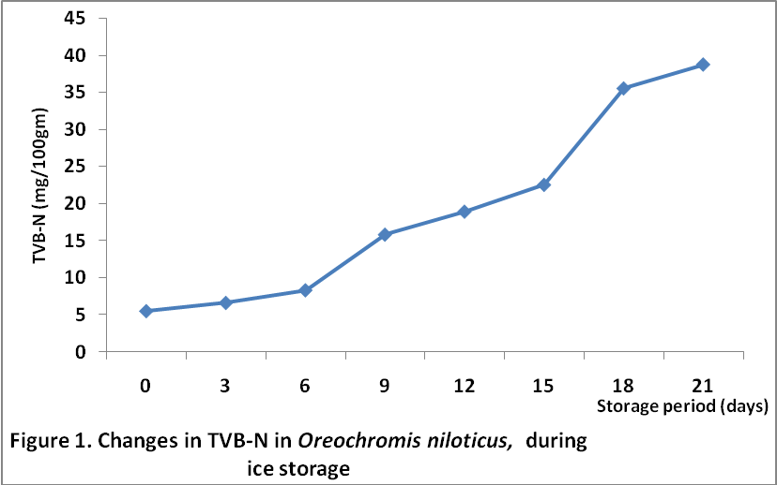
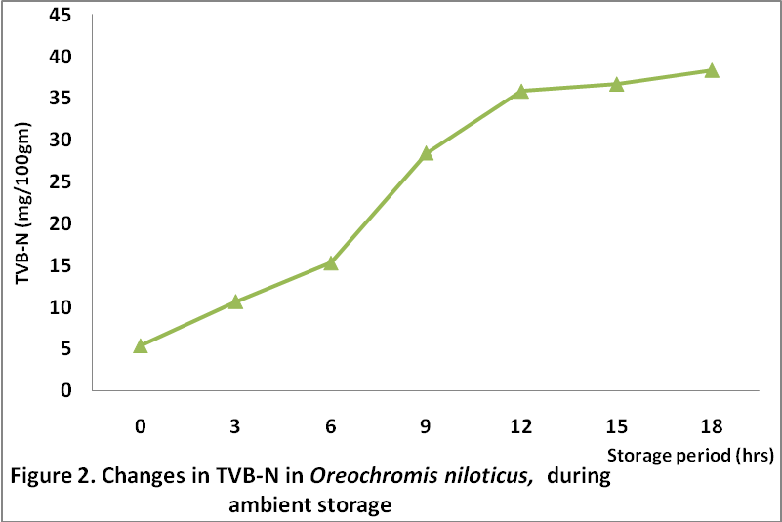

These results corroborate those of organoleptic assessment and microbial assessment in which Oreochromis niloticus, were in acceptable condition for 15 days in ice. Acceptability was about 9 hrs at ambient temperature. Increase in TVB-N with the lapse of storage, particularly, towards the end of storage period may be attributed to bacterial spoilage after the bacterial population has grown (Hossain et al., 2005). TVB-N is normally low during the edible storage period, increasing levels were found in fish near rejection levels. TVB-N might be considered a good indicator of freshness in ice and not at ambient temperature in the present study, since only the results of ice-stored samples supported those of organoleptic and microbial assessments in which acceptability was about 15 days in ice and 12 hrs at ambient temperature.
Results of peroxide value are presented in figures 3 and 4. Peroxide value in Oreochromis niloticus in ice was 3.24meq/kg of oil at day 0, 7.21 meq/kg of oil at day 9 and 9.74 meq/kg of oil at the end of the 21 days storage period. Results suggest that the fish are in good condition throughout the storage period based on values of 10-20 meq/kg of oil as recommended by Connell (1995). At ambient storage, results similarly indicate acceptability throughout the 18 hrs storage period. It was observed in this study that changes in peroxide value of the sample were initially very low indicating a low level oxidation in this fish. Peroxide value might not be considered a good indicator of freshness in this study as values were within the range of acceptability throughout the storage period, even when other results indicated rejection. This may be attributed to the low level of oil in this fish. According to (Hossain et al., 2005), lipid oxidation limits the shelf life of oily fish.
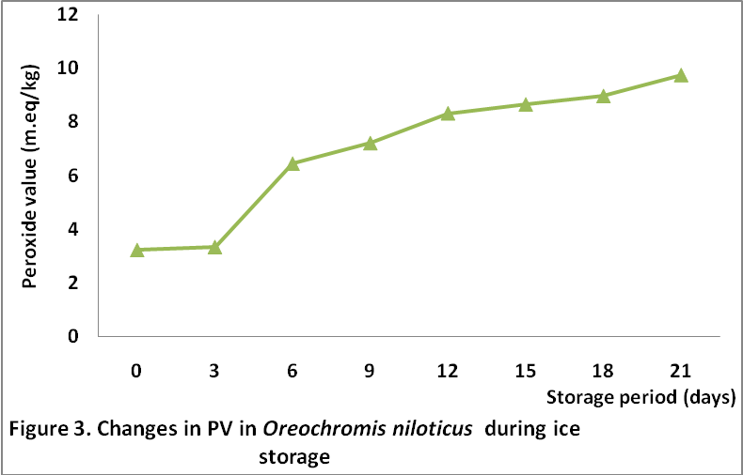
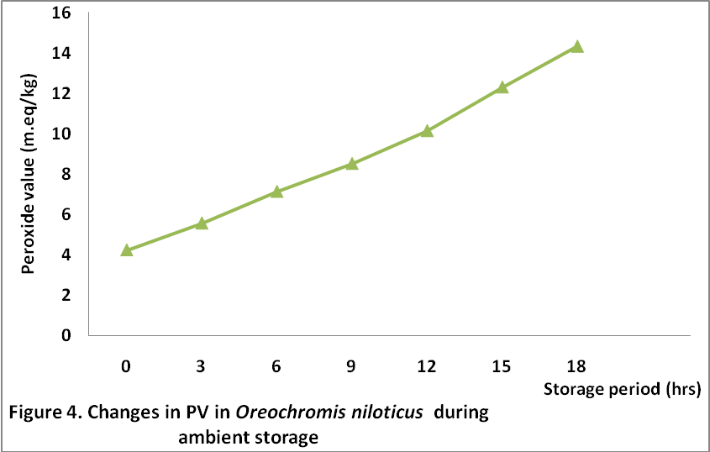
Changes in organoleptic qualities: The results of changes in organoleptic quality in Oreochromis niloticus during ice storage in an insulated box and ambient temperature are presented in tables 3 and 4. The quality of fish was graded using the score from 1-5. The score points less than 2 were considered as excellent. The points from 2 to less than 5 were judged as good or acceptable, while 5 and above were considered as bad or rejected. On the basis of the scores, the samples were found in acceptable conditions for 15days in ice storage and 12 hrs at ambient temperature before they became inedible. Rejection of raw fish by the taste panelists was mainly characterized by strong fishy to sour odors and soft texture. Cooked samples gave sour and ammoniacal to fecal odors with mushy texture. The predominant flavor was bitterness. From results of organoleptic assessment, maximum storage life of Oreochromis niloticus was found to be 15 days in ice and 12 hrs at ambient temperature.
Table 3. Changes in organolpetic qualities of Oreochromis niloticus during ice storage
Storage Defect Points Grade Overall qualities
Time (days)
0 1.28 A Excellent
3 1.71 A Excellent
6 2.95 B Acceptable
9 3.52 B Acceptable
12 3.88 B Acceptable
15 4.29 B Acceptable
18 5.00 C Rejected
21 5.00 C Rejected

Table 4. Changes in organolpetic qualities of Oreochromis niloticus during ambient storage
Storage Defect Points Grade Overall qualities
Time (hrs)
0 1.41 A Excellent
3 1.82 A Excellent
6 2.40 B Acceptable
9 3.97 B Acceptable
12 4.51 B Acceptable
15 5.00 C Rejected
18 5.00 C Rejected

Changes in bacterial load: Shown in figures 5 and 6 are the results of changes in bacterial load in muscle (with skin) of Oreochromis niloticus during ice storage and ambient temperature respectively. The initial total viable count in ice-stored samples was 2.8 x 10⁴cfu/g which increased to 3.2 x 10⁶cfu/g on day 15. At this stage the fish were in acceptable condition according to International Commission for Microbiological Safety of Foods (ICMSF, 1986), i.e. not exceeding 10⁶cfu/g. The values finally rose to an unacceptable value of 8.5 x 10⁸cfu/g at the end of the 21 days storage period. Results of samples stored at ambient temperature showed that the samples retained most of their freshness only for 12 hrs, when total bacterial count was 2.6 x 10⁵cfu/g, by the 15th hour the value was 8.9 x 10⁷cfu/g. This corroborates the results of organoleptic evaluation and TVB-N in which acceptability of Oreochromis niloticus was 15 days in ice. Total coliform counts were generally lower than total viable counts throughout the period of the experiment. However, the presence of coliform bacteria is indicative of fecal contamination of the samples.

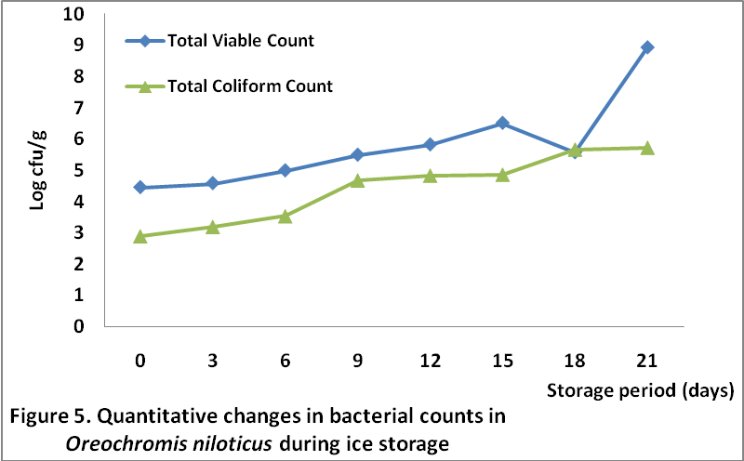
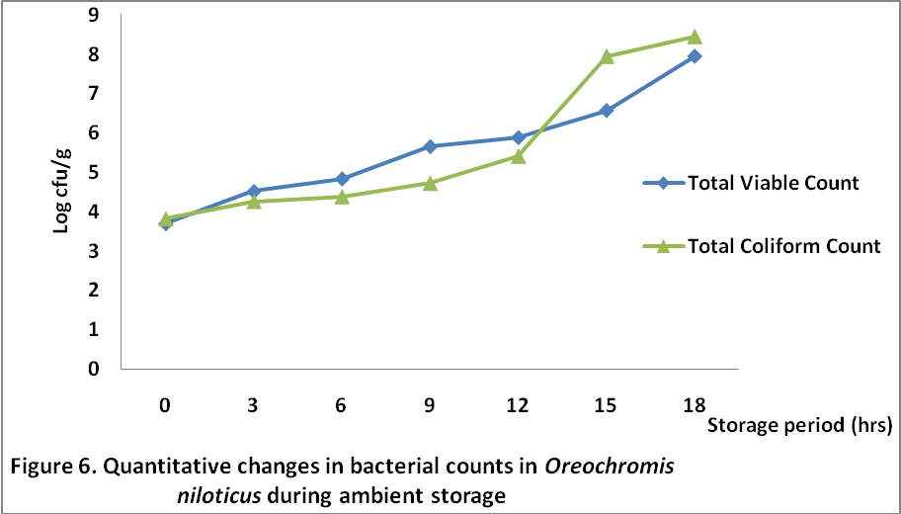

The composition of bacterial flora in Oreochromis niloticus is presented in figures 7 and 8. The fish sample recorded mesophilic bacteria population dominating the flora at the onset of experimental set up in ice-stored samples; Micrococcus spp. (50.7%), Bacillus spp. (42.4%), however, at the point of rejection due to bacterial spoilage, Aeromonas hydrophila was (34.3%), E. coli (30.1%), Shigella spp. (35.4%) dominating the bacterial flora. This reveals that the principal spoilage organisms during ice storage were Aeromonas hydrophila, E. coli and Shigella spp. At ambient storage, there was a general increase in total viable bacterial and coliform counts with increase in storage time. Acceptability based on ICMSF (1986) standards was limited to 12 hrs. Principal spoilage organisms during ambient storage were Aeromonas hydrophila, E. coli, Shigella spp., Salmonella typhi and Baccilus spp.
Conclusion: The results of the above studies showed that Oreochromis niloticus was found in edible condition for 15 days in ice storage and 12 hrs at ambient temperature. Results of TVB-N and microbial analysis supported those of sensory evaluation, in which values were within recommended limit of acceptability within 15 days in ice storage and 12 hrs at ambient temperature, except for TVB-N at ambient storage in which acceptability was limited to 9 hrs. Results of peroxide value, however, did not support other results, which may be attributed to the low oil content of the fish sample. Spoilage organisms in ice-stored samples were Aeromonas hydrophila, E. coli and Shigella spp. At ambient temperature, major spoilage organisms were Aeromonas hydrophila, E. coli, Shigella spp., Salmonella typhi and Baccilus spp.

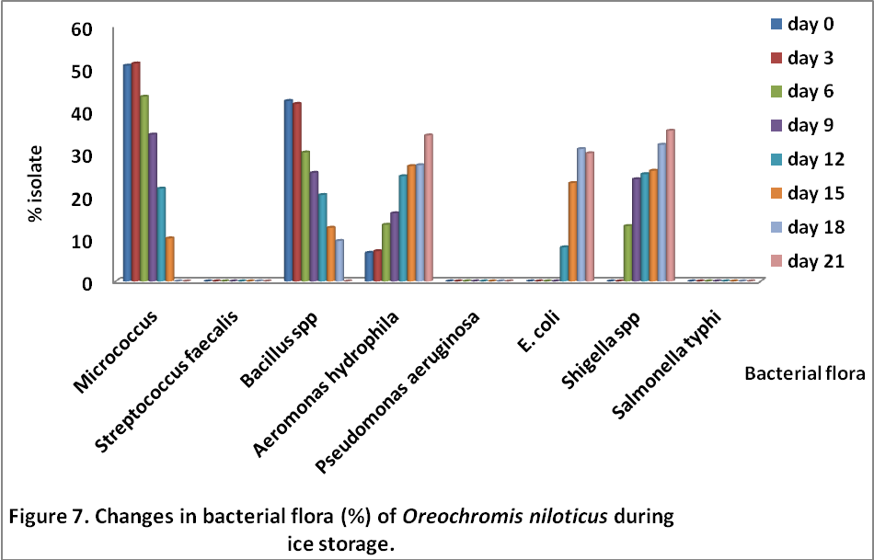
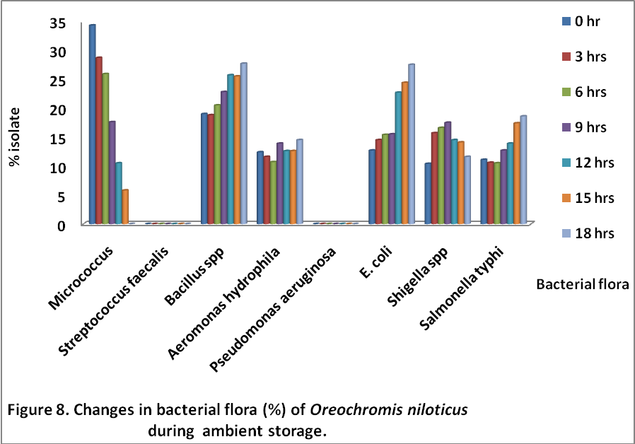

Table 2. Determination of defect points
Characteristics
of whole fish Defect characteristics Defect points Grade
Odor of neck a) Natural odor 2 Acceptable
when broken b) Faint or sour odor 5 Rejected

Odor of gills a) Natural odor 1 Excellent
b) Faint sour odor 2 Acceptable
c) Slight moderate sour odor 3 Acceptable
d) Moderate to strong sour odor 5 Rejected

Color of gills a) Slight pinkish red 1 Excellent
b) Pinkish red, or brown red, some mucus may be present 2 Acceptable
c) Brown or gray color covered with mucus 3 Acceptable
d) Bleached, thick yellow slime 5 Rejected

General a) Full bloom, bright, shining, iridescent 1 Excellent
Appearance b) Slight dullness and loss of bloom 2 Acceptable
c) Definite dullness and loss of bloom 3 Acceptable
d) Reddish lateral line, dull, no bloom 5 Rejected

Eyes a) Bulging with protruding lens; transparent eye cap 1 Excellent
b) Slight clouding of lens and sunken 2 Acceptable
c) Dull; sunken; cloudy 3 Acceptable
d) Sunken eye covered with yellow slime 5 Rejected

Slime a) Usually clear, transparent and uniformly spread,
but occasionally may be slightly opaque or milky 1 Excellent
b) Becoming turbid, opaque and milky, with marked
increase in amount of slime present in skin 2 Acceptable
c) Thick, sticky, yellowish greenish color 5 Rejected

Consistency a) Firm and elastic 1 Excellent
of flesh b) Moderately soft and some loss of elasticity 2 Acceptable
c) Some softening 3 Acceptable
d) Limp and floppy 5 Rejected

Acknowledgements: The author is grateful to Dr. Aminu Raji, the Executive Director of NIFFR, and the entire members of management of the Institute, for sponsoring this research work.

Correspondence to:
Ihuahi, Josiah Adoga
National Institute for freshwater Fisheries Research
(NIFFR), P.M.B. 6006, New-Bussa, Niger-State,
Nigeria.
E-mail: joeihua@yahoo.co.uk

REFERENCES
- A.A. Eyo. (Fish Processing Technology in the Tropics, 2001. University of Ilorin Press, Nigeria.
- Abe, H. and E. Okuma. Rigor mortis progress of carp acclimated to different water temperatures. Nippon Suisan Gakkaishi, 1991, 57:2095-2100.
- AOAC (Association of Official Analytical Chemists). Official methods of analysis of the Association of Official analytical Chemists, AOAC, 1990 (13th edition), Washington, D.C.
- Connell, J.J. Quality deterioration and extrinsic quality defects in raw material, 1995. In: Control of Fish Quality, Fishing News Books Ltd. Surrey, England. 31-35.
- European Communities (EC). Determination of the concentration of volatile nitrogenous bases (TVB-N) in fish and fish products, 1995. A reference procedure. Official Journal of European Communities. Commission Decision. 15p.
- Huss, H. H. Quality and quality changes in fresh fish. FAO Fisheries Technical Paper 348, 1995. Sub-committee on Fish Trade, Food and Agriculture Organization of the United Nations.
- Huss, H.H. Fresh fish quality and quality changes. FAO/DANIDA. A training manual, FAO Fisheries Series No. 29, 1988.
- ICMSF (International Commission on Microbiological Specifications for Foods, 1986. Micro organisms in Foods 2, Sampling for Microbiological Analysis. Principles and Specific Applications, 2nd edn. Oxford: Blackwell Science.
- M.I. Hossain, M.S. Islam, F.H. Shikha, M. Kamal, and M.N. Islam. Physicochemical changes in Thai Pangas (Pangasius sutchi) muscle during ice-storage in an insulated ice box. Pakistan Journal of Biological Sciences, 2005. 8(6): 798-804.
- Margaret Masette and Tom Kasiga. The effect of size and holding temperatures on rigor mortis phenomenon in Nile Tilapia (Oreochromis niloticus), 2005. 17-25.
- Ola, Joseph Babajide and Oladipo, Adnes Etanuoma. Storage life of Croaker (Pseudotholitus senegalensis) in ice and ambient temperature. African Journal of Biomedical Research, vol. 7 (2004): 13-17.
- Omojowo Funso Samuel, Ihuahi Josiah Adoga. Preliminary report on the effects of differents sauces on pouched tilapia products. New York Science Journal, 2010; 3(5). 83-86.
- Oyelese, O. A. Time series behavioural effects and postmortem changes of Clarias gariepinus under varying gear handling conditions. Journal of Fisheries International 2 (1): 32-36, 2007.
- Sneath, P.H.A. Bergey’s manual of Systemic Bacteriology, Vol. 2, 1985, Baltimore: williama and wilking.
- Sneath PHA, Mair NS, Sharpe ME, Holt JG. Bergey’s Manual of Systemic Bacteriology, 1986, Vol. 2. Baltimore: Williams and Wilkins.
- Tobor, J.S. The fishing industry in Nigeria. Status and potential fish sufficiency in fish production. NIOMR Technical Paper No. 54, 1990.

Date of Submission of Article: 23rd April, 2010.

