Uncontrolled Diabetes Mellitus and Fetal Heart

Ehab H. Nashaat, MD*, Ghada M. Mansour, MD**
*Department of internal medicine, **Department of Obstetrics and Gynecology
Ain Shams University
ehabnashaat@hotmail.com gourmansour@hotmail.com

Abstract: One hundred diabetic pregnant ladies were investigated and classified according to HbA1c to controlled and uncontrolled groups. Ultrasound was done for all cases including fetal biometry and measurement of fetal cardiac inter-ventricular septal thickness. Doppler ultrasound was done and umbilical artery and fetal Aorta resistance indices (RI) were estimated for all cases. One hundred normal pregnant ladies acted as controls. A significant increase in septal thickness in uncontrolled diabetics was detected with lower fetal aorta RI compared to controlled diabetics and normal group. Septal thickness correlated with glycemic status in these fetuses. According to the results of this study, proper glycemic control and prenatal routine fetal echocardiography are recommended for all diabetic pregnant ladies. [Researcher. 2010;2(5):45-55]. (ISSN: 1553-9865).

Key Words: Fetal hypertrophic cardiomyopathy, diabetic pregnancy, Doppler ultraounsd, fetal aorta.

Synopsis: Fetal cardiac inter-ventricular septal thickness is increased in uncontrolled diabetic pregnancies, with lower fetal aorta resistance indices. Prenatal fetal echo-cardiographic scanning is recommended in all diabetic pregnancies for early prediction of septal hypertrophic cardiomyopathy.

Introduction:
Diabetes is the most common medical condition to complicate pregnancy and includes type I, type II and gestational diabetes. (Temple, 2006).
The risk of congenital anomalies is increased in infants of diabetic mothers, and is estimated to be between 2.5 to 12%, with an over-representation of congenital heart defects. (Arroyo, et al, 1992).

Although respiratory problems are also frequently found in those infants, they need to be differentiated from cardiovascular problems that such patients may also have, which include cardiovascular maladaptation to extra-uterine life, congenital heart defects and hypertrophic septal cardiomyopathy (Narchi and Kulaylat , 2000).

While symptomatic hypertrophic cardiomyopathy occurs in 12.1% of IDM, when routinely searched for with an echocardiographic scan it is found in 30%. (Arroyo, et al, 1992).

A high index of suspicion is required as the specific management may vary and digoxin, or inotropic agents which may be used in heart failure associated with structural heart defects are contraindicated if hypertrophic cardiomyopathy is present (Narchi and Kulaylat , 2000).
There should be a stress on the role of proper glycemic control all through the pregnancy and fetal echocardiography especially for uncontrolled diabetic females for early detection of such anomalies.

Aim of The Work:
To determine if proper glycemic control can prevent fetal hypertrophic cardiomyopathy in diabetic pregnant ladies.

Subjects and methods
The study included one hundred diabetic pregnant ladies at 36 weeks gestation. A full history was taken from all of them including age, parity and history of any associated medical disorders or drug intake.
According to HbA1c serum levels, they were classified to controlled (group I) and uncontrolled (group II) diabetic cases. HbA1c cut off value of 6.3 % was used. (Tavintharan et al 2000).
All the controlled group were followed up all through the pregnancy by the first author and were maintained on proper glycemic control using human insulin,
While the uncontrolled diabetic group were first seen at the 36th week of their pregnancy without proper follow up of their diabetes or antenatal care

Cases with any other associated medical disorders were excluded from the study.
An abdominal ultrasound was done for all cases including Doppler ultrasound.
Fetal biometry was done for all cases including measurements of biparietal diameter ( BPD), occipitofrontal diameter , head circumference (HC) , trans -abdominal diameter (TAD), abdominal circumference (AC), humerus length (HL) and femur length (FL).
The machine used was, Voluson Pro 730machine (General Electric Medical Systems, Waukesha, Wisconsin, USA)

Hadlock growth curves were used as reference for determination of fetal macrosomia. ( Hadlock et al 1991).

Doppler waveform impulse of umbilical and fetal Aorta arteries resistance indices were measured for all cases.

Thickness of the right and left fetal myocardium and inter-ventricular septal thickness were measured for all cases.
One hundred normal pregnant ladies acted as controls.

All ultraosongraphic scans were done by the first author.
While controlled diabetics were managed by the second author, the uncontrolled ones were referred for ultrasound scan after discovery of gestational diabetes late in their pregnancies.

After tabulation, all data were analyzed using SPSS software, version 11.0 (SPSS, Chicago, IL, USA). The Pearson χ2 test was used for nominal values and the paired t test and analysis of variance were used for numerical values. P<0.05 indicated
statistical significance.

Results
Age ranged from 24 - 36 (29.46 +/- 2.75) years in the study group and 25 – 34 (28.36 +/- 4.328) in control group.

According to HbA1c, study group was classified to controlled and uncontrolled (group I), (group II).
Controlled diabetics were 68, the mean HbA1c for this group during first trimester was 6.1±0.7%,while during the third trimester was 6.2±0.72.
While uncontrolled were 32, the mean HbA1c of this group at time of presentation was 9.1±1.6.There is a significant difference between both groups as regard HbA1c.(table 1,fig 1)
Cut off value of HbA1c used was 6.3% (Tavintharan et al, 2000).

There was no statistically significant difference between the groups in terms of maternal age, gravidity, parity and fetal biometry (P < 0.05).

The mean septal thickness in the controlled diabetics was 3.5 +/ - 1.24 mm (3 – 5 mm), in the uncontrolled diabetic group was 6.6 +/- 0.878 mm (5 – 8 mm), and 3.13 + / - 0.68 mm. (1 – 4 mm) in the normal group. (Table 2, Fig 2).

A significant difference was found as regards the septal thickness between uncontrolled and controlled diabetics and between uncontrolled and normal group and no difference found between controlled diabetics and controls. (P < 0.05).(Fig 3)

Myocardial thickness did not reveal a significant difference between the three groups. Means of group I, group II and control groups were 5.84 +/- 0.987 (4-7 mm), 5.85 +/- 1.12 (4-7) mm, 5.93 +/- 0.81 (5-7) mm successively. (Table 2, Fig 4).
Eight cases out of 32 had fetal macrosomia at 36 weeks exceeding normal range for gestational age according to growth curves and none of the controlled diabetics or normal cases had macrosomic fetuses (Fig 5).
The eight macrosomic fetuses had a mean inter-ventricular septal thickness of 7.38 +/- 0.74 mm which is relatively higher in comparison to the mean septal thickness of the total cases of group II.

The relation between macrosomia and septal thickness could not be statistically estimated due to the relatively small number of macrosomic fetuses in this study.

Umbilical artery RI revealed no significant difference between the three groups, means and ranges in group I , group II and controls were 0.58+/- 0.023 (0.56- 0.64), 0.54+/- 0.0279
(0.52- 0.61) and 0.56+/- 0.0312 (0.54- 0.63) successively
(Table 2, Fig 6).

Fetal aorta RI ranged from 0.7 – 0.8 (0.77 +/- 0.035) in group I, 0.5- 0.7 with a mean of 0.56 +/- 0.063 in group II, and 0.75 – 0.85 (0.785 +/- 0.027) in controls.
(Table 2, Fig 7).

Fetal aorta RI was significantly lower in cases of uncontrolled diabetes with increased inter-ventricular septal thickness than controlled diabetics and normal groups (Fig 8).
Using correlation coefficient test HbA1c was positively correlated with the septal thickness measurements in uncontrolled diabetics. No gross fetal anomalies were found at time of scan in any of the cases or controls in this study.

(Table 1) Means of HbA1c in controlled and uncontrolled diabetics.

 | controlled | uncontrolled | P value
Number | 68 | 32
HbA1c | 6.2±0.72 | 9.1±1.6 | (P < 0.05)

(Table 2) Means and ranges of data of the three groups.

 | Group I  Controlled  diabetics | Group II  Uncontrolled  diabetics | Control
Myocardial thickness | 5.84 +/- 0.987  (4-7 mm) | 5.85 +/- 1.12  (4 -7 mm) | 5.93 +/- 0.81  (5 -7 mm)
Septal thickness | 3.5 +/- 1.24  (3 – 5 mm) | 6.6 +/- 0.878  ( 5 – 8 mm) | 3.13 +/- 0.68  (1- 4 mm)
Umbilical artery RI | 0.58+/- 0.0238  (0.56- 0.64) | 0.54+/- 0.0279  (0.52- 0.61) | 0.56+/- 0.0312  (0.54- 0.63)
Fetal aorta RI | 0.77 +/- 0.035  (0.7 – 0.8) | 0.56 +/- 0.063  (0.5- 0.7) | 0.785 +/- 0.027  (0.75 – 0.85)

(Fig 1) Controlled versus uncontrolled diabetic pregnant females as regard HbA1c.

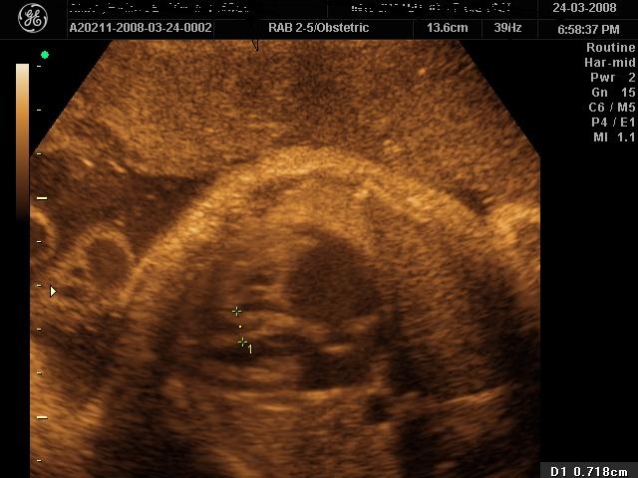

(Fig 2) Inter-ventricular septum 7 mm in a fetus of uncontrolled diabetic mother.

(Fig 3) Mean septal thickness in the three groups.

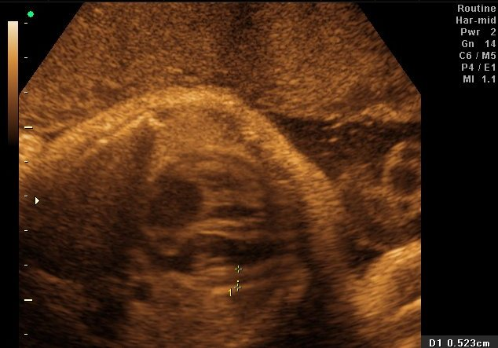

(Fig 4) Myocardial thickness in a fetus of uncontrolled diabetic mother.

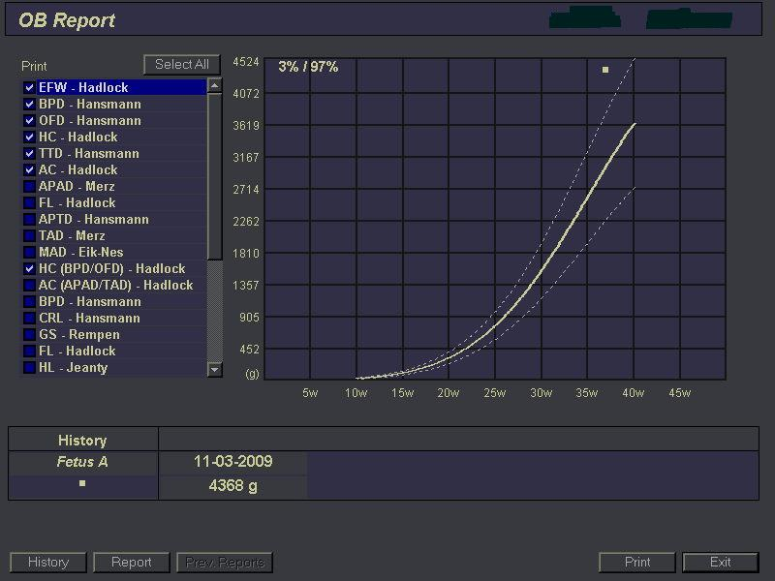

(Fig 5) A case of macrosomia

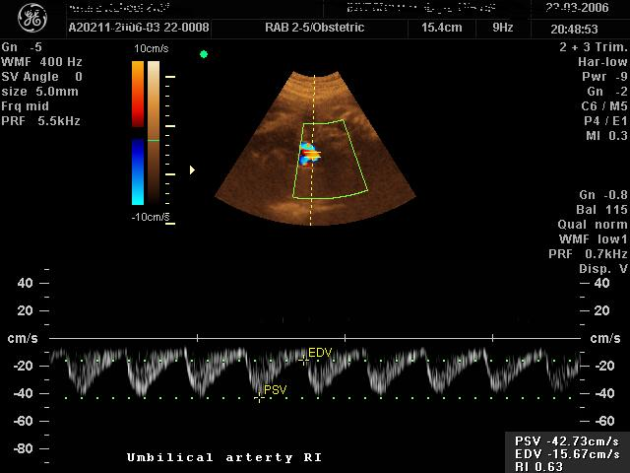

(Fig 6) Umbilical artery RI

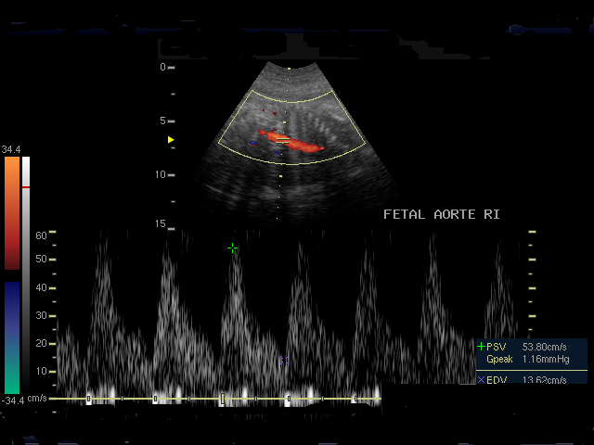

(Fig 7) Fetal Aorta RI

(Fig 8) Mean fetal aorta RI in the three groups

Discussion:
Diabetes is the most common medical condition to complicate pregnancy and includes type I, type II and gestational diabetes. Risks for the fetus include malformation, spontaneous abortion, stillbirth, neonatal death, macrosomia and intrauterine growth retardation (Temple, 2006).
The risk of congenital anomalies in infants of diabetic mothers is estimated to be between 2.5 to 12%, with an over-representation of congenital heart defects. (Arroyo, et al, 1992).
Hypertrophic septal cardiomyopathy is one of the common anomalies with diabetes, and a high index of suspicion is required as the specific management may vary and digoxin, or inotropic agents which may be used in heart failure associated with structural heart defects are contraindicated if hypertrophic cardiomyopathy is present (Narchi and Kulaylat , 2000).
The aim of this study is to determine if proper glycemic control can prevent fetal hypertrophic cardiomyopathy in diabetic pregnant ladies.
The study included one hundred diabetic pregnant ladies at 36 weeks gestation. A full history was taken from all of them including age, parity and history of any associated medical disorders or drug intake.
According to HbA1c serum levels, they were classified to controlled (group I) and uncontrolled (group II) diabetic cases. Controlled diabetics were 68, while uncontrolled were 32.
HbA1c cut off value of 6.3 % was used. (Tavintharan et al, 2000).
Controlled diabetics were 68, the mean HbA1c for this group during first trimester was 6.1±0.7%,while during the third trimester was 6.2±0.72.
While uncontrolled were 32, the mean HbA1c of this group at time of presentation was 9.1±1.6.There is a significant difference between both groups as regard HbA1c.(table 1,fig 1).

One hundred normal pregnant ladies acted as controls.

There was no statistically significant difference between the groups in terms of maternal age, gravidity, parity and fetal biometry. (P < 0.05).

The mean septal thickness in the controlled diabetics was 3.5 +/ - 1.24 mm (3 – 5 mm), in the uncontrolled diabetic group was 6.6 +/- 0.878 mm (5 – 8 mm), and in the normal group was 3.13 + / - 0.68 mm. (1 – 4 mm). (Table 2, Fig 2).
A significant difference was found as regards the septal thickness between uncontrolled and controlled diabetics and between uncontrolled and normal group and no difference found between controlled diabetics and normal group. (P < 0.05)
(Fig 3) These results agree with the results of many authors.
(Gandhi, etal 1995), (Vural et al, 1995), (Narchi and Kulaylat , 2000).
Walther et al, mentioned that the left ventricular mass and contractility in such cases are increased and there is left ventricular outflow tract (LVOT) obstruction with apposition of the anterior leaflet of the mitral valve to the interventricular septum during systole. Cardiac output is significantly reduced, secondary to reduced stroke volume and is directly related to the degree of septal hypertrophy. This asymmetric septal enlargement, with a disproportionally hypertrophic septum, is an anabolic result of fetal hyperinsulinemia triggered by maternal hyperglycemia during the third trimester (Walther et al 1985).
Narchi etal stated that the highest relative risk for major cardiovascular defects occurs if the mother has gestational diabetes and develops insulin resistance in the third trimester (Narchi and Kulaylat , 2000) and that what was proved in this study.
Using correlation coefficient test there was a positive correlation between HbA1c levels and septal thickness measurements.
That can reflect the importance of the proper control of diabetes and that there is a cumulative metabolic effect on the septal thickness, the longer the uncontrolled diabetes and the higher the levels of HbA1c , the thicker were the septa.
According to the results of this study, the metabolic effect of Diabetes is important, the controlled diabetic cases did not reveal higher septal thickness whatever the duration of diabetes was. These data disagreed with the data of Hornberger who stressed on the influence of pre-conceptional diabetes, beginning during embryonic development in the first trimester, with altered cardiac morphogenesis and placental development and that it continues to have an influence on the fetal circulation through the second and third trimesters and into the perinatal and neonatal period (Hornberger, 2006).
Cardiac septum hypertrophy correlated with maternal glycosylated haemoglobin levels and high levels of fetal insulin better than with macrosomia according to Narchi etal (Narchi and Kulaylat , 2000).
In this study, eight cases out of 32 had fetal macrosomia at 36 weeks exceeding normal range for gestational age according to growth curves and none of the uncontrolled diabetics or normal cases had macrosomic fetuses (Fig 5).
The eight cases had a mean inter-ventricular septal thickness of 7.38 +/- 0.74 mm which is relatively higher in comparison to the mean of the total cases of group I.
The relation between macrosomia and septal thickness could not be estimated statistically due to the relative small number of macrosomic fetuses in this study.
Myocardial thickness did not reveal a significant difference between the three groups. Means of group I, group II and control groups were 5.84 +/- 0.987 (4-7 mm), 5.85 +/- 1.12 (4-7) mm, 5.93 +/- 0.81 (5-7) mm successively (Table 2, Fig 4).

No gross anomalies were detected at time of scan in any of the cases of all groups in this study.

Umbilical artery RI revealed no significant difference between the three groups, means and ranges in group I , group II and controls were 0.58+/- 0.023 (0.56- 0.64), 0.54+/- 0.0279
(0.52- 0.61) and 0.56+/- 0.0312 (0.54- 0.63) successively
(Table 2, Fig 6).

Litvinova, mentioned the hemodynamic disturbances in the mother- placenta- fetus system , which depend on the disease severity and its a role in the pathogenesis of fetal cardiomyopathy(Litvinova, 1996).

In this study, fetal aorta RI ranged from 0.7 – 0.8 (0.77 +/- 0.035) in group I, 0.5- 0.7 with a mean of 0.56 +/- 0.063 in group II, and 0.75 – 0.85 (0.785 +/- 0.027) in controls.
(Table 2, Fig 7,8).

Fetal aorta RI was significantly lower in cases of uncontrolled diabetes with increased inter-ventricular septal thickness than controlled diabetics and normal groups which may be explained by the pathophysiology of the septal hypertrophy which affects LVOT and causes decrease in the cardiac out put (Reller et al, 1985) and hence the decreased fetal aorta RI is expressing this phenomenon. These cases were highly suggestive of complications and postnatal evaluation was recommended.
It was impossible in the current study, by the ultrasound and Doppler criteria to expect whether theses fetuses would be symptomatic postnatally or not. A recommendation of postnatal evaluation by a specialized neonatologist and cardiologist in such cases is a must.
It was mentioned by vural et al that, while symptomatic hypertrophic cardiomyopathy occurs in 12.1% of infants of diabetic mothers, when routinely searched for with an echocardiographic scan it is found in 30%. (Vural et al, 1995). Still, prenatally we can find a number of septal hypertrophy, which would not be symptomatic postanatally. Although most symptoms of cardiomyopathy of these infants usually spontaneously regress within a few weeks, sometimes, overt congestive heart failure develops, with tachypnea, tachycardia, gallop rhythm and hepatomegaly (Reller & Kaplan ,1988).
Prenatal awareness and prediction followed by postnatal evaluation would decrease morbidity and mortality of many of those infants.
Careful management of diabetes in pregnancy may reduce the severity of hypertrophic cardiomyopathy (Reller et al, 1985), (Reller & Kaplan ,1988)
Many studies discussed the role of echocardiography in fetuses and in infants born to diabetic mothers (Gladman et al, 1997),
( Halliday, 1981), ( Suda et al, 1997), (Meyer-Wittkopf et al, 1996), (Zielinsky, 1991), (Cooper, et al, 1995) and some authors tried to use HbA1c as predictor for fetal heart anomalies, but
up till now, the golden standard for prenatal prediction of septal hypertrophy of infant of diabetic mother is its measurement by ultrasound.
Conclusion
Fetal cardiomyopathy is one of the possible anomalies with uncontrolled diabetic pregnancies.
Ultrasonogrpahic measurement of the fetal cardiac inter-ventricular septal thickness and fetal myocardium should be added to the prenatal anomaly scanning in all diabetic pregnancies.
Careful management of diabetes in pregnancy reduce the incidence or severity of hypertrophic cardiomyopathy.
Further studies are needed with larger numbers and postnatal follow up to reach a cut off value of the septal thickness for the prenatal prediction of symptomatic cardiomyopathy in infants of diabetic mothers. Considering the pilot nature of measuring fetal aorta RI in relation to the septal thickness, further studies should be done to corroborate these findings.

References:
Arroyo R. MA, Rodriguez-Pinilla E, Cordero JF (1992).
Maternal diabetes: the risk for specific birth defects. Eur J Epidemiol. 8: 503-508.
Cooper MJ, Enderlein MA, Dyson DC, Roge CL, Tarnoff H (1995).
Fetal echocardiography: retrospective review of clinical experience and an evaluation of indications. Obstet Gynecol 86:577-582.

Gandhi, Jyotsna, Zhang, Xiao Yang , Maidman, Jack E (1995).
Fetal cardiac hypertrophy and cardiac function in diabetic pregnancies . Transactions Of the Fifteenth Annual Meeting Of The society Of Perinatal Obstetricians, American Journal of Obstetrics & Gynecology. 173(4):1132-1136.
Gladman G, McCrindle BW, Boutin C, Smallhorn JF
( 1997)
Fetal echocardiographic screening of diabetic pregnancies for congenital heart disease. Am J Perinatol. 14:59-62.

Hadlock FP, Harrist RB, Martinez-Poyer J, (1991).

In utero analysis of fetal growth: a sonographic weight standard, Radiology. Oct; 181(1):129-33.
Halliday HL (1981).
Hypertrophic cardiomyopathy in infants of poorly-controlled diabetic mothers. Arch Dis Child .56:258-263

Hornberger L K ( 2006)

Maternal diabetes and the fetal heart, Heart. 92:1019-1021.

Litvinova M. F. (1996)

Pathogenesis of fetal hypertrophic cardiomyopathy in insulin-dependent diabetes mellitus, Bulletin for experimental Biology and Medicine. 121; 698 – 701.
Meyer-Wittkopf M, Simpson JM, Sharland GK (1996).
Incidence of congenital heart defects in fetuses of diabetic mothers: a retrospective study of 326 cases. Ultrasound Obstet Gynecol .8:8-10
Narchi H, Kulaylat N ( 2000).
Heart disease in infants of diabetic mothers. Images Paediatr Cardiol . 3:17- 23.
Reller MD, Tsang RC, Meyer RA, Braun CP .(1985) Relationship of prospective diabetes control in pregnancy to neonatal cardiorespiratory function. J Pediatr. 106:86-90.

Reller MD, Kaplan S (1988).

Hypertrophic cardiomyopathy in infants of diabetic mothers: an update. Am J Perinatol .5:353-358.
Shields LE, Gan EA, Murphy HF, Sahn DJ, Moore TR (1993).
The prognostic value of hemoglobin A1c in predicting fetal heart disease in diabetic pregnancies. Obstet Gynecol; 81:954-957.
Suda K, Kohl T, Kovalchin JP, Silverman NH (1997).
Echocardiographic predictors of poor outcome in infants with hypertrophic cardiomyopathy. Am J Cardiol .80:595-600
Tavintharan S, Chew LS Heng DM (2000).
A rational alternative for the diagnosis of diabetes mellitus in high risk individuals,
Ann Acad Med Singapore. Mar; 29(2):213-8.

Temple R (2006).
Diabetes in pregnancy, Medicine, Volume 34, Issue 3, Pages 111-112.
Vural M, Leke L, Mahomedaly H, et al (1995)
Should an echocardiographic scan be done routinely for infants of diabetic mothers? Turk J Pediatr 37:351-356 .
Walther FJ, Siassi B, King J, Wu PY (1985).
Cardiac output in infants of insulin-dependent diabetic mothers. J Pediatr 107:109-114.
Zielinsky P (1991).
Role of prenatal echocardiography in the study of hypertrophic cardiomyopathy in the fetus. Echocardiography . 8:661-668

4/20/2010

