Development and Assessment of a Fish Feed to Assist in Aquaculture Nutrition Management

Swarnendu Chandra, Urmimala Chaudhury, Rajarshi Banerjee

School of Biotechnology and Life Sciences, Haldia Institute of Technology, Haldia, West Bengal, India 721657.
rajarshi.rishi@gmail.com

Abstract: The concept of Synbiotics was implemented to aquaculture feed formulation. Probiotic bacteria were isolated from the locally available confectionary sweetened food. The isolates were characterized through classical biochemical and microbiological techniques to identify them into the group of Lactobacillaceae. Further in the most potent isolate, an antibiotic molecular marker was developed through spontaneous mutation. Mass cultivation of freshwater Spirulina was after isolation and purification. Both were subjected to standardization of mass cultivation and harvesting of biomass. A globulated feed was formulated and fed to aquarium maintained catfish. A conclusion was drawn on the beneficial roles of such Synbiotic culture in Aquaculture nutrition management. [Researcher. 2010;2(5):63-75]. (ISSN: 1553-9865).

Key words: Economic Media, GIT Passage, Synbiotic Feed

1. Introduction
The term probiotic was derived from the Greek, meaning “for life”. The food and agricultural organization of the United Nations and the World Health Organization (WHO) have stated that there is potential for probiotic foods to provide health benefits and that specific strain are safe for human use (Reid et al., 2003)
Probiotics represents an expanding research area. A Medline search of the term probiotics illustrates the significant increase in research under taken in this area during the past five years: over 1000 publications sited compared to 85 for the past 25 years. While this demonstrates the potential significance of this emerging field, much still remains to be done to standardize the meaning of the term probiotic and which strains actually fulfill the criteria of true probiotic micro organism.( Reid et al., 2003)
The criteria for the microbes to be treated as probiotic include: ability to withstand and survive the effect of gastric acid, biliary secretions and pancreatic secretions in order to reach the small and large intestines, be non-pathogenic and non-toxic, remain viable during transport and storage, exert beneficial effects on the host; stabilize the intestinal microflora, adhere to the intestinal epithelial cell lining and produce antimicrobial substances towards pathogen. Probiotics microflora displays numerous health benefits beyond providing basic nutritional value. Most probiotics products contain bacteria from the genera Lactobacillus spp., Bifidobacterium spp. less commonly, species of Enterococcus, Saccharomyces, Escherichia, the spore-formers Sporolactobacillus, Brevibacillus and Bacillus have been suggested for probiotic effects. Bacillus spores are being used as human and animal probiotics despite the fact that studies now indicate extensive mislabelling of constituent Bacillus strains. The members of genus Bacillus are Gram-positive, aerobic or facultative anaerobic, catalase positive, rod-shaped endospore forming bacteria comprising more than 60 species with quite different phenotypes. Spores consist of several protective layers surrounding the nucleoid, which makes it extremely resistant to adverse gastrointestinal tract conditions and when germinate in the tract elicit positive effects for the host. It remains unclear that which form, cell or spore is responsible for competitive exclusion of other microbes and exhibit probiotic effects. Lactic acid bacteria and Bifiobacteria have been established to be safe and reliable as a probiotics; however Bacillus spp. has been relatively less studied as a probiotic (Patel et al., 2009).
Numerous species of bacteria and some species of actenomycetes have been considered for use in SCP production. These organisms have a wide range of carbon and energy source utilizations pattern and growth characteristics. Several photosynthetic bacteria and non photosynthetic bacteria have investigated for SCP production from various substrates like agricultural and industrial waste, on cow manure and anaerobic digest effluents. However, the requirements for light limit the applicability of photosynthetic bacteria to those regions where the available sunlight and temperatures permit open pond culture throughout the year. Consequently non-photosynthetic bacteria have greater utility of producing SCP (Litchfield, 2004).
Microalgae have been used as sources of Single Cell Proteins over decades (Fabregas and Herrero, 1985). The impetus behind single-cell protein research lies partly in the need for more protein, and partly in the commercial interest in the economic advantages to be gained by substitution of microbial protein for the conventional protein supplements used in livestock feeding. (Hitchneri and Leatherwood, 1980)
The evaluation of feed ingredients is crucial to nutritional research and feed development for aqua culture species. Fish diets of the future will include a wider range of alternative ingredients to fish meal than is currently the case. Many of these ingredients are more complex than fish meal and required thorough evaluation in order to determine their nutritional value and appropriate use levels in prospective diets. This nutritional evaluation process has several key facets that need to be undertaken to provide a clear indication of the potential that any ingredient may have for use in an aquaculture feed (Glencross et al., 2007).
Diseases may cause major economic losses in hatcheries. The port of entry of these pathogens has not been identified, but the gastrointestinal tract has been implicated as a site of colonization and a possible port of entry. Currently, either treatment with chemotherapeutic agents or vaccination is used to protect fish against different bacterial diseases in hatchery conditions. The former method may alter the profile of a healthy gut microflora, while the latter is stressful for fish; both methods may enable the access of some pathogens. The use of chemotherapeutic agents has also led to occurrence of resistant bacteria, and thus their use should be restricted. Both methods are also quite expensive. Preventing diseases in juvenile fish is of significant economic importance, since small fish have high mortality rates and are too small for vaccination. Probiotics may provide an alternative way to reduce the use of antibiotics in aquaculture and simultaneously avoid the development of antibiotic-resistant bacteria. Probiotics are microbial cell preparations or components of microbial cells that have a beneficial effect on the health and well-being of the host. Selected probiotics have been shown to have significant health benefits for humans, and thus several well-characterized strains are available for human use to reduce the risk of gastrointestinal infections or to treat such infections. Probiotics may provide a potential support or alternative to vaccinations and treatment with antibiotics in fish farming (Nikoskelainen et al., 2001).

2. Methods
  - Isolation of LAB
2.1.1 Isolation
Yoghurt samples from the local confectionary and home fermented yoghurt was inoculated in modified Rogosa’s media (Rogosa et al., 1951) with minor modifications for enrichment of LAB under wax sealed conditions. The culture was incubated for 48 hours in anaerobic condition at 37⁰C. The enriched broth was then streaked onto Rogosa Agar (Rogosa et al. 1951) and incubated at 37⁰C for 48 hrs under anaerobic conditions and preceded with single colony purification.
Observing the colony morphology the potential isolates of LAB were single colony purified in LB plate and gram’s nature was observed.
Standard cultures of Lactobacillus form Microbial Type Culture Collection, Chandigarh were procured namely Lactobacillus casei MTCC 1423(MTCC-1423) and Lactococcus lactis MTCC 440 (MTCC-440); and activated along with to facilitate a comparative study.

2.1.2 Characterization
The purified potential isolates were cultured in Luria Bertenni Broth (LB), Nutrient Broth (NB) and in modified Rogosa’s Broth and incubated at 37⁰C for 48 hrs under anaerobic conditions. Efficiency of growth in the different media was assessed. Standard LAB culture (Lactobacillus casei MTCC 1423 and Lactococcus lactis MTCC 440) were also processed along with for further comparisons.
The colony morphology in terms of macroscopic as well as microscopic characters was noted. Observation was also carried out in growth pattern in solid and liquid media.
    - Carbohydrate Fermentation
The fermentation patterns were checked on various sources of carbohydrates. 0.5% Peptone water was mixed with 1% of the following carbohydrates: Dextrose, Sucrose, Lactose, Starch, Inositol, Galactose, Mannitol, and Cellulose (as Whattman Filter Paper). Phenol Red was used as an acid-base indicator. Potential LAB isolates and standard cultures were incubated at 37⁰C under anaerobic condition and the results were noted after every 24hrs for acid and gas formation (Tserovska et al., 2000-2002; Nair and Surendran, 2004-2005).

    - IMViC Test
IMViC was performed following Benson (1990).

    - Qualitative Enzyme Assays
Enzymes Catalase, Peroxidase, Oxidase, Nitrate Reduction,Gelatinase and Urease assays were done following Benson (1990).

Growth curve assay
LRSU-IV, LRSU-IV^{rif}, MTCC-1423 and MTCC-1423^{rif} were individually grown in LB and EM. The mutants were grown in LB with antibiotic pressure. The growth was determined by taking the OD value spectrophotometrically (600nm) (Shimatzu) at every 2 hours interval.

    - Antibiotic Sensitivity Tests
The growth of potential isolates of LAB was checked on several antibiotics such as Oxytetracycline, Chloramphenicol, Rifampicin, Streptomycin, Gentamycin, Ampicillin, and Penicillin. In 5ml of L.B broth different concentrations of antibiotics were added aseptically. The concentrations were varied in between 5 to 25 µg/ml. Appropriate controls were also setup. Post inoculations of activated cultures, the tubes were incubated at 37⁰C under anaerobic conditions. Post incubation of 24 hrs the Optical Density (OD) was determined spectrophotometrically at 600 nm (Shimatzu).

2.2 Molecular marker development
The potential LABs, the isolate LRSU IV and MTCC 1423 were concentrated and plated on LB Agar plates containing the antibiotic pressure of 80μg/ml and incubated at 37⁰C for 24 hours. Spontaneous mutants were obtained as single colonies (modifying Vogler et al., 2002).
The single colony isolate (LRSU IV^{rif}) were harvested on Rifampicin spiked (80 μg/ml) plates. The mutant was subjected to high concentrations of Rifampicin to assess its resistance pattern. The growth curve of this mutant was also assayed along with the demonstration of its resistant pattern upto exceedingly high concentrations (80µg/ml to 300µg/ml) of rifampicin.

2.3 Feed development
2.3.1 Economic Media:
The Economic Media (EM) containing four components as rice water, whey, egg shells and mustered husk was devised. Tap water was used as a solvent diluter. The composition was standardized. Economic media was autoclaved at 121⁰C at 15psi. for 15 minutes. The media was inoculated with LRSU-IV, LRSU-IV^{rif}, MTCC 1423 and MTCC 1423^{rif} (in Erlenmeyer Flasks) and incubated for 7-10 days.
The biomass were harvested and concentrated by centrifugation.

2.3.2 Mass cultivation of Spirulina
Pure culture isolates of Spirulina platenis were procured from ISIBES, Dharmaj, Gujarat. They were mass cultivated in a devised synthetic media containing NaHCO₃ (0.155%), K₂HPO₄ (0.03%), NaNO₃ (0.205%), K₂SO₄/FeSO₄ (0.02%), NaCl (0.02%), MgCl₂ (0.02%).
The biomass were harvested and concentrated by centrifugation. The harvested mass was dried at 60-65⁰C and crushed to a uniform green powder.

    - Feed formulation
Commercially available flour, peptone, dried Spirulina and mass cultivated Sporulated LAB cultures were mixed in a definite proportion to formulate into small globulets (aspirating the slurry through a 5ml pathological syringe). Four different sets of globulets were formed with four different bacterial additives namely MTCC 1423, LRSU-IV, LRSU-IV^{rif}, MTCC 1423^{rif} and Control (without any bacterial supplement). The beads were dehydrated at 40⁰C, overnight and the globulets were fed to the fish.

    - LAB quantification of feed
The globulets were suspended in distilled water and spread on media plates to assess the viability of LABs in the formulated feed.

  - Aqua culture study
    - Fish weight, activity, colour
The fish activity, swimming patterns and body coloration were observed in the different tanks. At specific regular intervals the fresh weights of the fish were recorded to compare the differences in the differently feed treated tanks.

2.4.2 Gastrointestinal Tract Passage (GIT) Assay
Gastro-Intestinal Tract (GIT) passage of the fed fish was assayed. The assay was performed quantitatively by collecting the gastric juice from the stomach as well intestinal fluid and plating them onto LB agar plates spiked with rifampicin. The feces were also collected (Cho and Slinger, 1979) to be placed on rifampicin agar plates. Growth and survival and viable count of LAB were assessed after anaerobic incubation of the plates at 37⁰ C for 24 hours.

3. Result Analysis
The total numbers of 12 potential probiotic isolates were found on preliminary charecterisation in terms of colony morphology macroscopic and microscopic charecters, fermentation of carbohydrates, IMVic test (results not shown); the most closely related potential probiont was taken for further studies. Qualitative enzyme assay was found to be negative for the enzymes catalase, nitrate reductase, gelatinase etc.

3.1 Growth curve assay
The growth curve assay was performed for a comparative assessment of LRSU-IV with that of MTCC-1423. Comparison was initiated with that of the culture grown in different sets of media like Luria Broth (LB) as well the developed Economic Media (EM). Though the inoculums strength was not uniform; the age of the starter inoculums happened to be the same (activated culture of 48 hours).
With that of LRSU-IV (Figure 1) when compared the following deductions could be inferred. In LB there was an initial lag phase of 6 hours and then the gradual rise towards the log phase was observed. In the EM an initial lag phase of only 4 hours was seen and then till the 8th hour of growth a diauxic rise and fall is observed. Post 8 hours a steady increase towards the log phase is seen. The growth curve of MTCC-1423 is depicted in Figure 2. A lag phase of two hours was noticed for both EM and LB. Post 2nd hour EM grown MTCC 1423 showed a rapid rise till 4th hour followed by a diauxic fall at the 6th hour preceded by a gradual rise till the 10th hour post which the tendency to rise continues. While LB grown MTCC 1423 depicts a sluggish growth till 12th hour followed by a gradual rise. The LRSU IV^{rif} shows a sluggish lag phase for both LB and EM till 6th hour. The lag phase continues in EM 12th hour and beyond while in LB a rapid rise is observed from 6th to 12th hour followed by a trough (Figure 3). The growth pattern of MTCC 1423^{rif} is as shown in Figure 4. Both LB and EM shows a lag phase in 6 hours. EM rises post 6th hour till the 10th hour followed by a fall at the 12th hour post which the tendency to rise continues. The lag in LB dragged till the 10th hour with a rapid rise by the 12th hour followed by a fall. In EM LRSU IV showed a 4 hour lag phase followed by a rise to the log phase while the mutant strain of it (LRSU IV^{rif}) depicted an extended lag phase. EM grown MTCC 1423 showed a lag phase of 2 hours while the lag phase was extended to 6 hours in the mutant strain (MTCC 1423^{rif}).

3.2Antibiotic sensitivity test
LRSU-IV was found to be having a stimulatory growth in presence of Oxy- tetracycline up to a concentration of 5µg/ml. A retardation of growth is observed is observed at a concentration of 10 µg/ml till 20 µg/ml. 25 µg/ml of Oxy-tetracycline results in absolute cessation of growth. The growth in presence of Chloramphenicol is ceased at a concentration of 10 µg/ml. Rifampicin, Streptomycin and Gentamycin were exhibited to be resistant to LRSU-IV till a concentration of 25 µg/ml. Ampicillin exhibited a gradual cessation of growth from a concentration of 5 µg/ml to 25 µg/ml. Absolute cessation of growth was observed at 25 µg/ml. Resistance and in turn persistent growth was observed in presence of Penicillin at a concentration till 25 µg/ml (Figure 5 represents MIC for LRSU IV and Figure 6 represents MIC for MTCC 1423). From the above observations it was evident that LRSU-IV happened to be the most fast growing, most versatile and an evidently potent isolate of LAB.

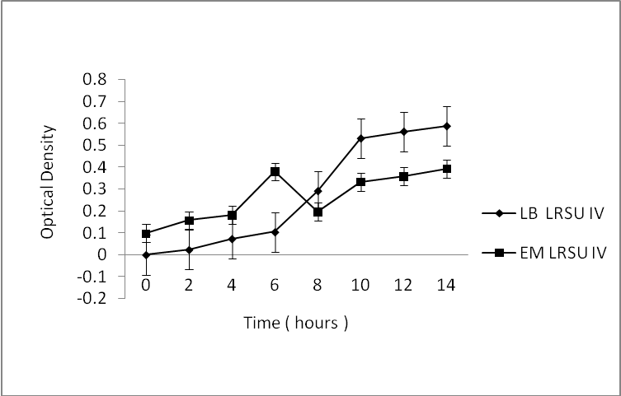
Figure 1. Growth patterns of LRSU IV in different media. (Standard error indicated in bars (I))

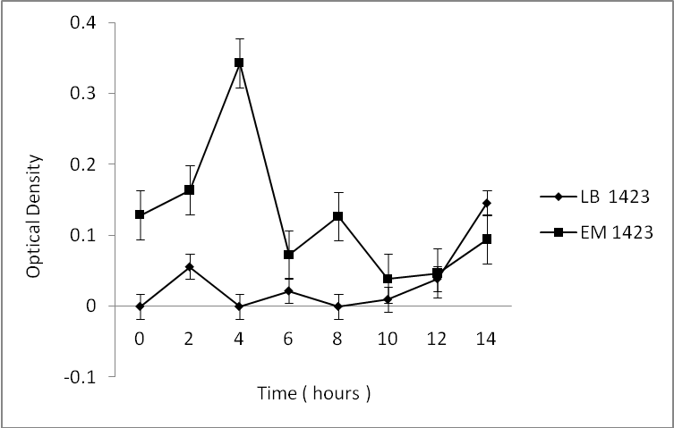
Figure 2. Growth patterns of MTCC 1423 in different media. (Standard error indicated in bars (I))

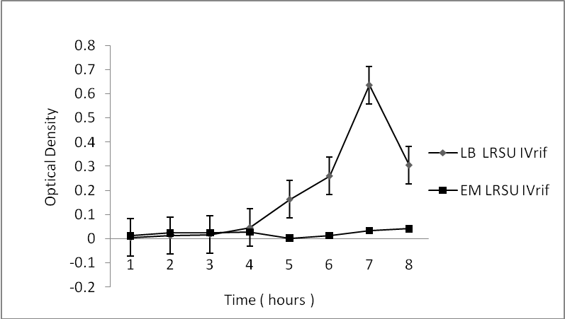
Figure 3: Growth patterns of LRSU IV^{rif} in different media. (Standard error indicated in bars (I))

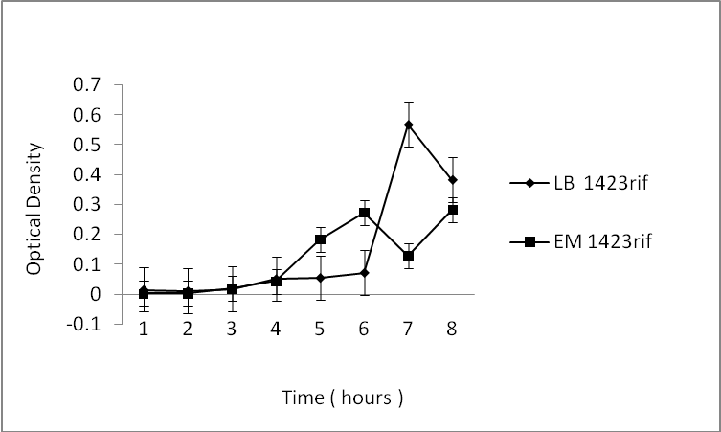
Figure 4: Growth patterns of MTCC 1423^{rif} in different media. (Standard error indicated in bars (I))

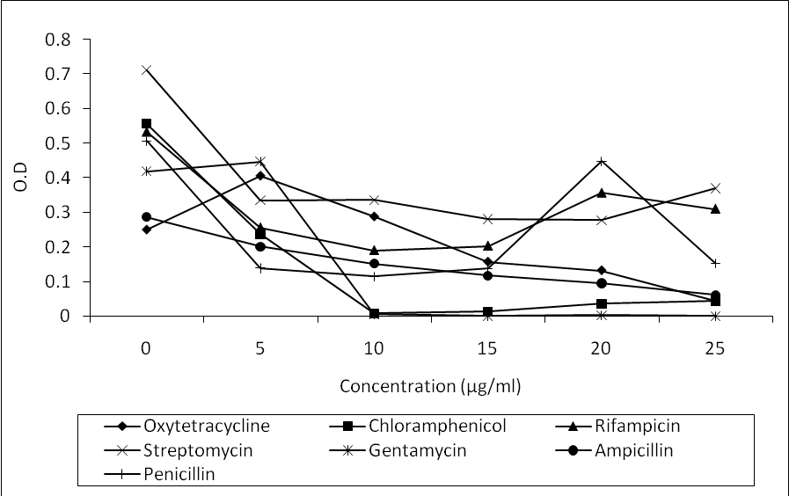
Figure 5: MIC for LRSU IV against various antibiotics.

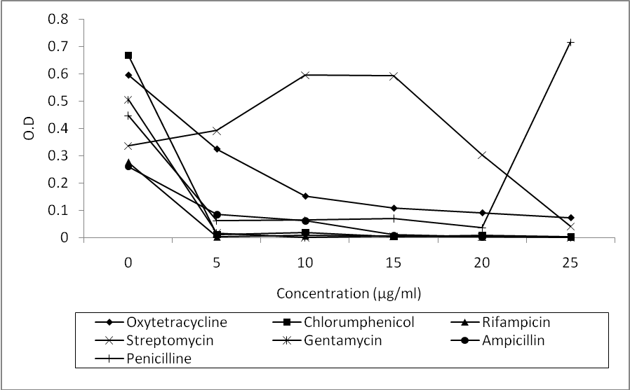
Figure 6: MIC for MTCC 1423 against various antibiotic

3.3 Molecular marker development
Spontaneous mutants were raised against Rifampicin to be incorporated as a molecular marker for further tests. Though the rate of mutants that could be raised through spontaneous mutation was less than 0.05 percent, nevertheless, the mutants that were raised had developed a strong resistance against towards the antibiotic Rifampicin.
The mutant raised was checked for its growth rate in terms of optical density compared with that of the wild type. The mutant was also checked for the range of high concentrations of the antibiotic refampicin (80µg/ml to 300µg/ml) and was found to be sustainably growing within this range when compared with that of the wild type (Figure 7 and Figure 8). The mutants were raised with two basic intensions. The marker that was inherently developed through classical mutation techniques would facilitate in the further studies of both molecular biology as well as cell biology techniques with this organism (LRSU-IV^{rif}). Moreover, if this organism is ever exploited as a therapeutic probiotic drug, the organism could be administered simultaneously along with the antibiotic treatment.

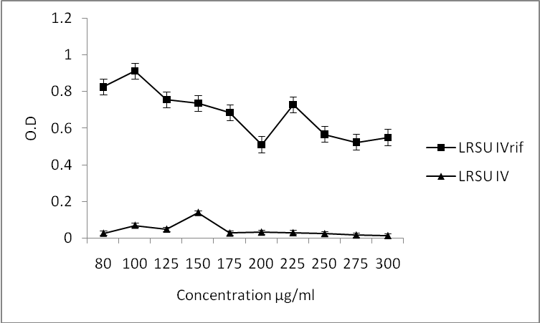
Figure 7: Growth rate comparison of LRSU IV and LRSU IV^{rif} with increasing concentration of rifampicin. (Standard error indicated in bars (I))

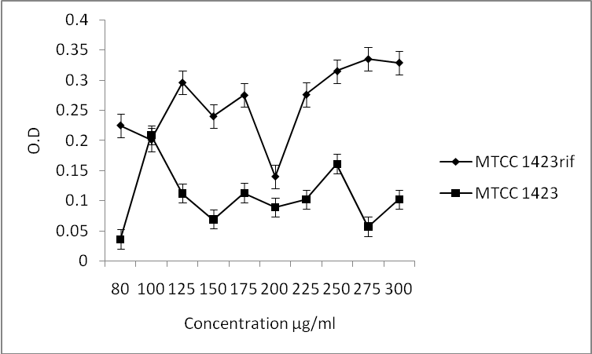
Figure 8: Growth rate comparison of MTCC 1423 and MTCC 1423^{rif} with increasing concentration of rifampicin. (Standard error indicated in bars (I))

3.4 Feed development
    - Economic media
Any mass cultivation media calls for a composition which would suffice the following principle factors (i) Abundant availability of the components, (ii) Cheep market price for the components, (iii) Noncorrosive/nontoxic nature of the components, (iv) The components be recalcitrant (optional), (v) Downstream processing and separation of the ferment (bacterial mass) be uncomplicated and easy. The media that was devised contained whey, rice water, mustered husk and egg shells. Whey happens to be a waste of the dairy industry (here we have used whey from the local sweet confectioners). Whey supplements most of the growth metabolites required for the growth of the cultured LABs. Rice water is a principle domestic liquid effluent of the East Indian household. Rice water supplements the carbohydrate requirement in the form of starch. Mustered husk, a solid waste of the mustered oil extraction plants was used as a supplementary protein source. Egg shells collected from the local fried snack preparatory was supplemented as a calcium source to enhance sporulation.
    - LAB Quantification
During formulation of fish feed the initial concentration of LAB that was added in the slurry was standardized to account of 500cfu/ml. after fish feed formulation, globulisation and dehydration the amount of LAB survivors in the feed were quantitated. Maximum survival was seen in MTCC1423^{rif} (293cfu/ml) followed by survivors in LRSU IV and LRSU IV^{rif} (110 and 140cfu/ml respectively). The quantification thus proved the survival rate of the LAB cultures in fish feed prior to feeding to be of approximately 36.2% of the initial inoculum fed. (Figure 9).

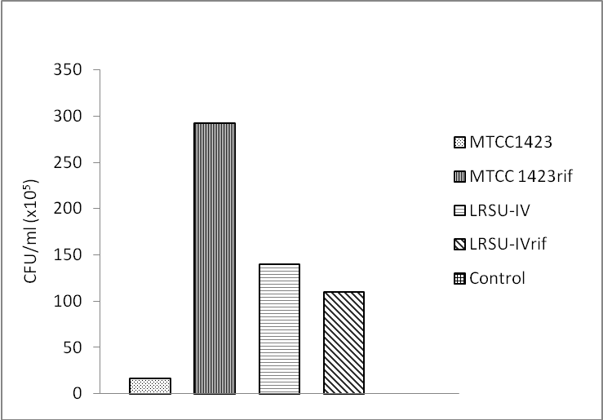
Figure 9: Quantitative estimation of LAB in fish feed.

  - Aquaculture study
    - Fish weight
Fishes were aclimatised in glass tanks and fed with the formulated fish feed with suitable controls for fish weight quantitation. The fish weight were quantitated on the first day after acclimatization and quantitated again after the formulated feed treatment for a period of 45 days (as shown in Figure 10). It was observed with the increase in weight percentage that in comparison to control (6.22% increase in weight), the MTCC cultures showed an average weight increase of 10% (MTCC1423 10.18% and MTCC 1423^{rif} 10.29%). The LRSU IV showed an increase of 12.3% and LRSU IV^{rif} 14.09% increase in the average weight of the fishes. Thus these observations point on the beneficial effects of the SCP and LAB provided in the feed in terms of supplementing nutritional metabolites and assimilation of the feed. The coloration, movement and activity were also observed during this period (45days). Though no significant difference in coloration was observed but the activity of the fishes in the synbiotic feed fed aquariums were found to be much more energetic and vigorous in terms of their swimming patterns.

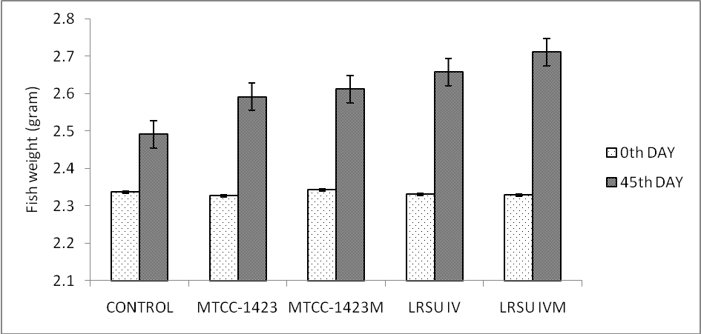
Figure 10: Fish weight comparison. (Standard error indicated in bars (I))

3.5.2 GIT Passage
Retention of the LAB in the GIT was quantitated and also multiplication of LAB was observed in the treated fishes with suitable controls. The GIT passages of the fishes were quantitated in from regions of the alimentary canal. The stomach fluid was quantitated with respect to the different feed in terms of LAB survival (cfu/ml) (Figure 11). LRSU IV^{rif} depicted the maximum survival, when compared with this the survival percentages of MTCC 1423, MTCC 1423^{rif} and LRSU IV were found to be 6.83%, 9.75% and 0% respectively.

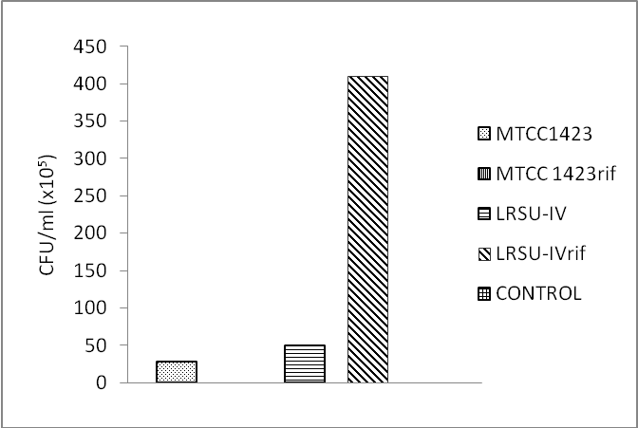
Figure 11: Quantative estimation of lab in stomach fluid

The intestinal fluid was quantitated with respect to the different feed in terms of LAB survival (cfu/ml) (Figure 12). MTCC 1423^{rif} depicted the maximum survival, when compared with this the survival percentages of MTCC 1423, LRSU IV and LRSU IV^{rif} were found to be 42%, 54.33% and 72% respectively.

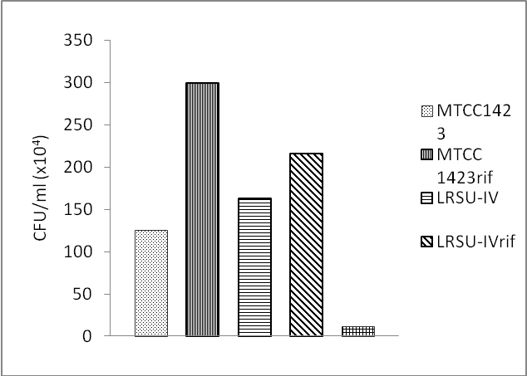
Figure 12: Quantative estimation of lab in intestinal fluid

The feces was quantitated with respect to the different feed in terms of LAB survival (cfu/ml) (Figure 13). LRSU IV^{rif} depicted the maximum survival, when compared with this the survival percentages of MTCC 1423, MTCC 1423^{rif} and LRSU IV were found to be 84.5%, 15.49% and 12.68% respectively.

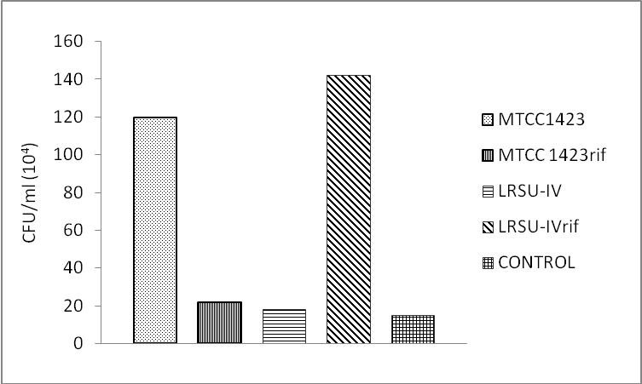
Figure 13: Quantative estimation of lab in fish feces

The stomach fluid presumably being highly acidic depicted the least survival chances fo LAB. Intestinal fluid depicted a greater cfu number and survival rate of the fact of its moderate pH level. The cfu numbers increased when compared to stomach fluid of the reason that the intestine of the organism inherently harbored are resident microbial (LAB) flora. The cfu numbers further increased in the feces because of not of only the survival rate but of also the multiplication of the microflora.

4. Discussion
One way of prophylaxis and treatment of some animal diseases is improvement of parameters of a metabolism and microbial ecology of an organism by application of biological medicines on the basis of lactate and Bifidobacteria. Universal treatment-and prophylactic properties of such drugs are caused by high concentration in them of the bacteria playing an essential role in normalization proteinaceous, lipidic and mineral metabolism of an organism due to production of a plenty of various ferments, including extra-cellular and cellwise bound proteinase, polysaccharides, glycoproteins and other bioactive compounds (Kaurus, 2005).
Good nutrition in animal production systems is essential to economically produce a healthy, high quality product. In fish farming, nutrition is critical because feed represents 40-50% of the production costs. Fish nutrition has advanced dramatically in recent years with the development of new, balanced commercial diets that promote optimal fish growth and health. The development of new species-specific diet formulations supports the aquaculture (fish farming) industry as it expands to satisfy increasing demand for affordable, safe, and high-quality fish and seafood products (Craig and Helfrich, 2002).
Yasuda and Taga (1980) suggested that bacteria would be found to be useful not only as food but also as biological controllers of fish disease and activators of nutrient regeneration. Only in the late 1980s did the first publications on biological control in aquaculture emerge, and since then the research effort has continually increased. Generally, probiotics are applied in the feed or added to the culture tank or pond as preventive agents against infection by pathogenic bacteria, although nutritional effects are also often attributed to probiotics, especially for filter feeders. Most probiotics proposed as biological control agents in aquaculture belong to the lactic acid bacteria (Lactobacillus,Carnobacterium, etc.), to the genus Vibrio (Vibrio alginolyticus,etc.), to the genus Bacillus, or to the genus Pseudomonas, although other genera or species have also been mentioned (Verschuere, 2000).
The development of probiotics applicable to commercial use in aquaculture is a multistep and multidisciplinary process requiring both empirical and fundamental research, full-scale trials, and an economic assessment of its use. The acquisition of a good pool of candidate probiotics is of major importance in this process. It is vital in this phase that the choice of strains is made as a function of the possible role of the probiotics to be developed, although there is no unequivocal indication that putative probiotics isolated from the host or from their ambient environment perform better than isolates completely alien to the cultured species or originating from a very different habitat. There are several reports of the use in aquaculture of probiotics developed for humans or terrestrial animals (Gatesoupe, 1991, 1994). However, there is an elegant logic in isolating putative probiotics from the host or the environment in which the bacteria are supposed to exert their probiotic effect. Generally at the end of the previous phase, one ends up with a pool of isolates that must be screened and preselected to obtain a restricted number of isolates for further examination (Verschuere, 2000).
It would appear that encapsulating diet together with bacteria in an aqueous phase provides an optimum environment for the bacteria to grow, secrete the enzyme and digest the protein available from the diet and from the capsule walls. The results from the study of Sirvas-Cornejo et al., (2007) demonstrate that microencapsulated feeds, supplemented with bacterial cells producing digestive enzymes, can sustain the growth of F. indicus PL during the first 16 days of the PL stage, and promote a satisfactory level of survival. In the future, such diets could potentially replace live food during this stage of development.
Therefore, the intimate relationship between bacteria and their host should be considered. In this respect, Olafsen (2001) stated that the use of probiotics which has proven advantageous in domestic animal or poultry and microbial management may also have a potential in aquaculture. This is because the gastrointestinal microbiota of fish is peculiarly dependent on the external environment, due to the water flow passing through the digestive tract. Most bacterial cells are transient in the gut, with continuous intrusion of microbes coming from water and food .In addition, by feeding fish with probiotics bacteria, these bacteria will also be present in the surrounding water and also colonise the fish skin and other parts of the body. The most likely explanation of the effective role of probiotics is their effect in suppressing pathogenic coli forms in the stomach and intestine and improving the absorption of nutrients by reducing the thickness of intestinal epithelium.
The improvement in live body weight in probiotic treated groups of fish is mainly due to maintaining the beneficial bacteria such as Lactobacillus in the intestinal tract which can competes with the undesirable organisms for space and nutrients as reported by Jena et al., (1996). Such useful bacterial growth facilitates the fermentation process which is of nutritional significant such as producing various types of vitamins (Fuller, 1997) and organic acids which provide energy to the host as well as stimulate the growth (Ali et al., 2010).
The probiotics of live microbes have shown their effectiveness to mitigate the effects of stress, resulting in a greater production. Olvera et al., (2001) concluded that yeast have a positive effect on fish performance when cultured under stress condition of lowering dietary protein, leading to improving growth and feed efficiency. In contrast, Hidalgo et al., (2006) found that growth and feed conversion of juvenile dentex were not significantly influenced by probiotics which is in agreement with the findings, Shelby et al. (2006) who found that the probiotic used with juvenile channel catfish diet had lack effect on specific growth promoting or immune stimulating aspects. On the other hand, many studies concluded the positive effect of using viable microorganisms in probiotic mixtures into diets of fish (Ghazalah et al., 2010)

5. Conclusion
Thus from the above work a probable solution to aquaculture nutrition management could be paved. The isolated probionts depicted to be showing beneficial health implications on the cat fish species (Arius seemani) studied. The SCP provided in the feed supplemented the prebiotic requirement for the fishes. Aquaculture nutrition management through this nutracutical feed formulation concept needs to be studied more elaborately under pilot and then further under field conditions.

Acknowledgement:
The authors are grateful to School of Biotechnology and Life Sciences, Haldia Institute of Technology, Haldia, WB, India for the infrastructural support and partial financial support rendered during the experiments. The corresponding author acknowledges Ipcowala Santram Institute of Biotechnology and Emerging Sciences (ISIBES), Dharmaj, Gujarat, India for the provision of Spirulina pure cultures.

Correspondence to:
Rajarshi Banerjee
School of Biotechnology and Life Sciences, Haldia Institute of Technology, ICARE Complex, HIT Campus, P.O. HIT,Haldia; Purba Medinipur – 721 657; W.B.; INDIA
Telephone: 91 03224 252900 Ext. 232
Cellular phone: 09903048060
Email: rajarshi.rishi@gmail.com

References
[1] Ali HM, Ghazalah AA, Gehad EA, Hammouda YA, Abo-State HA. 2010. Practical Aspects and Immune response of Probiotics Preparations Supplemented to Nile Tilapia (Oreochromis Niloticus) Diets. Nature and Science. 8(5):39-45.
[2] Benson HJ. 1990. Microbiological applications, fifth ed. Wm. C. Brown Publishers.
[3] Cho CY, Slinger SJ. 1979. Apparent digestibility measurement in feedstuff for rainbow trout. In: Halver, J.E., Tiews, K. (Eds.), Finfish Nutrition and Fishfood Technology. Heenemann GmbH, Berlin. 2:239- 247.
[4] Craig S, Helfrich AL. 2000. Understanding Fish Nutrition, Feeds, and Feeding. 2002. Virginia Cooperative Extension. 420-256.
[5] Fabregas J, Herrero C. 1985. Marine microalgae as a potential (scp). Applied Microbiology and Biotechnology. 23:110-113
[6] Gatesoupe FJ. 1991. Bacillus sp. spores as food additive for the rotifer Brachionus plicatilis: improvement of their bacterial environment and their dietary value for larval turbot, Scophthalmus maximus L. In: Kaushik, S. (Eds.), Fish nutrition in practice. Proceedings of the 4th International Symposium on Fish Nutrition and Feeding. Paris, France. pp:561–568.
[7] Gatesoupe FJ. 1994. Lactic acid bacteria increase the resistance of turbot larvae, Scophthalmus maximus, against pathogenic Vibrio. Aquatic Living Resources. 7:277-282.
[8] Ghazalah AA, Ali HM, Gehad EA, Hammouda YA, Abo-State HA. 2010. Effect of Probiotics on performance and nutrients digestibility of Nile tilapia (Oreochromis niloticus) Fed Low Protein Diets. Nature and Science. 8(5):46-53.
[9] Glencross DB, Booth M, Allan LG. 2007. A feed is only as good as its ingredients - a review of ingredient evaluation strategies for aquaculture feeds. Aquaculture Nutrition. 13:17-34.
[10] Hidalgo Mc, Skalli A, Abellan E, Arizcum M, Gardenete G. 2006. Dietary intake of probiotics and maslinic acid in Juvenile dentex (Dentex dentex L.). effects on growth performance, survival and liver proteolytic activies. Aquaculture Nutrition. 12(4):256-266.
[11] Hitchneri VE, Leatherwood MJ. 1980. Use of a Cellulase-Derepressed Mutant of Cellulomonas in the Production of a Single-Cell Protein Product from Celluloset. Applied and Environmental Microbiology. 39(2):382-386.
[12] Jena JK, Mukhopadhyay PK, Sarkdr S, Aravindakshan PK, Muduli HK. 1996. Evaluation of a formulated diet for nursery rearing of Indian major carp under field condition. Journal of Aquaculture in the Tropics. 11:299-305.
[13] Kaurus M, Novik G, Elyashevich I, Kiptsevich L, Miklash E. 2005. Biological activity of probiotics. ISAH, Warsaw, Poland. 2470.
[14] Litchfield JH. 2004. Bacterial Biomass. In: Blanch WH, Drew S, Wang CID. (Eds.), Comprehensive Biotechnology. Pargmon Press, an imprint of ELSVIER, Oxford, England. 3:463-481.
[15] Nair SP, Surendran KP. 2004-2005. Biochemical characterization of lactic acid bacteria isolated from fish and prawn. Journal of Culture Collections. 4:48-52.
[16] Nikoskelainen S, Salminen S, Bylund G, Ouwehand CA. 2001. Characterization of the Properties of Human- and Dairy-Derived Probiotics for Prevention of Infectious Diseases in Fish. Applied and Environmental Microbiology. 67(6):2430-2435.
[17] Olafsen JA. 2001. Interactions between fish larvae and bacteria in marine Aquaculture. Aquaculture. 200:223-247.
[18] Olvera MA, Lara M, Guzman BE, Lopez WG. 2001. Effect of the use of probiotics on growth of tilapia Oreochromis niloticus reared under stress conditions. Aquacutlure-Book of abstracts 143-J.M. Parker- Coliseum-Louisiana Stat5e Univ., Baton-Rouge-LA-70803-USA. World-Aquaculture Society. 497.
[19] Patel KA, Deshattiwar KM, Chaudhari LB, Chincholkar BS. 2009. Production, purification and chemical characterization of the catecholate siderophore from potent probiotic strains of Bacillus spp. Bioresource Technology. 100:368-373
[20] Reid G, Jass J, Sebulsky MT, McCormick KJ. 2003. Potential Uses of Probiotics in Clinical Practice. Clinical Microbiology Reviews. 16(4):658-672.
[21] Rogosa M, Mitchell AJ, Wiseman FR. 1951. A selective medium for the isolation and enumaretioon of oral Lactobacilli. Journal of Bacteriology. 62(1):132-133.
[22] Shelby RA, Lim C, Yildirim M, Klesius PH. 2006. Effects of probiotic bacteria as dietary supplements on growth and disease resistance in young channel catfish. Intalurus punctatus (Rafinesque). Journal of Applied Aquaculture. 18(2): 49-60.
[23] Sirvas-Cornejo S, Latchford WJ, Jones AD. 2007. Effect of microencapsulated diets supplemented with genetically modified bacteria on the growth and survival of Fenneropenaeus indicus postlarvae. Aquaculture Nutrition. 13:10-16.
[24] Tserovska L, Stefanova S, Yordanova T. 2000-2002. Identification of lactic acid bacteria isolated from katyk, goat’s milk and cheese. Journal of Culture Collections. 3:48-52.
[25] Verschuere L, Rombaut G, Sorgeloos P, Verstraete W. 2000. Probiotic bacteria as biological control agents in aquaculture. Microbiology and Molecular Biology Reviews. 64:655-671.
[26] Vogler JA, Busch DJ, Percy-Fine S, Tipton-Hunton C, Smith LK, Keim P. 2002. Molecular analysis of rifampin resistance in bacillus anthracis and Bacillus cereus. Antimicrobial Agents and Chemotherapy. 46:511-513.
[27] Yasuda K, Taga N. 1980. A mass culture method for Artemia salina using bacteria as food. La Mer. 18:53-62.

5/06/2010

