Researcher

ISSN 1553-9865

Volume 2 - Issue 5 (Cumulated No. 11), May 10, 2010

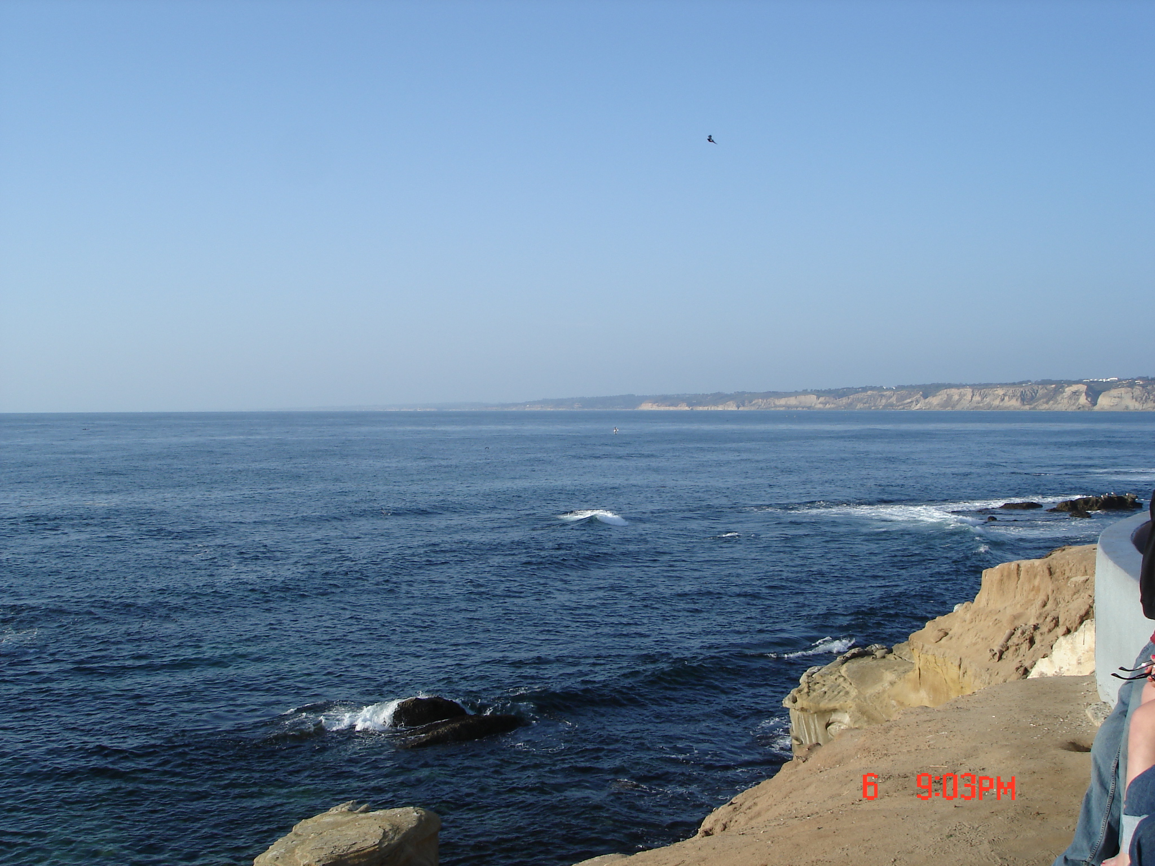

Marsland Press, New York, USA

Researcher

ISSN 1553-9865

Marsland Press
525 Rockaway PKWY, #B44
Brooklyn, New York 11212, USA
Telephone: 347-321-7172
sciencepub@gmail.com
http://www.sciencepub.net

ISSN 1553-9865


