Effect of Craway, Coriander and Fennel on the structure of Kidney and Islets of Langerhan in Alloxan-Induced Diabetic Rats: Histological and Histochemical Study.

Nermeen M. Shaffie, Fatma A. Morsy, Amina G. Ali, Hafiza A. Sharaf

Pathology Department, Medical researches Division, National Research Center, Cairo, Egypt.
nermshaf@yahoo.com

Abstract: Caraway, coriander and fennel are known hypoglycemic agents, which are used in folklori medicine for improving blood glucose level and preventing long term complications in diabetes mellitus. So, this study was designed to clarify their role on the histological and histochemical changes in kidney and islets of Langerhan in diabetic rats. 80 rats were divided into 5 groups. The first group was control. For the second group diabetes mellitus was induced in 40 rats, using alloxan. 30 rats of diabetic rats were divided into 3 subgroups: subgroup 1: was given caraway for 2 weeks. Subgroup 2: was given coriander for 2 weeks. Subgroup 3: was dosed orally by fennel for 2 weeks. Each of the remaining 3 groups was given Caraway, coriander and fennel respectively only for 2 weeks. Histopathological effects in kidney were massive inflammatory infiltrate in interstitial tissue, vacuolar degeneration in tubular epithelial cells, karyolysis and karyorrhexis and some glomerular degeneration. The islets of Langerhan showed severe necrotic changes of pancreatic islets, especially in the center. Karyolysis, dilatation, congestion of large vessels and marked increase in connective tissue component at the expense of functioning tissue leading to relative reduction in the size of islets were also seen. DNA analysis showed hypoploidy in kidney and pancreas of rats treated with alloxan only. Alloxan caused decrease of protein and mucopolysaccharide content. Conclusion: the treatment of diabetic rats with caraway, coriander and fennel resulted in amelioration of histopathological and histochemical changes in kidney and islets of Langerhans. [Researcher. 2010;2(7):27-40]. (ISSN: 1553-9865).

Key words: aloxan- kidney- pancreas- diabetes- caraway- coriander-fennel.

1. Introduction:
Alloxan is a hydrophilic and unstable substance. Its half-life at neutral pH and 37 °C is about 1.5 min and is longer at lower temperatures (Lenzen 2008). On the other hand, when a diabetogenic dose is used, the time of alloxan decomposition is sufficient to allow it to reach the pancreas in amounts that are deleterious (Szkudelski 2001).
The mechanism of alloxan action has been intensively studied, predominantly in vitro, it was demonstrated that alloxan evokes a sudden rise in insulin secretion in the presence or absence of glucose. Alloxan-induced insulin release is, however, of short duration and is followed by complete suppression of the islet response to glucose, even with high concentrations of this sugar (Kliber et al. 1996).
Alloxan induces diabetes in experimental animals through the selective damage of pancreatic b-cells. It is generally accepted that b-cell damage induced by alloxan occurs through the noxious oxygen free radicals (Takasu et al., 1991). However, the exact subcellular site for an initial attack by alloxan is still not clear. Evidences of damage to plasma membrane, mitochondria and nuclei are available. Okamoto (1985) proposed that reactive oxygen species produced from alloxan cause DNA strand breaks, and the damaged DNA activates nuclear poly(ADP-ribose) synthetase, which depletes the cellular pool of NAD+, resulting in b-cell damage (Hye-Won et al., 2000).
The action of alloxan in the pancreas is preceded by its rapid uptake by the B cells which has been proposed to be one of the important features determining alloxan diabetogenicity. A similar uptake of alloxan also takes place in the liver. However, the liver and other tissues are more resistant to reactive oxygen species in comparison to pancreatic B cells and this resistance protects them against alloxan toxicity. Another aspect concerns the formation of reactive oxygen species that is preceded by alloxan reduction. In B cells of the pancreas its reduction occurs in the presence of different reducing agents. Since alloxan exhibits a high affinity to the SH-containing cellular compounds, reduced glutathione (GSH), cysteine and protein-bound sulfhydryl groups (including SH containing enzymes) are very susceptible to its action. Alloxan and the product of its reduction, dialuric acid, establish a redox cycle with the formation of superoxide radicals. These radicals undergo dismutation to hydrogen peroxide. Thereafter highly reactive hydroxyl radicals are formed by the Fenton reaction. The action of reactive oxygen species with a simultaneous massive increase in cytosolic calcium concentration causes rapid destruction of B cells (Szkudelski, basc 2001).
Many traditional plant treatments for diabetes are used throughout the world but most of the evidence for their beneficial effects is anecdotal. After introduction of insulin therapy the use of traditional treatment for diabetes greatly declined, although some traditional practices are continued for prophylactic purpose and adjuncts to conventional therapy. In some of the societies there is strong desire to use herbs or plants for treatment, due to less side effects, easier consumption or availability. However, very few of the traditional treatments for diabetes have received scientific or medical scrutiny and several have been shown to assist glycemic control in non-insulin dependent form of diabetes (Gholamali et al., 2007).
Plants may act on blood glucose through different mechanism, some of them may have insulin-like substances (Gray and Flatt, 1999) some may inhibit insulinase activity, others may cause increase beta cells in pancreas by activating regeneration of these cells (Abdel et al, 1997). The fiber of plants may also interfere with carbohydrate absorption; thereby affecting blood glucose (Nelson et al, 1991). Effect of coriander leaf (coriandrum sativum L.) on serum cholesterol, triglyceride, ALT, and AST of alloxan diabetic rats was reported (Jelodar and Nazifi, 1999).
The caraway seeds, leaves and roots are considered useful in activating the glands, besides increasing the action of the kidneys. It is characterised as an excellent 'house cleaner' for the body. Caraway oil is used in medicine to relieve flatulence. It is also used to correct the nauseating and griping effects of some medicines. The chemical components of Caraway oil are Acetaldehyde, Cumuninic aldehyde, Furfurol, Carvone and Limonene.
Like many of its fellow spices, fennel contains its own unique combination of phytonutrients-including the flavonoids rutin, quercitin, and various kaempferol glycosides-that give it strong antioxidant activity. The phytonutrients in fennel extracts compare favorably in research studies to BHT (butylated hydroxytoluene), a potentially toxic antioxidant commonly added to processed foods. The most fascinating phytonutrient compound in fennel, however, may be anethole-the primary component of its volatile oil. In animal studies, the anethole in fennel has repeatedly been shown to reduce inflammation and to help prevent the occurrence of cancer.
In addition to its unusual phytonutrients, fennel bulb is an excellent source of vitamin C. Vitamin C is the body's primary water-soluble antioxidant, able to neutralize free radicals in all aqueous environments of the body. If left unchecked, these free radicals cause cellular damage that results in the pain and joint deterioration that occurs in conditions like osteoarthritis and rheumatoid arthritis. The vitamin C found in fennel bulb is directly antimicrobial and is also needed for the proper function of the immune system (Ozbek, 2003).

2. Material and methods:
Preparation of alloxan-induced diabetic rats:
Alloxan tetrahydrate (sigma) was dissolved in distlled water. Diabetes was induced in 40 adult male albino rats by interaperitoneal injection of 120mg/kg. The rats with blood glucose above 250mg/dl/. The range of diabetogenic dose of alloxan is quiet narrow and even light overdosing may generally toxic causing the loss of many animals. To prevent the toxic side effects, range of 80 -140mg/kg of alloxan (20mg interval) were tested and 120mg/kg was selected as the minimum and safest dose for induction of diabetes in this study.

Animal groups:
80 male adult albino rats weighting 200 -250 gm were used in this study. The animals were divided into 5 groups and 3 subgroups as follows:
Group 1: was kept as control.
Group 2: was a diabetic group, diabetes mellitus was induced into 40 rats by intraperitoneal injection of 120mg/kg of alloxan. 30 rats of diabetic rats were divided into 3 subgroups:
Subgroup 1: the diabetic rats were given caraway at dose level of 10 mg/kg body weight by stomach tube for 2 weeks.
Subgroup 2: the diabetic rats were given coriander at dose level of 40 mg/kg body weight by stomach tube for 2 weeks.
Subgroup 3: the diabetic rats were dosed orally by fennel at dose level 30mg/kg body weight for 2 weeks.
Each of the remaining 3 groups was given Caraway (10 mg/kg body weight), coriander (40 mg/kg body weight) and fennel (30 mg/kg body weight) respectively only for 2 weeks.
The kidney and pancreas of different groups were removed and fixed in 10% formal saline. Paraffin sections 5 μm thick were stained with haematoxylin and eosin (Drury and Wallington, 1980). Protein stain (Mazia et al., 1953) and mucopolysaccharids stain (Mac-Manus and Cason, 1950) were also performed. All sections were investigated by the light microscope.
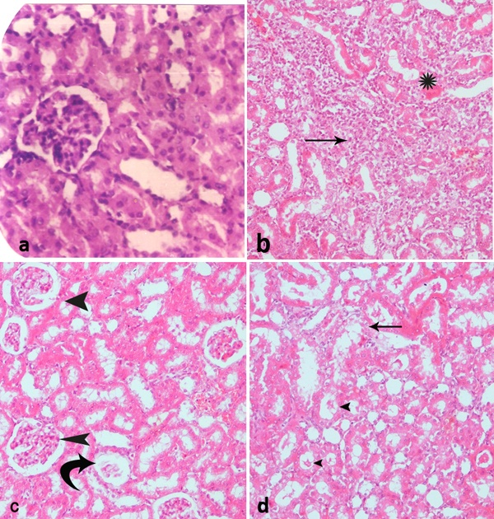
Further sections were stained for DNA (Feulgen and Rosenbeck, 1942), and DNA analysis was performed by lecia Qwin 500 image cytomery in the department of pathology, National Research Center. For each section (100-120 cells) were randomly measured. The threshold values were defined by measuring control cells. The results are presented as histograms and tables which demonstrate the percentage of the diploid cells (2C), the triploid cells (3C), the tetraploid cells (4C) and the aneuploid cells (>5C). The DNA histogram classified according to Danque et al., (1993).
Morphometrical analysis for the area of islets of Langerhan was done using lecia Qwin 500 image morphometry. For each section 5 fields were examined. The mean areas of the islets of Langerhan are presented in a table and a column chart.

3. Results:
- Kidney:
- Histological results:
The normal histological structure of the kidney was observed in (Figure 1, a).
No pathological changes could be noticed in kidney and pancreas of rat treated with caraway, coriander and fennel.
The kidney of the alloxanated diabetic rats showed vacuolar degeneration in some tubular epithelial cells and cell debris scattered in tubular lumina. Increase in thickness of tubular epithelial cells with narrowing of lumen, signs of degeneration in the form of karyolysis and karyorrhexis. Massive cellular infiltration, areas of hemorrhage in interstitial tissue and deformed renal tissue architecture were seen. Some glomeruli showed complete degeneration with thickening of Bowman’s capsule, while others showed lobulation with wide urinary space (Figure 1, b, c & d).
The kidney of the alloxanated diabetic rats subjected to caraway showed some pathological changes, but these changes were somewhat less than those in group treated with alloxan only. Examination of the kidney section showed some glomerular lobulation and others showed degeneration with wide urinary space. Mild cellular infiltration in interstitial tissue was also seen. (Figure 2,a).
The kidney of the alloxanated diabetic rats subjected to coriander showed some protective effects as compared to the control diabetic group. Examination of kidney sections showed glomerular degeneration, thickening of Bowman’s capsule, cell debris in some tubular lumina and mild cellular infiltration in interstitial tissue (Figure 2, b).
The kidney of alloxanated diabetic rats treated with fennel showed more protective effects as compared to diabetic group of rats in the form of diminution of cellular infiltration, hemorrhage in interstitial tissue, glomerular degeneration and cell debris in tubular lumina, while vacuolar degeneration in some tubular epithelial cells could be noticed (Figure 2, c).
Figure (1): Section of the kidney of a rat (a): control (Hx. & E. X 200). (b): Section of the kidney of an alloxanated diabetic rat showing massive cellular infiltration (arrow) and areas of hemorrhage in interstitial tissue (star). (Hx. & E. X 50) (c): Another field of the kidney of the same group showing some completely degenerated glomeruli with thickening of Bowman’s capsule (curved arrow), while others showed lobulation with wide urinary space (arrow head). (d): Another section of the same group showing vacuolar degeneration in some tubular epithelial cells (arrow), and cell debris scattered in tubular lumina (arrow head).
(Hx. & E. X 100)

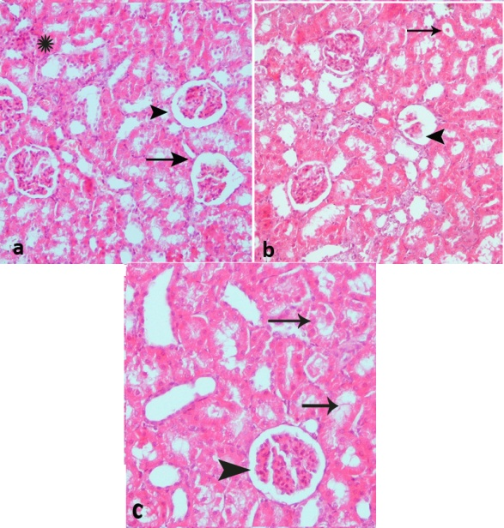

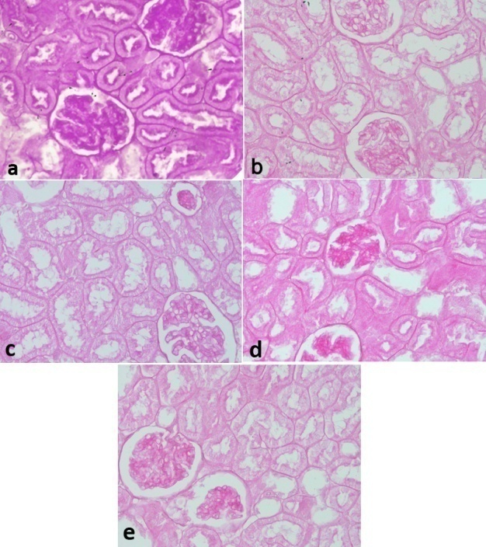

Figure (2): (a) Section of kidney from alloxanated-diabetic rat subjected to caraway showing only mild cellular infiltrate in the interstitial tissue (star), some glomeruli showed lobulation (arrow head) and others showed degeneration with wide urinary space (arrow). (b): Section of the kidney of an alloxanated diabetic rat treated with coriander showing glomerular degeneration (arrow head) with thickening of Bowman’s capsule and cell debris in some tubular lumina (arrow) . (c): Section of the kidney of an alloxanated diabetic rat treated with fennel showing lobulation of some glomeruli (arrow head) and vacuolar degeneration in some tubular epithelial cells (arrow). (Hx. & E. X 100)

- Histochemical results:
The periodic acid Scfiff’s technique was used to demonstrate the presence of polysaccharides in the kidney. The PAS +ve materials were mainly distributed at the brush border and basement membrane of the renal tubules (Figure 3, a).
The alloxanated diabetic rats showed marked diminution in mucopolysaccharide content in some tubules, while others showed diffuse stain ability (Figure 3, b).
Mild increase in mucopolysaccharide content was observed in the group of rats treated with caraway in combination with alloxan as compared to group of rats treated with alloxan only (Figure 3, c), whereas the treatment of rats with coriander or fennel showed the mucopolysaccharide content more or less approximated control level (Fig. 3, d).

Figure (3): Section of renal tissue showing PAS +ve material in the basement membrane and brush borders of the tubules. (a): control. (b): alloxan-diabetic rat showing decrease stainability of PAS +ve materials. (c): alloxan-diabetic rat subjected to caraway showing mild increase of PAS +ve materials. (d): alloxan-diabetic rat subjected to coriander showing the mucopolysccharide content more or less approximated control.
(PAS reaction X 100)

In normal rats, high protein inclusions in renal tubular cells were localized in the cytoplasm and to a lesser extent in their nuclei (Figure 4, a).
Marked diminution of protein content was recorded in alloxan diabetic rats’ renal tubular cells (Figure 4, b).
Rats treated with caraway and alloxan showed the protein content more or less near the control level (Figure 4, c).
Alloxanated diabetic rats treated with either coriander or fennel showed more improvement in protein content in some tubules approximating control group, while in others it was still decreased (Figure 4,d & e).

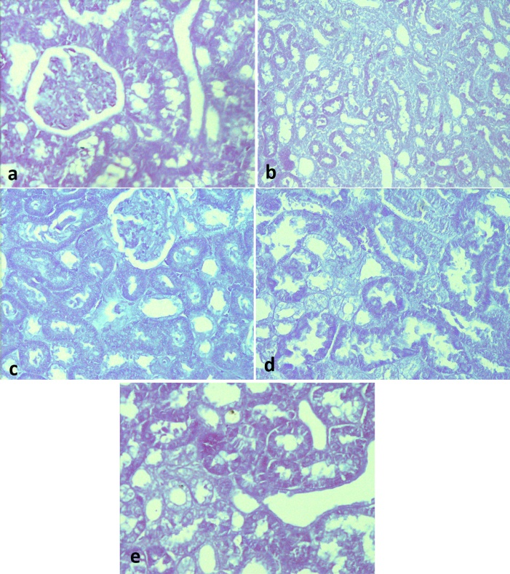
Figure (4): Section of kidney of a rat showing protein content in cytoplasm of renal tubular cells (a): control (b): alloxanated diabetic rat showing marked diminution in protein content. (c): alloxanated diabetic rat subjected to caraway showing moderate improvement in protein content. (d): alloxanated diabetic rat subjected to coriander or fennel showing moderate improvement in protein content. (Bromophenol blue stain X 100)

- DNA content:
In the present study, the Qwine 500 image analyzer was used to evaluate the DNA content. The image analysis system automatically express the DNA content of each individual cell measured then gave the percentage of each cell out of the total number of cells examined. Also, it classifies the cells into 4 groups; diploid (2C), proliferating cells (3C), tetraploid (4C) and aneuploid cells (> 5C). The proliferating cells were further classified according to Lee et al., (1999) into: (< 10%) low proliferating index, (10 – 20%) medium proliferating index and (>20%) high proliferating index.
Normal distribution of DNA content in the kidney of control group showed that 13.33% of the examined cells contained DNA (< 1.5C), 69.52% of the examined cells contained diploid DNA value (2C), 15.23% of the examined cells contained (3C) DNA value (medium proliferating index and 1.9% of the examined cells at (4C) area (table & histogram 1). The group subjected to alloxan showed that 37.38% of the examined cells contained DNA (< 1.5C), which means decrease in DNA content (hypoploidy) compared to the control group (table & histogram 2).
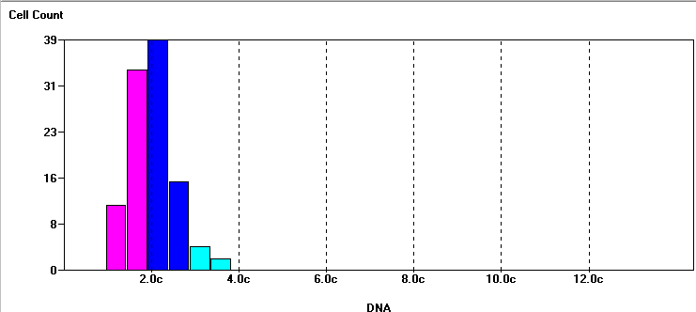
Table (1): DNA ploidy of Control –ve kidney
Range | Tot Cells | % Cells | DNA Index
All | 105 | 100.0% | 1.000
5cER | 0 | 0.0% | -
< 1.5c | 14 | 13.333% | 0.665
1.5c-2.5c | 73 | 69.524% | 0.966
2.5c-3.5c | 16 | 15.238% | 1.350
3.5c-4.5c | 2 | 1.905% | 1.801
> 4.5c | 0 | 0.0% | -

Histogram 1

Table (2): DNA ploidy of rat kidney treated with alloxan:
Range | Tot Cells | % Cells | DNA Index
All | 107 | 100.0% | 0.852
5cER | 0 | 0.0% | -
< 1.5c | 40 | 37.383% | 0.614
1.5c-2.5c | 59 | 55.14% | 0.940
2.5c-3.5c | 8 | 7.477% | 1.392
3.5c-4.5c | 0 | 0.0% | -
> 4.5c | 0 | 0.0% | -

Histogram 2

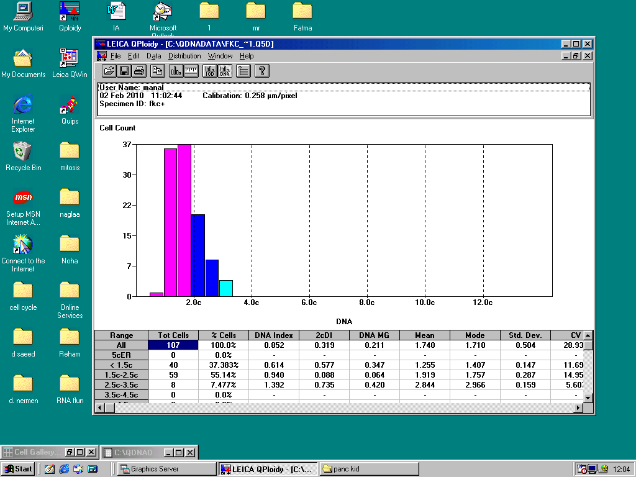

Treatment of rats with alloxan along with caraway showed that 8.62% of the examined cells contained DNA (< 1.5C), 63.79% of the examined cells contained diploid DNA value (2C), 24.13% of the examined cells contained (3C) DNA value (high proliferating index) and 3.44% of the examined cells at (4C) area (table & histogram 3).

Table (3): DNA ploidy of rat Kidney treated with alloxan along with caraway:
Range | Tot Cells | % Cells | DNA Index
All | 116 | 100.0% | 1.081
5cER | 0 | 0.0% | -
< 1.5c | 10 | 8.621% | 0.670
1.5c-2.5c | 74 | 63.793% | 0.993
2.5c-3.5c | 28 | 24.138% | 1.362
3.5c-4.5c | 4 | 3.448% | 1.793
> 4.5c | 0 | 0.0% | -

Histogram 3

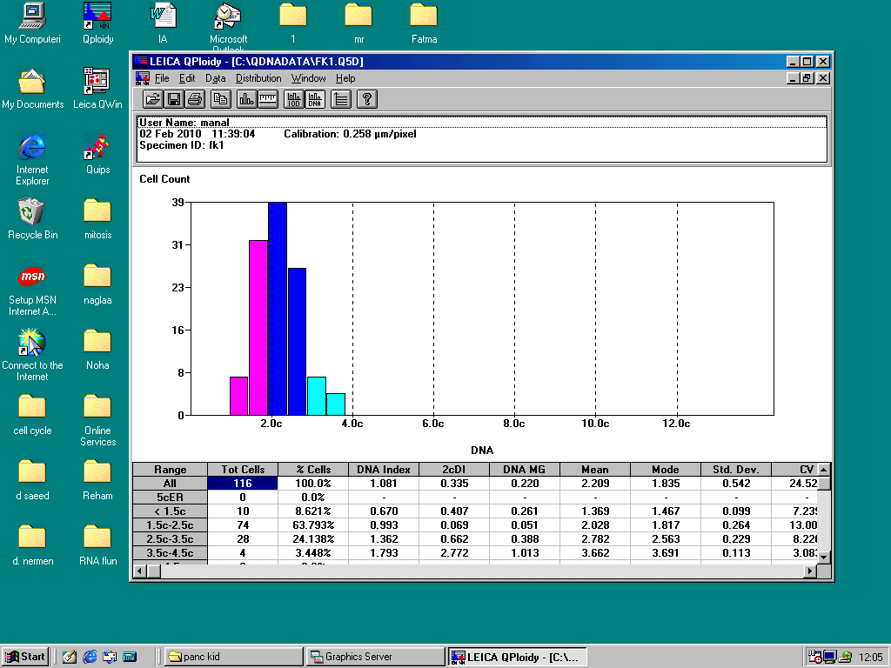
The group treated with alloxan together with coriander showed that 2.67% of the examined cells contained DNA (< 1.5C), 66.07% contained diploid DNA value (2C), 29.46% of the examined cells contained (3C) DNA value (high proliferating index) and 1.78% of the examined cells at (4C) area (table & histogram 4).
The group treated with alloxan together with fennel showed that 4.8% of the examined cells contained DNA (<1.5C), 54.8% of the examined cells contained diploid DNA value (2C), 38.46% of the examined cells contained (3C) DNA value (high proliferating index) and 1.9% of the examined cells at the (4C) area (table & histogram 5).
These results indicate that treatment with caraway, coriander and fennel showed DNA values comparable to the control values, while the group treated with alloxan showed decreased DNA values (hypoploidy).

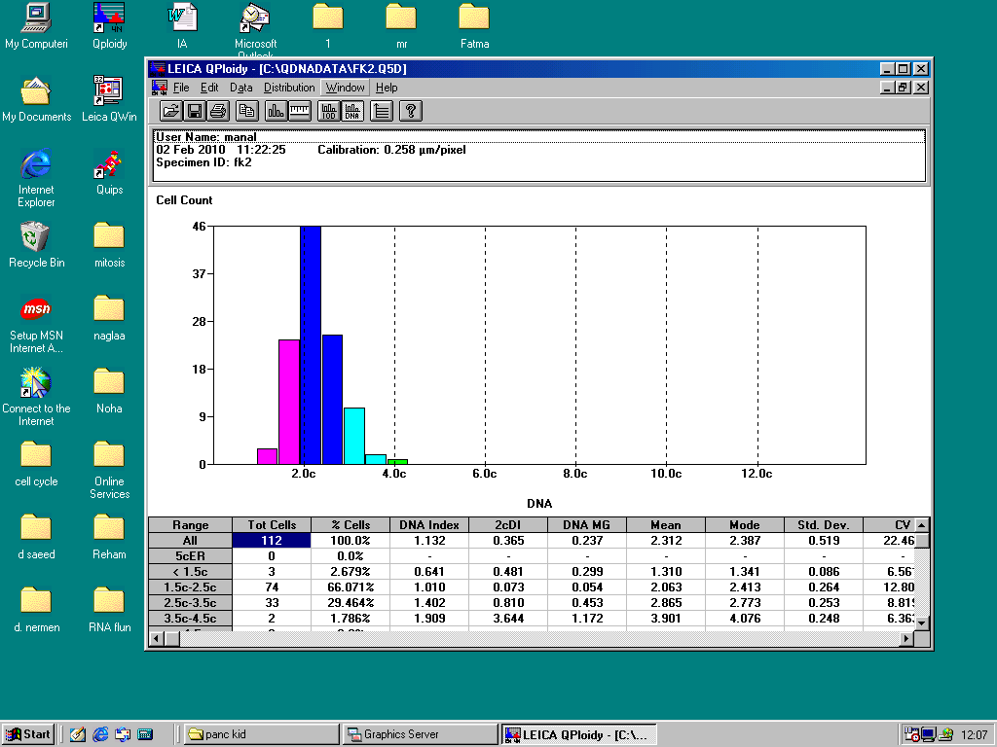
Histogram 4
Table (4): DNA ploidy of rat Kidney treated with alloxan along with coriander:
Range | Tot Cells | % Cells | DNA Index
All | 112 | 100.0% | 1.132
5cER | 0 | 0.0% | -
< 1.5c | 3 | 2.679% | 0.641
1.5c-2.5c | 74 | 66.071% | 1.010
2.5c-3.5c | 33 | 29.464% | 1.402
3.5c-4.5c | 2 | 1.786% | 1.909
> 4.5c | 0 | 0.0% | -

Histogram 5
Table (5): DNA ploidy of rat Kidney treated with alloxan along with fennel:
Range | Tot Cells | % Cells | DNA Index
All | 104 | 100.0% | 1.171
5cER | 0 | 0.0% | -
< 1.5c | 5 | 4.808% | 0.637
1.5c-2.5c | 57 | 54.808% | 1.026
2.5c-3.5c | 40 | 38.462% | 1.412
3.5c-4.5c | 2 | 1.923% | 1.810
> 4.5c | 0 | 0.0% | -

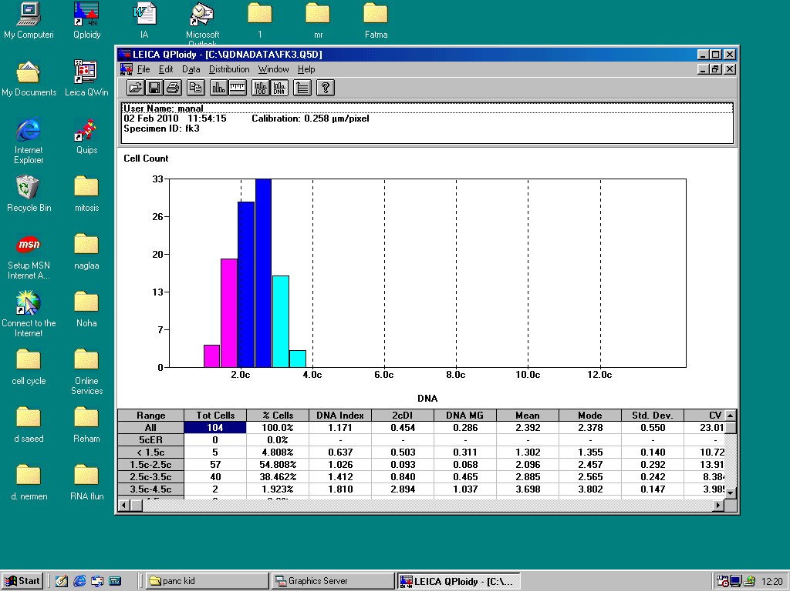

- Pancreas:
- Histological results:
The normal architecture of pancreatic tissue was noticed in (Figure 5,a).
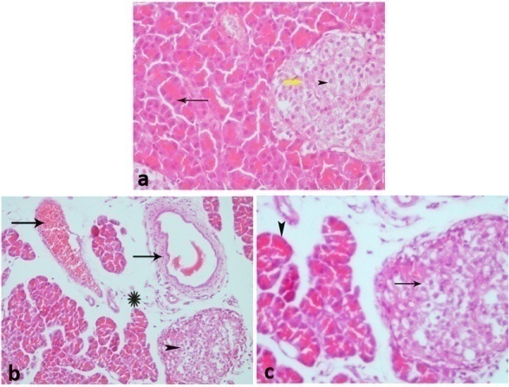
Pancreatic sections stained with HE showed that alloxan caused severe necrotic changes of pancreatic islets, especially in the center of the islets. Nuclear changes, karyolysis, disappearing of nucleus and in some places residue of destructed cells were visible. The relative reduction of the size of islets, dilatation and congestion of large vessel and marked increase in connective tissue component at the expense of functioning tissue were obvious. The exocrine part of the gland (serous acini) showed flattening of their nuclei that were pushed to the bottom of the cells (Figure 5, b &c).

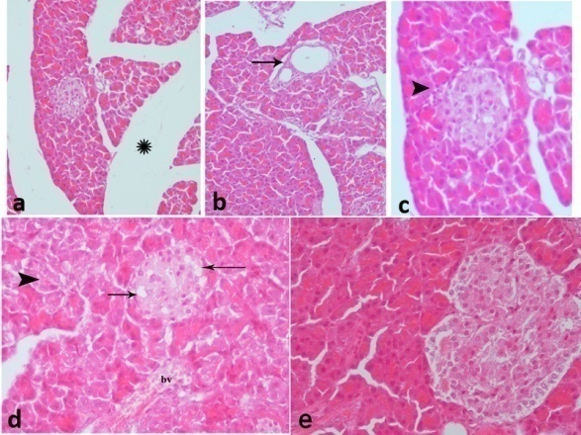

Figure (5):. Section of pancreas of a rat (a): control. (Hx. & E. X 100). (b): Section of pancreatic tissue of an alloxan-diabetic rat showing marked increase in the connective tissue component of the gland (interlobular and intralobular) (star)., blood vessels are markedly dilated and congested (arrow). (Hx. & E. X 50) (c): Higher magnification of the previous group shows vacuolar degeneration in the cells of islets of Langerhan specially in the center (arrow), while the nuclei of the serous acini cells appeared flattened and pushed towards the bottom of the cells (arrow head). (Hx. & E. X 100)

The pancreatic tissue of alloxanated diabetic rats subjected to caraway showed moderate protective effect comparing to group of rats treated with alloxan only. Examination of pancreatic tissue of this group showed a decrease in the degenerative changes in cells of Islets of Langerhan, although the increase in connective tissue component is still present as well as the dilatation of blood vessels (Figure 6, a, b & c).
The pancreas of alloxanated-diabetic rats, subjected to coriander showed a mild protective effect as compared to group of rats treated with alloxan only. Examination of pancreatic sections of this group showed that necrotic changes were still observed in both endocrine and exocrine parts of the gland. Blood vessels were still dilated and congested (Figure 6, d).
The best protective effect was obtained by using fennel to alloxanated diabetic rats. Examination of pancreas sections of this group showed that the pancreatic tissue retained its normal architecture. (Figure 6, e).

Figure 6: (a) Section of pancreatic tissue of an alloxan-diabetic rat treated with caraway showing marked decrease in vacuolar degeneration in cells of islets of langerhan, increase in connective tissue component of the gland is still present (star) and the lobules appear smaller in size than normal. (b): Showing dilatation of blood vessels with fibrosis around (arrow). (Hx. & E. X 50) (c): Showing slight cellular infiltrate in the connective tissue compartment (arrow head), most of the serous acini regain their normal appearance. (d): Section of pancreatic tissue of an alloxan-diabetic rat treated with coriander showing vacuolar degeneration is still observed in some cells of islets of Langerhan (arrows), also some of the acini cells show signs of degeneration (arrow head). The blood vessels are still slightly dilated and congested (bv). (e) is a section of pancreatic tissue of an alloxan-diabetic rat treated with fennel showing normalization of the pancreatic tissue.
(Hx. & E. X 100)

- Histochemical results:
Examination of pancreatic sections stained with bromophenol blue showed the normal protein content, where it was localized in the apical part of the serous acini cells and to a lesser extent in the islets of Langerhan’s cells (Figure 7,a).
Pancreatic tissue of alloxanated diabetic rats showed marked decrease in the protein content as compared to control rats (Figure 7,b).
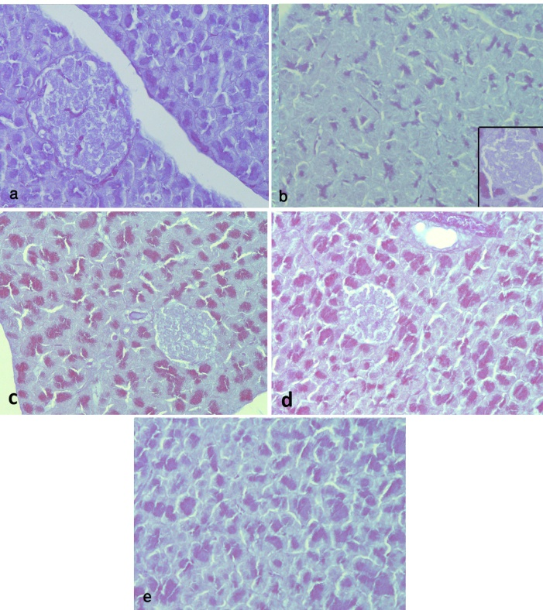
Figure (7): Section of pancreatic tissue of a rat showing the protein content in cytoplasm of serous acini. (a):control. (b): Alloxanated diabetic rat showing a marked decrease in the protein content. (c): Alloxanated diabetic rat subjected to caraway showing a noticeable improvement in the protein content of the tissue. (d): alloxanated diabetic rat subjected to coriander showing marked increase in the protein content of the serous acini .(e): alloxanated diabetic rat subjected to fennel showing a marked increase in the protein content of the tissue as compared with alloxan-treated group.
(Bromophenol blue X 50, 100)

Examination of alloxanated-dibetic rats treated with caraway showed a mild protective effect expressed in mild increase in protein content especially in serous acini cells (Figure 7, c).
Examination of pancreas of aloxanated-dibetic rats subjected to either coriander or fennel showed a better protective effect in the form of increase in protein content (Fig.ure 7, d & e).

- DNA content:
Normal distribution of DNA content in the pancreas of control group showed that 8.33% of the examined cells contained DNA (< 1.5C), 64.81% of the examined cells contained diploid DNA value (2C), 24.07% of the examined cells contained (3C) DNA value (medium proliferating index and 1.85% of the examined cells at (4C) area (table & histogram 6). The group subjected to alloxan showed that 0% of the examined cells contained DNA (< 1.5C) and only 22.72% of the examined cells contained diploid DNA value (2C), which means decrease in DNA content (hypoploidy) compared to the control group (table & histogram 7).
Table (6): DNA ploidy of Control –ve pancreas
Range | Tot Cells | % Cells | DNA Index
All | 108 | 100.0% | 1.000
5cER | 0 | 0.0% | -
< 1.5c | 9 | 8.333% | 0.603
1.5c-2.5c | 70 | 64.815% | 0.883
2.5c-3.5c | 26 | 24.074% | 1.356
3.5c-4.5c | 2 | 1.852% | 1.648
> 4.5c | 1 | 0.926% | 2.217

Histogram 6

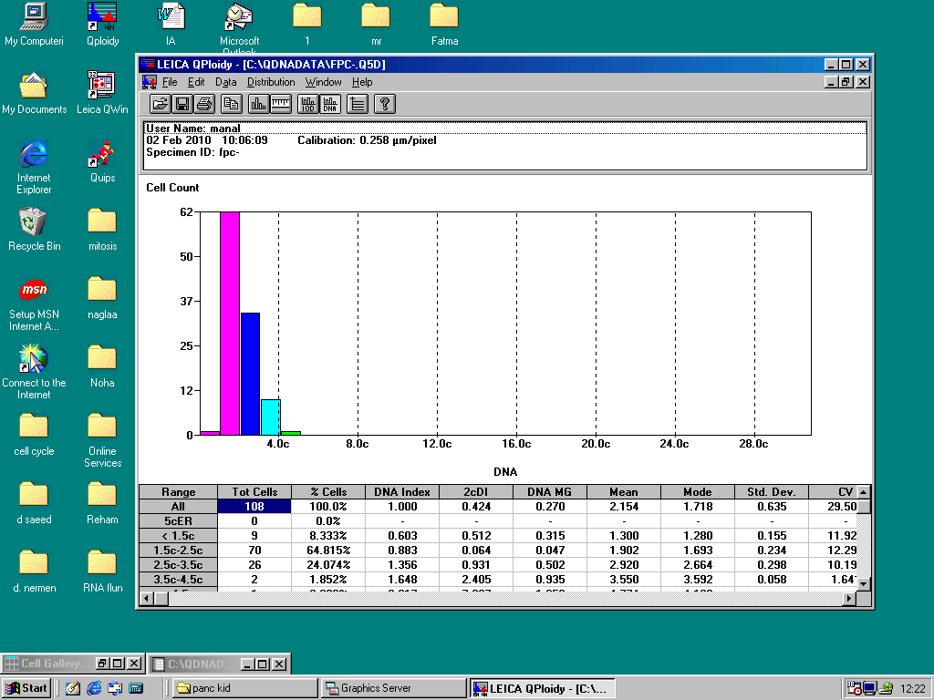
Treatment of rats with alloxan along with caraway showed that 0% of the examined cells contained DNA (< 1.5C), 39.06% of the examined cells contained diploid DNA value (2C), 48.43% of the examined cells contained (3C) DNA value (high proliferating index) and 11.71% of the examined cells at (4C) area (table & histogram 8).

Histogram 7
Table (7): DNA ploidy of rat pancreas treated with alloxan
Range | Tot Cells | % Cells | DNA Index
All | 132 | 100.0% | 1.406
5cER | 3 | 2.273% | 2.460
< 1.5c | 0 | 0.0% | -
1.5c-2.5c | 30 | 22.727% | 1.028
2.5c-3.5c | 69 | 52.273% | 1.336
3.5c-4.5c | 26 | 19.697% | 1.796
> 4.5c | 7 | 5.303% | 2.267

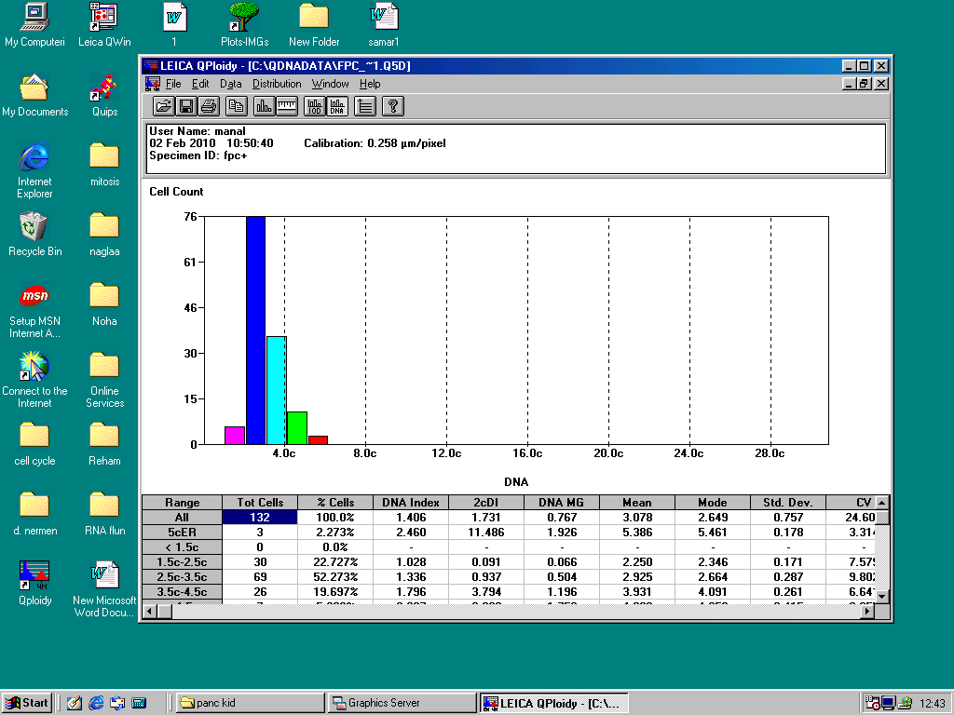

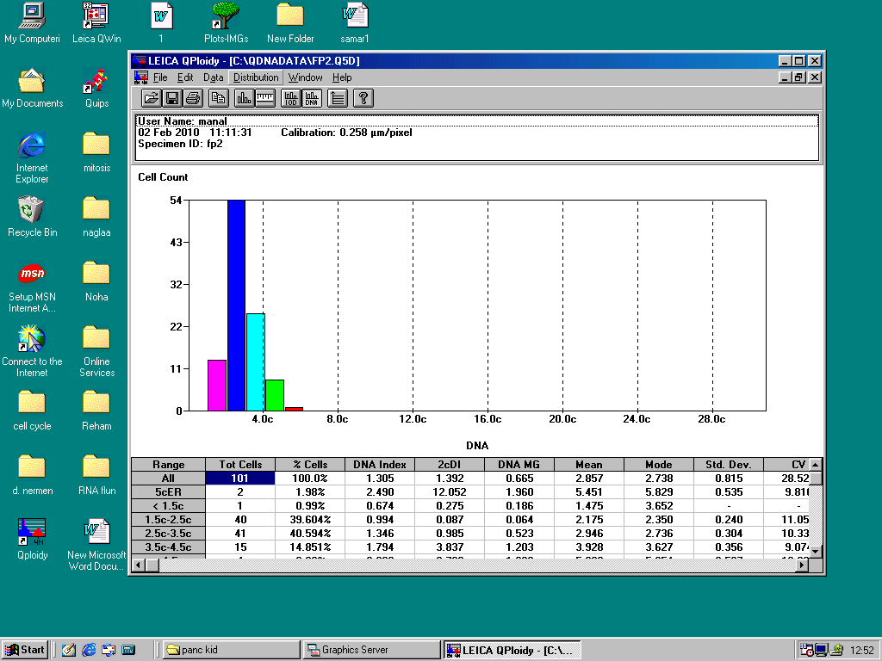

Histogram 8
Table (8): DNA ploidy of rat pancreas treated with alloxan along with caraway:
Range | Tot Cells | % Cells | DNA Index
All | 128 | 100.0% | 1.266
5cER | 0 | 0.0% | -
< 1.5c | 0 | 0.0% | -
1.5c-2.5c | 50 | 39.063% | 1.044
2.5c-3.5c | 62 | 48.438% | 1.305
3.5c-4.5c | 15 | 11.719% | 1.784
> 4.5c | 1 | 0.781% | 2.175

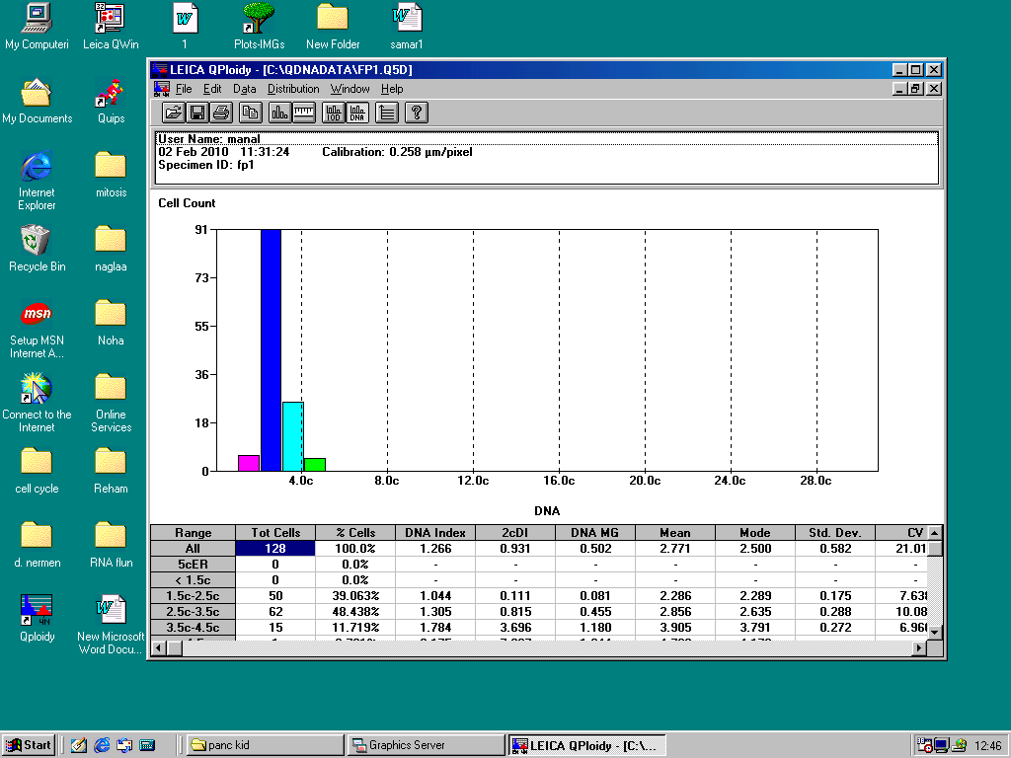
The group treated with alloxan together with coriander showed that 0.99% of the examined cells contained DNA (< 1.5C), 36.6% contained diploid DNA value (2C), 40.59% of the examined cells contained (3C) DNA value (high proliferating index) and 1.14.85% of the examined cells at (4C) area (table & histogram 9).
Table (9): DNA ploidy of rat pancreas treated with alloxan along with coriander:
Range | Tot Cells | % Cells | DNA Index
All | 101 | 100.0% | 1.305
5cER | 2 | 1.98% | 2.490
< 1.5c | 1 | 0.99% | 0.674
1.5c-2.5c | 40 | 39.604% | 0.994
2.5c-3.5c | 41 | 40.594% | 1.346
3.5c-4.5c | 15 | 14.851% | 1.794
> 4.5c | 4 | 3.96% | 2.322

Histogram 9

Histogram 9

The group treated with alloxan together with fennel showed that 3.1% of the examined cells contained DNA (<1.5C), 43.41% of the examined cells contained diploid DNA value (2C), 37.98% of the examined cells contained (3C) DNA value (high proliferating index) and 13.95% of the examined cells at the (4C) area (table & histogram 10).
These results indicate that treatment with caraway, coriander and fennel showed DNA values comparable to the control values, while the group treated with alloxan showed decreased DNA values (hypoploidy).

Table (10): DNA ploidy of rat pancreas treated with alloxan along with fennel:
Range | Tot Cells | % Cells | DNA Index
All | 129 | 100.0% | 1.232
5cER | 0 | 0.0% | -
< 1.5c | 4 | 3.101% | 0.359
1.5c-2.5c | 56 | 43.411% | 0.983
2.5c-3.5c | 49 | 37.984% | 1.325
3.5c-4.5c | 18 | 13.953% | 1.835
> 4.5c | 2 | 1.55% | 2.226

Histogram 10
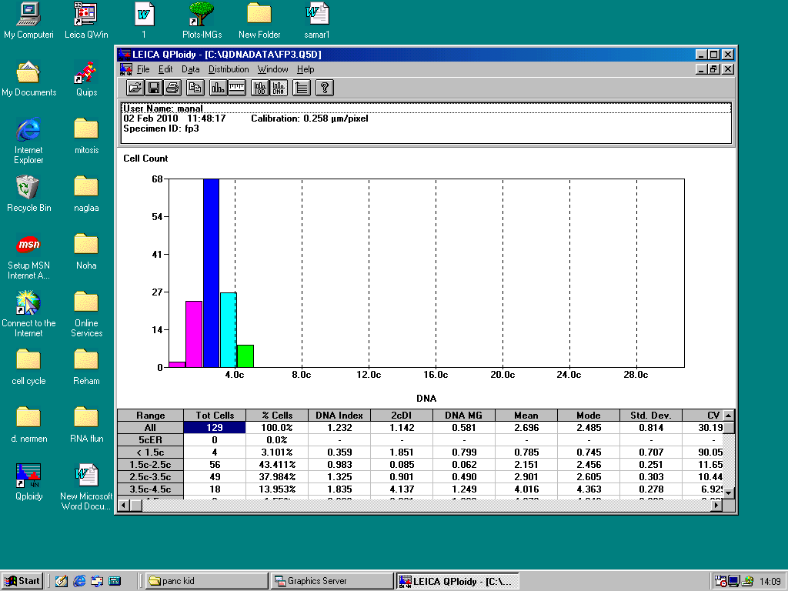
Morphometrical analysis:
Examination of the area of islets of Langerhan in pancreatic tissue revealed that alloxan caused marked diminution of the mean area of these islets. This finding was repaired by using the extracts of caraway, coriander and fennel. The best results obtained by using caraway, fennel and finally with coriander together with alloxan. With all of them the mean area of islets of Langerhan didn’t return to normal levels (chart 1& table 11)
group | mean area of islets
control -ve | 2112.42
control +ve | 434.53
Caraway | 1866
coriander | 784.18
fennel | 1239.88
Table 11
group | mean area of islets
control -ve | 2112.42
control +ve | 434.53
Caraway | 1866
coriander | 784.18
fennel | 1239.88

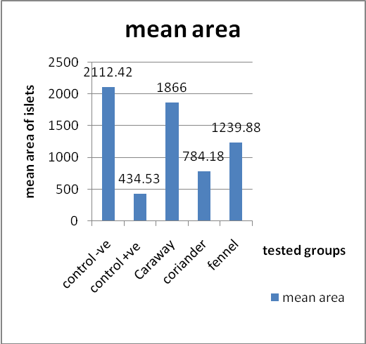
4. Discussion:
Diabetes is one of the fastest growing diseases in the world. Diabetes mellitus remains one of the age-long chronic diseases of the human race and its frontiers are expanding by day (Atangwho et al., 2007). The world health organization (WHO 2008) estimates that more than 180 million people world wide has diabetes.
Herbal drugs are gaining popularity in the treatment of diabetic mellitus. The major advantages of herbal medicine seem to be their efficacy, low incidence of side effects, and low cost. (Fernandes et al 2007)
The microscopical appearance of kidney of alloxanated diabetic rat showed signs of degeneration in the form of karyolysis, karyorrhexis, massive cellular infiltration and areas of hemorrhage in interstitial tissue. Some glomeruli showed complete degeneration with thickening of Bowman's capsule. Others showed lobulation with wide urinary space and deformed tissue architecture. In agreement with Yassin et al., (2004) who noticed that in diabetic rats the glomerular tufts were obviously contracted, lobulated, degenerated and infiltrated by chronic inflammatory cells and RBCs. The glomeruli were more or less shrunken. The urinary space became wide. The nuclei of some deteriorated cells displayed obvious signs of karyorrhexis, while a few of these nuclei show marked karyolysis and change of architecture. According to Yanardag et al. (2002) the treatment of rats with alloxan showed some histopathological changes in the kidney in the form of degeneration, inflammation, necrosis, mesangial hypercellularity and deformed renal tissue architecture. Also, Selvant et al. (2008) reported that in diabetic rats the kidney showed degenerative changes in cortex, medulla and necrosis of tubules. In addition Zeeuw et al. (2006) observed that in diabetics, the kidney sections showed damaged glomeruli, proximal tubules and interstitial inflammation. However, Thakran et al., (2004) found that in liver and kidney of alloxan-induced diabetic rats histopathological studies showed liver degenerative and early nephropathic changes.
Histopathological examination of kidney of the alloxanated diabetic rats revealed vacuolar degeneration in tubular epithelial cells. Vacuolation may be due to altered permeability of the cell membrane that would allow increasing fluid uptake Jhonson, (1982). These vacuoles were demonstrated by Lannergren et al. (2002) they stated that the vacuoles were formed because of lactate accumulation in the tubules of the kidney resulting in increased osmotic pressure and subsequent water influx.
In the present work the treatment of rats with alloxan only at dose level of 50mg/kg produced signs of degeneration of islets' cells (karyolysis and karyorrhexis). Most of cells appeared ballooned with moderate vacuolation. The vacuolation were appeared in the center of islets. Congestion of blood vessels and increase in connective tissue were also seen. These findings are in agrement with Abunasef (2006) who found that the treatment of male rat with alloxan at dose level of 180 mg/kg induced severe degenerative changes of islet cells with different grades of nuclear degeneration. Most of cells appeared ballooned with marked vacuolation. These changes were occupying mostly the center of islets. Congestion of blood vessels was noticed. The dense connective tissue stroma was observed around some pancreatic ducts and blood vessels. Coinciding with Benoit-Biancamano et al. (2005) they reported that the pancreatic lesions are consisting of diffuse vacuolation of islats of Langerhan with both acute and chronic onset of diabetis.
In the present study the alloxanated diabetic rat showed mild interstitial cellular infiltration. In agreement with Abunasef (2006) who found that the presence of interstitial mononuclear cell infiltration as an indicator of inflammation (insulinitis) was evident. There was apparent reduction of size and number of islets. These results are in accordance with those of another study which affirmed that islet inflammation was dissociated from onset of clinical diabetes (Thulesen et al., 1997).
The pathological changes observed in the present work has been explained by Zhang et al. (2009) who stated that alloxan is believed to confer its diabetogenic effect by inhibiting pancreatic glucokinase activity, leading to pancreatic β-cell death, which have a particularly low antioxidative defence capacity.
In the present work the pathological changes observed in the kidney and pancreas of alloxanated diabetic rats may be attributed to an increased production of reactive oxygen species and free radicals or by impaired antioxidant defenses (Moritim et al., 2003 and Sushruta1, et al 2006), which is widely accepted as important in the development and progression of diabetes complications (Brownlee, 2005 and Yanardag et al., 2005).
Oxidative stress plays an important role in chronic complications of diabetes mellitus, and hence the regulation of free radicals is essential in the treatment of diabetes. This oxidative stress was related to decrease glutathione content and superoxide dismutase activity in tissues of alloxan diabetic rats (El-Missiry and El-Gindy 2000 and Yanardag et al., 2005) .
These side effects may be neutralized by antioxidant substances. Antioxidants scavenge superoxide radical, lipid peroxide and hydroxyl radical (Satyanarayana et al., 2004).
In the present work alloxanated diabetic rat treated with caraway, coriander and fennel showed no inflammatory infiltrate in kidney sections. This finding is in agreement with (Ruberto et al 2000), who stated that this decrease may be due to anti-inflammatory actions of these plants. This anti-inflammatory action has been explained by Ozbek et al. (2003), they proposed a biological mechanism that may explain these anti-inflammatory and anticancer effects. This mechanism involves the shutting down of a intercellular signaling system called tumor necrosis factor (or TNF)-mediated signaling. By shutting down this signaling process, the anethole in fennel prevents activation of a potentially strong gene-altering and inflammation-triggering molecule called NF-kappaB.
In the present work, sections of pancreas from alloxanated rats subjected to caraway showed marked decrease in vacuolar degeneration of islets of Langerhan’s cells. This result goes in agreement with Gholamali et al. (2005) they stated that the hypoglycemic effect of plants may be due to the presence of insulin-like substances in plants, stimulation of B cells to produce more insulin, high level of fiber which interferes with carbohydrate absorption or the regenerative effect of plants on pancreatic tissue. Also, Sushrutal et al (2006) reported that the extract of caraway, cumin and others contained flavonoids might have been responsible for the observed activity showed a reduction of blood glucose that was more in diabetic rats compared to non-diabetic rats at the same dose level of the extracts. So, it can be concluded that Caraway was found to be best among the extracts evaluated for glucose lowering activity.
Concerning the groups of alloxan-dibetic rats subjected to fennel showed more improvement in pathological changes in kidney and pancreas. Coinciding with Ruberto et al (2000) fennel and caraway promote the function of liver and kidney and remove waste material from the body. According to Ozbek et al. (2003), the fennel oil significantly reduced level of serum aspartate, amino transferase, alanine amino transferase, alkaline phoshatase and bilirubin. Also, Ozbek et al. (2003) reported that the treatment of rats with essential oil from fennel fruit induced elevation of biochemical markers as well as rat body weight and histopathology.
Antioxidants’direct effect on the regeneration of the islets of pancreas was also evidenced by the restoration of the architecture of the islets of Langerhans in histopathological studies.
Concerning histochemical results, the alloxanated diabetic rats showed marked diminution in PAS +ve materials in brush borders and basement membranes of some tubules in kidney sections.
These results go in agreement with El-missiry and El-Gindy (2000) they reported that a single dose of alloxan (100mg/kg) showed marked decrease in glycogen content. Disagreement with Zhang et al (2009) they found that the glycogen content was unchanged in alloxan-treated mice.
Diminution of glycogen content that was observed in the present work was most probably consequent to signs of degeneration and inflammation manifested in this work, or due to damaging effect of alloxan on cytoplasmic organelles and the association enzymes. However, Poop and Cattley (1991) reported that the decrease in mucopolysaccharide content in tissue may be due to disturbed role of Golgi apparatus, which is responsible for synthesis of polysaccharides.
Decrease in mucopolysaccharide content in kidney of alloxanated diabetic rats has been explained by Tunez et al (2003) they postulated that the decrease of glycogen content of rats treated with alloxan is due to express of glycogenolysis.
In the present work the treatment of alloxenated diabetic rats with caraway, coriander and fennel showed increase in mucopolysaccharide content in renal tubules. These effects may be due to antioxidant nature of these compounds. According to Poop and Cattley (1991) it seems clear that the increase of glycogen deposition in basement membranes and brush borders of renal tubules was a sign of glycogenesis.
In the present work, the alloxanated diabetic rats showed decrease in protein content in renal tubules of kidney and pancreas. This decrease may be due to a decrease in ribosomal granules of rough endoplasmic reticulum or due to a decrease in DNA content. The decrease of DNA content was associated with a decrease in protein content in kidney cells and pancreas of diabetic rats.
These results go in coincidence with Szkudelski (2001) who stated that one of the targets of the reactive oxygen species is DNA of pancreatic islets. Its fragmentation takes place in B cells exposed to alloxan. They are also in agreement with Blasiak et al (2003) they reported that alloxan can damage DNA in normal cells, operating therefore as a genotoxic compound. The observed DNA damage might be due to the induction of DNA strand breaks and/or the formation of alkali labile sites, which can be transformed into strand breaks in the alkaline comet assay. Although the ability of alloxan to generate free radicals in the presence of suitable reducing agents, like reduced glutathione, and oxygen are well known. Alloxan exerts its DNA-damaging action, at least in part, by the production of free radicals and that this action can be modulated by common antioxidants, which can easily supplement the diet.
Our results showed that alloxan-dibetic rats treated with caraway, coriander and fennel showed increase in protein content in renal tubules of kidney and in serous acini of pancreas as compared to group of rats subjected to alloxan only. Fennel is an effective antioxidant which can protect SH groups of metalothionine and other proteins against oxidation.
According to Tuenz et al. (2003) they reported that the treatment of rats with fennel caused increased amount of ribososmes in rough endoplasmic reticulum in cells, reflecting their ability to stimulate protein synthesis. Also, Sierens et al. (2001) who stated that the antioxidant species may act in vivo to decrease damage of protein content in tissues. Increase protein content indicating that caraway, coriander and fennel are more effective in improving kidney and pancreas cell dysfunction induced by alloxan.

Correspondence to:
Nermeen M. Shaffie
Pathology Department, Medical Researches Division, National Research Center, Dokki, Cairo, Egypt.
Telephone: 0020233364743
Cellular phone: 020109905277
e-mail: nermshaf@yahoo.com

References:
[1] Abdel MA, El-Feki M, Salah E. (1997): Effect of Nigella Sativa, Fish oil and Gliclazide on alloxan diabetic rats, 1-Biochemical and Histopathological studies. J Egy Ger Soci Zool; 23:237-65.
[2] Abunasef SKM (2006): Effect of Juniper on the structure of islets of Langerhans in alloxan-induced diabetic rats:Histological and Immunohistochemical study. The Egyptian Journal of Histology. Vol. 29,2: 193-224.
[3] Atang-who IJ, Ebong PE, Eteng MU, Eyong EV and Obi AU (2007): Effect of Vernomia Amygdalina Del leaf on kidney function of diabetic rats. International Journal of Pharmacology, 3 (2): 143 – 148.
[4] Benoit-Bancamano MO, Morin M and Longlois I (2005): Histopathologic lesions of Diabetes Mellitus in a domestic ferret. Can. Vet. S., 46(10): 895-897.
[5] Blasiak J, Sikora A, Czechowska A and Drzewoski J (2003): Free radical scavengers can modulate the DNA-damaging action of alloxan. Acta biochimica polonica Vol. 50 No. 1: 205–210.
[6] Brownlee M (2005): The pathology of diabetic complications: a unifying mechanism. Diabetis, 54: 1615- 1625.
[7] El-Missiry MA and El Gindy AM (2000): Amelioration of Alloxan Induced Diabetes mellitus and Oxidative Stress in Rats by Oil of Eruca sativa Seeds. Annals of Nutrition & Metabolism ,44:97-100 .
[8] Danque PD, Chen HB, Patil J, et al. (1993): Image analysis versus flow cytometry for DNA plody Quantitation of solid tumors: A comparison of six methods of sample preparation. Mod. Pathol. 6: 270-275.
[9] Drury, R.V.A. and Walligton, E.A.(1980): Carltons Histological techniques, 5th ed, Oxford University Press, New York, Pronto, 206.
[10] Fernandes NPC, Chakradhar VL, Vandana PS and Suresh NR (2007): An experimental evaluation of the antidiabetic and antilipidemic properties of a standardized Momordica charantia fruit extract. BMC Complementary and Alternative Medicine, 7:29.
[11] Feulgen R and Rosenbeck HC (1942): Manual of Histological Demonstration Technique. Butter worth & Co (publishers) Ltd. London, Therford, havrhill.
[12] Gholamali JA, Maleki M, Motadayen MH, Sirus S (2005): Effect of fenugreek, onion and garlic on blood glucose and histopathology of pancreas of alloxan-induced diabetic rats. Indian Journal of Medical Sciences, Vol. 59, No. 2, February, 2005, pp. 64-69.
[13] Gray AM and Flatt PR (1999): Insulin - releasing and insulin –like activity of the traditional anti-diabetic plant Coriandrum sativum (coriander). Br J Nutr, 81: 203-208.
[14] Hye-Won Rho1, Ji-Na Lee1, Hyung-Rho Kim1, Byung-Hyun Park1 and Jin-Woo Park1,2 (2000): Protective mechanism of glucose against alloxan-induced b- cell damage: Pivotal role of ATP. Experimental and Molecular Medicine, Vol. 32, No. 1, 12-17.
[15] Jhonson DR (1982): Role of renal cortical sulfhydry groups in development of mercury- induced renal toxicity. J. Toxicol. Environ. Health, 9: 119 -126.
[16] Kliber A, Szkudelski T, Chichlowska J (1996): Alloxan stimulation and subsequent inhibition of insulin release from in situ perfused rat pancreas. J Physiol Pharmacol 47: 321-328.
[17] Lannergren J, Westerblod H and Bruton SD (2002): Dynamic vacuolation in skeletal muscle fibers after fatigue. Cell Biol. Int., 26: 911 – 920.
[18] Lee KH, Lee JS, Lee JH, Kim et al. (1999): Prognostic value of DNA flow cytometry in stomach cancer: a 5-year prospectice study. Br. J. Cancer 79 (11-12): 1727 – 1735.
[19] Lenzen S (2008): The mechanisms of alloxan- and streptozotocin-induced diabetes. Diabetologia 51, 216-226. (Review)
[20] Mac-Manus JPA and Cason JE (1950): Carbohydrate histochemistry studies by a cetylation technique. Periodic acid method. J. Exp. Med., 91: 651.
[21] Mazia D, Drewer PA and Alfert M (1953): The cytochemical staining and measurement of protein with mercaric bromophenol blue. Biol. Bull., 104: 57-67.
[22] Moritim AC, Sanders RA and Watkins JB (2003): Diabetes, oxidative stress and antioxidants: a review. Biochem. Mol. Toxicol., 17:24-38.
[23] Nelson RW, Ihle SL, Lewis LD, Salisbury SK, Bottoms GD (1991): Effects of dietary fiber supplementation on glycemic control in dogs with alloxan-induced diabetes mellitus. Am J Vet Res; 52:2060-6.
[24] Okamoto H. (1985): Molecular basis of experimental diabetes: Degeneration, Oncogenesis and regeneration of pancreatic Bcells of islet of Langerhans. BioEssay 2: 15-21.
[25] Ozbek H, Ugras S, Dulger H et al. (2003): Hepatoprotective effect of Foeniculum vulgare essential oil. Fitoterapia, 74(3):317-319.
[26] Poop JA and Cattley RC (1991): Hepto-biliary system in handbook of toxicologic pathology (Haschek WM and Rousseaux CG eds) pp 279 – 314, San Diego, Academic Press Inc.
[27] Ruberto G, Baratta MT, Deans SG, Dorman HJ (2000): Antioxidant and antimicrobial activity of Foeniculum vulgare and Crithmum maritimum essential oils. Planta Med, 66(8):687-693.
[28] Satyanarayana S, Sushruta K, Sharma GS, Srinivas. N, Subba Raju GV (2004):Antioxidant activity of the aqueous extracts of spicy food additives – evaluation and comparison with ascorbic acid in in-vitro systems. J Herb Pharmacother; (2):1-10.
[29] Selvant VT, Mamikandam L, Kumar SG, Kakoti SR, Kumar GP, Shaha P, Gupto M and Muzumder VK (2008): International Journal of Applied Research in Natural Products, (1) 25 -33.
[30] Sierens J, Hartley JA, Campbell MJ et al. (2001): Effect of phytoestrogen and antioxidant supplementation on oxidative DNA damage assed using the comet assay. Mutat. Res., 7: 485(2): 169 – 176.
[31] Sushruta1 K, Satyanarayana S, Srinivas N, Raja Sekhar J (2006): Evaluation of the Blood-Glucose Reducing Effects of Aqueous Extracts of the Selected Umbelliferous Fruits Used in Culinary Practices. Tropical Journal of Pharmaceutical Research, 5 (2): 613-617.
[32] Szkudelski T (2001): The Mechanism of Alloxan and Streptozotocin Action in B Cells of the Rat Pancreas. Physiol. Res. 50: 536-546.
[33] Takasu N, AsawaT, Komiya I, Nagasawa Y, Yamada T (1991a): Alloxan-induced DNA strand breaks in pancreatic islets. J Biol Chem 266: 2112-2114.
[34] Thakran S, Siddiq MR and BaquerWZ (2004): Trigonela foenum graecum seed powder protect against histopathological abnormalities in tissues of diabetic rats. Molecular and Cellular Biochem., (1) 151 -159.
[35] Thulesen S, Orskov C, Holst SS and Poulsen SS (1997): Short term Insulin treatment prevents the diabetogenic action of streptozotocin in rat. Endocrinology, 138(1): 62-68.
[36] Tunez L, Munoz MC, Ferjoo-Lopez AL, Valdvira E, Bujalance-Arenas L and Montilla P (2003): Effect of melatonin on hyper lipidemic nephropathology under constant light exposure. J. Physiol. Biochem., 55(2): 104 -114.
[37] World Health Organization (2008): Fact sheet N° 312 http://who.Int/mediacentrefactsheets/fs 312/en/index.html.
[38] Yanardag R, Bolkent S, Ozsoysacan D and Karabulut BD (2002): The effects of chard (Beta Vulgaris L- Varcicla) extract on the kidney tissue, serum urea and creatinine levels of diabetic rats. Phytotherap. Research, 16 (8): 758 – 761.
[39] Yanardag R, Ozsoy-Sacan D, Drak H and Ozgey Sacan (2005): Protective effects of Glurenorm (Gliquidone) on the liver injury. Experimental Diabetis: Drug and Chemical Toxicology, 28(4): 483 -497.
[40] Yassin MM, Ashour AR and Elyazji NR (2004): Alternations in body weight, protein profile, non protein nitrogen constituents and kidney structure in diabetic rats under glibenclamid treatment. Journal of the Islamic University of Gaza (Natural Science Series).
[41] Zeeuw D, Porving HH and henning RH (2006): Microalbuminuria as an early marker for cardiovascular disease. J. Am. Soc. Nephrol., 17: 2100 – 2105.
[42] Zhang X, Liang W, Mao Y, Li H, Yang Y and Tan H (2009): Hepatic glucokinase activity is the primary defect in alloxan-induced diabetes of mice. Biomedicine & Pharmacotherapy, 63( 3): 180-186.

6/30/2010

