Development and Studies on Deferrated-Kaolinite-Template Porous Carbons from Furfuryl alcohol.

C.O. Nwokem ^{1,*}, N.C. Nwokem ²

- National Research Institute for Chemical Technology, PMB 1052, Zaria, Nigeria.
- Department of Chemistry, Ahmadu Bello University, Zaria, Nigeria.
onyenwokem@yahoo.com, nsi19@yahoo.com

Abstract: This study reports the preparation of porous carbon via the template synthesis technique using kaolinite clay from Kankara, Katsina State, Nigeria as template material and poly(furfuryl alcohol) as carbon precursor. Characterization of the prepared carbon was via determination of adsorptive capacities of the prepared carbons for methylene blue (indicating mesoporosity) and iodine (indicating microporosity). The adsorptive capacity of the free PFA and templated carbons for methylene blue are 256.14mg/g and 594.61mg/g respectively. The iodine number for the free PFA and template carbons are 984.30mg/g and 602.88mg/g respectively. These results reveal a higher degree of mesoporosity in the template carbons as compared to the free PFA carbon which had a higher degree of microporosity.

Keywords: porous carbon, kaolinite, poly(furfuryl alcohol), template

*Corresponding author

Introduction
Nanostructured porous carbons are potentially of great technological interests because they are excellent adsorbents, electrodes and catalyst supports for the conversion and storage of energy. They have been actively used in fuel cells, hydrogen storage carriers, electrochemical capacitors and lithium ion batteries (Liu and Cheng, 2005; Fabing et al., 2007).
The chemical functional groups on the surface, specific area and pore structure determines its applications (Wenzhong et al., 2008). The pore structure of porous carbons could be controlled via various routes such as activation conditions (activation agent, time and temperature), templates, precursor etc.
Many novel ways to precisely control the pore size and structure of different types of porous carbons have been proposed. They include the arc discharge, laser ablation, chemical vapour deposition and template synthesis techniques (Kyotani et al., 2000, Zhang et al., 2002). The properties of these nanoporous carbons are determined both by the nature and thermal history of the precursor. The template synthesis method can be used to produce novel forms of carbon with unusual properties (Goncalves et al., 2000; Sakintuna and Yurum, 2005). For example, polyfurfuryl alcohol (PFA) (a precursor to carbons that are not convertible into graphite even when heated at temperatures above 3000ºC), when carbonized between the lamellae of montmorillonite clay, yielded template carbon that was easily graphitized. This shows that the confined environment (of carbonization) can control the process of carbonization at molecular level. The structure of the resulting carbons is also dependent upon the properties of the inorganic matrix.
For example, carbon produced using PFA as precursor between lamellae of clays differs from that produced using same precursor, but this time, in zeolite channels (Zarbin et al., 2002).

The synthesis of ordered rigid arrays of nanoporous carbons using templates that leaves an ordered graphitic framework is a new trend in carbon research (Ren et al., 2007; Su et al., 2007; Zheng et al., 2007; ). It is one of the most important techniques and has been of interest to many researchers because it has proven to be a feasible method for the preparation of well-structured porous carbons with pore sizes that span from micropores (Kyotani .T., 2000; Kyotani et al., 2003), to mesopores (Ryoo et al., 2001; Lee et al., 2004), and macropores (Zakhidov et al., 1998). The template synthesis method also has the unique advantage of being easy, inexpensive and can be suitably adapted for large-scale production.

The template synthesis technique is based on the carbonization of an organic polymer such as sucrose, poly(propylene glycol) or phenol resin in an inorganic material which serves as a host. In the resulting nanostructured carbons, the pores behave as individual nanoscale reactors. As a result, chemical reactions are confined to take place inside the pores, with only limited diffusion between them. This phenomenon clearly indicates a method of synthesizing nanoscale materials (Kageyama et al., 1999). After the removal of the template, observation of the resultant carbons by means of X-ray diffraction (XRD), reveals lines which are only characteristic of a well-ordered pore arrangement. Characterization of the resultant carbon can be carried-out by observing its patterns using a diffractometer (XRD), Fourier Transform-Infrared (FT-IR) spectrophotometer, Raman spectroscope and/or Transmission electron microscope (TEM) (Darmstadt et al., 2000; Jun et al., 2000; Cláudio and Zarbin, 2006; Zarbin et al., 2002).

The use of poly(furfuryl alcohol) (PFA) as carbon source has been investigated and reported by many research groups (Domingo-Garc´ıa et al., 2000; Cláudio and Zarbin, 2006; Wang and Yao, 2006). PFA can be generated from the monomer liquid, furfuryl alcohol (FA) to which an acid has been added to catalyse the polymerization reaction.
The use of a wide range of materials such as TiO₂, mesoporous silicas, aluminium oxides and aluminosilicates templates for the synthesis of ordered carbons have been reported (Ma et al., 2001; Sang et al., 2001; Cláudio and Zarbin, 2006; Fabing et al., 2007). The synthesis of mesoporous carbon from PFA/silica nanocomposites has been reported (Kawashima et al., 2000; Zarbin et al., 2002; Zimer et al., 2003). The use of various kinds of surfactant-templated mesoporous silica materials as templates for the synthesis of many mesoporous carbon materials has also been reported (Joo et al., 2001; Lee et al., 2002).

However, inspite of the extensive research carried-out on the production of templated carbon, no work has been reported on the suitability of deferrated kaolinite from Kankara (Nigeria), as a possible template material. Kankara clay was selected for investigation because of its bulk availability (Lori et al., 2007).

This work therefore investigates Kankara kaolinite clay as a suitable template for the synthesis of ordered carbons from FA as carbon source. A novel approach for the characterization of the pore structure of the resulting carbons using iodine and methylene blue adsorption was also investigated.

MATERIALS AND METHODS

Materials
All reagents used were of analytical grade. Furfuryl alcohol was distilled and all other chemicals were used as purchased. All solutions were prepared using water that was distilled and deionized. Kankara clay was obtained from underground local mines at mining sites in Kankara. Defferated Kaolinite clay was prepared using the procedure reported by Lori et al., 2007.

Clay Intercalated polymer carbon and porous carbon prepared by pyrolysis of poly furfuryl alcohol were investigated for use as adsorbents for environmental use.
5 cm³ of FA was stirred with 25mg of oxalic acid and stirred for 72h at 70ºC. The product was kept in a sealed flask under inert atmosphere in a sealed flask for 20 days. The product was transferred into another flask containing CHCl₃ and was continuously stirred by means of a magnetic stirrer for 4hrs, to ensure complete dissolution of the residual monomers and low molecular weight oligomers. The resulting mixture was filtered and the residue was washed with 10 cm³ of CHCl₃ and dried at 50 ºC for 1hr. The resulting product is a brown free PFA resin.

Preparation of Deferrated-Kaolinite /PFA nanocomposites (D-KAO /PFA)
The method for the preparation of ( D-KAO /PFA nanocomposites is similar to the method described by Zarbin et al., 2002, but with slight modification. The D-KAO was dried at 200ºC in a vacuum for 4hrs. 5g of it was added to 2 cm³ of furfuryl alcohol (FA) contained in a flask. The mixture was maintained under magnetic stirring for 3hrs at 80ºC. Water and solvent was removed by heating at 40ºC under vacuum.
The remaining furfuryl alcohol without polymerization in the core of the template pores was polymerized by heating under vacuum at 80ºC.

Preparation of templated porous carbon
About 0.2g of the D-KAO/PFA sample was pyrolysed under vacuum. The temperature was ramped from room temperature to 900ºC at a rate 10ºC/min, and the temperature maintained at 900ºC for 2hrs and then cooled to room temperature (28°C) in a dessicator. The resulting black material is the Clay templated Carbon nanocomposite (D-KAO/C).

To remove the D-KAO template, the nanocomposite was boiled with vigorous stirring in 30 cm³ of 1M NaOH solution dissolved in 50:50 mixture of water and ethanol for 1 hr. (Kim et al., 2004).
The resulting insoluble carbon material was retrieved by centrifugation, washed exhaustively with deionised water and dried at 50ºC for 24hr.

To prepare the free polymer porous carbon (FPC) the free PFA was also subjected to the heat treatment described above excluding the treatment with NaOH solution.

RESULTS AND DISCUSSION

Synthesis of Furfuryl alcohol
It is well known that furfuryl alcohol can be derivatised from furfural. Upon dropwise addition of NaOH from the separatory funnel into furfural with stirring, a reddish-yellow precipitate was formed. Dissolution of the precipitate with distilled water and extraction with diethylether gave a yellow solution. Removal of the diethylether and re-distillation at 80 °C under reduced pressure (40 mmHg) gave a golden-yellow solution. About 15cm³ of furfuryl alcohol was obtained, which is small compared to the 86cm³ of starting material, furfural.

Synthesis of DKAO/PFA Composite
Poly(furfuryl alcohol) can be formed from furfuryl alcohol monomer via acid catalysis and thermal treatment (Zarbin et al., 2002; de Almeida-Filho and Zarbin, 2006).
Addition of oxalic acid to the deferrated kaolinite and furfuryl alcohol monomer and heat treatment at 80°C for 3 hours with stirring brings about polymerization of the monomer. Subjecting the powdered composite obtained to further heating at 100°C for 1 hour ensures solvent removal and complete polymerization of the monomer. The dark brown composite obtained is in agreement with reports in literature (Zarbin et al., 2002; de Almeida-Filho and Zarbin, 2006).

Preparation of Templated Carbon by Pyrolysis and HF Treatment of DKAO/PFA Composite.
During DKAO/PFA pyrolysis, the organic components of the composite are converted into carbon which is dispersed in the interlamellar structure of the DKAO template.
The formation of carbon is evidenced by the black colour of the DKAO/Carbon composite obtained.
Thermal treatment of the DKAO/PFA composite was carried-out at 500 °C as kaolinite remains stable at that temperature.

Treatment of the DKAO/C composite with HF solution dissolves the clay fraction leaving the templated carbon as the insoluble fraction. However, results from gravimetric analysis reveal that about 95% of the clay was removed through the HF treatment.

Adsorption Characteristics
Pyrolysis of the free poly(furfuryl alcohol) resin and DKAO/poly(furfuryl alcohol) composite produced carbon which was characterized by aqueous phase adsorption of methylene blue and iodine.

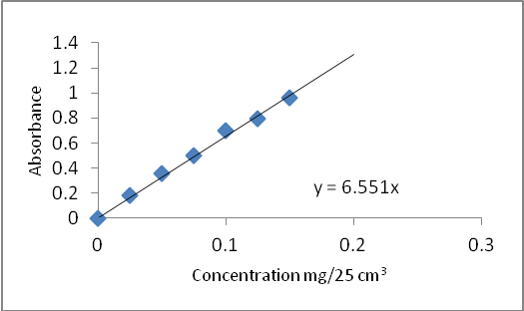

Figure 1. Calibration curve for methylene blue.

Methylene blue Adsorption
Figure 1 is the calibration curve for methylene blue, a plot of absorbance against various concentrations, at a wavelength of maximum absorption (λ_{max})of 665nm. The equation of the line determined from the curve is given by Y = 6.551x.

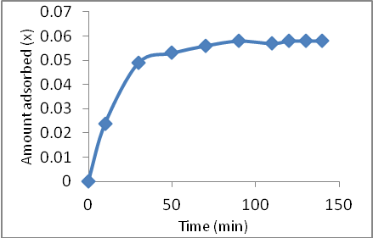

Figure 2. Graph showing time for equilibrium adsorption

From Figure 2, the time for equilibrium adsorption of methylene blue at the wavelength of maximum absorption (λ_{max}) 665nm is 100 minutes. This is less than the stipulated contact time of 2 hours ASTM D3860-98 (2003). However, it was recommended that time for equilibrium adsorption be determined for carbon samples.

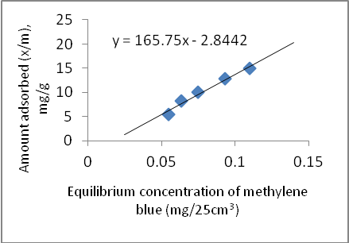

Figure 3. Adsorption isotherm of methylene blue on free PFA carbon at room temperature (28 °C).

.
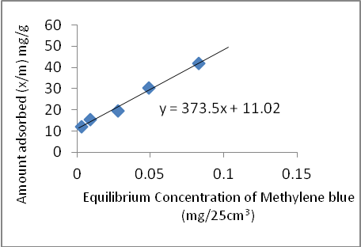

Figure 4. Adsorption isotherm of methylene blue on templated carbon at room temperature (28 °C).

Figures 3 and 4 show the adsorption isotherms of methylene blue at room temperature (28 °C) on both free and templated carbon respectively.
The adsorptive capacity of the carbon for methylene blue is given by the value of x/m at a concentration of 0.0625mg/cm³.
The adsorptive capacity of the free PFA carbon for methylene blue is 256.14mg/g. while the adsorptive

capacity of the templated carbon for methylene blue is 594.61mg/g.

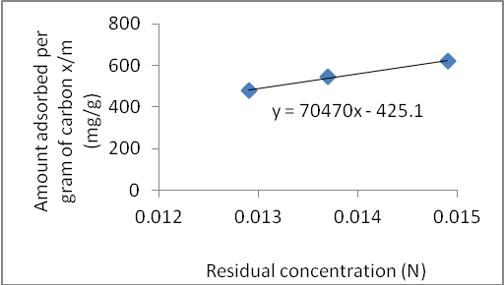

Figure 5. Adsorption isotherm of iodine on free PFA carbon at room temperature (28°C).

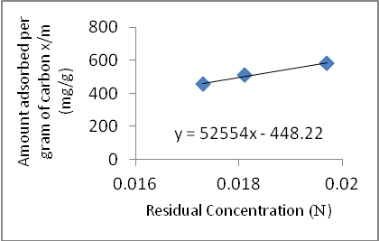

Figure 6. Adsorption isotherm of iodine on templated carbon at room temperature 28°C.

Figures 5 and 6 show the adsorption isotherms of iodine on the free PFA and templated carbon respectively, at room temperature (28°C).
The iodine number of the free PFA carbon is 984.3mg/g. Whereas, the iodine number for the template carbon is 602.88mg/g.

These results show the extents of mesoporosity and microporosity of the synthesized carbon materials as represented by the adsorption of methylene blue and iodine respectively.
The higher value of methylene blue number for the templated carbon compared to the methylene blue number for the free PFA carbon is indicative of the presence of more of wider micropores (> 1.4nm) and mesopores. This can only be explained by the template effect during the synthesis of the templated carbon.

Whereas, the higher value of iodine number for the free PFA carbon as compared to the iodine number for the templated carbon is indicative of the presence of more of micropores (< 0.5nm).
This tends to be in agreement with report by Burket et al., that from 500 °C and above, free PFA carbon is almost completely microporous with pore size centered at 0.4 – 0.5nm (Burket et al., 2006).

Conclusion
In this study, porous carbon was produced using deferrated-kaolinite template. The characterization data presented reveal that the carbon may not necessarily be of a uniform pore size, though, there is a higher degree of mesoporosity in the templated carbon as compared to the free PFA carbon (control). This characteristic is linked with the presence of the template. However, it is difficult to conclude that the carbon is an exact replica of the template material and that it is more ordered than the free PFA carbon as this would require further investigation with more sophisticated equipments.

Correspondence to:
Nwokem Calvin O.
National Research Institute for Chemical Technology, PMB 1052, Zaria, Nigeria.

Telephone: 07026331857
Emails: onyenwokem@yahoo.com, nsi19@yahoo.com

References
- Cláudio de Almeida Filho, Zarbin AJG. Porous carbon obtained by the pyrolysis of TiO₂/Poly(furfuryl alcohol) nanocomposite: Preparation, characterization and utilization for adsorption of reactive dyes from aqueous solution. Journal of Brazillian Chemical Society, 2006;17 (6): 1151-1157.

- Darmstadt H, Roy C, Kaliaguine S, Xu G, Auger M, Tuel A. Solid state C-13-NMR spectroscopy and XRD studies of commercial and pyrolytic carbon blacks. Carbon, 2000;38(9):1279–87.

- Domingo-Garc´ıa M, Lo´pez-Garzo´n FJ, Pe´rez-Mendoza M. Modifications produced by O₂ plasma treatments on a mesoporous glassy carbon. Carbon, 2000;38(4):555–63.

- Fabing S, Jianhuang Z, Peng B, Lu L, Pei-Zhi G, Hong S, Hong LL, Jianqiang Y, Jim YL, Xiu SZ. Template synthesis of mesoporous carbon microfibers as a catalyst support for methanol electrooxidation. Industrial & Engineering Chemistry Research, 2007;46: 9097-9102.

- Goncalves AB, Mangrich AS, Zarbin AJG.
Polymerization of pyrrole between the layers of alpha-tin (IV) bis(hydrogen phosphate). Synthetic Metals 2000;114(2):119–24.

- Joo SH, Choi SJ, Oh I, Kwak J, Liu Z, Terasaki O. Ordered nanoporous arrays of carbon supporting high dispersions of platinum nanoparticles. Nature, Macmillian Mag. Ltd., London, 2001;412:169–72.

- Jun S, Joo SH, Choi SJ, Oh I, Kwak J, Liu Z, Terasaki O. Synthesis of new nanoporous carbon with hexagonally ordered mesostructure. Journal of American Chemical Society, 2000;122:10712–10713.

- Kageyama K, Tamazawa J, Aida T. Extrusion polymerization: catalyzed synthesis of crystalline linear polyethylene nanofibers within a mesoporous silica. Science 1999;285:2113-2115.

- Kawashima D, Aihara T, Kobayashi Y, Kyotani T, Tomita A. Preparation of mesoporous carbon from organic polymer/ silica nanocomposite. Journal of Materials Chemistry, 2000;12(11):3397–401.

- Kyotani T, Tsai IF, Tomita A. Formation of ultrafine carbon tubes by using an anodic aluminium oxide film as a template. Journal of Materials Chemistry, 2000;7: 1427-1428.

- Kyotani T. Control of pore structure in carbon. Carbon 2000;38(2):269–86.

- Kyotani T, Ma Z, Tomita A. Template synthesis of novel porous carbons using various types of zeolites. Carbon 2003;41(7):1451–9.

- Lee JS, Joo SH, Ryoo R. Synthesis of mesoporous silicas of controlled pore wall thickness and their replication to ordered nanoporous carbons with various pore diameters. Journal of American Chemical Society, 2002;124:1156–7.

- Lee J, Han S, Hyeon T. Synthesis of new nanoporous carbon materials using nanostructured silica materials as templates. Journal of Materials Chemistry, 2004;14 :478–86.

- Liu C, Cheng HM. Carbon nanotubes for clean energy applications. Journal of Physics D: Applied Physics, 2005;38, 231.

- Lori JA, Lawal AO, Ekanem EJ. Characterisation and optimisation of deferration of Kankara clay. ARPN Journal of Engineering and Applied Sciences 2007;2 (5), 60-74.

- Ma Z, Kyotani T, Liu Z, Terasaki O, Tomita A. Very high surface area microporous carbon with a three-dimensional nano-array structure: synthesis and its molecular structure. Journal of Materials Chemistry, 2001;13(12):4413–5.

- Ren J, Ding J, Chan KY, Wang H. Dual-porosity carbon templated from monosize mesoporous silica nanoparticles. Journal of Materials Chemistry, 2007;19: 2786.

- Ryoo R, Joo SH, Kruk M, Jaroniec M. Ordered mesoporous carbons. Advanced Materials 2001;13(9):677–81.

- Sakintuna B, Yurum Y. Templated porous carbons: A review article. Industrial & Engineering Chemistry Research, 2005;44: 2893.

- Sang HJ, Seong JC, Ilwhan O, Juhyoun K, Zheng L, Osamu T, Ryong R. Ordered nanoporous arrays of carbon supporting high dispersions of platinum nanoparticles. Nature, Macmillian Mag. Ltd., London, 2001; 412:169-171.

- Su F, Zhou Z, Guo W, Liu J, Tian XN, Zhao XS. Template approaches to preparing porous carbon. In Chemistry and Physics of Carbon;

- Radovic, L. R., Ed.; Marcel Dekker, Inc.: New York. 2007:63-128.

- Wang H, Yao J. Use of poly (furfuryl alcohol) in the fabrication of nanostructured carbons and nanocomposites. Industrial & Engineering Chemistry Research, 2006;45:6393.

- Wenzhong S, Zhijie L, Yihong L. Surface chemical functional groups modification of porous carbon. Recent patents on chemical engineering, Bentham Science Publishers Ltd, New Jersey. 2008;1:27.

- Zakhidov AA, Baughman R, Iqbal Z, Cui C, Khayrullin I, Dantas SO. Carbon structures with three-dimensional periodicity at optical wavelengths. Science 1998;282 :897–901.

- Zhang WH, Liang C, Sun H, Shen Z, Guan Y, Ying P. et al. Synthesis of ordered mesoporous carbons composed of nanotubes via catalytic chemical vapor deposition. Advanced Materials, 2002;14 :1776–8.

- Zheng M, Cao J, Ke X, Ji G, Chen Y, Shen K, Tao J. One-step synthesis of new mesoporous carbon nanofibers through an easy template method. Carbon, 2007;45:111.

- Zimer AM, Bertholdo R, Grassi MT, Zarbin AJG, Mascaro LH. Template carbon dispersed in polyaniline matrix electrodes: evaluation and application as electrochemical sensors to low concentrations of Cu²⁺ and Pb²⁺. Electrochemistry Communications, 2003;5:983–988.

6/29/2010

