An Energy optimisation Approach for WSN

*Vikas Gahlot ¹, Rajender Kumar ² and Anuj Goel ³

- Department of Electronics & Communication Engineering, U.I.E.T., Kurukshetra University, INDIA
- Department of Electronics & Communication Engineering, N.I.T., Kurukshetra, INDIA
- Department of Electronics & Communication Engineering, M.M.U., Mullana, INDIA
*vikasgahlot@gmail.com

Abstract: Energy Optimisation is one of the critical issues and an important research topic in emerging wireless sensor networks (WSNs). There is a greater need of reducing energy/ power consumption in nodes deployed in WSN. Paper investigates key energy models used in WSN and simulates the different battery models. Paper provides a comparative analysis of MICA Motes & MICAZ energy models. Finally Mica-motes seem to be more promising energy model as compared to MicaZ, when deployed in sensor nodes transmitting at higher power level. [Researcher. 2010;2(8):20-23]. (ISSN: 1553-9865).

Keywords: Wireless sensor network, MICAZ, MICA Motes, Nodes, transmission power.

1. Introduction
A wireless sensor network consists of spatially distributed autonomous sensors to cooperatively monitor physical or environmental conditions, such as temperature, sound, vibration, pressure, motion or pollutants. A WSN consists of a large number of unattended sensors with limited storage, battery power, computation, and communication capabilities, where battery power (or energy) is the most crucial resource for sensor nodes [1]. It may be used to sense the parameter in high voltage lines or to measure the temperature in agriculture fields. The usual topology of wireless sensor networks involves having many network nodes dispersed throughout a specific physical area. Energy efficiency and power management is usually characterized before deployment using network simulators or test beds [2]. The figure shows the architecture of wireless sensor network. The node gives information to the server node from there it travels through higher level for processing. Unlike the wire line networks, the wireless channel has several unique characteristics that need to be taken into account when designing wireless networks [3, 4]. Selecting the optimum sensors and wireless communications link requires knowledge of the application and problem definition.
Figure 1.1. Basic Wireless Sensor Network architecture

Battery life, sensor update rates, and size are all major design considerations & challenges for modeling WSN. Transmission delay is equally important to many applications such as disaster monitoring. Therefore to achieve a delay and energy tradeoff networks simulation is necessary [5]. Nodes in wireless sensor networks consist of sensors, processors and communication interfaces (e.g. IEEE 802.15.4). For these applications the used microprocessors should typically have low energy consumption and for that reason have limited processing power [6]. Lifetime is extremely critical for most applications, and its primary limiting factor is the energy consumption of the nodes, which need to be self-powering [7]. Despite the energy efficiency of specific hardware platforms, Sensor network lifetime can be significantly enhanced if the software of the system, including different layers and protocols are designed in a way that lower the consumption of energy [8].

2. Literature Survey
2.1 About MicaZ and Mica Mote Family
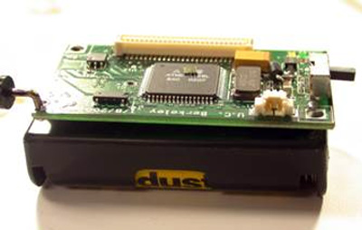
Figure 2. The Mica Mote Node
Mica Mote is a commercially available product that has been used widely by researchers and developers. It has all of the typical features of a mote and therefore can help you understand what this technology makes possible today. MICA Motes are available to the general public through a company called Crossbow. This low power consumption allows a MICA Mote to run for more than a year with two AA batteries [9, 10]. A typical AA battery can produce about one thousand milliamp-hours. However, the programmer will typically write his/her code so that the CPU is asleep much of the time, allowing it to extend battery life considerably.

2.2 Software Simulation

Qualnet's unparalleled speed, scalability, and fidelity make it easy for modelers to optimize different networks through quick model setup and in-depth analysis tools. Models in source form provide developers a solid library on which experiment with new network functionality can be build.

  - Simulation Result
Wireless sensor network is simulated on Qualnet software (from scalable-networks, USA). In WSN both types of hardware i.e. MICA and MICAZ mote are implemented. The energy consumed in transmit mode is taken for both motes at different transmission power level (in milli-decibel). The lifetime of the network can be maximized, since the energy is taken into account while selecting nodes forming a route.

Table1. Energy consumed in WSN
Transmission Power (dBm) | Energy Consumed in transmit mode by Mica Motes Energy Model (mjoule) | Energy Consumed in transmit mode by MicaZ Energy Model (mjoule)
-20 | 0.050675 | 0.057387
-15 | 0.051064 | 0.058335
-10 | 0.051492 | 0.060424
-5 | 0.052846 | 0.067028
-3 | 0.054004 | 0.076903
-1 | 0.057128 | 0.087889
0 | 0.057128 | 0.087889
1 | 0.058749 | 0.095819
2 | 0.060791 | 0.105775
3 | 0.06336 | 0.118308
5 | 0.081297 | 0.15395
10 | 0.146665 | 0.362784
15 | 0.248891 | 1.02317

3. Result and Discussion

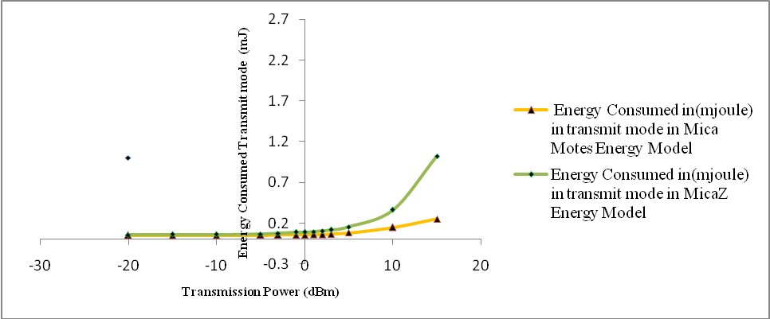
Figure 3 Transmission power vs Energy Consumed in transmit mode for WSN

Energy consumption is calculated for Mica motes & MicaZ energy models in transmit mode. Though there is a gradual increase in energy consumption with increase in transmission power, consumption abruptly increases for MicaZ models when transmitted beyond 10 dbm power level.
The maximum energy is consumed at a peak value of 1.02317 and the minimum energy is consumed having minimum value of 0.057387. In this paper, Comparative analysis of two mentioned energy model is done and performance of WSN using a reactive protocol is investigated. Reactive protocol optimizes distance, available energy, and delay for WSN. While ensuring that the path from the base to the nodes is free from loops, it also ensures that the selected route is both energy efficient, and has a minimal end to end (E2E) delay.
Due to the consideration of energy level in the routing protocol, there is also a balancing of energy consumption across the network. Lifetime of the battery used in WSN can be maximized, since transmitted power is directly related with the rate at which energy is being consumed. This basic operational difference between the two energy model, makes Mica motes a better candidate than MicaZ.

Table 2. Energy consumed in WSN with maximum and minimum values
Energy consumed in | Energy Consumed in transmit mode by Mica Motes Model (mjoule)  Max Min |  | Energy Consumed in transmit mode by MicaZ Model (mjoule)  Max Min
Transmit mode | 0.248891 | 0.050675 | 1.02317 | 0.057387
Receive mode | 0.007307 | 0.007075 | 0.014335 | 0.013879

Conclusion & Future work
There is a gradual increase in energy consumption with increase in transmission power and consumption abruptly increases for MicaZ models when transmitted beyond 10 dbm power level. Thus, Mica motes seem to be more promising energy model as compared to MicaZ when deployed in nodes transmitting at higher power level especially where signals are more prone to fading and shadowing. A feedback system can be provided by the format convertor of each simulator to give feedback about parameters. The scope of the work may incorporate the interworking environment to further evaluate challenges and benefits of the proposed comparison.

Acknowledgement:
The authors are grateful to M.M. University, Mullana (Ambala) and N.I.T., Kurukshetra for providing assistance and laboratory facilities to carry out the work.

Correspondence to:
Vikas Gahlot
Electronics & Communication Engineering Department, U.I.E.T. Kurukshetra University Kurukshetra, 136119 (India)
Email:vikasgahlot@gmail.com
Mobile: +91-9468082734.

References
- Habib M. Ammari , Sajal K. Das , A trade-off between energy and delay in data dissemination for wireless sensor networks using transmission range slicing, Elsevier Transactions on Computer Communications ,Vol. 31, pp. 1687-1704, 2008.
- C. Behrens, O. Bischoff, M. Lueders, and R. Laur, Energy-efficient topology control for wireless sensor networks using online battery monitoring, Advances in Radio Science, Vol. 5, pp.205-208, 2007.
- S. Shakkottai, P. C. Karlsson, and T. S. Rappaport, Cross-Layer Design for Wireless Networks, IEEE Communications Transaction, Vol. 41, Issue 10, pp. 74-80, 2003.
- I.F. Akyildiz, W. Su, Y. Sankarasubramaniam, and E. Cayirci, A survey on sensor networks, IEEE Communications Transaction, Vol. 40, No. 8, pp. 102-116, 2002.
- Wuyungerile Li, Daisuke Okamura, Masaki Bandai, and Takashi Watanabe, Tradeoff between Delay and Energy Consumption of Partial Data Aggregation in Wireless Sensor Networks, International Conference on Mobile Computing and Ubiquitous Networking, pp-1-8, April 2010.
- Sebastiaan Wielens, Michael Galetzka, Peter Schneider, Design Support for Wireless Sensor Networks Based on the IEEE 802.15.4 Standard , IEEE International Symposium on Personal, Indoor and Mobile Radio Communications, pp-1-5, Sep 2008.
- Daniele Puccinelli, and Martin Haenggi, Wireless Sensor Networks, Applications and Challenges of Ubiquitous Sensing, IEEE Circuits and systems magazine, pp.1-11, 2005.
- V. Raghunathan, C. Schurgers, S. Park, and M. Srivastava, Energy Aware Wireless Sensor Networks, IEEE Signal Processing Magazine,vol. 19, pp.40-50, 2002.
- Chris Townsend, and Steven Arms, Wireless Sensor Networks, Principles and Applications, sensor technology Handbook Newness Publication, 2005.
- Jerry Zeyu, Gao,Simon Shim, Hsing Mei and Xiao Su, Engineering Wireless-Based Software Systems and Applications, Artech House Inc, 2006.

07/14/2010

