Population Dynamics And Seasonal Abundance Of Zooplankton Community In Narmada River (India)

*Shailendra Sharma, **Anis Siddique, **Karam Singh, *Meenakshi Chouhan, *Amrita Vyas,.C.M.Solnki, Dhavni Sharma ,Smitha Nair

*Department of Zoology, Shri Umiya Girls College, Mandleshwar -451221 (M.P.) INDIA.
**Department of Zoology, Holkar Science College, Indore-452003 (M.P.) INDIA.
shailendra.b.sharma@gmail.com

Abstract: Zooplankton organisms occupy a central position in the food webs of aquatic ecosystem. They do not only form an integral part of the lentic community but also contribute significantly, the biological productivity of the fresh water ecosystem (Wetzel 2001). The importance of the Zooplankton is well recognized as these have vital part in food chain and play a key role in cycling of organic matter in an aquatic ecosystem. In the present study the total Zooplankton density exhibited a single peak during March. However, a sudden increase was noticed in the month of October which continued till March. This increase is attributed to the settling of rain water return of favourable conditions in post monsoon period.In the present study total Zooplankton comprises of 4 groups: Protozoa, Rotifera, Gladocera, Copepode. Out of this group Rotifera is the dominant group and the order of dominance is as Rotifera > Cladocera > Copepode > Protozoa. [Researcher. 2010;2(9):1-9]. (ISSN: 1553-9865).
Keywords: Zooplanktons,Narmada River, Population dynamics, correlation coefficient seasonal abundance.

INTRODUCTION
Majority of the water bodies in India are temporary, shallow or exhibit such large washer level changes annually that a large proportion of the basin is exposed to drying. The survival strategies of the zooplankton have been reported in a few studies and examined in some detail recently by Khatavkar (1992). Similarly seed banks and seasonal cycles of macrophytes were commented up on by Mishra (1976) and later discussed by Gopal (1998).
Zooplankton communities have been investigated in numerous reservoirs, lakes, and shallow waterbodies (Abbasi et al., (1997) and Sugunan, (1980). The dominance of zooplankton in shallow water bodies by rotifers cladocera or copepods varies according to the degree of organic pollution Moitra & Bhowmik, (1968), Verma & Munshi, (1995), Rao & Durve, (1992). In most of the studies, two or more peaks of zooplankton densities have been recorded which in is generally during the early winter season (December) and the second peak is variable for different groups. Within rotifers and copepods different taxa obtain their peak population at different times, the year, thus keeping the zooplankton diversity relatively high throughout there year. In an interesting study of a highly polluted pond, Abdul Kader et al., (1998), reported complete absence of phytoplankton and total dependence of zooplankton on the bacteria.
Zooplanktons are often an important link in the transformation of energy from producers to consumers Shastree and Pathak, (1993). due to their large density, shorter life span, drifting nature, high group or species diversity and different tolerance to the stress, Zooplankton are being used as a indicator organisms for the physical, chemical and biological process in the aquatic for the physical, chemical and biological process in the aquatic ecosystem Ganguli (1999). Pawar and Sharma (2001) started that the species richness and evenness were inversely related to the zooplankton biomass. Patil (2003) observed that cladocera and meroplanktonic larva reached peak abundance in saline water mass. Mishra (2005) noticed that displacement volume were higher at those stations where swarms of hydromedusae and ctenophores occurred.
1. Material and Methods
1.1 DESCRIPTION OF NARMADA RIVER
The Narmada river, hemmed between Vindya and Satpuda ranges, extends over an area of 98,796 km². And lies between east longitudes 72 degrees 32' to 81 degrees 45' and north latitudes 21 degrees 20' to 23 degrees 45' lying on the northern extremity of the Deccan Plateau. The basin covers large areas in the states of Madhya Pradesh (86%), Gujarat (14%) and a comparatively smaller area (2%) in Maharashtra. There are 41 triburaries, out of which 22 are from the Satpuda range and the rest on the right bank are from the Vindhya range.
Study Area/Sampling Station:
The water samples would be collected from the various selected sampling station in the Narmada river which are as under.
Before finally fixing the sampling stations a general survey of River was made, samples were collected and estimated from various regions in which Narmada river flow. Accordingly & study areas were fixed.
A. Omkareshwar:
Omkareshwar is a famous place of pilgrimages, situated 77 km from Indore in Khandwa District. Madhya Pradesh shaped like the holy Hindu Symbol. ‘OM’, this sacred island, on the conflux of the river Narmada and Kaveri is visited by pilgrims from all over the country to seek blessing at the temple of Shri Omkar Mandhata.
It’s Latitude (D M S) – 22º15’ 1” N and Longitude – (DMS) 76º8’ 48” E
B. Mandleshwar:
Mandleshwar is a small town and a Nagar Panchayat Khargon District in the Madhya Pradesh state of India (Asia). It is a town of historical and religious importance situated on the banks of Narmada river at a distance of 8 km east from Maheshwar, which was the capital of Holkar States and 99 km from Indore.
It’s Latitude– 22º18 Latitude (DMS) 22º10’ 60” N and Longitude –75º67. Longitude (DMS) 75º0’ 0” E.
C. Maheshwar:
Maheshwar is a small town in Khargone district of Madhya Pradesh state in central India. It is located 91 km. away from Indore (4 hour by bus), the commercial capital of the state. The town lies on the North bank of the Narmada river. It’s Latitude– 22º18 Latitude (DMS) 22º10’ 60” and Longitude –75º58, Longitude (DMS) 75º54’ 60” E.
D. Barwani:
Barwani, also known as Barwani or Siddh Nagar, is a city and a municipality in Barwani District in the state of Madhya Pradesh, India. The town is situated near the left bank of the Narmada river. The great Narmada river flows through Barwani (Just 5 km from city). Barwani is located 150 km away from Indore.
It is Latitude– 22º03, Latitude (DMS) 22º1’ 60” N and Longitude –749.9, Longitude (DMS) 74º54’ 0” E.
Collection, preservation and Identification of Plankton:
The plankton samples were collected following Lind (1979, Welch 1953), Wetzel (1975), by filtering 40 Liters of water through plankton net having pore size 64 µ. The concentration plankton samples were fixed in 4% formalin and Lugal’s solution for zooplankton and phytoplankton study respectively.
Zooplankton were identified with the help of keys’ provided by Pemak (1978), Sehgal (1083), Needham and Needham (1962), Tonapi (1980), APHA (1980).
Counting of the individual plankton was done by “Lac Keys” dropping method (1935). Using the formula.
Plankton units/Liter = N x C x 10
Y
N = Number of plankton counted in 0.1 ml. concentrate.
C = Total volume of concentrate in ml.
Y = Total volume of water filtered for sample in liters.
The phytoplankton density was expressed on units/liter and zooplankton density was expressed on individuals/liter.

Population dynamics is analyzed by correlation coefficient: When relationship between variables is of quantitative nature. The Appropriate statistical tool for discovering and measuring the relationship as well as expressing it in brief formula is known as correlation. Correlation analysis helps us in determining the degree of relationship between two variable it doesn’t tell us anything about cause and effect relationship.
- If both variable are changing in the same direction i. e. both are increasing or both are decreasing then they have a positive correlation between them. If they vary in opposite directions they posses negative correlation for calculation purpose formula for coefficient of correlation (Karl pearson method) used is.

n ∑ dx – dy - ∑ dx . ∑ dy
r =
√ (n ∑ dx² – (∑ dx)² . √ (n∑dy² – (∑dy)²

The coefficient of correlation measures the degree of relationship between two sets of figures.
For interpretation purpose.

r = 1 is considered to be prefect positive correlation.
0 < r < 0.39 is considered to be low positive correlation.
0.40 < r < 0.69 is considered to be moderate positive correlation.
0.70 < r < 0.99 is considered to be high positive correlation.
- 0.39 < r < -0.1 is considered to be low negative correlation.
-0.69 < r < -0.40 is considered to be moderate negative correlation.

Results and discussion
Plankton population on which the whole aquatic life depends directly or indirectly is largely governed by the interaction of a number of physical, chemical and biological conditions and tolerance to one or more of these conditions (Reid and Wood 1976). No individual factor like physical or chemical is singly responsible for the fluctuations of phyto or zooplanktonic populations. Number of physical, chemical and biological environmental factors affecting simultaneously must be taken into consideration in understanding the fluctuating of plankton population (Davis 1954).
Zooplankton population of the Narmada river comprised generally Protozoans Rotifers, Cladoceran and Copepods. All dominant groups of Zooplankton were present throughout the year of investigation (analysis). Zooplankton here showed variations in their abundance during different months of the year. The peak period of zooplankton were observed in March (363) with down confluence in April during the year 2009 fig-01-15.
The percentage of the four groups of zooplankton are given in table 9 to 12. The ratio of zooplankton varied from 14.80 to 44.05%. It showed the highest number of rotifers (363) in the zooplankton population among the various groups of zooplanktons next to rotifers cladoceran (191) were the most abundant next to copepods (148). The minimal productions were recorded of protozoans, (122).
In all 39 species of zooplankton were identified, As far the qualitative (species wise) abundance is concerned, the rotifers had 12 species, followed by Cledoceran with 07 species, and Copepod with 5 species and protozoan with 06 species Zooplankton also showed seasonal prefer over, Zooplankton, the Production was maximum during months from January to April.

Group Wise –
      - Protozoa – The maximum number of protozoans were reported in March and the minimum during August, September and October. The average percentage of protozoans in total Zooplankton population was 14.80% only six genera of protozoans were recorded namely Arcella and Diffuzia Euglypha, oppercularis species, Oxytrica spcies, Centropyxis spcies. The deffuzia in abundance.
      - Rotifera – The major portion of the zooplankton population were shared by rotifers. The population of rotifers was maximum in March and was minimum in August. The average percentage of rotifers in total zooplankton population were 44.05% units/l.
The 12 species of rotifers were recorded and the common genera was Brachionus Filinia and Keratella, Brachionus were found throughout the year Filinia was next to Brachionus as for as the numerical abundance of rotifers was concerned. It was recorded in majority of the month.
      - Cladocera – The cladocera were generally abundance from January to April. The maximum number was recorded in March with decline from April to onwards. Moina, Ceriodaphnia, Daphnia and Macrothrix species. common genera. The average percentage of Cladoceran in total zooplankton population was 23.17% only.
      - Copepoda – Copepods were represented in the sample by the genera Cyclops and Mesocylops. This group thriven well from March to April. The maximum number was recorded in March. The average percentage of copepods in total zooplankton population was 18.81%.

Table -01 Showing Coefficient of Correlation between Zooplaktons and Physico-chemical Parameters of Narmada river during August 2008 to April 2009.

Parameters | Protozoa | Rotifera | Cladocera | Copepod
Temperature | 0.747492 | 0.788476 | 0.559019 | 0.532191
pH | 0.239459 | 0.284112 | 0.313509 | 0.339372
Total dissolved O2 | -0.57661 | -0.56231 | -0.4947 | -0.52996
B.O.D. | -0.61697 | -0.67972 | -0.59941 | -0.60376
Chloride | 0.377705 | 0.434782 | 0.134917 | 0.109502
Phosphate | -0.82446 | -0.84005 | -0.7622 | -0.7883

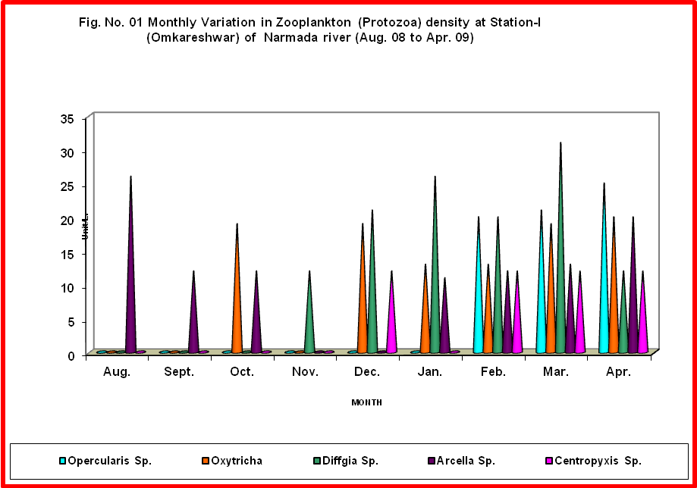

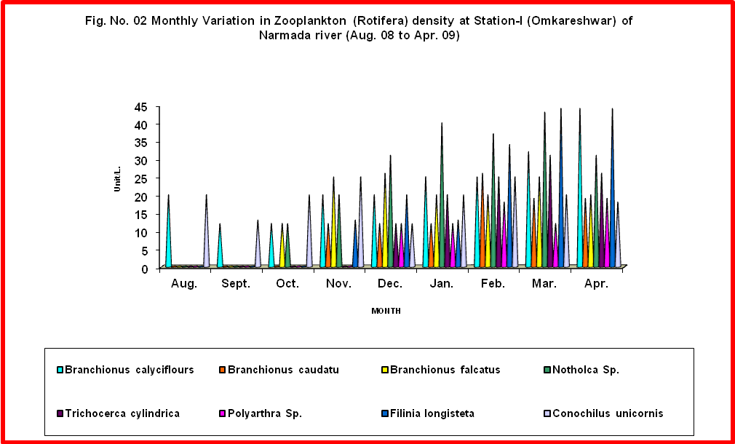

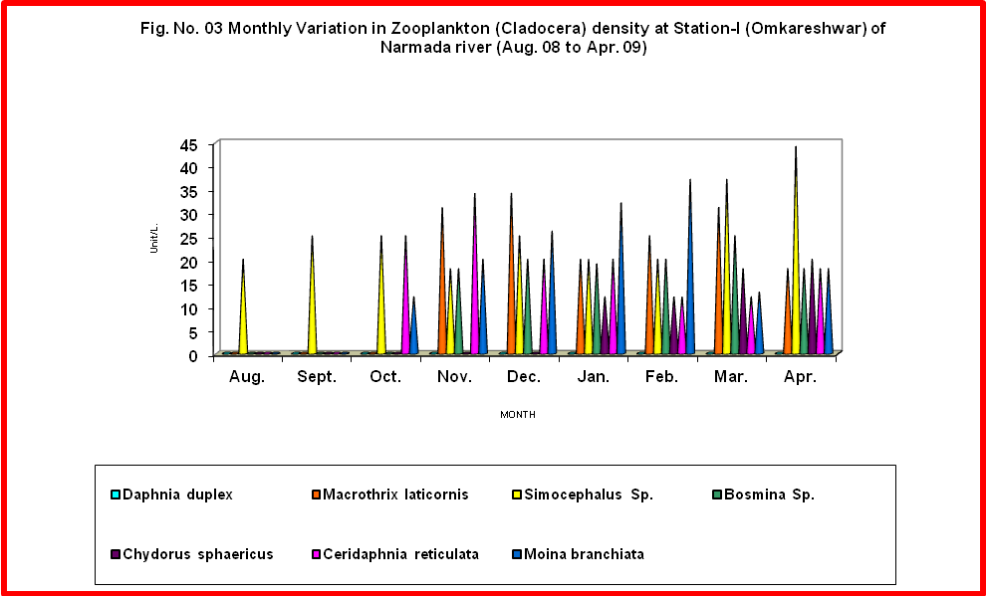

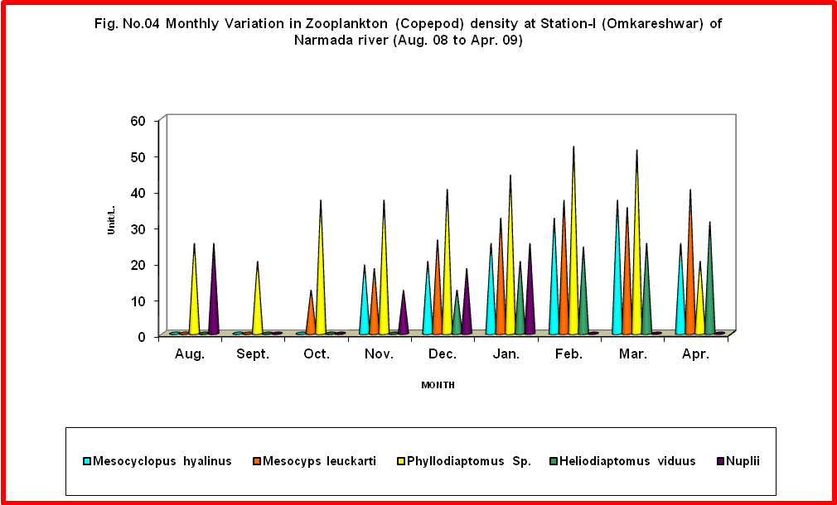

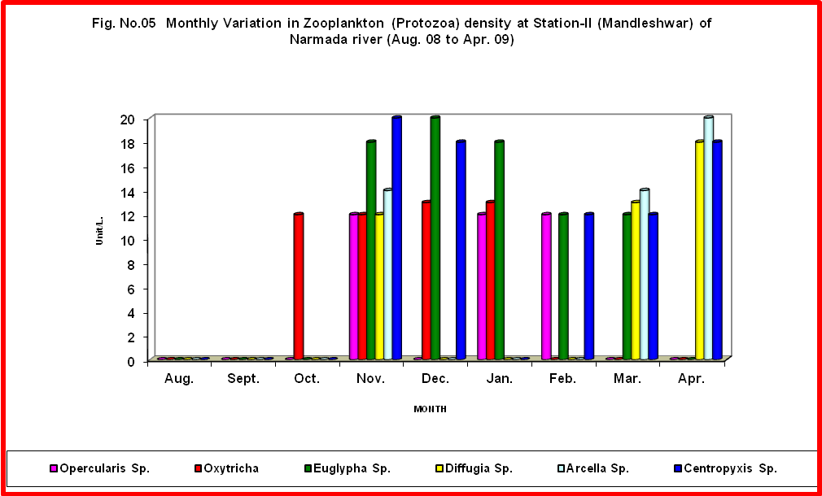

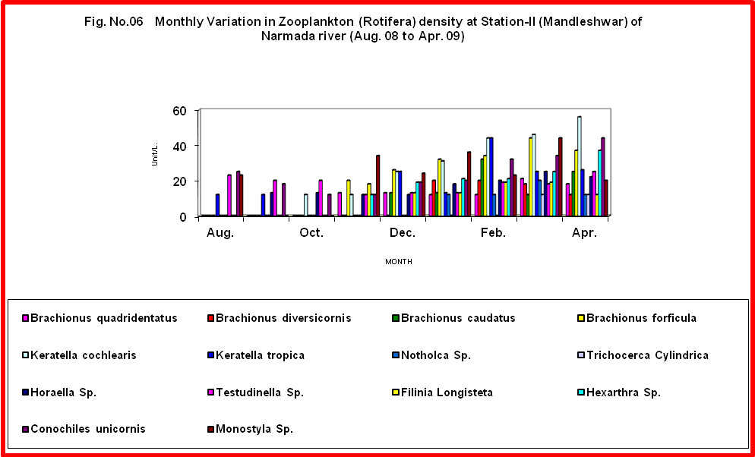

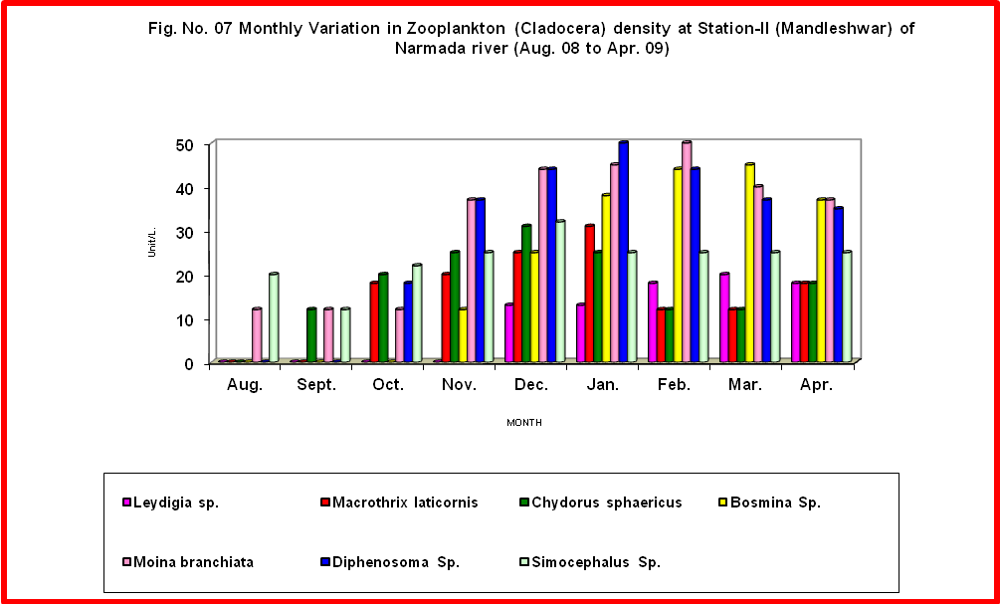

0
10
20
30
40
50
60
Unit/L.
Aug.
Sept.
Oct.
Nov.
Dec.
Jan.
Feb.
Mar.
Apr.
MONTH
Fig. No. 08 Monthly Variation in Zooplankton (Copepod) density at
Station-II (Mandleshwar) of Narmadar river (Aug. 08 to Apr. 09)
Mesocyclopus hyalinus
Mesocyps leuckarti
Phyllodiaptomus Sp.
Heliodiaptomus viduus
Nuplii

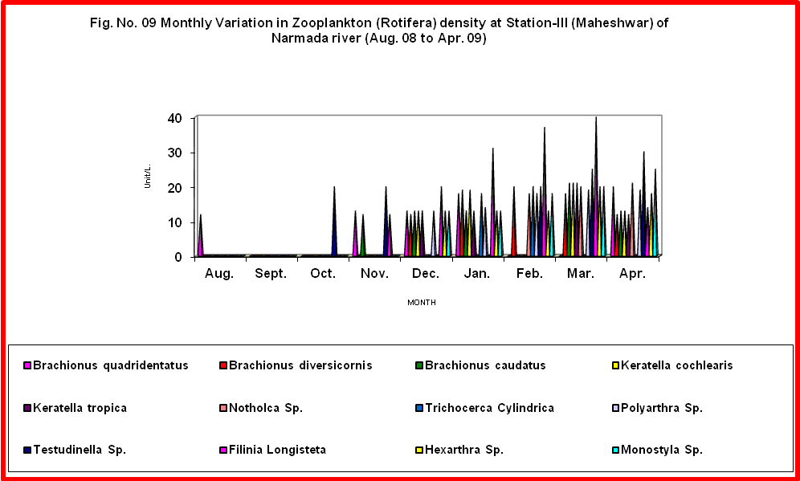

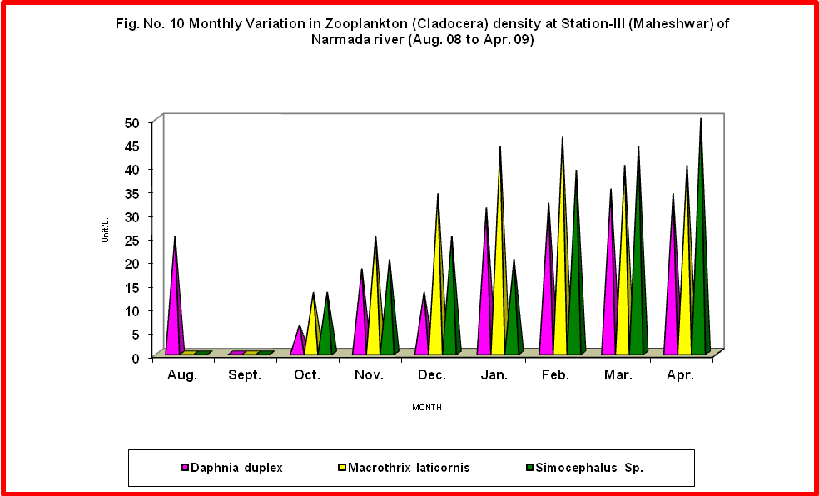

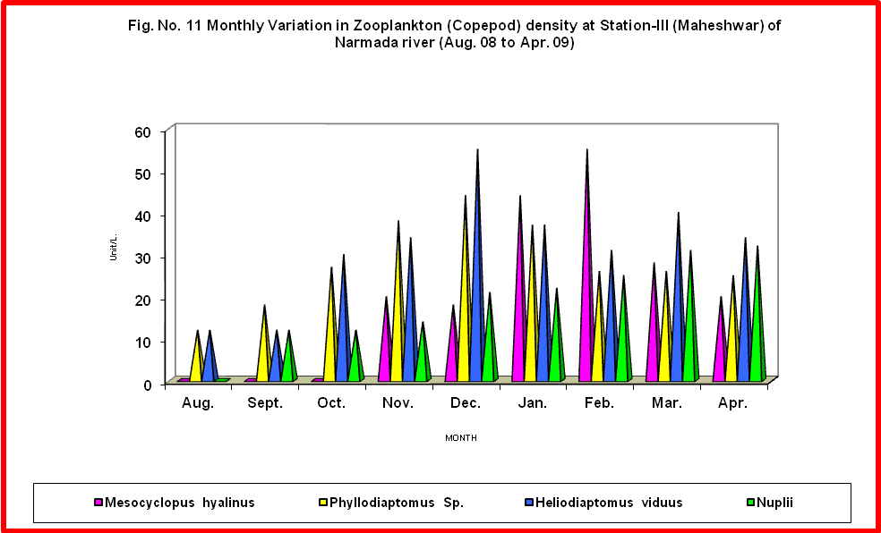

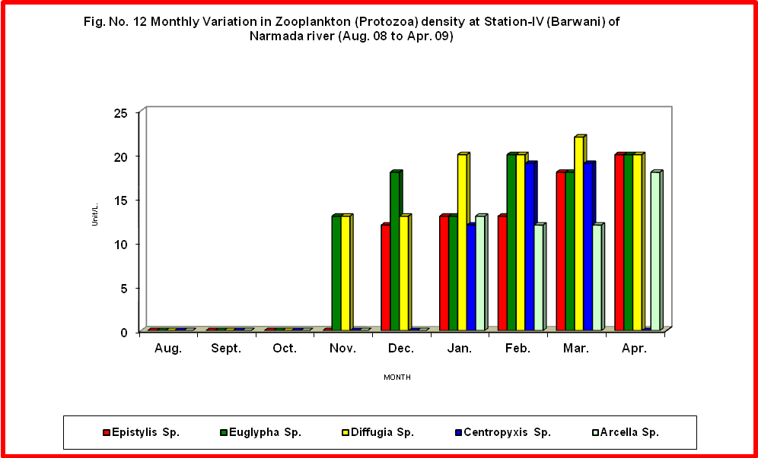

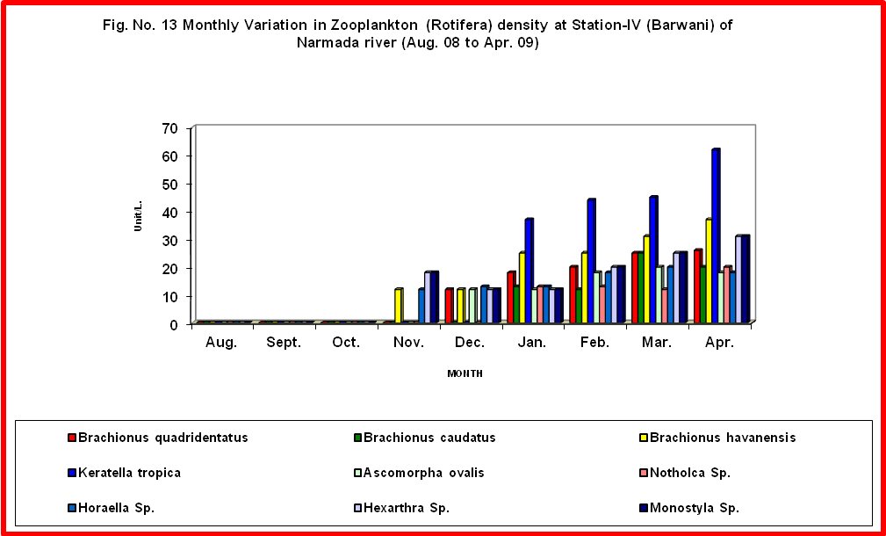

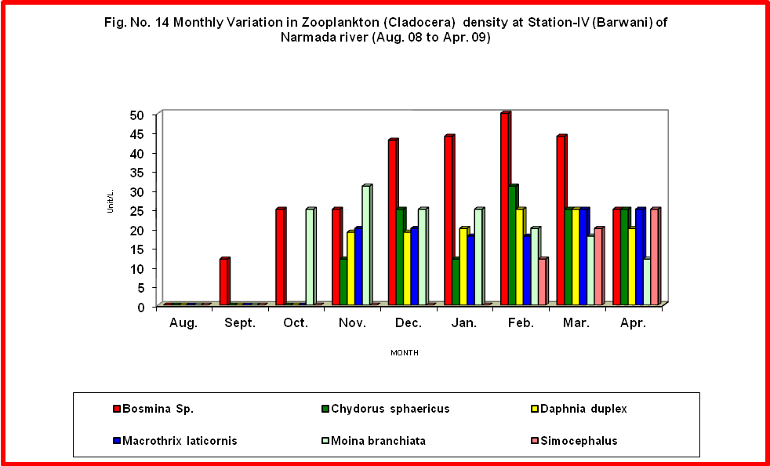

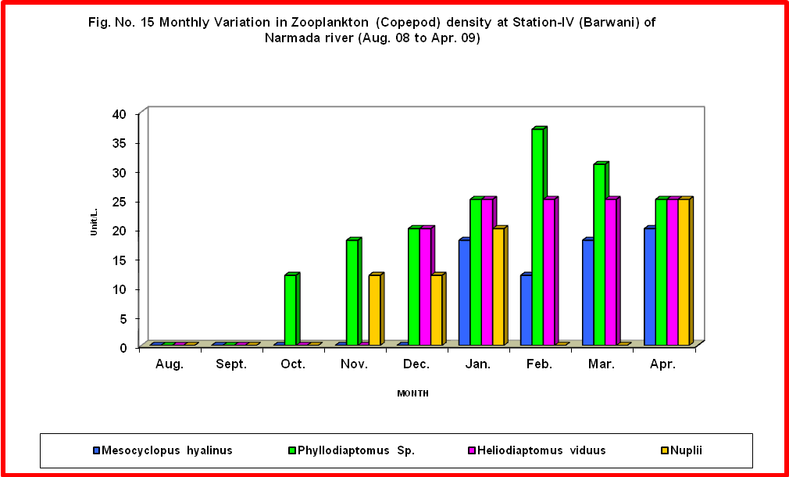

Evaluation of Zooplankton density and distribution:
Zooplankton organisms occupy a central position in the food webs of aquatic ecosystem. They do not only form an integral part of the lentic community but also contribute significantly, the biological productivity of the fresh water ecosystem (Wetzel 2001). The importance of the Zooplankton is well recognized as these have vital part in food chain and play a key role in cycling of organic matter in an aquatic ecosystem.
Keeping in view the interaction between Zooplankton and their environment, in the present study the total density, seasonal variation in density, temporal variations, species composition and correlation with various physico-chemical and biological parameters are dealt and discussed.
In the present study the average density of total Zooplankton ranged between 89.8 Ind/l in August and September to 771.3 Ind/l. in March.
In the present study the total Zooplankton density exhibited a single peak during March. However, a sudden increase was noticed in the month of October which continued till March (Table 9 to 12). This increase is attributed to the settling of rain water return of favourable conditions in post monsoon period. However many workers Welch, (1952), Das and Shrivastava (1956), Mohanta (2000) reported bimodel pattern of Zooplankton list. Sompato et al., (2002) and Patil et al., (2003) also reported a single peak but in the month of October from Madurai water body.
Significant negative correlation between Zooplankton density and dissolved oxygen as obtained in the present study is attributed to low dissolved oxygen concentration during the month of summer months which is the period for the maximum density of Zooplankton. The reduction in oxygen concentration April also is due to increased respiratory rate of Zooplankton.

Temporary variation in Zooplankton.
In Narmada River the total Zooplankton comprises of four groups Protozos, Rotifera, Cladocera and Copepoda. These groups are represented in order of dominance as Rotifera > Cladocera > Copepod > Protozoa.

Rotifera
The Rotifers are microscopic soft bodies’ fresh water invertebrates. Their distribution and ecology have interesting evolutionary implications (Krishnamoorthy and Sakhivel 2007). Rotifers have often been used to indicate trophic status of a water body.
During the present study rotifers stand first in order to abundance and exhibiting a bimodal pattern with the minor peak (51.3 Ind/l) in the month of August and the major peak (344.3 Ind/l) in the month of March.
The present study clearly reveals the significant positive correlation between temperature, pH, Chloride and rotifers density. Singhai et al., (2004), Correlets rotifers abundance in relation to other abiotic factors like dissolved oxygen, pH, transparency and chlorides in the study on Narmada river.

Cladocera
The group Cladocera Species comprised of water fleas is common occurance in almost all the fresh water habitats. These represent an important link in the aquatic food chain and form the favourable food for both young and adult fishes.
Among the total Zooplankton population, Cladocera Species is reported as second in order of abundance in Narmada river.
In the present study the peak in Cladoceran Species population during March month showed the preference of the group towards the increasing temperature along with increase in alkalinity, pH, Ca and chlorides. Choubey (1991) also supported the present finding in his studies on Narmada river.

Copepods
The living copepods constitute an essential link in the aquatic food chain. Though they are not as important element in fish diet as the Cladoceran Species however they are in intermediate trophic level among bacteria, algae and protozoa on one hand and small and large plankton predators on the other.
The Copepods population ranked third in order of dominance during the study period in Narmada river. The group exhibited two peaks, the major peak in April and the minor peak in January.
In the present study Phyllodiaptomus species were recorded in moderate numbers throughout the year except monsoon season.
In the present study the copepod population shows positive correlation with temperature, pH, total dissolved oxygen and chloride, (Table 19) Abhay Kumar Singh (2002) experimentally proved the effect of temperature on body form of copepods. Webber and Myers (2005) comments that copepods are much more tolerant to oxygen deficiency.
Mesocyclopus hyalinus Species is the second dominant species. This species is recorded only at reservoir sites. The maximum density of this species recorded in March and April Months. This species also shows preference for high temperature, pH and nutrients.
Protozoa
Protozoan planktons are the smallest in size essentially form a link in food chain in an aquatic ecosystem. The protozoan population in Narmada river contributed only 14.8% of total Zooplankton and represented by 10 species. The maximum average density has been reported in March (101.8 Ind/l) and minimum in August (7.2 Ind/l). Protozoan species are not recorded during monsoon months. Biswas (2000) also recorded the protozoan population with the least percentage contribution among total zooplankton.
In the present study the protozoan population dynamic is positively correlated with temperature pH, chloride. Rao (2001), also observed the direct relationship between protozoa, pH and dissolved oxygen this view was further exported by Tungawat (2001).

REFERENCES
- Abhay Kumar Singh (2002): Quality Assessment of surface and sub-surface water of Damodar river basin, India J. Environ. HLTH 1 Vol. 44 (1) PP. 41-49.
- APHA (1998): Standard methods for Examination of water and waste water American public health Association 20th Ec. APHA, New York.
- Battish, S. K. (1992). Freshwater Zooplankton of India. Oxford and IBH Publication Co. New Delhi.
- Dodson, S. (2005): Introduction to Limnology. ISBN 0-07-284935-1.
- Duncan, A. (1983): The composition density and distribution of the zooplankton in Parakrama Samudra in Schimer. f (ed) Limnology of Prakarma. Samudra Srilanka. Dr. W. Junk The Hague PP 85-94.
- Edmondson, W. P. (1997): Population dynamics and secondary production, Ergeb. Limnol. Vol. (8). PP. 56-64.
- Fernando, G. H. (1980): The fresh water zooplankton of Srilanka, with a discussion of Tropical fresh water zooplankton composition. Int. Rev. Ges, Hydrobiol. Vol. (65). PP 85-125.
- G. Krishnamoorthy, S. Rajalakshmi and D. Sakthivel (2007): Diversity of Zooplankton in mangrove Areas of Puducherry, India, J. Aqua. Bio. Vol. 22 (1) PP 45-48.
- G. T. Tonapi (1962): Fresh water animals of India an ecological approach. Head Department of Zoology, University of Poona. Ganeshkhind Poona 411007.
- Ganapati, S. V. (1955): Hydrobiological investigation on the stanly Reservior and of the river Cauvery at Mattur Dam. Mat. Kam. Vol. 6 (2): PP. 1-8.
- Golterman, H. L. (1975): River ecology (Edited by B.A. Whitton) Black-Weel Scientific Publications Oxford, London, Edinburg Melbourne PP. 39-80.
- Gopal, B. and Zutschi, D. P. (1998), Fifty years of hydro biological research in India, Hydrobiologia, Vol. (384) PP. 267-290.
- Green, J. (1960); Zooplankton of river Skuto. The Rotifera; Proc. Zool. Soc. London. Vol. (135) PP. 491-523.
- Kalff. J. (2002): Limnology prentice hall New Jessy PP 592.
- Khanna, D. R. and Singh, R. K. (2000): Seasonal fluctuation in the plankton of Suswa river at Raiwal (Dehradun). Environ. Cons. J. Vol. 1(2 & 3): PP 89-92.
- Munawar, M. (1970): Limnological studies on fresh water ponds of Hyderabad, India II Hydrobiologia Vol. (31): PP 101-128.
- Needham, J G. Needham, P. R. (1962). A Guide to the study of freshwater biology. Holdend-day inc. Sanfrancisco, California: 108.
- Neves, I. F., O. Rocha, K. F. Rocha, K. F. Roche and A. A. Pinto (2003): Zooplankton community structure of two marginal lakes of the River Cuiaba (Mato Grasso, Brazil) with analysis of rotifera cladocera diversity Braz. J. Bio. Vol. 62 (3) PP 329-345.
- Pandit, S. V., V. V. Vaidya and P. P. Joshi (2007): The study on zooplankton Diversity of Pravara river, Near Sangamner city, Dist. Ahmednagar, Maharashtra. J. Aqua. Biol. Vol 22 (2) PP 33-38.
- Roy, P. N. (2002): Studies on Hydrological status of stream in Santel Pargans (South Bihar) with special reference to pollution. Indian J. Environ. & Ecoplan. Vol. 3(1): PP.127-130.
- Sharma, Anupam, Gupta T. R. C. and Prabhu, H. V. (1999): Studies on zooplankton community of the Tungabhadra river in Karnataka receiving domestic sewage from Haridwar region J. Envi & Pollu. Vol. 6 (2 & 3): PP. 161-166.
- Unni, K. S. (1997): Ecology of Narmada river Ashish Publishing House New Delhi Vol. 371, P-8. Rao, N. G. and Durve, V. I. (1992): Structure and dynamics of zooplankton community in lake Raga Sagar, Udaipur, India. J. Environ. Biol; Vol. 13 (3): 343 – 355.
- Vandysh, O. I. (2004): Zooplankton as an indicator of state of lake of ecosystems polluted with mining waste water in the Kolapeninsula. Russian J. Ecol., Vol. 35 (2) PP 110-116.
- Verghese Susan P. singh Monika and Mishra Anjali (2005): An Assessment of water quality of river Yamuna during Mansoon at Agra City” Indina J. Env. Prot. Vol. 25 (10) PP: 893-898.
- Ward, H. B. and Whipple, G. C. (1954). Fresh water biology 2nd edition. John Wiley and sons. New York.
- Welch, P. S. (1952): Limnological methods. Blakiston Co; Philadelphia. Pa.
- Wetzell, R. G. (2001): Limnology: Lake and river Ecosystem, 3rd ed. Academic Press. ISBN –12-744760-1.

8/30/2010

