Drug designing and docking efficacy assessment of halogen substituted aspirin

¹Debyani Samantray, and ¹R.K. Sahu
¹Department of Bioinformatics, B.J.B (A) College, Bhubaneswar, Orissa, India
sahurajani.sahu@gmail.com, debyani.samantray@gmail.com

Abstract: COX-2 inhibitors are a class of drugs which selectively inhibit cox-2, an enzyme involved in inflammation pathway. Prostaglandins induce inflammation, pain and fever. Aspirin blocks the enzyme cyclooxygenase (COX-1,2) which is involved in the ring closure and addition of O₂ to arachidonic acid converting to prostaglandins . The present study was undertaken to analyze the docking efficacy of aspirin with the target molecule (1IGX) and to assess the best ligand for inhibiting COX and to analyze the docking programme by ARGUSLAB. Substituting the –Cl ion in place of –OH group in aspirin showed two hydrogen bonds with phenylalanine and glutamine residues as its docking site where as substituting the –Br ion showed two hydrogen bonds with Histidine and glutamine residues as its docking site. The finding suggests halogen substituted Aspirin to be a better ligand preferably with Bromine. However clinical trials and laboratory investigation will help in marketing the modified drug.
[Debyani Samantray and R.K. Sahu. Durg designing and docking efficacy assessment of halogen substituted aspirin. Researcher. 2010;2(10):17–23] (ISSN: 1097 – 8135).

Key words: Cyclooxygenase, Docking, Drug designing, Aspirin, Ligand.

- Introduction
Cyclooxygenase (COX) is an enzyme (EC 1.14.99.1) that is responsible for formation of important biological mediators called prostanoids (including prostaglandins, prostacyclin and thromboxane). Pharmacological inhibition of COX can provide relief from the symptoms of inflammation and pain; this is the method of action of non-steroidal anti-inflammatory drugs, such as the well-known aspirin and ibuprofen. The names "prostaglandin synthase" is still sometimes used to refer to the COX enzyme (Green, 2001). In the course of the search for a specific inhibitor of the negative effects of prostaglandins which spread the positive effects, it was discovered that prostaglandins could indeed be separated into two general classes which could loosely be regarded that as “good prostaglandins” and “bad prostaglandins”, according to the structure of a particular enzyme involved in their biosysnthesis, cyclooxygease. Prostaglandins whose synthesis involves cyclooxygease-1 enzyme, or COX-1, are responsible for maintaince and protection of the gastrointestinal tract, while Prostaglandins whose synthesis involves the cyclooxygease-11 enzyme or COX-2, are responsible for inflammation and pain. The existing non-steroidal anti-inflammatory drugs (NSAIDs) differ in their relative specificities for COX-2 and COX-1; while aspirin in equipotent at inhibiting COX-2 and COX-1 enzymes in vitro (Aaron et al., 2002).
The first crystal structure of human cyclooxygenase-2, in the presence of a selective inhibitor, is similar to that of cyclooxygenase-1. The structure of the NSAID binding site is also well conserved, although there are differences in its overall size and shape which may be exploited for the further development of selective COX-2 inhibitors. A second COX-2 structure with a different bound inhibitor displays a new, open conformation at the bottom of the NSAID binding site, without significant changes in other regions of the COX-2 structure. These two COX-2 structures provide evidence for the flexible nature of cyclooxygenase, revealing details about how substrate and inhibitor may gain access to the cyclooxygenase active site from within the membrane (Goetzl et al., 1995; Smith et al., 1991). COX-1 and COX-2 are both targets of nonselective nonsteroidal antiinflammatory drugs (nsNSAIDs) including aspirin and ibuprofen, while COX-2 activity is selectively blocked by COX-2 inhibitors called coxibs (e.g., celecoxib) (Grosser et al., 2006). Aspirin is an acetyl derivative of salicylic acid that is a white, crystalline, weakly acidic substance, with melting point 137°C (Fig-1).
Aspirin is unique to a third group of inhibitors that cause a time-dependent, covalent inhibition. Binding of aspirin by PGHS-1 or PGHS-2 leads to an irreversible acetylation of a highly conserved Ser-530 (Rouzer and Marnett, 2003; Schneider et al., 2007; Smith, 2008; van der Donk et al., 2002). Aspirin acetylates one monomer of PGHS-1 to cause a temporally correlated loss of COX activity (Rimon et al., 2010). COX-1 and COX-2 are homodimers that exhibit half of sites enzymatic activity (Yuan et al., 2006; Yuan et al., 2009), and many nsNSAIDs, apparently those involved in time-dependent inhibition, maximally inhibit the enzymes upon binding to only one monomer (Yuan et al., 2006; Kulmacz and Lands, 1985). However, it appears that nsNSAIDs that are reversible, competitive inhibitors of COXs must bind to both monomers to cause enzyme inhibition (Prusakiewicz et al., 2009). Similarly, fatty acids are bound to both monomers of a dimer during catalysis (Yuan et al., 2009). Fatty acid binding to the first monomer transforms it to an allosteric monomer that, in turn, modulates the substrate specificity of the second, now catalytically active, partner monomer.
Coxibs, at concentrations that do not inhibit COX-1 catalytic activity, have been reported to interfere with the abilities of nsNSAIDs including aspirin to inhibit COX-1 in vitro (Rosenstock et al.,1999; Ouellet et al., 2001). This suggests that COX-2 inhibitors are able to bind to COX-1 and somehow compete with nsNSAID actions on COX-1 without affecting AA oxygenation. This is a potentially important clinical issue because many elderly patients take a combination of a coxib for pain relief and low-dose aspirin to counterbalance the potential cardiovascular side effects of coxibs (Grosser et al.,2002). Extensive clinical trial data on interactions between aspirin and coxibs are only available for one coxib, rofecoxib (Gladding et al., 2008), and no significant effect on aspirin inhibition of thrombosis was detected. However, rofecoxib is the COX-2 inhibitor that is least effective in attenuating aspirin inhibition of COX-1 in vitro (Ouellet et al., 2001). Currently, the most widely used coxib is celecoxib. In two small trials with healthy human volunteers, the effects of aspirin were found not to be attenuated by celecoxib (Gladding et al., 2008); however, in both trials, the volunteers were given a 324 mg daily dose of aspirin, which is four times the dose of 81 mg commonly considered to be “low-dose” aspirin. In a potentially related study, celecoxib did attenuate aspirin inhibition in a dog model of thrombosis (Hennan et al., 2001).
In the present study, we have used substituted the halogen compounds (Cl, Br) in place of -OH groups in the best chosen ligand (Aspirin) elaborates the minor change with the best ligand pose of ligand molecule after substitution.
2. Materials and Methods
In the field of molecular modeling, docking is a method which predicts the preferred orientation of one molecule to a second when bound to each other to form a stable complex (Lengauer and Rarey, 1996). Knowledge of the preferred orientation in turn may be used to predict the strength of association or binding affinity between two molecules using for example scoring functions. Docking is frequently used to predict the binding orientation of small molecule drug candidates to their protein targets in order to in turn predict the affinity and activity of the small molecule. Hence docking plays an important role in the rational design of drugs (Kitchen et al., 2004).
In our study the legand Aspirin will docked with receptor molecule by using the softwares and bioinformatics tools, PDB, NCBI, DB, PYMOLE, AUTO DOCK, CHEM SCKTCH and ARUGUS LAB (Lengauer et al., 2008). The detail procedure is mentioned in flow chart-1 and 2.
- Docking of aspirin with the target molecule 1igx was processed in the following manner.
- Retrieval of receptor from PDB.
- Retrieval of ligands from (NCBI tool, PUBCHEM compound and Drug Bank database).
- Interaction of target and ligands in ARGUSLAB.
- Docking of target and ligand.
- Visualization of molecule in PYMOL to find out the best ligand.
- Modifying the ligand to design a drug by using chem scketch. Substituted halogen ions (Cl, Br) in place of oh and h groups.
- 3-D optimization was performed.
- Docking of the substituted ligand using ARGUS LAB was performed to get the better result
3. Results and Discussion
Initially the Target, 1IGX is docked with the geometrically optimized ligand Aspirin and the best ligand pose with the hydrogen bonds were tabulated. (Fig-3,4,5 and Table-1 )The docking results of 1IGX and each ligand were found to vary with the best ligand pose and the presence of hydrogen bonds. Aspirin revealed one hydrogen bond with phenylalanine residue at its docking site. We substituted the halogen groups (Cl, Br) in place of -OH groups in the best chosen ligand, (Aspirin) and the changes are revealed with the best ligand pose of halogen substituted ligand molecule. Substituting the -Cl ion in place of –OH group in aspirin showed two hydrogen bonds with phenylalanine and Glutamine residues as its docking site (Fig-6,7,8) whereas, Substituting the -Br ion in place of –OH group in aspirin showed two hydrogen bonds with Histidine and Glutamine residues as its docking site.(Fig-9,10,11).
Scoring functions are fast approximate mathematical method used to predict the strength of the non-covalent interactions between two molecules after they have been docked. Most commonly one of the molecules is a drug and second is target molecule such as protein receptor. It can also predict the strength of inter molecular interaction. In the present study the scoring function of the halogen substituted aspirin is higher than normal aspirin (Table-1). Among the two halogen groups Br demonstrated higher scoring function in comparison to Cl. This gives us a clue regarding the stronger affinity and strength of inter molecular Vanderwaals and electrostatic interaction inside the molecular complex and the energies of two binding partners (Jain, 2006; lensik et al 2007; Bohm, 1998).

Conclusion
It is concluded that the structural modification done to the aspirin has undergone few changes with the help of docking software. The structural and functional relationship with the target is well established and reveals more hydrogen bonds and scoring function which function with better affinity with target molecule. Hence the substitution of halogen substituted aspirin appears to be a better ligand among which substitution of bromine proves to be better than chlorine .However pharmacokinetics activity and toxicological investigation in experimental approach will authenticate the positive effect of the modified aspirin.
Acknowledgement
Authors are thankful to Dr. S.K. Rout the Advisor of Heritage Vision, B.J.B Autonomous College and also thankful to Yogamaya Dhal for helping in computation work and constant encouragement.

Table-1
The docking efficacy of halogen substituted cox inhibitor
Sl.No | Target | Ligand | Total No. of grid points |  | Best ligand pose Kcal/mol | No. of Hydrogen bonds
1 | 1IGX | Aspirin | Not Substituted | 3442951 | -9.93768kcal/mol | 1
2 | 1IGX | Aspirin | Substituted with Bromine | 3442951 | -10.4621 kcal/mol | 2
3 | 1IGX | Aspirin | Substituted with Chlorine | 3442951 | -10.3571 kcal/mol | 2

Flow chart-1: Description of the retrieval and optimization for docking
REMOVE HETATOMS AND SAVE
DRUG BANK DATABASE
RETRIEVAL OF LIGANDS
ASPIRIN
ADD HYDROGEN AND GEOMETRY OPTIMISATION OF LIGAND & SAVED
A
OPEN LIGAND & SELECT RESIDUE

PUBCHEM COMPOUND
NCBI TOOL
RETRIVE 1IGX RECEPTOR
RCSB PDB
OPEN RECEPTOR
ADD HYDROGEN TO RECEPTOR & SELECT RESIDUE
MAKE GROUPS –SELECT BINDING SITE
MAKE GROUPS-LIGAND SITE
SETUP DOCK CALCULATION
NOTE THE TOTAL NO.OF GRID POINTS & BEST LIGAND POSE
SAVE THE DOCKED MOLECULE BOTH IN AGF & PDB FORMAT

OPEN THE DOCKED MOLECULE IN PYMOL VIEWER
NOTE THE HYDROGEN BONDS
A

Flow chart-2. To analyze the docking efficacy of halogen substituted cox- inhibitors
OPEN THE CHEMSKETCH TOOL

OPEN THE BEST LIGAND
(ASPIRIN)

SUBSTITUTE THE HALOGEN GROUPS (Cl, Br) IN PLACE OF OH GROUPS

PERFORM 3D OPTIMISATION

OPEN THIS MODIFIED LIGAND IN ARGUSLAB

REPEAT THE DOCKING PROCESS

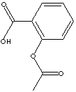
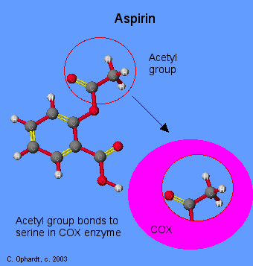

Fig-1 Structure of Aspirin Fig-2 Aspirin blocks the enzyme Cyclooxygenase
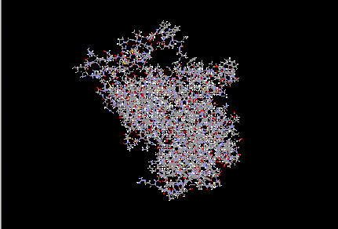
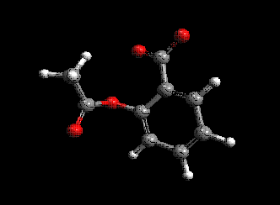

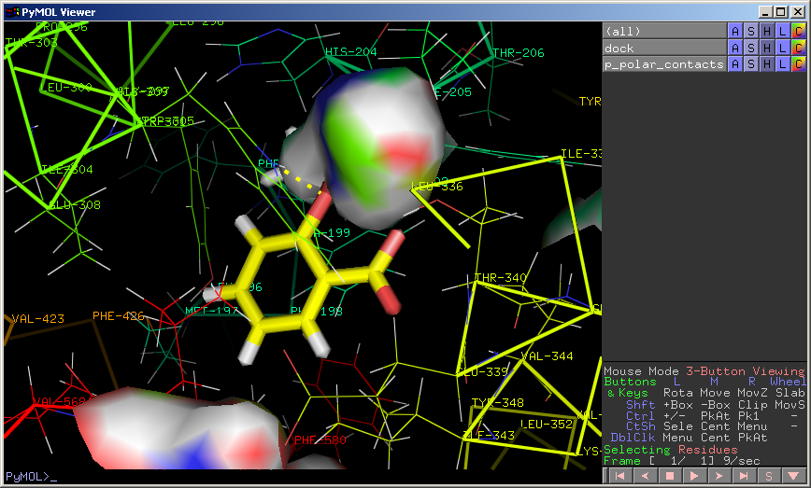
Fig-3 1IGX –target Fig-4 Aspirin – geometry optimization (Removal of H atoms and addition of hydrogen)
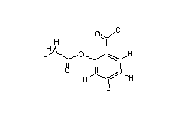

Fig-5 Aspirin docked with 1IGX –Pymol viewer Fig-6 Aspirin substituted with chlorine
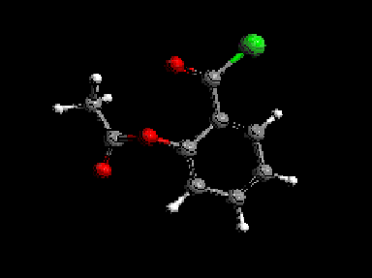
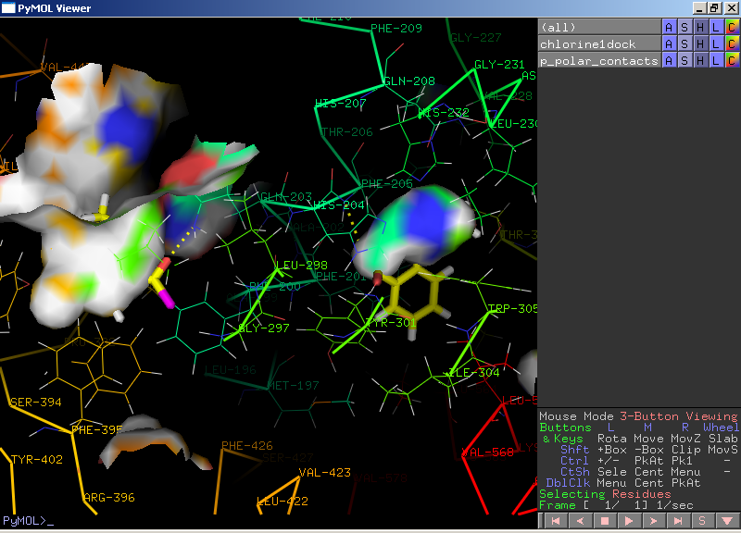

Fig-7 Aspirin substituted with chlorine- geometry optimization Fig-8 Chlorine substituted Aspirin docked with 1IGX-Pymo
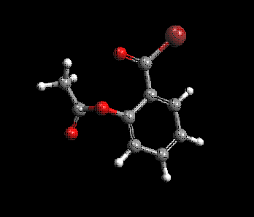
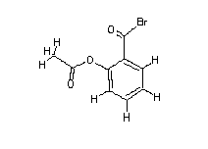

Fig-9 Aspirin substituted with bromine Fig-10 Aspirin substituted with bromine – geometry optimizatio

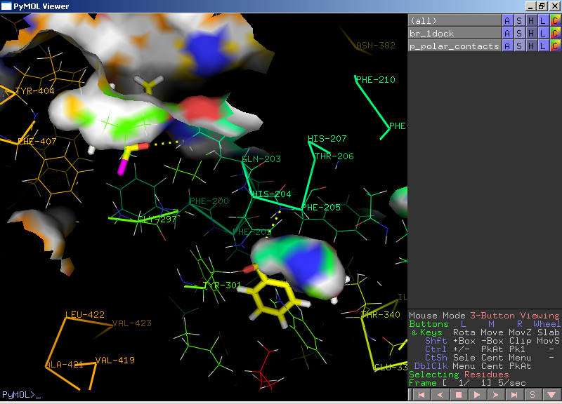

Fig-11 Bromine substituteed aspirin docked with 1IGX- Pymol
Refernces
- Aaron J.M., Johon Broekman M., Pinsky D.J. Cox inhibitors and thromboregulation. New England .J. Med. 2002;347(13): 1025-1026.
- Bohrn H.J. Prediction of bindings constants of protein ligands: a fact method for the prioritization of hits obtained from de novo design or 3D data base search programs J. Comput Aided Mol.Des. 1998;12(4): 309-23.
- Goetzl, E.J., An, S. & Smith, W.L. Specificty of expression and effects of eicosanoid mediators in normal physiology and human diseases. FASEB J. 9, 1995;1051−1058.
- Green G.A. Understanding NSAIDS: from aspirin to cox-2. Clin Cornerstone. 2001;3(5): 50-60.
- Grosser T, Fries S, FitzGerald GA. Biological basis for the cardiovascular consequences of COX-2 inhibition: Therapeutic challenges and opportunities. J Clin Invest. 2006;116(1):4–15.
- Hennan J.K., Huang J., Barrett T.D., Driscoll E.M., Willens D.E., Park A.M., Crofford L.J., Lucchesi B.R. Effects of selective cyclooxygenase-2 inhibition on vascular responses and thrombosis in canine coronary arteries. Circulation. 2001;104:820–825.
- Jain A.N. Scorings function for protein – ligand docking. Curr. Protein Pept. Sci. 2006; 7(5):407-20.
- Kitchen D.B., Decornez H., Furr J.R., Bajorath J. Docking and scoring in virtual screening for drug discovery: methods and applications. Nature reviews. Drug discovery. 2004;3 (11): 935–49.
- Kulmacz R.J., Lands W.E.M. Stoichiometry and kinetics of the interaction of prostaglandin H synthase with anti-inflammatory agents. J Biol Chem. 1985;260(23):12572–12578.
- Lengauer T. & Rarey M. Computational methods for biomoleculardocking". Curr. Opin. Struct. Biol. 1996; 6 (3):402–6.
- Lengauer T., Rarey M. Review Computational methods for bimolecular docking. Curr. Opin. Struct. Bio. 2008;48(3):602-12.
- Lensink M.F., Mendez R., Wodak S.J. Docking and scoring protein complexes. CAPRI 3rd Edition Protein Structure Function and Bioinformatics. 2007;69: 704.
- Middlekauff H.R., Chiu J., Hamilton M.A., Fonarow G.C., MacLellan W.R., Hage A., Moriguchi J., Patel J. Muscle mechanoreceptor sensitivity in heart failure. Am. J. Physiology: Heart Circ Physiol. 2004;287, 1937-1943.
- Ouellet M., Riendeau D.., Percival MD. A high level of cyclooxygenase-2 inhibitor selectivity is associated with a reduced interference of platelet cyclooxygenase-1 inactivation by aspirin.
- Proc Natl Acad Sci USA. 2001;98(25):14583–14588.
- Prusakiewicz J., Duggan K., Rouzer C., Marnett L. Differential sensitivity and mechanism of inhibition of COX-2 oxygenation of arachidonic acid and 2-arachidonoylglycerol by ibuprofen and mefenamic acid. Biochemistry. 2009;49:7353–7355.
- Rimon G., Sidhu R.S., Lauver D.A., Lee J.Y., Sharma N.P., Yuan C., Frieler R.A., Trievel R.C., Lucchesi B.R. and Smith W.L. Coxibs interfere with the action of aspirin by binding tightly to one monomer of cyclooxygenase-1. Proc Natl Acad Sci USA. 2010;107(1):28-33.
- Rosenstock M., Danon A., Rimon G. PGHS-2 inhibitors, NS-398 and DuP-697, attenuate the inhibition of PGHS-1 by aspirin and indomethacin without altering its activity. Biochim Biophys Acta. 1999;1440(1):127–137.
- Rouzer C. and Marnett L . Mechanism of free radical oxygenation of polyunsaturated fatty acids by cyclooxygenases. Chem Rev. 2003;103(6):2239-2304.
- Schneider C., Pratt D.A., Porter N.A. and Brash A.R. Control of oxygenation in lipoxygenase and cyclooxygenase catalysis. Chem Biol. 2007;14(5):473-488.
- Smith W.L. Nutritionally essential fatty acids and biologically indispensable cyclooxygenases. Trends Biochem Sci. 2008;33(1):27–37.
- Van der Donk W., Tsai A. and Kulmacz R. The cyclooxygenase reaction mechanism. Biochemistry 2002;41(52):15451-15458.
- Yan Q. The integration of personalized and systems medicine: Bioinformatics support for pharmacogenomics and drug discovery. Methods Mol. Biol. 2008;448:1-19.
- Yuan C., Rieke C.J., Rimon G., Wingerd B.A., Smith W.L. Partnering between monomers of cyclooxygenase-2 homodimers. Proc Natl Acad Sci USA. 2006;103(16):6142–6147.
- Yuan C., Sidhu R.S., Kuklev D.V., Kado Y., Wada M., Song I. and Smith W.L. Cyclooxygenase Allosterism, Fatty Acid-mediated Cross-talk between Monomers of Cyclooxygenase Homodimers. J Biol Chem. 2009;284(15):10046-10055.

9/26/2010

