Diversity And Abundance Of Spider Fauna Of Narmada River At
Rajghat (Barwani) (Madhya Pradesh) India

*Shailendra Sharma, **Amrita Vyas, **Rekha Sharma

*Department of Zoology, Shri Umiya Girls College, Mandleshwar -451221 (M.P.) INDIA.
**Department of Zoology, Holkar Science College, Indore-452003 (M.P.) INDIA.
shailendra.b.sharma@gmail.com; amritavyas2008@gmail.com

ABSTRACT: The Biodiversity of Narmada valley having rich biodiversity of spiders. The spiders of Narmada valley were collected from Barwani from last week of August to Jan. 2010, using insect nets, tapping sticks, umbrella. Pit fall trap etc. During this study 117 specimens were collected from the Rajghat (Barwani). 44 species were identify belonging to 12 Families. Among the specimens most of the individuals were adult and few females were observed the Family Araneidae represented 13 species, Salticidae represented 9 species, Oxyopidae 3,and Eracidae 4 species, Theriddidae 3, and Thomosidae represented 2 species , Lycosidae 3 and Pholcidae represented 2 species. Families Clubionidae 1, Philodromide 1, Tetragnathidae 2, Uloboridae, represent 1 species. The population of Spiders was abundant species richness and diversity was high during the month of October to December.
[Shailendra Sharma, Amrita Vyas, Rekha Sharma. Diversity And Abundance Of Spider Fauna Of Narmada River At Rajghat (Barwani) (Madhya Pradesh) India. Researcher. 2010;2(11):1-5]. (ISSN: 1553-9865). http://www.sciencepub.net

Keywords: Spiders, Biodiversity, Insect, Raighat, Narmada Valley

1. Introduction
Biodiversity short for biological diversity refers to all the population species and communities in a defined area present study was designed to asses the biodiversity valley is having very rich biodiversity of spiders Narmada river hemmed between Vindhya and Satpuda ranges extends over area of 98, 796 km2, and lies between east longitudes 70o 32’ to 81o 45’ and north latitudes 21o 20’ to 23o 45’ lying in the northern extremity of the Deccan plateau, the basin covers larges areas in the state of Madhya Pradesh and Gujarat and a comparatively smaller are in Maharashtra. There are 41 tributaries out of which 22 are in the Vindhya ranges. Spiders are arthropods called arachnids. They belong to order Araneae is a large group of animals which is commonly called as spiders. Spiders occupy an important part of the overall predatory arthropod fauna in different terrestrial ecosystem. All spider are predators and because the man item in most spider diets is insects human benefit enormously from spiders are important in controlling insect pests in most agricultural crops Bioindicators, spiders are the largest groups of arachnids comprising more than 30,000 species distributed over 60 families world wide. Spiders are carnivorous creatures feeding on insects and small arachnids which is most abundant and ecologically important in almost every terrestrial and semi terrestrial habitat. On earth from cold tundra and alpine ecosystem to tropical rain forests and deserts. Some species live on the shorts of the ocean and some live into ponds and streams in search of prey members of one Eurasian spider family spiders also eat many Insects that bothers humans, such as mosquitoes and cockroaches. Since a single spider may eat many mosquitoes in one day over the course of its lifetime a spider may prevent hundreds of mosquitoes from surviving to produce even more mosquitoes offspring. Similarly a spider in your house “pays rent” by ridding the premises of many cockroaches or other insects.
Spiders are an important food source for birds, lizards, wasps and other animals. Ground dwelling spiders may be important in transferring energy directly from the below-ground detritus food wells to the above-grounds terrestrial food web of familiar birds, reptiles, amphibians and mammals (Johnston 2000) spiders are an important source of food for many birds especially in the aeinter many types of spiders construct specific types of silken web to trap prey these come in a variety of forms, from the familiar orb web and cobweb to sheets, funnels, tabs, ladders and even a single thread. A single spider may produce more than a half dozen difference kinds of silk for difference purposes.
Spiders are clearly an integral part of global biodiversity since the play many important role in ecosystem as predators important role in food chain of the ecosystem. They are one of the most common predator group of ecosystem, they are hunters of insects and other small invertebrates and reduced pest animals inside and outside our houses they are prey for many hunting animals like insectivorous birds and reptiles most spider spend their entire life in one particular habitat because of their ability to produce silk. Venom and their use of defense macaronis.
About 34,000 species of spiders known to science belong to about 105 families, about 10% of these species are known from America, North of Mexico (3,500 species, Roth 1933, Schaefer and Kosztarab 1991). Many spider species are not yet known to science, though particularly in the tropics. Some arachnologists estimate that only 20% of spider species have been described, meaning that there may be as many as 1,70,000 spider species sharing our planet with us (Coddington and Levi, 1991).
Some of the most diverse spider families include the familiar hairy, big-eyed “Jumping spiders” (family Salticidae 4,400 species worldwide); the small “Sheet-web spiders” (Linyphiidae, 3,700 species); the “Orb weaving spiders” (Araneidae, 2,600 species); the “Cobweb spiders” (Theridiidae, 2,200 species); the non-web weaving “Wolf spiders” (Lycosidae, 2,200 species); and the “Crab Spiders” (Thomisidae, 2,000 species Coddington and Levi, 1991).
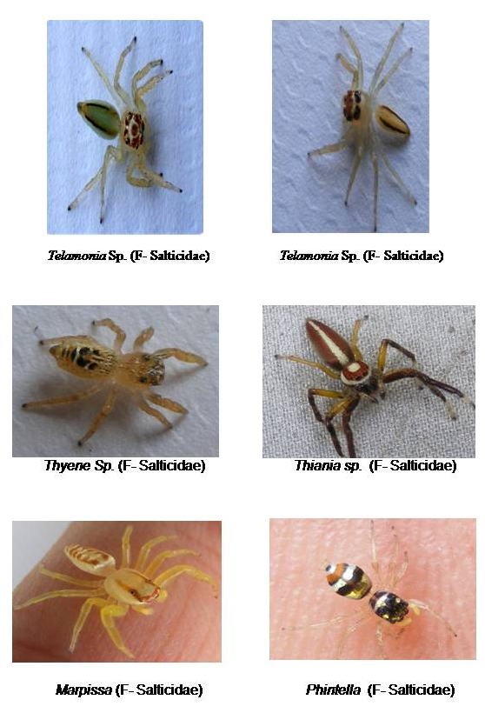
2. Materials and methods
Collection: spider fauna was collected from forest plantation, crops, and agriculture fields and wild plants in some habitats of Rajghat( Barwani).
Following methods are used for the collection of spider. Spiders were collected from Rajghat (Barwani) near Narmada valley for collection of spiders insects nets pitfall trap stroking sticks umbrellas were used the specimens were but in to 70% alcohol, labeled and identified according to Tikader (1962, 1973 1982). Before preservation the photographs were taken in different views to get the clear eye position pattern and shades of cephalothoraxes and abdomen, hair and spines pattern etc.
Identification: Identification was done on the basis of morphometric characters of various body parts.They help was mainly taken from the keys and catalogues provided by,Kaston (1978), Tikader and Biswas (1981),Tikader(1982),Davies and Zabka (1989),Plantnick (1989),Biswas and Biswas (1992),Barrion and Litsinger (1995),Gajbe (1987), Nentwig et al.(2003)and Platnick (2004)

3. Result and dissution
During this study 117 specimens were collected from the Rajghat(Barwani). 44 species were identify belonging to 12 Families. Among the specimens most of the individuals were adult and few females were observed the Family Araneidae represented 13 species, Salticidae represented 9 species, Oxyopidae 3,and Eracidae 4 species, Theriddidae 3, and Thomosidae represented 2 species , Lycosidae 3 and Pholcidae represented 2 species. Families Clubionidae 1, Philodromide 1, Tetragnathidae 2, Uloboridae, represent 1 species. The population of Spiders was abundant species richness and diversity was high during the month of October to December.

1. FAMILY- ARANEIDAE
- Araneus sp.
- Araneus sp.
- Araneus mitifica
- Argiope sp.
- Argiope aemula
- Cyclosa hexatuberculata
- Cyclosa spirifera
- Cyclosa moonduensis
- Cyclosa sp.
- Neoscona theis
- Neoscona sp.
- Larinia sp.
- Zygilla sp.
2. FAMILY-CLUBIONIDAE
- Clubiona sp.

3. FAMILY-ERASIDAE
- Stegodypus sp.
- Stegodypus sp.
- Stegodypus prakashi
- Stegodypus sarasinorum
4. FAMILY-LYCOSIDAE (WOLF SPIDERS)
- Lycosa sp.
- Hyppasa sp.
- Hyppasa sp.
5. FAMILY-OXYOPIDAE (LYNX SPIDERS)
- Oxyopus pankaji.
- Oxyopupus
- Oxyopus sp.

6. FAMILY-PHILODROMIDAE
- Philodromous sp.

7. FAMILY-PHOLCIDAE
- Pholcus sp.
- Pholcus sp.

8. FAMILY-SALTICIDAE
- Myrmarachne sp.
- Phintella sp.
- Marpissa sp.
- Thyene sp.
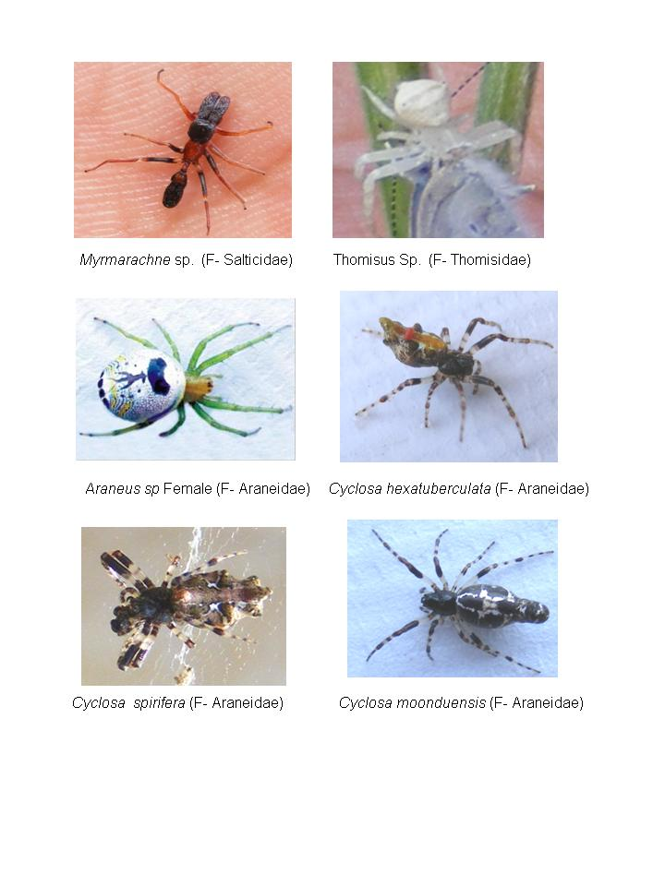
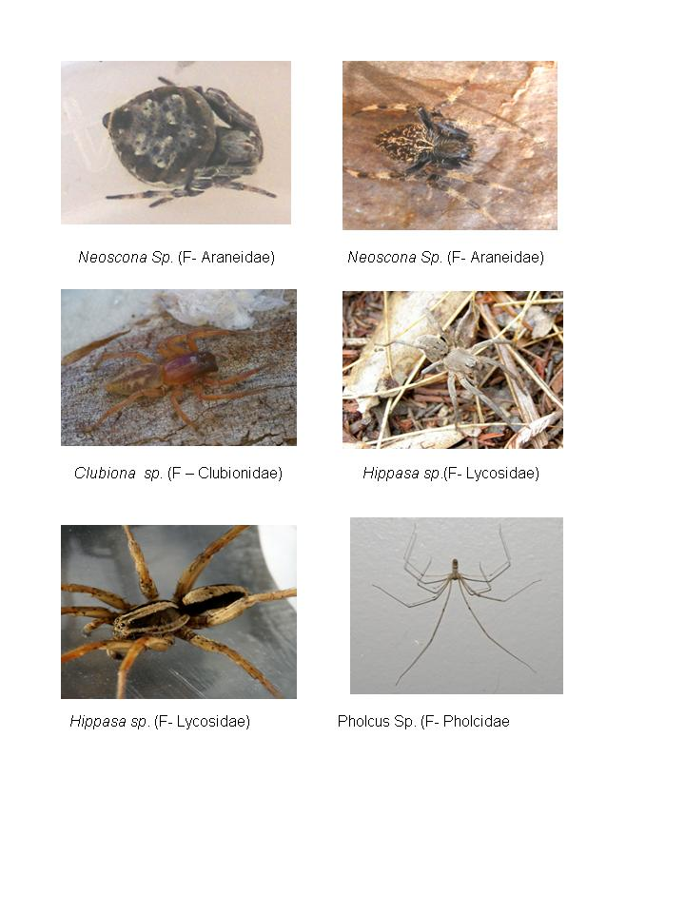
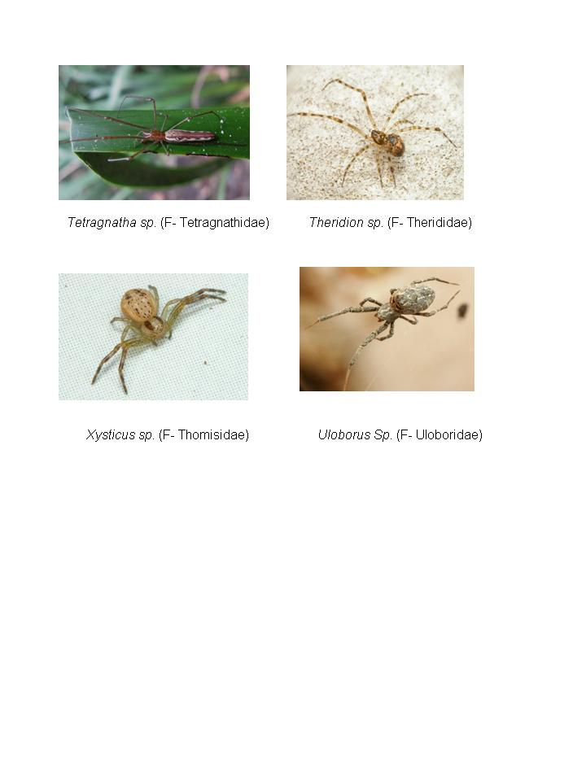
- Thiania sp.
- Telamonia sp.
- Euophrys sp.
- Phidippus sp.
- Plexipus sp.
9. FAMILY –TETRAGNATHIDAE (LONG)
- Tetragnatha mandibulata
- Tetragnatha sp.

10. FAMILY-THERIDIDAE
- Theridion sp.
- Leucauge decorate
- Leucauge sp.
11. FAMILY-THOMISIDAE (CRAB SPIDERS)
- Thomisus sp.
- Xysticus sp.

12. FAMILY-ULOBORIDAE
- Uloborus sp.
Spider Diversity

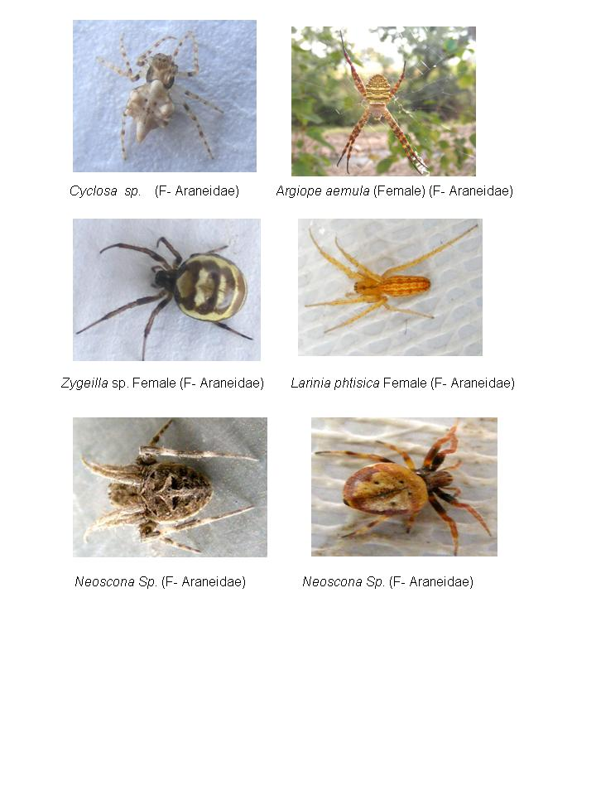
The spiders were found to be living in different types of habitats the spiders belonging to Families Araneidae, Tetragnathidae, Salticidae, Thomisidae, Oxyopidae, and Eracidae, were mainly found in Narmada river at Rajghat (Barwani). Spiders living in the corners of the rivers and semiterrestial area included those belonging to family Salticidae, Araneidae, Uloboridae.most spiders were found living on the ground under the stones or in vegetation exhibiting some kind of colorations for cosmofuge.
No exceptionally poisonous spiders were found among the species recorded in the Narmada valley. The spiders are most abundant and ecological important they are exclusively carnivorous and hence help naturally to control insect pest agro-ecosystems and indicators.
There are many environmental factors that affects species diversity (Rosenzweig 1995).However, when spiders were divided according to their functional group there was a significant effect of habitat on the diversity of these groups. The web building and foliage running spiders rely on vegetation for some part of their lives, either for finding food, building retreats or for web building. The structure of the vegetation is therefore expected to influence the diversity of spiders found in the habitat. Studies have demonstrated that a correlation exists between the structural complexity of habitats and species diversity (Hawksworth, Kalin-Arroyo 1995).Diversity generally increases when a greater variety of habitats types are present (Ried, Miller 1989). Uetz (1991) suggests that structurally more complex shrubs can support a more diverse spider community. Downie et al.(1999) and New (1999) have demonstrated that spiders are extremely sensitive to small changes in the habitat structure, including habitats complexity, litter depth and microclimate characteristics. Spiders generally have humidity and temperature preferences that limit them to areas within the range of their “physiological tolerances” which make them ideal candidates for land conservation studies (Riechert, Gillespie 1986).therefore, documenting spider diversity patterns in this ecosystems can provide important information to justify the conservation of this ecosystem.
This is the first attempt in the central part of Madhya Pradesh. Spider Fauna were studied during the present study. No body has done work on such aspects .During the present investigation 44 species Identify out of 117 specimens were collected.
This study shows that the Narmada River basin has rich Biodiversity of Spiders Fauna.

- Dr. Shailendra Sharma
(Corresponding Author)
Principal.
Shri Umiya Girls College, Mandleshwar-451221 (M.P.) India.
Email:Add-shailendra.b.sharma@gmail.com

2) Dr. Rekha Sharma
Professor
Holkar Science College, Indore (M.P.) India.

3) Dr. Amrita Vyas
Research scholar
Holkar Science College, Indore (M.P.) India.
Email Add- amritavyas2008@gmail.com

4. References
- Alfred, J.R.B., Das, A.K. and Sanyal, A.K. (1998). Faunal Diversity of India. Zoological Survey of India, Calcutta.
- Bhandari, R. and P. Gajbe (2001). An ecological study of some spiders forms Jabalpur, pp. 121.127. In; Singh, S.M. (Ed.), Contemporary Trends in Biological Sciences. Prof. S.C. Pathak Festschrift, R.D. University, Jabalpur, India.
- Biswas, B. and K.Biswas (1992). Araneae:spiders,pp.357-500.In: state Fauna Series-3:Fauna of West Bengal, Part 3.Zoological Survey of India Publication
- Churchill, T.B. (1997). Spiders as ecological indicators: An overview for Australia. Memoirs of Victoria. 56 (2): 331-337.
- DownieI. S., W. L. Wilson, V. JAbernethy, D. I. Mccracken, G. N. Foster, I. Ribera, K. J. Murphy, A. Water-House (1999) . The impact of different agriculture land-use on epigeal spider diversity in Scotland.-Journal of Insect Conservation, 3:273-286.
- De, Rupak. (2001) Management Plan of Dudwa Tiger Reserve (2000- 2001 to 2009-2010), wildlife Preservation organization, Forest department, Utter Pradesh. 407 pp.
- Gajbe, P. (2001) A faunistic survey of spiders (Arachnida) and their diversity in and around jabalpur with special reference to their ecology. Ph. D. Thesis. Rani Durgavati University, Jabalpur, M.P., India.
- Gajbe,P.(2003). A checklist of spiders (Arachnida: Araneae) of Jabalpur, Madhya Pradesh, India. Records of the Zoological Survey of India 101 (3-4): 43-47.
- Gajbe, P. (2003). Checklist of Spiders (Arachnida: Araneae) of Madhya Pradesh and Chhatisgarh. Zoos, Print Journal 18 (10): 1223-1226.
- Gajbe, U.A. (1987). A new scopodes spider from India (Araneae: Gnaphosidae) bulletin of the zoological survey of India 8:285-287.
- Hawksworth D. L., M. T. Kalin -Arroyo (1995). Magnitude and distribution of biodiversity: In Heywood V. H. (ed.): Global Biodiversity Assessment. United Nations Environment Programme. London, Cambridge University press,107-191.
- Kaston, B. J. (1981): Spiders of Connecticut. Connecticut Geological Natural History Survey, Bulletin No. 70. State Department of Environmental Protection, Hartford.
- Platnick, N.I. (1991). A revision of the gourd spider family Cithaeronidae (Araneae, Gnaphosoidea). American Museum Novitates 3018:1-13.
- Platnick, N.I and U.A.A Gajbe (1994) Supplementary notes on the ground spider family Cithaeronidae (Araneae, Gnaphosoidea). Journal of Arachnology 22: 82-83.
- Pocok, R.I. (1900). The Fauna of Britiesh India, Arachnida. Taylor & Francis, London, 279 pp.
- Pinault, G. (1992); l’utilisation des arthopodes comme bio-indicateurs dans les reserves naturelles des Pyrenees - Orientales. Insecter 6:5-6.
- Ried W. V., K. R. Miller (1989). Keeping options alive: A scientific basis for conserving biodiversity. Washington D. C., World Resources Institute.
- Riechert S. E., R. G. Gillespie (1986). Habitat choice and utilization in web-building spiders.-In: Shear W.B. (ed.): Spiders: Webs, Behavior and Evolution. Stanford, Stanford University Press, 23-48.
- Tikader, B.K., (1962) Studies on some Indian spiders (Araneae; Arachnida) J. Linn. Soc. Londan, 44 (300); 561-584.
- Tikader, B.K., (1973) Studies n some spiders of the Family Gnaphosidae from India. Acad. Sci. 77(5): 186-189.
- Tikader, B.K. (1982). The fauna of India Araneae, 2 (1)1-293.
- Tikader B. K. (1982). The fauna of Indian Araneae. 2 (1):1- 293.

9/2/2010

