Numerical Analysis of Magnetic Field with the Hemodynamics Of Large Blood Vessel

Babadipe, E.S
Department of Mathematical Sciences, Redeemer’s University, Mowe Ogun state. Nigeria.
babadipe@yahoo.com

Abstract: The function of blood is to deliver necessary substances to the body cells such as nutrients and oxygen through the blood vessels. In earlier works on hemodynamics of blood, the effect of the uniform magnetic field applied to the flow channel was investigated. In this current work, the problem was modelled and the non-dimensionalised equation is then solved numerically involving asymptotic expansion for fixed injection Reynolds Number and Maxwell Visco-elastic analysis. The effect of visco-elastic K and the viscosity variation parameters on the velocity field are advanced.
[Babadipe, E.S. Numerical Analysis of Magnetic Field with the Hemodynamics Of Large Blood Vessel. Researcher. 2010;2(11):82-94]. (ISSN: 1553-9865). http://www.sciencepub.net.
Keywords: Hemodynamics, Flow Channel, Visco Elastic, Asymptotic Expansion, Reynolds Number
1.Introduction
The visco-elastic model of the study of blood flow in blood vessels assuming a constant blood viscosity for non Newtonian blood flow has been variously discussed [1-5] under different flow conditions.
In this work, a study of the interaction of magnetic field with the hemodynamic of large blood vessels [6-7] is extended so as to examine the effect of Hematocrit variation on the velocity profile when magnetic field is included. Furthermore is to examine the effect of increase in magnetic field variation on hemodynamics and the effect of magnetic field on pressure gradients
We consider the viscous, incompressible, homogeneous and laminar flow under the influence of uniform external magnetic field flowing through a large blood vessel. The geometry of the flow under consideration in this present study is given below.
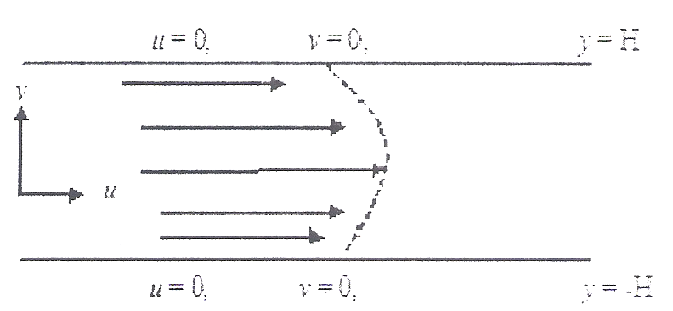
Figure 1: Flow geometry
The continuity equation is
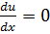 ………………………… (1.1)

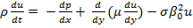 ……………………… (1.2)

Where represents the dynamic viscosity and σ = electrical conductivity, u = velocity, = density, = viscosity, p = pressure, x = co-ordinate in the direction of flow, y = coordinate across the flow.

Introducing the following dimensionless parameters
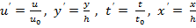 ……………………… (1.3)

We obtain the dimensionless equation after dropping (') for clarity with the appropriate initial and boundary condition.

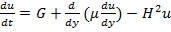 ………………… (1.4)

With 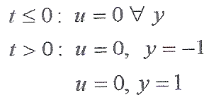 (1.5)
At steady state we have,
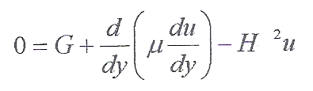 (1.6)
With boundary conditions
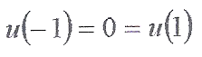 (1.7)

The relationship between the red blood cell and viscocity is given by (Makinde 2008) to be
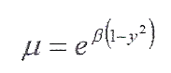 …………………………….(1.8)
Where represents the viscosity variation parameter
Substituting (8) into equation (6) we obtain
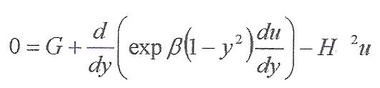 ………... (1.9)
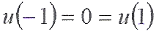

Definition 1.1:
(Corddington and Leviton, 1955) for a system of equation
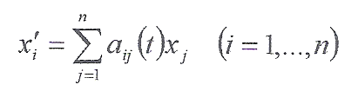 …………(1.10)
Where a_{ij} are continuous functions on some closed bounded t interval [a, b]. If f is the vector with components f_{i} defined by
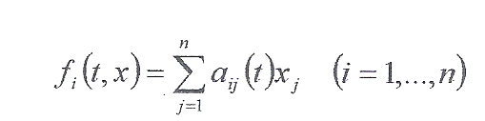 ………………………. (1.11)
then f satisfies the Lipschitz condition on the (n+1) –dimensional region 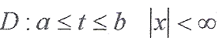 infact
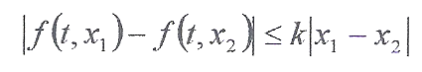 (1.12)
Where
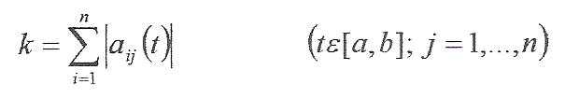 …………………….(1.13)

Theorem 1.1: (Existence and Uniqueness Theorem) for the linear system (L), where the functions a_{ij} C on [a, b], there exists one and only one solution of (L) on [a, b] passing through any point ( that is
We shall use the theorem of (Corddington and Leviton, 1955) to prove our result

Proof:- we have to show that the vector f satisfies the Lipschiitz condition on D, then the existence and uniqueness is guaranteed at the initial point x₁ (0) = -1. It suffices to show that the solution can be continued to a unique solution in the entire interval [a, b]

Now
Let x₁ = y, x₂ = u, x₃ = u' ……………………….. (1.14)
Then, (2.11) becomes
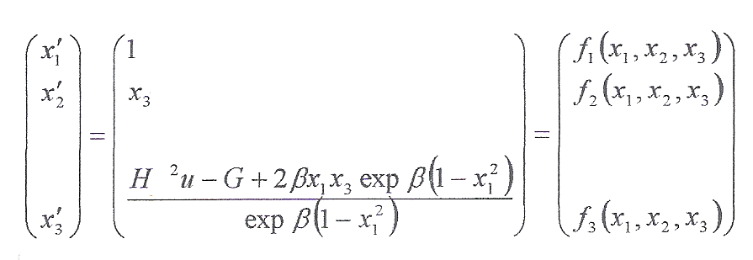 ……………………… (1.15)
subject to the initial conditions
x₁ (0) = 0
x₂ (0) = -1
x₃ (0) = D …………………… (1.16)
Clearly 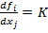 therefore (1.15) is Lipschitz continuous which implies that it is bounded below and above with D as a guess value set to meet the other boundary condition
Now that we have proved that the solution exists and it’s unique, we can proceed to solve (1.15) which represents a non-linear equation
Then,
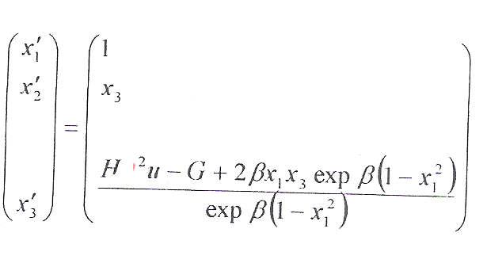 ………………. (1.17)
Subject to the initial conditions
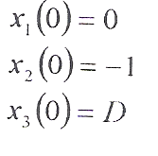 ………………… (1.18)
then (1.17) is evaluated with a Pascal code to give the result in Table 1-3 for various values of the different parameters

- FURTHER MATHEMATICAL ANALYSIS
We consider the visco-elastic fluid model given (Singh, 1983) whose constitutive equation is characterized by
……………….. (2.1)
Where
………..…….….. (2.2)
- is the stress tensor, λ – is the relaxation, - is the dynamic viscosity, - the rate of strain tensor.
For any contra-variant tensor b^{tk}
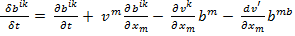 ………………… (2.3)
The continuity equation for the incompressible unsteady flow of fluid of density is
= 0 ………………. (2.4)
Let us assume that v is every where negative that is v = -v_{o} (constant) and u = u(y, t) and then the momentum equation gives
………………… (2.5)
Equation (1) gives,
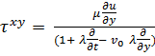 ………………….. (2.6)
We assume a variable viscosity (Makinde, 2008)
……………… (2.7)
Where
is the dynamic velocity, u= velocity, = density, p = pressure, x = co-ordinate in the direction of flow, y = coordinate across the flow, v_{o} is the constant vertical substituting (2.6) in (2.5)

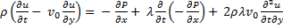 - 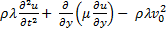 …… (2.8)

Now introducing the following dimensionless parameters
……………… (2.9)

We obtain
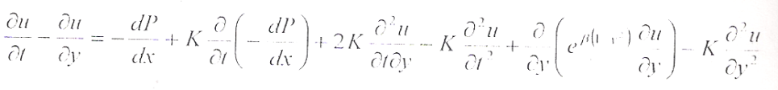 ……………………… (2.10)
Subject to initial and boundary conditions
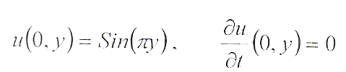 ………………………….. (2.11)
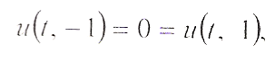

3. STEADY STATE SOLUTION
We assume that blood flow steadily therefore (2.10) reduces to
0 = + 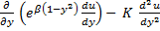 ………………………….. (3.1)
Subject to the boundary conditions
u (-1) = 0 = u (1) ………………………. (3.2)
Let 0 < << 1 therefore by asymptotic expansion
We take u = u_{o} + u₁ + ²u₂ neglecting other terms ……..………… (3.3)
Taking the Taylor’s expansion of about
= 1 + + 0.5 …………… (3.4)
Equating coefficients
0 = 1 + 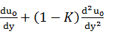 …………………………. (3.5)
u_{o} (-1) = 0 = u_{o} (1) …………………………….. (3.6) 0 = 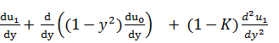 ………………….. (3.7)
u₁ (-1) = 0 = u₁ (1) …………………… (3.8)
0 = 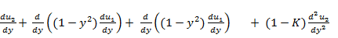 …………… (3.9)
u₂ (-1) = 0 = u₂ (1) ……………. (3.10)
Using mathematical version (3.6) the solution of (3.3) is given in the graphical results of figure 2 and 3.

4. NUMERICAL RESULTS
The numerical result are herein presented in both tabular and graphical forms subject to (1.17).

Table 01
y u, = 0.1 u, = 0.3 u, = 0.5 u, = 0.7
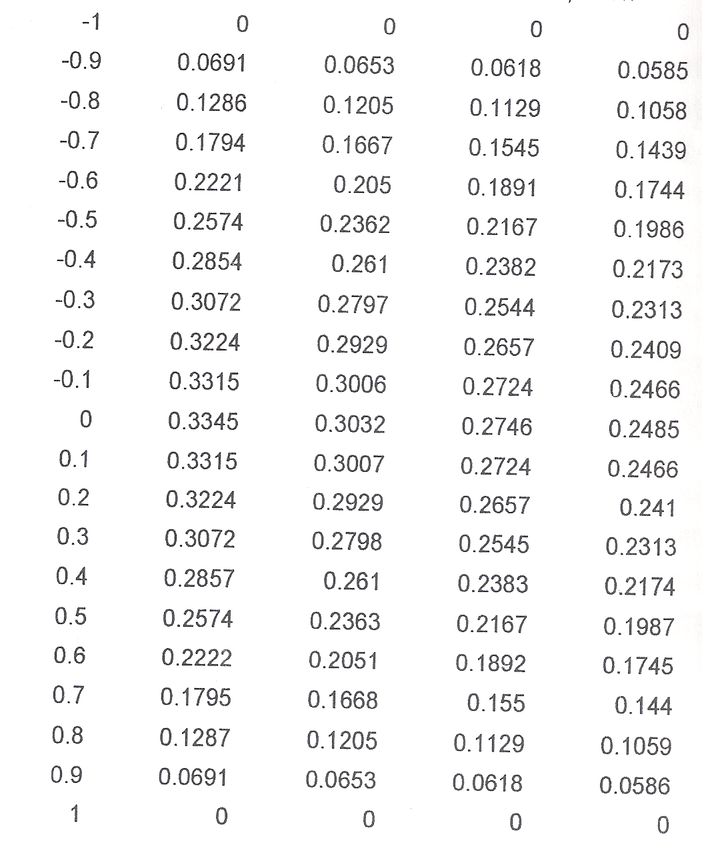

Table 02
y u, = 0.1 u, = 0.3 u, = 0.5 u, = 0.7

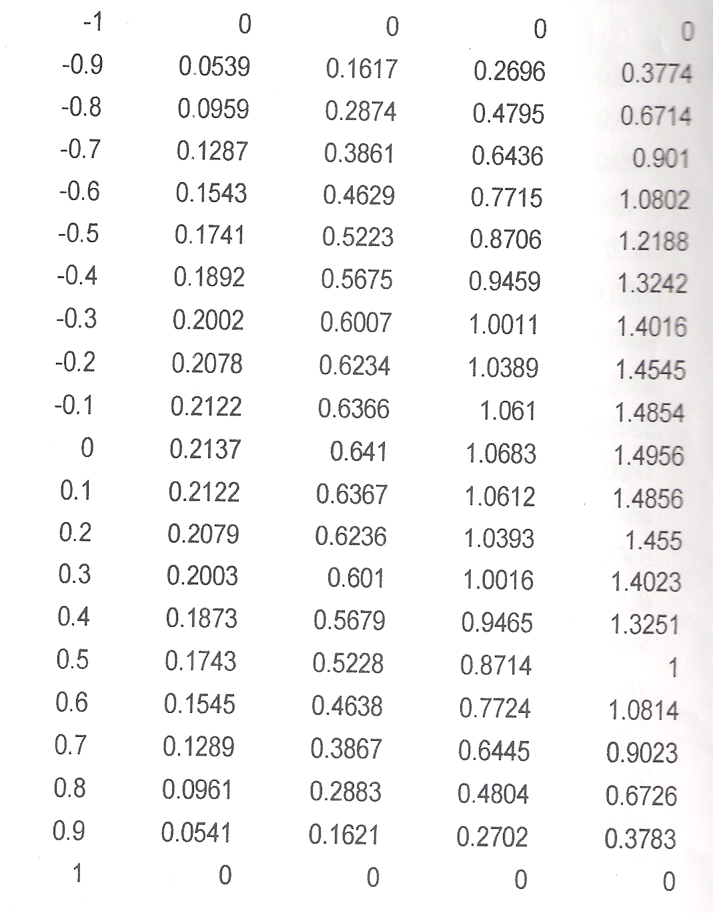

Table 03
y u, H = 1 u, H = 3 u, H = 5 u, H = 7
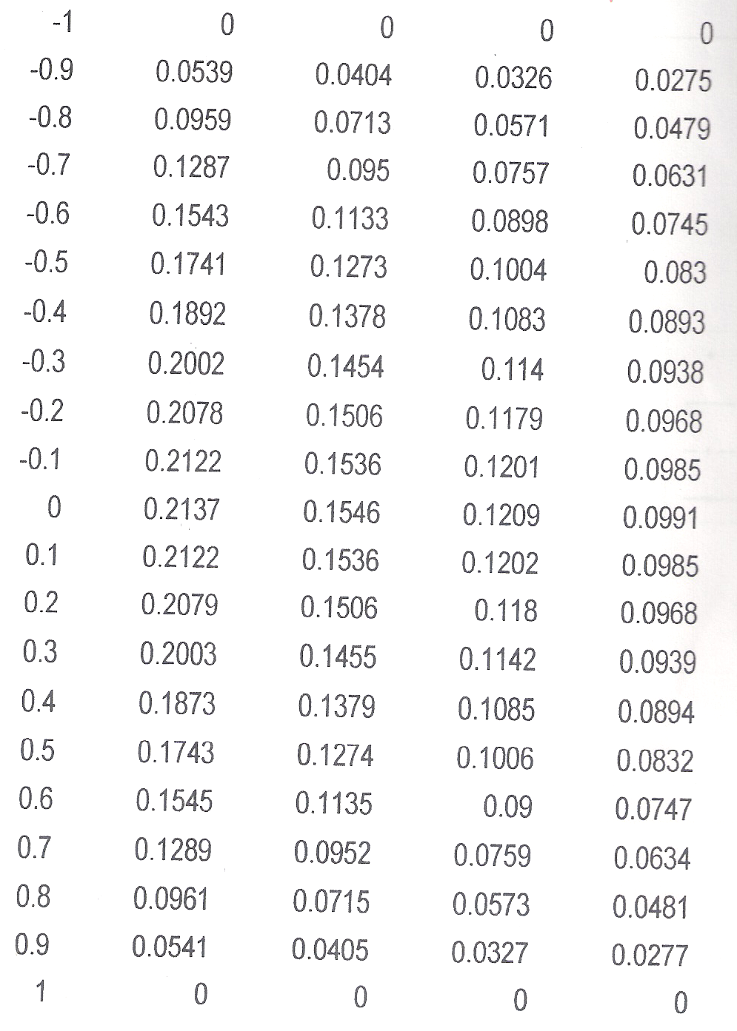

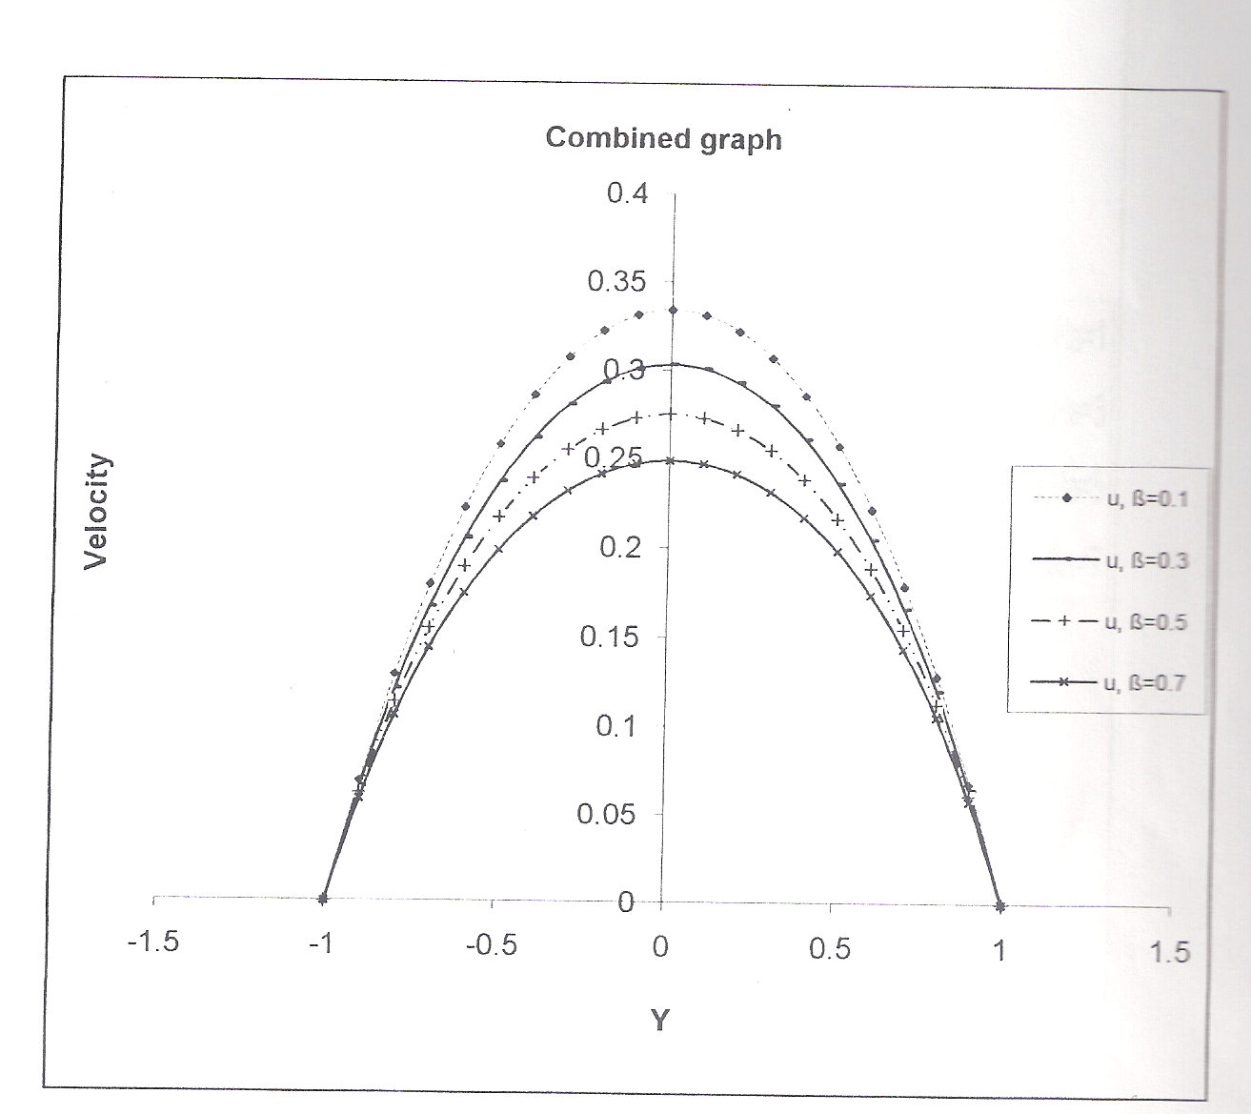
Figure 2: Graph of Velocity against distance between plates, Y involving table 1 and 2. It is evident that U(Y) is a well behaved function, since the boundary conditions are satisfied and variations of parameters due to cause and effect are seen.

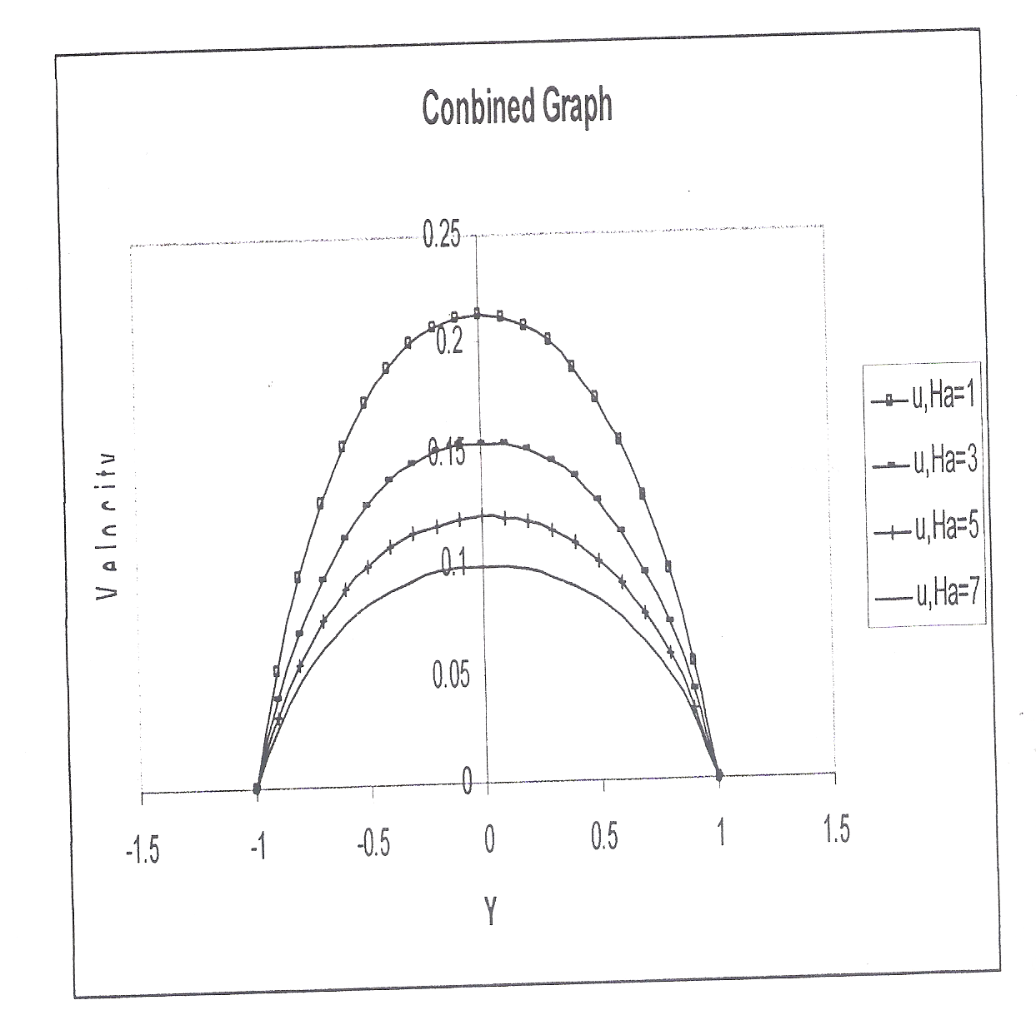

Figure 3i: Graph of Velocity against distance between plates, Y involving pressure gradients.

CONCLUSION
The magnetic field interaction with herodynamics in steady state increases the viscosity parameter as the flow velocity. This is a pre-condition associated with hypertension. Furtherance to our study of the steady flow of Maxwell fluid at steady state, we noted that as relaxation time reduces, the fluid shows Newtonian behaviour while velocity reduces with increase in viscosity. The application is in the treatment and diagnosis of cardiovascular diseases and stenosis.
- O. D. Makinde (2008), computation hemodynamics and analysis in large blood vessels: effect of hematocrit variation on the flow stability, poster presentation. IMA design in biological systems, University of Minestota, April 21-25.
- N. L Singh (1983) India J. of Pure and Appl. Maths. 14(11) 1362-1366
- Venkateswam and J.A. Rao (2004), India J. of Biochemistry and Biophysics (41) pp 241-245
- Guiseppe Pontrelli (1998), compt. and fluids vol. 27 No. 3 pp 367-380
- M. Anand, K.R. Rajagopal (2004). Int. J of cardiovascular medicine and science vol. 4 No. 2 pp 59-68
- Akhtar Waseem, Corina Fetecau, V Tigoiu, C. Fetecau (2008), ZAMP, DOI 10. 1007/s00033-008-7129-8
- Babadipe E.S, Adesanya S.O and Ayeni R.O (2010): “Asymptotic Expansion Method for Solving Variable Viscous Flow of Maxwell Fluid”- New York Science Journal (2010).
- http//www.sciencepub.net/report (Report and Opinion,2010;2 (11) (40% contribution).

10/18/2010

