Effect of Aqueous Extract of Andrographis paniculata on Blood
Glucose, and Lipid and Protein Profiles in Male Rat

Oyewo Bukoye ^{1, +} and Akanji Musbau ²

- Ladoke Akintola University of Technology, P. M. B. 4000, Ogbomoso. Nigeria
- University of Ilorin, P. M. B. 1515 Ilorin, Kwara State. Nigeria
askafterbukoye@yahoo.com, akanjima@yahoo.com

Abstract: The chronic administration of aqueous extract of Andrographis paniculata leaves on body and organ weight, blood glucose, lipid and protein profiles, liver and heart lipid profiles was investigated. Forty male albino rats were picked into four groups. The first group received distilled water, while 250 mg/kg, 500 mg/kg and 1000 mg/kg BW doses were administered once daily for 84 days to other groups. After 32 days, four rats in the 1000mg/kg BW dose were less active with watery pale coloured feaces, had the fur falling off and drank more water. Dose dependent significant reductions (p<0.05) in the body weight and blood glucose were observed. Organ-body weights ratio of the hearts and livers were not changed significantly (p<0.05), while prostate increased significantly (p<0.05) dose dependently. Significant reduction and increase (p<0.05) were observed in the kidneys and spleen in group 4. Serum total cholesterol (TC), VLDL-C, TAG, LDL-C and atherogenic index (AI) were reduced significantly (p<0.05) dose dependent with the TAG, LDL- C and AI been statistically the same for group 3 and 4, while groups 2 and 3 were also the same for VLDL-C. HDL-C concentration increased significantly (p<0.05) in group 2 and 3. Total protein and globulins were significantly increased (p<0.05) in group 4, while albumin reduced significantly (p<0.05) in group 4. A/G was reduced significantly (p<0.05) with the group 2 and 3 been statistically the same. Liver TC and VLDL-C were reduced significantly dose dependently with TC in group 2 and 3 been statistically the same (p<0.05), while LDL-C were not significantly reduced in group 2 (p<0.05). Liver TAG increased significantly (p<0.05) with group 2 and 3 been statistically the same, while HDL-C increased significantly (p< 0.05) in group 2 and 3. Heart TC was reduced significantly with no significant difference (p<0.05) between group 3 and 4 and dose dependent significant decrease (p<0.05) in TAG were observed. From the findings, it was logical to make the submission that the chronic administration of the aqueous extract of A. paniculata exhibited hypoglycemic, hypolipidemic and weight reducing properties.
[Oyewo Bukoye and Akanji Musbau. Effect of Aqueous Extract of Andrographis paniculata on Blood Glucose, and Lipid and Protein Profiles in Male Rat. Researcher. 2011;3(1):38-47]. (ISSN: 1553-9865). http://www.sciencepub.net.

Keywords: Andrographis paniculata, Chronic administration, Atherogenic index, Hypoglycemic, Hypolipidaemic,
Weight reducing

1.0 Introduction
An herb is a plant or part of plant that is used for a long time for acclaimed health benefit. However, herbs are sometimes taken in combinations, in relatively large unmeasured quantities, under highly socialized conditions. Phytochemicals present in the herbal medicines have been reported to possess many pharmacological activities, which are used for the prevention or treatment of ailments (kapil et al., 1998). Andrographis paniculata, an herbaceous plant native to India and Sri Lanka is a member of the plant family, Acanthaceace. The genus Andrographis consists of 28 species of small annual shrubs essentially distributed globally, but only a few species are medicinal, of which A. paniculata is the most popular (Caceras et al., 1997). The herb is also available in northern stations of Java, Malaysia, America, China, Hong Kong, Bahamas, West Indies, Nigeria etc.
Andrographis paniculata has been suggested for many uses, based on tradition or on scientific theories. However, these uses have not been thoroughly studied, and there is limited scientific evidence about safety or effectiveness. Some of the suggested uses are for conditions that are potentially very serious and even life-threatening. It was also suggested to have analgesic, anti-inflammatory, antibacterial, antiperiodic (counteracts periodic/intermittent diseases, such as malaria), antipyretic, antiviral, cardioprotective, depurative (cleans and purifies the system, particularly the blood, promotes digestion, expectorant, laxative, sedative and vermicidal, among its many other uses (Borhanuddin et al., 1994; Raj, 1995; Barilla, 1999: Gabrielian et al., 2002: Coon and Ernst, 2004).
Researches conducted in the ‘1980's and ‘1990's has confirmed that A. paniculata, when properly administered, has a surprisingly broad range of pharmacological effects, of which some are extremely beneficial. The aerial parts are commonly used for medicinal purposes (Borhanuddin et al., 1994). Both the fresh and dried A. paniculata leaves, as well as the fresh juice of the whole plant have been widely used in traditional remedies and folkloric medicines for liver disorders, bowel complaints of children, colic pain, cases of general debility, and convalescence after fevers (Gabrielian et al., 2002: Coon and Ernst, 2004). In Malaysia, A. paniculata is used as a folk medicine remedy for cases of diabetes mellitus (Borhanuddlin et al., 1994). Narrowing caused by injury to the inner lining of the blood vessel and by high cholesterol in the diet was also found to be decreased by A. paniculata (Wang and Zhao, 1993).
The regular consumption of the infused aerial parts of A. paniculata, alongside with meals (as blood tonic), is being encouraged, because of the medicinal properties alleged by traditional medical practitioners, especially as immune booster and the prevention of degenerative diseases. However, no information is available on the effect of the chronic consumption of the extract of A. paniculata on glucose, lipid and protein metabolism of the consumer. More so, since A. paniculata is alleged as an important remedy for diabetic and heart disease patients, then its chronic consumption could affect adversely glucose and lipid metabolism. Therefore, this study aimed at providing information on the effect of the chronic administration of the aqueous extract of A. paniculata on the blood glucose level, blood lipid and protein profiles, and the heart and liver lipid profiles in male albino rats.

2.0 Materials and methods
2.1 Plant material for analysis
The aerial part of A. paniculata was collected from the natural habitat around Airport area in Ilorin, Kwara State. The plant was identified by Mr. L. T. Soyewo at Forest Research Institute of Nigeria, Ibadan, Oyo State. A specimen of the plant was kept with voucher number (108453) for future reference. The leaves were rinsed thoroughly in distil water and dried in the shade for 14 days. The dried leaves were ground to fine powder, using a domestic electric grinder and extracted with water at 37ºC. The filtrates were pulled together and centrifuged at 2000rpm for 10 minutes. The supernatant was filtered again and lyophilised using a freeze dryer. The yield of the aqueous extract was 16.28%^{w}/_{w}. The dried extract was stored in the desiccators and kept in the dark till when needed.

2.2 Chemicals
All the chemicals and reagents used in the study were of analytical grades from the Bristish Drug House and Sigma Aldrich.

2.3 Blood glucose glucometer
Accu- chek active glucometer and visual blood glucose test stripes, products of Roche Diagnostic Gmbh, D-68298 Mannheim, Germany were used for the fasting blood glucose level estimation.

2.4 Quantitative assay kits
The lipid profile and protein profile were estimated using reagent kits produced by LABKIT, CHEMELEX, S.A. Pol. Ind. Can Castells. C / Industria 113, Nau J. 08240 Canovelles – Barcelona.

2.5 Laboratory animals
Forty 10–12 weeks old male albino rats of average body weight of 125–140 g were obtained locally from Oyo Town, Oyo State. The rats were housed in animal care facility at the Faculty of Basic Medical Sciences, LAUTECH, Ogbomoso.

2.6 Methods
2.6.1 Experimental animals and procedure
The forty male albino rats were randomly grouped into four, comprising of ten rats per group. They were housed in animal care facility at the Faculty of Basic Medical Sciences, LAUTECH, Ogbomoso with 12-hours light/dark cycle. They were fed free standard pellet diet and tap water, and were acclimatized for 10 days before the administration of the aqueous extract of A. paniculata was commenced. The cages were cleaned every morning and disinfected 3 days interval. Calculated doses of the plant extracts (mg/kg body weight of rat) were dissolved in distilled water and stored air tight at 4⁰C. Administration was performed orally at 24 hours interval, using metal cannula attached to a 2ml syringe.
Group 1: Control, received 1.5ml distilled water.
Group 2: Test, received 250 mg/kg body weight of A. paniculata
Group 3: Test, received 500 mg/kg body weight of A. paniculata
Group 4: Test, received 1000 mg/kg body weight of A. paniculata

Prior to the administration of the aqueous extract of A. paniculata and later every 7 days interval till the day the rats were sacrificed, the fasting blood glucose levels and the body weights of the experimental animals were determined. Administration lasted for 84 days. The rats were sacrificed by anaesthetia, using di-methyl ether, after the rats were fasted for 12 hours. Incision was made quickly in the chest region and the heart was pierced to collect blood into non–anticoagulant bottles. The liver, the kidneys, heart, spleen and prostate were also quickly decapsulated, cleansed of blood and tissues, and the weights were taken.

2.6.2 Blood glucose estimation
The fasting blood glucose was estimated by Trinder GOD - POD reaction method, using Accu- chek active glucometer and visual blood glucose test stripes. Glucose oxidase / peroxidase with chromogen indicators and non-reactive agents are contained in the reagent pads to which 2µl of whole blood were applied.

2.6.3 Lipid profile assay
The lipid profile assay was performed using reagent kits from LABKIT. The assay was carried out on the serum, liver and the heart.

2.6.4 Serum and total cholesterol estimation
The serum total cholesterol level was estimated by CHOD-POD enzymatic colourimetric reaction, according to the method as described by Naito (1984).

2.6.5 Triglyceride (TAG) estimation
The serum triglyceride level was estimated by GPO-POD enzymatic colourimetric reaction, according to the method as described by (Buccolo et al., 1979: Fossati et al., 1982).

2.6.6 High density lipoprotein cholesterol (HDL-C) estimation
The serum HDL-C cholesterol level was estimated by precipitation and CHOD-POD enzymatic colourimetric reaction, according to the method as described by (Grove 1979: Naito 1984).

2.6.7 Low density lipoprotein cholesterol (LDL-C) and very low lipoprotein cholesterol (VLDL-C) estimation
The VLDL-C cholesterol and LDL-C were estimated by computation, according to the methods described by (Friedewald et al., 1972).

2.6.8 Protein profile assay
The protein profile assay was perfomed using reagent kits from LABKIT. The assay was done on the serum.

2.6.8.1 Total protein estimation
The serum total protein concentration was estimated by Biuret colourimetric reaction, according to the method as described by (Koller, 1984: Burtis et al., 1999).

2.6.8.2 Albumin estimation
The serum albumin concentration was estimated by bromocresol green colourimetric reaction, according to the method as described by (Doumas, 1971: Gendler, 1984).

Globulin conc (g/dl) = Total protein conc. (g/dl) –
Albumin conc. (g/dl)

2.7 Statistical analysis
This research work was a completely randomized design (CRD). Results analyses were performed using Prism 3.00 software. The results were expressed as mean ± standard deviation of 3 - 8 replicates where appropriate. Results were subjected to one way analysis of variance (ANOVA) to test the effect of each dose level on the parameter under investigation at 5% degree of freedom. The Duncan Multiple Range Test (DMRT) was conducted for the pair-wise mean comparisons, to determine the significant treatment dose at 5% level of significance. P-value <0.05 was regarded as statistically significant and denoted by alphabets.

3.0 Results
The results were presented in figures (bar chart and histogram) and tables. The dependent variables (parameter under investigation) were plotted on the y-axis, while the independent variables (groups of rats) were represented on the x-axis. The values were expressed as mean ± standard deviation of at least 5 replicates and alphabets were used to depict significantly different (p<0.05) mean values.

3.1 Body weight response
Administration of the aqueous extract of A. paniculata to albino rats recorded the death of one rat at the 500 mg/kg BW dose after 71 days and partial paralysis and/ mortality of three rats at 1000 mg/kg BW dose after 50 days. The rats of the 1000 mg/kg BW dose group were often less active after administration and consumed more water than the other dose groups. After 32 days of administration, four rats in this group had their fur dropping off, the feaces were watery with the colour faded and the eyes were very red and budged out. However, one of the three paralyzed rats did not die till the end of the experiment. Figure 1 depicts the pictures of the rats in the each group.
Figure 2 shows the body weight response of the rats following the repeated administration of the extract. The weekly determined body weights of the control rats (group 1) increased steadily at the start of administration till week 3, when it increased sharply and was steady again after week 5 till the stop of administration. However, the body weight response of the test groups (2, 3 and 4) elucidated patterns that were not consistent throughout the study. After 2 weeks of administration, significant reduction (p < 0.05) was observed in the body weight of the 1000 mg/kg BW dose group only and was sustained till week 3. At week 4 significant reductions were observed among the test groups with the group2 and 3 been statistically the same. The trend was sustained till week 7, after which the reductions in body weight were significant (p < 0.05) dose dependently till the stop of administration.

3.2 Blood glucose tolerance test
The results of the weekly glucose tolerance test was depicted in figure x. Significant reductions (p < 0.05) were observed in the test groups (2, 3 and 4) compared to control rats (group 1) and were sustained till the stop of administration. The fasting blood glucose level were significantly reduced following administration of the aqueous extract of A. paniculata, but with no differences among groups till week 3 (figure 3). At week 4, significant reductions were observed dose dependently with no difference in groups 3 and 4. No significant differences were shown among the test groups at week 5 and 6. However, significant reductions were observed at week 7 in group 4 with no significant difference in group 2 and 3 and the trend was sustained till the stop of administration`

3.3 Organ – body weight index
The effect of the administration of aqueous extract of A. paniculata on the weights of some organs to body weights of rat was shown in table 1. The extract had no effect (p < 0.05) on the organ: body weights of the hearts and livers. However, significant reduction and increase (p < 0.05) were observed respectively in the kidneys and spleen of the 1000 mg/kg BW dose group only. The prostate of the test groups increased significantly (p < 0.05) dose dependent, but with the group 2 and 3 been statistically equal.

3.4 Serum lipid profile
The effect of the extract on serum lipid profile is depicted in table 2. The total cholesterol and TAG were reduced significantly (p < 0.05) dose dependent with the TAG concentrations been statistically the same for group 3 and 4. Significant reductions (p < 0.05) dose dependent were observed in the VLDL-C concentrations with group 2 and 3 been statistically equal. The HDL-C concentration increased significantly (p < 0.05) in group 2 and 3, while group 4 was statistically the same (p < 0.05). The LDL- C concentration was significantly reduced (p < 0.05) dose dependently with group 3 and 4 been statistically the same (table 2). The risk of developing coronary heart diseases (CHD) was reduced significantly (p < 0.05) in the test groups with group 3 and 4 been statistically the same (table 2).
Serum protein profile
The result of the serum protein profile was presented in table 3. The concentrations of total protein and globulins were significantly increased (p < 0.05) for group 4 rats only. The albumin concentrations was reduced significantly (p < 0.05) in group 4 only. However, the A/G ratio were reduced significantly (p < 0.05) dose dependent with the group 2 and 3 been statistically the same (table 3).

3.5 Heart lipid profile
The heart total cholesterol concentrations were reduced significantly dose dependently (p<0.05) in the test groups with no significant difference (p<0.05) between group 3 and 4. The TAG concentrations of the heart were increased significantly (p<0.05) in the test groups in a dose dependent manner (table 4).

3.6 Liver lipid profile
The effect of the aqueous extract of A. paniculata on liver lipid profile was presented in table 5. The liver total cholesterol concentrations were reduced significantly dose dependently with group 2 and 3 been statistically the same (p<0.05), while TAG concentrations increased significantly dose dependent (p<0.05), but group 2 and 3 were statistically the same (table 5). HDL-C concentrations increased significantly (p< 0.05) in group 2 and 3 only and the VLDL-C concentrations were reduced significantly (p<0.05) dose dependently. The LDL-C concentrations were not significantly reduced in group 2 (p<0.05).

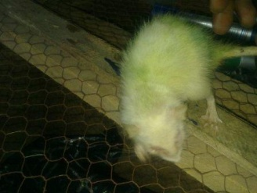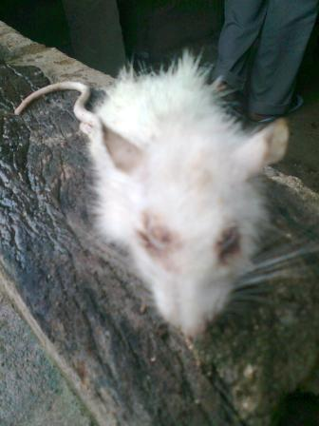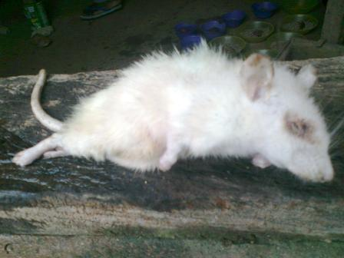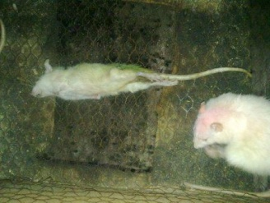
Figure 1: Photograghs of Four Rats in the 1000 mg/kg BW dose group.

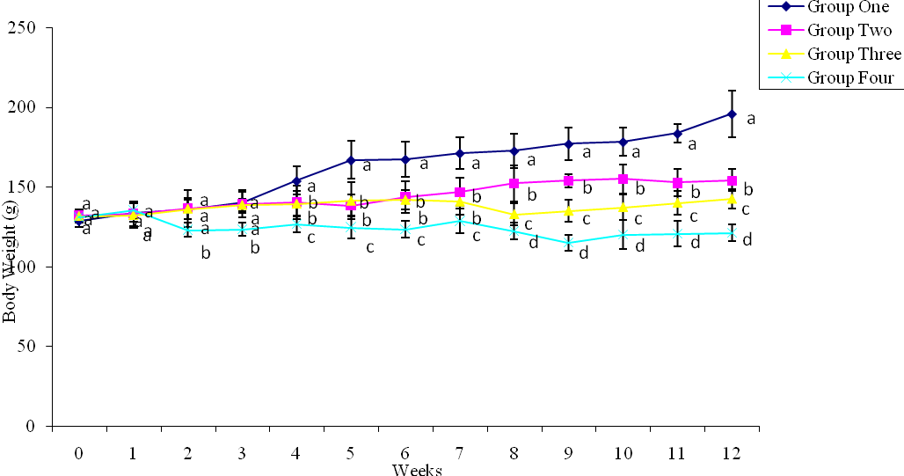Figure 2: Body Weights Response of Rats following Administration of Aqueous Extract of A. paniculata Leaves.
Values are mean ± SD of at least seven determinants. Values with different alphabets are significantly different (p<0.05)
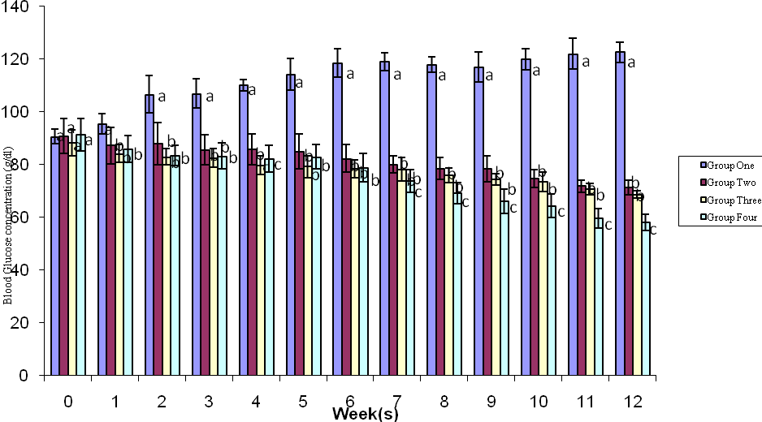

Figure 3: Glucose Tolerance Test of Rats following Chronic Administration of Aqueous Extract of A. paniculata Leaves. Values are mean ± SD of at least seven determinants. Values with different alphabets are significantly different (p<0.05).

Table 1. Organ - Body Weight (BW) Ratio of Rats following Chronic Administration of Aqueous Extract of A. paniculata Leaves.
 | Control | 250 mg/kg BW | 500 mg/kg BW | 1000 mg/kg BW
Heart - BW (10 ⁻³) | 3.532 ± 0.7645ª | 2.667 ± 0.4983ª | 2.829 ± 0.7957ª | 3.460 ± 0.5983ª
Kidney - BW (10 ⁻³) | 8.573 ± 0.8132ª | 8.396 ± 1.1518ª | 8.571 ± 0.2956ª | 7.171 ± 0.4959^{b}
Liver - BW (10 ⁻²) | 3.543 ± 0.5383ª | 3.112 ± 0.6251ª | 3.397 ± 0.1690ª | 3.579 ± 0.3885ª
Spleen - BW (10 ⁻³) | 4.704 ± 0.9691ª | 4.547 ± 0.8168ª | 4.672 ± 0.5528ª | 6.000 ± 0.8774^{b}
Prostate - BW (10 ⁻³) | 2.368 ± 0.4032ª | 3.945 ± 0.7821^{b} | 4.112± 0.6431^{b} | 4.659 ± 0.7401^{c}

Values are mean ± SD of at least six determinants. Values with different alphabets are significantly different (p<0.05).

Table 2. Serum Lipid Profile and Cardiovascular Disease Risk Ratio of Rats following Chronic Administration of Aqueous Extract of A. paniculata Leaves.
 | Control | 250 mg/kg BW | 500 mg/kg BW | 1000 mg/kg BW
Total cholesterol (mg/dl) | 179.209 ±16.924ª | 143.011 ± 16.393 ^{b} | 113.027 ± 8.149 ^{c} | 95.515 ± 5.978 ^{d}
Triacylglycerol (mg/dl) | 174.627 ±15.880ª | 112.434 ± 18.470 ^{b} | 97.655 ± 13.047 ^{b} | 59.883 ±10.600 ^{c}
HDL-C (mg/dl) | 35.612 ±13.672 ª | 44.111 ± 8.443 ^{b} | 40.741 ± 6.729 ^{b} | 29.204 ± 4.818 ª
VLDL-C (mg/dl) | 37.090 ± 4.834 ª | 22.488 ± 3.694 ^{b} | 20.448 ± 3.419 ^{b} | 15.678 ± 6.711 ^{c}
LDL-C (mg/dl) | 126.906 ± 7.518 ª | 103.331 ± 6.145 ^{b} | 69.544 ± 8.123 ^{c} | 56.259 ± 8.053 ^{c}
LDL-C / HDL-C | 3.193 ± 0.340 ª | 2.190 ± 0.217 ^{b} | 1.515 ± 0.152 ^{c} | 1.751 ± 0.247 ^{c}
Values are mean ± SD of at least five determinants. Values with different alphabets are significantly different (p<0.05).

Table 3. Serum Protein Profile of Rats following Chronic Administration of Aqueous Extract of A. paniculata Leaves.
 | Control | 250 mg/kg BW | 500 mg/kg BW | 1000 mg/kg BW
Total protein (g/dl) | 6.105 ± 0.1160ª | 6.443± 0.3050ª | 6.736 ± 0.3571ª | 7.262 ± 0.1992^{b}
Albumin (g/dl) | 3.743 ± 0.3819ª | 3.545 ± 0.4406ª | 3.503 ± 0.3519ª | 3.173 ± 0.2289^{b}
Globulin(g/dl) | 2.504 ± 0.3056ª | 2.898 ± 0.2292ª | 3.232 ± 0.2884ª | 3.920 ± 0.2280^{b}
Albumin / globulin | 1.501 ± 0.1688ª | 1.231 ± 0.2469^{b} | 1.080 ± 0.1124^{b} | 0.806 ± 0.0891^{c}
Values are mean ± SD of at least five determinants. Values with different alphabets are significantly different (p<0.05)

Table 4. Heart Total Cholesterol and Triacylglycerol of Rats following Chronic Administration of Aqueous Extract of A. paniculata Leaves.
 | Control | 250 mg/kg BW | 500 mg/kg BW | 1000 mg/kg BW
Total cholesterol (mg/dl) | 89.334 ± 7.5221 ª | 69.183 ± 2.932 ^{b} | 53.804 ± 3.4661 ^{c} | 50.003 ± 3.4985 ^{c}
Triacylglycerol (mg/dl) | 171.005 ± 11.4907 ª | 155.938 ± 8.3289 ^{b} | 143.972 ± 4.4206 ^{c} | 137.661 ±7.5217 ^{d}
Values are mean ± SD of at least six determinants. Values with different alphabets are significantly different (p<0.05).

Table 5. Liver Lipid Profile of Rats following Chronic Administration of Aqueous Extract of A. paniculata Leaves.

 | Control | 250 mg/kg BW | 500 mg/kg BW | 1000 mg/kg BW
Total cholesterol (mg/dl) | 129.602 ± 9.3208 ª | 116.003 ± 7.3814 ^{b} | 106.757 ± 15.4321 ^{b} | 89.000 ± 6.3801 ^{c}
Triacylglycerol (mg/dl) | 204.057 ± 12.1722 ª | 233.364 ± 8.3147 ^{b} | 242.791 ± 6.0856 ^{b} | 268.056±12.3366 ^{c}
HDL-C (mg/dl) | 25.425 ± 3.7784 ª | 35.815 ± 3.2156 ^{b} | 37.997 ± 4.3683 ^{b} | 25.832 ± 3.9495 ª
VLDL-C (mg/dl) | 40.812 ± 2.4341 ª | 35.126 ± 2.8337 ^{b} | 31.635 ± 1.5282 ^{c} | 28.819 ± 5.8525 ^{d}
LDL-C (mg/dl) | 65.864 ±12.9912 ª | 55.226 ± 5.6425 ª | 47.905 ± 9.1154 ^{b} | 30.588 ± 4.6828 ^{b}
Values are mean ± SD of at least six determinants. Values with different alphabets are significantly different (p<0.05).

4.0 Discussion
The dropping of the fur of the rat at the 1000 mg/kg BW and the partial paralysis and or, mortality that was observed at the dose of mg/kg body weight indicate that the aqueous extract of A. paniculata is toxic at the dose as recommended by OECD guidelines- 423 (Ecobichon, 1997). The fade in the colour (pale) of the stool observed in the 1000 mg/kg BW dose group may be due the inability of the liver to efficiently metabolize bilirubin and secrete it into bile (Oyewo and Akanji, 2010). The paralysis and / mortality that was recorded in the 1000 mg/kg BW dose group may be due to sepsis shock and organ failure, caused by the prolonged productions of IL-6 and TNF- α (Oyewo and Akanji, 2010). The thirst for water observed in the 1000 mg/kg BW dose group could be due to the chronic overproduction of TNF- α, which causes dehydration as reported previous (Oyewo and Akanji, 2010).
The administrations of the aqueous extract of A. paniculata have hypoglycemic activity (figure 3), which may be attributed to the presence of alkaloids and polyphenols (Oyewo et al., 2010). The hypoglycemic activity was accompanied with reduction in the body weights of rats (figure 2). Therefore, the probable mechanism of the hypoglycemia coupled with body weight loss: could not be through increased insulin secretion by pancreatic stimulation: but may be through the prevention of the absorption of glucose in the gut and increase utilization of peripheral glucose (Bever and Zahad, 1979; and Borhanduddlin et al., 1994). The decrease observed in the fasting blood glucose levels implies that the aqueous extract of A. paniculata did possess hypoglycemic properties. However, the consumption of the extract at 1000 mg/kg BW might have adverse hypoglycemic effect, because the fasting blood glucose was later reduced below the reference range. The extract did exhibit body weight maintenance capability as seen in the body weight response (figure 2) at the dose of 250 mg/kg BW, and partly 500 mg/kg BW (till week 6), after which the body weight dropped sharply. The extract at 1000 mg/kg BW showed body weight losing property.
The extract did not reduce nor increase the heart - body weight ratio and liver - body weight ratio at the different doses (table 1). Therefore, may have no marked effect on the metabolism of the heart and the liver at the administered doses. However, the reduction in the kidney – body weight ratio and increase in the spleen – body weight ratio at 1000 mg/kg BW dose may indicate possible loss of organs functions. The increased prostate- and spleen- body weight ratios (table 1) may be due the inflammation or necrosis (possibly due to tissue damage) caused by prolonged overproduction of IL-6 and TNF- α respectively (Oyewo and Akanji, 2010). The dose dependent increase in the prostate – body weight ratio indicates that the extract may induce inflammation or malignant cells formation in prostate (table 1) (Tracey and Cerami, 1994: Smith et al., 2001).
The dose dependent reduction in the serum total cholesterol (table 2) of the test rats may be due to the levels of polyphenolic (flavonoids, tannin and saponins) compounds in the aqueous extract of A. paniculata (Oyewo et al., 2010), and the inhibition of cholesterol biosynthesis in the liver (Sinclair et al., 2001: Igwe et al., 2007). Also, soluble fibres in plants (although not quantified in A. paniculata) are known to bind to dietary cholesterol and prevent or reduce cholesterol absorption by the small intestine (Oloyede, 2005: Gorinstein et al., 2006). The hypotriacylglycerolemia recorded in this study may be due to level of IL-6 (Oyewo and Akanji, 2010), which mediates energy mobilization in the muscles and fat tissues. Serum levels of IL-6 and TNF-α are inversely correlated to the serum triacylglycerol level (Tracey and Cerami, 1994). As seen in prolonged fasting, stored fats are only degraded as needed by the body, therefore, hypotriacylglycerolemia result (Champe et al., 2005). More so, the observed hypocholesterolemia in this study was not accompanied by lipolysis, as seen in the serum TAG levels (table 1). All these accounted for the trends observed in the growth response of test rats (figure 2).
The increase in the serum HDL level in the 250mg/kg BW and 500mg/kg BW may be adduced possibly to the boost of HDL- C biosynthesis in the liver by the presence of flavonoids (Renaud et al., 1999). Therefore, more cholesterol would be transported from the peripheral tissues to the liver for excretion. The reduced serum levels of VLDL-C explained the observed decrease in serum TAG, meaning less TAG are exported from the liver to the extra-hepatic tissues. Thus, the risk of liver fatty infiltration may be increased (Jeremy et al., 2001). Dose dependent decrease in the serum LDL-C levels explained the serum cholesterol-lowering capability of the aqueous extract, which could possibly be by enhanced reverse cholesterol transport and bile acid excretion, by inhibiting the production of apo B, needed for LDL-C production, transport and binding (Turner et al., 2004).
The observed increase and decrease in the serum HDL-C and LDL-C respectively, explained the reduced risk of developing atherosclerosis following the repeated administrations of the aqueous extract of A. paniculata in the study (table 2). Complete hypolipidemia (marked decreased levels of VLDL-C, LDL-C, total cholesterol, and TAG ) suggest malabsorpion of lipid that could caused mental, physical retardations, prevention of fat soluble vitamins, which may lead to blindness or eyes defects due degenerative changes in the retina (Jeremy et al., 2001). Therefore, the bulged or swollen red eyes reported in the 1000 mg/kg BW dose group (figure 1) were probably due to the marked hypolipidemia observed at the dose level.
The increase in the serum total protein levels of the test groups, though only significant in the 1000mg/kg BW (table 3), could be adduced to possible chronic infection, liver dysfunction, rheumatoid arthritis, systemic lupus, scleroderma, hypersensitivity states, inflammation, dehydration (chronic diarrhea), respiratory distress, haemolysis and alcoholism (Ackerman, 1992: and Ganong, 2001).
The observed differences in the serum albumin and globulin levels (table 3) supported the explanation of the increase in serum total protein levels: as serum albumin levels are decreased in malnutrition, increased serum IL-6 and TNF- α levels (previously reported by Oyewo and Akanji, 2010), which may be due to acute phase response, liver disease, increased protein utilization or degradation, increased glucocorticoids. With reduced levels of serum albumin, fluid may escape into tissues to cause localized oedema and reduce the delivery of nutrients to tissues. Decreased serum albumin usually indicates liver disease of more than 3 weeks duration (Lichenstein et al., 1994), and it is a reliable prognostic indicator for increased risk of morbidity and mortality (Haefliger et al., 1989). Serum globulins are increased by the stimulation of B lymphocytes differentiation and proliferation by IL-6 andTNF- α (Tracey and Cerami, 1994). Increased serum level of globulins are implicated in chronic infections (parasites, some cases of viral and bacterial infection), liver diseases (biliary cirrhosis, obstructive jaundice), rheumatoid arthritis, multiple myelomas, leukaemias, waldenstrom's macroglobulinemia, autoimmunity (systemic lupus, collagen diseases) and nephrosis (Ackerman, 1992).
Decrease in serum albumin that is accompanied with increased serum globulin possibly suggests kidney problems, chronic infections, inflammation, cirrhosis etc (Jeremy et al., 2001). Thus, the 1000 mg/kg BW dose of aqueous extract of A. paniculata support the possibility of chronic infections and inflammation. However, the decreased albumin / globulin ratio may be adduced to possible risk or presence of chronic liver disease (Ganong, 2001).
In all the serum protein profile parameters estimated, except for the albumin: globulin ratio, it was noted that the dose of 1000 mg/kg BW only was significantly different, which could suggest that symptoms of prolonged overproduction of IL-6 and TNF-α (Oyewo and Akanji, 2010) were evident at the dose level.
The reduced level of the liver total cholesterol and LDL-C (table 5) support the possibilities of the inhibition of de novo cholesterol biosynthesis by the aqueous extract of A. paniculata (due to the saponin and polyphenol levels as reported by Oyewo et al., 2010), the enhanced reverse cholesterol transport and bile acid excretion, and the inhibition the production of apo B, needed for LDL-C production, transport and binding (Turner et al., 2004). The increased level of TAG in the liver could be adduced to observed dose dependent decrease in the liver VLDL-C levels. VLDL-C is known to export TAG synthesized in the liver to the peripheral tissues, so a reduced level of VLDL-C in the liver increases the risk of fatty infiltrations of the hepatocytes due to imbalance between hepatic TAG synthesis and the secretion of VLDL-C (Champe et al., 2005).
The dose dependent reduction of the total cholesterol levels of the heart in the study (table 4) supported the observation that the aqueous extract of A. paniculata reduced the risk of hyperlipidemia related heart diseases, as seen in the reduced serum LDL-C - HDL-C ratio (table 2). Also, the observed dose dependent reduction in the TAG concentration of the heart (table 4) is in line with reduced serum VLDL-C and liver LDL-C presented in the study (table 2 and table 5 respectively). Thus, less TAG were deposited in the extra-hepatic tissues. However, increased serum levels of IL-6 and TNF-α are strongly implicated in high predisposition to atherosclerosis, myocardial infarction and stroke, when other major risk factors like blood lipid, body mass index, diabetes, blood pressure, alcoholism etc were normal (Szekanecz et al., 1994: Biasucci et al., 1996: Dubiński and Zdrojewicz, 2007). This is due to their abilities to stimulate the release of acute phase proteins that induces inflammation and clot formation (Ford and Giles, 2000: Morrow and Ridker, 2000). Inflammation - related molecules are now used as better predictors of heart disease in people with no conventional risk factors (Morrow and Ridker, 2000). Thus, controlling the release of these cytokines is very important if the immune response is to be enhanced effectively and reduce the risk of degenerative diseases (Dubiński and Zdrojewicz, 2007).

5.0 Conclusion
The aqueous extract of A. paniculata exhibited hypoglycemic, hypolipidemic and weight reducing properties at all the studied doses. However, the marked hypoglycemia and hypolipidemia recorded in the study were not desirable at the 1000 mg/kg BW dose. Therefore, the chronic administration of the aqueous extract of A. paniculata at 1000 mg/kg BW dose could be potentially toxic as presented in the over - all findings in the study. However, to confirm this submission, comprehensive toxicological studies is currently been carried out on the activities of some marker enzymes in the serum, kidneys, liver, heart, prostate and spleen of rats. And also, the histopathology studies on the selected organs.

Acknowledgement
We acknowledge the assistance of Messrs Adedeji Laurence L. and Adekunle A. S. of Biochemistry Department, Ladoke Akintola University Technology, Ogbomoso to the success of this work. The technical contribution of Messrs Akinyinka and Salisu of Chemical Pathology Unit of University of Ilorin Teaching Hospital, is also appreciated.

Disclosure Statement
“No competing financial interests exist."

Correspondence to:
Emmanuel Bukoye Oyewo,
Department of Biochemistry,
Faculty of Basic Medical Sciences,
Ladoke Akintola University of Technology,
P. M. B. 4000,
Ogbomoso, Oyo State.
Nigeria.
+234-8035184135 / +234-0867250878
Email: askafterbukoye@yahoo.com
References
[1] Ackerman U. Blood proteins. Essential of
human physiology. Churchhill Livingstone,
New York. 1992: 32-35.
[2] Barilla M.S. Andrographis paniculata: Can
herbs fight common ailments, cancer, and
chronic viral infections?, A Keats Good Health
Guide. 1999: 17-20.
[3] Bever, B.O and Zahad, G.R. Plants with oral
hypoglycaemic action. J.Crude Res. 1979; 17:
139-196.
[4] Biasucci LM, Vitelli A, Liuzzo G, Altamura S,
Caligiuri G, Monaco C, Rebuzzi AG, Ciliberto
G, Maseri A: Elevated levels of interleukin-6 in
unstable angina. Circulation. 1996;
94:874-877.
[5] Borhanuddin M, Shamsuzzoha M, Hussain AH.
Hypoglycaemic effects of Andrographis
paniculata Nees on non-diabetic rabbits. 1994;
20 (1): 24-26.
[6] Buccolo G, David H, Armand, M., Senft, M.
Quantitative determination of serum
triglycerides by use of enzymes. Clin. Chem.
1973; 19 (5): 476-482.
[7] Burtis CA, Ashwood ER, Bruns DE, eds. In:
Tietz textbook of clinical chemistry and
molecular diagnostics, 3rd ed AACC. 1999:
1915-1916.
[8] Caceres DD, Hancke JL, Burgos RA.
Prevention of common colds with
Andrographis paniculata dried extract: A pilot
double blind trial. Phytomedicine. 1997;
4:101-104.
[9] Champe P, Harvey R and Ferrier D. Lipid
metabolism. Lippicott’s illustrated review:
Biochemistry. Indian edition, Jaypee Brother
Med. Publisher (P) Ltd. 2005: 171-217.
[10] Coon JT and Ernst ET. Andrographis
paniculata in the treatment of upper
respiratory tract infections: assystemic review
of safety and efficacy. Planta Medica.2004;
70 (4): 293 – 298.
[11] Doumas BT, Waston WA, Brigg HG.. Albumin
standards and the measurement of serum
albumin with bromocresol green. Clin.
Chem.. Acta. 1971; 31: 87–96
[12] Dubiński A and Zdrojewicz Z. "[The role of
interleukin-6 in development and progression
of atherosclerosis]" (in Polish). Pol. Merkur.
Lekarski. 2007; 22 (130): 291–4.
[13] Ecobichon D. J. The basis of toxicology
testing. CRC press, New York. 1979: 43 – 86.
[14] Friedewald WT, Levy RI Fredrickson DS.
"Estimation of the concentration of
low-density lipoprotein cholesterol in plasma,
without use of the preparative ultra-
centrifuge". Clinical Chemistry. 1972; 18 (6):
499–502
[15] Ford ES and Giles WH: Serum C-reactive
protein and fibrinogen concentrations and
self-reported angina pectoris and myocardial
infarction: findings from National Health and
Nutrition Examination Survey III. J Clin
Epidemiol. 2000: 53:95-102.
[16] Fossati P, Prencipe L, Lorenzo P. Serum
triglycerigle determination colourimetrically
with an enzyme that produces hydrogen
peroxide Clin. Chem. 1982; 28(10); 2077 –
2080.
[17] Gabrielian ES, Shukarian AK, Goukasova GI,
Chandanian GL, Panossian AG., Wikman G.,
and Wagner H. A double blind,
placebo-controlled study of Andrographis
paniculata fixed combination Kan Jang in the
treatment of acute upper respiratory tract
infections including sinusitis. Phytomedicine.
2002; 9 (7):589-597
[18] Ganong WF. Homoestasis. Review of medical
physiology, twenty first edition. 2000: 518.
[19] Gendler S, Uric acid. Kaplan A et al. Clin
Chem. The C. V. Mosby Co St. Louis,
Toronto Princeton. 1984: 425 and 1268-1273.
[20] Gorinstein S, Caspi A, Libman I, Lerner H,
Huang D, Feng S, Trakhtenberg S. Grapefruit
positively influences Serum triglycerides
level in the patients suffering from coronary
atherosclerosis: studies in vitro and in human.
J. Agric. Food Chem. 2006: 54 (5);
1887-1892.
[21] Grove T H. Effect of reagent pH on
determination of HDL-C by precipitation with
Na-phosphotungsate-magnesium.
Clin. Chem. 1979: 25; 560.
[22] Haefliger DN, Moskaitis JE, Schoenberg DR,
Wahli W. "Amphibian albumins as members
of the albumin, alpha-fetoprotein, vitamin
D-binding protein multigene family". J. Mol.
Evol. 1989; 29 (4): 344–54.
[23] Jeremy MB, Tymoczko LJ, Lubert S. The
Immune System. Biochemistry.5th Edition,
Freeman and Company. NY. 2001: 926 – 945.
[24] Kapil A., IB Koul, SK Banerjee, BD Gupta.
Antihepatotoxic effects of major diterpenoid
constituents of Andrographis paniculata.
Biochemical Pharmacology. 1993;
46(1):182-85.
[25] Koller A, Total serum protein. Kaplan A et al.
Clin Chem. The C. V. Mosby Co St. Louis,
Toronto Princeton. 1984: 418 and 1316-1324.
[26] Lichenstein HS, Lyons DE, Wurfel MM,
Johnson DA, McGinley MD, Leidli JC,
Trollinger DB, Mayer JP, Wright SD,
Zukowski MM. "Afamin is a new member of
the albumin, alpha-fetoprotein, and vitamin
D-binding protein gene family". J. Biol.
Chem. 1994; 269 (27): 18149–54.
[27] Morrow DA, Ridker PM: C-reactive protein,
inflammation, and coronary risk. Med. Clin.
North Amer. 2000; 84:149-161.
[28] Naito H K. Cholesterol. Kaplan A et al. Clin.
Chem. The C. V. Mosby Co St. Louis,
Toronto Princeton. 1984: 437 and 1194-1206.
[29] Naito H K. High-density lipoprotein (HDL)
cholesterol. Kaplan A et al. Clin Chem. The
C. V. Mosby Co St. Louis, Toronto Princeton.
1984: 437 and 1207-1213.
[30] Oloyede OB. Carbohydrates. “All for the love
of nutrient”. The seventy eight inaugural
lecture. University of Ilorin. 2005: 14.
[31] Oyewo EB and Akanji MA. Immune
Modulation Potentials of Aqueous Extract of
Andrographis paniculata Leaves in Male Rat
(UNPUBLISHED) Researcher. 2010.
[32] Oyewo B, Akanji M, Onifade. In vitro and In
vivo Evaluation of the Antioxidant
Properties of Aqueous Extract of
Andrographis paniculata Leaves.
Researcher. 2010; 2 (11): 42 - 51.
[33] Raj RK. Screening of indigenous plants for
anthelmintic action against human Ascaris
lumbricoides: Part—II. Indian J Physiol
Pharmacol. 1975;19(1):213-19.
[34] Renaud S, Gueguen R, Siest G and Salamon
R. Wine, beer and mortality in middle-aged
men from eastern France. Arch. Intern. Med.
1999; 159: 1885-1870.
[35] Smith PC, Hobisch A, Lin DL, Culig Z, Keller
ET. "Interleukin-6 and prostate cancer
progression". Cytokine Growth Factor Rev.,
2001; 12 (1): 33–40.
[36] Szekanecz Z, Shah MR, Pearce WH, Koch AE:
Human atherosclerotic abdominal aortic
aneurysms produce interleukin (IL)-6 and
interferon-gamma but not IL-2 and IL-4: the
possible role for IL-6 and interferon-gamma
in vascular inflammation. Agents Actions
1994; 42:159-162.
[37] Tracey K and Cerami, A. Tumor Necrosis
Factor : A Pleiotropic Cytokine and
Therapeutic Target.Annual Review of
Medicine. 1994; 45 : 491-503
[38] Turner W, Vanamala J, Leonardi T., Patil B,
Murphy M., Wang N and Pike L. Grapefruit
and its isolated Bioactive compounds on
colon cancer chemoprotectants in rats. The
228th ACS National Meeting, Philadelpia, P.
A. 2004: 43
[39] Wang D and Zhao H. 1993. Experimental
studies on prevention of atherosclerotic
arterial stenosis and restenosis after
angioplasty with Andrographis paniculata
Nees and fish oil. J. of Tongji Medical
University. 1993;13(4):193-98.

11/07/2010.

