**The impacts of competitive advantage in marketing the branches of Meli Bank of Ahvaz**

Manoochehr Ebadi**\***, Ghanbar Amirnezhad**\*\***

**\***Department of Business Management, Persian Gulf International Branch, Islamic Azad university, khorramshahr, Iran

**\*\***Department of Management, Ahvaz Branch, Islamic Azad university, Ahvaz, iran

**Abstract:** With the Appearance of a Competitive Economy, Concepts Such as Customer Orientation, Customer Focus and Customer Satisfaction Considered Foundation of Business, and Those Organizations That Does Not Pay Attention to it, Removed From The Market. Internal Marketing Activities through Employees Influence and Motivate (Internal Customers) Lead to Customer Satisfaction and Organizational Competitiveness. The Main Purpose This Study Is to Investigate the Effect Internal Marketing (Organizational Vision, Reward System, Staff development) on Competitive Advantage with Mediating Role of Customer Satisfaction. Using of Simple Random Sampling Method, and With Using krejcie and Morgan Table, 245 of them were Chosen. In Total, 245 Questionnaires Were Distribute And The 235 Number Questionnaires Were Collected From The Respondents. Data Analysis On Two Levels: Descriptive And Inferential Statistics With Using Statistical Software SPSS And Lisrrl Done. Research Findings Show That Internal Marketing Has Positive and Significant Effect on Customer Satisfaction and Competitive Advantage; Also Findings Show That Internal Marketing Has Positive and Significant Impact on Competitive Advantage through Mediating Role of Customer Saris faction in MELI Bank Branches of Khuzestan Province-Ahvaz.

[Manoochehr Ebadi, Ghanbar Amirnezhad. **The impacts of competitive advantage in marketing the branches of Meli Bank of Ahvaz.** *Researcher* 2016;8(10):10-15]. ISSN 1553-9865 (print); ISSN 2163-8950 (online). <http://www.sciencepub.net/researcher>. 2. doi:[10.7537/marsrsj081016.02](http://www.dx.doi.org/10.7537/marsrsj081016.02).

**Keywords:** Internal Marketing (IM), Customer Satisfaction, Competitive Advantage MELI Bank Branches of Khuzestan Province (Ahvaz branches Study)

**Introduction**

Now a days, providing costumers’ satisfaction is one of the important competitive advantages in dynamic environments. Costumers’ satisfaction is a way that costumer feels that products’ qualities, or services is adaptable with his expectation. In fact, costumer’s satisfaction is because of the supplied products qualities and services that encourages him to buy and use them. The main goal of considering costumer’s satisfaction is to get feedback from costumes, so that we can govern the activities and resources of the organization in a way that, finally, to provide the most important goal of an organization which is to keep the costumers and to have a long term relation with them, so reinforcement of the costumers is one of the strategic challengings for organizations that their main goal is to stabilize their place in these times competitive marketing(Moharram nejhad, 1389). Organization staff are one of the major beneficiaries whether directly or indirectly influence the costumer’s understanding of the value of the products. Considering the staff’s needs and providing them can encourage them to create a good value for the costumer.

**Literature review**

**External literature**

Caldon and his colleagues(2015), did their conceptual study entitled “ internal marketing in order to gain competitive advantages. Using the intelligent and effective internal marketing can make an organization to create a relation with key costumers, so the organization will be able to reach not-for-profit organization.

Khodabakhsh and Mashaiekhi (2014) did their study entitled “The evaluation of the effects of internal marketing on the satisfaction of costumers in insurance companies”. The results of data analyses confirmed the research assumptions. If we can provide good services for internal costumers, the result will be the satisfaction of the external costumers by better services.

Ihalainen (2011) did his study entitled “ competitive advantages by costumer’s satisfaction. The main foal of this research was to evaluate the effects of costumer’s satisfaction to gain the advantages of competitive marketing. The results confirmed that by costumers’ satisfaction can achieve the advantages of competitive marketing.

**Internal Literature**

Younesi Far and his colleagues (1392) did their research entitled” The effects of internal marketing over the improvement of the staff working in Shahid Sadoghi Hospital, Yazd. The results have shown the direct and positive internal marketing and staff improvement activities.

Teymourie Ghaziani (1391) did his study on the evaluation of” The factors involved in marketing with competitive advantages (case study: Melli Bank branches in Gilan province).” The results derived from data analyses questionnaires, confirmed that there is positive a relation between the factors of internal marketing with the competitive advantage.

Younesi Far and his colleagues (1391) did their research entitled “The effects of internal marketing on the improvement of qualities of services and satisfaction of costumers (case study: Melli Bank branches in Yazd Province). According to the results of data analyses and of questionnaires it was evident that internal marketing by the increasing of organizational function can make better the services and so, the costumers’ satisfaction.

* Assumption 1: internal marketing has a positive and meaningful effect on the competitive advantage with a role of mediation of costumers’ satisfaction in the Melli Bank branches of Khozestan Province.

**Research hypotheses**

Hypothesis 1: internal marketing and a significant positive impact on competitive advantage through the mediating role of customer satisfaction in the branches of National Bank of Khozestan - Ahvaz there.

Hypothesis 2: internal marketing a positive and significant impact on customer satisfaction branches of National Bank of Khozestan - Ahvaz there.

**Conceptual model of research**

In this research, the following conceptual model (figure 2-8) was accepted and analyzed in order to investigate the effect of internal marketing on competitive advantage with mediating role of customer satisfaction.

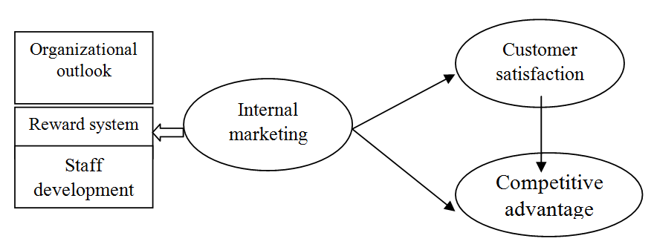

Figure 2-8: conceptual model of research (resulted from literature and theories of research)

**The results of Kolmogorov-Smirnov test**

In this section, by using the Kolmogorov-Smirnov test, the condition of the statistics the of distribution has evaluated.

Table 6-4: The results of Kolmogorov-Smirnov test

|  |  |  |  |
| --- | --- | --- | --- |
|  | Internal marketing | Costumer’s satisfaction | Competitive advantage |
| Kolmogorov-Smirnov ZAsymp. Sig. (2-tailed) | .807.532 | 1.240.093 | 1.552.061 |

**The results of t Test**

1-2-3-4: Internal marketing condition and its consequences in Melli bank of Ahwaz-Khozestan Province.

In order to condition monitoring the internal marketing and its consequences, one variable t Test was used in Melli bank of Ahwaz-Khozestan Province. The results of this analyses are indicated in the 4-7 table.

As it is evident, the average result is more than 3, so it confirms that the condition of this variable is favorable in Melli Bank of Ahwaz-Khozestan Province.

Table 4-7: Internal marketing and its consequences with using the one variable t Test

| Average SEM | Standard error of the mean (SEM) | average | quantity | variable |
| --- | --- | --- | --- | --- |
| 05071. | 235 | 3.4489 | 235 | Landscape |
| 05317. | 235 | 3.1709 | 235 | Praise system |
| 04881. | 235 | 3.3794 | 235 | Employment |
| 04595. | 235 | 3.3331 | 235 | Internal marketing |

One-Sample Test

|  |  |  |  |  |  |  |
| --- | --- | --- | --- | --- | --- | --- |
|  | Test Value: 3 | | | | | |
| T | Degree of freedom | Sig (2. tailed) | Average Difference | 95% the assurance of average difference |  |
| Least | Most |
| Landscape  Praise system  Employment  Internal marketing | 8.854  3.215  7.773  7.249 | 234  234  234  234 | .000  .001  .000  .000 | .44894  .17092  .37943  .33310 | .3490  .0662  .2833  .2426 | .5488  .2757  .4756  .4236 |

Costumers’ satisfaction condition in Melli Bank branches of Ahwaz- Khozestan Province

In order to condition monitoring of costumers’ satisfaction one sample t Test was done in Melli Bank branches of Ahwaz- Khozestan Province. The results of these data analyses are indicated in 4-8 table.

As it is evident the costumer’s satisfaction is more than 3 in Melli Bank branches of Ahwaz- Khozestan Province, so it is evident that the condition of this variant is favorable competitive advantage condition in Melli Bank Branches of Ahwaz- Khozestan Province.

Table 4-8: costumer’s satisfaction One variable t Test

| **One-Sample Statistics** | | | | |
| --- | --- | --- | --- | --- |
| Average SEM | Standard error of the mean(SEM) | average | quantity | variable |
| .04456 | 68307. | 3.0783 | 235 | Costumer’s satisfaction |

**One-Sample Test**

|  |  |  |  |  |  |  |
| --- | --- | --- | --- | --- | --- | --- |
|  | Test Value =3 |  |  |  |  |  |
| T | Degree of freedom | Sig. (2-tailed) | Average difference | 95% the assurance of average difference |  |
| Least | Most |
| Costumer’s Satisfaction | 6.908 | 234 | .30780 | .000 | 2200 | .3956 |

In order to condition monitoring one sample t Test was done in Melli Bank Branches of Ahwaz- Khozestan. The results of these data analyses are indicated in 4-9 table.

As it is evident competitive advantage average in Melli Bank branches of Ahwaz- Khozestan Province is more than 3, so it is evident that the condition of this variant is favorable.

Table 4-8: competitive advantage of on variable t Test

| **One-Sample Statistics** | | | | |
| --- | --- | --- | --- | --- |
| Average SEM | Standard error of the mean(SEM) | average | quantity | variable |
| .05195 | 79634. | 3.2349 | 235 | Competitive advantage. |

**One-Sample Test**

|  |  |  |  |  |  |  |
| --- | --- | --- | --- | --- | --- | --- |
|  | Test Value =3 |  |  |  |  |  |
| T | Degree of freedom | Sig. (2-tailed) | Average difference | 95% the assurance of average difference |  |
| Least | Most |
| Competitive advantage | 4.522 | 234 | .000 | .23489 | .1325 | .3372 |

**The results of Friedman Test**

In this section, we used Friedman Test in order to rank the research parameters.

As it is indicated in the 4-10 table, According to the average ranking of internal marketing parameters in Melli Bank branches of Ahwaz- Khozestan Province, They are ordered respectively as landscape, praise system, and employment.

Table 4-10: The results of Friedman Test for internal marketing parameters

| ranking | Average ranking | variant |
| --- | --- | --- |
| 1 | 2.22 | Landscape |
| 2 | 1.74 | Praise system |
| 3 | 2.04 | Employment |

**Research Test assumptions**

In order to test the assumptions, we used the structural equation modeling(SEM) and Lisrel software.

In projecting structural equation modeling in order to test the research assumptions, at the beginning the outcome of software indicated that the structural fitting model is favorable (df/2χ= 1/35, RMSEA= 0/047, GFI=0/95, AGFI= 0/93, NFI= 0/96, NNFI= 0/98, CFI= 0/99). In other words, It is crystal clear that the data is parallel to the maximum point over the research mean model. (table4-14)

The results of structural equation modeling confirms that internal marketing has a positive and meaningful effect on costumer’s satisfaction (β=0.79, t=9.32) and competitive advantage (β=0.27, t=3.40) in Melli Bank branches of Ahwaz- Khozestan Province. Costumers satisfaction has a direct and meaningful effect on the competitive advantage in Melli Bank branches of Ahwaz- Khozestan Province (β=0.68, t=5.97). Also these results confirm the effect of costumer’s satisfaction variant mediation in realizing the relation between competitive advantage and internal marketing (β:0.27, β:0.79*0.68=0.5372), so the zero assumption is rejected instead, all of the research assumptions are confirmed.

**The results of research Test**

**Secondary assumption 1:** Internal marketing has a positive and meaningful effect on the Melli Bank branches in Ahwaz- Khozestan Province. The results in this research confirm the assumption with coefficient process 0.79 and the mean number 9.32. As a result, we can conclude that if we can prepare the condition in order to achieve satisfaction among staff, the result will be the satisfaction of external costumers. If staff feel that the organization behave them fairly, they will probably behave costumers fairly. In other words, the effective function of organization in which it is because of training capable and satisfied staff in the organization, can lead to attract loyal and satisfied customers.

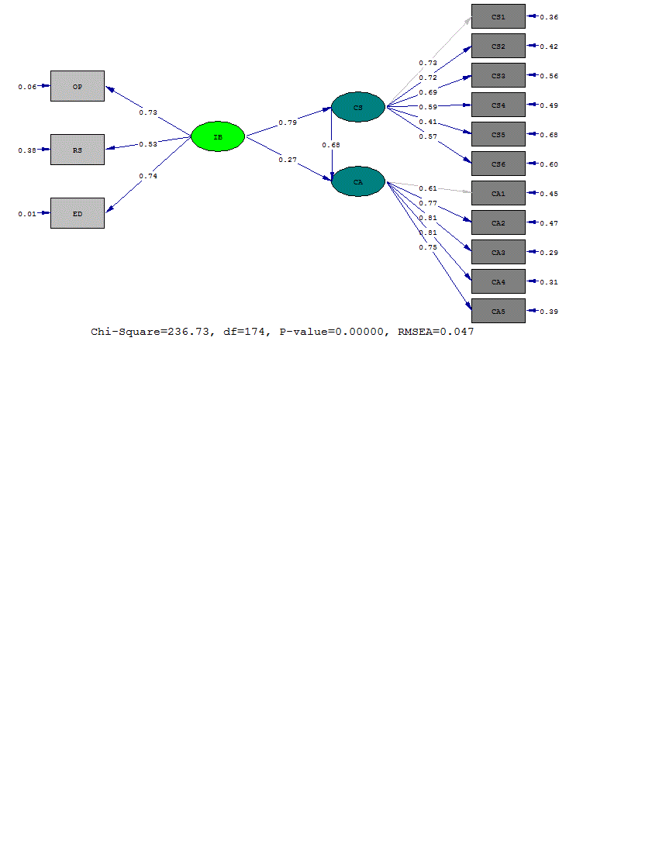

Structural model of the study in standard estimate

The significance coefficients and achieved parameters of the structural model of the study are indicated in table 4-15.

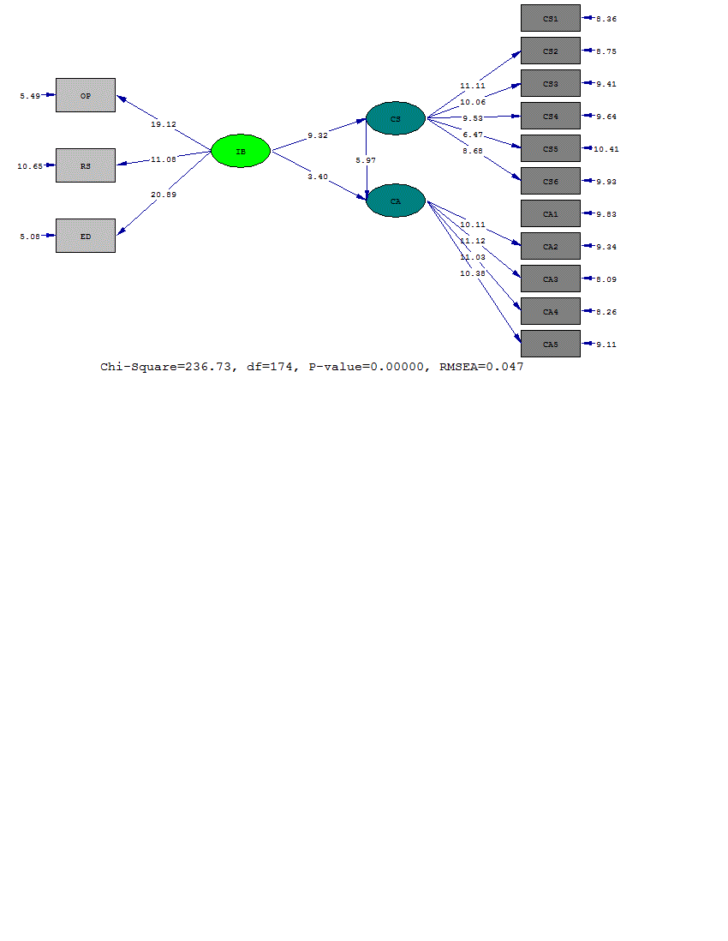

Table 4-15: Coefficients significance numbers (values) in structural model of study

**Major assumption:**

Internal marketing has a positive and meaningful effect on the competitive advantage by using the costumer’s satisfaction mediation role in Melli Bank branches in Ahwaz- Khozestan Province. Research’s data confirms the major assumption with coefficient process 0.53, so it can be stated that with a great investment of this Bank for training organizational staff and create motivated staff, we can achieve satisfaction and the result will be the competitive advantage. In fact it is the bank that make a distance with other competitors by attracting costumers and keep the staff who care for costumers and participate in loyalty programs of the bank.

**Reference**

1. Ahmed, P. K., Rafiq, M., and Saad, N. M, (2003)," Internal marketing and the mediating role of organizational competencies", European Journal of Marketing; Vol. 37, No. 9, pp. 1221-1221.
2. Alhakimi, W; Alhariry, K. (2014). Internal Marketing as a Competitive Advantage in Banking Industry, Academic Journal of Management Sciences, ISSN 2305-2864.
3. Awan, H.M; Siddiquei, A.N; Jabbar, A; Abrar, M; Baig, S.A. (2015). Internal Marketing and Customer Loyalty: A Dyadic, Analysis. Journal of Service Science and Management, 8, 216-228.
4. Bearden, W.O., Teel, J.E., (1983). Selected determinants of consumer satisfaction and complaint reports. Journal of Marketing Research 20 (February), 21–28.
5. Barnes, B.R; Morris, D.S. (2000). Revising Quality Awareness Through Internal Marketing: an Exploratory Study among French and English Medium-Sized Enterprises, Total Quality Management, 11(4/5&6), S473-S483.
6. Barney, Jay B. (2001) Gaining And Sustaining Competitive Advantage, Mass.: Addison-Wesley.
7. Barney, J. & Wright, P. M. (2001). On Becoming A Strategic Partner: The Role Of Human Resource In Gaining Competitive Advantage. Human Resource Management, 37. 31-46.
8. Bhatt, G. And Emdad, A. And Roberts, N. And Grover, V. (2010). Building And Leveraging Information In Dynamic Environments: The Role Of It Infrastructure ﬂexibility As Enabler Of Organizational Responsiveness And Competitive Advantage, Information And Management, 47, Pp. 341-349.
9. Caldwell, C. Licona, B. Floyd, L.A. (2015), Internal Marketing to Achieve Competitive Advantage, International Business and Management, Vol. 10, No. 1.
10. Chen Y.H., (2011). The service quality and consumer behavior analysis in Taiwan, International Conference on Asia Pacific Business Innovation & Technology Management Procedia - Social and Behavioral Sciences 25, pp. 16 – 24.
11. Chebat, J., and Slusarczyk, W. (2005), "How Emotions Mediate the Effects Of perceived Justice on Loyalty in Service Recovery Situations: An Empiricalstudy", Journal of Business Research, 58 (5), 664−673.
12. Cooper, J., & Cronin, J. (2011). Internal Marketing: Competitive Trategy for the Long-Term Care Industry. Journal of Business Research, 8(6), 177-181.
13. Dalbooh, M; Khasawneh, M. (2013). The Effect of Internal Marketing on Increasing Customer's Satisfaction in Jordanian Tourism Sector: An Empirical Study on the Northern Region from the Viewpoint of Customers, Exploying Research an Innovations, ISSN. 2250-2459, Vol. 3, Issue. 11.
14. Foreman S. K., Money A.H. (1995). Internal Marketing: Concepts, Measurement, and Application, Journal of Marketing Management, Vol.11.
15. Hao Ma. (1999), Creational Preemption For Competitive Advantages, Management Decision, Vol. 37, No. 3.
16. Hung-chang, C; Yi-hing, L; Chuan, L; Monle, L. (2005). Relationship Marketing and Consumer Switching Behavior, Journal of Business Research, Vol. 57.
17. Ihalainen, M. (2011). Competitive Advantage through Customer Satisfaction, Thesis for Degree Programme in Business Management Bachelor’s Thesis.
18. Kaleka, A. (2002). Resources And Capabilities Driving Competitive Advantage In Export Markets: Guidelines For Industrial Exporters. Industrial Marketing Management, 31(3), 273-283.
19. Khodabakhsh, F; Mashayekhi, M. (2014). Analyzing the Effect of Internal Marketing on Customer’s Satisfaction in Insurance Companies, International Journal of Scientific Management and Development, Vol. 2, 471-478.
20. Lee C., Chen W.J. (2005). The Effects Of Internal Marketing And Organizational Culture On Knowledge Management In The Information Technology Industry”; International Journal of Management, Vol.22, No.4.
21. Lings, L. (2000). Internal Marketing and Supply Change Management. Jounal of Service Marketing, 14(1), 27-43.
22. Parasurman, A. (1994), "A Conceptual Model of Services Quality and its Implications for Future Research", Journal of Marketing, 13(49), 41-50.
23. Roudriguez, M. A., Ricart, J. E., Sanchez, P. (2002); "Sustainable Development And The Sustainability Of Competition Advantages", Creativity And Innovation Management, 11(3). Pp 53-78.
24. Sadri, G; Lees, B. (2001). Developing Corporate Culture as a Competitive Advantage, Journal of Management Development, 20 (10).
25. Yang, J.T. (2015). Effect Of Internal Marketing On Knowledge Sharing And Organisational Effectiveness In The Hotel Industry, Total Quality Management & Business Excellence, 26:1-2, 76-92.

10/6/2016