Investigation Quantitative Features of Quercus Kamarovit Longifolia Oliv in Arasbaran Region

Vali Seifi Ghadi¹ (Corresponding author), Habib Fathi¹, Dr. Ali Kialashaki²
- MSc of Natural Resources Engineering, Forestry Orientation, Islamic Azad University of Chaloos, Mazandaran, Iran
- Associate Professor in Forestry, Faculty member of Islamic Azad University of Chaloos, Mazandaran, Iran
saheb_1360@yahoo.com

Abstract: Understanding the study area before you take any kind of administrative actions seem important, because it provides the possibility to please an appropriate assessment according to characteristics have Quantitative mass and given the potential to provide a good habitat management model. Arasbaran located in the north of Aras river, from the west to the highlands city of Tabriz and Sarab and the East border of Ardabil and East Azerbaijan province and also Marand and Jolfa and the West is limited. Data using SPSS software and Excel for charting and Duncan test and analysis of variance according to the characteristics of Quantitative separate groups were compared. With the help of statistical tests to compare multiple analysis of variance showed that the mean diameter at breast height, tree height, crown diameter, crown height to 95% there is no significant difference. Arasbaran forest area in the not too distant past has been a significant extent due to indiscriminate felling of forests for charcoal large area of the forest is gone, now Arasbaran 164000 hectares of forest area which this area of 148000 hectares as forest protection has been reported. The annual rainfall average area of 400-600mm is estimated. The number of foggy days this area is significant and increasing role in regional water balance which affects the amount of rain forests Arasbaran that make rainfall of 450 mm to 750 mm and perhaps, the main reason is the same Arasbaran diversity of species.
[Vali Seifi Ghadi, Habib Fathi, Ali Kialashaki. Investigation Quantitative Features of Quercus Kamarovit Longifolia Oliv in Arasbaran Region. Researcher 2017;9(5):96-100]. ISSN 1553-9865 (print); ISSN 2163-8950 (online). http://www.sciencepub.net/researcher. 15. doi:10.7537/marsrsj090517.15.

Keywords: Quercus Kamarovit Longifolia Oliv, ANOVA technique, Arasbaran

1. Introduction
Arasbaran located in the north of Aras river, from the west to the highlands city of Tabriz and Sarab and the East border of Ardabil and East Azerbaijan province and also Marand and Jolfa and the West is limited. Data using SPSS software and Excel for charting and Duncan test and analysis of variance according to the characteristics of Quantitative separate groups were compared.
Arasbaran forest area in the not too distant past has been a significant extent due to indiscriminate felling of forests for charcoal large area of the forest is gone, now Arasbaran 164000 hectares of forest area which this area of 148000 hectares as forest protection has been reported. The annual rainfall average area of 400-600mm is estimated. The number of foggy days this area is significant and increasing role in regional water balance that which affects the amount of rain forests Arasbaran that make rainfall of 450 mm to 750 mm and perhaps, the main reason is the same Arasbaran diversity of species. Arasbaran can be in terms of diversity of tree species and shrubs and herbaceous plants and woody and also in terms of faunal diversity unparalleled announced as a reserve.
The aim of this study was to determine the characteristics of Quantitative species of white oak, diameter, height, crown height and crown diameter.
Yazdian, F. and Marvi, M. (2000) investigated the oak forests in Arasbaran. Based on the results of this study Arasbaran forests and type of diversity is very high, according to the distribution of two species of white oak and oak forest types in different situations physiographic and ecological chest will appear. The total area of about 104,890 hectares of oak forest of these, only 57,020 hectares with a canopy density of more than 50 percent.
Elahian, S. (2008) Classification of forest ecosystems Arasbaran by Bio Geo Climatic (BEC) review.
And concluded that the total area of 558200 ha area into three zones are:
- Zone Q.k
- Zone Q.M
- Zone M.G
Mixed hardwoods and softwoods divided the sub-regional area of 426 hectares and 574 hectares, the rest is pasture.
Nikdel, M. et al (2006) study a comparative study of how the loss of seed-eating weevils and moths Arasbaran oak forests studied. The results showed that the mean percentage of damaged trees is always the weevils, moths and other destructive factors in the first year were 29, 25.5 and 13.3 and in the second year was 40.6, and 15.8 and 8 percent. Oak species have no significant effect on the amount of damage caused by this pest, and thus the two troughs, both species of oak equally preferred, while the extent of the damage caused by the weevil Curculio glandium oak seed and seed moths Cyndi fagiglandana significant difference.
Miroshnichenko Leboa (1974) Effect of fertilizer seal metabolism were studied in White Oak, the results showed that organic fertilizers are better than chemical fertilizers in boosting carbohydrates in plant growth effectively.

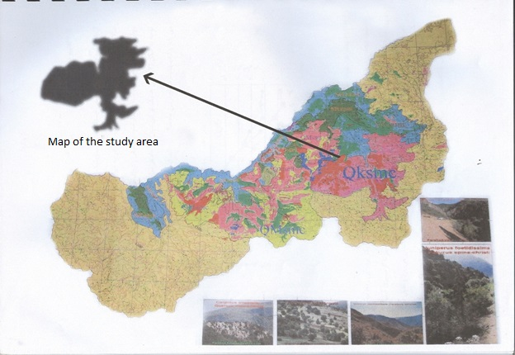
Figure 1. Map of the Geographical Location of Arasbaran region

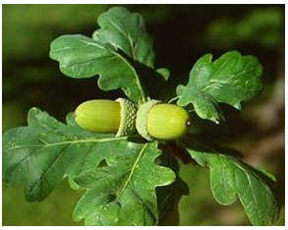
Figure 2. The leaves of Quercus

Oak public word can be used on hundreds of tree species of the genus Quercus. This category, which includes species of deciduous and evergreen native to the Northern Hemisphere is cold to tropical regions of Asia and America are expanding. Oak tree leaves in the winter sheds familiar and full-bodied with a length of up to forty meters and Dora the foliage of a tree trunk that is smooth and gray, and over the years, gaps picks. The leaves are oblong lobes on each side 3 to 7 and blueberry flowers appear next to them. In the fall, fertilize the tree of flowers, fruits, chestnut brown to green produce.
Different species of oak in Iran that is characteristic of all of them on the sidelines of a rectangular leaf lobe is significant. Coarse oak fruit and nut are the type of coverage surrounding the bowl like them.
Oak trees grow in terms of the weather conditions are special. North mild climate and temperate mountain climate suitable for growing this plant. The other side of the trees at an altitude of 1000 to 1200 meters above sea level grow. Hence, their habitats and the rest of the world that has such circumstances, searched, therefore oak tree in locations in Asia, Europe and America and Europe who go above conditions.
Estimated that there are about 400 species of oak in the ground which consist of multiple species and sex (Byfield, Liz,1990).
Distribution of various species of oak in the world is as follows:
- Quercus type: white oaks of Europe, Asia and North America.
- Hungarian oak types and varieties of the family of Europe and Asia.
- Oak Turkey from Europe and Asia.
- Oak grown in the valleys and in the southwestern and northwestern United States of America and Mexico.
- Red Oaks rendered North, Central and North America and South America.
- Tree rings from East and Southeast Asia cup Logan, William B. (2005)
Round oak pollination in the world has led to the evolution of new species (Royston, Angela (2000), this leads to frequent hybridization and high level of penetration as a result of various species and 50% of genetic information, genetic data produced from Savage, Stephen (1994).
Iran trees, oak and chestnut on the sidelines of the Caspian Sea and the oak tree Iran in West Iran from Sardasht, Kurdistan, Kermanshah, Ilam, part of Khuzestan, Lorestan, Chahar Mahal and Bakhtiari, Kohgiluyeh and Boyer Ahmad and Fars (habitat Zagros) scattered the Javanshir (book Atlas of Woody plants (1957). the number of species is estimated that approximately 200.

Table 1. scientific name, Persian and local name of tree and shrub species identified in the Arasbaran habitat
Local  name | Persian  name | scientific name | Local  name | Persian  name | scientific name
Dooghe | Sand | Lonicera iberica | Aghajaghim | Korb | Acer campestre
Alma | Apple | Malus orientalis | Aghajaghim | White Korakou | Acer hyrcnum
Azgila | Medlar | Mespilos germanica | Karkoo | Korakou | Acer ibericum
Ghare Tikan | Black Tello | Paliurus spinachristi | Badamche | Badamchh | Amygdalus fenzeliana
Saghez Aghagi | Atlantica | Pistacia mutica | Charan Garnik | Karvankesh | Artaphaxis spinosa
Samarghand | Padeh | Popolus euphratica | Zarish | Barberry | Berberis integerima
- | Prosopis Farcta | Prosopis fareta | Zarish | Barberry | Berberis integerima
Malab | Mohallab | Pruns mahaleb | Emlas | Hornbeam | Carpinus schschaensis
Alche | Plum | Prunus spinosa | Olas | Kachef | Carpinus schschaensis
Anar | Pomegranate | Panica granata | Daghdaghan | Hackberry | Celtis caucastica
Aghermit | pear | Pyrus elaegnifolia | Marmar | Marmara | Cerasus incana
Armit | pear | Pyrus elaegnifolia | Daghdaghak | Colutea | Calutea buhsei
Armit | pear | Pyrus syriaca | Daghdaghak | Colutea | Calutea Cilicia
AghPalit | White Oak | Quercus komarovii | Daghdaghak | Colutea | Calutea buhsei
GarehPalit | White Oak | Quercus macrantera | Shaft | Ale | Calutea buhsei
Ashangoor | Rhamnus cathartica | Rhamnus cathantera | Zoghal Akhte | Blueberries | Cornus australis
Ashangoor | Dogwood | Rhamnus albursensis | Fandigh | Hazelnut | Cornus mass
Ghareh Mikh | P. lycioides | Rhamnus pallasii | Zarnikh | Full | Coeylus avellana
Sarmakh | Sumac | Rhus coriaria | Chalghi | Clay milk | Cotoneaster integerrime
Ghareh Ghat | Gooseberry | Ribes bieberteini | Chalghi | Clay milk | Cotoneaster melanocarpus

Research Methodology:
The study area on the topographic map 1:250,000 were identified. Other requirements such as maps apple Map, direction and elevation using GIS software package called ILWIS was extracted. After it was selected points within the brigade that had been the least disturbance and interference and this was done because the area selected to interfere with its low land forms are representing the actual coverage. So within each land forms (edges, slopes and valleys) in the four cardinal directions (North, South, East, West) systematic random circular plots an area of 10 R (1000 m) and 50 pieces selected and Parameters evaluated in GPS, land form, aspect, slope (using an inclinometer) forest types and degrees of cover notes and the size quantitative and qualitative characteristics of the following apply:
View quantitative document eg, diameter, height, crown diameter, crown height, trunk quality characteristics of quality, the quality of the trunk, crown health, quality crown.
Statistical Analysis:
For statistical analysis of the characteristics of trees such as diameter at breast height, SPSS software was used. After variance analysis to evaluate the significance or non-significance, the comparison of quantitative Duncan (Duncan) was conducted as well as to evaluate the qualitative characteristics of the trees using chi-square test.

Results:
Compare quantitative white oak trees on the slope of the different classes: The average characteristics of Quantitative white oak trees located in different classes in Ilganeh Chai categories given below. Diameter at breast height, crown diameter, crown height, white oak trees of different classes slope there is no significant difference (Table 2).
The mean diameter at breast oak tree there is no significant difference in slopes.

Table 2. ANOVA, diameter at breast height, crown diameter and crown height white oak at different slopes
Source of changes | df | value | Sig level
Diameter at breast | 1 | 0.53 | 0.99
Height | 1 | 0.06 | 0.085
Crown diameter | 1 | 0.66 | 0.424
Crown height | 1 | 0.11 | 0.737

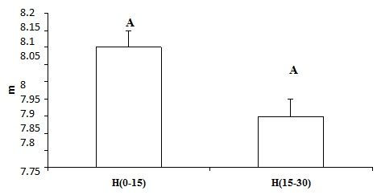
Figure 3. Average White oak chest height at different slopes

The average height of the trees on the slope (15-30) increased considerably in the floors slope and height of white oak trees have the greatest height (Figure 4).

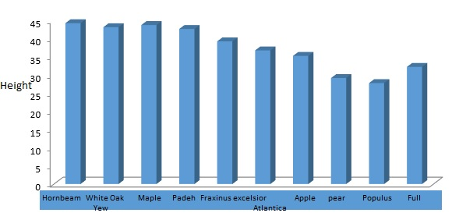
Figure 4, Average height of trees in different plots (slope 15-30)

Discussion and conclusion:
In general, white oak species are resistant and grows in a wide range of environmental conditions, most of the mass of the white oak forest in the study area at the bottom of the valley of the shadow and the underside of the floor and the upper floor their hornbeam. Given that in article analyzes are presented as white oak habitat Arasbaran by Yazdian, M. and Marvi Mohajer was investigated. Elevation ranges from 500 to 1600 meters of white oak habitats in the world. The study was conducted in the area Ilganeh Chai Arasbaran this result can be achieved, the distribution of oak in this area is in the range of 200 to 1400 meters. However, a single white oak base rises to a height of 2100 m. According to the results of qualitative and quantitative study of white oak in Arasbaran (basin Ilganeh Chai) can be stated that Quantitative review of the white oak trees factors (altitude, aspect and slope) density and distribution of plants and climates in the region (Ilganeh Chai) has caused significant difference in slopes. Most floors of the height of the slope (15-0) percent and the highest mating on the northern slopes and canopy closure (50-90) and herbaceous less than 10% is observed, because in these domains moisture and heat and light regime is more appropriate and less competition between herbaceous and revitalization.

References:
- Javanshir, K. 1959-1960. Atlas of Woody Plants, Tehran University, Journal of Forestry. Page 240.
- Department of Natural Resources of East Azarbaijan, 2003. Plan is to preserve the forests Arasbaran. Page 240.
- Yazdian, F. Mohammadreza, M. 2005, the introduction of oak forests in Arasbaran, Iranian Journal of Natural Resources, Volume 2. 9.
- Nikdel, M. 2006. A comparative study of how and damage of seed weevils and moths Arasbaran oak. College of Natural Resources analytical article, number 34.
- Elahian, R., 2008, classified, jungle Arasbaran by Bio Geo Climatic, a graduate of Forestry, Islamic Azad University Branch.
- Leboa, M. 1974. of forest zons of C.

5/23/2017

