Clostridium Difficile Causing Nosocomial Diarrhea in Children with malignant tumors

El Sayed Ahmed El Sayed Gouda ¹, Ibrahim Mohammed Al-Hosiny ¹, Tarik Hassan M. Kabel ¹, Reham Abdelaziz Khedr ² and Ibrahim Hassan Bayomy¹.

¹ Medical Microbiology and immunology, Faculty of Medicine, Al- Azhar University, Cairo, Egypt
² Pediatric Oncology, National Cancer Institute, Cairo University, Cairo, Egypt
Ihbda7108@yahoo.com

Abstract: Background: Nowadays, patients with cancer receive more intensive chemotherapeutic regimens together with broad-spectrum antibiotics during periods of intense immunosuppression. Thus, cancer patients are susceptible to colonization with C. difficile, but the role of this pathogen in pediatric oncology patients is poorly understood. Objectives: detect the prevalence of C. difficile, analyze what risk factors which favor the development of C. difficile associated diarrhea (CDAD) in pediatric oncology patients and evaluate the usefulness of direct stool PCR assay as a diagnostic tool for diagnosis of CDAD as compared with other laboratory tests. Subjects and Methods: The current study comprised Ninety pediatric oncology Patients, having nosocomial diarrhea from National Cancer Institute, Cairo University (NCI) after obtaining an informed written consent for participation in the present study. Demographic Data including age, sex, Diagnosis, disease status and treatment phase of the enrolled patients was collected. Clinical Outcome was reported. Stool samples were collected from each patient and were subjected to direct Toxin A/B ELISA and anaerobic culture on Cycloserine, cefoxitin, fructose agar (CCFA) for 72hrs. Clostridium difficile isolates were confirmed by a distinctive odor, fluorescence, motility and biochemical reactions. DNA was extracted from all C. difficile isolates and stool samples. the presence of tcdA and tcdB (Toxin) genes were tested using polymerase chain reaction. Results: Toxigenic Clostridium difficile strains isolated were detected in 14 (15.6%) pediatric cancer patients receiving chemotherapy. Considering the toxigenic stool culture as the "gold standard", the sensitivities, specificities, positive and negative predictive values, and accuracies of the assays, respectively, were 85.7%, 97.7%, 75%, 97.3% and 93.3% for direct Toxin A/B ELISA compared with 88.9%, 100%, 100%, 98.8% and 98.9% for direct PCR detection for toxin A gene and 85.7%, 100%, 100%, 97.4% and 97.8 for direct PCR detection for toxin B gene. Conclusion and recommendations: C. difficile is an important cause of diarrhea in pediatric cancer patients. Direct detection of C. difficile genes from stool samples based on PCR is more sensitive and less time-consuming than culture methods and provides greater sensitivity than an enzyme immunoassay.
[El Sayed Ahmed El Sayed Gouda, Ibrahim Mohammed Al-Hosiny, Tarik Hassan M. Kabel, Reham Abdelaziz Khedr and Ibrahim Hassan Bayomy. Clostridium Difficile Causing Nosocomial Diarrhea in Children with malignant tumors. Researcher 2017;9(6):15-24]. ISSN 1553-9865 (print); ISSN 2163-8950 (online). http://www.sciencepub.net/researcher. 4. doi:10.7537/marsrsj090617.04.

Keywords: C. difficile, diarrhea, children and malignant tumors.

1. Introduction:
Children are increasingly being recognized as an emerging population at risk for C. difficile infection (CDI). Nowadays, the possibility of administering more intensive chemotherapeutic regimens, the introduction of new techniques such as allogenic hematopoietic cell transplantation and autologous stem cell infusion, the applications of growth factors, the implantation of central venous catheters, progress in diagnostic techniques and in antimicrobial chemotherapy are associated with the improved prognosis of patients with malignancies. Prolonged survival during periods of profound immunosuppression has also render cancer patients susceptible to abroad array of potential pathogens causing infections. Gastrointestinal manifestations following newer protocol of chemotherapy are becoming more common (Kari and Alison, 2017).
C. difficile cause essentially all cases of pseudomembranous colitis and about 25% of antibiotic associated diarrhea. Cancer patients often receive broad spectrum antibiotics in addition to antineoplastic chemotherapy. Both treatments are known to predispose oncology patients to colonization and infection with C. difficile (Hadis et al., 2014).

2. Subjects and Methods:
Subjects: This study was carried on Ninety pediatric oncology patients at National Cancer Institute, Cairo University, who developed nosocomial diarrhea after obtaining an informed written consent for participation in the present study during the period from March, 2015 to Jan,2017.
Inclusion criteria:
1-Development of diarrhea, defined as the passage of ≥ 3 unformed stools within a 24-h period, for more than 2 days with no other obvious etiology for the diarrhea.
2-Hospitalization for ≥48h when diarrhea developed.
Patients were included into two groups (group A, with CDAD, no.: 14 cases and group B, with nosocomial diarrhea other than C. difficile, no.: 76 cases).
Methods:
Demographic data including age, sex, diagnosis, disease status and treatment phase of the enrolled patients were collected. Clinical outcome was reported. Stool samples were collected in a clean dry leak proof container and subjected to physical evaluation before processing. Each stool specimen was then divided into three aliquots, the first part was cultured immediately after receipt at the laboratory, the second part was refrigerated at 4° C until it was tested by TOX A/B EIA in the following 24 hours as was documented by Lyerly et al., 1998; and the third was frozen at -70º C for PCR testing as was documented by Arzese et al., 1995.
Stool samples were treated with absolute alcohol and cultured on cycloserine-cefoxitin-fructose agar (Oxoid, Basingstoke, United Kingdom). The inoculated plates were incubated in an anaerobic jar using anaerogen/campygen gas packs (90% N₂ /10% Co₂) (Oxoid), for 72 hours at 35°C (Brazier, 1998a). Clostridium difficile isolates were confirmed by Colonial characters (yellowish, flat, circular to irregular, and 4 to 8 mm in diameter), a distinctive odor resembling that of elephant or horse manure, a yellow/green fluorescence in long wave (305 nm) UV light, Gram positive bacilli with subterminal or terminal non-bulging oval spores, characteristic oscillating motility, negative lipase, negative lecithinase and negative Indole tests, direct detection of toxins using Radiascreen C. difficile Toxin A/B ELISA (r-Biopharm) (Bartlett et al., 2008) in addition to PCR Assay for detection of toxin A and B genes.
DNA extraction: DNA was prepared from both stool samples and bacterial isolates. A bacterial colony was taken from blood agar culture and suspended in 1 ml of distilled water, 20 µl proteinase K (0.5mg/ml; Sigma Chemicals, USA) and 15 µl lysozyme (20 mg/ml; Sigma Chemicals, USA) in a microcentrifuge tube. The suspension was then boiled for 20 min. prior to being centrifuged at 14.000 r.p.m. for 20 min to settle bacterial debris and 10 µl supernatant containing the genomic DNA was used for subsequent PCR amplification (Lemee et al., 2004).
DNA extraction from the stool samples was carried as described by Arzese et al., 1995 as follows:
1-One hundred milligrams of feces were suspended in 2 ml of sterile distilled water and heated at 100°C for 10 minutes.
2-After a short centrifugation (14.000 r.p.m, 20°C, 5 minutes), the supernatant was treated with 40 µl proteinase K (0.5mg/ml; Sigma Chemicals, USA) and 20 µl lysozyme (20 mg/ml; Sigma Chemicals, USA) at 56°C for 90 minutes.
3-Samples were then heated at 100°C for 5 minutes, centrifuged and the supernatant was used as a template in the PCR reaction mixture.
Amplification: TcdA gene and tcdB gene were amplified separately using the primer pairs A4570F and A5382R for tcdA as was described by J Scott et al., 2000 and the primers YT 17 and YT 18 for tcdB as was described by Titov et al., 2000. The primer pairs that were used are shown in table (1).

Table (1): Primer pairs used for amplification of toxin A and B genes
Primer pair | Sequence (5′-3') | Expected size (bp)
tcdA-F | TAACAGGAAAATACTATGTTG | 810
tcdA-R | CATTATATATCCTAATGATAG | 810
tcdB-F | GGTGGAGCTGCTTCATTGGAGAG | 399
tcdB-R | GTGTAACCTACTTTCATAACACCA | 399

Amplifications using each primer pair for each of toxin A and B genes were performed separately as follows:
-In a PCR eppendorf tube, the following reactants were added to make a total of 25 µl reaction volume: 2 X PCR master mixes 12.5µl, each of the primers 1 µl, template DNA 3 µl, sterile deionized water to 25 µl.
-The tubes were then placed in the thermal cycler and the cycler was programmed as follows: heating at 94°C for 5 min (initial denaturation step), 95°C for 15 seconds, 50 °C for 20 seconds (for annealing), 72°C for 40 seconds (repeated 35 times) (for polymerization) and final extension step at 72°C for 7 min then the amplification products were kept at 4°C for the next 24 hours.
Detection of amplified products:
DNA banding patterns from PCR amplifications were visualized by running 12 µl of the amplification product in a 2% agarose gel in Tris-borate-EDTA buffer. Two micro liters of Thermo Scientific Gene Ruler 50bp DNA Ladder was included as a molecular size marker. Gels were stained in an ethidium bromide solution (0.5 µg/ml), then were run at a constant 110 V for 60 minutes and then photographed under UV light (Arzese et al., 1995).
Statistical analysis:
Data were collected, revised and entered using the statistical package SPSS. The collected data was tabulated and analyzed with the suitable statistical methods using mean value ± standard deviation, T-test, analysis of variant and chi square test. P value of less than 0.05 was considered statistically significant.

3. Results:
The present study involved a total of 90 nosocomial diarrheal episodes experienced by pediatrics cancer patients under myeloablative therapy. The underlying disease was an acute lymphoblastic leukemia (ALL) in 32 (35.6%) cases, acute myeloid leukemia (AML) in 18 (20%) cases, lymphoma in 19 (21.1%) cases and a solid tumor in 21 (23.3%) cases. The state of the disease at the time of occurrence of diarrhea was during induction in 20 (22.2%) cases, at a complete remission in 47 (52.2%) cases and during disease relapse in 23 (25.6%) cases.

Table (2) Prevalence of C. difficile positive culture, positive ELISA for A/B toxins and PCR gene detection among studied diarrheal cases:
The test | Culture | Direct ELISA | PCR
The test | Culture | Direct ELISA | On isolates | On stool samples
prevalence | 17 | 16 | 14 | 12
percentage | 18.9% | 17.8% | 15.6% | 13.3%

Only 17 of the 90 (18.9%) samples yielded colonies resembling those of C. difficile. The presumptive colonies were confirmed by a distinctive odor, fluorescence, motility and biochemical reactions. The table (2) shows that prevalence of positive culture, positive ELISA for A/B toxins, PCR gene detection from isolates and PCR gene detection from stool samples were 17 (18.9%), 16 (17.8%), 14 (15.6%) and 12 (13.3%) respectively.
PCR on the isolates of the 17 samples yielded C. difficile colonies toxin A gene was detected in 9 (10%) and toxin B gene in 14(15.6%) (Toxin A+/B+ variants was 9 (10%) cases and A-/B+ variants was 5 (5.6%)) while direct PCR on stool samples of the 90 cases was detected toxin A in 8 (8.9%) and toxin B gene in 12(13.3%) (Toxin A+/B+ variants was 8 (8.9%) cases and A-/B+ variants was 4 (4.4%)).
Clustering of cases was observed in 2 incidents. In the first incident 4 patients (numbered 21,22,25 and 27) were diagnosed during a 1 week period in one ward and all were A+B+ variants; whereas, in the second incident outbreak was observed in 3 cases (numbered 32,35 and 36) in 5 day period in another ward and all were A-B+ variants suggesting that the 2 outbreaks not related to each other.

Table (3) comparisons between results of direct Toxin A/B ELISA, direct PCR and PCR on isolates for detection of toxin B gene:
The test |  | Direct Toxin A/B ELISA |  | Direct PCR for Toxin B |  | Total
 |  | Positive | Negative | Positive | Negative | Total
PCR on isolates | Positive | 12 | 2 | 12 | 2 | 14
PCR on isolates | Negative | 4 | 72 | 0 | 76 | 76
Total |  | 16 | 74 | 12 | 78 | 90
Sensitivity |  | 85.7% |  | 85.7%
Specificity |  | 97.7% |  | 100%
Positive predictive value |  | 75% |  | 100%
Negative predictive value |  | 97.3% |  | 98.8%
accuracy |  | 93.3% |  | 98.8%

Results of toxigenic cultures do serve as the current gold-standard against which other test modalities are compared in clinical trials of performance (High sensitivity and high specificity) (Kvach et al., 2010) so, we considered the culture followed by PCR amplification of toxin gene (PCR on colonies) as the standard. The sensitivities, specificities, positive and negative predictive values and accuracies respectively were 85.7%, 97.7%, 75%, 97.3% and 93.3% for direct Toxin A/B ELISA compared with 88.9%, 100%, 100%, 98.8% and 98.9% for direct PCR detection for toxin A gene and 85.7%,100%, 100%, 97.4% and 97.8 for direct PCR detection for toxin B gene.

Table (4) comparisons between results of direct PCR and PCR on isolates for detection of toxin A gene:
The test |  | Direct PCR for Toxin A |  | Total
 |  | Positive | Negative | Total
PCR on isolates  For toxin A | Positive | 8 | 1 | 9
PCR on isolates  For toxin A | Negative | 0 | 81 | 81
Total |  | 8 | 82 | 90
Sensitivity |  | 88.9%
Specificity |  | 100%
Positive predictive value |  | 100%
Negative predictive value |  | 98.8%
accuracy |  | 98.9%

Figure (1): Presentation the studied sample according to results of PCR on isolates into:
Group (A): children with CDAD. Group (B): children without CDAD.

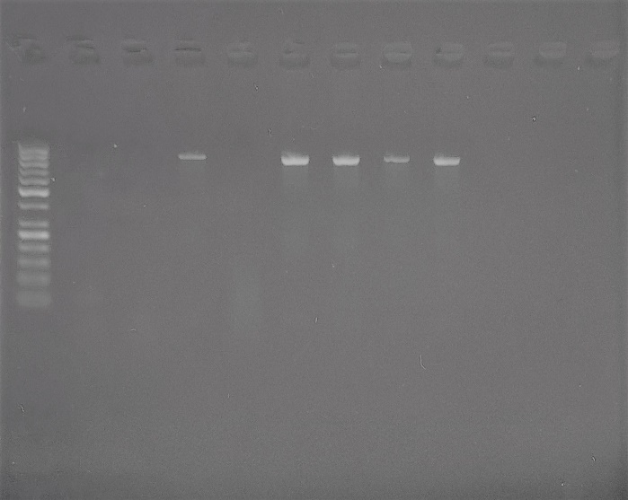  Figure (2) agarose gel electrophoresis for detection of toxin A (tcdA) in DNA from colonies (810 bp).  Lane (1) shows 50-1000 bp DNA Molecular Weight Marker with two reference bands (500 and 250 bp).  Lanes (4, 6,7,8 and 9) show bands of toxin A at 810 bp.  Lanes (2,3,5,10,11 and 12) show negative samples. | 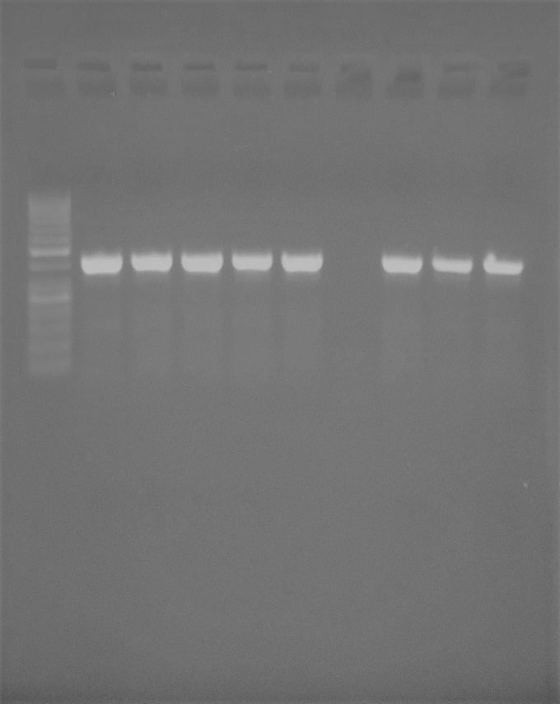  Figure (3) agarose gel electrophoresis for detection of toxin B (tcdB) in DNA from colonies (399 bp).  Lane (1) shows 50-1000 bp DNA Molecular Weight Marker with two reference bands (500 and 250 bp).  Lanes (2,3,4,5,6,8,9,10) show bands of toxin B at 399 bp.  Lane (7) shows negative sample.
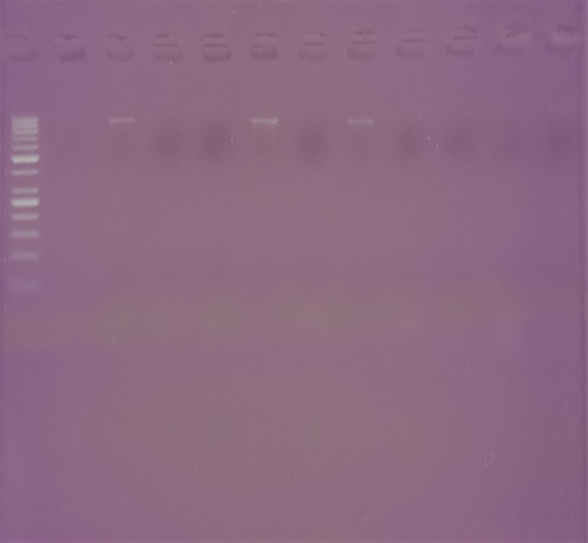  Figure (4) agarose gel electrophoresis for direct detection of toxin A (tcdA) in DNA from stool samples (810 bp).  Lane (1) shows 50-1000 bp DNA Molecular Weight Marker with two reference bands (500 and 250 bp).  Lanes (3, 6 and 8) show bands of toxin A at 810 bp.  Lanes (2,4,5,7,9,10,11 and 12) show negative samples. | 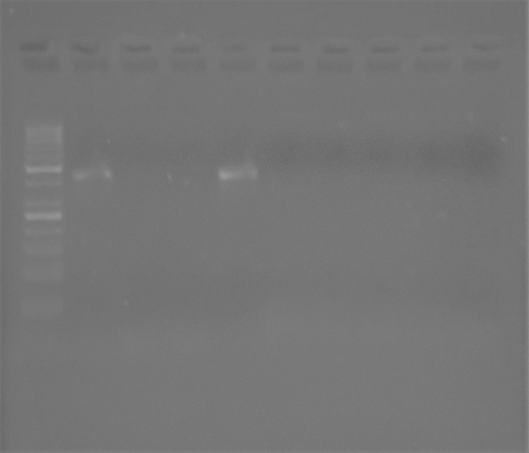  Figure (5) agarose gel electrophoresis for direct detection of toxin B (tcdB) in DNA from stool samples (399 bp).  Lane (1) shows 50-1000 bp DNA Molecular Weight Marker with two reference bands (500 and 250 bp).  Lanes (2 and 5) show bands of toxin B at 399 bp.  Lanes (3,4,6,7,8,9 and 10) show negative samples.

(5): Demographic characteristics of the patients studied:
Characteristics |  |  | Group A  (n=14) | Group B  (n=76) | Statistical analysis | P. value
Age in years |  | Mean | 6.86 | 8.25 | t =2.358 | 0.128
 |  | ±SD | 3.25 | 3.09 | t =2.358 | 0.128
Gender |  | Male | 7 | 46 | X² = 0.541 | 0.327
 |  | Female | 7 | 30 | X² = 0.541 | 0.327
Underlying disease | ALL | N | 5 | 27
Underlying disease | ALL | % | 35.8 | 35.5
Underlying disease | AML | N | 3 | 15 | X² = 0.044 | 0.998
Underlying disease | AML | % | 21.4 | 19.7 | X² = 0.044 | 0.998
Underlying disease | Lymphoma | N | 3 | 16 | X² = 0.044 | 0.998
Underlying disease | Lymphoma | % | 21.4 | 21.1 | X² = 0.044 | 0.998
Underlying disease | Solid tumor | N | 3 | 18 | X² = 0.044 | 0.998
Underlying disease | Solid tumor | % | 21.4 | 23.7 | X² = 0.044 | 0.998
Status of underlying disease  Status of underlying disease | Induction | N | 5 | 15 | X² = 3.803 | 0.149
Status of underlying disease  Status of underlying disease | Induction | % | 35.7 | 19.7 | X² = 3.803 | 0.149
Status of underlying disease  Status of underlying disease | A complete remission | N | 4 | 43 | X² = 3.803 | 0.149
Status of underlying disease  Status of underlying disease | A complete remission | % | 28.6 | 56.6 | X² = 3.803 | 0.149
Status of underlying disease  Status of underlying disease | Relapse | N | 5 | 18 | X² = 3.803 | 0.149
Status of underlying disease  Status of underlying disease | Relapse | % | 35.7 | 23.7 | X² = 3.803 | 0.149

When we compared both groups in terms of the demographic characteristics (Age, Gender, Underlying disease and the Status of underlying disease) the differences were insignificant. This is presented in table (5).
Chemotherapeutic protocols showed no significant difference between both groups in all Chemotherapeutic agents except for Doxorubicin (Adriamycin) and Methotrexate (MTX). Doxorubicin showed significant lower number of cases taking it in group A than group B while opposite finding in Methotrexate (p < 0.05). Methotrexate was associated significantly with development of CDAD Table (6).

Cilastatin/Imipenem and Fluoroquinolone were Significancy associated with CDAD. Metronidazole and Vancomycin was Significancy prescribed after onset of CDAD (p < 0.05). Other antibiotics showed no significance association between group A and B Table (7).
When we compared both groups in terms of associated manifestations accompanying diarrhea we found dehydration, abdominal distention and abdominal colic observed significantly in group A. The diarrhea was worse in group A as evidenced by a significant number of bowel motions and long duration. Watery and mucoid stool properties were significant in group A. The longer hospital stay, IV antibiotic ≥ 1 week, using antiacids and ICU admission were the main risk factors for developing of CDAD. Poor response to therapy was encountered in most cases of group A with highly Significancy difference.

Table (6): Chemotherapeutic agents among group A & group B:
Chemotherapeutic agents |  | Group A  (n=14) | Group B  (n=76) | Chi-Square X² | Odds ratio | P. value
AraC | N | 11 | 45 | 1.885 | 2.526 | 0.141
AraC | % | 78.6 | 58.2 | 1.885 | 2.526 | 0.141
Doxorubicin | N | 3 | 38 | 3.891 | 0.273 | 0.044
Doxorubicin | % | 21.4 | 50 | 3.891 | 0.273 | 0.044
MTX | N | 12 | 41 | 4.928 | 5.122 | 0.023
MTX | % | 85.7 | 53.9 | 4.928 | 5.122 | 0.023
VCR | N | 5 | 46 | 2.964 | 0.362 | 0.077
VCR | % | 35.7 | 60.5 | 2.964 | 0.362 | 0.077
CTX | N | 3 | 29 | 1.444 | 0.442 | 0.186
CTX | % | 21.4 | 38.2 | 1.444 | 0.442 | 0.186

AraC: Cystosar, MTX: Methotrexate, VCR: Vincristine and CTX: Cyclophosphamide

Table (7): Antibiotics agents among group A & group B:
Antibiotics agents |  | Group A  (n=14) | Group B  (n=76) | Chi-Square X² | Odds ratio | P. value
Azithromycin | N | 0 | 15 | 3.316 | 0.813 | 0.062
Azithromycin | % | 0 | 19.7 | 3.316 | 0.813 | 0.062
Aminoglycoside | N | 4 | 41 | 3.045 | 0.341 | 0.072
Aminoglycoside | % | 28.6 | 53.9 | 3.045 | 0.341 | 0.072
Cilastatin & Imipenem | N | 14 | 44 | 9.147 | 1.318 | < 0.01**
Cilastatin & Imipenem | % | 100 | 57.9 | 9.147 | 1.318 | < 0.01**
Metronidazole* | N | 11 | 38 | 3.891 | 3.667 | 0.044
Metronidazole* | % | 78.6 | 50 | 3.891 | 3.667 | 0.044
Fluoroquinolone | N | 8 | 12 | 11.697 | 7.111 | < 0.01**
Fluoroquinolone | % | 40 | 15.8 | 11.697 | 7.111 | < 0.01**
Sulphamethoxazole & trimethoprim | N | 5 | 16 | 1.421 | 2.083 | 0.195
Sulphamethoxazole & trimethoprim | % | 35.7 | 21.1 | 1.421 | 2.083 | 0.195
Vancomycin* | N | 8 | 20 | 5.242 | 3.733 | 0.027
Vancomycin* | % | 57.1 | 26.3 | 5.242 | 3.733 | 0.027

*antibiotics were taken after onset of diarrhea. **highly significant statistically.

Table (8): Clinical characteristics of the studied patients:
Characteristics |  | Group A (n=14) | Group B (n=76) | Statistical analysis | P. value
Dehydration | N | 12 | 38 | X²=6.107 | 0.012
Dehydration | % | 85.7 | 50 | X²=6.107 | 0.012
Abdominal distention | N | 12 | 8 | X²=38.668 | < 0.01**
Abdominal distention | % | 85.7 | 10.5 | X²=38.668 | < 0.01**
Abdominal colic | N | 11 | 19 | X²=15.268 | < 0.01**
Abdominal colic | % | 78.6 | 25 | X²=15.268 | < 0.01**
Fever ≥ 38.5 | N | 12 | 51 | X²=1.950 | 0.39
Fever ≥ 38.5 | % | 85.7 | 67.1 | X²=1.950 | 0.39
Vomiting | N | 1 | 1 | X²=1.847 | 0.288
Vomiting | % | 7.1 | 1.3 | X²=1.847 | 0.288
Duration of diarrhea | Mean | 14.71 | 10.24 | t = 9.807 | < 0.01**
Duration of diarrhea | ±SD | 6.19 | 4.66 | t = 9.807 | < 0.01**
The number of motions / day | Mean | 7.5 | 5.75 | t = 6.776 | < 0.01**
The number of motions / day | ±SD | 2.71 | 2.24 | t = 6.776 | < 0.01**
the duration of hospital stay | Mean | 23.42 | 16.68 | t = 10.544 | < 0.01**
the duration of hospital stay | ±SD | 8.88 | 6.79 | t = 10.544 | < 0.01**
IV antibiotic ≥ 1 week | N | 9 | 11 | X²=16.972 | < 0.01**
IV antibiotic ≥ 1 week | % | 64.3 | 14.5 | X²=16.972 | < 0.01**
Recurrence of diarrhea | N | 6 | 35 | X²=0.049 | 0.531
Recurrence of diarrhea | % | 42.9 | 46.1 | X²=0.049 | 0.531
Poor response to antibiotic therapy | N | 11 | 21 | X²=13.388 | < 0.01**
Poor response to antibiotic therapy | % | 78.6 | 27.6 | X²=13.388 | < 0.01**
Using antiacids | N | 14 | 41 | X²=10.55 | < 0.01**
Using antiacids | % | 100 | 53.9 | X²=10.55 | < 0.01**
ICU admission | N | 6 | 7 | X²=10.830 | < 0.01**
ICU admission | % | 42.9 | 9.2 | X²=10.830 | < 0.01**
Watery stool consistency | N | 12 | 17 | X²=21.72 | < 0.01**
Watery stool consistency | % | 85.7 | 22.4 | X²=21.72 | < 0.01**
Bloody stool | N | 2 | 9 | X²=0.66 | 0.541
Bloody stool | % | 14.3 | 11.8 | X²=0.66 | 0.541
Mucus in stool | N | 11 | 29 | X²=7.82 | < 0.01**
Mucus in stool | % | 78.6 | 38.2 | X²=7.82 | < 0.01**
**highly significant statistically.

Table (9): Laboratory findings in the studied population:
Variable |  | Group A  (n=14) | Group B  (n=76) | Statistical analysis | P. value
Hb  (gm/dl) | Mean | 8.85 | 8.78 | t = 0.028 | 0.868
Hb  (gm/dl) | SD | 1.46 | 1.37 | t = 0.028 | 0.868
RBCs  (X10³/mm³) | Mean | 3.45 | 3.97 | t = 0.299 | 0.586
RBCs  (X10³/mm³) | SD | 0.718 | 3.566 | t = 0.299 | 0.586
WBCs  (X10³/mm³) | Mean | 19.27 | 11.96 | t = 0.479 | 0.491
WBCs  (X10³/mm³) | SD | 55.515 | 31.867 | t = 0.479 | 0.491
ANC< 500/µL  (X10³/mm³) | N | 7 | 7 | X² = 13.263 | < 0.01**
ANC< 500/µL  (X10³/mm³) | % | 46.7 | 9.3 | X² = 13.263 | < 0.01**
Platelets  (X10³/mm³) | Mean | 277.64 | 377.66 | t = 1.057 | 0.307
Platelets  (X10³/mm³) | SD | 285.19 | 342.26 | t = 1.057 | 0.307

**highly significant statistically

When we compared both groups in terms of Absolute neutrophilic count (ANC) < 500/µL, the difference was highly Significant while there was no significant difference between both groups in other parameters.

4. Discussion:
In our study, CDAD was detected in 14 (15.6%) pediatric cancer patients receiving chemotherapy. These results were found to agree with the results of a multicenter survey of cancer centers in united states that pooled rates of CDAD was 15.8% (Chopra et al., 2011), prevalence of CDAD in a cancer hospital in Beijing, China, were 15% (Han et al., 2013) and a study in oncology unit of Mahak, Imam Hussein hospital, and Children’ Medical Center in Tehran, the prevalence of CDAD was 12.4% (Hadis et al., 2014).
In our study, C. difficile isolates were detected in stool samples of patients by several methods. To identify a relevant but more rapid technique for detection of C. difficile in patients with diarrhea, we performed a rapid direct C. difficile Toxin A/B ELISA on stool samples and a direct PCR for detection of tcdA and tcdB in addition to the standard toxigenic stool culture method.
Considering the toxigenic stool culture as the “gold standard”, the sensitivities, specificities, positive and negative predictive values, and accuracies of the assays, respectively, were 85.7%, 97.7%, 75%, 97.3% and 93.3% for direct Toxin A/B ELISA compared with 88.9%, 100%, 100%, 98.8% and 98.9% for direct PCR detection for toxin A gene and 85.7%,100%, 100%, 97.4% and 97.8 for direct PCR detection for toxin B gene.
These results agree with what has been previously published by Peterson et al, (2007). They reported that the sensitivity, specificity, and positive and negative predictive values were 73.3%, 97.6%, 73.3%, and 97.6%, respectively, for enzyme immunoassay; while were 93.3%, 97.4%, 75.7%, and 99.4% respectively, for PCR. Also, these results are in accordance with the results of Hansen et al, (2010) who reported that the sensitivity of Enzyme Immunoassay (EIA) for toxin A is 83.3 %, the specificity is 96.7 %, the negative predictive value is 91.7 % and positive predictive value 93.2 %, while for PCR the sensitivity is 95%, the specificity is 96 %, the negative predictive value is 98% and the positive predictive value is 90%.
From the previous results, we concluded that direct detection of toxin genes from stool samples by direct PCR method is considered a rapid, sensitive and specific method for diagnosis of C. difficile.
In our study the 14 toxigenic samples,9 cases were A⁺B⁺,5 cases were A⁻B⁺. These results in agreement with the Lemee et al., 2004 who reported that most pathogenic strains of C. difficile are A⁺B⁺.
Two outbreaks of CDAD were observed in our study as 2 clusters of cases occurred in less than a week period each. Pointing to the communicable capability of this pathogen. C. difficile was previously regarded as a communicable disease in pediatric oncology patients (Burgner et al., 1997). In the latter study,21cases of CDAD occurred on a pediatric oncology unit in one year; of which 11 cases were clustered in 2 months’ period.
In our study, there were no bad impact of age, gender or type of underlying disease found on developing CDAD (P = 0.13, 0.33 and 0.99 respectively). These results were in agreement with Hadir et al., 2004 who reported that there is no bad impact of age and type of underlying disease on outcome of diarrhea (P = 0.73 and 0.48 respectively), another study found no significant relation between age groups and gender on cytopathic effect of C. difficile (P = 0.3 and 0.9 respectively) (Shahnaz et al., 2013) and a small cohort study that found that there was no relationship between a solid tumor type and CDAD (Rodríguez et al., 2015).
Although antibiotics are clearly linked to the development of CDAD, there is also evidence that cytotoxic chemotherapeutic agents can promote CDAD, even in the absence of antibiotics. In our study, Methotrexate was associated significantly with development of CDAD. These results are in agreement with Kari suggesting that methotrexate toxicity resulted in a favorable environment for C. difficile growth (Kari and Freifeld, 2017). These results were differed from results of small cohort study reported that No relationship between specific types of antineoplastic therapy and CDAD (Rodríguez et al., 2015). This difference may be due to differences in the population and sample size.
Exposure to antibiotics was the main risk factor associated with C difficile–associated diarrhea, as found in many other studies. In our study intake of iv antibiotic ≥ 1 week prior to occurrence of diarrhea is highly significance associated with CDAD. These results were in agreement with Hadir et al., 2004.
In our study Cilastatin/Imipenem and Fluoroquinolone were Significancy associated with CDAD. These results were in agreement with a case report Imipenem-induced CDAD in a patient with chronic renal failure (Enríquez et al., 2011) and another study showed that the C. difficile epidemic was an unintended consequence of intensive use of an fluoroquinolones, and control was achieved by specifically reducing use of this antibiotic (Dingle et al., 2017).
In our study antiacids including proton pump inhibitor (PPIs) were Significancy associated with CDAD. This results were in agreement with that of Forgacs and Loganayagam who reported on increasing risk of Clostridium difficile infection with use of PPIs in hospitals (Forgacs and Loganayagam, 2008).
In our study admission to ICU was Significancy associated with CDAD. These results are in parallel to those reported by previous studies (Bliss et al., 1998; Turco et al., 2010 and Dodek et al, 2013).
Fever was a common manifestation (85.7%) in CDAD in this study but with no significant differences because most of cases were suffering from fever. Sever enterocolitis associated with dehydration was encountered in 12/14 (85.7%) CDAD cases. Diarrhea was worse with C. difficile as evidenced by a significant number of bowel motions per day and duration of diarrhea, associated with abdominal colic and distention and duration of hospital stay these were in agreement with previous studies. (Hadir et al., 2004 and Peter et al., 2013).
In our study, Absolute neutrophilic count (ANC) < 500/µL was Significancy associated with CDAD. These results are in parallel to those reported by previous studies (Turco et al., 2010 and Laila et al, 2012).
Watery and mucoid stool samples were the significant properties of the samples of CDAD cases. These results are in agreement to those reported by previous studies. (Hadir et al., 2004 and Peter et al., 2013).
Response and outcome: in our study 11/14 (78.6%) received metronidazole as the first line of treatment with addition of vancomycin in 8/14 (57.1%) CDAD cases. Response to antimicrobial therapy was consider satisfactory if cessation of diarrhea occurred in ≤ 1 week period. Poor response to therapy was encountered in 11(78.6%) CDAD cases. These results are in agreement to those reported by previous study. (Hadir et al., 2004).
The recurrence of diarrhea was recorded in 6/14 (42.9%) CDAD cases and in 35/76 (46.1%) other cases. These results are in parallel to those reported by previous studies (Hadir et al., 2004 and Peter et al., 2013).

Conclusion:
Diarrhea is occurring with increased frequency and toxigenic C. difficile is an important cause of diarrhea in pediatric cancer patients. Although direct detection of C. difficile genes from stool samples based on PCR (polymerase chain reaction) is expensive, yet this method is more sensitive and less time-consuming than culture methods and provides both greater sensitivity and specificity than an enzyme immunoassay. A hospital “antacid policy” would be helpful, in which the judicious use of gastric acid suppressant treatment (not limited to PPIs) is advised.

References:
- Arzese A, Trani G, Riul L, Botta GA. (1995): Rapid polymerase chain reaction method for specific detection of toxigenic Clostridium difficile. Eur J Clin Microbiol Infect Dis. 14(8):716-719.
- Bartlett, J. G., and D. N. Gerding. (2008): Clinical recognition and diagnosis of C. difficile infection: Clin Infect Dis, v. 46 Suppl 1, p. S12-8.
- Bliss D.Z.; Johnson S. and Savik K. (1998): Acquisition of C. difficile and C. difficile-associated diarrhea in hospitalized patients receiving tube feeding. Ann. Intern. Med.; 129(12):1012-9.
- Brazier J.S. (1998): The diagnosis of Clostridium difficile -associated disease. J. Antim. Chemist.; 41:29-40.
- Burgner D, Siarakas S, Eagles G, McCarthy A, Bradbury R and Stevens M. (1997): A prospective study of C. difficile Infection and colonization in pediatric oncology patients. Pediatr Infect Dis J. 1997; 16 (12): 1131-4.
- Dingle KE, Didelot X and Quan TP. (2017): Effects of control interventions on Clostridium difficile infection in England: an observational study. Lancet. doi:10.1016/s1473-3099(16)30514-x.
- Dodek P. M.; Norena M.; Ay as N.T.; Romney M. and Wong H. (2013): Length of stay and mortality due to C. difficile infection in the intensive care unit. J.Crit. Care; 28(4):335-40.
- Enríquez R, Borrás-Blasco J, Sirvent AE, Padilla S, Navarro-Ruiz A, Solavera J and Amoros F. (2011): Imipenem-induced clostridium difficile diarrhea in a patient with chronic renal failure Saudi J Kidney Dis Transpl;22:541-3.
- Forgacs I and Loganayagam A. (2008): Overprescribing proton pump inhibitors. BMJ; 336:2-3. (5 January).
- Hadir A. El-Mahallawy, Nelly H. Aly El-Din, Fatma Salah, Maha El-Arousy, and Sherif Abou El-Naga. (2004): Epidemiologic Profile of Symptomatic Gastroenteritis in Pediatric Oncology Patients Receiving Chemotherapy. Pediatr Blood Cancer; 42:338–342.
- Han X.H., Du C.X., Zhang C.L., Zheng C.L., Wang L., Li D., Feng Y., Du Pont H.L., Jiang Z.D. and Shi Y.K. (2013): Clostridium difficile infection in hospitalized cancer patients in Beijing, China is facilitated by receipt of cancer chemotherapy Anaerobe 24, 82e84.
- Hansen G.; Blatt S.; Brecher S.M.; Dubberke E. and Dorsett (2010): Clostridium difficile Navigating the Testing Options for Diagnosis. Clinical Laboratory News.; 36 (7).
- J. Scott Moncrief*, Limin Zheng, Laurie M. Neville, and David M. Lyerly. (2000): Genetic Characterization of Toxin A-Negative, Toxin B-Positive Clostridium difficile Isolates by PCR J. Clin. Microbiol. August vol. 38 no. 8 3072-3075.
- Kari Neemann, and Alison Freifeld. (2017): Clostridium difficile–Associated Diarrhea in the Oncology Patient. American Society of Clinical Oncology Volume 13 / Issue 1 / January.
- Kvach E.J.; Ferguson D.; Riska P.F. and Landry M.L. (2010): Comparison of BD Gene Ohm C. diff real-time PCR assay with a two-step algorithm and a toxin A/B enzyme-linked immunosorbent assay for diagnosis of toxigenic C. difficile infection. J. Clin. Microbiol.; 48:109-14.
- Laila M. Sherief, Mohamed R. Beshir, Naglaa Mohamed Kamal, Maha K. Gohar, and Ghada K. (2012): Gohar Diarrhea in neutropenic children with cancer: An Egyptian center experience, with emphasis on neutropenic enterocolitis Indian J Med Paediatr Oncol. Apr Ju;33(2): 95–101.
- Lemee L.; Dhalluin A.; Testelin S.; Mattrat M.A.; Maillard K. and Lemeland J.F. (2004): Multiplex PCR targeting tpi (Triose Phosphate Isomerase), tcdA (Toxin A), and tcdB (Toxin B) genes for toxigenic culture of C. difficile. J. Clin. Microbiol.; 42 (12): 5710-5714.
- Lyerly D M, Neville L M, Evans D T, Fill J, Allen S, Greene W, Sautter R, Hnatuck P, Torpey D J and Schealbe R. (1998): Multicenter evaluation of the Clostridium difficile TOX A/B TEST. J Clin Microbiol.;36:184–190.
- Peter de Blank, Theoklis Zaoutis, Brian Fisher, Andrea Troxel, Jason Kim, and Richard Aplenc. (2013): Trends in C. difficile Infection and Risk Factors for Hospital Acquisition of C. difficile Among Children with Cancer J Pediatr. September; 163(3): 699–705.e1. doi: 10.1016/j.jpeds.01.062.
- Peterson L.; Rebecca U.; Suzanne M.; Donna M.; Ari R.; Richard T. and Karen L. (2007): Detection of Toxigenic Clostridium difficile in Stool Samples by Polymerase Chain Reaction for the Diagnosis of CDAD. CID: 45.
- Rodríguez Garzotto A, M´ erida Garc´ıa A and Muñoz Unceta N. (2015): Risk factors associated with Clostridium difficile infection in adult oncology patients. Support Care Cancer 23:1569-1577.
- Shahnaz Armin, Shahin Shamsian and Hojatollah Drakhshanfar. (2013): Colonization with C. difficile in Children with Cancer Iran J Pediatr Aug; Vol 23 (No 4), Pp: 473-476.
- Titov L, Lebedkova N, Shabanov A, Tang YJ, Cohen SH, Silva JJr (2000): Isolation and molecular characterization of C. difficile strains from patients and the hospital environment in Belarus. J. Clin Microbiol., 38: 1200-1202.
- Turco R.; Martinelli M.; Miele E.; Roscetto E.; Del Pezzo M.; Greco L. and Staiano A. (2010): Proton pump inhibitors as a risk factor for paediatric C. difficile infection. Aliment Pharmacol. Ther.; 31(7):754.

5/24/2017

