Clinical and molecular genetic study of congenital platelets dysfunction in children

Randa K. A. Raouf¹, Mohamed B. Taher², Khalda S.Amr³, Sonia A.Habib⁴, Ghada Y. El-Kamah², Hanan H. Afifi²

¹Department of Medical Studies Faculty of Postgraduate Childhood Studies, Ain Shams University, Egypt
²Clinical Genetics Department, National Research Centre, Egypt
³Medical Molecular Genetics Department, National Research Centre, Egypt
⁴Pediatric department, National Research Centre, Egypt
Mohamed_badietaher@hotmail.com

Abstract: Congenital platelets dysfunctions, including Von Willebrand disease (VWD) and Glanzmann thrombasthenia (GT), are rare disorders. We studied 20 WVD patients from 10 families; and 19 GT patients from 10 families. All the patients underwent detailed history taking, clinical examination and laboratory diagnostic evaluation using several tests for platelets dysfunction. Molecular analysis of common mutations located in exon 28 of VWF gene for VWD and the hot spots of exons ITGB3 gene for GT patients was performed in all patients. The age of disease onset among our 2 groups of patients was mostly below the age of 5 years. Increased parental consanguinity was detected among the VWD and GT families. A clinical classification was applied to categorize the patients into mild, moderate and severely affected. VWD activity and antigen levels among VWD patients were lower than normal values; and the decrease in values correlated significantly with the severity level of VWD. The platelet aggregation with adenosine diphosphate (ADP) levels among GT patients were also lower than normal values. Sequencing of VWF gene revealed new homozygous missense mutation in 6 VWD patients descending from 2 of the studied families. The novel mutation caused the conversion of A>G at base pair c.4140 resulting in a change of ACC>GCC (Threonin>Alanin) located at exon 28. The same mutation, but in heterozygous state, was detected in the parents. Sequencing of ITGB3 hot spot exons (4, 5 and 11) among GT patients showed no mutation. In conclusion, early diagnosis of VWD and GT patients, using various laboratory investigations, is essential for proper management. Hence, further molecular studies are needed to delineate different mutations of these two diseases.
[Randa K. A. Raouf, Mohamed B. Taher, Khalda S.Amr, Sonia A.Habib, Ghada Y. El-Kamah, Hanan H. Afifi Clinical and molecular genetic study of congenital platelets dysfunction in children Researcher 2018; 10(12):52-57]. ISSN 1553-9865 (print); ISSN 2163-8950 (online). http://www.sciencepub.net/researcher. 8.
doi:10.7537/marsrsj101218.08.

Key words: Congenital platelets dysfunction - Von Willebrand disease- Glanzmann thrombasthenia - laboratory investigations - gene mutation.

1. Introduction
Human platelets are small and discoid in shape, with dimensions of approximately 2.0–4.0 by 0.5 um. They are the second most numerous corpuscles in the blood normally circulating at between 150000–450000 corpuscles/L. Platelets are anucleated cells derived from megakaryocytes and typically circulate for 7-10 days. Their shape and small size enables the platelets to be pushed to the edge of vessels, placing them in the optimum location required to constantly survey the integrity of the vasculature (George, 2000).
The formation of a stable platelet plug hinges on the ability of the platelet to interact with the damaged vascular bed and recruitment of other cells in the process of haemostasis and repair. Any defect in this process can cause bleeding symptoms, ranging from clinically insignificant to severe. Platelet defects can be classified by their location in the three phases of clot formation: initiation, extension, and cohesion or aggregation, based on their particular structural or functional deficiency (Nurden and Nurden, 2008).

Congenital Platelets Dysfunction;
Von Willebrand disease (VWD) is a congenital bleeding disorder that arises from deficiency and/or defects of von Willebrand factor (VWF) (Favaloro and Soma, 2016). The mode of inheritance of VWD has a different mode of inheritance; type 1 VWD is inherited as autosomal dominant disorders, type 2 is inherited both autosomal dominant and recessive and type 3VWD is inherited in autosomal recessive mode (OMIM, 2018).The hallmark of VWD is defective platelets adhesion to subendothelial components caused by a deficiency of the plasma protein VWF.
VWF has a major role in primary hemostasis as mediator which induce interaction of the platelet to the subendothelium via the GP Ib complex. In addition, von Willebrand protein acts as a carrier and stabilizer of coagulation factor VIII by forming a complex in the circulation. In the absence of VWF, the factor VIII activity level is low (Shi and Montgomery, 2010). In VWD there may be partial quantitative VWF deficiency, qualitative VWF deficiency and total quantitative VWF deficiency.
The clinical presentation of VWD involves an excessive mucocutaneous bleeding phenotype with easy bruising, epistaxis, bleeding from wounds and prolonged post-procedural bleeding. In women with VWD, menorrhagia may be the only clinical manifestation. Soft tissue bleeding and hemarthrosis are only encountered with severe VWF deficiency (plasma levels <0.01 U/mL). The diagnosis of VWD requires consideration of three components: a personal history of excessive mucocutaneous bleeding, a set of laboratory abnormalities consistent with the diagnosis of VWD and a family history of excessive bleeding (Stone et al., 2014).
Glanzmann thrombasthenia (GT) is a rare autosomal recessive disorder characterized by a deficiency or functional defect of platelet glycoprotein (GP) IIb/IIIa. Physiologically, this platelet receptor normally binds several adhesive plasma proteins, which facilitate attachment and aggregation of platelets to ensure thrombus formation at sites of vascular injury. The lack of resultant platelet aggregation in GT leads to mucocutaneous bleeding whose manifestation may be clinically variable, ranging from easy bruising to severe and potentially life-threatening hemorrhages (Franchini et al., 2010). The two genes, encoding GPIIb (ITGA2B) and GPIIIa (ITGB3) are closely associated at chromosome 17q21 (Rosenberg et al., 2003).
Bernard-Soulier Syndrome is a very rare disorder, reported in a few Italian families and one Swedish patient. It is characterized by qualitative and mild quantitative platelets disorder resulting in failure of platelets adhesion (OMIM, 2018). This syndrome was not recorded among Egyptians.

2. Subjects and Methods
The study included 10 families with VWD having 20 affected individuals; and 10 families with GT having 19 affected individuals recruited from the outpatients of Hereditary Blood Disorders Clinic and Clinical Genetics Clinic, National Research Centre with inclusion criteria: Egyptian male and female individuals age between 2 to 18 years old, who were diagnosed clinically and laboratory as having Von Willebrand disease or Glanzmann thrombasthenia, their parents and available sibs. We needed a clinical classification for the severity of manifestations among our studied patients and we could not find a suitable one. Hence, we used the severity of patient’s bleeding as main criteria. Then we adopted the clinical manifestations part of the hemophilia classification as a reference (world federation of hemophilia, 2018) to create a new clinical classification of VWD and GT patients; where there is a mild, moderate and severe degree of the disease. In this classification, spontaneous bleeding is categorized as severe degree and bleeding after surgery is categorized as mild degree. The following are the criteria of our cases grouping after we applied the clinical manifestations part of hemophilia to them:
Patients with severe manifestations usually spontaneously and/or bleed frequently into their muscles or joints. They may bleed one to two times per week. Bleeding is often spontaneous, which means it happens for no obvious reason.
Patients with moderate manifestations bleed less frequently, about once a month. They may bleed for a long time after surgery, a bad injury, or dental work. A person with moderate degree will rarely experience spontaneous bleeding.
Patients with mild manifestations usually bleed as a result of surgery or major injury. They do not bleed often and, in fact, some may never have a bleeding problem.
This study is descriptive study. All patients underwent: detailed history taken, family history and pedigree construction, meticulous clinical examination, anthropometric measurements, laboratory testing (CBC, Coagulation profile, VWF activity, VWD antigen, and platelet aggregation with ADP). DNA was extracted from blood samples obtained from patients with Von Willebrand disease and Glanzmann thrombasthenia, their parents and other affected family member(s). Molecular studies of the mutations located in exon 28 and promoter region of VWF gene (MIM 613160) for VWD patients, as an increasing number of mutations and polymorphisms have been identified in the von Willebrand factor (VWF) gene of patients with various types of VWD. Most of the sequence alterations are within exon 28 and promoter region of VWF that is why we chose this part of the VWF for molecular analysis in all our VWD patients. Also, molecular analysis of the hot spots of exons and exon-intron junctions of the ITGB3 gene (MIM 173470) e.g. in exons 4, 5 & 11 for GT patients were amplified and analyzed.
Genetic Counseling including: analysis of genetic information, genetic risk assessment, education about inheritance, genetic testing, management, and research opportunities, were offered to the families. Data were analyzed using the Statistical Package for Social Science (SPSS version 12). Tests used for analysis of data depend on the obtained results.
3- Results
There was no significant difference in gender distribution among VWD and GT patients with ratio 1+01 between male and female. The age of disease onset among VWD patients and GT patients was mostly below the age of 5 years. Positive parental consanguinity among VWD families was 70%, while the parental consanguinity among GT families was 90%. The number of affected member per family varied among our 10 VWD families: 3 families had 1 patient per family and 7 families had more than one affected member. While among the 10 studied GT families: one affected member was found in 5 families and more than one affected member in the other 5 families.
Clinical examination of VWD patients and GT patients showed different distribution of symptoms among VWD patients and GT patients (table 1). The study revealed significant increase in number of patients with moderate severity of VWD while patients with other degrees of the disease. There was no significant difference in distribution of degree of disease severity among the patients with GT (table 2).

Table 1: Distribution of symptoms among VWD patients and GT patients
Symptoms | VWD  N^{O} & % | GT  N^{O} & %
Bruises | 17 (85%) | 17 (89.47%)
Petichae | 15 ( 75%) | 16 (84.21%)
Weakness | 2 (10%) | 2 (10.52%)
Joint warmth | 6 (30%) | 4 (21.05%)
Joint stiffness | 4 (20%) | 3 (15.78%)
Joint Pain | 5 (25%) | 3 (15.78%)
Bleeding | 20 (100%) | 19 (100%)

Table 2: Degree of disease severity among studied VWD and GT patients
Disease | N^{O} of patients with disease severity |  |  | P-value
Disease | Mild | Moderate | Severe | P-value
VWD | 6 | 12 * | 2 | 0.022
GT | 3 | 10 | 6 | 0.143
* Statistically significant using Chi-Square test

There was a significant difference in the number of patients with low hemoglobin values among VWD and GT patients compared to normal population. The results showed that VWD activity, VWD antigen and Factor VIII clotting activity decrease among the majority of our cases than the normal range. The percentage of platelets aggregation with ADP was decreased among the majority of our GT patients compared to normal ranges.
There was a significant difference in the VWF activity and VWD antigen values among our patients (figure 1). These decreased antigen values correlated with disease severity of VWD patients with negative correlation. Among our GT patients, the values of platelets aggregation with ADP were decreased in most patients; there was no detected correlation between platelets aggregation and the degree of disease (figure 2).
Sequencing of VWF gene in all VWD patients revealed novel homozygous missense mutation (c.4140 A>G located at exon 28) in 6 patients descending from 2 of the studied families affected with VWD. The same novel mutation, but in heterozygous state was detected in their parents (figure 3). Sequencing of ITGB3 hot spot exons (4, 5 and 11) in the 19 GT patients showed normal sequence (figure 4).
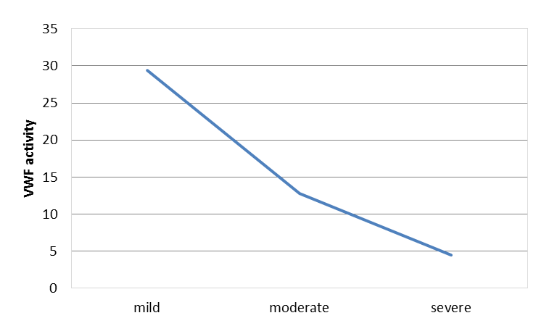
Figure 1: Using spearman’s rank correlation between VWF activity and the severity of VWD among the studied VWD patients: R_{s} =-1.
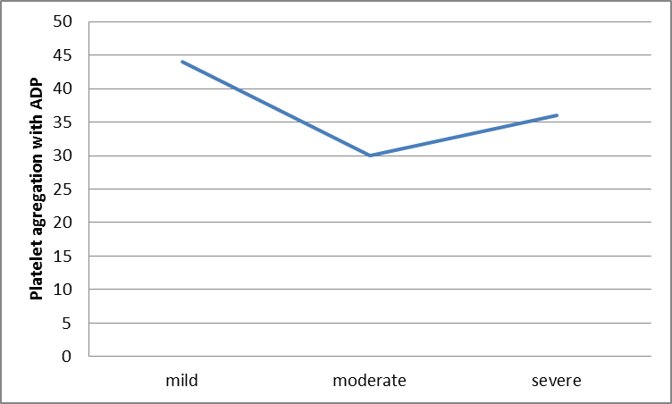
Figure 2: Using spearman’s rank there is no orrelation between percentage of platelet aggregation with ADP and degree of clinical severity in GT patients.
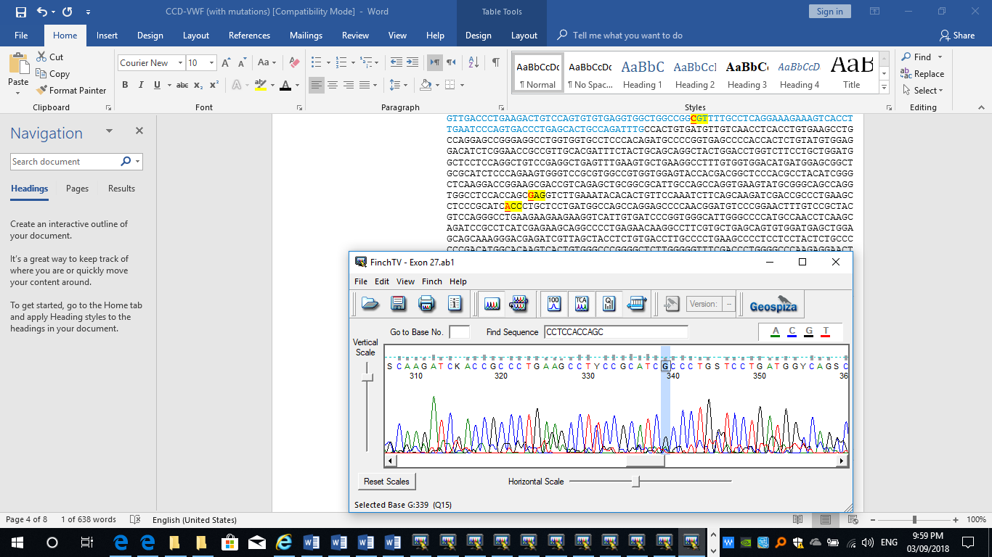
Figure3: Chromatogram of the novel exon 28 mutaion, c.4140A>G (ACC>GCC)
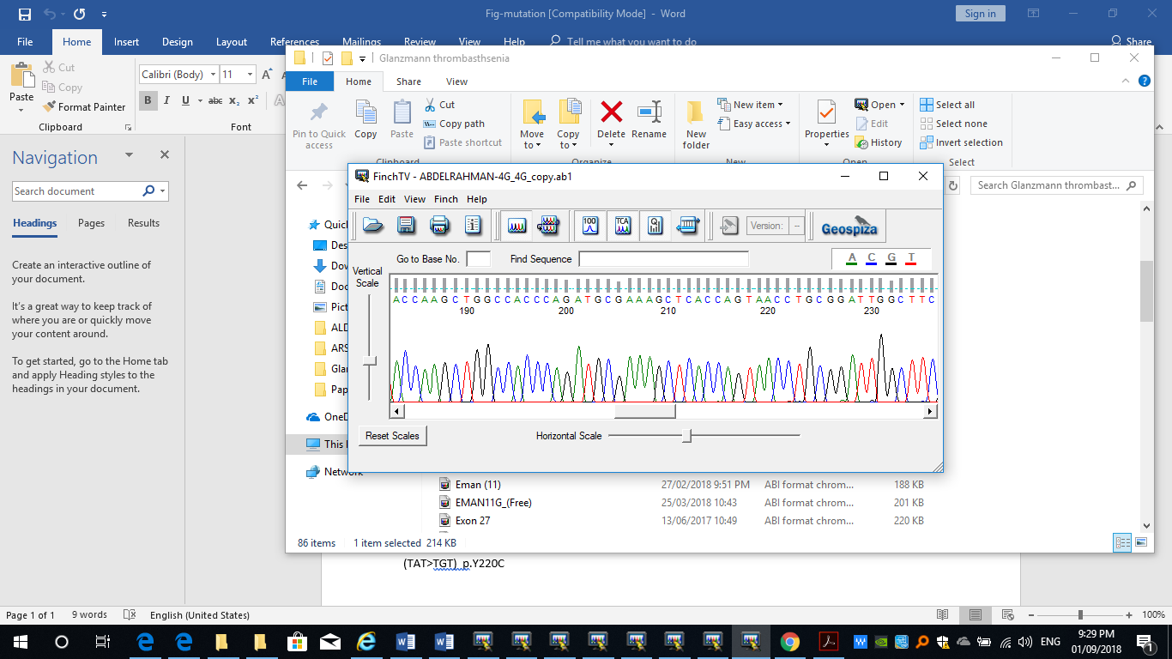
Figure 4: Chromatogram of normal sequence of ITGB3

4. Discussion

The two studied blood disorders (VWD and GT) are inherited as mainly as autosomal recessive disorders. However, VWD has a complex mode of inheritance; as some types of VWD (e.g. type 1 VWD) are inherited as autosomal dominant disorders, while the other types (e.g. type 3VWD) are inherited in autosomal recessive mode (OMIM, 2018). All our VWD patients had autosomal recessive VWD, which explains the increased parental consanguinity and affection of more than one family member. The positive parental consanguinity among Egyptian population was reported to be 30% (Temtamy and Aglan). Rayan et al., (2015) and Liange et al., (2017) observed several affected members in the same family and others families had one member affected. A Saudi Arabian study (Al-Barghouthi et al., 1997) reported 93% positive parental consanguinity among cases with GT.
The age of onset of the disease ranged between 2-18 years among the studied VWD and GT patients. The appearance of manifestations among our VWD patients were below 3 years in all studied cases (100%), which agree with Abdulsalam et al. (2018). The authors noticed that age of onset of VWD presentation was between 1 month and 5 years in 95% of their patients. Another Iraqi study by (Mohsin et al., 2012), reported that 50% of their VWD patients had manifestations of the disease below the age of 1 year. This finding is also similar to our results, where we detected that in 40% of our VWD patients the manifestations of the disease appeared below 1 year.
The age of onset of GT manifestations among our studied patients was below 3 years in all patients (100%), with predominance of onset (56%) between 1 and 2 years of age. This finding agrees with Solh et al., (2015), where the authors observed that most of the children begun their manifestation under 5 years. The explanation of early age of onset may be because VWD and GT usually runs in families, parents are more aware of the disease and early diagnosis becomes easier. However, symptoms of VWD and GT may still become apparent only on hemostatic challenge, which becomes more obvious with increasing age.
In this study all patients had bleeding manifestations, however the degree and site of bleeding varied among the patients. All VWD patients reported bleeding from nose, gums, teeth and/or other sites following minor trauma or surgery. A commonly presenting manifestation among the 20 VWD patients was excessive bruising from minor injuries and minor trauma in 85% of patients. Other bleeding manifestations e.g. : joints redness, warmth, joint pain occurred with different percentage among the patients,30% and 25% of mentioned disorders, respectively. Kasatkar et al., (2014) found that VWD patients presented with wide range of clinical manifestations varying from mild mucocutaneous bleeding like epistaxis, gum bleeding to severe postoperative and gastrointestinal bleeding.
All 19 studied GT patients (100%) reported bleeding from nose, gums, teeth and/or other sites of bleeding following minor trauma or surgery. Other manifestations were reported among GT patients in the following percentages: 89% had excessive bruising from minor injuries and minor trauma; similarly 85% had petichae all over the body, which arose spontaneously or after minor trauma. Less frequent were the other manifestations among our GT patients like joint pain, redness, warmth and stiffness. Al-Barghouthi et al., (1997) agreed with our study, where they observed that purpura, epistaxis, gingival bleeding were nearly constant features. Epistaxis was the most common cause of severe bleeding in GT.
Essential anthropometric measures (weight, height and head circumference) of all studied patients (either those with VWD or GT) were assessed, and then compared to the normal range of the Egyptian children found in WHO growth standard curves (2006). Interestingly, all studied patients had within normal essential growth measures. Even in patients with severe degree of VWD or GT. This may be attributed to the care and medications our patients were receiving since their onset of disease and early diagnosis. The early start of treatment and the different methods of intervention offered to improve the quality of life of those patients were described as possible causes for the insignificant affection of the children‘s growth curves (Johnson and Gorlin, 2013).
Statistical analysis of the degrees of disease severity among our patients revealed significant increase in number of patients with moderate severity of VWD (12 patients= 60%) compared to patients with other degrees of the same disease (severe degree in 2 patients [10%] and mild degree in 6 patients [30%]). There was no statistical significant difference in the distribution of severity of disease among the patients with GT, although 52.6% of GT patients (10 patients) had moderate severity of the disease. The rest of GT patients were 6 patients with severe degree (31.6%) and 3 patients with mild degree (15.8%) of the disease. An Iranian study (Farsinejad et al., 2010) used a grading of bleeding severity on bases on: 1) interview of patient, 2) examination of the patient, and 3) a questionnaire completed by the examining physician and modified for age and sex. Patients were clinically classified as mild, moderate, or severe bleeders. Their results were: the severe phenotype was seen in 50%, followed by moderate in 33% and mild in 15%. The results of the Iranian study are different than our results as regard distribution of severity among the patients. The difference may be due to difference ethnicity, different number of patients.
All our patients of VWD and GT patients had low hemoglobin concentration, while they had normal values of white blood cells, platelets and coagulation profile with no statistical difference when compared to normal population. Statistical analysis of our VWD and GT patients revealed significant difference in number of patients with low hemoglobin value among all our VWD and GT patients compared to normal population. Similar results were obtained by other researchers, where they documented that the majority of their VWD and GT patients showed anemia and the platelet count and prothrombin time were normal (AI-Barghouthi et al., 1997; Abdulsalam et al. 2018).
In this work, we studied the level of VWF activity and antigen among our VWD patients. We observed a decrease in both VWF activity and antigen, which correlated with the degree of disease severity. Similarly Sharma and Flood (2017) detected low VWF activity association with increased degree of bleeding. Lalezari et al., (2014) reported reduced bleeding rate in patients with high VWD antigen. The percentage of Factor VIII clotting activity was decreased among all our VWD patients. However, the results showed no significant difference in Factor VIII decrease of activity at different severity levels among the studied VWD patients. Statistical analysis revealed no correlation or relation between the degree of disease severity and Factor VIII. This result agrees with the findings of Zetterberg et al. (2017), where they documented no correlation between the degree of VWD severity and the level of Factor VIII. The correlation between the degree of VWD severity and the level of VWF activity and antigen may provide data to help target therapy for patients.
The percentage of platelets aggregation with ADP were measured in the studied GT patients. There was a decrease in the percentage of platelets aggregation with ADP among most of our GT patients with a mean value of 35.7%. However, there was no significant difference in the levels of platelets aggregation with ADP at different clinical degrees of disease severity among studied GT patients. Hence, no correlation was detected between the degree of GT severity and the levels of platelets aggregation with ADP. This result agrees with the findings of Farsinejad et al., (2010), where they confirmed that the severity of bleeding in their study, did not correlate with the severity of the platelet GP IIb-IIIa abnormality.
Sequencing of exon 28 and promotor region of VWF gene in all VWD patients and hotspots in the ITGB3 gene in the all GT patients revealed the following results:
In patients with VWD: a novel missense mutation detected in 6 patients descending from 2 of the studied families. The rest of our VWD patients had normal sequence of the molecularly analyzed VWF regions. The novel mutation is a conversion of A>G at base pair c.4140, which resulted in a change of ACC>GCC (p.T1381A) (Threonin>Alanin) located at exon 28. This novel mutation was found in homozygous state in the VWD patients and in heterozygous state in their parents. Hence, our results revealed the presence of a haplotype in the Egyptian population, containing a novel SNP. Although VWF gene exon 28 has been demonstrated to be the most commonly mutated region in VWD, exon 28 hotspots mutations were detected in only 30% of the patients (OMIM, 2018).
In patients with GT: Sequencing of ITGB3 hot spot exons (4, 5 and 11) in the 19 GT Egyptian patien showed normal sequence, where no mutation was detected in ITGB3 exons 4, 5, and 11.

5. Conclusion
Application of competent clinical classification for VWD and GT is essential for proper management of the diseases, especially if combined with early diagnosis and use of efficient laboratory parameters e.g. VWD activity and antigen. Application of molecular analysis detected novel missense mutation in exon 28 of VWF gene among Egyptians with VWD, while no mutation were found in ITGB3 exons 4, 5, and 11 of GT patient. Further molecular studies are needed to delineate the different mutations of these two diseases.

6. References
- Abdulsalam AH, Ghiath Y, Alrahal N. Presentation and diagnosis of patients with type 3 von Willebrand diseases in resources-limited laboratory. Hematology/ Oncology and Stem Cell Therapy, July 2018. DOI: 10.1016/j.hemonc.2018.05.006.
- Ahmed MM, Al-Sohaibani MO, AI-Mohaya SA, et al. Inherited bleeding disorders in the Eastern Province of Saudi Arabia. Acta Haemat. 1988; 79:202–206.
- AI-Barghouthi SK, AI-Othman A, Lardhi A. Glanzmann's thrombasthenia-spectrum of clinical presentation on saudi patients in the eastern province. J family community med. 1997; 4(1): 57–61. James AH. Von Willebrand disease in women: awareness and diagnosis. Thromb Res. 2009; 124 Suppl 1:S7-10.
- Casonato A, Pontara E, Sartorello F, et al. Identifying carriers of type 2N von Willebrand disease: procedures and significance. Clin Appl Thromb Hemost.2007; 13:194–200.
- Farsinejad A, Abolghasemi H, Kazemi A, et al. Density of Platelet GPIIb-IIIa and Bleeding Severity in Iranian Patients with Glanzmann’s Thrombasthenia. IJBC. 2010; 3: 115-121.
- Favaloro EJ, Soma M. Evaluation of a von Willebrand factor three test panel and chemiluminescent-based assay system for identification of,and therapy monitoring in, von Willebrand disease. Thrombosis Research 2016; 141: 202–211.
- Franchini M, Favaloro EJ, Lippi G. Glanzmann thrombasthenia: An update. Clinica Chimica Acta 2010; 411: 1–6.
- George JN. Platelets. Lancet 2000; 355:1531–9.
- Johnson MJ, Gorlin JB. Child Development with a Bleeding Disorder and Transition. National Hemophilia Foundation. 2013; 1 -6.
- Kasatkar P, Shetty S, Ghosh K. Genetic Heterogeneity in a Large Cohort of Indian Type 3 von Willebrand Disease Patients. 2014. https://doi.org/10.1371/journal.pone.0092575
- Kremer Hovinga JA, Zeerleder S, Kessler P, et al. ADAMTS-13, von Willebrand factor and related parameters in severe sepsis and septic shock. J Thromb Haemost. 2007 Nov; 5(11):2284-2290.
- Lalezari S, Martinowitz U, Windyga J et al. Correlation between endogenous VWF:Ag and PK parameters and bleeding frequency in severe haemophilia A subjects during three-times-weekly prophylaxis with rFVIII-FS. Haemophilia. 2014; 20(1): e15–e22.
- Liang Q, Qin H, Ding Q, et al. Molecular and clinical profile of VWD in a large cohort of Chinese population: application of next generation sequencing and CNVplex technique. Thromb Haemost. 2017; 117(8):1534-1548.
- Metjian AD, Wang C, Sood SL Cuker A, et al. Bleeding symptoms and laboratory correlation in patients with severe von Willebrand disease. Haemophilia. 2009; 15:918–925
- Mohsin S, Aslam M, Hussain S, et al. Clinical Manifestations and Complications of von Willebrand Disease. Journal of Rawalpindi Medical College (JRMC). 2012; 16(1):19-21.
- Nurden AT, Fiore M, Nurden P, et al. Glanzmann thrombasthenia: a review of ITGA2B and ITGB3 defects with emphasis on variants, phenotypic variability, and mouse models.Blood. 2011; 118:5996-6005.
- Nurden P, Nurden AT. Congenital disorders associated with platelet dysfunctions. Thromb Haemost 2008; 99: 253–263.
- OMIM. Online Mendelian Inheritance Of Man.McKusick-Nathans Institute for Genetic Medicine, John Hopkins University (Baltimore, MD) and National Center for Biotechnology Information, National Library of Medicine (Bethesda, MD). World Wide Web URL: http://www.ncbi.nlm.nih.gov/omim/ Last accessed 30 October 2018.
- Recht M, Rajpurkar M, Chitlur MB, et al. Impact of Glanzmann’s Thrombasthenia (GT): Perceptions from US Patients and Parents. Blood 2014; 124:4853-4858.
- Rosas RR, Kurth MH, Sidman J. Treatment and outcomes for epistaxis in children with Glanzmann’s thrombastheni. Laryngoscope. 2010; 120(12):2374–2377
- Rosenberg N, Yatuv R, Sobolev V, et al. Major mutations in calf-1 and calf-2 domains of glycoprotein IIb in patients with Glanzmann thrombasthenia enable GPIIb/IIIa complex formation, but impair its transport from the endoplasmic reticulum to the Golgi apparatus. Blood 2003; 101:4808–4815.
- Ryan E, Rajpurkar M, Lum C, et al. Concordance of DDAVP Response in Siblings with Von Willebrand Disease or Hemophilia A. Blood 2015; 126:4684-4688
- Shi Q, Montgomery RR. Platelets as delivery systems for disease treatments. Adv Drug Deliv Rev 2010; 62: 1196–1203.
- Solh T, Botsford A, Solh M.. Glanzmann’s thrombasthenia: pathogenesis, diagnosis, and current and emerging treatment options. J Blood Med. 2015; 6: 219–227.
- Stone ME, Mazzeffi M, Derham J, et al. Current management of von Willebrand disease and von Willebrand syndrome. Curr Opin Anaesthesiol 2014; 27:353-358.
- Temtamy S, Aglan M. Consanguinity and genetic disorders in Egypt. Middle East Journal of Medical Genetics. 2012:12–17
- world federation of hemophilia; https://www.wfh.org/en/page.aspx?pid=643
- Zetterberg E, Brolin K, Lindahl R, et al. Evaluation of prophylactic therapy in haemophilia with global coagulation tests. Haemophilia.2017;24: 1, (e10-e13).

