Application of satellite data and Geographical Information System (GIS) in Zonation of Soil Erosion Hazard and sediment yield (Case study: Saqqez basin)

Himan Shahabi¹, Snoor Hosseini², Baharin Bin Ahmad¹

¹ Department of Geoinformation, Faculty of Geoinformation and Real Estate, Universiti Teknologi Malaysia, Malaysia
² Department of Soil and Water Engineering, Faculty of Agriculture, Islamic Azad University, Tabriz Branch, Iran
himanshahabi@gmail.com

Abstract: Undesirable effect of erosion may not be significant in short time, but it will be clear on long time. Erosion and soil losse. are the main concerns decrease soil fertility and yield production, deposition materials in waterways, irrigation channels and rivers, declining dam capacity, flooding and environmental pollution and closing roads. The Saqqez catchment area is about 22,313 hectares. This watershed is one of Chehel cheshmeh mountainous basins that is located in the Saqqez county. The Cheraghvais dam are established on its main branches that estimated amount of soil erosion and sedimentation of behind the dam is necessary. Hence EPM model have been used using In order to prepare the first series of data, IRS satellite data, Landsat ETM⁺, basic maps, the Arial photos and GIS. Required layers information including geology, topography , pedology, land cover maps and runoff data , the current state of erosion, river erosion status using existing maps, satellite images, weather data stations, hydrometery and field operations were taken then into GIS environment. The formation of databases and the weighting of each of the map layers based on EPM model erosion and sedimentation maps were extracted according to the hydrologic units. The results which are presented as maps and erosion statistics, not only identify hazardous erosive areas, but also open a new horizon in the field of watershed management and sediment control by having a special outlook towards executive priorities.
[Himan Shahabi, Snoor Hosseini, Baharin Bin Ahmad. Application of satellite data and Geographical Information System (GIS) in Zonation of Soil Erosion Hazard and sediment yield (Case study: Saqqez basin)
Researcher 2021;14(6):34-40]. ISSN 1553-9865 (print); ISSN 2163-8950 (online). http://www.sciencepub.net/researcher. 5. doi:10.7537/marsrsj130621.05.

Key words: Remote Sensing; GIS; EPM Model; Erosion; Sedimentation; Saqqez basin.

1. Introduction
Surface erosion and mass movements within a catchment area produce sediment which becomes available for transport. Changes in land use due to development strategies exposing erosion-sensitive geological formations consisting largely of shale and marl, and poor vegetation cover in the Zagros Mountains are the main factors in making millions of tons of sediment available annually for erosion and transport. Surface erosion and sediment yield are important factors that should be taken into account in planning renewable natural resource projects . Although the history of studies about erosion and sedimentation dates back to many years ago internationally, the first comprehensive report on soil erosion and then the importance of water and soil protection was only published in Iran in 1948 by FAO experts and, in 1950, some parts of the Karaj dam watershed in Sirachal zone were studied by Iranian experts associated with FAO .
Use of GIS techniques to model runoﬀ and erosion in catchments has much potential . Remote sensing techniques assist the evaluation of erosion processes and the generation of land use maps, while the integration of such data layers with the generation of erosion-severity and sediment-yield maps can readily be performed by the use of the analytical tools of a GIS. Remote sensing and GIS techniques have recently been interfaced with standard hydrology models of either the distributed type or the empirical parameter type to capture the spatial variation of the quantities computed . The objectives of this study were: (i) to determine the dominant erosion features in the Saqqez catchment, Iran; (ii) using remote sensing and GIS techniques to prepare a soil erosion and natural resources inventory and in analysis to assess soil erosion and watershed prioritization. Hence, the goals of the current study were achieved by applying the above mentioned techniques and frequent evaluations.

The study area
The region subject to this study is located in Kurdistan province at central part of Zagros Range. The selected section is Saqqez basin of 22313 hectares in western part of Zarinerud watering basin. This region is located between longitudes of 45˚ 12' 24" and 46˚ 23' 13" east, and latitudes of 35˚ 69' 04" and 36˚ 13' 18" north. The highest point in the region is 3290 meters and the lowest part is 1200 meters (Figure 1). From tectonic and geologic point of view located along the Zagros reverse fault and on the border of tectonic zone of Broken Zagros (Crashed Zone) and Sanandaj-Sirjan Zone. Average rate of 2.17 cubic meters per second,
which is equal to the area affected by the study area is mountainous, semi-arid climate.

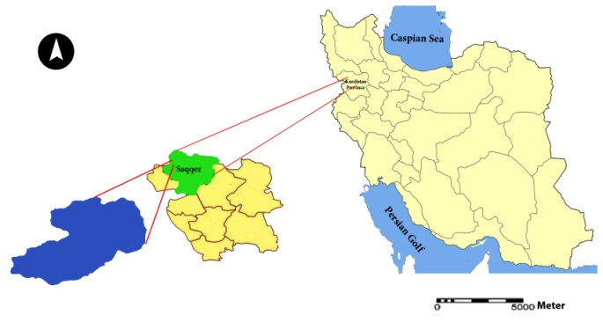
Figure 1. Geographical location of the Saqqez basin in Iran and the Kurdistan Province

3. Material and Methods
The Erosion Potential Method (EPM) is a model for qualifying the erosion severity and estimating the total annual sediment yield of a sub-catchment area, developed initially from the investigation of data in Yugoslavia by . This method considers six factors that depend on surface geology and soils, topographic features, climatic factors (including mean annual rainfall, and mean annual temperature), and land use. Three naturally occurring factors control erosion development (exposed rock and soil, topography, and climate), while land use is entirely man-dependent . The important layers that have been used in this study are the topographic map, geology and soil map, erosion, vegetation and land use. There are lots of layers in EPM model which will be used to produce erosion map and calculate the erosion intensity. In the use of this model, the first step was to develop a topographic map in 1:50000 of the study area. Using contour map, the slope and aspects maps as well as digital elevation model (DEM) were prepared. Operative maps digitizing by using ILWIS software.

An erosion feature map was obtained using aerials photos of 1:40000 scale. In the second step to determine the rating factor for the use of land to enhance the spatial resolution, the ETM+ 2003 satellite image combined with IRS-ID, PAN 2003 digital data to provide the land use map using supervised classification method. In this image process done using Pci-Geomatica and ILWIS softwares. The field visits that were used to provide information on the local topography, climatic factors, geology, pedology and land use data of the study area. Precipitation and temperature maps were obtained from the climatic data measured by gages placed in the watershed and hydrometric stations. Moreover, overlapping geology, soil, land use, erosion feature map, slope were determine and finally, the erosion map was produce by EPM model and reclassify the raster data. The flowchart of EPM model showed in Figure 2.

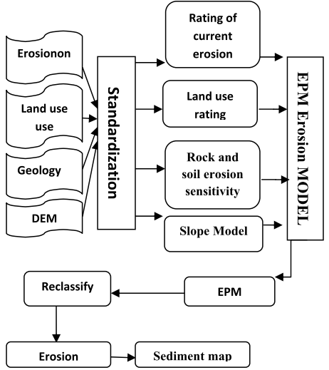
Figure 2. Flowchart of EPM model for soil erosion

Therefore, sediment estimation in this model is based on four factors consisting, Ψ: Erosion coefficient of watershed, X: Land use coefficient, Y:susceptibility of rock and soil to erosion, I: mean watershed slope each one of these factors will receive a proper value according to its contribution to erosion process (Amiri, 2010) (Table 1).

Table 1. The contributing factors in EMP model to estimate the soil erosion
Factor | Necessary information | Results
1 | Slope map | I: mean watershed slope
2 | Aspect map | Ψ: value for different erosions
3 | Land use | Xa: value for different land uses
4 | rock and soil susceptibility to erosion | Y: value for rock and soil susceptibility

The following sections describe the techniques used to generate the data layers and to evaluate the erosion factors for EPM model based on the data layers.

3.1 Surface geology and soil type
Geological data were compiled by visual interpretation of 1:100,000 geological maps together with ﬁeld observations (Figure 3). Rock exposures in the study area consist of limestone, marl, stone, marly, young terraces, quartzite, marble, shale, sandstone and conglomerate, with different resistance to erosion. The lithological map was manually digitized using a Calcomp table digitizer to be used as a GIS layer. Lithological units were re-classiﬁed into 10 categories based on their sensitivity to erosion.

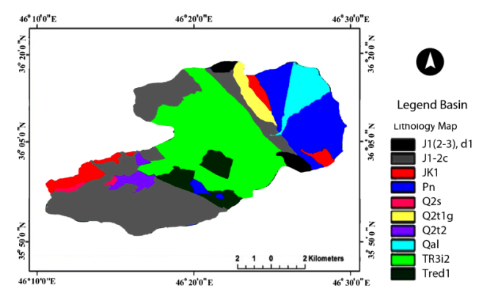
Figure 3. The Lithology map of Saqqez basin

Data for estimating the coefﬁcient of rock and soil resistance to erosion (y-factor) were obtained by examining rock and soils from 50 test sites, representative of the major rock and soil map units. The coefﬁcients of rock and soil resistance to erosion (y-factor) were assigned for each map class. The rock type data layer and the soil type layer from the

Quaternary alluvial deposits were combined in a single data layer using a cut and paste procedure. The data layer was ﬁnally converted to a raster format with cell-size of 50×50 m. The same examinations and evaluations were implemented in all the test sites and the results are shown in Tables 2.

Table 2. Evaluated coefﬁcients of rock resistance to erosion (y-factor) and the coefﬁcient of observed erosion processes (4-factor) of the study area, used in EPM model
Main lithology | y-factor | Φ-factor
Limestone | 1.2 | 0.8
Marl | 0.6 | 0.3
Stone | 1.3 | 1.0
Marly | 0.6 | 0.9
Young terraces | 0.8 | 1.2
Quartzite | 1.1 | 0.5
Marble | - | 0.7
Shale | 1.5 | 0.8
sandstone | 0.8 | 1.0
conglomerate | 0.9 | 1.2

3.2 Slope
Land slopes (Figure 4) were calculated using 1:5,000 topographic maps produced by the Iran Cartographic Organization. The original digital data in Microstation DesiGN (DGN) format were used to build up a DEM (Digital Elevation Model) of the sub-catchment area.

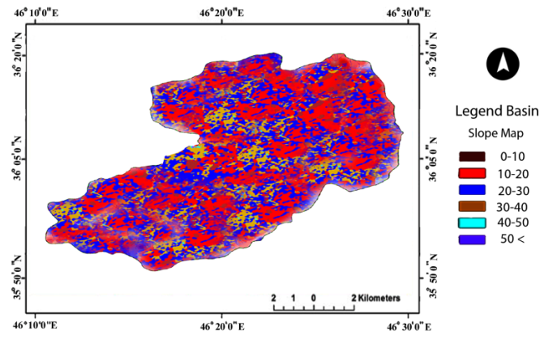
Figure 4. Slope map of Saqqez basin

The slopes were re-classiﬁed into six categories ranging from 0–10 to 50<. The mean values of each slope class was assigned in decimal system (Table 3) to determine the ‘I-factor’ (Gavrilovic, 1988).

Table 3. Slope classes and the assigned ‘I-factor’ for each map class used in EPM
Slope class | Slope (%) | I-factor
1 | 0-10 | 0.050
2 | 10-20 | 0.075
3 | 20-30 | 0. 150
4 | 30-40 | 0.200
5 | 40-50 | 0.350
6 | 50< | 0.400

3.3 land cover
To determine the ‘Xa-factor’, and ‘landcover’ values utilized by the EPM method, a land-cover map was generated by ETM+ acquired in May 2003 satellite image combined with IRS-ID, PAN 2003 digital data using supervised classification using bands 1, 3, 4, 5, and 7 to recognize the unique spectral signatures associated with those land features. (Figure 5).

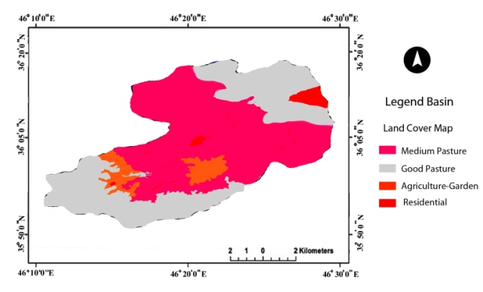
Figure 5. Land cover map of Saqqez basin

The land cover coefﬁcient (Xa) corresponding to each land cover class was estimated by the use of EPM Guide Table (Gavrilovic, 1988) (Table 4). This model classiﬁes land cover into 4 categories and evaluates the coefﬁcient ‘Xa’ from 0.1 (for high-density good pasture) to 1.0 (for residential). The study area was classiﬁed into four categories and the land cover coefﬁcient was evaluated for each map class (Table 4).

Table 4. Land cover coefﬁcient (Xa) used in EPM model
Land cover | Xa
Medium pasture | 0.50
Good pasture | 0.90
Agriculture-Garden | 0.75
Residential | 0.55

3.4 Climate
Although it has been suggested that rainfall erosivity has a positive linear relationship with the volume of precipitation ; , recent work suggests that elevation may also inﬂuence erosivity ; . A mean annual rainfall map (Figure 6) at the scale of 1:50,000 was generated from annual statistics over the last 30 years.

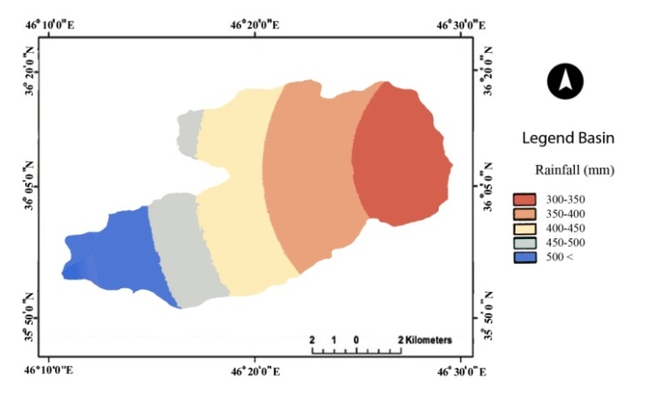
Figure 6. The Rainfall map of Saqqez basin

The area was subdivided into five 50 mm-interval rainfall levels, ranging from 300 to 500< mm. The rainfall intervals were evaluated and assigned based on the rainfall-topography gradient equation derived directly from the 30-year rainfall statistics. Table 5 showed the EPM method uses annual rainfall as ‘H’ in Eq. (2) for erosion severity and sediment yield assessments.

Table 5. Rainfall and 'H' Parameter used in EPM model
Rainfall (mm) | H
300-350 | 235
350-400 | 355
400-450 | 375
450-500 | 425
500 < | 475

3.5 The Relationship between erosion and sedimentation in EMP Model

This model is able to measure erosion, sediment carrying capacity as well as a primary as estimation of sediments behind the reservoirs. The coefficient of erosion intensity (Z) is calculated by the following equation in this model:
(1)

Where; Y: Rock and soil susceptibility coefficient, Xa: Land cover coeficient, : Erosion coefficient of watershed, I: average slope (percent) .
The volume of soil erosion is calculated by the following equation in this method:
(2)
Where, W is the weight and W_{sp} the average annual speciﬁc production of sediments per km² in m^{3/year}, T is a temperature coefﬁcient, calculated as:
(3)
with t=the mean annual temperature in degrees Celsius (ºC), H the mean annual amount of precipitation in mm/year, and Z the coefﬁcient of erosion calculated from Eq. (1).
The sediment production rate in this model is calculated based on the ratio of eroded materials in each section of the stream to the total erosion in the whole watershed area (Eq. 4)
(4)
Where:
P: circumference of the watershed, L: watershed length (Km), D: height difference in the watershed area (Km) After calculation of Ru value, the special sediment rate is estimated by equations Eq. 5 and 6:
GSP=WSP.Ru (5)
GS=GSP.F (6)
Where:

G.S.P: Special sediment rate, WSP: volume of special erosion (m³/km2/yr), Ru: Sedimentation coefficient, GS= total sediment rate (m3/yr), F= Total watershed area (km²).

4. Results and Discussion
EPM model for the study area were run within IDRISI . The quantitative output of erosion severity (parameter Z) in the EPM model was evaluated mathematically by solving Eq. (1) for values of factor classes, and was then collapsed into four ordinal classes to generate the erosion potential map, using the method described by Gavrilovic (1988). Areas with Z>1.0 are those with the potential for severe erosion, while areas with Z<0.19 correspond to a slight
erosion potential. The average annual speciﬁc production of sediments per km² in m3/year (Wsp), was
predicted using Eqs. (2) and (3). The volume of erosion (WSP) was then calculated by equation No. 2 and Figure 7 shows the erosion in the watershed area. The sedimentation yield in the Saqqez basin was classified in four erosion categories eroded (low, medium, high and very high) using EPM model.

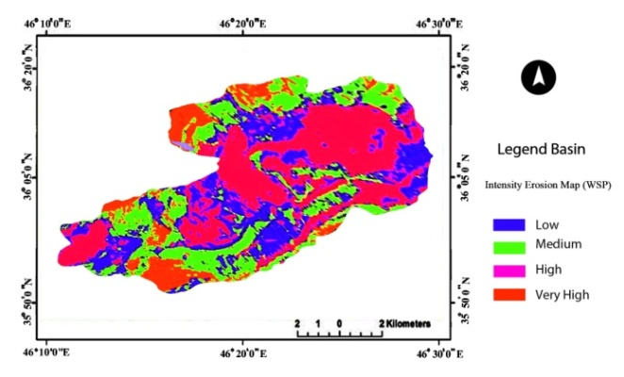
Figure 7. The Intensity Erosion Map (WSP) of Saqqez basin

In order to determine the accuracy of EPM model, ten sample points were randomly assigned to each subunits. Amounts of sediment yield can be estimated from available sediment concentration data collected at sedimentary gauge in the sub-watershed outlet. The t-student test was employed to compare the estimated erosion and sediment values by EPM model with measured values using SPSS statistical package. The

results in Table 7 showed that there were no significant differences (P<0.05) between the estimated and measured values. These results support the pervious achievements by the other researchers .

Table 7. The statistical analysis and mean comparisons in EPM model
Statistical characters | Erosion statistical analysis
Statistical characters | C1 | C2 | C3 | C4
d_{i} | 5345.2 | 98.6 | 2321 | 6729.234
 |  |  |  | 1375.267
S_{n-1} |  |  |  | 4328.336
S |  |  |  | 1176.975
calculated t |  |  |  | 1.26
Statistical characters | Sedimentation statistical analysis
Statistical characters | C1 | C2 | C3 | C4
d_{i} | 2324.8 | 2567.9 | 2175.4 | -921.4
 |  |  |  | 998.315
S_{n-1} |  |  |  | 3784.332
S |  |  |  | 1126.349
calculated t |  |  |  | 0.986

5. Conclusion
GIS (Geographic Information System) is an effective tool for calculating the mathematical equations of an erosion potential and sediment yield mapping model such as EPM. The sediment yield equations can
be programmed in the coverages, and the results stored in a new coverage and/or database. GIS can also be used to present the results from yield analyses graphically. The study provided useful data on erosion severity for Saqqez sub-catchment area, which could be used in natural resources and soil conservation projects. Although the EPM is method for rapid and easy access to the erosion severity and sediment yield, they are completely knowledge based, and the accuracy of analyzed data primarily depends on the experience and knowledge of the experts who determine the values of erosion coefﬁcients.
By reviewing the Slope map of the study area, we noted that the slope is low in the most of areas, as an illustration in the south part, the erosion is low‐moderate due to the lower slope and in the north part ,the erosion is intensive along of soil and rock material and poor land use. Although, in some areas have high slope, erosion is low‐moderate due to the forest cover and grassland. The result of comparing erosion and sediment values using an EPM model with measured values showed that no significant difference was observed between the estimated and measured
values (P <0.05). The results of this study can be used to estimate the amount of sediment reaching the dam was being built. Information can also be obtained in natural resource management, land use planning programs can be used in watershed areas.

Acknowledgment
We are thankful to the Department of Geo information in Universiti Teknologi Malaysia (UTM) and International Doctorial Fellowship (IDF) for providing the facilities for this investigation.

Corresponding Author:
Himan Shahabi, Department of Geoinformation, Faculty of Geoinformation and Real Estate, Universiti Teknologi Malaysia, 81310 UTM Skudai, Johor Bahru, Malaysia
E-mail: himanshahabi@gmail.com

References
1. Tangestani MH. Comparison of EPM and PSIAC models in GIS for erosion and sediment yield
assessment in a semi-arid environment: Afzar Catchment, Fars Province, Iran. Journal of Asian earth sciences 2006; 27 (5):585-597.
2. Pourali SH, Matkan AA, Hosseini-asl A. Preparing the Map of Erosion Hazard and Sedimentation in Dez Watershed by Remote Sensing and GIS. Environmental Sciences 2008; 6 (1):83-100.
3. De Roo A. Modelling runoff and sediment transport in catchments using GIS. Hydrological Processes 1998; 12 (6):905-922.
4. Jasrotia A, Singh R. Modeling runoff and soil erosion in a catchment area, using the GIS, in the Himalayan region, India. Environmental Geology 2006; 51 (1):29-37.
5. Amiri F. Estimate of erosion and sedimentation in semi-arid basin using empirical models of erosion potential within a geographic information system. Air, Soil and Water Research 2010; 3 (2): 37-44.
6. Gavrilovic Z. Use of an Empirical Method (Erosion Potential Method) for Calculating Sediment Production and Transportation in Unstudied or Torrential Streams. In: International Conference on River Regime. Hydraulics Research Limited, Wallingford, Oxon UK, 1988.
7. Cook DJ, Dickinson WT, Rudra RP. GAMES: The Guelph Model for Evaluating Effects of Agricultural Management Systems on Erosion and Sedimentation. School of Engineering, Ontario Agricultural College, 1985.
8. Renard KG, Freimund JR. Using monthly precipitation data to estimate the R-factor in the revised USLE. Journal of hydrology 1994; 157 (1):287-306.
9. Daly C, Neilson RP, Phillips DL. A statistical-topographic model for mapping climatological precipitation over mountainous terrain. Journal of applied meteorology 1994; 33 (2):140-158.
10. Mikhailova EA, Bryant R, Schwager S, Smith S. Predicting rainfall erosivity in Honduras. Soil Science Society of America Journal 1997; 61 (1):273-279.
11. Eastman J. Idrisi for Windows, User’s Guide, version 2.0: Clark Labs for Cartographic Technology and Geographic Analysis. Clark University, Worcester, 1997.
12. Amiri F, Tabatabaie T. EPM Approach for Erosion Modeling by Using RS and GIS. In: 7th Regional Conference Spatial Data Serving People: Land Governance and the Environment-Building the Capacity, Hanoi, Vietnam, 2009.

13. Eisazadeh L, Sokouti R, Homaee M, Pazira E. Comparison of empirical models to estimate soil

erosion and sediment yield in micro catchments. Eurasian Journal of Soil Science 2012; 1 (1):28-33.

2/5/2021

