Calculation of the effective technological mode of operation of the underground gas storage facilities
with the application of detailed 3D live constant operating geological-process models

Victor Alkin¹, Anton Degterev², Vladislav Kuleshov³

¹ NIIgazekonomika, LLC, Moscow, Russia
² Gazprom VNIIGAZ, LLC, Russia
³ Uktha State Technical University, Ukhta, Russia
vkuleshov@ugtu.net (Vladislav Kuleshov), Alkin_V@mail.ru (Victor Alkin)

Abstract: The creation and the operation of the underground gas storage facility (UGSF) is the important task for the reliability of operation of gas transmission systems, uninterrupted supply of consumers by gas a covering of seasonal unevenness of gas consumption at peak demand. At the most cold periods of the winter UGSF can provide to 30% of daily supply of gas for all Russian consumers. Decades of operation of the gas storages created in porous layers, allowed to reveal high heterogeneity and instability of wells’ operation. The main reasons of the heterogeneity of work of UGSF are: heterogeneity of filtration-capacitive properties of layer collector (object of operation); the uneven drainage of layer collector; different technical conditions of wells; the formation of cones during the flood in the period of extraction of gas; lateral implementation of formation water. In this case the development and the application of the methods of the determination of the effective technological mode of operation of single underground gas storage facilities is the actual task for the research activities.
[Alkin V. A., Degterev A. Yu., Kuleshov V. E. Calculation of the effective technological mode of operation of the underground gas storage facilities with the application of detailed 3D live constant operating geological-process models. Researcher 2021;13(7):33-39]. ISSN 1553-9865 (print); ISSN 2163-8950 (online).
http://www.sciencepub.net/researcher. 7. doi:10.7537/marsrsj130721.07.

Keywords: 3D live geological-process models, underground gas storage, UGSF well operating mode, geological examinations of reservoirs.

Introduction:3D live geological-process models
Recently 3D live geological-process models have been actively built and used for solving underground gas storage problems (Alkin et al, 2012). The term “live geological-process models” is traditionally understood as a set comprising a detailed 3D geological model and a simulation model built on its basis. As building of UGSF geological models implies arrangement and integration of all available geoscience data, building and application of such models enabled detailed geological examinations of reservoirs used for gas storage, cap rocks, control horizons and overlying deposits (Fig. 1).

a 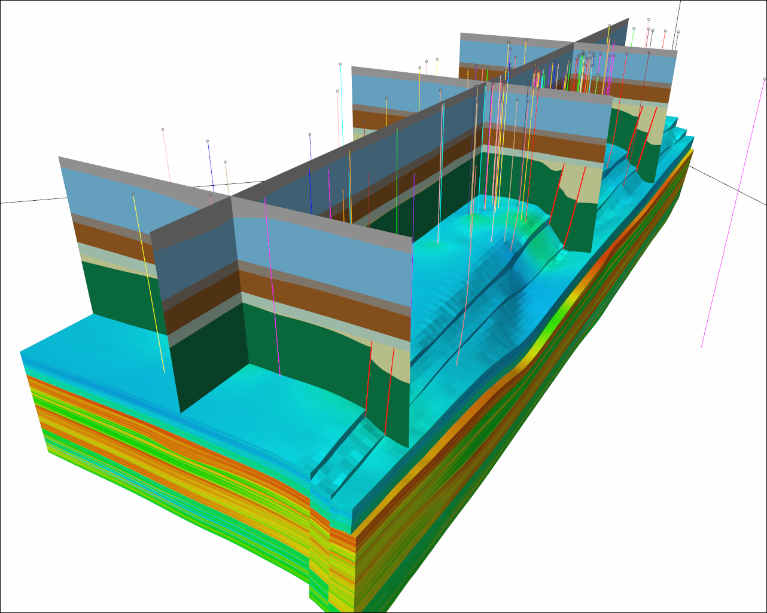 b 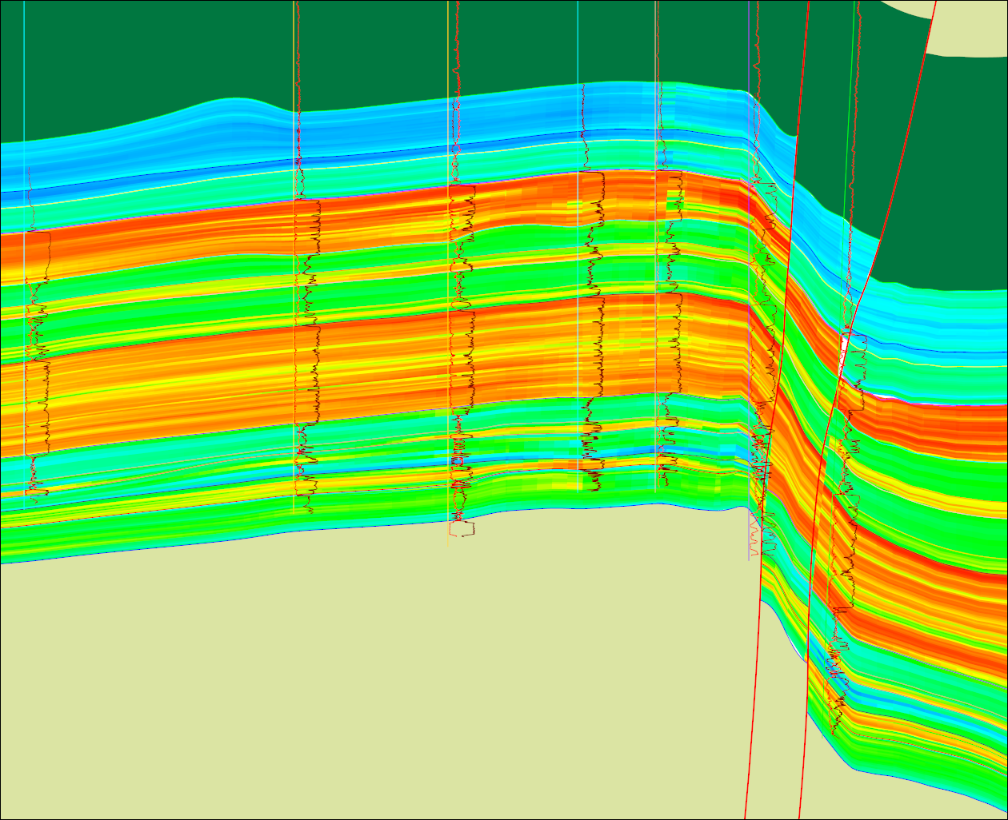
Fig. 1. Example of a detailed 3D geological UGSF model built in a water-bearing formation, a – general view, b – vertical section.

Consider methods for determination of effective (individual) well operation modes using live geological-process models.
Effective technological mode of operation of underground gas storage facilities is an optimal well production rate determined based on a set of scientifically grounded characteristics subject to permeability and porosity of the target formation and gas-dynamic tests.
Thus, individual process modes for each production well considering reservoir permeability and porosity shall be developed to ensure uniform reservoir drainage in the injection season and to prevent nonuniform ground water intrusion in the takeoff season.
One of the prerequisites for correct reservoir evaluation results is availability of a correct geological model of the reservoir which accurately simulates the studied properties. According to the UGSF geologic modeling practice, UGSF geologic modeling tasks though being related to oil field geologic modeling tasks, have some specific features, which require special methods and approaches (Degterev, 2012).
In actual practice, correctness of geological models of UGSF, especially of UGS models in water bearing formations, cannot be guaranteed either by using popular software products or their integrated modeling tools; it requires the model making geologist to understand the task specifics and consciously select the applied software tools.
A characteristic feature of UGSF targets in a water bearing formation is significant areal heterogeneity of well placement due to specific character of their operation. As a rule it is expressed in significantly closer well placement in the central domed part of the structures with their significantly rarer placement in the periphery parts. The distances between adjacent wells may differ by a factor of several times (Fig. 2). Peculiarities of explorations and production drilling also result in significant vertical heterogeneity of source data distribution. Apart from the fact that deeper horizons are characterized by less data than incumbent horizons, production wells partially penetrate the reservoir, very often tests are performed by intervals with partial overlapping of horizons, and horizons are very heterogeneously characterized by core data, etc. (Fig. 3). At the same time the modeled horizons themselves often have significant inherent variability.

a 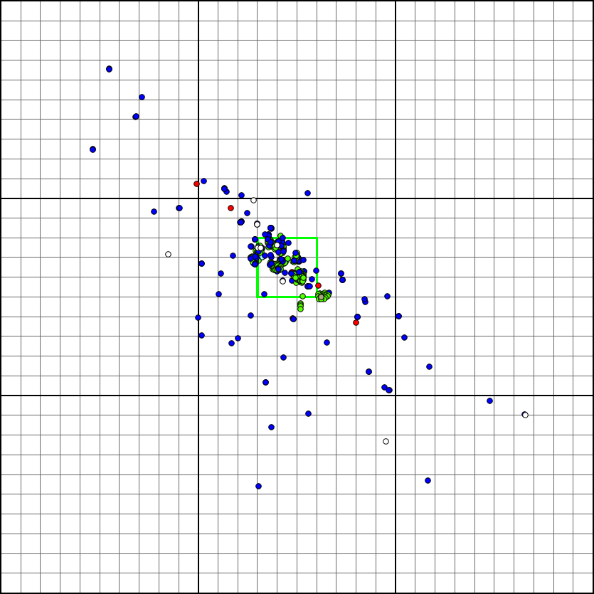 b 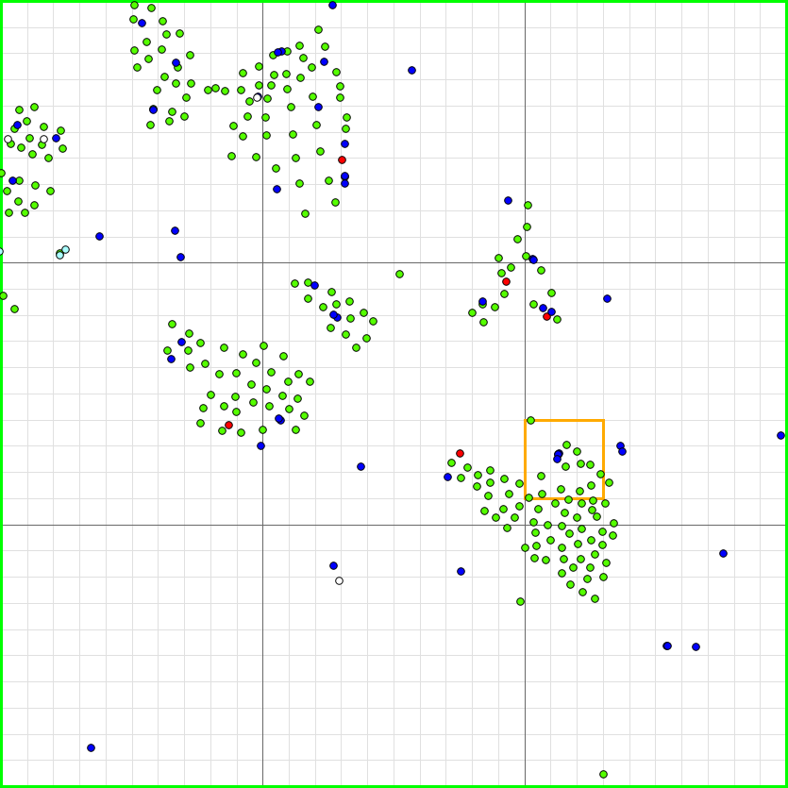 c 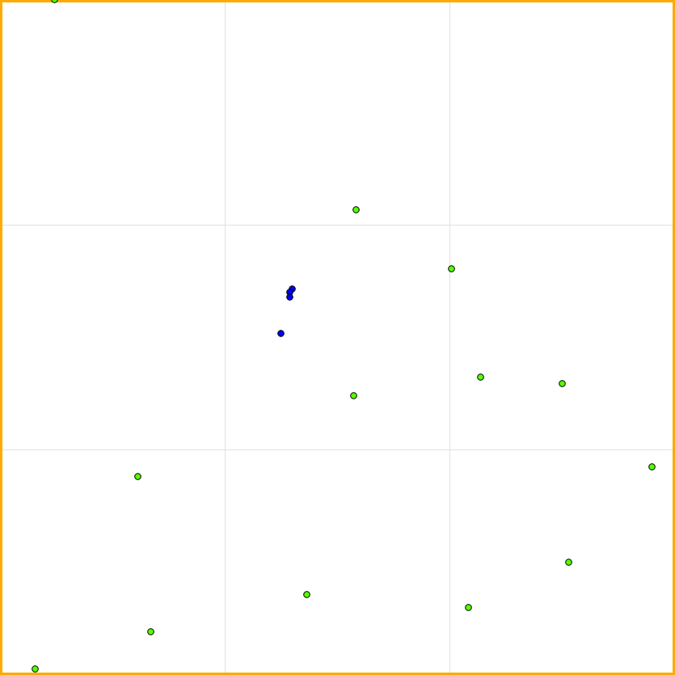

Fig. 2. Heterogeneity of UGSF well distribution in a water bearing formation: A – at the formation level, b – at the level of a part of the formation, c – local.
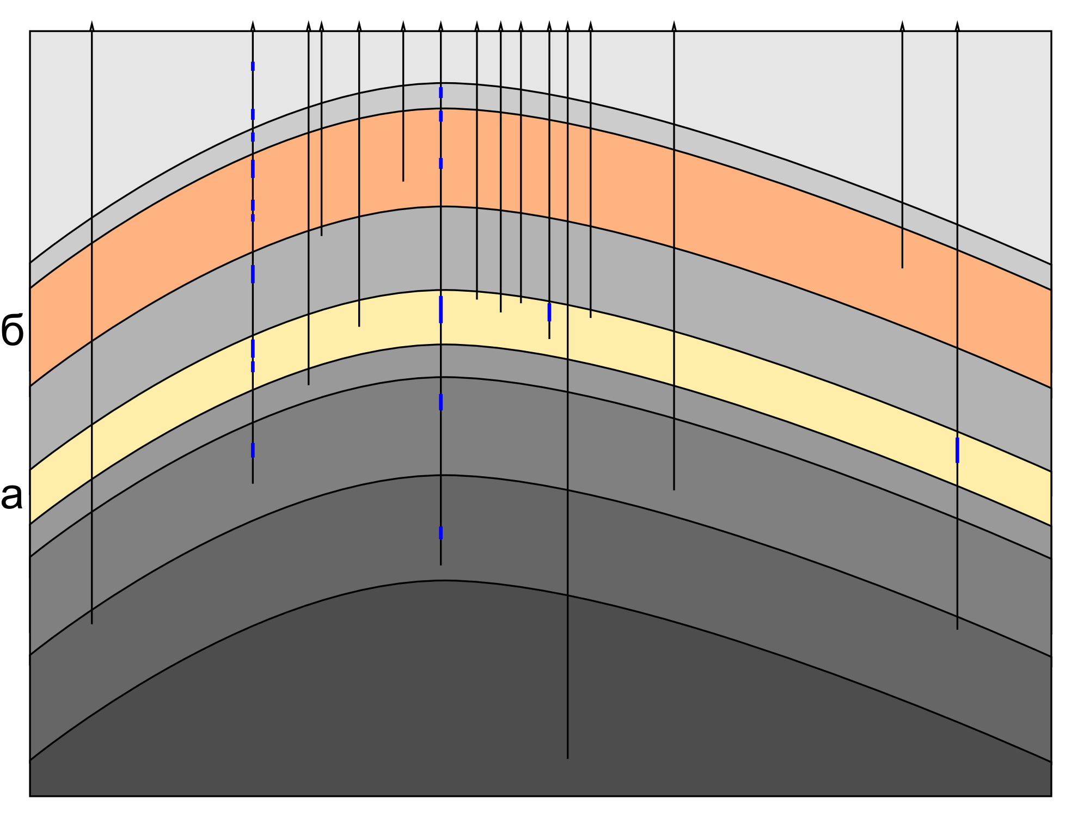
Fig. 3. Diagram of heterogeneity of geological-geophysical exploration degree of an idealized UGSF with 100% wells characterization by the log data: a – reservoir, b – control horizon. Blue areas represent cored intervals.

All these factors specify conditions where many popular geological modeling tools are often used in abnormal conditions, which reveal their hidden limitations that may often lead to incorrect models even if they are based on absolutely correct source data (Degterev, 2010; Degterev & Kahn, 2013).
Generally the applied geological modeling approaches can be divided into deterministic and stochastic and into "geometrical” and statistical. The deterministic approach provides one but the most probable solution, while the stochastic approach provides a set of equally probable solutions, none of which is preferred. According to the work principle, such methods can be conditionally divided into "geometrical”, which work based on the source data values and their positions, and “statistical”, which work based on transfer of the source data statistical characteristics into the final model. Thus, the applied methods may be conditionally presented as an array with cells representing a combination of these approaches. Such methods as Triangulation, Natural Neighbor, Spline, Convergent, Minimum curvature, Polynomial are “geometrical” deterministic methods. A popular statistical deterministic method of interpolation is Krige method (Kriging) and its variations, and a popular statistical stochastic method is the Sequential Gaussian Simulation method (Table 1). Besides the majority of facial simulation methods are also statistical.

Table 1. Classification of routine geological modeling methods.
 | Deterministic approach | Stochastic approach
“Geometrical” methods | Triangulation, Natural neighbor, Spline, Convergent, Minimum curvature, Polynomial
Statistical methods | Kriging | Sequential Gaussian simulation

The specific feature of deterministic methods is variable frequency of the developed models, which means that the high-frequency component of the properties variability is lost in the area of rarer location of source data (Fig. 4a). Sometimes this specific feature is presented as a disadvantage of the deterministic approach, though it does not cause any significant negative consequences in practice.
One of the constraints of popular statistical methods, which are sometimes generally referred to as “geostatistical”, is acceptance of the stationarity hypothesis, which means that the studied value starts to be randomly considered as a stationary random function, and all the source data – as the points belonging to it. The properties variability character described by an autocorrelation function or a variogram is taken up as equal for the whole modeled object. Apart from acceptance of the stationarity hypothesis, which is the weakest point of “geostatistical” methods, there is a problem of correct calculations of the variogram and the general distribution (histogram) of values. It is impossibility of their correct calculation which often creates problems for correct application of these methods when simulating heterogeneously studied objects. Though generally the methods based on global properties simulation turn out to be poorly adapted for handling heterogeneous source data, it is possible to avoid some constraints. E.g. in case correct variogram analysis is impossible due to heterogeneous source data, it is possible to use the variogram radius which is equal to a half of the simulated object. It is possible to avoid significant errors during stochastic modeling by carefully following the procedure of source data declustering when calculating global statistics at all modeling stages (Fig. 4). If it is impossible to calculate the global statistics correctly, stochastic modeling should not be used.

a 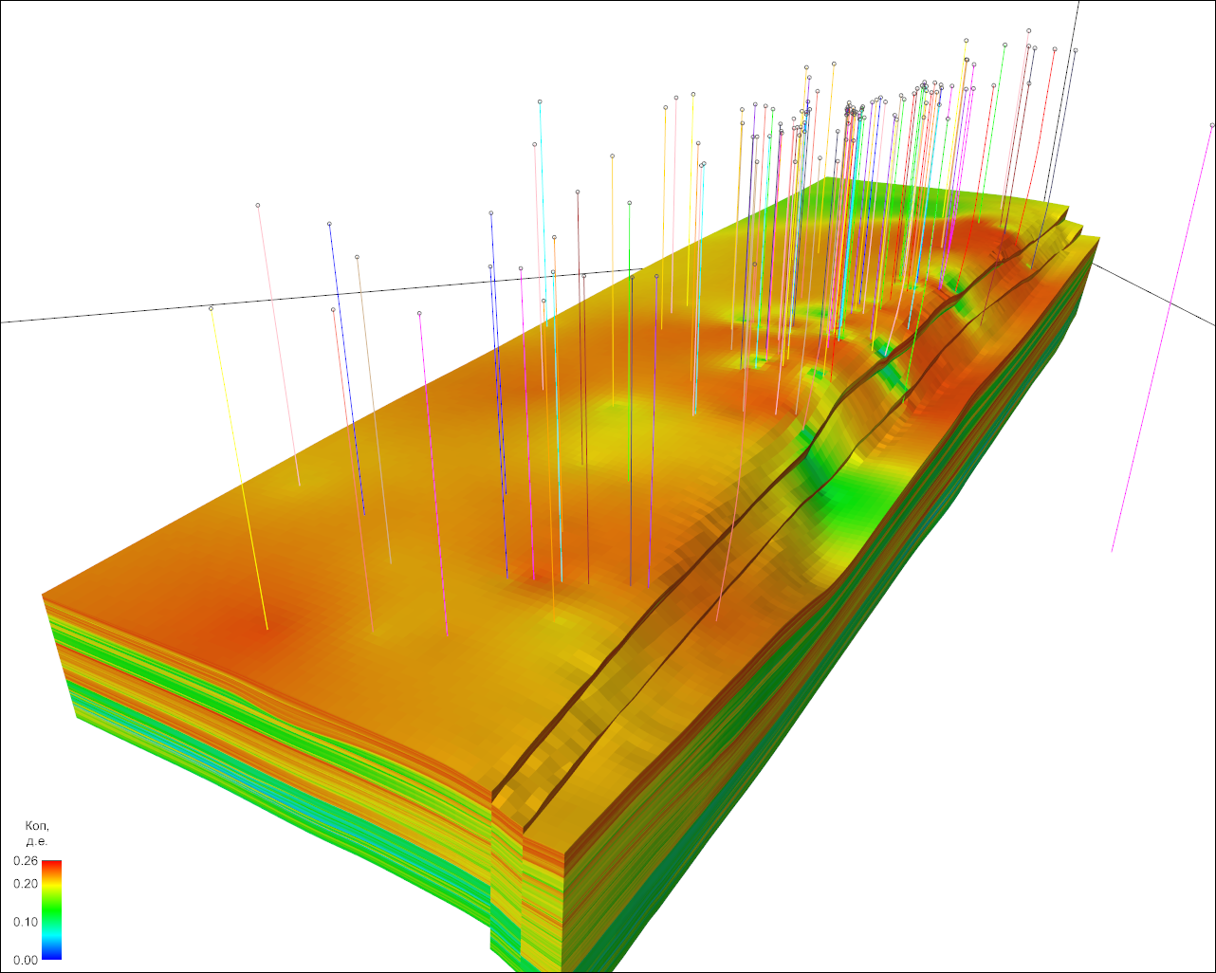 b 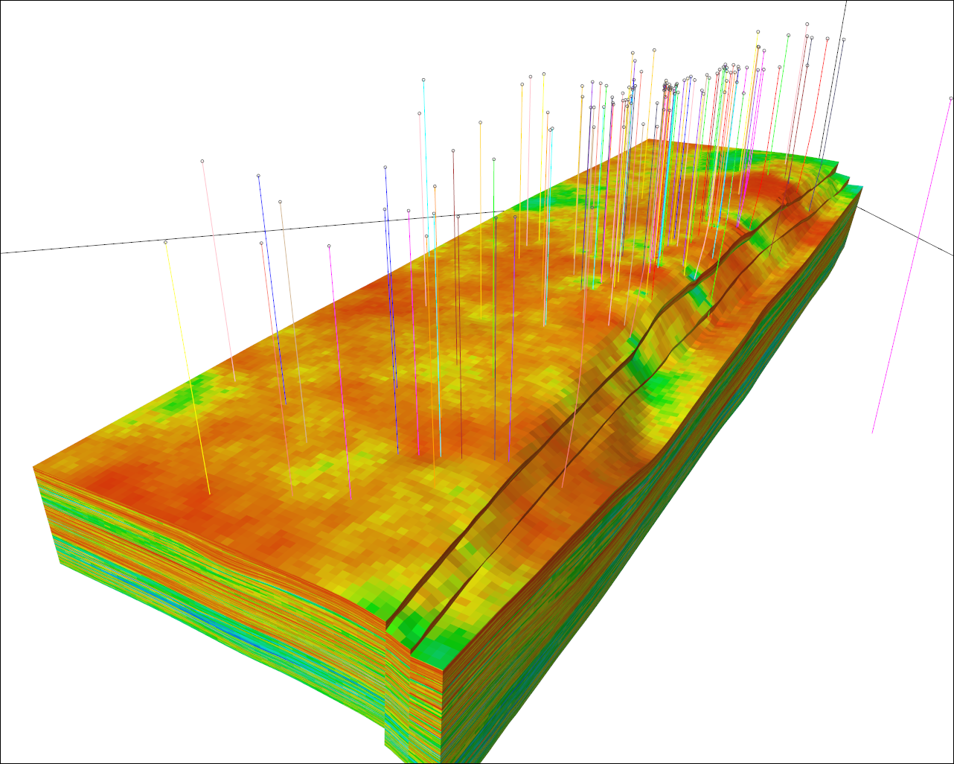
Fig. 4. Results of correct application of “geostatistical” algorithms during geological modeling of heterogeneously examined objects: a – deterministic approach (Kriging), b – stochastic approach (Sequential Gaussian Simulation)

In any case strict expert control of the obtained results is needed when using automated simulation methods. At the same time the majority of problems can be avoided as early as at the exploration planning stage by proactive consideration of further data application specifics during geological simulation.
In spite of some objective challenges there are some specific opportunities to improve UGSF modeling reliability unavailable for fields modeling.
The prime means of significant improvement of the forecast uniqueness and general model reliability is using additional data charactering the modeled object. In case of UGSF, such data include field data for which steady trends depending on geological factors can be determined. A large scope of such data is accumulated by means of cyclicity of UGSF operation, which enables to verify and refine the values of geological parameters, which direct recording is impossible or difficult. Identification of main uncertainty factors enables to match the geological modeling results with the field data using the expert method and refine the geological model while adapting the hydrodynamic model. In this case the hydrodynamic model is used as an agent to verify the geological model adequacy according to the field data and to refine it considering these data. This results not only in building a correct hydrodynamic model, but also in improved reliability of geological modeling (Degterev et al, 2011). A significantly smoother procedure of approving the current resources also contributes to it as compared to the procedure used for fields, which makes it possible to continuously update the UGSF geological model.

Determining optimal well operating modes
This is an example of applying a reliable live geological-process model of a Russian UGSF for determining optimal well operating modes. Permeability and porosity of formations may differ significantly due to reservoir heterogeneity (Fig. 5, Table 2). E.g., the reservoir net thickness in Well No. 1 is 4m, and in Well No. 3 is 16.36m (Table 2). Having similar effective porosity, the pore space effective volume of the reservoir in the near wellbore areas will differ fourfold. It means that to achieve uniform reservoir drainage in the first well, conditionally the volume of gas injected in the second well shall be four times less (Fig. 5, Table 2) (Degterev et al, 2011).
Heterogeneity is observed for the formation thickness, effective porosity and other reservoir properties. So, a complex parameter which considers heterogeneity both of the effective porosity and reservoir thickness (of the target formation) is required for correcting the well operating mode. According to the authors, effective pore volume in the well zone may be used as such parameter.

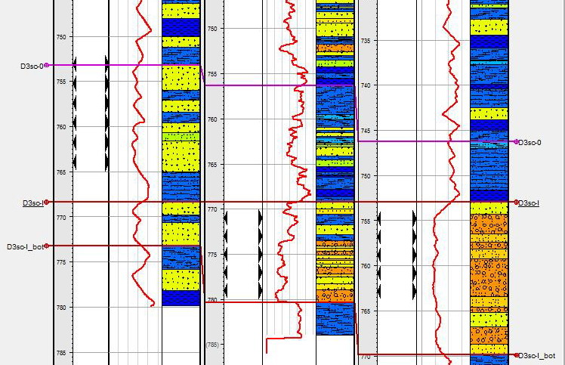
Well No. 1
Well No. 2
Well No. 3

Fig. 5. Example of reservoir heterogeneity by wells in UGSF in a water bearing formation.
Table 2. Permeability and porosity of the reservoir (target formation) used for gas storage
Well No. | Formation thickness, m | Net thickness, m | Average reservoir porosity, unit fraction | Area in 25 m radius, m2 | Effective volume,  m³ | Factor of injection volume distribution by UGSF wells, unit fraction
well | Th | Th_eff | Kpor | S | Th_eff*Kpor*S | Th_eff*Kpor*S/∑Th_eff*Kpor*S
1 | 4.85 | 4 | 0.25 | 1962.5 | 1963 | 0.0037
2 | 11.1 | 10.09 | 0.26 | 1962.5 | 5148 | 0.0098
3 | 16.96 | 16.36 | 0.3 | 1962.5 | 9632 | 0.0182

Table 3. Example of calculating optimal gas injection volumes for each UGSF well based on the reservoir permeability and porosity distribution in near wellbore areas.
Well No. | Effective volume, m³ | Ratio of injection volume distribution by UGSF wells, unit fraction | Injection volume for each UGSF well, Mcm
well | Th_eff*Kpor*S | Th_eff*Kpor*S/∑Th_eff*Kpor*S | Kdistrib.*Vfinal
1 | 1963 | 0.0037 | 3.35
2 | 5148 | 0.0098 | 8.78
3 | 9632 | 0.0182 | 16.42

Effective pore volume in terrigenous rocks in the wells zone is determined by multiplying effective porosity by net reservoir thickness. The reservoir effective pore volume in the wells zone characterizes permeability and porosity distribution in the target formation. Thus, the value of the reservoir effective pore volume in the near wellbore areas shall be used for designing optimal wells operating mode during UGSF operation.
For determining an effective pore volume in near wellbore area it is necessary to determine the area within the calculation boundaries. As in this case formation permeability and porosity in the production well zone need to be evaluated, it would be logical to limit the pore volume evaluation area to half of the distance between the wells. The distance between the wells is approximately 50km. So, in this case, the pore volume estimation shall be performed in the well zone with 25m radius (Alkin et al, 2012). Using a live UGSF geological-process model the effective pore volume can be calculated in the production well zone (Table 2).
Then, having calculated the volume ratio (effective pore volume in the well divided by the sum of effective pore volumes in all production wells) we can get the conditional well potential based on the specific features of the reservoir geological structure. This volume ratio may be used as the ratio of the total injection volume distribution in UGSF by the volumes for each well (Table 3).
Thus, the optimal gas injection volumes for each well can be determined based on reservoir (target formation) permeability and porosity distribution.
Studying the specific features of the reservoir structure in the near wellbore area provides the possibility to increase the efficiency of UGSF operation.

Resume.
Application of reliable geological models provides the possibility to correctly solve problems related to estimation of local variability of permeability and porosity significantly computerizing the process of effective UGSF well operating modes determination. Though the proposed approach simulates only the conditional potential of each well based on the specific features of the reservoir geological structure, which may by many reasons differ from the actual results of its operation (because of low quality of penetration, screens clogging, various types of penetration, etc.), this requires adjustment of the received gas volumes according to the field data; it supposes significant improvement of efficiency of solving such problems. Additional time that the operator gets as a result of automation may be effectively used for expert evaluation of the obtained results and their comparison with the results obtained by other methods.
Integrated application of the above methods allows determining of the optimal UGSF well operating mode.

Corresponding Author:
Dr. Vladislav Kuleshov
Vice Rector for Research and Innovation
Uktha State Technical University,
Ukhta, 169300, Russia
vkuleshov@ugtu.net

References
- Alkin V.A., Iskhakov A. Y., Kahn V.E. (2012). Determination of the optimum volume of gas injection in wells during gas storage operating (on an example of Uvyazovskoe UGS). Scientific and technical journal. "Geology, geophysics and oil and gas fields development". Moscow "VNIIOENG, JSC”. P. 66.
- Buzinov S.N., Mikhailovskiy A.A., Solovjev A.N., Parfenov V. I. (2003). Schelkovskoe underground gas storage facility: problems, solutions and prospects. Actual situation review. Transport and underground gas storage. Moscow, "Gazprom information and advertising center, LLC", p. 59.
- Degterev A. Y. (2012). Actual methods of UGS geological modeling. Collection of scientific articles of graduate students and “Gazprom VNIIGAZ, LLC” applicants, Moscow. – Gazprom VNIIGAZ, p. 162- P.112-122
- Degterev A. Y. (2010). Quantitative evaluation of the geological modeling reliability in non-stationary geostatistical characteristics conditions of the geological environment. II scientific and practical conference "New technologies in gas industry: experience and continuity", “Gazprom VNIIGAZ, LLC”, Moscow.
- Degterev A. Y., Grishin A.V., Kahn V. E. (2011). Geological uncertainty factors control in UGS modeling. III International scientific and practical conference "Underground Gas Storage : Reliability and efficiency" (UGS-2011), Moscow.
- Degterev A. Y. Kahn V. E. (2013). Problems of patchy investigated geological objects modeling reliability. III International scientific and practical conference and exhibition "World resources and gas reserves and promising technologies for their development" (WGRR-2013), Moscow.
- Gazprom Company Standard 2-3.5-348-2009 "Operation on the underground gas storages producing and operation supervision in porous formations".
- Iskhakov A.Y., Alkin V. A. (2011). Water factor forecast in terms of the underground gas storage developed in aquiferous stratum. Scientific and technical journal. "Geology, geophysics and oil and gas fields development". Moscow “VNIIOENG, JSC”. P. 72.
- Volkova P.A., Shipunov A. B. (2012). Statistical analysis in research works. Moscow. "Forum". p. 96.
- 55 Years VNIIGAZ. Actual problems of the development, exploitation abd operation of the operation of natural gas fields.: Collection of scientific treatises – М.: JSC Novosti Printing House 2003. – 540 pages. 2003. – 540 p.

7/22/2021

