Dynamic Node-relocation Techniques for Wireless Sensor Networks: A Survey

Muhammad Amir Khan ¹, Halabi Hasbullah ¹, Babar Nazir ²

^{1.} Department of Computer and Information Sciences, Universiti Teknologi PETRONAS, Malaysia
^{2.} Computer Science Department, COMSATS Institute of Information Technology Abbottabad Pakistan
Email: amirkhancomsats@gmail.com

Abstract: In determining the application efficiency the capability of inter-node connectivity among nodes is essential. Some nodes are also involved to uphold the flow of information from the sensor to remote users. A node loss can be encountered due to deployment ruthless and unattended areas. The network may get partition into multiple disjoint blocks and stop functioning because of depletion of onboard energy or due to physical damage. In this paper, the current and up to date state of research on the dynamic node relocation in Wireless Sensor Networks is presented. This work categorizes the node relocation techniques in to post-deployment and on-demand relocation depending whether the optimization is performed at the time of deployment or when the network is operational. This paper also identifies the open problems and future directions in this area of research.
[Muhammad Amir Khan, Halabi Hasbullah, Babar Nazir. Dynamic Node-relocation Techniques for Wireless Sensor Networks: A Survey. Researcher 2021;13(9):48-65] ISSN 1553-9865 (print); ISSN 2163-8950 (online).
http://www.sciencepub.net/researcher. 7. doi:10.7537/marsrsj130921.07.

Keywords: Wireless Sensor Networks; node relocation, node replacement; failure recovery; mobile sensors; network connectivity

1. Introduction
Wireless Sensor Network abbreviated (WSN) is considered as one of the most significant technologies and is becoming a well-developed research field for its wide utility. WSN for having some depressed energy and the affordable densely fixed undersized mobile sensor nodes has commonly been mostly done well in use such as in the surveillance for environment, assigning the data and communication among each other through radio [1-5]. Functionally, it is capable of minimizing the cost and delay in development and applicable for any environment, specifically in the one indicating an impossibility of deployment for the conventional wired sensor network such as in battleground, deep oceans, or outer space [6, 7]. By and large, the sensor nodes applications are used in medical care, households, or armed forces. In military for example, through their punctual process, independent adjustment and defective endurance character the sensor networks has shown its high suitability for the systems in any armed forces including commanding, scheming, communication, inspection and targeting. In health field, they, meanwhile, are contributed to monitor patient and help disabled patients. Even, it is also acceptable for applying them in commerce as in inventory management and product quality as well as disaster areas monitoring [8-10].
Figure 1 provides the random deployment of sensor nodes in a sensor field in which both of them individually are in charge of doing the given duty and being in touch to each other with an aim to return the sensing data to the sink as equally occurred in the intercommunication of sensor nodes 1, 2, 3, 4, and 5. The data, having been formed to be functional, are directed to the users via internet then [11-13].

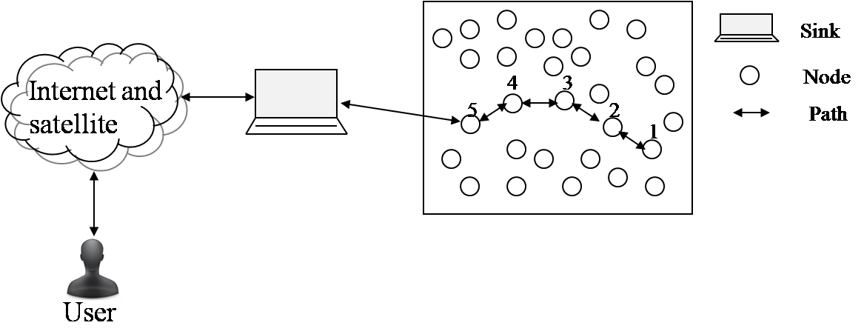 Figure 1. Pictorial representation of Wireless Sensor Network (WSN)

It comes to be possible for both the occurrence of missing a node as the power involved are running down and a break, which will substantially leads the interconnecting system to be possibly apart into several dislocated units or can prevent it to continue functioning caused by the reposition into certain inconsiderate and unattended locales that later are commonly known as the sensing holes. Hence, filling the holes might be essential in this case in order to cope with these failures by moving the spare sensors or earlier deployed sensors or by responding to an event requiring the movement of a sensor into a particular location [14-16]. It is also found that the interconnection among nodes will be essential in ensuring the efficacy of running the program similar to some nodes in maintaining the information flow for enabling a successful interaction of the fully-prepared and distant users [17]. It is furthermore considered that to deploy a replacement of the futile node could be time-consuming and, somehow, impossible in insecure condition like in battle. Related to this, it has been revealed in some informing that the node reposition, somehow, is an efficient device in partitioned networks restoration. [18-21].
A dynamic reposition of the nodes in a network operation is very important for the improvement of the network performance. As an illustration, it can be seen how a number of unnecessary sensors from diverse segments of the observed locales are possible to be identified and repositioned for the substitution of the departed sensors for the improvement of network sustainability when most of sensors in the surrounding base-station area are no longer being functional for the their batteries collapse [22-24]. This kind of the dynamic reposition, in fact, might be also suitable in an appliance of following the movement of the target; even for the ones movable. , To illustrate it comes to be possible to relocate some sensors nearby to the target for obtaining the enhancement of the fidelity of the sensor’s data. In certain appliances for sustaining its availability, placing the base-station into a secure space from the uncertain targets such as enemy tank, at this point, might be a wise deed [25-27].
For some reasons, a nodes’ relocation might be very challenging specifically during a regular network operation. This relocation, being different from the initial placement, will be preceded as a reaction for a network- or environment-based stimulus. As a consequence, a constant surveillance of the condition of a system and routine as well as examination of proceedings in the surrounding areas of the nodes is required [28-30]. Even, considering the potential of disruption in delivering the data, a careful conduct during the process of relocation is highly needed to consider. Principally, the issues could be addressed into the following points: What is sensible occasion for a relocation of node, what destination should the node goes through and in what way should the data be in retreat while the node is in a movement [31].
The main contributions of this paper can be summarized as follows:

- Varieties of approaches in literature on dynamic node positioning are categorized by elaborating the effect of dynamic node relocation in sensor network field. Therefore during the normal network operation or after deployment this may turn in to a practical medium to achieve better enhancement in the performance.
- In the node repositioning, it is possible to handle the dynamic variation in the surrounding environment of network resource as it is different from the initial careful placement. In this research work numerous technical issues applicable for node relocation. These technical issues describe where to move the node and how to manage the network when the node is in motion.
- Various techniques of dynamic node positioning are reviewed and are compared based on their methodology, objectives and applications. As a result, it is assumed that the nodes which are movable can possibly be dynamically relocated in order to fill the coverage and connectivity by managing the changes in the user interest.
- The problem of coordinate multi-node reposition is identified as an open research area and a notable attention is paid to this challenging and interesting area.
The following parts of this paper are structured as follows. Section 2 begins by presenting the issues in node relocation and followed by Section 3 presenting the schemes of dynamic node relocation. The desire goals for optimization algorithm are then presented in Section 4. Open issues are discussed in Section 5. Section 6 in turn is to present the comparison among a number of techniques in relocating node. Finally the Section 7 and 8 that provide the future direction of the paper and the highlights for conclusion, respectively.

2. Node repositioning issues
In order to improve the performance of the network it is essential to dynamically reposition the nodes while the network is in operation. For instance, because of exhaustion of batteries many sensors stop function in the vicinity of base-station, therefore to improve the network lifetime replace the dead sensor by some redundant sensors from other parts of monitored region are identified and relocated. The dynamic relocation such like this is very beneficial in a target tracking application when the target is movable. As an example, to increase the fidelity of the sensor’s data, few of the sensors can be relocated. In addition to this it may be prudent in some application to keep the base-station a safe from harmful targets, e.g. an enemy tank by relocating it to safer area to ensure its availability. Therefore it is very challenging to relocate the nodes during the regular network operation. In response to a network or environment-based incentives such type of relocation is pursued.
As a result the continuous monitoring of the network state and performance is required and also the analysis of events happening in the surrounding of the node. In addition, careful handling of relocation process is also required as it may cause e disruption in the delivery of data. The basic issues can be specified as: when does it make sense for a node to relocate, where must it goes and how will the data be routed while the node is moving? In following section we discuss these issues in detail and survey the published approaches on dynamic node repositioning. We have grouped the published work according to whether the node being repositioned is a sensor or a data collector.

2.1. Repositioning consideration time
A consideration in moving a node should provide a motive either from an improper routine assessment (in this case, notwithstanding the placement of the most proficient constituent of network) or a need for the enhancement of such measures towards what can be achieved at the present node position. At this point, the motives might be different and determined by the features of the targeted design as in doing surveillance on the narrow part of the path when broadcasting the information, reduction of the amount of node coverage in certain region, augmentation of the latency of a block of data or excessiveness of the absorbed energy for delivering a block of data. Additionally, a weighted average could be followed through for the combination of numerous metrics based on the readily accessible application [32]. A node, having had its motive, will considerably make a movement to a new position. At this point, leading to an actual relocation is not becoming a necessary consideration. Initially, it is necessary for the node to qualify any influence of the reposition at the new location from the network performance or from operation. For this, it may make sense if the issue about time and place in the movement of the node are tightly interconnected. Assessing the relocation overhead for the incurrence of the system and the node, additionally, comes to be a must. In robot for example, the significant energy absorption through a movement run by several motorized components might lead to a considerable operating cost, specifically for the life span of the battery of the robot. As a consequence, it necessarily should be reduced. Equally to an optimal solicitude given to the power and timely topology, a good consideration must be given regarding the brunt towards both the durability of individual sensors and the route maintenance [33].

2.2. Place for relocation
Having a motive to relocate, it is necessary for the node to identify a novel location that afterward would meet the needs of the motive, for example by entirely enhancing the performance of the network. At this point, qualifying a novel location and probably searching the standard might be different depending on the attributes of the design. In essence, in consideration of two main existing factors, determination of the most favorable locality for a node in a multi-movement network might be highly multi-faceted. The initial factor deals with the potentiality of unlimited quantity for the location in which the node will come to. Another factor is related to the expense or cost for tracking the network as well as for having the data about the condition of the node in finding the novel position. Furthermore, for each provisional solution taken into account considered during searching for an optimal position, there is a need of an establishment for certain novel multi-movement constituent parts intentionally for the comparison of the provisional clarification between currently selected and that of formerly selected [34]. On the other side, the formula for solving the issue on node reposition might occupy a vast number of parameters such as the positioned nodes’ arrangement along with the fact of their condition such as the detainment of the energy or broadcast capacity and the supply of the data in the network. What is more, on the purpose of determining its novel position, it is necessary for a node to perform identification towards the limits of the screened area, the extent of the flow in the system, the place of departed sensor nodes or the existing data. Considering that the appliance of WSN possesses the huge quantity of nodes, the infeasibility for an inclusive searching might arise then. Again, the process of optimization could be repetitious due to the fast alteration of node position as well as data sources in the very dynamic network. Moreover, it might be unexpected for the entailment of the nodes in a multifarious computation as this could lead to a redirection of both the computation capacity in performing the application-level (e.g. data fusion), and the energy for the movement of the node. Thus, it makes sense if the approximate and local solutions, or search heuristics, are more acceptable in the framework of WSNs [35].

2.3. Movement Management and Justification
After picking and confirming the novel position of the node in enhancing a number of the characteristics of the preferred pattern, it is required for the node to be capable of knowing a course for travelling to the novel position in which the total distance of the course, topography appropriateness, secure course and jeopardy of the disruption in the system performance become the major contributing factors in selecting the course. Considering that energy that will be consumed by a number of constituent parts for a movement, compared to the energy for the communication and computation, is much higher, reduction on the length of the course movement of the nodes is highly required. It comes to be reasonable then to identify the shortest possible path in reaching a new location. Nevertheless, it also is required for the node to pick a physically feasible path to pass through. For this, it is necessary for the node to consult a plot of topography or to be dependent upon particular onboard equipment, like cameras to evade certain impediments and dead ends [36]. Protecting the node during the movement is becoming another concern as well. This is due to a WSN that commonly is deployed in harsh environments in detecting and tracking the harmful targets or events, the node should not be in a state of being exposed to harm or to be in trap, for instance by passing through a fire in reaching a new location. Minimizing any negative effect on a network operation is also becoming essential for a node; meaning that the node, while moving, must ascertain about the continuance of the data flow. As an illustration, it is a must for a sensor to boost its transmission power in covering the planned travel course to ascertain the continuance of the packets to reach it. A continuance of data delivery is useful for a node to keep the important reports during the relocation. Otherwise, it might lead to the failure in the application level, such robustness of which refers to a design attribute in itself. Hence, restricting the changes to the network topology will be advantageous. A preclusive action towards some fundamental transformation for the course of the data potentially is able to keep the error or disturbance in the process of running data as well as to curtail the incurrence of the reposition. In response this, there will be a mediatory consideration by the node between for what has been obtained during the travel to the novel position and for what has been burdened from the extra energy taken for other nodes’ movement. In this case, a justification of the motion will make the node to be able to relocate physically. The final issue is to find out if there are any restrictions on time duration budgeted by the node for the movement. These restrictions potentially may occur in an environment with a frequently changing traffic pattern that in turn can make what has been obtained during the travel to the novel position is to be fading or deteriorating in a rapid manner. In response, the node will try to move to the next or even to preceding position [37] or even simply move to and fro from one location to other. Hence, a continuance in dealing with this phenomenon is necessary.

3. Dynamic node relocation schemes
The issue on dynamic node relocation problem has been being under discussion [22]. In literature, several proposed schemes in positioning a dynamic sensor can be categorized into two those are post-deployment repositioning based on whether relocation is exploited, in which the repositioning is tolerated by the approach only at the beginning and on-demand repositioning, meanwhile, is when the movement could be arranged by the approach anytime.

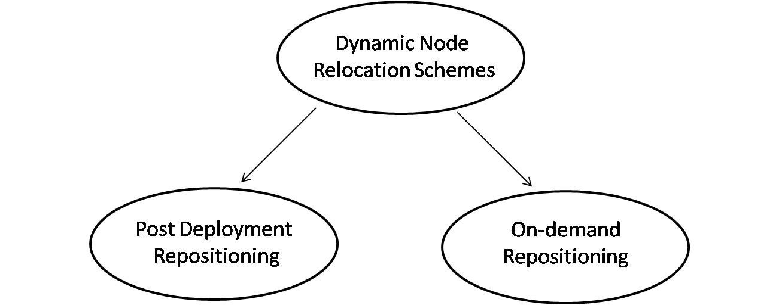

Figure 2. Evolution and categories of dynamic node relocation

3.1. Post-deployment repositioning
VECtor-based Algorithm (VEC), VORonoi-based Algorithm (VOR) and Minimax Algorithm have been becoming the proposition of Wang et al. [38] related to this category. There are a tight relationship of each of these three algorithms to the Voronoi polygon of sensor node or point in which a node or point lying closer than other to the sensory boundary. In this case, VECtor-based Algorithm is processed following Coulomb's law as an equating process that shows the prevention among electrostatic particles. The node for the dispossession of a component of a node's Voronoi polygon consequently is going to be driven away from other nodes nearby by vigour comparative to the interval it has either from the nodes themselves or from the angular points of the polygon. A corresponding routine as a manifestation of Coulomb's law has been proposed by Neo and Varshney [39], but in this case without regard to it was the node's Voronoi polygon. Each node functionally as a proxy in turn proportionally is going to move far away to the nodes’ compactness in its locale mostly nearby. Being capable of making the nodes moving to the most in contiguous point of its Voronoi polygon, and simultaneously emerging the more regular polygon; VORonoi-based algorithm, in fact, may create a fluctuation of the nodes in a number of locales. Meanwhile, the relative small and customary movement is found in the Minimax algorithm even with less fluctuation. Above all, those processes (algorithm) above in fact might emerge the intermittent in movement that afterward leads the energy and time to be wasteful then.
Purposively to create a reduction in the extent of the length for the course, [40] has recommended an approach based on proxy with the absence of a physical movement of the sensor nodes, except if their destination has been already calculated. Here, the authors more put emphasis on a system with the corroboration of either mobile sensors or immobile ones. In this case, the mobile nodes are in charged of loading the extent of the positions from which the nodes are absent in a distributive manner predictable by immobile nodes, implying that the mobile nodes are in a logical movement and position the immobile ones as the agent as well. Through this approach, there will be a very significant reduction in the distance either from its mean or from totality in which the mobile nodes direct along in keeping the coverage in the equal rate as [38]. Conversely, this approach might emerge an increase only in a density of message. In a word, it could be assumed here that such approaches, rather than focusing on the connectivity, tend to more evade the empty space in coverage. Wu et al, purposely to reduce the entire deployment time, have proposed a different answer using 2D scrutinization towards the networks that have been selected also called SMART [41]. It has been performed using an approach adopted from a well-accepted design for a load balance among nodes in a number of conformations on the parallel processing in which a process is separated into parts, simultaneously executed on different processors. This design, in turn, is used in a multi-cluster WSN in which every single cluster will be represented by a square cell that forms a 2D mesh and several sensors added on a single cell will characterize the cluster load. The locality in an interconnection either in horizontal or in vertical indices and the quantity of the sensor in its cluster giving an indication that the only communication a cluster-head can have is by using the similar position of its in other cells nearby. Subsequently, the corresponding achieved coverage is associated with the issue on the balance of the amount of the energy for leveling the sensors’ distribution among the clusters.

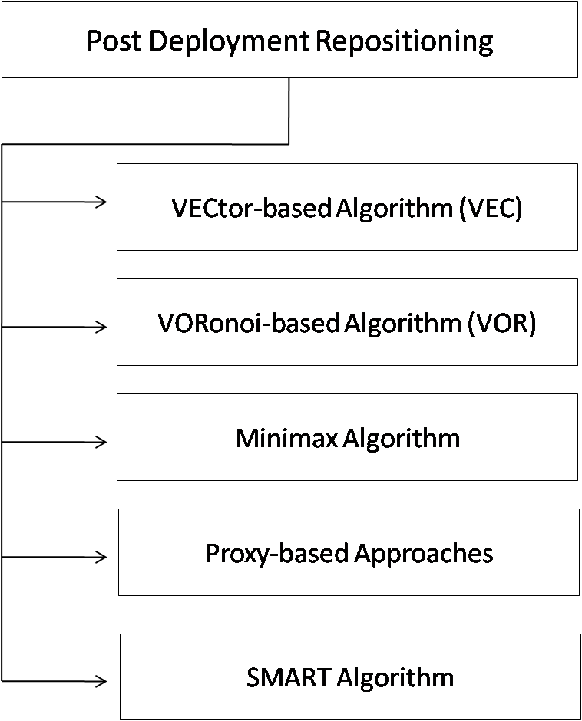

Figure 3. Post deployment repositioning schemes in WSN

3.2. On-demand repositioning
The most efficient structure of repositioning comes to be the target of this category. Efficiency in the beginning of network application mostly is becoming less for the node failure. In addition, the essence of the efficiency may also be influenced by any changes in the application requirements. In other cases, it is suggested that nodes should move orderly for maintaining the efficiency of a network layout. Wang et al. [43] in response to substitute a failed sensor has proposed Cascaded Movement, in this case, using a repetitious substitution towards the node close to another superfluous one.
Figure 4 illustrates the proposed Cascaded Movement where s1 represents the redundant node and s1 and s are the redundant node and the faulty node, respectively. Here, the sensor node s3 having found that s4 is failed, will search for the redundant node. It is assumed that the sensor node s3 finds the redundant node s1 by means of the sensor node s2, nodes s3, s2, and s1, subsequently, will substitute the faulty node by the cascaded movement (the movements of s3 to s4, s2 to s3, and s1 to s2 occur simultaneously).

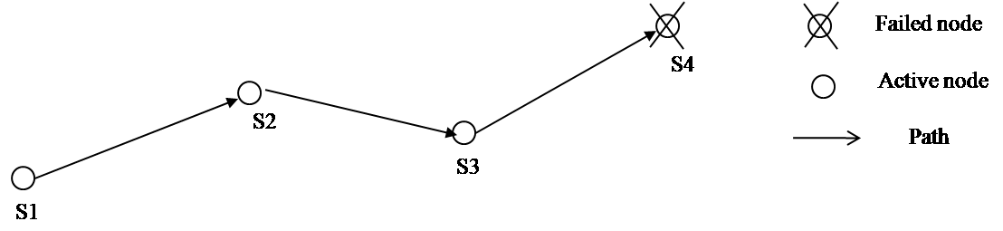
Figure 4. Cascaded Movement proposed in [43]

Similarly, connectivity has been taken into account by other works in which as exemplified in [43] one approach fixes on sustaining the two-degree connectivity even under link or node failure based on moving a subset of the nodes. Although being able to lessen the relocation time using the cascade movement; the researches due to the disorder arrangement of redundant nodes are still not able to lessen the time to find the redundant node.
Meanwhile, post-deployment connectivity and coverage were considered by Susi et al. [44] and Anchare et al. [45]. Coverage is increased without breaking any existing internode links when C2AP (Coverage-aware Connectivity-constrained Actor) spreads out the connected nodes. Whilst with COCOLA (COnnected COverage and Latency aware Actor placement), a network architecture that is hierarchical is considered. In this approach, nodes on a higher tier are repositioned, incrementally, so that the coverage can be maximized but with no extension to the data route to the node on the first tier. This is so that a desired bound on data latency is maintained. However, the impact that a failed node has is not handled by either C2AP or COCOLA.
On the other hand, Ameer et al. [46] put forward a set of rules of a scattered actor improvement in order to fix the partitioned actor networks DARA raising real time restoration without any hypothesis on the interconnection of the network before facing the malfunction of an actor. Figure 5(a) illustrates DARA using the network topology by positioning A1 as a cut-vertex. Figure 5(b), meanwhile, shows how the malfunction of A1 later could make the network separated into three parts, that are {A2, A3}, {A4, A5, A6, A7, A8} and {A9, A10, A11, A12, A13, A14, A15} and are not interrelated to each other. DARA, in place of moving a block [43], might track a flown reposition of a number of actors - assuming that a small amount of movements, instead of the block movement, somewhat, leading to the movement of the actors entirely, are needed in the flown reposition or movement. The block movement also entails the awareness of the whole actors in each divided network towards the place and distance of the movement introducing the extra messaging, in this case, to structure the two-hop neighbour lists that can be maintained at ease. Of A2, A7, A8 and A9, only does A9 have the most significant node level in height making it driven out then. A7 following A9 has the second largest level of node between A2 and A8 that have the corresponding level and at an equal distance with A, subsequently making A8 to be driven out as well in accordance with the node ID. On the other hand, Figure 5(c) depicts the intercorrelated of network subsequent to the improvement. Highlighted here, when A2 is driven out, the movement of A3 is deemed necessary as depicted in Figure 5(d). By so doing, this might enable the process of detaching the whole occupied actors to be much greater compared to the selected node A8. Above all, it indicates that optimal results are not always produced in DARA showing as a gluttonous approach. In the following discussion, it, conversely, will show the employment of DARA towards few optimization techniques proving its effectiveness for restricting the disproportionateness of the flown movement. Figure 5(d) provides an example of how the accessibility of A4 to A3 has made the connectivity of A3 to A2 missing and consequently making the overhead reduced.

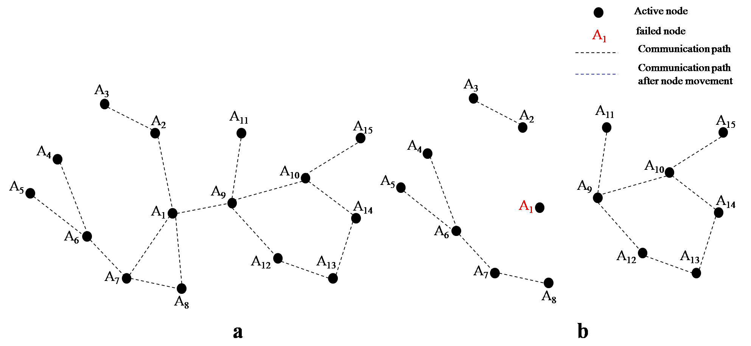

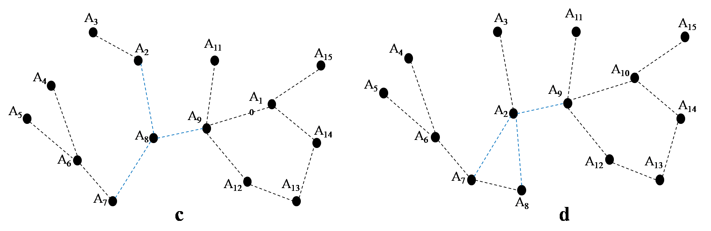
Figure 5 (a). An example connected inter-actor network, (b) Actor A1 fails causing the network to be partitioned into 3 disjoint sub-networks, (c) Node A8 replaced the faulty actor and re-establish connectivity between actors, (d) The topology if node A2 is picked to replace A1. A3 has also to move to sustain it connectivity to A2

Abbasi et al. [47] have proposed a concept of the assignment of MRI to every actor in accordance with the impact of the presently performed task. At this point, the MRI value will make allowance for an actor to move or not. Figure 6(a) illustrates a 1-connected inter-actor network topology in which a failure of non-critical actors (A2, A8, and A5) will not hurt the inter-actor connectivity for the availability of other alternate paths. Similarly, a failure of an actor e.g. A10, A15 and A12 at network boundary with 1 for the actor node degree will also have no damaging effect for the inter-actor connectivity. It is, however, in contrast with a cut-vertex actor failure that can divide the network into parts as the failure of A1 as well as that of A9 and A13 is able to divide the network into three disjoint networks as exemplified in Figure 6(b). Figure 6(c), meanwhile, shows the replacement and reestablishment of node A3 towards the faulty actor and the connectivity among actors, respectively. A topology after processing C2AM with node A5 substituting A1, followed by the cascaded motion of A6, A9 and A11 is illustrated in Figure 6(d).

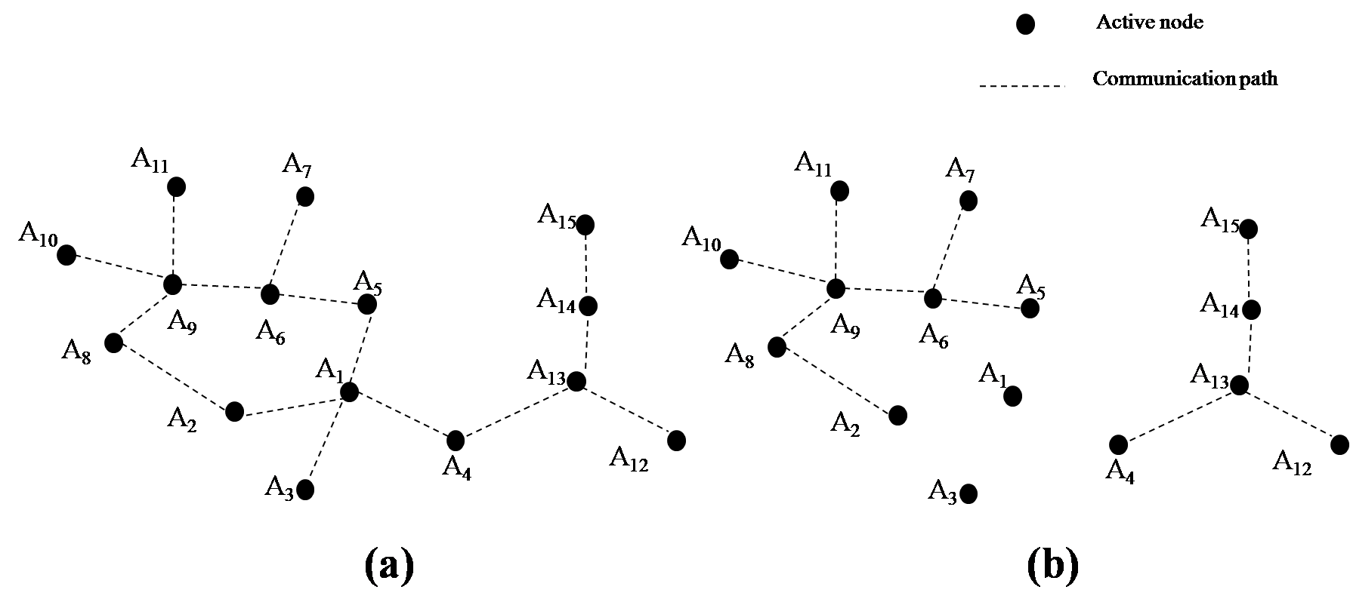

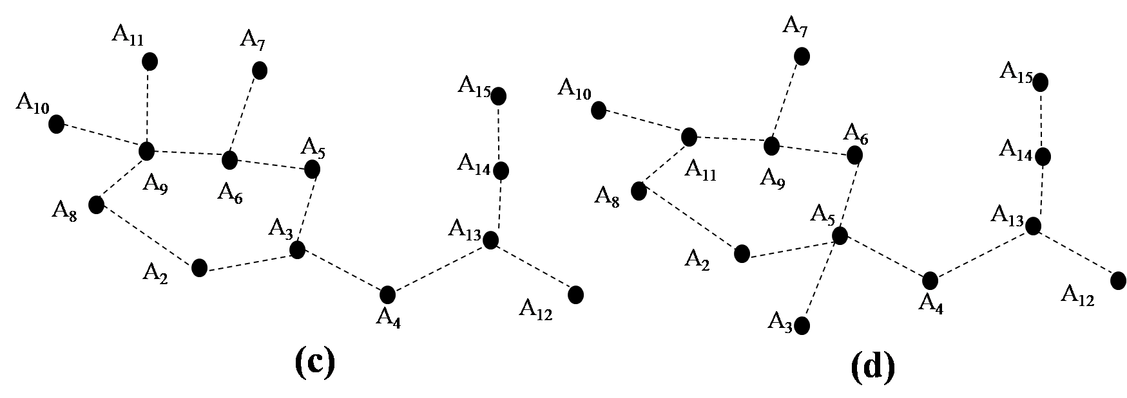
Figure 6 (a). Pre-failure network topology, (b) After A1 fails the network gets partitioned into three disjointed sub-networks, (c) node A3 replaced the faulty actor and re-established connectivity between actors, (d) The topology after running C2AM with node A5 replacing A1, followed with cascaded motion of A6, A9 and A11

In the proposed algorithm, three drawbacks have been found. That C2AM purely is a reactive approach making it possibly not suitable for mission-critical time-sensitive applications is the first drawback. The second one shows that C2AM does not consider the capability of the actor while moving an actor in recovering a malfunction. Here, to conduct a movement of an ineffectual actor could lead to may emerge an opposite of desired impact in the appliance. The last drawback shows how C2AM requires maintenance of 2-hop information and has no any concern with the actor coverage.
Younis et al. [48] in turn have proposed NN (Nearest Neighbour) and RIM (Recovery through Inward Motion) algorithms; both of which pursue the voracious heuristics. In NN after the failure in a node, NN is going to travel, Failure neighbour node (FNN) as the one much closer to the position of F for repairing the severed connectivity around. Considering that there will be a movement of the most nearby one of the neighbours of FNN, which, afterwards, will situate in the place of FNN, the neighbours of FNN in response will react its removal.
Figure 7 illustrates one example of the NN algorithm in which the preliminary topology and relations, which are going to be disengaged once F ceases (lines marked in red) are depicted in part (a). Being aware the nearest node of B to F, nodes A, G and H is going to stay for the movement of B. Node B apprises C and D prior to be in motion and A, G and H are when finding a novel locale. Furthermore, both part (b) and part (c) demonstrate the interconnection of the network once D is substituted by B as well as B by F. Node E as depicted in part (D) is becoming the As seen in part (d), node E is becoming the only node to be influenced and thus travelling to the previous place of D.

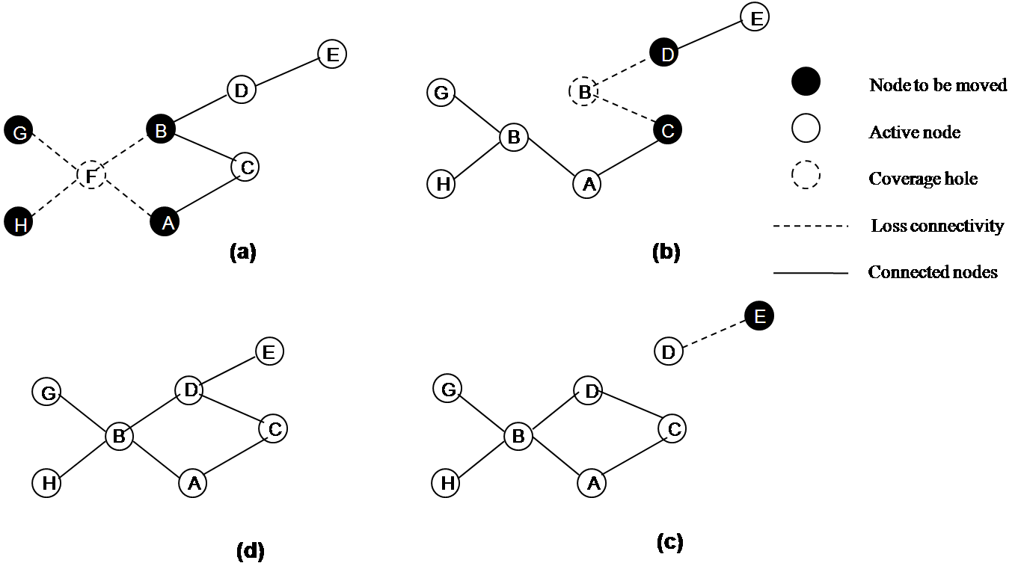
Figure.7. An example that illustrates how the NN algorithm restores connectivity by replacing the failed node with its nearest neighbour and repeating this process for every node that leaves its position

For the improvement of the network, RIM as shown in Figure 8, a set of rules spread through the internal movement, possesses a foremost scheme showing an inward direction of the node F’s neighbours to its position when a failure occurs on it for enabling the interconnection between them. This occurrence is determined by the neighbours directly affected by the F failure, and afterward, once reaching each other, the restoration of the interconnection of the network will be done directed to the previous position before being malfunctioning.
The relocation procedure is done using a recursive handling to any nodes being not interrelated in the movement of one of their neighbours, say, to those that have gone to the damaged node. NN subsequently will stop when finding no neighbour for a deceased node (reaching the border of the network) or after the movement of all nodes in the network. If RIM applies 1-hop neighbour list, the set of rules in NN algorithm, in turn, necessitates that each of node should be on the alert for its 2-hop neighbours since it can enable to identify the neighbour much nearby ahead of the malfunction of node F. At this point, there will be no concern of both RIM and NN with the consequence that possibly emerges in the connectivity restoring on the covered network.

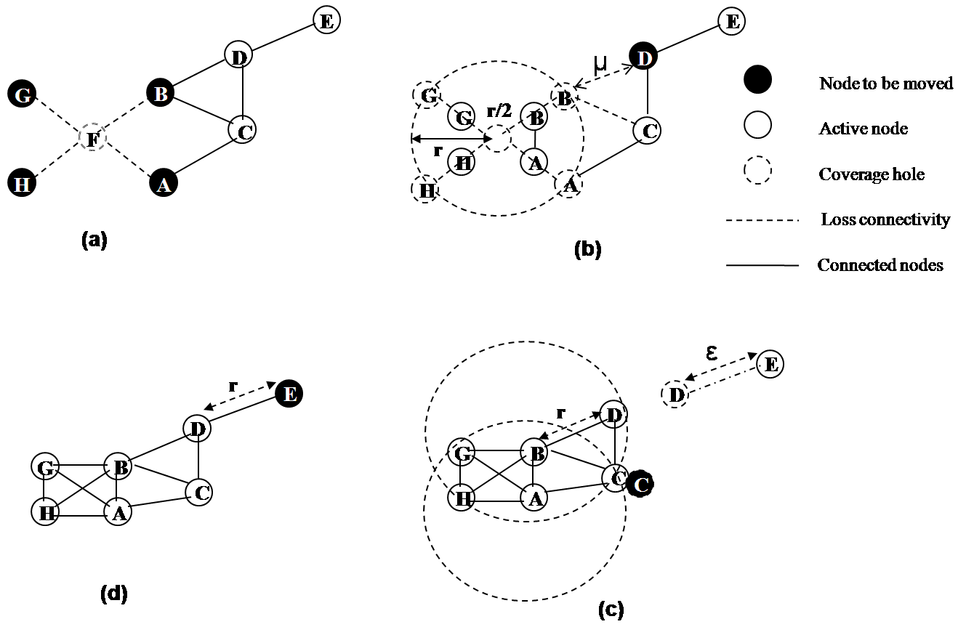
Figure 8. (a)-(d) An example for how RIM restoration process; each shaded node moves based on the position of its neighbours, denoted in dotted lined circles

This undeviating relocation could prevent by the algorithm of C³R also called as coverage conscious connectivity restoration [49]. Though the replacement of the neighbour node to another is capable of taking back the interconnection, it simply alter the coverage hole of the field partly in fact, either in the internal part of the network or at the border and mobile sensor repositioning to deal effectively with the leakage of coverage and connectivity from a node failure. The nodes, instead of the network topology reconfiguration, are going to be in to and fro to substitute the pointless node in the aim of providing intermittent recovery not a permanent one.

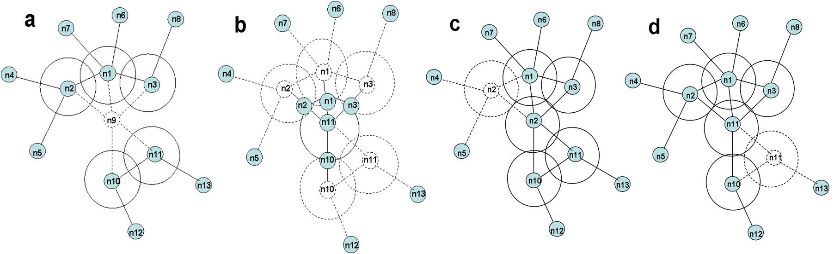

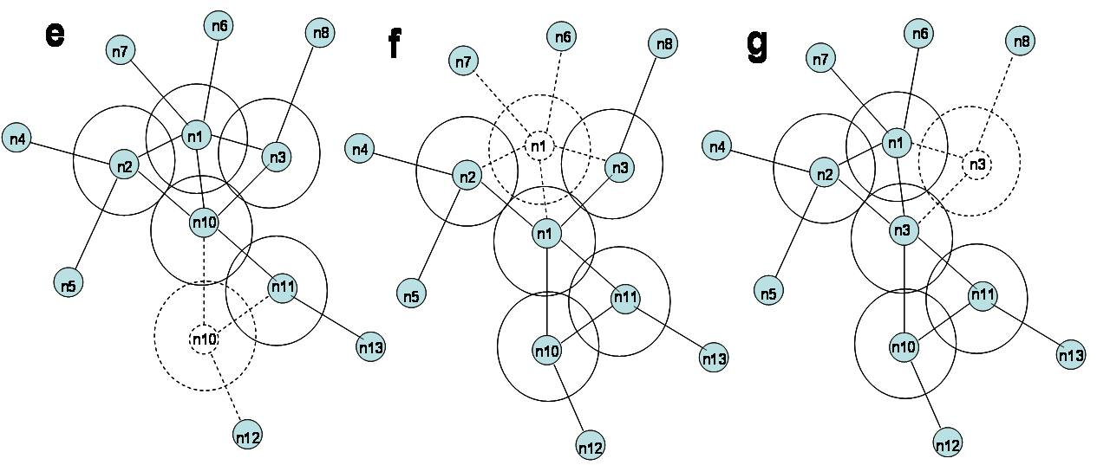
Figure 9. The illustration of C³R technique

Figure 9 shows how C³R is being under an improvement through the pattern network. Then, it could be figured out that the capacity of the neighbours for the connection of node n9 will faded and run an internal movement when finding the malfunction of n9. This is performed on the purpose to make a design in coping with the malfunction. Furthermore, since being positioned as the closest node towards n9, the node n11, as a result, is able to reach n9 much more rapidly compared to other living nearby. Even, n11 is positioned as a coordinator as presented in Figure 9(b). In this case, a number of nodes will accumulate the schedule from n11 and return their spot not including n2 as the initial node programmed for revitalization for possessing a high overlapping coverage as revealed in Figure 9(c). Figure 9(d)–(g), moreover, presents a back and forth movement of different neighbours of n9 sequentially for the network revitalization from the malfunction of n9. This resolution evidently will emerge a number of recurrent changes in interconnection and might inflict a large amount of overhead. It is not wonder why then if this resolution is impermanent in anticipation of the operation of spare nodes. C³R, in addition, only consider one failure separately not coping with the multiple and simultaneous node failures.

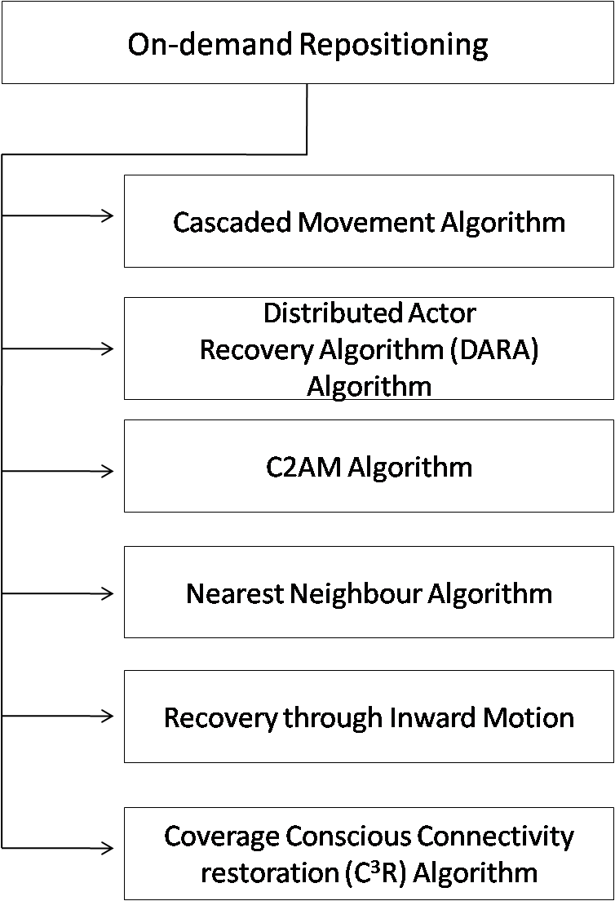
Figure 10. On-demand repositioning schemes

4. Design goals for optimization algorithm
Following principles must be optimized to manage the issues in repositioning of the sensor node.

4.1. Shortest total travelling distance
This is used to indicate the efficiency of the technique in terms of energy overhead. Actually when a failed node is replaced it aims to capture the total distance travelled by all the sensor nodes.

4.2. Fast hole healing
If any of the node fails during the normal operation of the network, or there is a network hole, then the neighbours nodes immediately identify this network hole. The algorithm for identifying the network hole must be fast for maintaining the network connectivity and coverage the recovery process.

4.3. Minimum message overhead and
In order to restore the connectivity of the network, this shows the total number of messages sent by the all nodes. It is another metric for accessing the overhead incurred by the nodes.

4.4. Energy efficiency
The nodes of WSN are typically battery equipped; if the node is mobile then the primary design goal is to optimize the amount of energy used for transmission and node movement. Different energy conservation techniques and algorithms are used for computing the optimal transmitting ranges, in order to generate a network with desired properties while reducing sensors energy consumption.

5. Open issues
Major progress has been achieved in optimization of node repositioning in the area of WSN, but still some challengeable problems need more attention in this field. This section highlights some open research issues that are categorized in to coordinated multi-node relocation and three-dimensional sensor node relocation.

5.1. Coordinated multi-node relocation
While dealing with the multi-node relocation, the repositioning of nodes will be much complex. On the other hand simultaneously node relocation raises the convergence issue. Relocation one node can make the move that was concurrently made by another node either redundant and/or incompatible. For example, an autonomous decision by multiple nodes for relocation towards an event may lower the coverage in another region while increasing the fidelity of monitoring the event more than necessary. Lightweight synchronization protocols and/or localized schemes may be required, especially for large networks, in order to ensure convergence of the relocation process to an optimized network state, consistent with the objectives and constraint of the move.
We envision the coordinated multi-node relocation to be a promising research direction, as little attention has been paid to tackle the challenges of coordinated multi-node relocation.

5.2. Node relocation in three-dimensional application setups
The scope of the majority of published papers on static and dynamic node positioning strategies are limited to terrestrial networks, where covered space is two-dimensional (2-D) and is for small indoor setups. Even for applications that employ range finders, imagers and video sensors the focus has been on the quality of the collected data and coverage of some 2-D space. As it is mentioned in Sections 3.1and 3.2, many popular coverage analysis and placement strategies pursued for 2-D space become NP-Hard in 3-D. However, with the increased interest in applications of sensor networks in space exploration, airborne and underwater surveillance, oceanic studies, storm tracking, etc. tackling the contemporary design issues such as coverage and connectivity in 3-D has become a necessity. We expect optimization strategies for node positioning in WSN applications in large-scale 3-D setups to be one of the hot topics of research in the next few years. In fact, some preliminary research results have started to emerge.

6. Comparison of node relocation technique
A comparison of Dynamic node relocation schemes shown in the following table (Table 1).

Table 1: Comparison of Dynamic relocation schemes

Reference | Optimization objective | Migration Technique | Node type | Area partition | Network Architecture | Sensor Mobility | hops | Limitations/Constraint

Post-Deployment Repositioning

[38] | Connectivity restoration | Direct | Sensor | Voronoi Diagram | Centralized | Robot | 2 | Convergence time, Do not consider Coverage
[39] | Connectivity Restoration | Shifted | Data collector | Zone | Centralized | Robot | 2 | Convergence time, Do not consider Coverage
[40] | Coverage | Shifted | Sensor | Plane | Centralized | Actuator | 2 | Do not consider connectivity
[41] | Connectivity | Shifted | Sensor | Square or Hexagon | Centralized | Mobile sensor | 2 | Do not consider connectivity
[42] | Connectivity | Shifted | Data collector | Mesh | Distributed | Robot | 1 | Do not handle actor failure

On-Demand Repositioning

[43] | Coverage | Direct | Data collector | Plane | Distributed | Actuator | 1 | Neither consider coverage nor application level interests
[44] | Connectivity | Shifted | Sensor | Plane | Centralized | Sensor | 2 | Convergence time, Do not consider Coverage
[45] | Connectivity | Shifted | Sensor | Plane | Distributed | Sensor | 2 | Convergence time, Do not consider Coverage
[46] | Coverage | Shifted | Data collector | Plane | Distributed | Actuator | 1 | Do not handle actor failure
[47] | Connectivity | Shifted | Sensor | Grid | Distributed | Mobile sensor | 2 | Do not consider connectivity
[48] | Connectivity | Direct | Sensor | Grid | Distributed | Mobile sensor | 2 | Do not consider connectivity
[49] | Connectivity and Coverage | Direct | Sensors | Grid | Distributed | Mobile sensor | 1 | Do not consider Multi-node and simultaneous node failure

7. Future directions
Coping with the concurrent malfunction of few nodes, while sustaining the restricted network state information, will be the upcoming project of ours. To exemplify it, a number of sensor nodes, either collocated or a distance apart from each other, may simultaneously fail - consequently leading the network to be apart into a number of incoherent subdivisions. For this, we have planned either to make an assessment on the effect of certain mobile node malfunctions or to occupy the existing nodes mobility. It will, in turn, be based on both the level of occurred damage and the particular application. Not only is entirely considering coverage and connectivity, but also the improvement for the malfunction of a node comes to be our concern.

8. Conclusion
Today, a great number of considerations has been put into Wireless sensor networks (WSNs) for its latent qualities or abilities to be variously in use such as in protecting certain boundary or in observing a protection and battle region. Concerning with the criticality of such applications, it will be very vital then to establish a resourceful network process as a deep-seated purpose. Nonetheless, the resource-constrained nature of sensor nodes and the ad-hoc formation of the network, frequently coupled with an unattended use, has come out a number of non-conventional challenges and motivated certain requirements for certain particular techniques WSN for design or for management. This paper is designed for giving an elaboration on the effect of vibrant node relocation in the sensor field, in this case, by classifying a range of approaches in literature on vibrant node positioning, which after a deployment or during the normal network operation, might be becoming a practical medium to achieve the performance enhancement. It is different from the initial watchful placement as in node repositioning; it comes to be possible to handle the vibrant distinction in network possessions and the environment nearby. A number of technical issues applicable for node relocation, in addition, has been identified in this research; those are to find the destination of the movement and to figure out a way in managing the network in the movement of the node. In turn, several published techniques for dynamic node positioning have been studied as well been compared in consideration of their aim, method, and appliance. An assumption could be emerged here that the movable nodes can possibly be dynamically relocated ether to load the coverage and the gap in interconnection and to deal with changes in user interests. To end up, a coordinated multi-node repositioning problem as an open research area has been identified and a little attention has been paid to such challenging and interesting area.

Acknowledgements:
The authors would also like to thank Universiti Teknologi PETRONAS for providing the financial assistance in the form of the Graduate Assistantship (GA) to carry out the research.

Corresponding Author:
Muhammad Amir Khan
Department of Computer and Information Sciences,
Universiti Teknologi PETRONAS,
Bandar Seri Iskandar,
31750 Tronoh, Perak, Malaysia.
E-mail: amirkhancomsats@gmail.com

References
- Chen, J., Diaz, M., Llops, L., Rubio, B., & Troya, J. M. (2011). A survey on quality of service support in wireless sensor and actor networks: Requirements and challenges in the context of critical infrastructure protection. Journal of Network and Computer Applications (Elsevier), 34, 1225-1239.
- I. Senturk, K. Akkaya, F. Senel and M. Younis, "Connectivity Restoration in Disjoint Wireless Sensor Networks using Limited Number of Mobile Relays," in the Proceedings of the IEEE International Conference on Communications (ICC 13), Budapest, Hungary, June 2013.
- I. Senturk, S. Yilmaz, K. Akkaya, "A Game-Theoretic Approach to Connectivity Restoration in Wireless Sensor and Actor Networks," in the Proceedings of the Wireless Sensor Actor and Actuator Networks (ICC 12), Vancouver, Canada, June 2012.
- I. Senturk, K. Akkaya and S. Yilmaz, "Distributed Relay Node Positioning for Connectivity Restoration in Partitioned Wireless Sensor Networks," in the Proceedings of the IEEE International Symposium and Computers and Communications (ISCC2012), Capadocia, Turkey, July 2012.
- T. Imboden, K. Akkaya and Z. Moore, "Performance Evaluation of Wireless Mesh Networks using IEEE 802.11s and IEEE 802.11n," in the Proceedings of the Proceedings of Convergence among Heterogeneous Wireless Systems in Future Internet Workshop, in conjunction with IEEE ICC 2012 Ottawa, Canada, June 2012.
- H. Oztarak, T. Yilmaz, K. Akkaya and A. Yazici, "Efficient and Accurate Object Classification in Wireless Multimedia Sensor Networks," in the Proceedings of the 21st IEEE International Conference on Computer Communications and Networks (ICCCN), Munich, Germany, July 2012.
- N. Saputro and K. Akkaya, "Performance Evaluation of Smart Grid Data Aggregation via Homomorphic Encryption," in the Proceedings of the IEEE Wireless Communications and Networking Conference (WCNC), Paris, France, April 2012.
- S. Janansefat, I. Senturk, K. Akkaya and T. Gloff, "A Mobile Sensor Network Testbed Using iRobots," in the Proceedings of the Demonstrations of the IEEE Conference on Local Computer Networks 2012 Clear Water, Florida, USA, October 2012.
- Ong, J., You, Y. Z., Mills-Beale, J., Tan, E. L., Pereles, B., & Ghee, K. (2008). A wireless, passive embedded sensor for real-time monitoring of water content in civil engineering materials. IEEE Sensors Journal, 8, 2053-2058.
- M. Younis, P. Munshi, E. Al-Shaer, "Architecture for efficient monitoring and management of sensor networks," in: Proceedings of the IFIP/IEEE Workshop on End-to- End Monitoring Techniques and Services (E2EMON_03), Belfast, Northern Ireland, September 2003, pp. 140-146.
- W. Heinzelman. A. Chandrakasan and W. Balakrishnan. "An Application-Specific Protocol Architecture for Wireless Microsensor Networks:" IEEE Transactions on wireless Communicarions, vol. 1, October 2011, pp. 233-246.
- T. Clouqueur, V. Phipatanasuphorn. P. Ramanathan and K. k. Saluja. "Sensor Deployment Strategy for Target Detection." First ACM International Workshop on Wireless Sensor Networks arid Applications, 2010, pp 122-128.
- G. J. Pottiz and W. J. Kaiser. "Wireless Integrated Network Sensors." Communications of the ACM. May 2000, pp. 299-305.
- K. Akkaya and M. Younis, "COLA: A Coverage and Latency aware Actor Placement for Wireless Sensor and Actor Networks", in the Proceedings of IEEE Vehicular Technology Conference (VTC-Fall'06), Montreal, Canada, September 2006, pp. 110-116.
- T. Melodia, D.Pompili, V. C. Gungor, I. F, Ikyildiz"A Distributed Coordination Framework for Wireless Sensor and Actor Networks," in the Proceedings of The 6th ACM International Symposium on Mobile Ad Hoc Networking and Computing (Mobihoc'05), Urbana-Champaign, Illinois May 2005, pp. 168-176.
- P. Basu and J. Redi, "Movement Control Algorithms for Realization of Fault-Tolerant Ad Hoc Robot Networks," IEEE Networks, Vol. 18, No. 4, August 2004, pp. 36-44.
- K. Akkaya, M. Younis and M. Bangad "Sink Repositioning for Enhanced Performance in Wireless Sensor Networks," Elsevier Computer Networks, Vol. 49, Feb, 2010, pp. 512-434.
- X. Liu, L. Xiao, A. Kreling, and Y. Liu, "Optimizing Overlay Topology by Reducing Cut Vertices," in the Proceedings of ACM International Workshop on Network and Operating Systems Support for Digital Audio and Video (NOSSDAV'06), Newport, Rhode Island, May 2006, pp. 112-119.
- S. S. Dhillon and K. Chakrabarty, "Sensor placement for effective coverage and surveillance in distributed sensor networks," in Proc. IEEE Wireless Commun. Netw. Conf., 2003, pp. 1609-1614.
- [3] Salarian, H., Chin, K.-W., & Naghdy, F. (2012). Coordination in wireless sensor-actuator networks: A survey. Journal of Parallel and Distributed Computing, 72(7), 856-867.
- E. Biagioni and G. Sasaki, "Wireless sensor placement for reliable and efficient data collection," in Proc. Hawaii Int. Conf Syst. Sci., Jan. 2003, pp. 127-134.
- I. Senturk, K. Akkaya and S. Yilmaz, "Distributed Relay Node Positioning for Connectivity Restoration in Partitioned Wireless Sensor Networks," in the Proceedings of the IEEE International Symposium and Computers and Communications (ISCC2012), Capadocia, Turkey, July 2012.
- Younis M, Akkaya K, "Strategies and techniques for node placement I wireless sensor networks": A survey, The Journal of Ad-Hoc Networks, 2008;6(4): pp. 621-55.
- Wang G, Cao G La Porta T, Movement-assisted sensor deployment, In: proceedings of the 23rd annual joint conference of the IEEE computer and communications societies (INFOCOM'04), Hong Kong, March 2004, pp. 119-115.
- G. Wang, G. Cao, T. La Porta, and W. Zhang, "Sensor Relocation in Mobile Sensor Networks," in the Proceedings of the 24th Annual IEEE Conf. on Computer Communications (INFOCOM'05), Miami, FL, Mar. 2008.
- P. Basu and J. Redi, "Movement Control Algorithms for Realization of Fault-Tolerant Ad Hoc Robot Networks," IEEE Networks, Vol. 18, No. 4, pp. 36-44, Aug. 2011.
- A. Abbasi, K. Akkaya and M. Younis, "A Distributed Connectivity Restoration Algorithm in Wireless Sensor and Actor Networks," in the Proceedings of the 32nd IEEE Conf. on Local Computer Networks (LCN'07), Dublin, Ireland, Oct. 2009, pp. 120-127.
- Younis M, Akkaya K, "A localized self-healing algorithm for networks of moveable sensor nodes," In: Proceedings of the IEEE global telecommunications conference (Globecom'08), New Orleans, LA, November 2008, pp. 22-28.
- Bao L., Garcia-Luna-Aceves J.J, "Topology management in ad hoc networks," In: Proceedings of the fourth ACM international symposium on mobile ad hoc networking and computing (MobiHoc 2003), Annapolis, MD, June 2011, pp. 190-196.
- Bulusu N, Heidemann J, Estrin D. "GPS-less low-cost outdoor localization for very small devices," IEEE Personal Communications October, 2009;7(5): pp. 28-34.
- J. Chen and X. Koutsoukos. "Survey on coverage problems in wireless ad hoc sensor networks". In IEEE SouthEastCon, Richmond, VA, March 2007.
- S. Yang, F. Dai, M. Cardei, J. Wu, and F. Patterson, "On Connected Multiple Point Coverage in Wireless Sensor Networks", Journal of Network and Computer Applications, Volume 32 , Issue 4, Pp. 866-877, (July 2009).
- X. Bai, Z. Yun, D. Xuan, T. Lai, and W. Jia, "Optimal Patterns for Four-Connectivity and Full Coverage in Wireless Sensor Networks", IEEE Transactions on Mobile Computing, 2008.
- Chatzigiannakis, G. Mylonas and S. Nikoletseas, "Modeling and Evaluation of the Effect of Obstacles on the Performance of Wireless Sensor Networks", The 39th Annual ACM/IEEE Simulation Symposium (ANSS 06), Huntsville, USA, April 2006.
- M. Hefeeda and M. Bagheri. "Randomized k-coverage algorithms for dense sensor networks". In Proc. of IEEE INFO-COM 2007 Minisymposium, pages 2376-2380, Anchorage, AK, May 2007.
- Butterfield J, Dantu K, Gerkey B, Jenkins OC, and Sukhatme GS. 2008. Autonomous biconnected networks of mobile robots. 6th International Symposium on Modeling and Optimization in Mobile, Ad Hoc, and Wireless Networks and Workshops (WiOPT 2008) Berlin, Germany. pp. 640-646.
- McLaughlan B, and Akkaya K. 2007. Coverage-based Clustering of Wireless Sensor and Actor Networks. IEEE International Conference on Pervasive Services. Istanbul, Turkey. pp. 45-54.
- Wang G, Cao G La Porta T, Movement-assisted sensor deployment, In: proceedings of the 23rd annual joint conference of the IEEE computer and communications societies (INFOCOM'04), Hong Kong, March 2004, pp. 119-115.
- N. Heo and P. K. Varshney, "Energy-Efficient Deployment of Intelligent Mobile Sensor Networks," IEEE Trans. On Systems, Man, Cybernetics, Part A, Vol. 35, No. 1, Jan, 2005, pp. 117-127.
- G. Wang, G. Cao, T. La Porta. Proxy-based sensor deployment for mobile sensor networks, in: Proceedings of the 1st IEEE International Conference on Mobile Ad-hoc and Sensor Systems (MASS'04), Fort Lauderdale, Florida, October, 2004
- Akkaya K, Senel F, Thimmapuram A, and Uludag S. 2010. Distributed Recovery from Network Partitioning in Movable Sensor/Actor Networks via Controlled Mobility. IEEE Transactions on Computers 59(2):258-271.
- Akkaya K, and Younis M. 2006. COLA: A Coverage and Latency Aware Actor Placement for Wireless Sensor and Actor Networks. IEEE 64th Vehicular Technology Conference (VTC-2006), 2006 Montreal, Canada. pp. 1-5.
- McLaughlan B, and Akkaya K. 2007. Coverage-based Clustering of Wireless Sensor and Actor Networks. IEEE International Conference on Pervasive Services. Istanbul, Turkey. pp. 45-54.
- K. Akkaya and M. Younis, "COLA: A Coverage and Latency aware Actor Placement for Wireless Sensor and Actor Networks," in the Proceedings of the IEEE Vehicular Technology Conference (VTC), Montreal, Canada, September 2006.
- K. Akkaya and M. Younis, "C2AP: Coverage-aware and Connectivity Constrained Actor Positioning in Wireless Sensor and Actor Networks," in the Proceedings of the IEEE IPCCC 2007New Orleans, LA, USA, April 2007.
- A. Abbasi, K. Akkaya and M. Younis, "A Distributed Connectivity Restoration Algorithm in Wireless Sensor and Actor Networks," in the Proceedings of the 32nd IEEE Conf. on Local Computer Networks (LCN'07), Dublin, Ireland, Oct. 2009, pp. 120-127.
- A. Abbasi, U. Baraudi, M. Younis, K. Akkaya, "C2AM: An Algorithm for Application-Aware Movement-Assisted Recovery in Wireless Sensor and Actor Networks," in the Proceedings of the IEEE International Conference on Wireless Communications and Mobile Computing Leipzig, Germany, June 2009.
- M. Younis, S. Lee, A. Abbasi, "A Localized Algorithm for Restoring Internode Connectivity in Networks of Moveable Sensors," IEEE Transaction on Computers, Vol. 59, no. 12, December 2010, pp 1669-1682.
- Neelofer Tamboli, Mohamed Younis, "Coverage-aware connectivity restoration in mobile sensor networks," Journal of Network and Computer Applications 33 (2010), pp. 363-374.

7/1/2021

