Appraisal of Urban Planning and Growth Analysis using Quick Bird Satellite Data

Vinay Prasad Mandal¹, Sham Sutrana², N.Ravisankar¹, N.Subash¹, Sandeep Sharma¹

¹Project Directorate for Farming Systems Research, Modipuram, Meerut
² Punjab, Govt. of Punjab, India
Correspondence Author: vinnumandal@gmail.com

Abstract: In the present study we have taken the urban area of Jind District of the Haryana state. The study has been done on the basis of Design Standards and Methodology formulated in “National Urban Information System” (NUIS) scheme by “Standing Committee on Urban Management” (SC-U) under the “Ministry of Urban Development” (MOUD), in 2006.The major objective of NUIS scheme is to design, organize and establish a comprehensive information system and the study area, materials and methodology designs standard have been discussed. Urban planners require information related to the spatial information within time frame. Remote sensing and GIS along with collateral data help of analysis the LU/LC mapping. In the present study conduct high resolution data (Quick Bird and Resources Sat-1 LISS IV and other side secondary data census of India 2011. The result conceded of the study area highest agricultural land covered by 71.31% which is optimised through RS and GIS based. Image classification scheme LU/LC going to be Level IV and the resulted shown Level II 19 categories identify of the study area. The study areas occupy 9365.80 ha⁻¹ lands and out of 17.48 % taken urban built up land.
[Vinay Prasad Mandal, Sham Sutrana, N. Ravisankar, N. Subash, Sandeep Sharma. Appraisal of Urban Planning and Growth Analysis using Quick Bird Satellite Data. Researcher 2022;14(5):26-35] ISSN 1553-9865 (print); ISSN 2163-8950 (online) http://www.sciencepub.net/researcher. 5. doi:10.7537/marsrsj140522.05.

Keywords: LU/LC, Urban planning, Quick bird, LISS-IV, RS and GIS Approach

1. Introduction
Urban planning integrates land use planning and urban renewal to improve the built and social environments of communities by adapting urban planning methods to existing cities suffering from decay and lack of investment. Sustainable development and sustainability influence today's urban planners. The high resolution data with SOI top sheet has been used to create base map and for extracting the features used for study [Pandey and Nathawat, 2006]. Sustainable development is a recent, controversial concept every parcel of land on the earth’s surface is unique in the cover it possesses. [Chakraborthy et al., 1998]. The heterogeneous climate and physiographic conditions in these districts has resulted in the development of different land use/ land cover in these districts mapping of Panchkula, Ambala and Yamunangar districts, Haryana State in India [Khan et al., 2001]. Through remote sensing and GIS, the main classes of land use/land cover types which can be easily identified are cropland, fallow, forest, land with scrub, land without scrub, sandy area and the water body. [James et al., 1971] With the high resolution data the information that can be inferred by satellite image goes to a higher level of details. [Holmberg, 1994] To date, the most successful attempt in developing a general purpose classification scheme compatible with remote sensing data. Advantages with GIS is that a few number of ground truth points (control points located on ground that reveals the true features and materials, and can be used as calibration in RS and GIS) may be collected, and then the same data can be interpreted over large areas, e.g. land coverage, while at the same time complex relations and large amounts of data can become visualized in a graspable manner [Taubenböcka et al., 2008; Kundu 2005]. An evaluation by digital analysis of satellite data indicates that majority of areas in these districts are used for agricultural purpose. The hilly regions exhibit fair development of reserved forests. It is inferred that land use/ land cover pattern in the area are generally controlled by agro-climatic conditions, ground water potential and a host of other factors [Rani et al., 2011]. In some instances, land use/ land cover change may result in environmental, social and economic impacts of greater damage than benefit to great importance to planners in monitoring the consequences of land use change on the area. Such data are of value to resources management and agencies that plan and assess land use patterns and in modeling and predicting future changes [Rani et al., 2011].

2. Material and Methods
The district lies in the North of Haryana between 29.03’ and 29.51’ North latitude and 75.53’ and 76.47’ East longitude. On its East and North-East lie the districts of Panipat, Karnal and Kaithal respectively. Its boundary line on the North forms the inter-state Haryana- Punjab border with Patiala and Sangurar districts of Punjab. In the West and South-West it has a common boundary with district Hisar & Fatehabad and in its South and South-East lies the district of Rohtak and Sonipat respectively. The total area of Jind district is 3606 sqkms. The soils of the Jind district according to physical characteristics may be divided as sandy, clay, Kallar or Rehi. It is, therefore, evident that, for obtaining good yields, the soils need heavy manuring with nitrogenous and phosphatic fertilizers soils. The climate of the study area is on the whole dry hot in summer maximum temperature 48⁰C rather than cold in winter minimum temperature 6⁰C. The average rainfall over the districts as whole is 55 cm. The study area is a flat monotonous upland plain. The area of Jind district is irrigated the Western Yamuna (Jumna) Canal and the Bhakra Canal. The ground water table is a thick zone of saturation and general the ground water is alkaline of the study area shown in Figure 1.

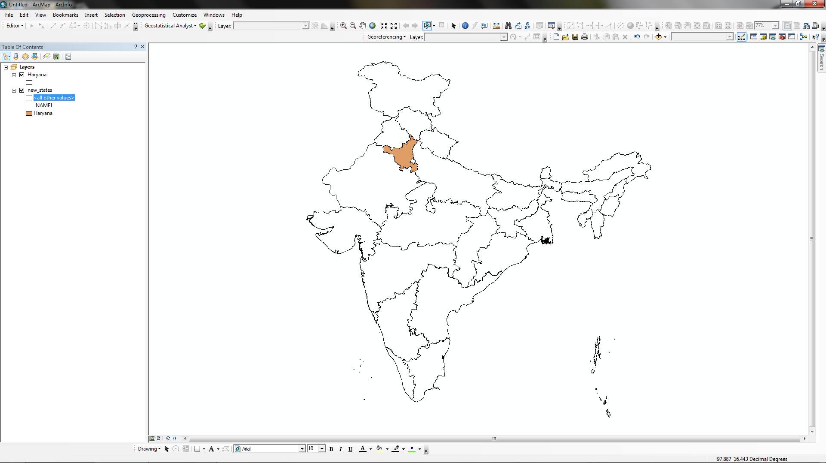
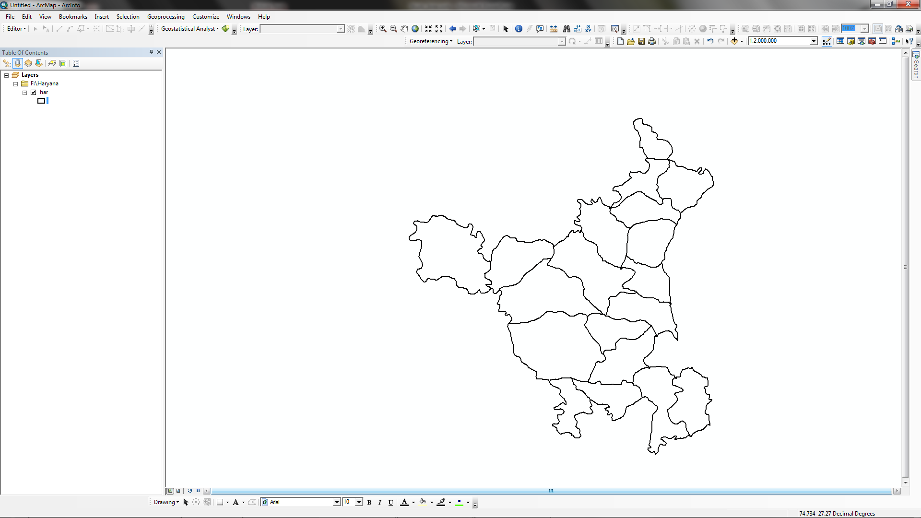
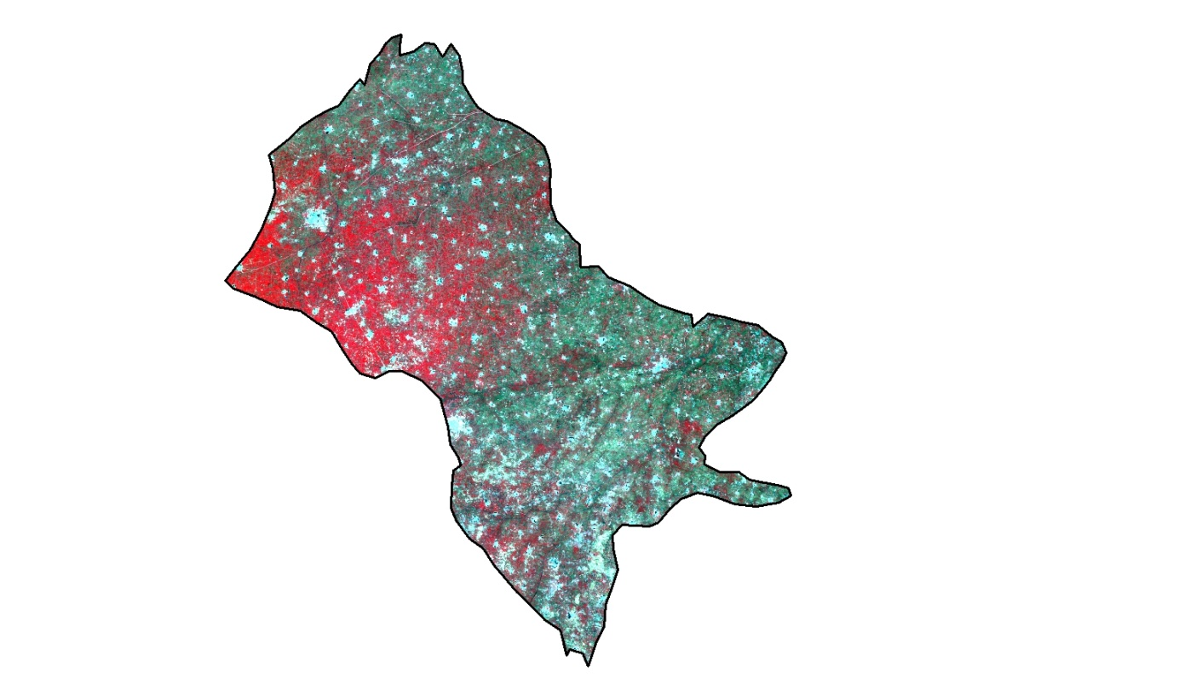
India
Rajasthan
Study Area

Fig: 1 Location Map

2.1 Data Base
The NUIS (National Urban Information System) Design Standards suggests that the Thematic Mapping Activity comprising geospatial database of both Primary themes and Incorporated or attribute Layers at scale of 1:10000.Satellite data: The satellite data consists of high resolution Quick Bird (Panchromatic) stereo data of during the year 2006. The data of Indian Remote Sensing Satellite P-6 (also called Resource Satellite) LISS-IV of the same year has also been used. The details of the satellite data and their characteristics are given in Table 1. Surveys of India (SOI) Toposheets have been used on the scale of 1:50,000. The number of toposheets used are-53C/2, 53C/3, 53C/4, 53C/6, 53C/7, 53C/8, and 53C/11.

Table 1: Satellite Sensor and its Characteristics
Satellite | Sensor | Spatial Resolution (m) | Temporal Resolution
Quick Bird | Pan | 0.61 at nadir | 1-3.5 days
Resourcesat - 1 | LISS-IV(MS) | 5.8 m | 24 days

The sources for acquiring ground truth data under NUIS Thematic Mapping activity include – visual observations of sample doubtful points in field for verification/correlating image interpreted spectral signatures of thematic details; making field photographs and collecting GPS derived measurements in field. Ground truth should cover up to 40% of the study area. Secondary Data, The secondary data under this heading broadly confirms to two types: Spatial data, Administrative and Town Boundary data is spatial in form such as district, Taluk, village cantonment, wards. Non-spatial data, Statistical Abstracts of Haryana have been used to collect some attribute information like urban infrastructure (transportation), housing, demography, socio-economic, utilities; environment and land use.
The methodology adapted to the Generation of Urban Planning Thematic layers database is accomplished through a series of procedural steps. The first of all the quick bird and LISS- IV images georeferenced with the help of SOI toposheet and recognized properly UTM and datum [Kumar et al., 2013; Kumar et al., 2012; Tomar et al., 2013; Bisht et al., 2014; Rani et al., 2011; Kumar and Tomar, 2013; Kumar et al., 2010]. After that with the help of ARC GIS package create the different type of layer and for the quality assessment we can use of GPS data. The approach to 1:10,000 scale thematic mapping is given in Figure 2.

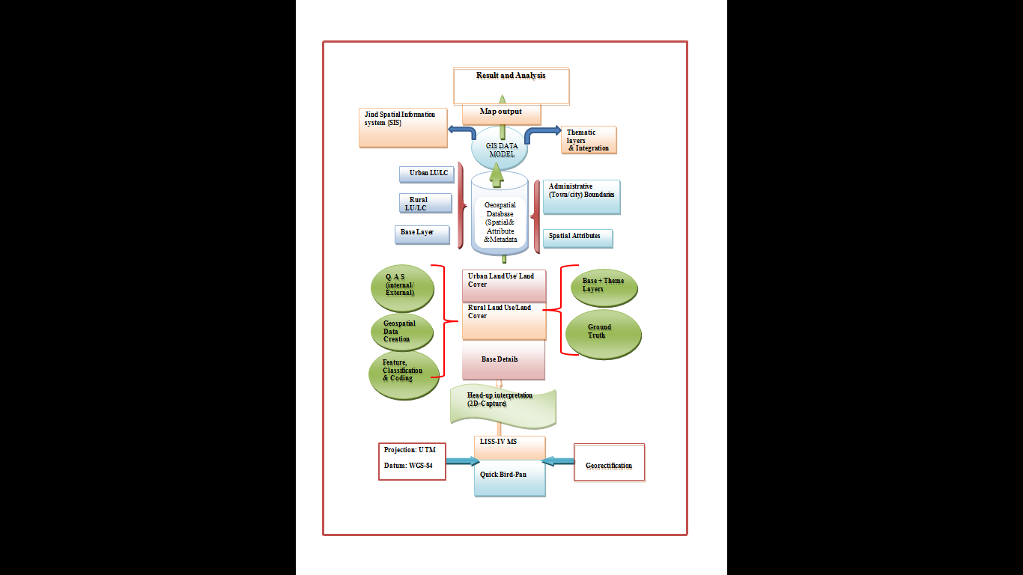
Fig. 2: Methodology of Thematic Mapping

3. Results
At the moment, India is among the countries of low level of urbanization. Number of urban agglomeration /town has grown from 1827 in 1901 to 5161 in 2001. Number of population residing in urban areas has increased from 2.58 crores in 1901 to 28.53 crores in 2001. Only 27.78% of population was living in urban areas as per 2001 census.. Thus, we are likely to face a scenario where a large number of people would have live in compact geographical areas. In 1991, India had 23 million plus cities and a decade later in 2001; this number has increased to 31.6 according to census of India 2011.The current scenario of urban population density 382 persons/ Km2in India.

3.1 Land Use/Land Cover
The present study “Urban Planning of Jind City, Haryana, Through Geo-Informatics”, clearly demonstrates the importance and role of GIS based information system and potentialities of satellite remote sensing technique for preparation of more updated and reliable information. The features of the first level as depicted in the LU/LC Classification Schema in Table 2 and Figure 3 [Kumar et al., 2013]. It includes the features of built-up urban, built-up rural, agriculture land, forest, wasteland, water bodies, transportation and other poly features.The study area, e.g. Jind city and its environ, covers a total area of 9365.80 hectares.

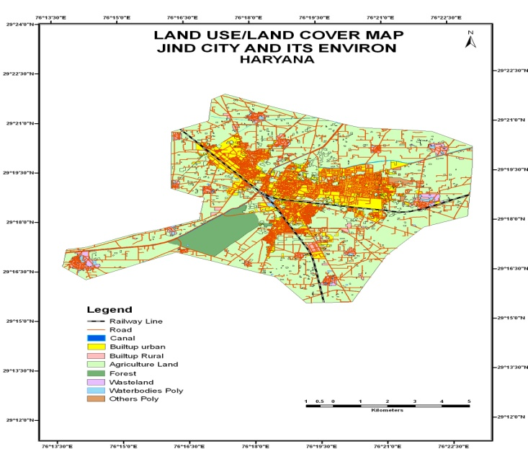

Fig 3: Land Use/Land Cover Map

It is dominated by the agriculture land that covers its 71.31%. Other features, e.g. built-up urban, forest, built-up rural, water bodies, waste land, other poly features and transportation cover 17.48, 4.75, 3.54, 1.17, 0.86, 0.50 and 0.39 percent of the total study area.(Table:3).

Table 2: Area of LU/LC of Jind City & its Environ
S.N. | LU/LC | Area in ha | Area in %
1 | Agriculture Land | 6678.82 | 71.31
2 | Built-up Urban | 1637.28 | 17.48
3 | Forest | 445.01 | 4.75
4 | Built-up Rural | 332.00 | 3.54
5 | Water Bodies | 109.31 | 1.17
6 | Waste Land | 80.43 | 0.86
7 | Other Features | 46.58 | 0.50
8 | Transportation | 36.38 | 0.39
 | Total | 9365.80 | 100.00

3.2 Surface Water Bodies
It comprises areas with surface water, either impounded or in the form of lakes/ponds, tanks/reservoirs or cooling ponds and abandoned quarries with water. There are clearly identified and delineated on the satellite image based on size and shape characteristics. Rivers/streams are natural course of a drainage network of a catchment or river basins. Pond is accumulation of water in a topographical Depression or low lands and are generally small in size with or without water. They are identified by their size and geometry on the image. In Jind city there is an important lake surrounding the Rani Talab. The village ponds cover an area of 0.75% of the study area (0.69% of filled ponds and 0.06% of the dry ponds). Canals are man-made channels constructed mainly for the purpose of irrigation, navigation or to drain out excess water from agricultural lands. There is one main canal named Hansi Branch (Western Yamuna Canal) and some branch canals in Table 3.

Table 3: Area of Water Body & Drainage System
S.N. | Water Body | Area in ha |  | Area in %
1 | Lakes/Ponds |  | 70.30 |  | 0.75
2 | Main canal |  | 27.00 |  | 0.29
3 | Branch Canals |  | 12.00 |  | 0.13
 | Total |  | 109.30 |  | 1.17

3.3 Agricultural Land
In Jind study area, the total agricultural land comprises 71.31%of total area. There is no grazing and saline land. It is a land over which the crop is grown of 66.8% of the study area. The predominant crops grown are wheat, rice, cotton, bajra, sugarcane; fodder etc. The land which is left uncultivated for one to three years is called the fallow land. In the study area fallow land comprises 2.14% in Table 4.

Table 4: Area of Agriculture Land
S.N. | Ag. Land | Area in ha | Area in %
1 | Crop Land | 6251.09 | 93.60
2 | Ag. plantation | 203.91 | 3.05
3 | Fallow Land | 142.9 | 2.14
4 | Land without Scrubs | 80.9 | 1.21
 | Total | 6678.8 | 100

3.4 Forest
There is a Birbaraban that is declared as a reserved forest, covers an area of 4.75% of the study area. Apart from it there is absence of forest cover in the study area, in spite of some patches of tree plantation. Unreserved forests cover an area of 0.45% of the total area. The total coverage of the forests area is 5.20% in Table 5.

Built-Up Rural:
The built-up rural class alone constitutes 4.04% of total area of the study area. In this category four feature classes are included, e.g. settlement, public & Semi-Public, brick Kilns and vacant land that cover 2.27%, 0.98%, 0.50% and 0.29% respectively in Table 6.

Table 5: Forest covers area
S.N. | Forest Cover | Area in ha | Area in %
1 | Reserved | 445.01 | 4.75
2 | Unreserved | 41.96 | 0.45
 | Total | 486.97 | 5.20

Table 6: Distribution of Built up Area
S.N. | Built up Area | Area in ha | Area in %
1 | Residential | 213.00 | 2.27
2 | Public | 92.00 | 0.98
3 | Brick Kilns | 46.58 | 0.50
4 | Vacant Land | 27.00 | 0.29
 | Total | 378.58 | 4.04

3.5 Urban Land use and Infrastructure Mapping
The urban land use classification can be delineated from Quick Bird and LISS-IV MS data up to Level-IV on 1:10,000 scales. The classes as mentioned in the classification may or may not reflect in Jind town/city and vice-versa is shown in Table 7. Similarly all land use classes observed in a Jind town/city might not have been incorporated in the classification schema. The urban land use classification at 1:10,000 scale is designed with classes hierarchically arranged with increasing informing content as the levels increase from Level I to Level-III .The classification also consists of certain land cover classes up to Level II designed to accommodate the rural classes noticed within the urban administrative limits in Figure 4.

Table 7: Area of Urban Infrastructure
S.N. | Urban Infrastructure | Area in ha | Area in %
1 | Residential Area | 707.25 | 7.55
2 | Public Area | 237.34 | 2.53
3 | Plotted Area | 206.03 | 2.2
4 | Industrial Area | 185.03 | 1.98
5 | Commercial Area | 88.51 | 0.94
6 | Road | 29.38 | 0.31
7 | Recreational Land | 28.66 | 0.31
8 | Railway station | 7.67 | 0.08
9 | Railway Line | 7 | 0.07
10 | Public Utilities | 5.08 | 0.05
11 | Bus Terminus | 3.67 | 0.04
12 | Truck Terminus | 1.02 | 0.01
 | Total | 1506.64 | 16.09

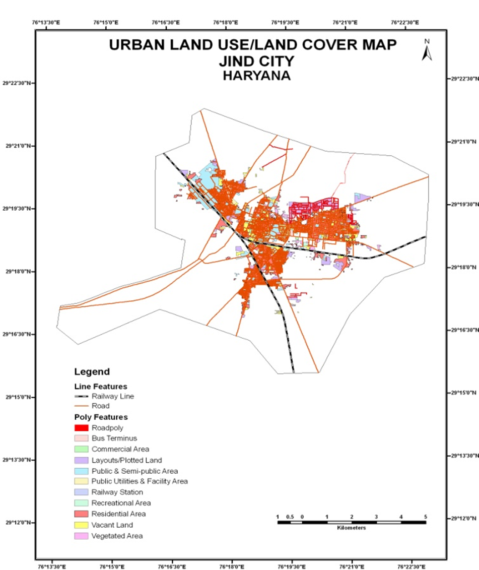

Fig. 4: Urban Land use/land Cover Map

This classification schema is indicative and flexible. Any new or additional classes delineated during the process of interpretation can be suffixed against the appropriate classes which would also enable to strengthen the classification schema in geodatabase structure in ArcGIS 9.2 Software. In the present study, the Thematic Mapping of Urban Land use is the main theme. All other thematic layers’ data is used in conjunction with the urban land use thematic data, while deciding on the future land management, suitability and allocation proposals for Jind town/city to meet the growing population needs or demands. Under NUIS, the urbanizable areas of each town are to be mapped for urban land use using high resolution satellite data. The urban utilities under the study area is very low which is total 0.05 % out of 17.86 % urban built-up rather than semi- public area 2.53 % of the study area. Other hand the current population of Jind 12% of Haryana and urban population 22.90% . Road analysis in an integrated social and economic approach to transportation. There were 155.13 km state highway, 51.96 km major district, and 699.01 km other district road in the Jind district in 2003-04 (India Disaster Resource Network, http://Idra.gov.in), while in 2010-11 the total length of National Highway 124 km, 995 km state highway of the Jind shown in Table 8 .

Table 8: Transportation Network area
S.N. | Transportation | Area in ha | Area in %
1 | Road | 29.38 | 0.31
2 | Railway station | 7.67 | 0.08
3 | Railway Line | 7.00 | 0.07
4 | Bus Terminus | 3.67 | 0.04
5 | Truck Terminus | 1.02 | 0.01
 | Total | 48.74 | 0.52

Built-up Urban:
The Built up Urban area alone covers 16.90% of total area of Jind AOI. It is an area of human habitation developed due to non-agricultural use and high density of population and which has a cover of buildings, connectivity by transport, communication and have utilities in association with water, vegetation and vacant lands in the selected urban area of Jind district.

4. Discussions
The study demonstrates the importance and potentiality of Satellite Remote Sensing technique for preparation of more consistent, accurate and up-to-date baseline information on urban land use for future planning, management and development of any area, The present study is derived on the basis of interpretation of Jind city with the help of satellite data- Quick Bird (Panchromatic) & IRS LISS-IV (Multispectral data). The study together with satellite data incorporated with ground truth data and secondary data.
The hypothesis referring that the growth of Jind urban area is relatively lower than the state growth is true. On the basis of the results and discussion, that has been derived on the basis of interpretation of satellite data at scale of 1:10000, incorporation of ground data & secondary data.
After the image interpretation and data analysis, we come to know that the growth of the Jind City and it’s environ is relatively lower than that of the state. Since the city surrounds an agricultural productive land so the expansion of the city urban area will be at the cost of that land. So care must be taken while it’s planning. There are some factors responsible for its low urban growth like Lack of industrial share in its economy; the city lacks the higher educational institutes, slow growth of other social urban infrastructure development.
Taking into consideration the above problems following recommendations can be done for the future development planning purpose like the agro-industry should be developed in the city so that the potentials of the city environ would be harnessed, some national and state level educational institutes should be set up there that can foster the economy of the city, public infrastructure, e.g. roads, flyovers, planned residential colonies, hotels, restaurants etc. should be developed with combined effort of the city municipality authority and the HUDA and in the city, the only available land that can be utilized for the purpose of the urban infrastructure development is the vacant land that covers an area of 125 hectares. So this available land must be used for the different required purposes.

Acknowledgements:
We are thankful to Haryana Space Application Centre, Hisar for the providing satellite image.

Corresponding Author:
Vinay Prasad Mandal
Project Directorate for Farming Systems Research, Modipuram, Meerut,India
E-mail: vinnumandal@gmail.com

Authors

Vinay Prasad Mandal received his M. A. in Geography and Advanced Diploma in Remote Sensing & GIS applications from Jamia Millia Islamia University, New Delhi, India. He is currently working as Research Associate in PDFSR, Modipuram, Meerut, UP, India.


Sham Shatrana received his M. A. in Geography from Punjab University and Advanced Diploma in Remote Sensing & GIS applications from Jamia Millia Islamia University, New Delhi, India. He is currently working as Filed Officer in Govt. of Punjab, India.


Dr N. Ravisankar Principal Scientist, (Agronomy). PDFSR, Modipuram, Meerut, His main area work included crop diversification, integrated farming systems for coastal and degraded lands and water resource creation and utilization for multiple uses.


Dr N. Subash Senior Scientist,(Agro-meteorology) PDFSR, Modipuram, Meerut. He is having number of research papers in NAAS rated national and international journals.


Sandeep Sharma received his M.sc.in Agriculture (Agronomy) from Bundelkhand University, JhansiIndia. He is currently working as Research Associate in Project Directorate for Farming System Research, Modipuram, Meerut, UP, India.

References
- Pandey PC, and Nathawat MS. Land Use/Land Cover Mapping Through Digital Image Processing of Satellite Data-A Case Study from Panchkula, Ambala & Yamunanagar District, Haryana, India. 2006.
- Chakraborthy D, Dutta D, and Chandrashekharan. Land Use Indicators of a Watershed in Arid Region, Western Rajasthan Using Remote Sensing and GIS. Jour. Ind. Soc. Remote Sensing 1998: 29(3):115-128.
- Khan MA, Gupta VP, and Moharana PC. Watershed prioritization of using remote sensing ad GIS: A case study from Guhiya, India. Journal of Arid Environments 2001; 49: 465-475.
- James R, Anderson Ernest, Hardy E, John T, and Richard E Witmer. A Land Use and Land Cover Classification System for Use with Remote Sensor Data. United States Govt. Printing Office, Washington, 1976.
- Holmberg SC. Geo-Informatics for Urban & Regional Planning: Environment, Planning & Design. 1994; 21(1): 5-19.
- Taubenböcka H, Wegmannb M, Rotha A, Mehla H, and Decha S. Urbanization in India – Spatiotemporal analysis using remote sensing data, 2008..
- Amitabh Kundu. A Handbook of Urbanization in India, Oxford N University Press, Washington, 2005.
- Rani M, Kumar P, Yadav M, Hooda R. Wetland Assessment and Monitoring Using Image Processing Techniques: A Case Study of Ranchi, India. Journal of Geographic Information System 2011; 3(4): 345-350.
- Kumar P, Sharma LK, Pandey PC, Sinha S and Nathawat MS. Geospatial strategy for tropical forest-wildlife reserve biomass estimation. IEEE J. Sel. Topics Appl. Earth Observat. Remote Sens. 2013; 6(2):917-923.
- Rani M, Kumar P, Yadav M, and Hooda R S. Wetland assessment and monitoring using image processing technique: A case study of Ranchi, India. J. Geograph. Inf. Syst. 2011; 3(4): 345-350.
- Kumar P, Singh BK, and Rani M. An efficient hybrid classification approach for land use/land cover analysis in semi-desert area using ETM+ and LISS-III sensor. IEEE Sensors J. 2013; 13:2161-2165.
- Kumar P, Kumar D, Mandal VP, Pandey PC, Rani M, and Tomar V. Settlement risk zone recognition using high resolution satellite data in Jharia Coal Field. Life Sci. J. 2012; 9(1s):1-6.
- Tomar V, Kumar P, Rani M, Gupta G, and Singh J. A satellite-based biodiversity dynamics capability in tropical forest. Electron. J. Geotech. Eng. 2013; 18 F: 1171 -1180.
- Poonam Bisht, Pavan Kumar, Manoj Yadav, Ravat JS, Sharma MP, and Hooda RS. Spatial Dynamics for Relative Contribution of Cropping Pattern Analysis on Environment by Integrating Remote Sensing and GIS. International Journal of Plant Production 2011; 8(1):1-17.
- Meenu Rani, Pavan Kumar, Manoj Yadav, and Hooda RS. Role of Geospatial Techniques in Forest Resource Management of Sariska Tiger Reserve (Rajasthan), India. New York Science Journal 2011; 4(6): 77-82.
- Kumar Pavan, and Tomar Vandana. Monitoring of Traffic and its Impact on Environment Using Geospatial Technology. Journal of Ecosystem Ecography 2013 3(1): 123.
- Kumar Pavan, Rani Meenu, Pandey PC, Arnab Majumdar, and Nathawat MS. Monitoring of Deforestation and Forest Degradation Using Remote Sensing and GIS: A Case Study of Ranchi in Jharkhand (India). Report and Opinion 2010; 2(4):14-20.

5/22/2022

