Indirect Assessment of Student Learning in a Software Testing Course

Abdulhameed Alelaiwi

Department of Software Engineering, College of Computer & Information Sciences, King Saud University, P.O. Box 51178, Riyadh 11543, Kingdom of Saudi Arabia
aalelaiwi@ksu.edu.sa

Abstract: The assessment of student learning is always an important task for educational institutions, and several techniques and methods have been developed for this purpose. Assessment results lead institutions to change their curricula and teaching methods to make it easier for students to acquire appropriate knowledge and complete their required programs successfully. Student feedback is an important type of indirect assessment. This paper discusses a case study where indirect assessment, that is, feedback from students, was used during a course in software testing. The Accreditation Board for Engineering and Technology methodology was used for the indirect assessment. This paper shows students’ feedback about the course and analyzes the data to determine students’ assessment of the course. We compare Student Outcomes with Course Outcomes that are derived from the ABET standards.
[Abdulhameed Alelaiwi. Indirect Assessment of Student Learning in a Software Testing Course. Researcher 2022;14(5):45-53] ISSN 1553-9865 (print); ISSN 2163-8950 (online) http://www.sciencepub.net/researcher. 7.
doi:10.7537/marsrsj140522.07.

Key Words: Student Outcomes (SOs), Course Outcomes (COs), ABET, Indirect Assessment.

1. Introduction
Educational institutions are always seeking to improve their reputations by providing the best education to their students. As such, it is most important for them to hire the best faculty in their fields as well to design curricula as per industry requirements. Creating and updating their curricula requires assessing students’ learning with quizzes, assignments, presentations, and projects. If the assessment reveals that changes in the curricula are necessary, then it is important to review the contents of the curricula with the help of expert faculty in the institutions. On the other hand, if the assessment reveals positive results for the curricula, then the teaching methods and techniques should be modified.
Assessment of students’ learning can be categorized as direct or indirect (Allen, 2008). Direct assessment is based on the point of view of faculty members and is conducted via quizzes, assignments, presentations, and projects. Indirect assessment is based on the point of view of students and what they learned during the course. Both types of assessments are based on students’ learning outcomes that are defined for a specific course. It is important for institutions to continually improve in order to maintain their good reputations and their standards of education (Merhout & Benamati, 2008). This includes the establishment of Student Outcomes (SOs), assignments to achieve these SOs, and the use of both direct and indirect assessment.
Students’ learning must be assessed in terms of SOs and continuous improvements must be made in programs. This paper considers a course called “Software Testing and Validation” as a case study. We use indirect assessment methods to evaluate SOs and Course Outcomes (COs). A comparison of indirect assessment methods will also be presented in terms of average score for each SO and percentage of students achieving the satisfactory or exemplary levels for each SO.

2. Material and Methods
Many techniques and methods have been used previously to evaluate the assessment of students’ learning in institutions. Previous researchers have identified and presented different assessment methods and techniques. This section discusses some of that work.
argued that when assessing a group of students, it is important to know the contribution of each student in the group. Peer assessment can be useful to encourage students’ individual efforts. However, peer assessment should be fair and confidential. If some students or a single student did not fully contribute, then some points should be deducted or the grade should be lowered. As an experiment, the authors applied a peer assessment model to a group of students. They found that only 5% of students were affected after the peer assessment. Moreover, results showed that this method encouraged students to participate in the group and perform their parts fully. Their findings showed that students were encouraged and supported by peer assessment during group work.
Another interesting study on peer assessment was conducted by . This study examined students’ behavior concerning receiving grades and the importance of peer assessment for their learning. Davey used different types of materials and methods such as the students and their course, the assignments and solutions, the Student Evaluation of Learning & Teaching (SELT), and participation. Ideal answers for the quizzes and assignments provided more successful peer assessment. Lecturers involved in this study gave fewer grades than assessors (persons involved in evaluating the peer assessment) and lecturers were stricter in grading than assessors. Overall, the study showed that peer assessment was encouraged by the students and they also wanted to be assessed in other courses as well.
As assessment is always important in any type of education, self-assessment also plays a key role for students to improve their skills and acquire more knowledge in their field. conducted a meta-analysis of the previous research on self-assessment. He examined 35 published articles that dealt with the topic of self-assessment. He identified the types of self-assessment that were presented in these studies, the characteristics that influenced self-assessment accuracy, and the theoretical approaches used to measure the accuracy of self-assessment reports. His analysis showed that students are able to assess themselves effectively, and that overall students are overestimated in terms of communications. In terms of gender, female students underestimate their performance when compared to male students. Importantly, the ability to understand the over- and underestimation factor is not possible without calculating the direction of inaccuracy.
To assess the performance of the students in a practical way is not an easy process. There are different types of challenges and they all are associated with each other in different ways. categorize these challenges into three main types: understanding problems related to the behavior that is necessary for judging competency; the potential level of assessors; and the modification of student performance according to faculty members’ requirements. For the accurate evaluation of student performance, the use of the Creighton-Simulation Evaluation Instrument (C-SEI) was proposed. The authors suggested that experimental evaluation is the most effective way to assess students’ learning.

3. COs
It is important to describe COs for every course in order to promote learning during the class. These COs are not created by Accreditation Board for Engineering and Technology (ABET);rather, they are determined by the department council with the help of concerned faculty members. The ABET states that COs should be related to the general and specific SOs for the engineering courses. These COs should be designed in consultation with the SOs that are described by the ABET. In our example course, the following SOs are mentioned and also included on the syllabus.
- Understand the importance of software testing in the software development lifecycle. [SO ( l )]
- Understand and distinguish between different types of tests unit testing, integration testing, system testing, etc. [SO ( l )]
- Develop a test plan for a specific software project. [SO ( b )]
- Understand and use different techniques for software testing. [SO ( k )]
- Understand and apply functional testing. [SO ( l )]
- Understand and apply structural testing. [SO ( l )]
- Understand and apply mutation testing. [SO ( l )]
- Understand reliability assessment. [SO ( a )]
- Organize and manage the testing process. [SO ( o )]
- Use different techniques for software testing. [SO ( k )]
- Use software testing tools and international testing standards. [SO ( k )]
4. SOs
It is also important to design SOs that are related to the course syllabus and the ABET-provided SOs. Faculty members can choose SOs that are related to the COs. In our example course, the following SOs are described on the syllabus.
- SO (a): Ability to apply knowledge of mathematics, science, and engineering.
- SO (b): Ability to design and conduct experiments, as well as to analyze and interpret data.
- SO (k): Ability to use the techniques, skills, and modern engineering tools necessary for the engineering practice.
- SO (l): Ability to analyze, design, verify, validate, implement, apply, and maintain software systems.
- SO (o): Ability to manage the development of software systems.
The following table shows the relationship between the COs and SOs for this course.

Table 1. Relationship between COs and SOs

 | SO (a) | SO (b) | SO (k) | SO (l) | SO (o)
CO (1) |  |  |  | √
CO (2) |  |  |  | √
CO (3) |  | √
CO (4) |  |  | √
CO (5) |  |  |  | √
CO (6) |  |  |  | √
CO (7) |  |  |  | √
CO (8) | √
CO (9) |  |  |  |  | √
CO (10) |  |  | √
CO (11) |  |  | √

5. Methodology
We used indirect assessment methods to evaluate students’ learning. Indirect assessment techniques ask the students themselves to evaluate their learning in the courses with the help of different surveys that cover the COs and SOs. We used two calculations to determine students’ assessment of the course:

- The average score achieved by students for each outcome covered by the course.
- The percentage (%) of students achieving the satisfactory or exemplary levels.

For the indirect assessment, five levels were defined:

- Strongly Agree (100%)
- Agree (80%)
- Neutral (60%)
- Disagree (40%)
- Strongly Disagree (20%)

For satisfaction, we defined four levels:

- Unsatisfactory: students whose scoreswere40% or below (Disagree + Strongly Disagree)
- Developing: students whose scoreswere60% (Neutral)
- Satisfactory: students whose scoreswere80% (Agree)
- Exemplary: students whose scores were100% (Strongly Agree)

For the judgment of outcomes, we defined the criteria shown in Table 2.

Table 2. Outcome evaluation criteria
Exceeds Expectations  (EE) | Meets Expectations  (ME) | Progressing Towards Expectations  (PE) | Does Not Meet Expectations  (DNME)
Above 80% | 70% - 80% | 60% - 70% | Below 60%
Continue the good work | Continue the good work | Attention is required to some elements | Immediate action is required to resolve issues

Our example course covers five SOs that are shown in Table 3.

Table 3. Student Outcomes
Outcome | Outcome Description | Contribution
(a) | Ability to apply knowledge of mathematics, science, and engineering. | M
(b) | Ability to design and conduct experiments, as well as to analyze and interpret data. | H
(k) | Ability to use the techniques, skills, and modern engineering tools necessary for the engineering practice. | M
(l) | Ability to analyze, design, verify, validate, implement, apply, and maintain software systems. | H
(o) | Ability to manage the development of software systems. | L

H = High
M = Medium
L = Low.

5.1 Example Survey
The following is an example of a survey that was distributed to the students in the course. They were asked to give their feedback. Almost all students participated, and this shows their interest in improving the course and what they learned during the semester.

Assessment of Course Learning Outcomes
At the end of this course, I am able to:
- Understand the importance of software testing in the software development lifecycle.
Strongly Agree AgreeNeutral  Disagree  Strongly Disagree
- Understand and distinguish between different types of tests including unit testing, integration testing, and system testing.
Strongly Agree AgreeNeutral  Disagree  Strongly Disagree
- Develop a test plan for a specific software project.
Strongly Agree AgreeNeutral  Disagree  Strongly Disagree
- Understand and use different techniques for software testing.
Strongly Agree AgreeNeutral  Disagree  Strongly Disagree
- Understand and apply functional testing.
Strongly Agree AgreeNeutral  Disagree  Strongly Disagree
- Understand and apply structural testing.
Strongly Agree AgreeNeutral  Disagree  Strongly Disagree
- Understand and apply mutation testing.
Strongly Agree AgreeNeutral  Disagree  Strongly Disagree
- Understand reliability assessment.
Strongly Agree AgreeNeutral  Disagree  Strongly Disagree
- Organize and manage the testing process.
Strongly Agree AgreeNeutral  Disagree  Strongly Disagree
- Use different techniques for software testing.
Strongly Agree AgreeNeutral  Disagree  Strongly Disagree
- Use software testing tools and international testing standards.
Strongly Agree AgreeNeutral  Disagree  Strongly Disagree

5.2 Attainment of COs through indirect assessment
After getting the surveys back from the students, we analyzed the data. A summary of the course learning outcomes is given below in Table 4.

Table 4. Indirect assessment results for each CO
 | Strongly Agree (5) | Agree (4) | Neutral (3) | Disagree (2) | Strongly Disagree (1) | Total | Average Score | % Students Achieving Satisfactory-Exemplary levels
CO 1 | 38% | 54% | 8% | 0% | 0% | 100% | 86.15% | 92.31%
CO 2 | 23% | 69% | 8% | 0% | 0% | 100% | 83.08% | 92.31%
CO 3 | 23% | 38% | 38% | 0% | 0% | 100% | 76.92% | 61.54%
CO 4 | 23% | 69% | 0% | 8% | 0% | 100% | 81.54% | 92.31%
CO 5 | 23% | 62% | 15% | 0% | 0% | 100% | 81.54% | 84.62%
CO 6 | 31% | 46% | 23% | 0% | 0% | 100% | 81.54% | 76.92%
CO 7 | 31% | 54% | 15% | 0% | 0% | 100% | 83.08% | 84.62%
CO 8 | 15% | 23% | 62% | 0% | 0% | 100% | 70.77% | 38.46%
CO 9 | 15% | 77% | 8% | 0% | 0% | 100% | 81.54% | 92.31%
CO10 | 23% | 54% | 23% | 0% | 0% | 100% | 80.00% | 76.92%
CO11 | 23% | 31% | 38% | 0% | 8% | 100% | 72.31% | 53.85%

The following figures present the results in a comparative style and identify the level of students’ understanding about the course. Figure 1 shows the average scores for each CO.

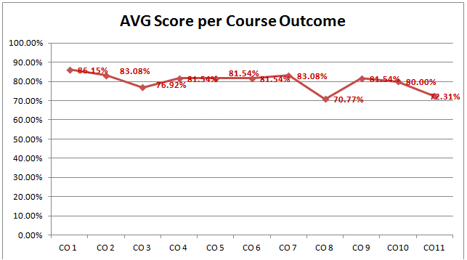

Figure 1. Average score for each CO

Figure 2 presents the indirect assessment results in terms of the percentage of students who achieved satisfactory or exemplary levels for each CO.

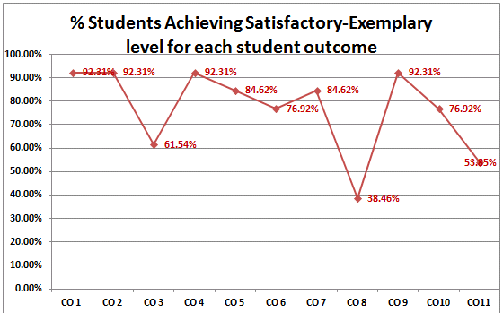

Figure 2. Satisfactory or exemplary levels for each CO

5.3 Attainment of SOs through indirect assessment
Table 5 shows the aggregated results for the Cos and SOs. The average score for each SO is used as well as the percentage of students achieving the satisfactory-exemplary levels.
Student Outcomes | Strongly Agree (5) | Agree (4) | Neutral (3) | Disagree (2) | Strongly Disagree (1) | Total | AVG Score | % Satisfactory-Exemplary levels
SO (a) | 15.38% | 23.08% | 61.54% | 0.00% | 0.00% | 100% | 70.77% | 38.46%
SO (b) | 23.08% | 38.46% | 38.46% | 0.00% | 0.00% | 100% | 76.92% | 61.54%
SO (k) | 23.08% | 51.28% | 20.51% | 2.56% | 2.56% | 100% | 77.95% | 74.36%
SO (l) | 29.23% | 56.92% | 13.85% | 0.00% | 0.00% | 100% | 83.08% | 86.15%
SO (o) | 15.38% | 76.92% | 7.69% | 0.00% | 0.00% | 100% | 81.54% | 92.31%
Table 5. Indirect assessment result for each SO

Figure 3 shows the average score achieved by students for each SO in the indirect assessment.
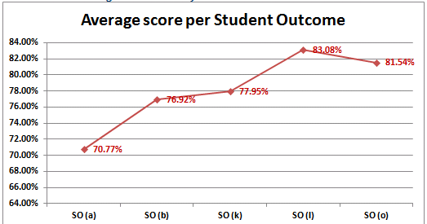

Figure 3. Average score for each SO

The final results of the average scores for each SO are shown in Table 6. Results showed that overall students achieved more than 70% for each SO. This result is based on indirect assessment and only covers the average score for each SO.

Table 6. Final results for average score for each SO
Student Outcomes | Outcome Importance | Final Result (based on indirect assessment)
SO (a) | M | ME (AVG score between 70% and 80%)
SO (b) | H | ME (AVG score between 70% and 80%)
SO (k) | M | ME (AVG score between 70% and 80%)
SO (l) | H | EE (AVG score above 80%)
SO (o) | L | EE (AVG score above 80%)

After measuring the average scores for achievement for each SO using indirect assessment, we also measured the percentage of students who achieved satisfactory or exemplary levels for each SO. Figure 4 shows the satisfactory and exemplary levels of students for each SO.
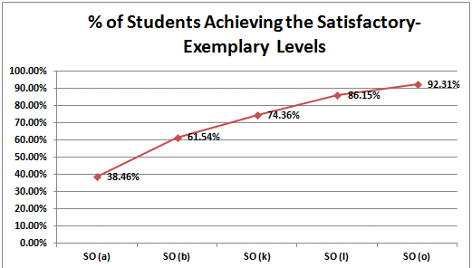

Figure 4. Achievement of the satisfactory and exemplary levels

Table 7 shows the final results of the percentage of students achieving satisfactory or exemplary levels for each SO. These results are based on indirect assessment and only cover the percentage of students who achieved satisfactory or exemplary levels for each SO.

Table 7. Final results of percentage of students achieving satisfactory or exemplary levels for each SO
Student Outcomes | Outcome Importance | Final Result (based on indirect assessment)
SO (a) | M | DNME (AVG score below 60%)
SO (b) | H | PE (AVG score between 60% and 70%)
SO (k) | M | ME (AVG score between 70% and 80%)
SO (l) | H | EE (AVG score above 80%)
SO (o) | L | EE (AVG score above 80%)

6. Results and Discussion
By evaluating the indirect assessment used in this study, we have found that overall students were satisfied in terms of the average feedback for each CO. Overall satisfaction levels for all the COs were on average more than 70%, and this is a positive result for the course. However, when compared with the percentage of students achieving the satisfactory or exemplary levels, overall students are satisfied with each CO and a few, such as CO8 and CO11,received less than 50%. This result shows that these COs need more attention from the faculty members in terms of reviewing the syllabus or changes in the methods and techniques for delivering their lectures to the students.
The feedback also shows that overall students were satisfied and understood the course material during the semester. On average, students were satisfied and their feedback results show a more than 70% satisfactory level for each SO. However, for the percentage of students achieving satisfactory or exemplary levels, the result for SO(a) is less than 40%.This finding suggests that some students were unsatisfied and more attention is required to improve the course delivery or change the curriculum. In the case of SO(b), the results are also less than 70%, but more than 60%.This finding is acceptable, but some attention is required.
During our case study, we found that students’ feedback (indirect assessment) helped improve the course as well as the department and institution. To improve surveys’ output and make them more effective, it is important to encourage the students to provide honest feedback. For this purpose, we used anonymous surveys so that students would feel free to provide their feedback. We recommend this method to be used for indirect assessment in order to obtain honest and helpful feedback.

7. Conclusion
The assessment of students’ learning remains a critical goal for institutions. Many methods and techniques have been developed for this purpose. This paper discussed the use of indirect assessment methods to obtain students’ feedback on their learning and the course delivery and material. Assessment of students’ learning plays an important role in designing curricula and evaluating the students’ ability to learn. Our work showed that with the help of indirect assessment methods, students can provide their feedback and institutions can use this information to improve their curricula. These assessment results may also be the impetus for additional training sessions for the faculty members. Our work will help institutions improve their services for students and also their reputations. Relating COs with SOs makes it easy for students to understand and helps the faculty members to see the effects of their lectures. The evaluation of the assessment in this study was based on the average scores for the SOs and Cos, and the satisfactory or exemplary levels for each SO and CO. These techniques revealed positive results that support decisions about changes in the curriculum and teaching methods.

Acknowledgements:
The authors extend their appreciation to the Deanship of Scientific Research at King Saud University, Riyadh, Saudi Arabia for funding this work through the research group project No RGP-VPP-318

Corresponding Author:
Dr. Abdulhameed Alelaiwi
Department of Software Engineering
College of Computer & Information Sciences, King Saud University E-mail: aalelaiwi@ksu.edu.sa

References
- Allen M J. Strategies for direct and indirect assessment of student learning, SACS-COC Summer Institute, Duke University. 2008.
- Blanch-Hartigan D. Medical students’ self-assessment of performance: Results from three meta-analyses. Patient Education and Counseling 2011;84(1):3-9.
- Davey K R. Student peer assessment: Research findings from a case study in a master of chemical engineering coursework-program. Education for Chemical Engineers 2011;6(4):e122-e131.
- Kench P L, Field N, et al. Peer assessment of individual contributions to a group project: Student perceptions. Radiography 2009;15(2): 158-165.
- Manz J A, Hercinger M, et al. Improving consistency of assessment of student performance during simulated experiences. Clinical Simulation in Nursing(0).
- Merhout J,Benamati J, et al. Implementing direct and indirect assessment in the MIS curriculum. Communications of the Association for Information Systems 2008;23(24):419.

5/22/2022

