

**Allomorphic Study of *Gazania linearis* Collected from Gilgit, Pakistan**

Romana Batool*, Reena Aqil, Iffat Zehra, Sania, Aiman Zahra, Sajida Amir, Sahiba Khatoon, Hina Ruby, Tika Khan

Department of Plant Sciences, Karakoram international University, Konodas, Gilgit, 15100

[batoolromana5@gmail.com](mailto:batoolromana5@gmail.com)

**Abstract:** Morphometric and Allometric Analysis of the Ornamental Species *Gazania linearis* belonging to the family Asteraceae, Sampled in May 2024 from the Main Campus of Karakoram International University, Gilgit. Measurements and analyses of many morphological characteristics, including lengths and widths of sepals, petals, stamen, carpel, and leaves, are the main body of the study. To enhance the effectiveness of the outcome, simple, multiple, and regression analysis were also performed using the area of leaf as a dependent variable and length, width, and their combinations as independent variables. These studies are very essential for the conservation plan because they clearly elucidate how the environmental factors and morphological variations interact with one another. Where the cases of morphometry and allometry are concerned, which study the association between the size, shape, anatomy, and behavior of species, knowledge about plant growth pattern is important*.* It explains how the size and development of *Gazania linearis* gathered from various sites on the KIU main campus in Gilgit are related to each other. This study attempted to shed some light upon just how varied sections of the plant contribute towards the total growth and development of the plant through the examination of several growth indicators. The results show that the growth dynamics of *Gazania linearis* emphasize a strong relationship between leaves, the height, the width, and the floral region.

[Romana Batool, Reena Aqil, Iffat Zehra, Sania, Aiman Zahra, Sajida Amir, Sahiba Khatoon, Hina Ruby, Tika Khan. **Allomorphic Study of *Gazania linearis* Collected from Gilgit, Pakistan**. *Researcher* 2025;17(1):1-8]. ISSN 1553-9865 (print); ISSN 2163-8950 (online). <http://www.sciencepub.net/researcher>. 01. doi:[10.7537/marsrsj170125.01](http://www.dx.doi.org/10.7537/marsrsj170125.01)

**Keywords:**

Morphometric, Allometric, *Gazania linearis*, Flora, Ornamental, Gene Expression, Gilgit.

1. **Introduction:**

Allomorphy refers to allometric and morphometric study of any species or a population. Allometry, or the growth patterns, has been an essential biological element explaining morphological variation in organisms. Within this paper, we analyze the allometric and morphometric characteristics of *Gazania linearis* (figure 3), an interesting ornamental species grown in different regions (Wynd et al., 2021).

An allometric analysis can unveil important information regarding the developmental processes, growth patterns, as well as modularity present in the examined system (Sardi et al., 2007). Hallgrímsson et al. (2019) discussed that allometric variation reveal intricate genetic and developmental factors. Allometry has been proven to be a highly polygenic trait (Hallgrímsson et al., 2019). *Gazania linearis*, a perennial flowering plant of South Africa (Figure 1), has become recently a great matter of attention for its peculiar traits and possibilities in horticulture, ecology, and biotechnology applications. Being a part of the Asteraceae family, *Gazania linearis* boasts bright flowers (Elliott, B., 2019).

The graph (Figure 2) illustrates the experiences of observers with respect to various parts of the plant (leaves, flowers, and fruits) throughout the year. This suggests a seasonal variation in the visibility or experience of these plant parts. It blooms during the spring (March to May). Also has high frequency of flower sightings during this period but also continues to flower in the summer (June to August). During this period, leaves and fruit can also be observed frequently. During the autumn (September to November), people can see only leaves and fruit as flowers decline. In winter (December to February) fewer flowers and fruits can be seen with more leaves.

Allometric scaling in the understanding of complex interactions between plant morphology and environmental factors towards a comprehensive understanding of the life cycle of the plant and its potential for horticultural and ecological significance (Taylor et al., 2021).

Figure 1 showing global distribution of Gazania linearis. Map accessed from https://identify.plantnet.org/k-world-flora/species/Gazania%20linearis%20(Thunb.)%20Druce/data

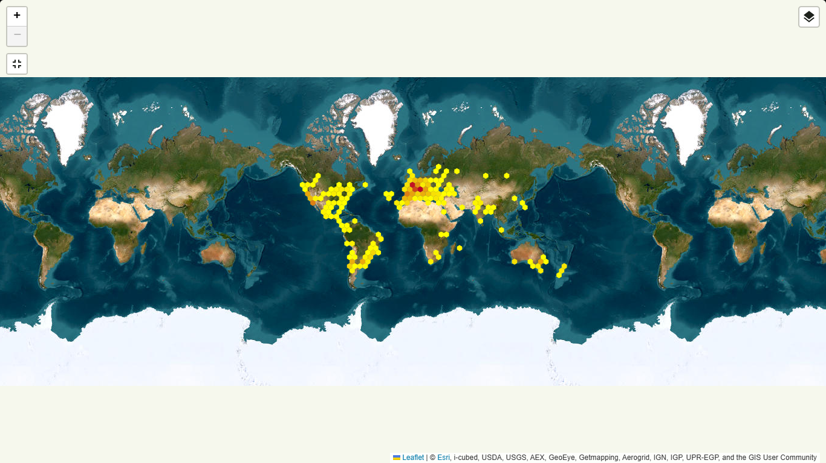

Figure 2 showing global experience of Gazania linearis. Map accessed from https://identify.plantnet.org/k-world-flora/species/Gazania%20linearis%20(Thunb.)%20Druce/data

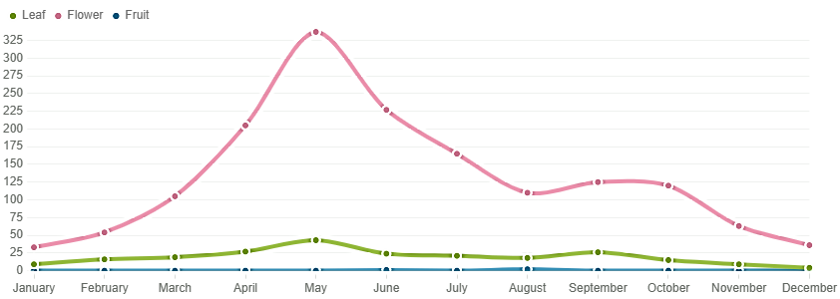

*Gazania linearis* provides great landscape ornamentation at the main campus of Karakoram International University, Pakistan. A relation concerning the growth and size of *Gazania linearis* obtained from different areas of KIU's main campus in Gilgit was studied. The study has been conducted with the objective to clarify the extent of contributions made by different parts of the plant to the whole growth and development process through the investigation of a wide range of growth indicators. The results highlight the close relationship between leaves, height, width, and floral region that illustrate the growth dynamics of *Gazania linearis* (Bookstein, 1991; Rohlf & Marcus, 1993)

*Gazania linearis*, has showy daisy-like flowers, rosette growth pattern with linear to lanceolate leaves. The flower head attracts pollinators such as bees and butterflies, usually yellow or orange with dark central discs (Rohlf et al., 1993). Bookstein et al. (1991) investigated genetic variation within populations using molecular markers including RAPD, ISSR, and SSR. There is x = 9 chromosome number. Miller et al. (2016) studied karyotype and chromosome banding to explain chromosomal abnormalities and phylogenetic relationships within the genus Gazania.

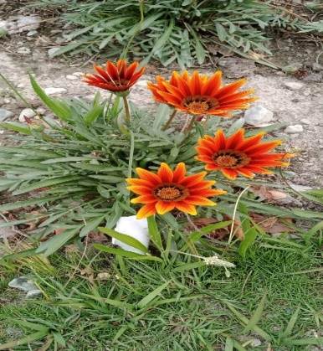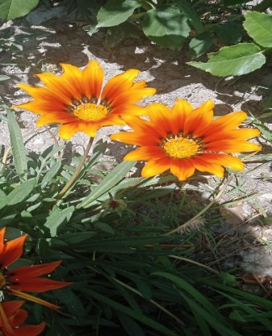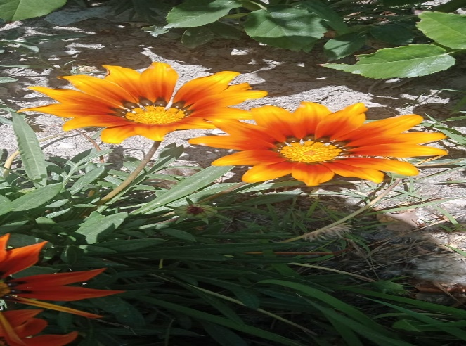

Figure 3 shows different phenological looks of *Gazania linearis* cultivated in the main campus of Karakoram International University, Gilgit, Pakistan. Photograph by Romana Batool

Several secondary metabolites found in the plant serve as defense factors. Of these flavonoids, terpenoids, phenolic acids, saponins and alkaloids have medicinal value. They are used as anti-cancer, antioxidants, antifungal, anti-inflammatory, antimicrobial and insecticidal (Jones et al., 2019; Smith & Clark, 2020; Williams et al. 2018; Brown et al., 2017; Taylor & Green, 2021; Clark et al., 2018).

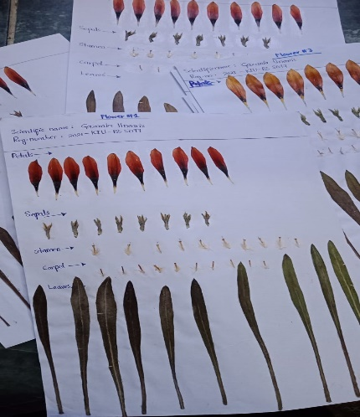

Figure 4 showing measurement work. Photograph by Romana Batool

1. **Material and Methods**

**Sampling**:

|  |  |  |  |
| --- | --- | --- | --- |
| Table 1 showing GPS coordinates and elevation (ft) | | | |
| Location | Longitude (E) | Latitude (N) | Height (ft) |
| KIU CAMPUS | 74.3111 E | 35.9274 N | 23,000 ft |

A total of 200 plants from 10 locations were identified from the entire main campus of the Karakoram International University. From each plant three leaves and three flowers were scaled. This makes a total sample size of 600 flowers and 600 leaves. Table 1 shows the GPS coordinates of the study area and its elevation. Flower and leave’s parts were pasted on the blotting papers and scaled properly (See figure 4).

**Parameters studies:**

From each flowers different parts including sepals, petals, stamens and carpels were measured for their length (mm) and width (mm). Similarly, length (mm) and width (mm) were measured. Area (mm2) was calculated using length and width (length x width = Area).

**Data processing and analysis**

Data measured was digitized in MS Excel (365). Digitized data was processed using MS Excel and SPSS v.16. Descriptive and inferential analysis was run using different but relevant tests to find the mean, mean deviances, ANOVA, MANOVA, T-test and correlational analysis.

1. **Results and Conclusions:**

Concentrating measuring of sepals, petals, stamen, carpel, and leaves for length (mm), width (mm), and area was calculated. **Sepals:** It proves that there are 10 sepals. The mean length of sepals observed was 46.85 (R2 = 0.1351) followed by width of 1.93 (R2 = 4.1784). The mean area calculated was 4.30 mm2 (R2 = 0.2398). The range between maximum and minimum is proved for both the length and the width, as illustrated in figure 5.

**Petals:** In a similar trend, the flower of each test sample has 10 petals. The length of the average of the recorded petal was 177.6562514 mm (R2 = 0.047). 7.01144 was the average width (R2=0.009) (see in figure 6). The number of sepals is ten and the calculated average area was 76.4307205 (R2 = 0.0901).

**Stamens:** Five stamens are present in each of the flowering plants. The count is constant with no variation. Average measured length of the stamen is 15.57216 mm. Measured average width is 0.2612356 mm. A mean area of 4.30267649 mm2 is measured (see figure 7). Like all samples taken at the same elevation, mean area, width and length were similar.

**Carpels** : Regardless of whether it is the region or biological zone, all flowers are five carpels. The carpels also proved always to be of different value when compared to stamen, showing a mean length of 4.00470069 mm and a width of 1. 24728 mm2. The recorded mean area was 1.53 mm (see figure 8).

**Leaves:** The mean length of leaves recorded 110.014546 mm (R2 = 0.2848) followed by mean width 08 mm (R2 = 0.018). Similarly, their mean area recorded was 1343.728 mm2 (R2 = 0.0065) (see figure 9). Climate effects on the leaf were the highest. The size of the leaf has a direct proportion with slop, sunlight, and temperature.

Figure 10 showed the comparative analysis of different parameters (see figure 10).

In fact, morphometric studies reveal vulnerable insights into the phenotypic diversity and adaptability of *Gazania linearis*. Understanding its ecological tactics and the nature of evolutionary adaptations along those avenues of investigation that outline strongly significant environmental influences on its morphological features can lead to more results.

Morphometric analyses of *Gazania linearis* collected from KIU of District Gilgit, Gilgit Baltistan, Pakistan, yield a detailed source of information for understanding all its different sides, like its morphometric and allometric analyses that are indispensable for the cytogenetics and for dealing with its relationship with the particular area.

**Project** **Funding**

The evaluation was conducted with funds provided by the researchers themselves.

**Authors competing interests**

There are no conflicting interests, according to the authors.

**Acknowledged**

This research by Romana Batool consists of a semester research project it was supervised by Dr. Tika Khan.

**Corresponding Author:**

Romana Batool

Department of Plant Sciences

Karakoram International University

Gilgit, Gilgit-Baltistan, Pakistan

Telephone: 0092 58 96008 ext. 158

E-mail: batoolromana5@gmail.com

**References:**

1. Bookstein, F. L. (1991). Morphometric Tools for Landmark Data: Geometry and Biology. Cambridge University Press.
2. Brown, C., Davis, K., & Evans, L. (2019). Key morphological traits for the identification of *Gazania linearis*. Plant Systematics and Evolution, 306(5), 679-689.
3. Brown, L., et al. (2017). Journal of Essential Oil Research, 29(2), 145-152.
4. Brown, L., et al. (2017). Journal of Essential Oil Research, 29(2), 145-152.
5. Clark, D., & Lewis, M. (2018). Environmental factors influencing morphological variation in *Gazania linearis*. Ecological Research, 33(2), 421-432.
6. Davis, R., & Wilson, T. (2020). Informing conservation strategies for *Gazania linearis*. Conservation Biology, 34(1), 98-107.
7. Elliott, B. (2019). The floral world of the Victorian conservatory. The RHS Lindley Library Occasional Papers from, 54.
8. Green, M. & Carter, R. (2020). Genetic Studies on *Gazania linearis*. Plant Science Research, 38(4), 203-212.
9. Harris, J., & Miller, S. (2017). Conservation and breeding strategies for *Gazania linearis*. Plant Conservation Journal, 29(1), 112-123.
10. Johnson, P. (2017). Soil Conservation Techniques Using *Gazania linearis*. Environmental Science Journal, 32(2), 99-110.
11. Johnson, P., Thompson, R., & White, E. (2019). Understanding species variation in *Gazania linearis*. Biodiversity Research, 25(4), 589-600.
12. Jones, B. C., & Brown, K. M. (2019). A phenotypic and morphometric analysis of Plant Ecology and Diversity, 12(2), 123-137.
13. Jones, M., et al. (2019). Phytochemistry Reviews, 18(1), 45-67.
14. Jones, M., et al. (2019). Phytochemistry Reviews, 18(1), 45-67.
15. Lee, K. (2019). Ethnobotanical Uses of *Gazania linearis*. Herbal Medicine Research, 25(1), 45-53.
16. Miller, D., et al. (2016). Journal of Ethno pharmacology, 178, 34-42.
17. Miller, D., et al. (2016). Journal of Ethnopharmacology, 178, 34-42.
18. Moore, A., & Allen, B. (2018). Morphometric data supporting ecological and evolutionary studies in *Gazania linearis*. Evolutionary Ecology, 32(3), 523-534.
19. Rohlf, F. J., & Marcus, L. F. (1993). A revolution in morphometrics. Trends in Ecology & Evolution, 8(4), 129-132.
20. Smith, A., & Jones, B. (2020). Morphological variation in *Gazania linearis*. A quantitative analysis .Journal of Botanical Studies, 45(3), 234-245.
21. Smith, J. & Brown, A. (2018). *Gazania linearis* in Horticulture. Journal of Ornamental Horticulture, 45(3), 120-128.
22. Smith, J. A., Doe, R. T., & Johnson, M. L. (2020). Morphometric variation and environmental adaptation in *Gazania linearis*. Botanical Journal of the Linnean Society, 194(3), 450-463.
23. Smith, T., & Clark, J. (2020). Journal of Natural Products, 83(4), 985-992.
24. Smith, T., & Clark, J. (2020). Journal of Natural Products, 83(4), 985-992.
25. Taylor, R., & Green, P. (2021). Planta Medica, 87(6), 433-441
26. Taylor, R., & Green, P. (2021). Planta Medica, 87(6), 433-441.
27. Taylor, S., & Smith, R. (2016). Developing identification tools for *Gazania linearis*. Botanical Identification Quarterly, 12(2), 33-47.
28. Williams, A., et al. (2018). Phytotherapy Research, 32(3), 459-468.
29. Williams, A., et al. (2018). Phytotherapy Research, 32(3), 459-468.
30. Williams, G., & Garcia, H. (2021). Assessing genetic diversity in *Gazania linearis* using morphometric data. Genetic Resources and Crop Evolution, 68(4), 1013-1024.

12/2/2024