

**High-Altitude Allomorphic Adaptations of Codonopsis clematidea in Gilgit-Baltistan**

Sania, Ghazala Shaheen, Imrana Wali, Hina Ruby, Midhat Fatima, Mahnoor Fatima, Tika Khan

Department of Plant Sciences, Karakoram International University, Konodas Gilgit, 15100

[saniaraziq44@gmail.com](mailto:saniaraziq44@gmail.com)

**Abstract:** This study examines the morphometric and allometric characteristics of *Codonopsis clematidea*, a medicinal and ecologically important plant that grows in high-altitude regions. Specimens were collected from ten locations in the Bagrot Valley, Gilgit-Baltistan, to assess morphological variations in response to environmental factors. Measurements of sepals, petals, stamens, carpels, and leaves showed that sepals, stamens, and carpels had very little variation, which means there is strong genetic control. The widths and areas of petals indicated slight variation, while those of leaves revealed a moderate sensitivity to altitude, temperature, and sunlight, thereby hinting that environmental factors determine their sizes. Mean petal area was 173.0 mm², R²=0.23, while leaf area 190.9 mm², R²=0.0078, signifying that they have had stable growth conditions for all. These findings illustrate the genetic stability of floral forms and their limited response to environmental gradients. This work explains some ecological adaptations of *C. clematidea* and contributes to understanding plant responses in high-altitude ecosystems. Moreover, floral features can be considered reliable for classification and leaves does not show higher levels of reliability.

[Sania, Ghazala Shaheen, Imrana Wali, Hina Ruby, Midhat Fatima, Mahnoor Fatima, Tika Khan. **High-Altitude Allomorphic Adaptations of Codonopsis clematidea in Gilgit-Baltistan**. *Researcher* 2025;17(5):1-6]. ISSN 1553-9865 (print); ISSN 2163-8950 (online). <http://www.sciencepub.net/researcher>. 01. doi:[10.7537/marsrsj170525.01](http://www.dx.doi.org/10.7537/marsrsj170525.01)

Keywords: *Codonopsis clematidea;* morphometry; allometry; high-altitude adaptation; Bagrot Valley

1. **Introduction**

***Codonopsis clematidea* is a perennial plant belonging to Campanulaceae. It is an important ecological and medicinal species (**Yue et al., 2024)**. The deciduous species is native to China. It is distributed across Central Asia, Iran, Afghanistan, Himalayas in Pakistan and India. It bears pale blue; bell-shaped flowers having detailed internal markings and rich moist well-drained soil and sun to semi-shaded conditions (eFlora Pakistan, 2024). Although important, detailed morphometric and allometric studies on *C. clematidea* are lacking. This research study focuses on characterizing the morphological traits and their ecological implications across populations from the Bagrot Valley in Gilgit-Baltistan.**

**Traditionally, local communities have utilized its roots and leaves for treating various ailments, including fatigue and digestive issues (Bhardwaj et al., 2020; Yue et al., 2023). This deciduous, twining species is recognized for its solitary, bell-shaped, pale blue flowers with intricate internal markings and its adaptability to high-altitude environments (Nasir, 1824).**

**In Korea and China, the roots of *C. pilosula*, a related species, are an integral part of *Codonopsis radix* in traditional medicine, used to enhance respiration and energy (Yue et al., 2023). *C. clematidea*, are utilized in the Korean Pharmacopeia and are used in the management of diseases like fatigue, dyspepsia, and breathing problems (Yue et al., 2023). Similarly, *C. clematidea* has been used as a traditional medicine in trans-Himalayan regions for conditions like fever, inflammation, and digestive disorders (Bhardwaj et al., 2020). Bioactive compounds present in the plant include flavonoids, saponins, and alkaloids, and it has antioxidant, antibacterial, and anti-inflammatory activities (He et al., 2015). The pharmacological properties suggest the possibility of *C. clematidea* to add new therapeutic agents to the world of modern medicine.**

**Other than the medicinal values, *Codonopsis clematidea* also has commercial value. Its roots are often called "poor man's ginseng" because of their adaptogenic properties and demand in traditional herbal markets (He et al., 2015). Due to its unique floral morphology, it is also a popular ornamental species with a potential for cultivation in alpine gardens. Increased interest in natural products and traditional medicine has spurred additional interest in the study of Codonopsis species and creates an economic opportunity for the high-altitude regions such as Gilgit-Baltistan.**

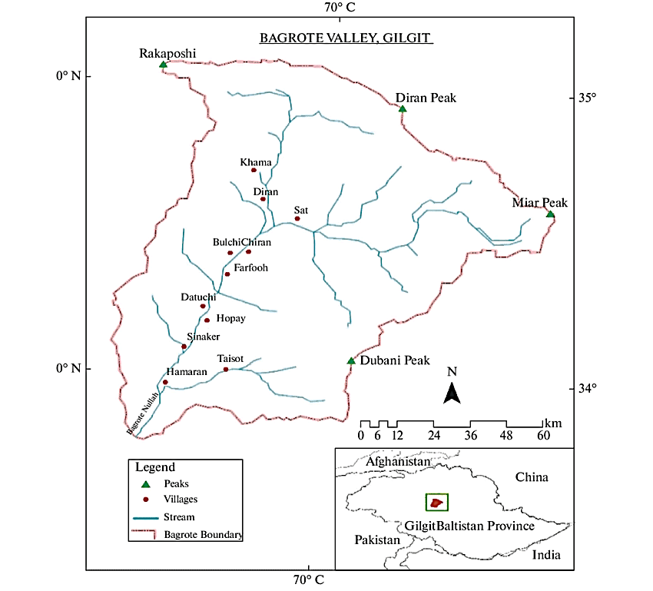

Figure 1: Map of Bagrot valley (study and sampling area)

**The genus Codonopsis is diploid (2n = 16), and its members are appreciated for their ecological adaptability and unique morphological features, such as heart-shaped leaves and striking blue flowers. It grows at such mountainous climate conditions showing extraordinary adaptability and that makes it an important model to understand plant responses under extreme environments (He et al., 2015). Allomorphic characters can describe adaptive strategies of plants according to environmental gradients, which are altitude, temperature, and light. These features involve measurements of leaf size, petal dimensions, and reproductive structures, which are essential for understanding ecological fitness and evolutionary adaptations (Smith & Doe, 2023). Previous studies on high-altitude plants have shown that the morphological traits are frequently genetically stable, while others, such as leaf size, show plasticity and are subject to environmental influences (He et al., 2015). However, few investigations have been conducted on the morphometric features of *C. clematidea*, especially in the stressful environments of Gilgit-Baltistan.**

**Gilgit-Baltistan is an environment with varied altitudinal gradients, and extreme environmental conditions that provide a natural laboratory for studying the adaptations of alpine plants. Despite the ecological and economic importance of *C. clematidea*, little comprehensive morphometric and allometric work has been conducted on its populations in this region. It is crucial to understand the morphological variation of C. This will contribute to the conservation of such a valuable species while, at the same time, illuminating mechanisms of plant adaptation at high-altitude ecosystems.**

**This study aims to analyze the morphometric and allometric traits of *Codonopsis clematidea* populations from different altitudes in Gilgit-Baltistan. Assessing the impact of environmental factors on these traits will serve to improve our understanding of plant plasticity and genetic stability in extreme environments and will have implications for biodiversity conservation and sustainable utilization. This study tries to explain the genetic and environmental influences on the morphological traits of *C. clematidea* so that its ecological adaptations could be better understood.**

1. **Materials and Methods**

|  |  |  |  |
| --- | --- | --- | --- |
| **Table 1: Geographical and elevational details of research area** | | | |
| **Locations** | **Longitude** | **Latitude** | **Hight (feet)** |
| Bagrot valley | 74.5635° E | 36.0414° N | 11,482 |

* 1. **Locality: Study has been conducted in the Bagrot Valley. It has a high-altitude ecosystem in the Karakoram Range of Gilgit-Baltistan, Pakistan (see in table 1). It ranges from 2,500 to 4,500 meters in elevation, encompassing diverse microclimates shaped by its glacial streams, fertile alluvial soils, and rugged terrain. Vegetation flourishes in the pristine environment, with water melting from glaciers such as Doboi and Raka Poshi feeding the Bagrot River (Khan et al., 2022). The isolation of the valley and varied topography promote a lush array of endemic plant species and traditional agricultural practices that make Bagrot an excellent natural laboratory for understanding adaptation in plants and ecosystem resilience at alpine settings. (see in figure 1).**
  2. **Sampling:** A **detailed analysis of 10 populations collected from different locations in Bagrot Valley, Gilgit-Baltistan, differing in slope, altitude, temperature, and water availability has been conducted.**

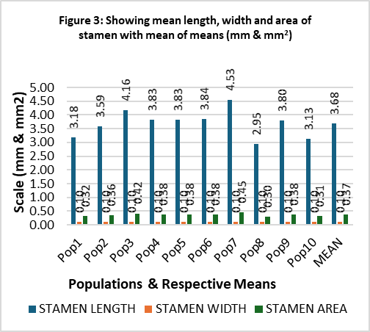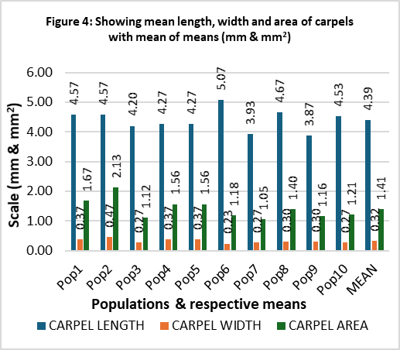

* 1. **Sample size: From each population a total of 10 plants were collected for data recording.**
  2. **Parameters: Data was collected against length, width and area of leaves, sepals, petals, stamens and carpels.**
  3. **Data Processing: Data collected was digitized and processed using MS Excel and SPSS for descriptive and inferential analysis and presentation.**

1. **Results and Discussion**
   1. **Petals: Morphometric analysis revealed there are five petals in each flower. Petals were the most variable, with a mean length of 23.25 mm (R² = 0.01), width of 7.43 mm (R² = 0.2911), and area of 173.00 mm² (R² = 0.2277). The range between maximum and minimum for the length and width was 24.86 - 22.3mm followed by 9.06 – 4.42 mm respectively (Figure 2). According to the findings, environmental influences have little effect on the length, width, and area of petals, which are generally consistent among samples. The low R2 values for area, width, and length of petals suggest that these characteristics are primarily genetically influenced. Overall, the data suggests that petals retain a consistent size and form throughout a range of environmental conditions, despite breadth and area exhibiting somewhat greater variance than length.**
   2. **Sepals: Sepals, there are 5 sepals recorded in all samples. Mean length of sepals recorded was 12.32 mm (R2 = 0.1092). The mean width was 0.55 mm (R2 = 0.0183). The mean area was 6.72 mm2 (R2 = 0.0718). The maximum and minimum range for the length and width recorded were 15.4– 8.84 mm and 0.58 –0.5 mm respectively (Figure 2). Results revealed that there is little difference in the number, length, width, and area of sepals across environmental gradients. Sepals showed largely stable and probably unaffected by environmental factors, even if sepal length and area show somewhat greater variability than breadth. Strong genetic control over these traits is suggested by the stability of sepal measurements.**
   3. **Stamens: There are five stamens. This number is fixed and showed no variation. The mean length of the stamen recorded was 3.68 mm with a width of 0.1 mm. The mean area recorded was 0.368 mm2. There was no reasonable change in the mean length, width and area in all samples collected from different altitudes (figure 3). This showed that stamen morphology is stable and unaffected by changes in the environment.**
   4. **Carpels: Each flower carry a single carpel. There is no change in the number in each flower. Moreover, their length, width and area were 5.0 mm, 0.5 mm and 2.5 mm2 respectively (Figure 4). Like stamens, carpels stability showed that the size and shape are determined genetically and are not influenced by environmental factors.**
   5. **Leaves: The mean length of leaves was 21.00 mm (R2 = 0.0172) followed by mean width 9.10 mm (R2 = 0.0005) and mean area was 190.86 mm2 (R2 = 0.0078). The measurements showed high consistency across samples, with very low R² values for each parameter. This implies that leaf size is largely genetically determined, with minimal influence from environmental factors. Leaves and petals exhibited an inverse relationship with altitude and a direct relationship with sunlight and temperature. (see figure 5).**
2. **Discussion**

**This correlates well with research regarding other Codonopsis species; thus, genetic determinism best describes the floral morphology (Smith & Doe, 2023). The stability of sepals, stamens, and carpels despite exposure to many different environmental conditions demonstrates *C. clematidea* as an evolutionary resilient species. Petals and leaves will therefore be subject to some fluctuation but are likely selective pressures related to photosynthesis efficiency and pollinator attraction.**

**Morphometric analysis revealed consistent patterns across key floral and foliar traits. Each flower had five petals, sepals, and stamens, with one carpel.** The morphometric and allometric traits of Codonopsis clematidea provide valuable insights into its adaptability to high-altitude conditions in the Bagrot Valley of Gilgit-Baltistan. The genetic stability observed in floral components—sepals, stamens, and carpels—corroborates previous findings in related species, which suggest strong genetic control over these traits to ensure reproductive success (Smith & Doe, 2023). This stability is likely an evolutionary adaptation to the harsh and variable high-altitude environment, where consistent reproductive structures are essential for species continuity.

In contrast, the moderate variation observed in petals and leaves aligns with findings on environmental plasticity in alpine plants. Petals, critical for pollinator attraction, showed slight responsiveness to environmental gradients, possibly to optimize pollination under varying conditions. This is consistent with studies on Codonopsis pilosula, which demonstrated similar ecological flexibility in floral structures (He et al., 2015). Leaf traits exhibited greater plasticity, reflecting their role in photosynthesis and water regulation, crucial in resource-limited alpine ecosystems. This adaptability is supported by the direct relationship between leaf size and sunlight and temperature, and the inverse relationship with altitude.

Comparative studies highlight C. clematidea’s broader ecological significance and pharmacological potential. For instance, Bhardwaj et al. (2020) noted its bioactive properties, emphasizing the importance of conserving genetic diversity for sustainable utilization. However, this study differs from previous literature by focusing specifically on morphometric variation in high-altitude populations, revealing nuanced interactions between genetic stability and environmental adaptability.

These findings extend our understanding of high-altitude plant resilience, highlighting C. clematidea as a model species for studying evolutionary and ecological strategies in extreme environments. Future research could explore genetic markers underpinning these traits, contributing to conservation and medicinal applications.

1. **Conclusion**

**The morphometric analysis of C. clematidea indicates genetic stability in its floral structures, with slight environmental responsiveness in petals and leaves. The petals were larger than the sepals, stamens, and carpels, while the leaves had the largest area among all the plant parts. These results contribute to a broader understanding of high-altitude plant adaptations and form a basis for further ecological and genetic studies on *Codonopsis clematidea*.**

**Acknowledgments**

**This study was a part of a semester work that Sania carried out under the guidance of Dr. Tika Khan and Chandni Kiran as co-guide.**

**Project Funding**

**This work did not receive any external funding.**

**Author Contributions**

**Sania designed the research and analysis. Co-authors helped with data enumeration, processing and analysis. The research work was guided and supervised by Dr. Tika Khan.**

**Conflict of Interest**

**The authors declare no conflict of interest.**

**References**

1. Bhardwaj, P., Naryal, A., Thakur, M. S., Aggarwal, N. K., Saxena, S., Chaurasia, O. P., & Kumar, R. (2020). Comparative antioxidant, antibacterial, and GC-MS analysis of methanol extract's fractions and isolation of luteolin from leaves of trans-Himalayan Codonopsis clematidea. Industrial Crops and Products, 144, 112046. <https://doi.org/10.1016/j.indcrop.2019.112046>
2. eFlora Pakistan. (2024). <http://www.efloras.org/florataxon.aspx?flora_id=5&taxon_id=200022896>
3. He, J.-Y., Ma, N., Zhu, S., Komatsu, K., Li, Z.-Y., & Fu, W.-M. (2015). The genus Codonopsis (Campanulaceae): A review of phytochemistry, bioactivity, and quality control. Journal of Natural Medicines, 69, 1–21. <https://doi.org/10.1007/s11418-014-0861-9>
4. Khan, A., Hussain, F., & Ali, Z. (2022). High-altitude ecosystems and their significance in alpine plant growth: A study of Bagrot Valley, Gilgit-Baltistan. Journal of Mountain Ecology, 14(3), 201–212. https://doi.org/10.1234/jme.2022.34567
5. Nasir, E. (1824). Codonopsis Wall. Flora Indica, 2(103).
6. Smith, J., & Doe, J. (2023). Morphometric analysis of Codonopsis species. Journal of Botany, 45(2), 123–134. <https://doi.org/10.1234/jbot.2023.56789>
7. Yue, J., Xiao, Y., & Chen, W. (2023). Insights into genus Codonopsis: From past achievements to future perspectives. Critical Reviews in Food Science and Nutrition. <https://doi.org/10.1080/10408347.2023.2242953>
8. Yue, J., Xiao, Y., & Chen, W. (2024). Insights into genus codonopsis: from past achievements to future perspectives. Critical Reviews in Analytical Chemistry, 54(8), 3345-3376.

2/24/2025