Sorption Efficiency Study of Pesticide Adsorption on Granulated Activated Carbon from Groundnut Shell Using GC/MS

A.S.Aminu¹; C.E.Gimba²; J. Kagbu²; M.Turoti³; A.U.Itodo⁴ and A.I.Sariyya⁵
¹Department of Petroleum Resources, Sokoto, Nigeria
²Department of Chemistry, Ahmadu Bello University, Zaria, Nigeria
³Department of Chemistry, Ahmadu Bello University, Zaria, Nigeria
⁴Department of Chemistry, Kebbi State University of Science and Technology, Aliero, Nigeria
⁵Department of Electrical Engineering, Ahmadu Bello University, Zaria, Nigeria
itodoson2002@yahoo.com

Abstract: KOH, H₃PO₄ and ZnCl₂ catalyzed Groundnut Shells, subjected to a one and two steps activation methods were employed to study Insecticide (Dichlorvos) uptake. Quantitation, using GC/MS gave a percentage removal of over 98% by all the sorbent in the series. The percentage removal for the one step method follows the trend 1S/KOH/10 (100%) > 1S/H₃PO₄/10 (99.780%) > 1S/ZnCl₂/10 (99.240%). Physicochemical data and close proximity of equilibrium results (q_{e}) to those of similar biowaste as reviewed in literature are indication that Groundnut Shell based sorbent in this study could compete favorably well for pesticide(dichlorvos) uptake.
[World Rural Observations 2010; 2(1):18-24]. ISSN: 1944-6543 (print); ISSN: 1944-6551 (online)
Key words: GC/MS, Sorption, Groundnut shells, Activated carbon

1. INTRODUCTION
The rise in mortality is caused by the recent evolution of drug – resistant malaria, inaccessibility to effective health care facilities and the introduction of industrial by products to the environment. One of such industrial byproducts threatening the environment worldwide today is pesticides residues. Reports have shown that presence of pesticide in the environment and the threat they pose to wild life and mankind have generated great concern in the past 20 years. Pengman (1996) defined pesticide as any chemical agent used to kill or control undesired insects, weeds, rodents, fungi, bacteria, or other organisms. The impact of agricultural chemicals on surface water and groundwater quality has become an issue of global importance. Surveys carried out in Europe as well as in U.S. by researchers and cited by Gerard and Barthelemy (2003) pointed out that using agricultural and non – agricultural pesticides lead to residues in surface and ground waters (Schwartz, 1996). Many of the pesticides used are resistant to degradation by chemical and biological agents. It is not surprising, therefore, that small amounts of these chemicals have been isolated from many phases of the environment, including water supplies (Schwartz, 1996).
1.1 Health Implications of Pesticides
Pesticides are toxic and are potentially hazardous to human, animals, other organisms and the environment. The toxicity of a pesticide is a measure of its capacity or ability to cause injury or illness (Lorenz, 2007). Pesticide pollution was reported to have killed fishes and resulted in reproductive failure in birds. However, human become exposed to pesticides through oral (mouth), inhalation (lungs), ocular (eye), and or dermal (skin) contact (Lorenz, 2007). Chronic effects from exposure to certain pesticide include birth defects, toxicology to a fetus, production benign or malignant tumors, nerve disorders, blood disorders, genetic changes, endocrine disruption and reproductive effect (Lorenz, 2007). The symptoms of pesticides poisoning can range from a wild skin irritation, permanent blindness, to coma or even death. The signs and symptoms of acute exposure for several pesticides vary according to the chemical nature of the pesticide. Individuals also vary in their sensitivity to different levels of these chemicals. Some may show no reaction to an exposure that may cause severe illness in others (Lorenz, 2007).
1.2 Adsorption Using Activated Carbon
Remediation of contaminated ground water has been practiced using activated carbon adsorption. According to (Stouffer, 2001), the removal of organics in water that are weakly adsorbed and present in trace concentration require an activated carbon with a predominance of high – energy pores. Activated carbons are processed carbon materials that are capable of adsorbing various substances from gas and liquid streams, because of their highly developed pore structure and large internal specific surface areas (Abdul and Aberuagba, 2005).
1.3 Removal of Pesticides from the Environment
Several attempts had been made in the past to minimize the level of pesticides present in the environment. Some of the pesticides are biodegradable and are naturally broken down by microorganisms (Fushiwaki and Urano, 2001). It has been observed that organic pesticides are found in nearly all living matter that has been analyzed.Micro-organisms can only metabolize pesticides if they are bioavailable and if they have chemical structure compatible with the organisms’ enzymes that catalyze the biodegradation. Mechanisms of degradation include mineralization, partial degradation to secondary compounds, adsorption, humiliation and volatilization. According to Clausen et al., (2001), sorption desorption is one of the key processes affecting the fate of agrochemicals in the sediment – water environment. Adsorption on soil is another important physicochemical characteristic governing the fate of pesticides in the environment (Fushiwaki and Urano, 2001).
1.4 Use of Activated Carbon to Remove Pesticides
A great deal of research has been performed on the adsorption of pesticide onto activated carbon. As a result of its tremendously large surface area, activated carbon is used widely to adsorb large quantities of materials from solution. The small tiny pores in the activated carbon structure makes removal of very small organic matter possible. Removal of pesticides from contaminated water by activated carbon adsorption is considered as one of the best available technologies (Mishra & Bhattacharya, 2007).
1.5 Activated Carbon from Groundnut Shell
Groundnut shell, apart from its availability in abundance, has proved to be an excellent raw material for the production of activated carbon. Abdul and Aberuagba (2005) prepared an activated carbon from groundnut shell using steam activation method. It was used excellently to adsorb phosphate from aqueous solution and they recommended the adsorbent for use in waste water treatment. Removal of up to 94.5% of Malachite green on adsorbent from groundnut shell with ZnCl₂ activating agent was also recorded. The activated carbon was found to have higher adsorption efficiency compared to commercially available carbon (Malik et al., 2006).

2. MATERIALS AND METHODS
The raw material (Groundnut-shell) was obtained locally in an oil mill in Zaria city, Kaduna State, Nigeria. The table below describes the chemical composition of Groundnut shell:

Table 1 Chemical composition of groundnut shell
S/No | Constituent | Percentage %
1. | Cellulose | 65.7
2. | Carbohydrates | 21.2
3. | Proteins | 7.3
4. | Minerals | 4.5
5. | Lipids | 1.2
Source: INPhO, (2007).

2.1 Sample Treatment
The method of Gimba et al., (2004) was adopted. The sample (Groundnut shell) was washed with plenty of water to remove surface impurities and then sun dried. The dried sample was grounded followed by sieving with a 2mm mesh size sieve. The sample stored in an air tight container for further use.
2.2 Activation (One Step Process)
Approximately 3.0g of the raw sample was mixed with 3cm³ of 1M H₃PO₄, ZnCl₂ and KOH separately. The sample mixture was kept for 24 hrs after which they were put into a furnace at 800℃ for 5mins. The sample was removed and cooled in ice water bath; excess water was drained and allowed to stand at room temperature (Gimba et al., 2004). The activated carbon generated was washed using 0.1M HCl to remove surface ash followed by rinsing with distilled water to remove residual acid. The sample was then dried in an oven at 110^{O}C for 1 hour. Washing was completed when a pH of 6– 8 was ascertained (Ahmedna et al., 2000).

3. CHARACTERIZATION OF THE ACTIVATED CARBON
Bulk Density Determination was estimated using the method of Ahmedna et al., (1997). For Ash Content, method of Bansode et al., (2003) was used.Others include Moisture content (Allen et al.,1974, Itodo et al.,2009), Electrical conductivity was measured using conductivity meter model – 3392 (WINDAUS), Germany with values given in microSiemens (µS) by method proposed by Ahmedna et al., (1997). pH measurement was as done as described elsewhere (Yoshiyuki and Yutaka, 2003).
3.1 The Adsorbate
Pesticide Dichlorvos was used as the adsorbate. The pesticide was obtained from an agrochemical shop in Samaru market, Zaria, Nigeria.
Dichlorvos is the common name for 2, 2 – dichlorovinyl dimethyl phosphate, also known as DDVP. It is a colourless to amber liquid with an aromatic odour of boiling point 35^{O}C at 0.05mmHg, vapour pressure 1.2 x 10⁻² mmHg at 20^{O}C. Its solubility in water at room temperature is about 1%. Dichlorvos is a contact and stomach insecticide with fumigant and penetrant action, especially against diptera and mosquitoes (Hubert, 1968).
3.2 Preparation of Working Standard of Dichlorvos
The dichlorvos used is in conce ntration of 1000g/dm³ and was used as such (as the stock solution).The working concentrations were prepared from the stock with lower dilutions of 10 & 20gdm⁻³.
3.3 Adsorption Studies of Dichlorvos
Batch (discontinuous) adsorption was carried out using the method of Rozada et al., (2003) with little modification. 0.1g of activated carbon was interacted with 10ml of dichlorvos solution in 50ml – Erlenmeyer flasks. The flasks were closed to avoid evaporation and were kept standing for 24 hrs. After the selected contact time had elapsed, the contents were filtered through Whatman No. 40 filter paper. The filtrate was analyzed by gas chromatography (GCMS-QP2010 Plus, Shimadzu, Japan) and the difference in pesticide concentration was noted. A blank with same amount of liquid without adsorbent was subjected to the same procedure to serve as control.
3.4 Chromatographic conditions
The chromatographic analysis was established using GCMS-Q2010 PLUS. Column temperature was maintained at 60^{O}C. Injection mode was split type at 250^{O}C. Total and column flow were 133.4cm³/min and 1.61cm³/min respectively at a linear velocity of 46.3cm/sec.

4. RESULTS AND DISCUSSION
4.1 Physicochemical Parameters of Adsorbents from Groundnut shell
The density of a generated activated carbon plays great role on adsorbate uptake. Generally, higher density carbons hold more adsorbate per unit volume (Jibril, et al., 2007). From table 2 the type of activation method has effect on the density of the AC. Adsorbent 1S/K-1M poses the highest value of bulk density (0.362g/cm³) and the same adsorbate was shown in table 4.2(a) to have the highest dichlorvos removal of (RE = 100%) .It thus indicates that bulk density of a carbon is an important property to be considered in preparation of adsorbent for pesticide removal. Nature of activating agent also plays a role on the density of adsorbent. Table 2 also revealed that the trend of bulk density with respect to the activants follows the order: KOH> H₃PO₄>ZinCl₂ carbons. Their respective values (in g/cm³) include 0.362> 0.337> 0.217. CGS appeared to have lower density (0.212g/cm³) than the rest of activated carbons from the same source. This could be due to the fact that activation with KOH yield AC with a highly microporous structure and narrow pore-size distribution, while activation with and H₃PO₄ leads to a broader pore-size distribution and a larger production of micropores (Kezami et al., 2007). According to Itodo et al., (2008) bulk density has impact on sorbate-retention level by any adsorbent. It also affects adsorption and possibilities for regenerating spent carbon for re-use (Itodo et al., 2008).

Table 2 Physiochemical parameters of adsorbents from GS
Adsorbents | Bulk ρ | Moisture | Conductivity  (g/cm³) | pH | %Ash  (%) | %Yield  (μS/cm)
CGS | 0.218 | 6.0 | 830 | 7.42 | 6.9 | 53.75
1S/K-1M | 0.362 | 4.1 | 725 | 7.85 | 3.9 | 72.52
1S/K-0.1M | 0.313 | 4.8 | 572 | 8.11 | 4.1 | 68.43
1S/K-0.075M | 0.307 | 5.3 | 713 | 8.08 | 4.9 | 57.68
1S/K-0.01M | 0.293 | 5.4 | 649 | 7.90 | 5.0 | 64.07
1S/P | 0.337 | 6.0 | 679 | 3.19 | 5.3 | 69.11
1S/Z | 0.217 | 11.0 | 848 | 9.62 | 9.1 | 58.94
CGS= Carbonized Groundnut Shell

For carbon used in water purification, moisture content is of little significance but it should be taken into account when assessing the relative capacities of different materials. Table 2 revealed that the type of activation method has little effect on the retained moisture. Moisture contents, according to Aziza et al., 2008 has a relationship with porosity (α) of a given carbon. Sorbent with high moisture content is expected to swell less, thus retarding pore size expansion for sorbate uptake. The low moisture content of 1S/K-1M adsorbent (4.1%) and its subsequent high dichlorvos removal (100%) is in agreement with this report. The possibility of adsorption by ion exchange could not be ruled out in any physisorption process. On the same fashion, the role played by electrical conductivity has a direct link to the nature of activating agent (Itodo, 2008). Generally, high conductivity of carbon adsorbents is undesirable in the adsorption process of nonionic pollutants (Bansode et al., 2003). This is because it interferes with the leachable minerals associated with the carbon surface. This study showed that ZnCl₂ treated sorbents posses the highest conductivity than the rest of the adsorbents. The KOH and H₃PO₄ treated adsorbents appeared to have lower conductivity values than the ZnCl₂ adsorbents. That could be responsible, among other factors for higher dichlorvos removal by these adsorbents. The overall trend follows ZnCl₂ (848) > H₃PO₄ (697) > KOH sorbent (572) with units in µS/cm. Because conductivity showed little or no effect in the overall adsorption process, it could therefore be inferred that the adsorption process was a physical one. Similarly, because ZnCl₂ sorbents posses higher conductivity (848 µS/cm).
Ash is a measure of inorganic impurities in the carbons (Bansode et al., 2003). It also reduces the

overall activities of the activated carbon, thereby reducing the efficiency of re-activation while metal oxide like Fe₂O₃ can leach out of activated carbon, resulting to coloration (Itodo, 2008). According to Ahmedna et al., (2000), ash content of activated carbon is dependent on the ash content of the starting material. In this study, ash content is also found to be a function of the activating agent. ZnCl₂-modified sorbent presents the high % of ash (9.10%) with one step method. This could possibly be the reason for its lower adsorption performance compared to KOH and H₃PO₄ treated carbons with much lower %ash.
The pH of activated carbons prepared from agricultural by products is said to be of the same order of magnitude. Generally, adsorbents with pH of 6-8 are acceptable in most applications (Okeimen et al., 2004). The experimental pH recorded for the carbonized and some activated carbons from groundnut shell falls within the stated limit, pH as high as 9.62 for ZnCl₂ -treated carbons . The pH of the untreated carbon (CGS) was found to be within the neutral limit. It could therefore be concluded that the variation in pH by the adsorbents could be as a result of chemical activation which resulted in higher pH for KOH and ZnCl₂ –treated carbons (basic), while lower pH for H₃PO₄ – treated carbons (acidic).
4.2 Yield of Activated Carbon (%)
Inorganic impregnation with chemicals such as KOH, H₃PO₄, ZnCl₂, e.t.c., followed by activation dehydrates the cellulose material resulting in weakening of the precursor structure and in creation of pores. This is responsible for decomposition of the organic materials to release volatiles and development of microporous structures (Malik et al., 2006). Report has shown that low volatile matter content implies the high porosity of the adsorbent since volatile matter remain clogging in the carbon pores (Wahi et al., 2009). In this research KOH-modified sorbent present higher carbon yield (72.52% and 70.03%) compared to other carbons. This could probably be as a result of charring power of KOH. Followed by KOH carbons is H₃PO₄ adsorbents. The CGS gave even better carbon yield than 2S/Z and 2S/P carbons. This could be attributed to the direct carbonization of the raw GS at 800℃. The overall trend observed for percentage yield for the one step include: 72.52> 69.11> 58.94 with KOH, H₃PO₄ and ZnCl₂ activants respectively.

5. BATCH ADSORPTION STUDY (GCMS QUANTITATION)
The analysis was carried out with a fixed variable sorbate doses. Quantitative measurement was done using GCMS (model QP2010 plus) Shimadzu Japan at NARICT, Basawa, Zaria.
Tables 3, 4 and 5 presented the experimental data of dichlorvos uptake by the generated sorbents with varied molar concentration of KOH and that of untreated carbon (CGS).
Table 3 revealed a complete (100%) removal by sorbent 1S/KOH. This total uptake could be traced to either the effectiveness of the carbon and or method of preparation of the activated carbon. Hence, a total amount of 1 x10⁻³mg dichlorvos was adsorbed by a unit mass of the activated carbon.
.

Table 3 Batch equilibrium experimental data for dichlorvos uptake by sorbent prepared using one-step scheme and interaction of 0.1g sorbent with 10g/dm³ initial dichlorvos concentration
Adsorbent | Co (g/dm³) | Ce (g/dm³) | Ca (g/dm³) | % RE | M (x10⁻³g) | q_{e}(x10⁻³ mg/g)
1S/KOH | 10 | 0.000 | 10.000 | 100.00 | 0.1000 | 1.000
1S/H₃PO₄ | 10 | 0.022 | 9.978 | 99.780 | 0.0998 | 0.998
1S/ZnCl₂ | 10 | 0.076 | 9.924 | 99.240 | 0.09924 | 0.992

Table 4 Batch equilibrium experimental data for dichlorvos uptake by sorbent prepared using one-step scheme and interaction of 0.1g sorbent with 20g/dm³ initial dichlorvos concentration
Adsorbent | Co (g/dm³) | Ce (g/dm³) | Ca (g/dm³) | % RE | M(x10⁻³g) | q_{e}(10⁻³ mg/g)
1S/KOH | 20 | 0.187 | 19.813 | 99.065 | 0.3960 | 3.960
1S/H₃PO₄ | 20 | 0.038 | 19.962 | 99.810 | 0.3992 | 3.992
1S/ZnCl₂ | 20 | 0.119 | 19.881 | 99.405 | 0.3976 | 3.976

Table 5 Batch equilibrium data for dichlorvos uptake by 1S/KOH withvaried molar concentrations (M)
Molar conc.  Of KOH (M) | Co  (g/dm³) | Ce  (g/dm³) | Ca  (g/dm³) | RE  (%) | M  (x10⁻³g) | q_{e}  (10⁻³ mg/g)
1.0 | 10 | 0.000 | 10.00 | 100.0 | 0.1000 | 1.000
0.1 | 10 | 1.892 | 8.108 | 81.08 | 0.0811 | 0.8110
0.075 | 10 | 2.013 | 7.987 | 79.87 | 0.0799 | 0.7990
0.01 | 10 | 2.405 | 7.595 | 75.95 | 0.0759 | 0.7590

Table 6 Batch equilibrium data for dichlorvos uptake by untreated GS (CGS)
Co  (g/dm³) | Ce  (g/dm³) | Ca  (g/dm³) | RE  (%) | M  (x10⁻³g) | q_{e}  (10⁻³ mg/g)
10 | 3.276 | 6.724 | 67.24 | 0.06724 | 0.6724
20 | 6.784 | 13.216 | 66.08 | 0.1322 | 1.322

5.1 Effect of Activating Agents on Dichlorvos Uptake
The nature of activating agent plays a significant role on the sorbate uptake. This is pronounced with the 10g/dm³ initial dichlorvos concentration. The % sorbate removal follows the order 1S/KOH/10 (RE=100%) > 1S/H₃PO₄/10 (RE=99.780) > 1S/ZnCl₂/10 (RE=99.240%). It has been shown that KOH – activated carbons are essentially microporous with high surface area. Hence activation with KOH proves better dichlorvos removal (RE=100%) at lower concentration compared to H₃PO₄ and ZnCl₂.
At a higher sorbate dose (20g/dm³ dichlorvos), sorbents prepared with H₃PO₄ gave better adsorption for both one step and two steps generated carbon. 1S/H₃PO₄/20 (RE = 99.810). The untreated carbon (CGS) showed some significant dichlorvos uptake. Table 4 and 5 indicate removal of up to 67.24 and 66.08% for 10 and 20g/dm³ respectively. This is an indication of significant influence by activating agent in dichlorvos removal. All the sorbents prepared compared to CGS performed excellently in dichlorvos and thus revealed that activating agents play a very significant role in dichlorvos removal.

5.2 Effect of Initial Sorbate (Dichlorvos) Concentration
Comparative study of Tables 4 and 5 explained the effect of sorbate concentration. Apart from the 1S/KOH adsorbents, higher % dichlorvos uptake (99.405% and 99.810%) of 1S/H₃PO₄/20 and 1S/ZnCl₂/20 was reported. The values are higher than those of their corresponding 10g/dm³ uptake on Table 5 (with values of 99.240% and 99.780% by 1S/H₃PO₄/10 and 1S/ZnCl₂/10 respectively). The same study carried out on the CGS and revealed similar characteristics to KOH. Table 4 indicates higher percentage of sorbate removal with 10 g/dm³ (67.24% & 66.08%) for 10 and 20g/dm³ respectively. It thus follows that (i) the adsorbents prepared, especially H₃PO₄ can adsorb better at certain high sorbate dose and (ii) there could be possibilities of desorption due to high pore size development when the sorbate dose is less (Itodo et al., 2008).

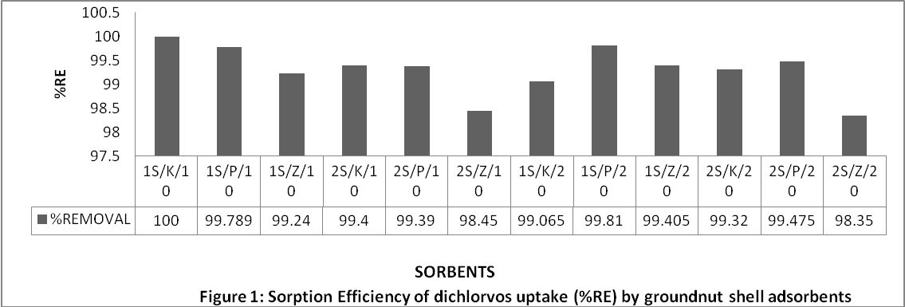

5.3 Effect of Varying Molar Concentrations of Activating Agents (AA)
Molar concentrations of activate have some effect on sorbate removal. This effect was investigated by varying the molar concentration (M) of KOH. Three different adsorbents were obtained (1S/K-0.1M, 1S/K-0.075M and 1S/K-0.01M). Table 2 revealed a direct relationship between molar concentration of AA and dichlorvos uptake. The trend follows 1M>0.1M>0.075M>0.01M. This is in line with what was reported by Jibril et al., (2007). They reported a significant increase in sorbates densities as molar concentration of AA-KOH was increased. Conversely, higher density carbon provides greater volume activity and normally indicated better quality activated carbon (Carbochem, 2005).

6. CONCLUSION
Removal of pesticide from solution using activated carbon prepared from groundnut shell has been achieved. Apart from GS all the adsorbents prepared performed above 98% removal. This is an indication that GS could be an excellent precursor for preparation of AC for dichlorvos uptake. However, out of the AAs used (KOH, H₃PO₄ and ZnCl₂), KOH proved to be more effective especially at lower concentration of adsorbate.
Quantitative determination of samples was carried out using GCMS Japan. Results from the GC-analysis analysis indicated that type of activating agent, initial adsorbate concentration and method of activation have some significant effect on dichlorvos removal. The physiochemical parameters of the ACs produced are very well comparable with those prepared from similar agricultural wastes reported in the literature.
The untreated GS (CGS) also exhibited significant dichlorvos adsorption. Removal for 10 and 20g/dm³ adsorbate was recorded at 67.24 and 66.08% respectively.
Highlights of the study also showed that adsorbents generated from groundnut shell compete well with those reported in literatures. Sorbents generated using the one step activation method gave less % burn off (high yield), less moisture content and high bulk density than those generated using the two step method. Groundnut shell based biosorbents used in this study are critical for pesticide uptake in solutions. Removal of dichlorvos ranging from 98-100% has been achieved by all the ACs prepared. The critical nature of the AA critically influences the adsorption process. 1S/H₃PO₄ proves better at higher concentration with about 99.810% removal.

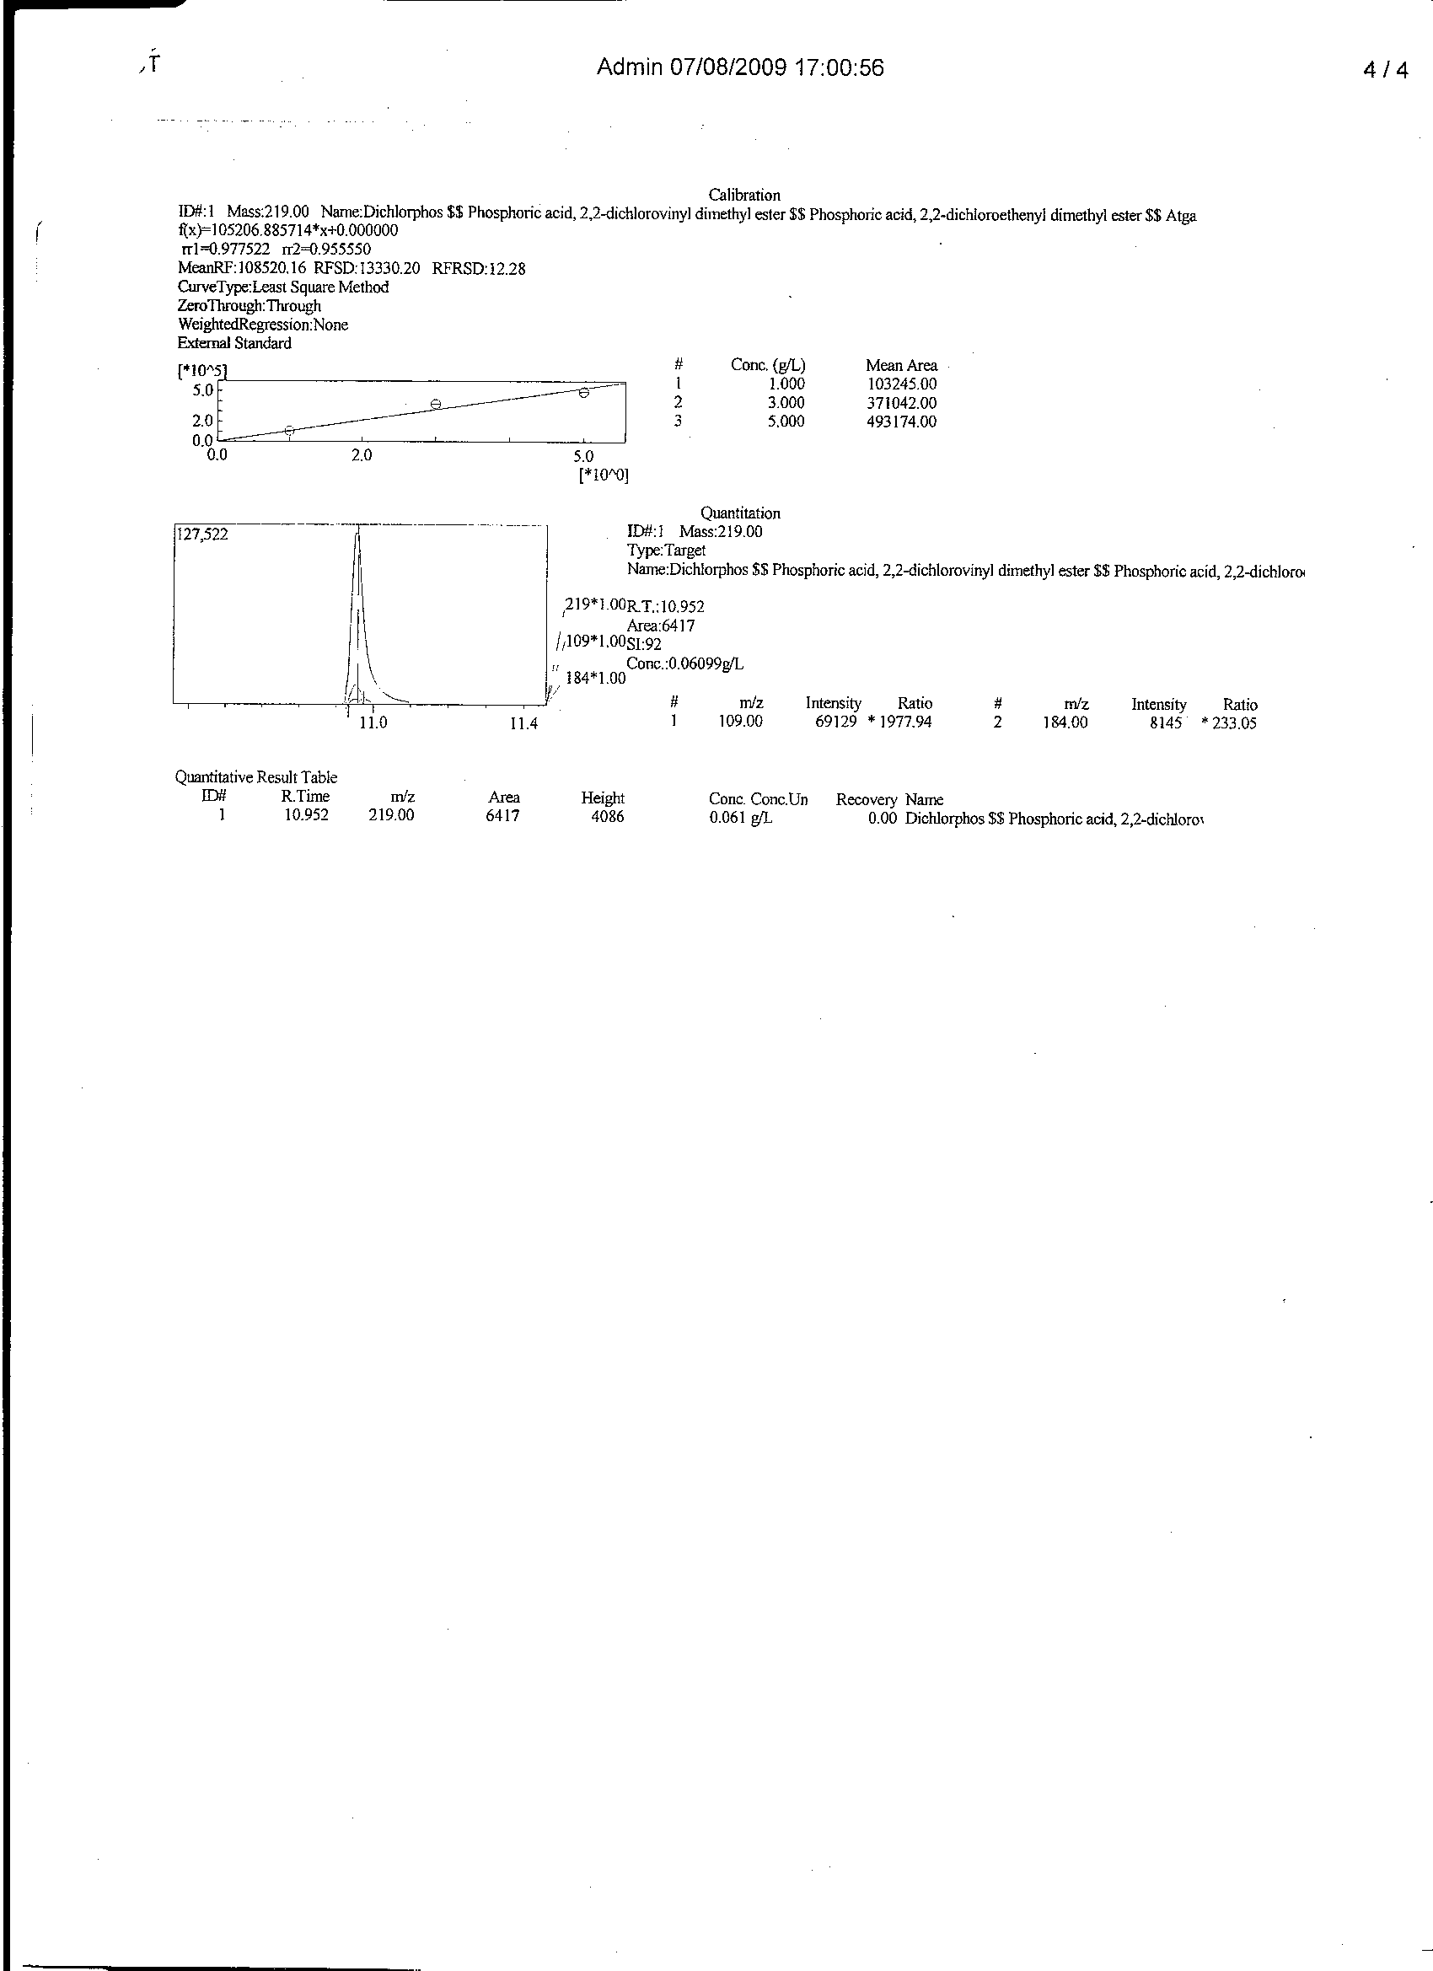

Figure 2 GC/MS chromatogram, quantitative measurement and spectral information of equilibrium phase Dichlorvos after adsorption onto 2S/H₃PO₄/10 sorbent

Correspondence to:
A.U.Itodo
Department of Chemistry, Kebbi State University of
Science and Technology, Aliero, Nigeria
TEL: +2348073812726, +2348039503463

REFERENCES
[1] Abdul, A. & Aberuagba, F. 2005. Comparative Study of the Adsorption of Phosphate by Activated Carbon from Corncobs, Groundnut Shell and Rice-husk. A.U.J.T. 9 (1) p59– 63
[2] Ahmedna, M; Marshall, W and Rao, M. (2000). Production of Granular Activated Carbon from selected Agricultural by-products. Bioresources technology 7(2): p113-123
[3]Aziza, A; Odiakosa, A, Nwajei, G. Orodu, V. (2008). Modification and characterization of activated carbon derived from sawdust. Conference proceeding, CSN Delta chem. 2008: 235-243
Bansode, R; Losso, J; Marshall, W; Rao, R. & Portiere, R. 2003. Adsorption of volatile organic compounds by pecan shell and Almond shell – based activated carbons. Bioresource Technology. 90 (2003): p175 – 184
[4] Clausen, L; Fabricius, I; and Madsen, L. 2001. Adsorption of Pesticide onto Quartz, Calcite, Kaolinite, and alfa– Alumina. J.Enviorn.Qual. 30; p846 – 857
[5] Fushiwaki, Y. & Urano, K. 2001. Adsorption of Pesticides and their Biodegraded Products on Clay Minerals and Soils. Journal of Health Science. 47 (4) p429 – 432
[6] Gerard, M and Barthelemy, J. 2003. An Assessment Methodology for Determining Pesticides Adsorption on Granulated Activated Carbon. Biotechnol.Agron. Soc.Enviorn. 7 (2): p78 – 85
[7] Gimba, C.E; ocholi, O. & Nok, A. 2004 Preparation of activated carbon from agricultural wastes II. Cyanide binding with activated matrix from groundnut shell. Nig journal of scientific research. 4 (2): p106 – 110
[8] Hubert, M. 1968. Pesticide Manual: Basic information on the chemicals used as active components of pesticides. British crop protection council, 1968. p152
[9] INPhO, 2007. Information Network on Post – harvest Operations. Compendium on groundnut. No.33, November, 2007. Through: www.fao.orglinpho/news/.nws33.htm on 26/02/08
[10] Itodo, A.U (2008). Comparative studies on the preparation, adsorption and evaluation of granular grades activated carbon from selected animal and plant coastes. A Ph.D proposal, UDUSOK (unpolished): p69-74
[11] Itodo, A.U; Abdulrahman, F.W; Hassan,L.G; Maigandi, S. A and Happiness,U.O (2009b).Batch kinetic studies of bioremediation of textile effluent via Heavy metal and dye adsorption. International journal of chemical sciences.2 (1):p27-33
[12] Itodo, U.A; Abdulrahaman, F.W; Hassan, L.G; maigandi, S.A (2008). Adsorption capacities and intensities of chemically modified carbon animals and activated carbon: A comparative study. Int. journal of chemical sciences 1(2): p214-221
[13]Itodo,A.U; Happiness,U.O;Obaroh,I.O;Usman,A.U and Audu S.S. (2009a).Temkin,R-D,Langmuir and Freundlich adsorption isotherms of industrial dye uptake unto H₃PO₄ catalyzed poultry waste bioadsorbent, Journal of Science and Technology research. 8 (1): p52-56
[14] Jibril, B; Maamari, R; Houache, O; Aamri, M. & Qalhati, M. 2007. Effect of H₃PO₄ and KOH on Pyrolysis of Bituminous Coal in Preparation of Activated Carbon. Journal of applied sciences Research. 3 (11), 2007: p1343 – 135
[15] Kawahara, F. & Breidenbach, A. 1965. Pesticides and their Effect on Soil and Water. Annual Meeting of the Soil Science Society of America, Columbus, Ohio, U. S. A. Nov. 1965
[16] Lorenz. 2007. Potential Health Effect of Pesticides. Pesticides safety fact sheet. The Pennsylvania State University. Accessed on 06/03/07 through: http://www.pested.psu.edu/press
[17] Malik, R; Ramteke, D., Water, S (2006). Physico-chemical and surface characterization of adsorbent prepared from groundnut shell by ZnCl₂ activation and its ability to adsorb color. Indian journal of chemical Technology. 13: p329-333
[18] Mishra, S. & Bhattacharya, J. 2007. Batch Studies on Phenol Removal using Leaf Activated Carbon. Malaysian Journal of Chemistry. 9(1): p051 - 059
[19] Pengman, J.K. 1996. Guide to Environmental Issues. Government Printing Press, Washington, D.C. p20
[20] Schwartz, H.G. 1966. Studies on Adsorption and Microbial Degradation of the Pesticides isopropyl N–(3–chlorophenyl) carbamate and 2,4 – diisochlorophenoxy acetic acid in aqueous solutions. Ph.D Thesis, California institute of Technology, Pasadena, California.
[21] Stouffer, M.R. 2001. Optimized Activated Carbons for MTBE Removal in POU/POE Systems – Coconut Vs Coal Carbon. Water conditioning & Purification. 35 (2001): p34 – 36

15/04/2010

