Fish consumption pattern in Kainji lake areas

Omojowo Funso Samuel, Olowosegun Toyin, *Omojowo Taiwo Mary
omojowofs@yahoo.com, toyin_motunrayo@yahoo.com, olarinde_samuel@yahoo.com

National Institute for Freshwater Fisheries Research, P.M.B. 6006, New-Bussa, Niger-State.
*Federal College of Freshwater Fisheries Research (FCFFT), New-Bussa, Niger State, Nigeria.

Abstract
Catch and consumption of fish were estimated for a year, from May 2004 to April 2005 using a sample of 341 households. The sample was taken in from a study area covering 6 fishing villages. Of the sampled household, 62.5% of households in the fishing communities were actively involved in fishing while the remaining 37.5% households are non-fishing households. The average annual catch per household was 1,300kg while the total production of fish in this six fishing communities was about 298 metric tonnes giving the average of 49.7 metric tonnes per fishing village. As expected the per capita consumption of fish by fishing households (38.4kg) was higher than the non-fishing household (28.8kg). While the average per capita consumption of fresh fish by all households in the fishing community is 33.6kg per annum. The total consumption of fish including the processed was estimated at 53kg per capita per annum in the fishing villages around the Kainji Lake areas. The fishing households consumed about 41.3% of the total fish catch. The total sold out is about 45% of which 20.7% is sold and consumed within the communities while 24.3% were only sold and consumed outside the communities.
[World Rural Observations 2010;2(1):75-79]. ISSN: 1944-6543 (print); ISSN: 1944-6551 (online).

Key words: Consumption, Catch per household, Fishing household.

INTRODUCTION.
Lake Kainji was formed by damming the River Niger at Kainji Island. The dam was closed on 2nd August 1968 and the reservoir created behind it has a surface area of 1,120km² at maximum-recorded level. The lake is 137km long and 24km wide (Welcome, 1972). Kainji Lake (Figure 1) is in the Guinea savannah vegetation zone of the north-western Nigeria. Kainji Lake is located between longitude 9º 50” and 10º 55” East and Latitude 4º 20” and 4º 45” North. It has a length of 134 km, a maximum width of 21.1km and a maximum depth of 60 meters. It has a surface area of 1270km² and a mean annual water temperature of 27.85ºC after construction (Abiodun, 2002). Although the primary aim of the impoundment is to generate hydroelectric power. The lake also offers opportunities for developmental projects like fisheries, irrigation and Navigation. Kainji Lake has its source from Futa Jalon in Niger republic. It takes three to four months for water from Futa Jalon to get to Kainji Lake especially the southern basin.
There are 316 fishing villages scattered all over the lake areas. Most of the fishing villages are inaccessible during raining season (Alamu et al; 2001).
According to Sikoki et al; (1992), the annual fish demand in Niger State in 1990 was 50,000mt. If the projections in 1995 was assumed to be 60,000 mt. The annual yield in Kainji lake area in 1995 was 32,474 mt (Table.1.). This yield from this lake would have met more than 50% of the fish demand of Niger-state.

Table 1. Statistics of annual catch in Kainji lake area (1995-2001)
Year | Annual yield (mt)
1995  1996  1997  1998  1999  2000  2001 | 32,474 mt  38,346 mt  28,753 mt  28,851 mt  16,351 mt  13,375 mt  13,361 mt
Source- Abiodun, 2002.

The reduction in annual catch from 1999 to date is as a result of the ban on small mesh-sized nets that catches the fingerlings, clupeids etc that accounts for some percentages of the catch in those years.

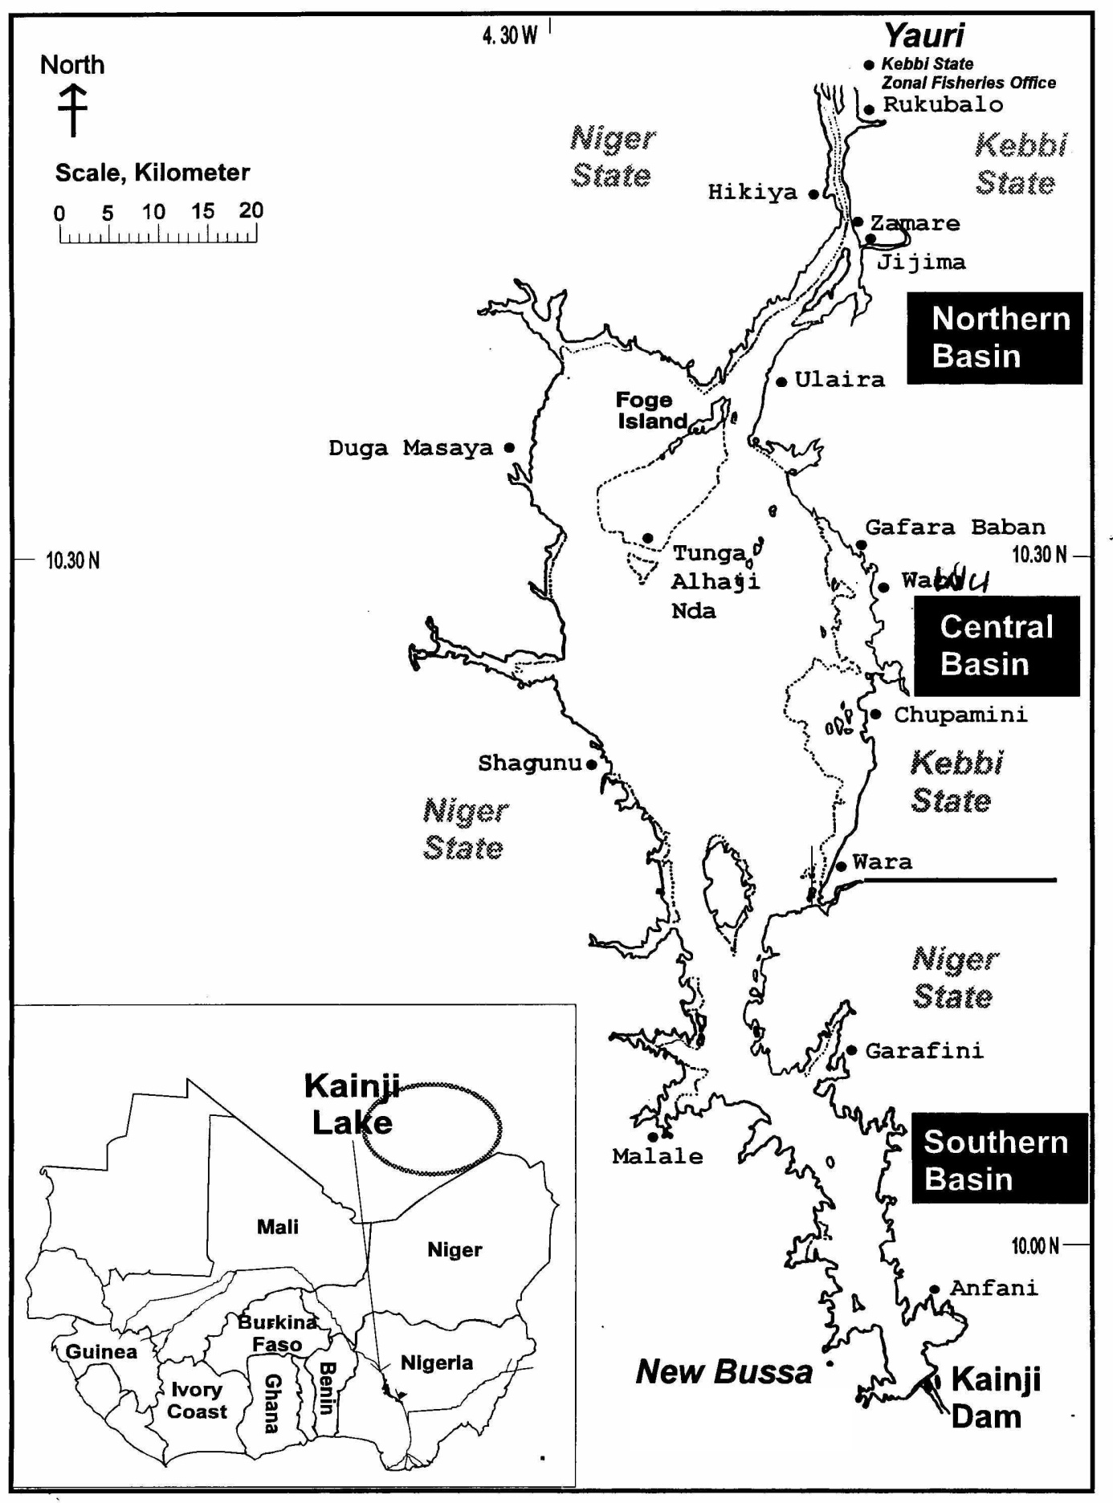
* 1
4*
*2
*3
Figure 1: A map of Lake Kainji, Nigeria showing some of the Fishing Villages

Objectives
This paper looks into the annual fish yield of some of the fishing villages in this area as a sample to the whole environment. However, the main thrust of this paper is to provide an analysis of the pattern of fish consumption by households living in the fishing communities around the Kainji lake areas.

Method of Data Collection
The household survey was conducted from May 2004- April 2005 in six randomly selected fishing communities around the Kainji lake basin. The communities are: Warra, Wawu, Uneku in Kebbi State and Monai, Malale, and Tungadanbaba in Niger State.
A total number of 341 households were sampled and 213 households are actively involved in fishing while the remaining 128 households are not engaged in fishing (Figure 2.). The households were categorised into two-actively involved fishing and non-fishing households

RESULT AND DISCUSSION

Economic Activity by Households
Households in the fishing communities are usually engaged in a wide range of production and income generating activities (Figure 3.). Most households combine farming with the fishing activity because of the availability of land. However, few households also engaged in exclusively fishing activity.
About 62.5% of the surveyed households are actively involved in fishing. These are regarded as fishing households. Here, fishing is their main occupation. Most of the catch of the fishing households is sold fresh or in processed forms. The remaining is consumed as food or with food. About 15% are actively engaged in selling fish, 25% are engaged in processing, about 52% in farming, 3% in craft/gear (this include both net-making and canoe building) and 18% in other trading (Figure 3.)

HOUSEHOLD FISH CATCH
Fishing activity can be looked into as mainly on subsistence level (family fishing) and fishing for commercial purposes. Almost all fishing households take part in family fishing throughout the year.
However, about 20% of the fishing households take part in medium- scale. Based on the catch reported by the fishing dependent households during the course of the interview and Data collection, the average annual catch per household for both medium-scale and family fishing is 1,300kg. The household catch varies slightly from one fishing community to the other. The average annual catch per households is highest in Wawu (1,535kg) and least in TungaDanbaba {1,112kg} as shown in Figure 4. The total annual catch by the sampled household in the six fishing villages is 298 metric tonnes (Table 2.) The average annual catch of fish in the each fishing village is about 49.7 metric tonnes and the average catch per household is 1,300 kg.

Figure 2. Numbers of Sampled Households by Villages

Table 2. Annual Catch of Fishing Household In The Villages
Fishing villages | No of fishing households | Annual catch (mt)
Warra  Monai  Wawu  Uneku  Malale  Tungadanbaba | 45  27  82  15  36  8  213 | 66.3mt  32.9mt  125.9mt  17.7mt  46.3mt  8.9mt  298mt

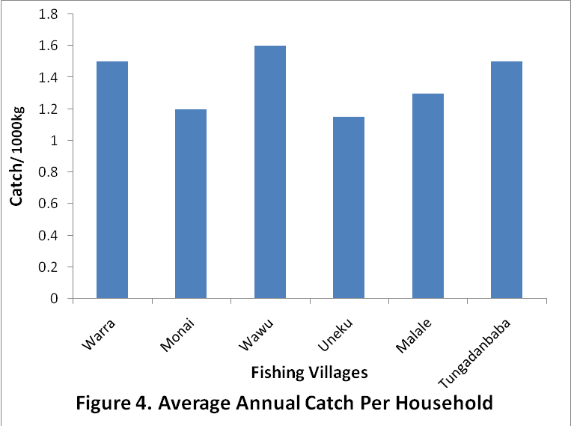

FISH CONSUMPTION PATTERN
The average annual consumption of fresh fish by households varies between different communities. It is generally observed that the fishing households have a higher per capita annual consumption of fresh fish (38.4kg) than non-fishing households (28.8kg) fig.5.
The average per caput consumption of fresh fish by all households in the fishing community is 33.6kg per annum. Besides fresh fish, some forms of processed fish are also consumed.
Due to the seasonal nature of fish harvest, high spoilage rates and other difficulty of delivering fresh fish to the markets, fish in small scale fisheries are generally sun-dried, smoked or salted by individual fishermen or their family (Lisac, 1976; Eyo, 2001). In the process of investigating the rate of consumption of processed fish in Kainji lake area of Nigeria, the two main preservation/processing techniques found was smoking and salting with sun-drying. Salting and sun-drying are usually combined together. This also agrees with earlier work (Eyo, 1992). The two major processed fish therefore are smoked fish and salted/sun-dried fish.
Both fishing and non-fishing household exhibit a uniform level of consumption of the processed fish. And when converted into fresh fish, smoked and salted/sun-dried processed fish accounts for up to 19.4kg of fresh fish. Hence per capita consumption of fish in both fresh and processed form amounts to 53kg per annum (Figure 6.). If this is compared to the Asian environment where they are noted to consume more fish and fishery product. It is quite interesting to note that the consumption pattern in these fishing villages of 53kg per capita per annum is 70% of the per capita consumption of Cambodia, which is noted to be high (75.6kg per annum) as estimated by Ahmed et al., (1999).
For fishing households, per capita consumption of fish is about 57.8kg per annum compared to about 48.2kg for non-fishing household. In the fishing villages the households’ size of 11-15 has the highest percentage of 44.1% and followed by the household size of 6-10, which is 31.2% (table 3.). The fishing household in the communities consumes about 41.3% of the fish-catch.

Table 3. Household Sizes across the Six Fishing Villages

No of persons | No of households | %
1-5  6-10  11-15  >15 | 55  87  123  14  279 | 19.7  31.2  44.1  5  100%

The total fish production/catch by all the sampled households from both small and medium-scale fishing in the six (6) study fishing villages/ community was estimated to be about 298,000kg i.e. 298 metric tones.
Based on the number of fishing household (213), average household size (which is taken as 10, since more than 75% of respondents fall between 6-15) and the per capita consumption, the total consumption by the fishing household could be estimated.
Fishing household x household size x per capita consumption of fishing household.
= 213 X 10 X 57.8kg
= 123,114kg
This is 41.3% of the total fish catch by the fishing villages. That is, the fishing households consume about 41.3% of the fish catch. The consumption of fish by the households living in other communities is expected to be high too. About 45% are sold while the remaining is accounted as loss due to spoilage. This agrees with earlier reports that fish and fisheries products are among the most perishable commodities worldwide mainly due to microbial spoilage ((Lund et al., 2000, Omojowo et al, 2010). However, the fish sold and consumed within the community apart from the fishing household is estimated as follows:
Non-fishing household x household size x consumption rate
128 x 10 x 48.2
= 61,696kg
This represents 20.7% of the total fish catch. It can therefore be deduced that of the estimated 45% sold, 20.7% are sold and consumed within the communities while 24.3% were sold outside the community.

Conclusion and Recommendation
In view of this high consumption rate, it is recommended that fishermen around Kainji Lake area be provided with fishing inputs and necessary infrastructure to enable then produce not only for subsistence but also for improved sale in order to enhance their household and also improve fisheries on a high sustainable level.
For many generation fish and other aquatic products have supplied a sizeable portion of protein and nutrition to this people. Even in the entire nation Nigeria, fish constitutes 40% of animal protein intake (Olatunde, 1989). Any disruption in the ecosystem will affect the food security of these people. Hence government should formulate policy or strengthen the existing policy that will develop fisheries development in these areas. Also funds for research work should be promptly released so that more works and relevant study will be carried out to aid the government in her policy making.

Acknowledgement.
The author is grateful to the Executive director of NIFFR, New-Bussa, Niger-state, Nigeria for sponsoring this research work.

Correspondence to:
Omojowo Funso Samuel,
National Institute for freshwater Fisheries Research (NIFFR). P.M.B. 6006, New-Bussa, Niger-State, Nigeria.

E-mail: omojowofs@yahoo.com, G.S.M: 08073536126

REFERENCES
[1] Abiodun, JA. Evaluation of Fisheries Catch trend on Lake Kainji in Nigeria from 1995-2001. Journal of Applied Sciences and Environmental Management, 2002 7(2). 9-13.

[2] Ahmed M, Navy H, Vuthy L, Santos RAV. Fish Consumption pattern in major fresh water fisheries provinces of Cambodia. In: The ICLARM Quarterly vol. 22, No. 2. April- June 1999.

[3] Alamu SO, Okomoda JK, Omorinkoba WS. Cooperative management of Artisan fisheries: Implementation of democratic principles in fisheries management around Lake Kainji. In: 2001 FISON Conference Proceedings, 2001.

[4] Eyo AA. Utilization of fresh water fish species in Nigeria. Proceeding of the 10th Annual Conference of FISON. Abeokuta, 1992 pp 32-37.

[5] Eyo AA. Fish Technology in the tropics, 2001, 403p.

[6] Lisac H. Fresh fish: the problems in small-scale fisheries. In: Handling, processing, and marketing of tropical fish, 1976, pp 105-114.

[7] Lund BM, Baird-Parker AC, Gould GW. The Microbiological Safety and Quality of Foods. 2000. Aspen Publishers, Inc. Maryland, USA, 1885 p.

[8] Olatunde AA. Focusing on research approaches to the study of Fishery biology in Nigeria inland waters. In: proceeding of the Conference on two decades of research on Kainji, Nigeria. NIFFR Publications, 1989.

[9] Omojowo FS, Omojasola PF, Kolawole MO, Ngwu EO, Oluborode GB, Adetunji CO. Effect On Brining On The Microbial Quality And Safety Of Smoked Catfish. In: New York Science Journal, 2010 Vol. 3(6):20-26.

[10] Sikoki FD, Oyero JO, Tsadu SMM. Options, limitations and approaches to fisheries Development and policy formulation in Niger state. Dept. of fish Tech; Federal University of Tech; Minna, Nigeria, 1992: Pp. 8-10.

[11] Welcomme RL. Compiled case histories. The Kainji experience in fisheries management in large river. Compiled by R.L. Welcomme, Rome, 1972: FAO 1979. V. 160p- 171, FAO Fisheries technical paper N0 (1994).

26/5/2010

