World Rural Observations
There are large rural areas in the world. The rural problems are important factors in history process and human progress in every country. World Rural Observations is an international journal with a purpose to provide a forum on rural problem discussions，enhance our knowledge and opinion dissemination in the world under the free publication principle. Any valuable paper that describes natural phenomena and existence of countryside development and management, rural society and economy, agricultural scientific and technology, agricultural resources and environment, farmer’s life, culture and educations or any reports that convey rural scientific research and pursuit is welcome. Papers submitted could be reviews, objective descriptions, research reports, opinions/debates, news, letters, and other types of writings that are rural observations related. All the manuscripts will be processed in a professional peer review. After the peer review, the journal will make the best efforts to publish all the valuable works as soon as possible.
Editor-in-Chief: Mark Hansen
Associate Editors-in-Chief: Eric Markham
Web Design: Jenny Young
Introductions to Authors

1. General Information
(1) Goals: As an international journal published both in print and on internet, World Rural Observations is dedicated to the dissemination of knowledge in all areas of describes natural phenomena and existence of rural development and management, countryside social economy, agricultural scientific and technology, agricultural resources and environment, farmer’s life, culture and educations or any reports that convey rural scientific research and pursuit. The main purpose of world Rural Observations is to enhance our knowledge spreading in the world under the free publication principle. It publishes full-length papers (original contributions), reviews, rapid communications, and any debates and opinions in all the fields of rural area.
(2) What to Do: World rural observations provides a place for discussion of rural problem news, research, theory, philosophy, profession and technology - that will drive scientific progress. Research reports and regular manuscripts that contain new and significant information of general interest are welcome.
(3) Who: All people are welcome to submit manuscripts in any fields of rural area.
(4) Distributions: Web version of the journal is freely opened to the world, without any payment or registration. The journal will be distributed to the selected libraries and institutions for free. For the subscription of other readers please contact with: editor@americanscience.org or americansciencej@gmail.com or editor@sciencepub.net
(5) Cost: The journal (online) is charging US$30/article for the publication fee. If the author needs hard copy of the journal, it will be charged for US$130/issue to cover the printing (US$100) and mailing fee (US$30).
(5) Advertisements: The price will be calculated as US$400/page, i.e. US$200/a half page, US$100/a quarter page, etc. Any size of the advertisement is welcome.
2. Manuscripts Submission
(1) Submission Methods: Electronic submission through email is encouraged and hard copies plus an IBM formatted computer diskette would also be accepted.
(2) Software: The Microsoft Word file will be preferred.
(3) Font: Normal, Times New Roman, 10 pt, single space.
(4) Indent: Type 4 spaces in the beginning of each new paragraph.
(5) Manuscript: Don’t use “Footnote” or “Header and Footer”.
(6) Cover Page: Put detail information of authors and a short title in the cover page.
(7) Title: Use Title Case in the title and subtitles, e.g. “Debt and Agency Costs”.
(8) Figures and Tables: Use full word of figure and table, e.g. “Figure 1. Annul Income of Different Groups”, Table 1. Annual Increase of Investment”.
(9) References: Cite references by “last name, year”, e.g. “(Smith, 2003)”. References should include all the authors’ last names and initials, title, journal, year, volume, issue, and pages etc.
Reference Examples:
Journal Article: Hacker J, Hentschel U, Dobrindt U. Prokaryotic chromosomes and disease. Science 2003;301(34):790-3. Book: Berkowitz BA, Katzung BG. Basic and clinical evaluation of new drugs. In: Katzung BG, ed. Basic and clinical pharmacology. Appleton & Lance Publisher. Norwalk, Connecticut, USA. 1995:60-9.
(10) Submission Address: wroeditor@gmail.com,
Marsland Press, 525 Rockaway PKWY, #B44,
Brooklyn, NY 11212, USA.
(11) Reviewers: Authors are encouraged to suggest 2-8 competent reviewers with their name and email.
3. Manuscript Preparation
Each manuscript is suggested to include the following components but authors can do their own ways:
(1) Title page: including the complete article title; each author’s full name; institution(s) with which each author is affiliated, with city, state/province, zip code, and country; and the name, complete mailing address, telephone number, facsimile number (if available), and e-mail address for all correspondence.
(2) Abstract: including Background, Materials and Methods, Results, and Discussions.
(3) Key Words.
(4) Introduction.
(5) Materials and Methods.
(6) Results.
(7) Discussions.
(8) References.
(9) Acknowledgments.

Mark Hanson PhD
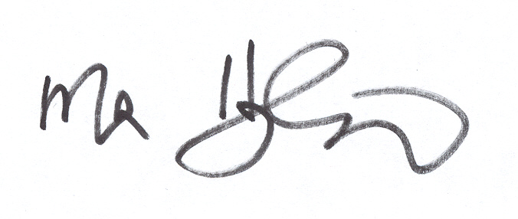
New York, USA

