Body Characteristics, Yield Indices And Proximate Composition Of Moonfish (Vomer setapinnis) Kolade

O.Y, Adejonwo O.A, Oramadike C.E, Ibrahim O.A.

Nigerian Institute for Oceanography and Marine Research Victoria Island Lagos.
Corresponding Author: Kemmystick2005@yahoo.com

ABSTRACT: The body characteristics, yield indices and proximate composition of moonfish (Vomer setapinnis) in Nigeria’s Coastal Waters were carried out with a view to obtaining the flesh yield, waste yield and their utilization potentials. The mean values of length (cm) and weight (g) were 22.76 ± 1.75 and 1 ± 31.7 respectively. Anatomical fractionation showed that Moonfish contained on the average 42.4% fillet, 26.1% head, 23.3% body frame and 4.9% gut. The proximate composition analysis showed that the fish sample contained 77.1% water content, 0.98% lipid, 20.4% protein and 1.5% ash. Moonfish thus constitutes a source of high protein as well as an ideal dietetic fish food.
[Kolade O.Y, Adejonwo O.A, Oramadike C.E, Ibrahim O.A. Body Characteristics, Yield Indices And Proximate Composition Of Moonfish (Vomer setapinnis). World Rural Observations 2010;2(2):61-64]; ISSN: 1944-6543 (Print); ISSN: 1944-6551 (Online). http://www.sciencepub.net/rural.
Keywords: Weight, Length, Anatomical, yield, Moonfish.

INTRODUCTION
Fish and fish products are known worldwide as a very important diet because of their high nutritive quality and significance in improving human health. Fish plays a vital role in feeding the worlds population and contributing significantly to the dietary protein intake of hundreds of millions of the populace. On a global scale, almost 16 percentage of total average intake of animal protein was attributable to fish in 1988 (FAO 1990). In the developing worlds, fish is a highly acceptable food that supplies as much as 40 percent of all animal protein available of the countries where fish is the main sources of animal protein, 39 out of the top 40 are found in the developing world. However, fish which contributes 36.6gm per day of net protein utilization in Nigerian homes is still below the recommended requirement by the world health organization (WHO). Moreover, the poor spend proportionally more on fish than on meat or other sources of animal protein. Fish has an edge over meat in that it is cheaper and relatively more abundant in Nigeria. (Eyo, 1986). Stansby (1954) established that information on the chemical composition of fish in respect to the nutritive value is important to compare with other source of animal protein in foods such as meat and poultry products.
In fish processing, the knowledge of proximate chemical composition of fish is very important, even as information on the lipid, protein, ash and water content is required for effective utilization. It is also essential to determine the proximate composition of the fish to report its nutritional composition from the public health point of view. Thus studies on fish composition and fish yield are essential if fish and fish products are to be maximally utilized. This work reports the body characteristics, yield indices and proximate composition of moon fish (Vomer setapinnis) caught in the costal waters of Lagos State Nigeria.

STUDY SITE
Fresh fish samples of Moonfish (V. setapinnis) were obtained from the Makoko fish market in Lagos. The fish samples were kept on ice in an insulated box and transported to the Nigerian Institute for Oceanography and Marine Research, Victoria Island Lagos for further analysis.

MATERIALS AND METHODS
Body characteristics and yield indices determination
Body characteristics and meat yield indices were determined using forty five fresh samples of Moonfish. The fish samples were first weighed whole using Ohau’s top loading electronic weighing balance. The total, standard and head lengths were measured using a standard graduated fish measuring board. The fish was be-headed, gutted and filleted. The separate parts were weighed each (in grammes) to determine the percentages compared to the local body weight.
Analyses
Fish samples were randomly selected for proximate composition. Triplicate determinations were carried out.
Proximate composition determination
The fillet of the fish samples were homogenized and used to determine proximate composition. The moisture content was estimated by drying samples to constant weight at 103±2⁰C using the oven dry method (AOAC, 1994). Lipid determination was carried out using the modified Bligh and Dyer procedure (AOAC, 1994), the ash content of the fish was determined by igniting the sample at 550⁰C for 5-6 hours until the sample was completely free from carbon particles in a carbolite Sheffield LMF3 muffle furnace while the total nitrogen was determined by the Kjeldahl method as described by Vlieg, 1984 and a factor of 6.25 was used for converting the total nitrogen to crude protein content of the fish sample.

RESULTS
The body characteristics of moonfish (V.setapinnis) were measured as shown in table 1. Moonfish samples had a standard length range from 16.4 -20.1 cm, total length range from 21.4 - 24.8 cm and total body weight range from 91.93-172.05 g and the total head length range from 3.3-6.6 cm.

Table 1: Body Characteristics of Moonfish (V. setapinnis)
Fish Parameter Measured  Total Weight (g)  Total Length (cm)  Standard Length (cm)  Head Length(cm) | Moonfish (V. setapinnis)  134.31 ± 31.7 (R= 91.93-172.05)  22.80 ± 1.75 (R= 21.4 - 24.8)  18.00 ± 3.66 (R= 16.4 - 20.1)  4.72 ± 1.41 (R= 3.3- 6.6)
Data are mean± SD and R= range
The yield characteristics of moonfish (V.setapinnis) as shown in table 2, showed a percentage decrease in the order of fillet, head, frame and gut of the fish samples. The order was 42.40 > 26.10 > 23.31 > 4.90 .
Table 2: Yield Characteristics of Moonfish (V.setapinnis)
Fish Parameter Measured  Gut As % Of Whole Fish  Head As % Of Whole Fish  Fillet As % Of Whole Fish  Frame As % Of Whole Fish | Moonfish (V. setapinnis)  4.90 ± 1.5 (R= 4.29-10.95)  26.10 ± 2.4 (R= 22.88- 46.07)  42.40 ± 3.7 (R= 57.26-62.35)  23.31 ± 1.8 (R= 22.41-37.48)
Data are percentage ± SD, R=range.
The results of the mean proximate composition of V.setapinnis are presented in figure 1.The fish specie had mean protein content of 20.42 %, lipid content of 0.98 %, water content of 77.1 % and ash content of 1.5 %.

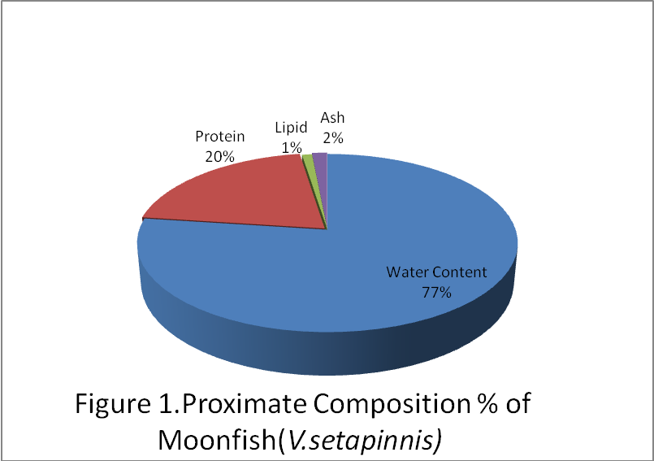

DISCUSSION
The mean length and weight of moonfish presented in table 1 were 22.8 ± 1.75 and 134.± 31.7 respectively. There were slight variations in sizes with respect to length and weight. This result was with respect to size, and could be due to interplay of factors affecting growth such as nutritional, physiological, biotic and climatic factors.
The result of yield indices in table 2 showed that the percentage yield of the edible flesh for moonfish (V. setapinnis) was 42.4%. This was gotten from the total of filleted skin of the fish sample, the remaining parts such as the head, gut and scale are regarded as waste. The percentage decrease in order of fillet, head, body frame and gut of the moonfish, agrees with Mohammed EL-Tahir Ali et al 1998. The fillet yield of 42.4% when compared to the entire percentage of the fish body weight, could be attributed to the feeding habit of the fish as a carnivore feeding on small fishes and crustaceans and the bony structure of the fish (Froese and Pauly, 2010).
The anatomical measurement of the moonfish gave an average of 31.1 % waste (i.e. 4.9% gut and 26.1 % head) and 65.7 % body trunk (i.e. 23.3 % body frame and 42.4 % fillet). The yield of edible portion of 65.7% of moonfish will make the fish a good source of raw material for canning and other value added products (Egwelle et al 1986). However, the waste recovered can be used for fish meal or silage production for animal feeds.
The results of the proximate composition of the moonfish showed that it is a high protein fish (15-21%) since its protein content is 20.42% with low lipid content of 1% . Fishes with lipid content below 5% are considered lean (Ackman,1989, Stanby,1982) hence moonfish is considered as a lean fish. The low lipid content value might be as a result of the environment and the type of diet the fishes feed upon. Its high protein content would make it an ideal source of animal protein that can be used to control diets.
The water content of the moonfish which was found to be quite high 77.1% was within the previously reported range in other fishes. (Gallagher, et al 1991). FAO report of 1999 states that water content and lipid content are inversely related and their sum is approximately 80% with other components accounting for the remaining 20 %.
Ash content of the fish which was in the high range of 1.5 % indicated that moonfish is a good source of minerals such as calcium, potassium, zinc, iron and magnesium.

CONCLUSION
The results of the experiment showed that moonfish has a high yield of edible portion making it suitable for canning and other value added product. It is also a suitable source of animal protein useful for controlling diets.

ACKNOWLEDGEMENTS
I wish to acknowledge Dr. G.R. Akande, H.O.D of Fish Technology/Biotechnology Department and Mr. M. Akinwale of the same department for their constructive criticism on this study.

REFERENCES
- Ackman, R.G (1989) Nutritional Composition Of Fats In Seafoods. Prog. Food Nutri.Sci.13:161-241.

- AOAC (1994) Official Methods Of Analysis. Association Of Official Analytical Chemists 15th ed. Arlington.

- Egwelle, A. U., Sorimade, S.O. and Talabi, S.O (1986) Nutritional Evaluation Of Traditionally Smoked Bonga Fish (Ethmalosa doralis) and Sawa (Sardinella aurita) Obtained From Different Markets In Lagos, Nigeria: A Preliminary investigation. In Proceedings of the FAO Expert Consultation on Fish Technology in Africa, Lisaka, Zambia, 21-25 January 1985.

- Eyo, A.A. (1986) Fish Handling, Preservation And Processing. In Fisheries Enterprises And Information Brochure p 40.

- FAO: Commodity Review and Outlook(1990-1991) (1990).

- Froese, R. and Pauly, D.2010 Selene setapinnis, Atlantic Moonfish:Fisheries,aquarium. Fish base World Wide Web Electronic Publication. http.//.fishbase.org/search.php.cite.2010.

- Gallagher, M. L., Harrell, M. L and Rulifson, R.A. (1991) Variation in Lipid and Fatty Acid Contents of Atlantic Croakers, Striped Mullet, and Summer flounder. Transactions of the American Fisheries Society 120:614-619.

- Mohammed El-Tahir Ali, Babikir, S.A., Tibin, I.M. (1998) Body Characteristics, Yield Indices And Proximate Composition of Commercial Fish Species of Lake Nubia. FAO Fisheries Technical paper pg 211-214

- Smith, C.L. (1997) National Audubon Society Field Guide To Tropical Marine Fishes Of The Caribbean, the Gulf Of Mexico, Florida, the Bahamas and Bermuda. Alfred A. Knopf, Inc. New York.720p

- Stansby, M.Z. 1954. Composition of certain species of freshwater fish. Food. Res. 19: 231-234

- Stansby, M.E (1982) Properties Of Fish oils And Their Application To Handling Of Fish And To Nutritional And Industrial Use. In: Martin, R.E., Flick, G.J., Hebard, C.E. and Ward, D.R. Eds Chemistry and Biochemistry Of Marine Food Products.pp75-92.Ayi Publishing Co., Westport, CT.

- Vlieg, P. (1984) Proximate Composition Of New Zealand Slender Tuna Allothunnus fallai. New Zealand Journal Of Science 27(4): 427-433.

6/11/2010

