Comparative Studies On Effects Of Garlic (Allium Sativum) And Ginger (Zingiber Officinale) Extracts On Cowpea Insects Pest Attack.

Isirima Chekwa, Ben¹, Umesi Ndubuisi² and Nnah Maxwell B.³
^{1&3}School of Vocational Education, Department of Agricultural Education, ²School of Science, Integrated Science Department. Federal College of Education(Technical ) Omoku.
Email: chekirima@yahoo.com

ABSTRACT: In an investigation conducted at the Teaching and Research Farming of the Rivers State University of Science and Technology Port Harcourt to compare the effects of plants extract of Garlic and Ginger on the growth and yield characteristics of cowpea, garlic bulbs and ginger rhizomes were weighed(0,30,and 60g/l) and ground into paste. Each rate of the pastes were steeped into two spoonfuls of vegetable oil and mixed with 10g of detergent(to serve as adjuvant) .Each rate of the garlic or ginger, vegetable oil and detergent mixture was diluted in 10 liters of water and applied as foliar spray on growing cowpea 3Weeks after planting. Subsequent spray scheduled was done at 10-day intervals. It was a 2×3×4 split plot factorial experiment fitted into a completely randomize design and replicated three times. Leaf damage decreased with increasing application of the plant extracts (garlic and ginger). Though a linear increase in insects pest population was observed as levels of the plant extracts increased , flower abscission decreased with increase in rates of the plant extract treatments. Again weight per 100 seeds and grain yield increased significantly with increasing rates of the plant extract treatments. The observed increase in cowpea insect pest incidence with increase in the rates of the plant extracts, implies that the plant extracts posses attractant properties while at the same time exhibiting antifeedant characteristic making it possible for an increase in grain yield as was observed in this study.
[Isirima Chekwa, Ben, Umesi Ndubuisi and Nnah Maxwell B. Comparative Studies On Effects Of Garlic (Allium Sativum) And Ginger (Zingiber Officinale) Extracts On Cowpea Insects Pest Attack. World Rural Observations 2010;2(2):65-71]; ISSN: 1944-6543 (Print); ISSN: 1944-6551 (Online). http://www.sciencepub.net/rural.
Key words: Comparative, Extracts, Ginger, Garlic, attractants, Antifeedants.

Introduction
Cowpea production in the rain forest zone is time bound. Most times, cultivation of this legume coincides with the season during which oviposition and breeding of most Insect pest of cowpea is highest. Insect pest attack is a major biotic constraint to increased crop productivity, Cowpea inclusive. Cowpea is one crop that is known to suffer severely at the event of insect pest attack.
The yield of Cowpea and other crops are known to decline considerably with increase in the incidence of insects pest attack. Cowpea is usually cropped at the end of the raining season (August –September), in the rain forest zone, incidentally is the breeding period for most cowpea insect pest. Leaf defoliators, flower bud and pod sucking bugs, thrips and mites are some of the classes of insects pest that attack cowpea. Incidence of insect pest attack on cowpea is specific to development phases of the crop. leaf defoliators (Grasshopper, Ootheca mutabilis etc.) attack cowpea at the early vegetative phase. While thrips and other insects like Nezara viridula mounts serious attack on cowpea plant during flowering phase, pod sucking bugs (Acanthomyia horrida Riptorus Anaplocnemis curvipes) attack cowpea from flowering through pod development and maturation phases
For effective cowpea production, cultural , physical , chemical or biological control measure has been employed as a strategy for insect pest control (Benz 1987, Alloty 1991). Oviposition, breeding and infestation activities of insects pest are time dependent. In recognition of this and an adequate knowledge of the physiology of the various insect pest species determines to a great extent the effectiveness of insecticide treatment. The use of synthetic chemicals has gained wide acceptance among farmers. Though, synthetic chemicals has been an effective measure for the control of insects pest attack on crops, its continual adoption as a means of pest control has been under sever criticisms not only due to problems of high cost of the chemicals but also as a result attendant toxicity problems and handling difficulties (Isirima, Wahua and Epidi,2008)
Reduction in percentage seed germination (Ram and Gupta, 1975) and insect pest resistance to prolong application of certain synthetic pesticides (Sing, 1990) are further pressure on the need to develop a friendly crop protection strategy that is not only cheap to acquire but also readily available and easy to handle.
Studies has shown that extracts of some plants could serve as a useful alternative to synthetic insecticides in the control of crops pests incidence, cowpea inclusive.
In addition to possessing broad spectrum potentials, plants extracts are biodegradable, inexpensive ,accessible to the farmers , safe to handle and simple to apply(Jacobson, 1983, Saxena(1989). The efficacy of plant extracts in the control of insects pest is based either on the insecticidal, larvacidal, repellent, antifeedant and/or fumigant characteristics possessed.
Garlic, a bulb producing crop in the family alliaceae , has a very strong pungnant odour and it is known to contain an essential oily (sulphur ) compounds (Duke 1983) whereas Ginger (Zingiber officinale) is a perennial and rhizome producing plant that is known to contain resins and a volatile oil (Grieve 1974). It has a penetrating and aromatic odour , these properties predispose extracts from the plants as an important biochemical substance for control of insect pest.
The aim of this study therefore is to compare the efficacy and suitability of plant extracts of ginger and garlic to the control of insects pest incidence of cowpea.

Materials and Methods
The experiment which was designed to compare the effects of Ginger and Garlic extract was located at the Teaching and Research Farm of the Rivers State University Of Science and Technology Port Harcourt in Rivers state of Nigeria. The plot for the experiment was cleared , stumped and a land area of 25×30m² marked out. Suitable seedbeds were prepared and Cowpea seeds planted soon after seedbed preparation.
It was a 2×3×4 factorial experimental design, fitted into a Completely randomize design which was replicated three times.
Cowpea seeds IT84-2246 obtained from IITA Ibadan were sown at the rate of 3 seeds per hole at a spacing of 30×50cm. The seeds were latter thinned to two per stand two weeks after planting.
Garlic bulbs and Ginger rhizomes purchased from a fruit market in Port Harcourt Rivers State of Nigeria were weighed and ground separately into paste at the rates of 0,30 and 60g/l. Each rate of the Garlic and Ginger paste were then steeped into two teaspoonfuls vegetable oil.
Each Garlic, Ginger and vegetable oil infusion were mixed with detergent soap and latter dissolved in a liter of water. Each rate of the mixture was first stirred and latter filtered through a fume muslin cloth. Each of the mixture were then diluted in 8 parts of water . The crude extract so obtained were sprayed on the growing cowpea plant .
Three weeks after planting (3WAP), subsequent spray schedule were at 10 days intervals.
Larva and insect pest population were determined by direct counting of the numbers found on the plants , percentage pod and leaf damage were also determined. The weight of the grains and weight per 100grains was determined using a weighting balance.

Results
Results of the effects of plant extracts of garlic and ginger on leaf and pod damage per plant, insect pest population, number of pods per plant, weight per 100 seeds and grain yield per ha is as shown in figures below. Leaf damage decreased significantly ( p<0.0.05) as levels of the plants extract increased from 0, 30 to 60g/l across three consecutive weeks of continuous (3,4 and 5WAP) observation (Fig.1a). Highest mean leaf damage of 7.0 and lowest mean damage 2.0 and 3.0 were observed at 0 and 60g /l garlic and ginger extracts treatment levels respectively.
Pod damage per plant did not differ significantly p ( <0.05) as the levels of ginger extracts increased. However at 60g/l garlic extract application rate, a significant p(<0.05) increase in pod damage was observed six weeks after planting (6WAP) as shown in Fig 1.
Insect pest population across different weeks of observation increased linearly as levels of the plant extracts of garlic increased as demonstrated in Fig. 2, but the population of insect pest within the different levels of ginger extract treatment did not differ significantly (p<0.05) as levels of ginger extracts treatment increased. An irregular pattern of response was observed across 3, 4, 5 and 6weeks of continuous observation, this could probably be associated with the a gradual oxidation of the olerisine substance in ginger rhizome due to exposure of the extract to sunlight.
Though insects pest population increased as levels of the plant extracts of garlic increased ,flower bud abscission showed a significant linear decreased at a p <0.05 with the application of increasing levels of garlic and ginger extracts (Fig.3).
Number of pods per plant increased significantly (P<0.05) with increase in levels of the plant extracts (Fig.4) but ginger extract showed a higher level of increase in number of pods per plant across the various treatment levels when compared with garlic extract treatment. On the other hand a curve linear response pattern was observed in Weight (g) per 100 seeds with the application of increasing levels of the plants extract( Fig. 5.) A linear increase was first observed at 30g/l treatment of the plant extracts, beyond this level, weight in g per 100 seeds decreased significantly in the respective treatments levels of the plants extract .
Within the various levels of garlic and ginger extracts treatment, a significant linear increase in grain yield (kg) was observed as levels of the plant extracts of garlic and ginger increased(Fig.6) but the application of garlic gave higher yield when compared with yield obtained from the same levels of ginger extracts treatment.

Discussion
Incidence of insect pest attack is usually very server at all stages of cowpea development . Often, it leads to significant reduction in yield(Amable,1991), especially where little or no control measure is applied. Several insect pest have been associated with attack on cowpea plant and their effect on the vegetative and yield characteristics of the plant have been document. In this study, the effect of garlic and ginger extract in the control of cowpea insect pest attack on the vegetative character and yield of cowpea is as presented earlier.
The observed linear decrease in leave and pod damage with increasing application of the plant extracts of garlic shows the potency of the plant extract to reduce incidence of leaf-hoppers, defoliators and pod sucking bugs in cowpea production. The ability of plants extracts to protect cowpea from severe attack of the leaf defoliators, leaf hoppers and pod sucking bugs is probably anchored on the antifeedant and repellent characteristics of garlic and ginger extracts respectively. A mechanism based on the presence of an olerisine substance, a volatile oil with camporous ordour characteristics of ginger and which is known to possess a burning sensation and the antifeedant characters of garlic due to the presence of an essential oil(allyl proply disulphide and daily disulphide).
The observed increased in insect pest population with application of increasing level of garlic shows that the plant extract posses attractant properties which is associated with the diffusive penetrating odour of garlic bulb. However, there seems to be a gradual oxidation of the camphorous substance in ginger rhizome, with the exposure of the ginger extract to sunlight, hence the observed irregular response pattern in number of insects per plant .
The decrease in flower bud abscissions and the linear increase in grain yield and weight per hundred seeds with the application of increasing levels of the plant extracts clearly shows that the earlier observed increase in insect population had no significant adverse effect on the grain production in cowpea. Earlier Isirima, Wahua, and Epidi (2008), reported increase in insect pest population, yield, and a linear reduction in flower abscission, leaf and pod damage as levels of garlic extract application increased.
Though, Zeher( 1980), reported that the use of substance of plant origin in the control of insect pest attack on crops, often yields conflicting and over lapping results, the ability of the plant extracts of garlic and ginger to control cowpea insect pest incidence has been clearly demonstrated in this study.

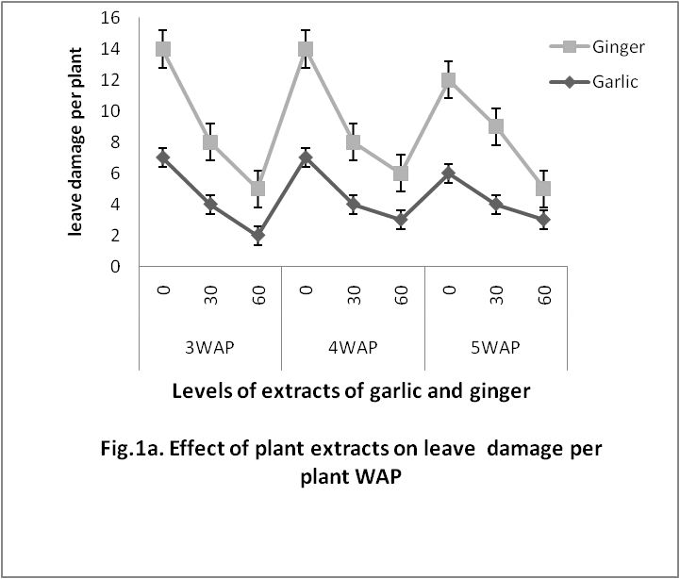

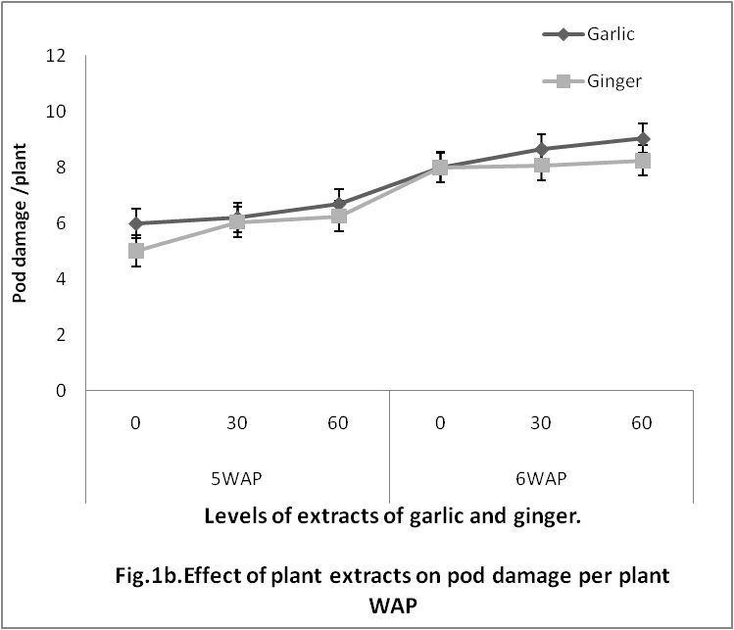

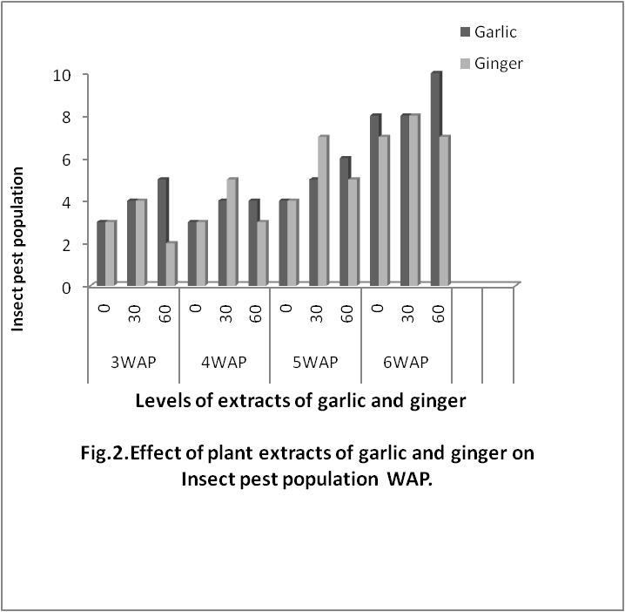

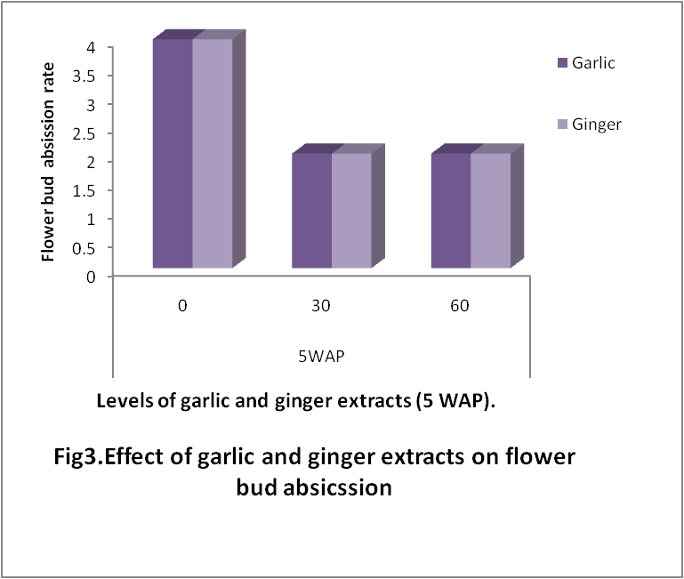

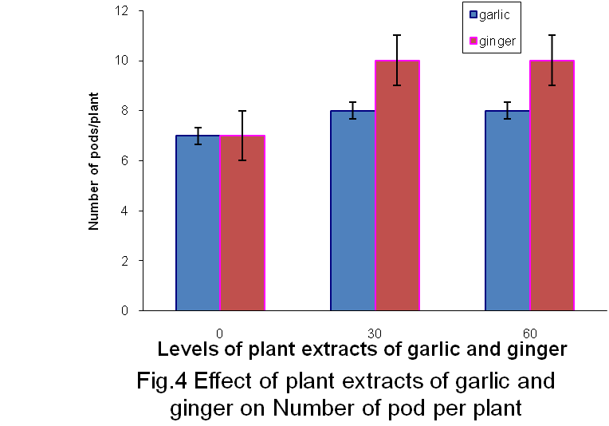

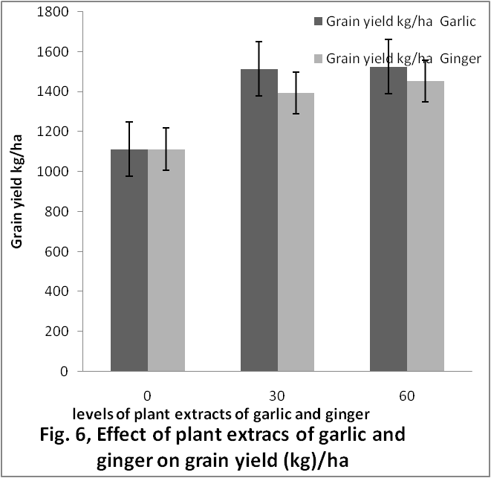

Conclusion
This study has shown that both garlic and ginger extracts has the capacity to reduce incidence of cowpea leaf hoppers, leaf defoliators and the degree of flower bud abscission translating to a reduction in flower bud abscission, leave and pod damage . At the same time, the study shows that increasing application of garlic and ginger extracts has the potency to promote grain yield, but an observed significant increase in insect pest population was recorded with increasing rate of garlic. This shows that the plants extracts of garlic posses attractant properties and in addition serve as antifeedant against cowpea insect pest incidence.

Authors:
Isirima Chekwa, Ben1, Umesi Ndubuisi2 and Nnah Maxwell B.3
1&3School of Vocational Education, Department of Agricultural Education,
2School of Science, Integrated Science Department.
Federal College of Education (Technical ) Omoku.
Email: chekirima@yahoo.com

6/25/2010

