2- D Electrical Imaging And Its Application In Groundwater Exploration In Part Of Kubanni River Basin-Zaria, Nigeria

Ameloko A. Anthony, *Rotimi O. John
Department of Petroleum Engineering Covenant Universty Ota Ogun State Nigeria
Corresponding e-mail/Tel: aduojo2001@yahoo.com/ 2348036878319
*E-mail: tossynrotimmy@yahoo.com

ABSTRACT: A modern field system, Terrameter (Signal Averaging System) SAS 4000/1000, was used to accomplished the task of exploring groundwater in Kubanni River Basin. 23 image lines were measured at different strategic locations of the study area based on the fractured map of the area and previous information obtained from the area. Four straight line profiles with a spread of 200 m per section were traversed during the course of this survey with three of them generally trending along a North-South direction while the fouth, trends approximately along the East- West direction. The four profiles has a total coverage distance of about 4.2 km. The data used for this survey was acquired by measuring a series of constant traverse along the same line but with the electrode spacing being increased with each successive traverse. Since increasing separation leads to greater depth penetration, the measured apparent resistivities was used to construct a vertical contoured section displaying the variation of resistivity both laterally and vertically over the section. Interpretaion of the data aquired using this equipment revealed the suitability of the Southern part of the study area for location of boreholes, as the resistivity values of rock obtained around this zone reflects aquiferous materials. More layers of rock units around Area BZ and Tudun Sarki were revealed than what was reported by previous workers. Also observed were slight variation in depth to bed rock around area BZ and the Nigerian College of Aviation Technology as compared with observations made by previous workers. However, the observation of the increasing undulating bedrock geometry with depth towards the southern part of the study area was consistent with that of the previous workers.
[Ameloko A. Anthony, Rotimi O. John. 2- D Electrical Imaging And Its Application In Groundwater Exploration In Part Of Kubanni River Basin-Zaria, Nigeria. World Rural Observations 2010;2(2):72-]; ISSN: 1944-6543 (Print); ISSN: 1944-6551 (Online). http://www.sciencepub.net/rural.

INTRIDUCTION
Since electrical imaging (2- dimentional) provides a more detailed view of subsurface structure, the present study is designed to produce appropriate images of the basin with the aim of investigating and delineating appropriate location for underground water exploitation.
A large number of geological and geophysical studies have been carried out over the past fouthy years in the basin. In one such works, Du preez (1956) reported the presence of well-developed, steep-dipping joints in some granitic outcrops in the basin. Unfortunately, the specific locations of the outcrops were not given. Also Messrs Preussag Nigeria Limited, between 1981 and 1982, was reported to have carried out a resistivity survey (1-dimentional) at Jama'a Kubanni village with the aim of siting a borehole at the village (Olufemi,1985). From the survey, the company inferred the presence of faults within the bedrock which they believed caused the down throw of certain portion in the study area. Furthermore, Hassan, et al (1991) carried out a geoelectrical (1-dimentional) investigation of the western half of the Basin and concluded that the bedrock in the study area is undulating with depths generally increasing towards the southern parts of the study area. They suggested the existence of a great depression in the South Eastern part of the study area, which trends SE-NW and NE-SW and occupies about 40% of the project area. The depth of investigation in the study varied from 20 m to 60 m in different places. They further asserted that the weathered basement thickness in the basin ranges from 11 m to 50 m. Shemang (1990) carried out a resistivity (1- dimentional) survey of the entire Kubanni basin and inferred that the weathered basement and fractured basement most likely constitute the main aquifer components which are well developed in the west-central part of the basin. He concluded that the weathered basement thickness in the basin ranges from 10 m to about 45 m, with an average thickness of about 15 m. He further confirmed the existence of a deepseated basement structure in the south western sector of the basin, which he suggested to be most likely a burried erosional feature rather than a structure originating from the subsidence of basement faults.
From the above summary, it implies that little or no 2-d electrical investigation had previously been carried out in the basin, as most researches were carried out using 1-dimentional electrical survey only. 2-d survey will throw more light on the aquifer types and general subsurface image of the basin.

THE PROJECT AREA
The Kubanni River basin occupies the centre of the South-Eastern sector of the Zaria sheet No 102 SW of the Nigerian Ordinance survey map ﴾Fig 1.1﴿. It is approximately bounded by latitudes 11 4' 25" N and 11 10' 46" N and longitudes 7 36' 55"E and 7 44' 12" E. The basin averages about 15 km and 7 km in lenght and width respectively with an approximate area of about 105 km² (Eigbefo, 1978). The basin is elongated in the NW-SE direction. It is widest near the Institute of Agricultural Research, Ahmadu Bello University, Zaria and narrowest where the river joins the Galma River (Eigbefo, 1978).

GEOLOGICAL SETTING OF THE KUBANNI RIVER BASIN
The Kubanni River basin is underlain by basement rocks of Precambrian age. They are mainly granites, gneisses, and schists. The Zaria crysalline rocks are part of the Nigerian Basement Complex. Oyawoye (1965) showed that there is structural relationship between this basement Complex and the rest of the West African basement. This is partly due to the fact that the whole region was involved in a single set of orogenic episode, the Pan African orogeny, which left an imprint of structural similarity upon the rock units.
Granitic intrusions form a suite of batholiths (the Zaria Batholiths), part of which outcrops as the Kufena Hill. The gneisses are found as small belts within the granite intrusions, and are also found east and west of the Batholiths. The biotite gneiss extends westward to form agradational boundary with the schist belt. The gneiss continues eastward to some extent and is occasionally broken up by the older granite (McCurry,1970). The Older granite intrusion is surposed to have been formed at the bottom of a fold mountain belt (Wright and McCurry, 1970).
The thrusting imposed on the basement complex during the Pan African Orogeny movement is believed to have brought together rocks of different ages with different structural and metamorphic styles (Grant, 1969). The metasediment probably belongs to the sedimentary and granitic facies that were formed in a geosynclinal trough which had earlier developed at the end of the Pan African Orogeny (Tokarski, 1972). During the Pan African Orogeny, the sediments and igneous material, together with the former metamorphosed basement rocks behaved as one tectonic unit. Some of these metamorphosed rocks became assimilated into the granite intrusions that accompanied the last orogeny (Grant, 1969).

AIM OF THE PRESENT STUDY
In carrying out this survey, the following objectives are the principal aim;
(i) To determine the appropriateness or otherwise of the locations imaged for siting of boreholes
(ii) To produce appropriate images of this part of the basin with the aim of determining aquifer thickness, depth to the bedrock, and fracture systems in the study area.
(iii) To shed more light on types and extent of the various aquifer in the study.

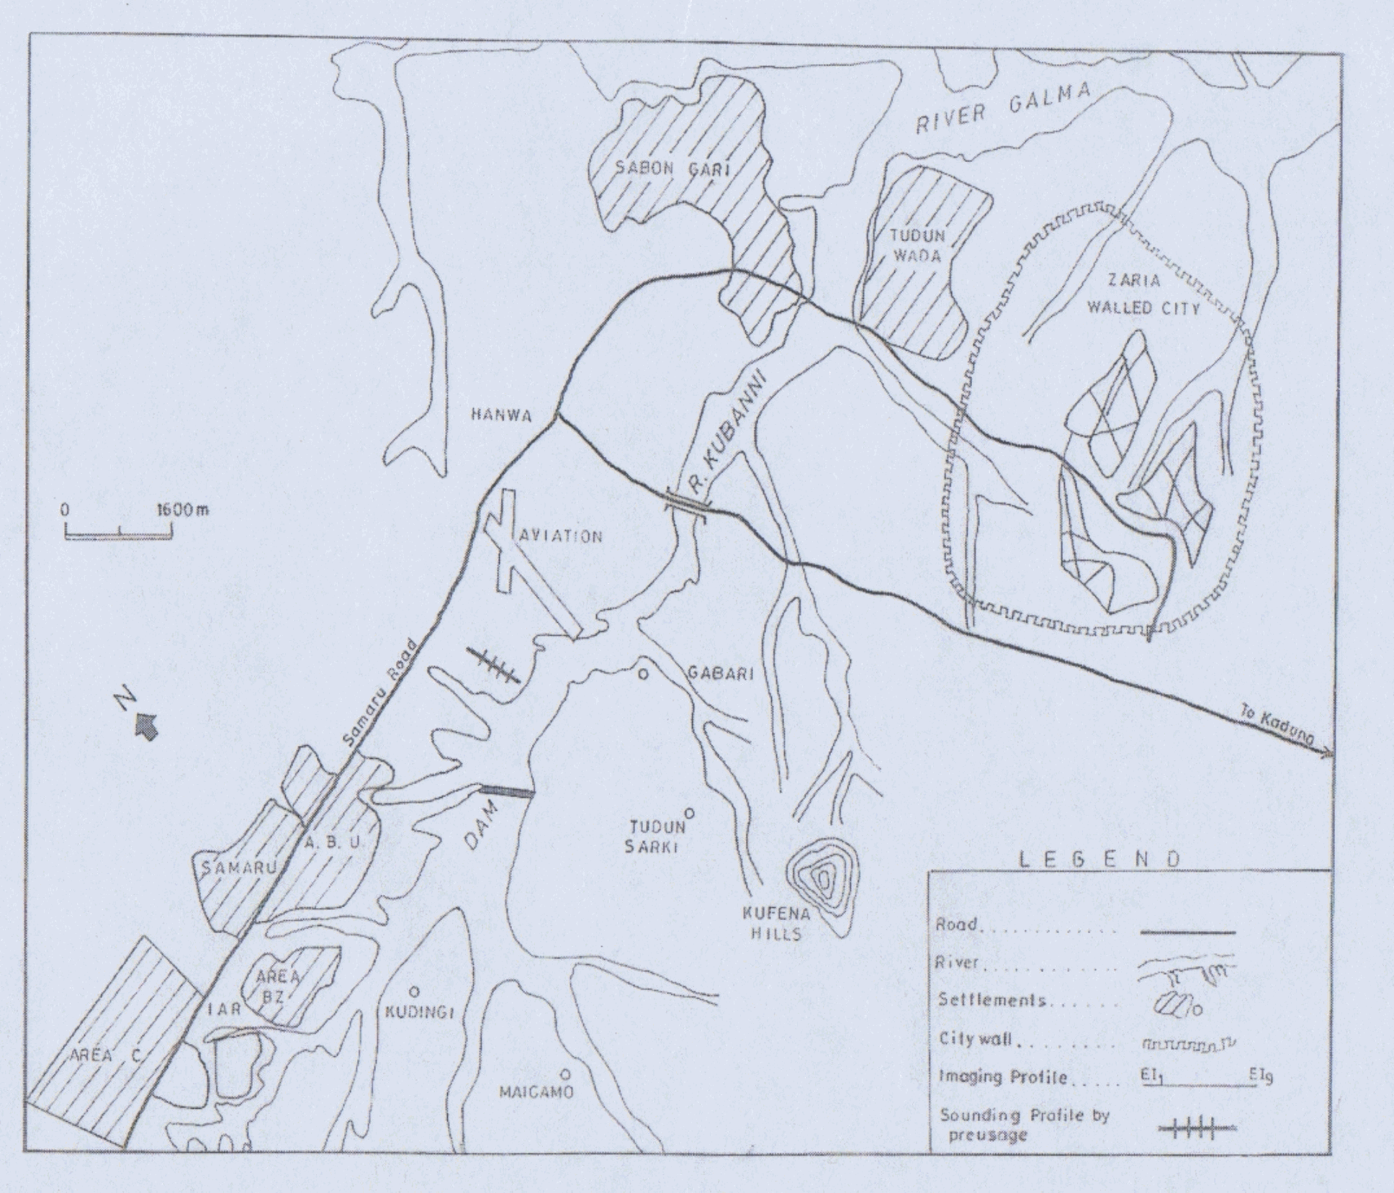
11⁰ 10' 45"' N 7⁰ 36' 55" E
Figure.1.1. Location map ofthe Kubanni Basin, Zaria and the study area

FIELD SURVEY METHOD AND MEASUREMENT PROCEDURE
One of the new developments in recent years is the use of 2-D electrical imaging/tomography surveys to map areas with mederately complex geology (Griffiths and Barker, 1993). Such surveys are usually carried out using a large number of electrodes, 25 or more, connected to a multi-core cable.
In the method employed in this study, Wenner Continuous Vertival Electrical Sounding (CVES) configuration, using the Abem Lund Imaging System with the electrode separation was put at 5 m with the imager system using a multicore cable to which 41 electrodes are connected at takeouts moulded on at predetermined equal intervals, with each spread covering a length of 200 m
Normally, a constant spacing between adjacent electrodes is used. The multi-core cable is attached to an electronic switching unit which is connected to a laptop computer. The sequence of measurements to take, the type of array to use and other survey parameters are normally entered into a text file which can be read by a computer program in a laptop computer. Different resistivity meters use different formats for the control file, so one will need to refer to the manual for the system. After reading the control file,the computer program then automatically selects the appropriate electrodes for each measurement. In a typical survey, most of the fieldwork is in laying out the cable.
To obtain a good 2-D picture of the subsurface, the coverage of the measurements must be 2-D as well. As an example, fig.1.2 shows a possible sequence of measurements for the Wenner electrode array for a system with 20 electrodes. In this example, the spacing between adjacent electrodes is "a". The first step is to make all the possible measurements with the Wenner array with electrode spacing of "1a". For the first measurement, electrodes number 1, 2, 3 and 4 are used. Notice that electrode 1 is used as the first current electrode C1, electrode 2 as the first potential electrode P1, electrode 3 as the second potential electrode P2 and electrode 4 as the second current electrode C2. For the second measurement, electrodes number 2, 3, 4, and 5 are used for C1, P1, P2, C2 respectively. This is repeated down the line of electrodes until electrodes 17, 18, 19 and 20 are used for the last measurement with "1a" spacing. For a system with 20 electrodes, note that there are 17 (20-3) possible measurements with "1a" spacing for the Wenner array.
After completing the sequence of measurement with "1a" spacing, the next sequence of measurements with "2a" electrode spacing is made. First electrodes 1, 3, 5, and 7 are used for the first measurements. The electrodes are chosen so that the spacing between adjacent electrodes is "2a". For the second measurement, electrodes 2, 4, 6, and 8 are used. This process is repeated down the line until electrodes 14, 16, 18 and 20 are used for the last measurement with spacing "2a" for a system with 20 electrodes.
The same process is repeated for measurements with "3a", "4a", "5a" and "6a" spacings. To get the best results, the measurements in a field survey should be carried out in a systematic manner so that, as far as possible, all the possible measurements are made. This will affect the quality of the interpretation model obtained from the inversion of the apparent resistivity measurements (Dahlin and Loke, 1998).

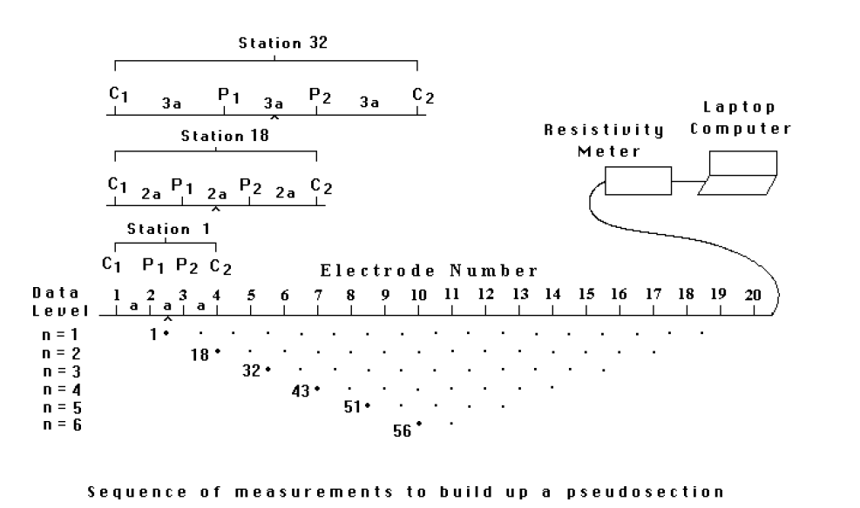
Figure 1.2 Sequence of measurement to build up a pseudosection

DATA COLLECTION
The location of the profile lines was made to extend beyond the areas surveyed by previous workers so as to achieve the stated objectives ﴾figure.1.1﴿.Three of the profiles trend in the N-S direction, with the fouth trending in E-W direction to give an effective maximum depth of imaging of about 40m to 50m. A summary of the lines is given in Table1.
Table 1.1Profile Locations In The Study Area
S/N | PROFILE | NO OF  ELECTRODES | LOCATION | LENGHT  M | ORIENTATION
1. | P1 | 41 | from Area BZ to  Maigamo Village | 200 | N-S
2. | P2 | 41 | Base of ABU Dam to  Tudun Sarki Village | 200 | N-S
3. | P3 | 41 | Back of School of  Aviation to Gabari  Village | 200 | N-S
4. | P4 | 41 | From Tudun Sarki  to Gabari Village | 200 | E-W

INTERPRETATION TECHNIQUE
As in all other geophysical methods, the interpretation of data from electrical imaging involves expressing in geological terms the information given by the measured apparent resistivity data. Such an interpretation demands, on the one hand, considerable practical experience with the method and, on the other, a sound knowledge of the geology of the region under consideration. In this work, all the available geological information on the project area was taken into consideration to constrain the interpretations. Also in interpreting the data, each layer of rock type in the Kubanni River basin was assumed to be homogeneous and isotropic.
In interpreting Lund imaging data, Computer assistance is needed due to the large amount of data collected from the field. The PSEUDO.EXE and ERIGRAPH.EXE software for instance are developed for automatic drawing of pseudosections in grey scales or colour, using linear interpolating between data points. Third party software packages for resistivity data processing can also be used for advanced interpretation. One example of such a program is RES2DINV.EXE, which performs smoothness constrained inversion (automatic model interpretation) using finite difference forward modeling and quasi- Newton technique (Loke, 1994).
However, for this survey, WINSURF and FORTRAN were the software and compiler used respectively for the qualitative interpretation of the data that were obtained using the Lund imaging equipment. The FORTRAN was used for sorting out the resistivity values obtained at various depths thereby making them compatible with the WINSURF that was used for the interpretation.
What the software does is simply plotting the data points in a diagram, using the length axis for the distance along the surveying line and the depth axis for the electrode separations. The distance for the electrode configuration midpoint is thus plotted against the electrode separation for each measured data point, letting the letter reflecting the measurement depth. The corresponding apparent resistivities for the plotted points are then used to contour the variation in apparent resistivity along the surveying line. The data that are contoured form a pseudo depth section that qualitatively reflects the spatial variation of resistivity in cross-section. The contoured pseudosection contains distinct subsurface geological imformation that is reflected in the general form of the pseudosection.
Typical Resistivity Values from Previous Works
Representative resistivity values of earth materials in the study area were derived from the works of Ososami (1968) and that of Messrs Preussag Ltd as contained in Olufemi (1985).

Table 1.2 Typical Resistivity values compiled from previous works (Shemang (1990); Aminudeen (1990); Hassan, Ajayi and Ojo (1991) and Baimba(1978) ).
Rock type | Resistivity (Ω m)
Clay – fresh water  Dry clay  Weathered basement  Laterite  Slightly weathered basement  Dry sand  Fresh basement (crystalline) | 30-70  40-100  50-100  200-400  200-500  500-1000  >1000

Table 1.3: Resistivity values used to derive geologic sections in this work
Rock type | Resistivity (Ω m)
Fadama loam  Clay, silt and sand (topsoil)  Sand and gravel  Weathered laterite  Fresh laterite  Weathered basement  Fresh basement | 30-90  100-200  100-180  200-500  500-600  20-100  > 1000

0.00
20.00
40.00
60.00
80.00
100.00
120.00
140.00
160.00
180.00
200.00
0.00
400.00
380.00
340.00
300.00
260.00
220.00
180.00
140.00
100.00
60.00
0.00
20.00
40.00
60.00
80.00
100.00
120.00
140.00
160.00
180.00
200.00
0.00
Distance (m)

Figure. 1.3 The second section along profile 1 around Area BZ (Table1.1)

0.00
20.00
40.00
60.00
80.00
100.00
120.00
140.00
160.00
180.00
200.00
0.00
550.00
500.00
450.00
400.00
350.00
300.00
250.00
200.00
0.00
20.00
40.00
60.00
80.00
100.00
120.00
140.00
160.00
180.00
200.00
0.00
1
50.00

Figure. 1.4 The third section obtained close to a river just before Kudingi Village (Table1.1)

0.00
20.00
40.00
60.00
80.00
100.00
120.00
140.00
160.00
180.00
200.00
300.00
270.00
240.00
210.00
180.00
150.00
120.00
90.00
60.00
0.00
20.00
40.00
60.00
80.00
100.00
120.00
140.00
160.00
180.00
200.00

Figure1.5 The third section obtained on Profile 4 around Tudun Sarki village (Table1.1)

ELECTRICAL IMAGES ALONG THE PROFILES
As mentioned earlier, four straight line profiles were traversed during the course of this survey and three of them, P1, P2 and P3 generally trend along a N-S direction while the fourth, P4 trends approximately E-W direction (Table1.1). Typical examples of cross sections along profiles, P1 and P4 are shown bellow. Similar plots and interpreted model were obtained for each of the other 20 interpreted CVES sections.

INTERPRETATION
Figure. 1.3 shows the second section along profile 1 around Area BZ, (Table1.1) and is basically composed of about four rock units. The topmost as seen from the section is made up of mostly sand and clay. This constitutes a low resistivity zone (60-100 Ω m) and represents about 20% of the entire formation within this section. It occurs up to the depth of about 20 m in some places. The second layer constitutes the intermediate resistivity zone (100-220 Ω m) and is attributed to the presence of sand, silt and gravel (lateritic) resulting from weathering of the basement structures and this layer extends to a depth between 20 to 45 m across the section. The third layer of low resistivity value is believed to be due to the presence of weathered basement materials. It has resistivity values between 20-60 Ω m and a thickness of about 8-10 m. The fourth layer with resistivity values between the ranges of 220-400 Ω m is attributed to the presence of fractured basement and it constitutes about 30% of the entire formation.
Figure. 1.4 shows the third section obtained close to a river just before Kudingi Village (Table1.1). The figure reveals that the section contains three types of rock formations. Generally, the resistivity values of the rock units range from 100-550 Ω m. The first layer has resistivity values ranging between 100-200 Ω m which is attributed to the presence of clay, silt and sand. This layer extends up to a depth of about 20 m from the surface as seen on the section. Generally, it constitutes about 40% of the entire rock units on this section. The zone of intermediate resistivity values (200-400 Ω m) is considered to be due to weathered laterites which span from a depth of about 20 m to 50 m below the first layer. This layer represents about 40% of the entire section. The zone of relatively higher resistivity (400-550 Ω m) is assigned to slightly weathered basement rock. On this section, it extends from a depth of about 45 m beyond the limit of the depth of investigation. Also the spatial distribution of the bedrock within the weathered laterites is probably associated with weathering activities. This third layer represents the remaining 20% of the entire formation.
Figure1.5 shows the third section obtained on Profile 4 around Tudun Sarki village (Table1.1). This section reveals the presence of three rock units. The first layer of intermediate resistivity values (100-210 Ω m) indicates the presence of sandy, silty and clayey materials with average thickness of about 18 m. The Low resistivity (30-90 Ω m) zone represents the weathered basement materials of thickness of about 20 m. The last layer of relatively higher resistivity values (210-370 Ω m) indicates the presence of a fractured basement rock.

DISCUSSION OF RESULTS
Based on the interpretation of the electrical images obtained from the study area, a number of deductions, which include the basement geometry and the groundwater potential of the study area in relation to work of previous workers were made. These deductions are discussed below.
The Groundwater Potential of the Study Area
The storage elements for groundwater in the Kubanni basin are the weathered basement, the weathered laterite and the alluvial sands (Olowu, 1967; Eigbefo, 1978).
According to Eigbefo (1978), the weathered basement is the most important component of the aquifer in the Kubanni basin. Generally, the electrical images along Profiles 2, 3 and 4 all located near the southern part of the study area indicate relatively large thicknesses of weathered materials overlying the basement rocks. These form the aquifer in the study area. Their thicknesses in some of the images were as large as 20-30 m as seen on sections E.I 22 on profile 4 (figure. 1.5)
The view of the previous workers in the basin in this regard also is consistent with this result, especially the work of Hassan, (1991) that suggested the area around Gabari Village to be associated with the maximum aquifer thickness. This was reflected on section E.I 20 of this work. However, the thicknesses of the aquifer in this area are thicker than what was observed by previous workers. This is reflected on the sections on profile four. From the interpreted images on Profiles 3 and 4, all around the southern part of the project area, it is observed that the fractured basement rocks are located deeper than 50 m and large thickness of loose materials deposited on them. Although fractures are not directly indicated, the increased thickness of weathering here provides a good reservoir with a higher probability of bedrock fracturing (Acworth, 1987).
Basement Geometry within the Study Area
The depths to bedrock are clearly shown on the sections obtained along the profiles traversed in the course of this work. Generally, the basement rocks are shallower around the northern part of the study area while they get deeper towards the southern part of the study area. This result, to a great extent, agrees with the work of Hassan (1991) and Ososami (1986). They observed that the bedrock generally gets deeper towards the southern part of the project area and reaching the deepest point around the end of profile 3. This is seen from the interpreted images. On Profile 1 for instance, the bedrock was prominently reflected at average depth of 20 m from the surface on section E.I.1 and about 25 m on E.I.2 (figure. 1.3) all around Area BZ (Northern part) of the study area, while sections obtained along the fourth profile revealed the presence of basement rock at a depth of about 50 m and beyond. This is an indication that bedrock in this area are found well below 50 m of depth. The first few sections, on profile 3, however did not show bedrock materials present at that point. This therefore suggests that the bedrock around this area is well situated below 60 m. The bedrock was however seen to be shallow around the Nigeria College of Aviation as reported by Hassan (1991).

LIMITATIONS
1. The PSEUDO.EXE, ERIGRAPH.EXE and RES2DINV.EXE software was not available to be used for interpretation.However, results obtained using FORTRAN and WINSURF yielded reasonable and accepted subsurface images.
2. Missing or Bad data points as a result of a bad electrode can distort the real anomaly and affect the interpretation accuracy.
SUGGESTIONS FOR FUTURE WORK
The electrical imaging technique is not a reconnaissance tool. It is suitable for the detailed study of problem areas that have been selected using other techniques, such as Electromagnetic Method (EM) or resistivity traversing. But to obtain the best results in the future, a combination of this method and seismic tomography is suggested. Seismic tomography could be used to delineate more accurately the layering and their depths in the area.
Secondly, The PSEUDO.EXE, ERIGRAPH.EXE and RES2DINV.EXE software should be used in order to remove geometrical effects from the pseudosection to produce more accurate image of the subsurface.

CONCLUSIONS
The electrical imaging method has in the past proved to be a powerful technique in the study of subsurface geology. This actually informed the decision of this work as it was meant to throw more light and act as a follow up to work that were previously carried out in the basin. This survey was able to reveal that bedrocks within the study area are undulating and shallower around the northern part of the study area while they get deeper towards the southern part of the study area as suspected by Hassan (1991) and other workers in the basin. It also revealed more layers of rock units in some places than what was quoted by previous workers. Also this study also revealed that the various layers of sediments around the southern part of the study area that forms the aquiferous zone are thicker than what was observed by previous workers. In most cases 3 layers were seen as were reflected on the sections presented in this work. Also the depth of the basement rocks around the southern part of the study area vis-a-vis the thickness of the aquiferous sediments resulting from weathering activities, confirms the suggestions of the previous works about the area being associated with down warping and faulting of the basement structures.
ACKNOWLEDGMENT
This research was carried out with economic and logistic support from the Department of Physics Ahmadu Bello University Zaria Nigeria. I remain grateful.
ABOUT THE AUTHORS
Ameloko Anthony attended the University of Jos, Nigeria after his secondary school education, where he bagged a Bachelor of science degree (B.Sc.) in Geology and Mining. Unsatisfied with this feat and his desire to attain the zenith of academics propelled him to proceed for a masters' degree. He earned that from the prestigious Ahmadu Bello University Zaria in May 2006. He currently lectures geosciences in the department of Petroleum Engineering, Covenant University Ota, Ogun State. His research interests are in electrical imaging and seismic methods of exploration geophysics.
Rotimi O John is a Lecturer at the department of Petroleum Engineering Covenant University Ota, Ogun State, Nigeria. He is a registered member of the Society of Exploration Geophysicists and Nigerian Association of Petroleum Explorationists. He holds a Master of Science (M.Sc.) in Geophysics from the University of Ibadan Nigeria. His research interests are in 3-d seismic imaging and resistivity imaging.
REFERENCES
- Acworth, R. I. (1987). The development of crystalline basement aquifers in a tropical environment. Quarterly Journal of Engineering Geology, 20, 265-272.
- Aminudeen, A. I., (1990): Geoelectrical investigations for groundwater in four villages in Roni Local Government Area, Kano State, Nigeria. Unpublished M. Sc. Thesis, Department of Physics, Ahmadu Bello University, Zaria.
- Baimba, A. B., (1978); Resistivity and refraction seismic methods for groundwater exploration at Zango, Kaduna state. Unpublished M. Sc. Thesis Ahmadu Bello University, Zaria.
- Dahlin, T. and Loke, M. H., (1998); Resolution of 2D Wenner resistivity imaging as assessed by numerical modeling, Journal of Applied Geophysics, 38, 237-249.
- Du Preez, J. W., (1956); Origin, Classification and distribution of Nigerian laterite, GSN report No. 810.
- Eigbefo, C. (1978); Hydrogeology of the Kubanni Drainage basin, Zaria. Unpublished M. Sc. Thesis. Ahmadu Bello University, Zaria.
- Griffiths D. H. and Barker R. D., (1993); Two-dimensional resistivity imaging and modeling in areas of complex geology. Journal of Applied Geophysics, 29, 211-226.
- Grant, N. K. (1969); The late Precambrian to early Paleozoic pan African Orogeny in Ghana Togo Dohomey, and Nigeria Geol. Soc. Am. Bull., Vol. 80., pp. 45-56.
- Hassan, M.; Ajayi, C. O. and Ojo, S. B. (1991); A Basement structure determined from Geoelectric mapping of the Kubanni River Basin, Zaria: Nigerian Journal of Physics, Vol. 3 pp. 166-173
- Loke, M. H., (1994); The inversion of two-dimensional resistivity data. Unpubl. Ph. D. Thesis, Un. Of Birmingham
- McCurry, P., (1970); The Geology of degree sheet 21, Zaria. Unpublished M. sc. Thesis Ahmadu Bello University, Zaria.
- Olowu, D., (1967); Preliminary investigation of the groundwater conditions in Zaria, sheet 102 SW: GSN report No. 1462.
- Olufemi, R. O., (1985); Hydrogeology of Jama-a Kubanni Area. (Zaria Sheet 102 SW). Unpublished B. sc. Thesis Ahmadu Bello University, Zaria
- Ososami, I. A., (1968); Assessment of the groundwater in the Kubanni Valley. Unpublished M. Sc. Thesis, Ahmadu Bello University, Zaria.
- Oyawoye, M. O., (1964); Geology of the Nigerian Basement Complex, Journal of Nigeria Mining, Geological and Metallurgical Society Vol. pp. 87-102.
- Shemang E. M., (1990): Electrical depth soundings at selected well sites within the Kubanni River Basin, Zaria, Unpublished M. Sc Thesis, Dept. of Physics, Ahmadu Bello University, Zaria.
- Tokarski, A., (1972); Heterogeneous Terrace Arrangement West of A.B.U. occasional paper No. 1 Department of Geology, Ahmadu Bello University, Zaria.
- Wright, J. B. and McCurry, P., (1970): The geology of the Zaria sheet 102 SW. Zaria and its region Ed. by M. J. Mortimore. Department of Geography occasional paper NO. 4 A. B.U., Zaria.

6/26/2010

