Water Quality Monitoring, A Must In Fisheries And Aquaculture Management

R.O.D. Shelle, A.O. Adeleye And I. A. Ladigbolu.
Department Of Physical/Chemical Oceanography, Nigerian Institute For Oceanography And Marine Research, Victorial Island, Lagos. P.M.B.12729, LAGOS.
e-mail: rodshele@gmail.com

ABSTRACT: Water Quality Monitoring is an essential tool in fisheries management. In order to keep the health of any aquaculture system at an optimal level, certain water quality parameters must be controlled. Some of these parameters that most directly affect the health of the system are pH, alkalinity, hardness, temperature, dissolved oxygen and nutrients. Temperature, Salinity, Dissolved Oxygen (DO), Turbidity, pH measurements and nutrient analysis were made at the Victoria Beach station and the NIOMR Jetty Station. At the Victoria Beach station, the water column was well oxygenated with recorded value ranging between 6.26 and 7.76 mg L⁻¹ while at the NIOMR Jetty Station, the water column was similarly well oxygenated with recorded values ranging between 4.74 and 6.64 mg L⁻¹.The surface water temperature ranged between 26.88 and 30.56⁰C. PH Value ranged between 7.49 and 8.16, while the salinity for both stations ranged between 6.39% and 33.89%. The minimum (26.88^{O}C) and maximum (30.98 ^{O}C) air temperatures were recorded of the year. The water column at both stations is well oxygenated. Even the lowest value of 4.74 mg L⁻¹ obtained in May at the Jetty station is adequate for aquatic life.
[R. O. D. Shelle, A. O. Adeleye And I. A. Ladigbolu. Water Quality Monitoring, A Must In Fisheries And Aquaculture Management. World Rural Observations 2010;2(3):38-41]; ISSN: 1944-6543 (Print); ISSN: 1944-6551 (Online). http://www.sciencepub.net/rural.

Keywords: Water column, Alkalinity, Hardness, Dissolved Oxygen, pH , Nutrients.

INTRODUCTION;-

Aquaculture is an industry of worldwide importance and is vital for the Economy of the country.

It is widely acknowledged that fisheries management has been characterised more by its failures than its successes. Reviewers usually attempt to identify what is ‘wrong' with fisheries management and offer suggestions as to how to put it right. However, from an alternative perspective, it is also possible to identify what is ‘right' with fisheries management in particular instances and to offer suggestions as to how to build upon such success.
Understanding the aquatic environment and the influences upon it are critical to the successful management of resources and systems. Policy makers must balance the impacts of fishing against the benefits in the short, medium and long term.
Effects of fishing on habitats and species, from plankton to predator, should be assessed to determine impacts of fishing on ecosystems. Results should incorporate in management strategy proposals. Impacts of non-fishing-related activities and influences on fish stocks should be considered, from long-term effects requiring management policies, to one-off disaster recovery situations.
Assessments should be included in biological and economic fisheries analyses for stakeholders.

MATERIALS AND METHOD:

Implementation Procedure:
On a daily basis (twice a day), Temperature, Salinity and Dissolved Oxygen (DO), Turbidity and pH measurements were made at the Victoria Beach station and the NIOMR Jetty Station for the period of 11 months. Using bottom water sampler, mercury in glass thermometer, heat jacket, Horiba –U10, salinometer and mass spectrophotometer.

Results:
TABLE 1: Monthly means of Water Parameters (of Feb. – Dec. 2008) at Victoria beach TABLE 1: Monthly means of Water Parameters at Victoria beach Feb – Dec. 2008.

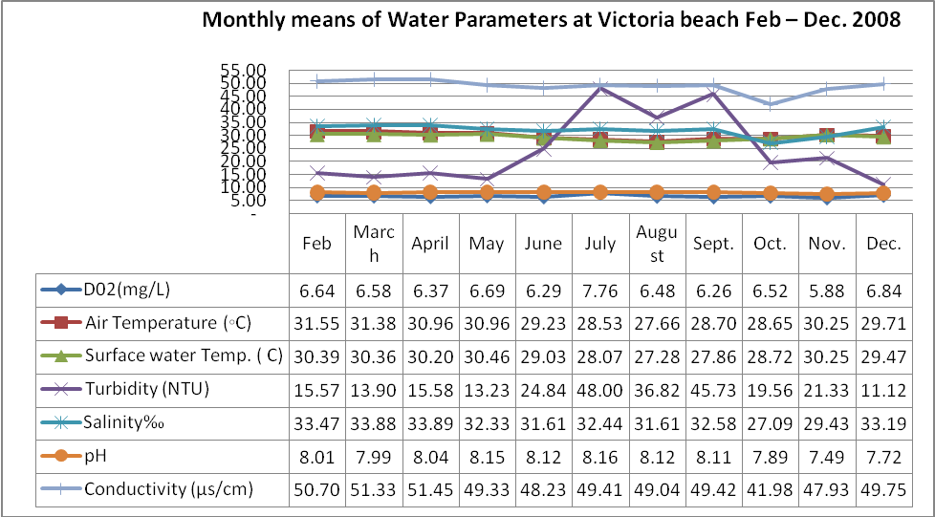

At the Victoria Beach station, the water column was well oxygenated with recorded value ranging between 6.26 and 7.76 mg L⁻¹. The maximum dissolved oxygen of 7.76 mg/l was observed in July while the minimum value of 6.26 mg/l was observed in September. The maximum air temperature of 31.55 ˚C in the Victoria Beach Station was observed in February, while the minimum air temperature of 27.66 ˚C was observed in August. The minimum (27.28^{O}C) and maximum (30.46 ^{O}C) surface water temperatures were recorded in August and May respectively. The minimum (31.61 %o) and maximum (33.89%o) salinity values at this station were recorded in June and April respectively (Table 1). The trend in conductivity is always the same with Salinity. The pH values ranged between 7.49 and 8.16 with the maximum value of 8.16 was observed in July.
At the NIOMR Jetty Station, the water column was similarly well oxygenated with recorded values ranging between 4.74 and 6.64 mg L⁻¹. The minimum (26.88 ^{O}C) and maximum (30.98 ^{O}C) air temperatures were recorded in August and March respectively. The minimum (26.88 ^{O}C) and maximum (30.36 ^{O}C) surface water temperatures were recorded also in August and March respectively. The minimum (6.59 %o) and maximum (31.29 %o) salinity values at this station were recorded in September and April respectively (Table 2).

Table 2. Monthly means of Water Parameters at NIOMR Jetty station Feb – Dec 2008
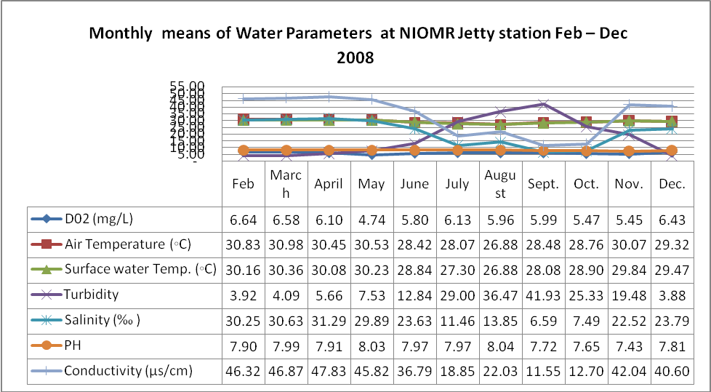

Discussion:
In line with a priori expectations, the pattern of distribution of temperature at both stations is similar in time and space: Both stations are influenced by the same meteorological factors and both are coupled by tidal flushing. The relatively higher temperatures around March are explicable, among other reasons, in terms of maximum isolation around this time of year. The lower temperatures recorded in the June / August period have usually been attributed to the general cooling of south Atlantic waters and the upward migration of cooler isotherms into supra-thermocline waters at this time of the year.
The salinity pattern at the Jetty station is a simple rain-dependent one. Lowest values are obtained in the July – October period largely because of the diluting influence of precipitation. This low salinity season comes just after the heavy rains in the preceding period.
The water column at both stations is well oxygenated. Even the lowest value of 4.74 mg L⁻¹ obtained in May at the Jetty station is adequate for aquatic life.

CONCLUSION
With the attention of all on the world food security, towards the millennium development goal (MDG), the importance of good water quality monitoring in a sustainable fisheries and aquaculture management could not be ignored. It is imperative to give adequate attention to the water quality.
Guidelines for water quality monitoring are readily available, the techniques are very simple and the equipments are affordable.
ACKNOWLEDGEMENT:
I wish to acknowledge the opportunity given by the E.D., Also the Director of physical/chemical oceanography, Director of Biological oceanography. Director of Fish and Biotechnology, and all other members of physical/chemical and biological oceanography for making this work possible.

REFERENCES:
- Morales, M.C.,Rivera, M.,Meruane, J., Galleguillos ,C. and Hosokawa, H. 2006. Morphological characterization of larval stages and first juvenile of freshwater prawn Cryphiops caemenarius (Molina, 1782) (Decapoda: Palaemonidae) under laboratory conditions. Aquaculture 261, 908 – 931.
- D’Abramo, L.R, Daniels, W.H.,Fondren, M.W. and Brunson,M.W. 1995. Management practices for culture of freshwater prawn (Macrobrachium rosenbergii) in temperate climate. Mississippi Agricultural and Forestry Experimental Station Bull.1030, 12pp.
- Geoff Tingly and Lowestoft . G. 2004. Fisheries and Aquaculture Business, sustainable fisheries management. CEFAS Loweslogt Pakefield Road, lLowest,Suffolk, NR33 OHT,UK.
- Flegel, T W 1995. Shrimp Health Management and the Environment. Paper presented to the Workshop on Aquaculture Sustainability and the Environment, Beijing, October 1995. NACA/ADB.

8/21/2010

