Improving Effect of Dietary Oat Bran Supplementation on Oxidative Stress Induced By Hyperlipidemic Diet

Ola S Mohamedª, Mostafa M Said^{b}, Zeinab Y Ali^{b*,} Hanan A Atiaª and Heba S Mostafa^{b}

ª Department of Biochemistry, Faculty of Pharmacy (girls), Al-Azhar University, Cairo, Egypt
^{b} Department of Biochemistry, National Organization for Drug Control and Research (NODCAR), Giza, Egypt.
*Corresponding author. Zeinab Yousef Ali (Ph D)
Biochemistry department, National Organization for Drug Control and Research (NODCAR), 6-Abu Hazem Street, Pyramids Ave. P.O. Box 29, 35521 Giza, Egypt.
e-mail: zeinabyousef65@ymail.com
Tel: 002-02-35851278, 002-02-35850005; Mobile: 002-012-8079870; Fax: 002-02-35855582

Abstract: Many epidemiological studies support the involvement of oxidative stress in pathogenesis and progression of many diseases such as hyperlipidemia and atherosclerosis. Oats (Avena sativa, Linn.) are rich in antioxidants and have cholesterol-reducing effect. This study aimed to evaluate the total phenolic and antioxidant activity as well as the prophylactic and curative effects of oat bran (2.70 g. kg⁻¹ b.w. day⁻¹) on oxidative stress induced by hyperlipideamic diet comparing with simvastatin (3.6 g. kg⁻¹ b.w.day⁻¹) as reference agent. Rats fed on hyperlipidemic diet supplemented with cholesterol, cholic acid and thiouracil (CCT, 3:1:0.5) exhibited significant elevation in hepatic antioxidant enzyme (SOD, CAT, GPx and GST) activities and lipid peroxide (MDA), and a significant depletion in reduced glutathione (GSH) content. Oat bran was able to maintain or ameliorate these changes to nearly normal levels and reveals its prophylactic and curative effects on oxidative stress associated with hyperlipidemia. Oat bran has nearly similar potent antioxidant effect as simvastatin. These beneficial effects could be attributed to the antioxidant activities of bioactive ingredients in oat bran. In conclusion, oat bran supplementation exhibited a powerful antioxidant potential and, thus, reduce incidence and prevent atherosclerosis through a reduction in oxidative stress induced by hyperlipidemia in rats.
[Ola S Mohamed, Mostafa M Said, Zeinab Y Ali, Hanan A Atia and Heba S Mostafa. Improving Effect of Dietary Oat Bran Supplementation on Oxidative Stress Induced By Hyperlipidemic Diet. World Rural Observations 2010;2(3):60-69]; ISSN: 1944-6543 (Print); ISSN: 1944-6551 (Online). http://www.sciencepub.net/rural.

Key Words: Avena sativa; oat bran; total phenolics; antioxidant activity; hyperlipidemia; atherosclerosis; oxidative stress; hepatic antioxidant.

1. Introduction
Cardiovascular diseases are the most common cause of death in industrialized countries. It is established that hyperlipidemia represents a major risk factor for the premature development of atherosclerosis and its cardiovascular complications (Gopichandchinta et al., 2009). Several studies demonstrated that disorders of lipid metabolism, hyperlipidemia and obesity are associated with overproduction of oxygen free radicals (Rehman et al., 2003). The enhanced accumulation of these radicals and dysfunction of antioxidant defense system result in oxidative stress (Giậo et al., 2008). These radicals can bind covalently to the macromolecules and induce peroxidative degradation of the membrane lipids rich in polyunsaturated fatty acids, leads to the formation of lipid peroxides followed by multiple pathological changes (Shyamala et al., 2003).
Oxygen dependant organisms possess several antioxidant defense mechanisms against oxidative damage by prooxidants, which convert active oxygen molecules into non-toxic compounds. These defense systems involve the antioxidant enzymes includes superoxide dismutase (SOD), catalase (CAT) and glutathione peroxidase (GPx) and glutathione S-transferases (GST), and non-enzymatic compounds include glutathione (GSH) and vitamins (Samudram et al., 2009). SOD, the first line of defenses against free radicals, catalyses the dismutation of superoxide anions into hydrogen peroxide (H₂O₂). CAT is a haemeprotein, catalyses the H₂O₂ to oxygen and water. GSH detoxifies toxic compounds as H₂O₂ and lipid peroxides directly or in GPx and GST (Townsend et al., 2003; Hamilton et al., 2004). However, the innate antioxidant defense mechanisms are often insufficient to combat the oxidative stress that can be an important mediator of progressive damage to cell structures. Consequently, to prevent or treat atherosclerosis and reduce the incidence of cardiovascular disease is to target the hyperlipidemia by diet and or lipid lowering drugs.
Control of cholesterol levels through therapeutic drugs as statins have significantly reduced the risk for developing atherosclerosis and associated cardiovascular diseases. Statins, a class of cholesterol-lowering drugs inhibiting cholesterol synthesis, have been most widely prescribed for treating hypercholesterolemia and reducing cardiovascular diseases (Sweetman, 2009). However, adverse effects associated with statin therapy such as liver damages (Parra and Reddy, 2003), myopathy (Kiortsis et al., 2007) and potential drug-drug interaction (Trifiro, 2006) have been reported. Therefore, on the basis of above stated facts there are an urgent need to have a drug having the dual property of lowering lipid level and antioxidant activities together.
Natural antioxidants with free radical-scavenging activity have received much attention as potential, non-toxic. Several epidemiological studies concluded that a high intake of food rich in natural antioxidants increases the antioxidant capacity of the body and reduces the risk of several diseases. Herbal remedies or food supplements have increasingly become attractive alternatives to prevent or treat hypercholesterolemia, especially for those with cholesterol at the borderline levels (Deng, 2009).
Oat (Avena sativa L.) family graminae/poaceae, is a light-green annual herb. It is an important crop produced in various regions of Europe and North America (Brindzová et al., 2008). It is distinct among other cereals by its multifunctional characteristics and nutritional profile (Butt et al., 2008). A recent advancement study in food and nutrition revealed that oat bran is a rich source of soluble fiber in the form of β-glucan and well-balanced carbohydrates, proteins, fats, vitamins (thiamine, pantothenic acid, niacin, folic acid and α-tocopherol) and minerals (calcium, phosphorus, potassium, magnesium, iron, zinc and copper), beside a wide spectrum of bioactive phenolic compounds contributed to its used as an alternative food for the human (Ötles and Cagindi, 2006; Butt et al., 2008). Oat β-glucan was reported to improve CVD risk through improvements in serum glucose, cholesterol and other intermediary risk factors when consumed as part of a moderate fat, balanced diet (Queenan et al., 2007). Moreover, Oat β-glucans was reported to exhibit antioxidant potential in-vitro (Brindzová et al., 2008). Therefore, the present study was designed to evaluate the prophylactic and curative effects of oat bran supplementation on oxidative stress induced in rats by feeding on hyperlipidemic diet.

2. Experimental
2.1. Plant material: Oat grains were supplied from local herbalists in Cairo, Egypt. Oat grains were separated into hulls and groats by dehuller. Oat groats were milled; bran was separated and stored in the refrigerator at 4ºC until used. Oat bran at a dose of 2.70 g. Kg⁻¹.day⁻¹ was used in the current study, which equivalent to the human consumption of 30 g. day⁻¹ (Paget and Barnes, 1964).

2.2. Chemicals: Simvastatin (80mg) film-coated tablets was purchased from Egypharm Co. and administrated in a dose of 3.6 mg Kg-1 b.w, which equivalent to 40 mg kg-1 b.w therapeutic dose in man (Paget and Barnes, 1964). All chemicals were purchased in analytical and purified grade from Sigma Chemical Co. (St. Louis, MO) and Merck (Darmstadt, Germany).
2.3. Experimental Animals: A total of 56 adult female albino rats of Swiss strain (100-125 g) were provided from the farm of National Organization for Drug Control and Research (NODCAR), Giza, Egypt. Animals were housed under conditions of controlled temperature (25 ± 2ºC) with a 12/12 hrs day–night cycle. They were allowed free access of water and fed on a standard diet for adaptation a week before initiation of the experiments.
2.4. Preparation of oat extracts: Oat bran was defatted twice with hexane. One gram of the defatted oat bran was extracted with 75% ethanol (3×15 ml) for one hour. The extracts were filtered and the supernatants were combined, and dried in vacuum at 40°C. The residue containing the extracted antioxidant was used for determination of total phenolic content and antioxidant activity.

2.5. Determination of total phenolic content: Total phenolic compounds were determined by using Folin-Ciocalteu method (Singelton et al., 1999). The oat bran ethanolic extract was oxidized with Folin-Ciocalteu reagent (Merck, Germany), and the reaction was neutralized with sodium carbonate (20%). The absorbance of the resulting blue color was measured at 760 nm after 60 min. using galic acid (Sigma-Aldrich, Germany) as standard. The total phenolic content was expressed as mg gallic acid equivalent (GAE) per 100 g dry weight of oat bran. Data reported of three replications.

2.6. In-vitro antioxidant activity: Antioxidant activity of the oat bran was assessed in terms of radical scavenging ability by using the stable radical 1, 1-diphenyl-2-picrylhydrazyl (DPPH), as described by Blois (1958). Different concentrations of oat bran (10-50 mg/ml) in ethanol were added at an equal volume (2.5 mL) to ethanolic solution of DPPH (0.3 mM, 1 mL) and incubated in the dark at room temperature for 30 min. The absorbance (Ab) values were measured against ethanol at 517 nm on a spectrophotometer (Unicam, Heλios). α-tocopherol as reference agent was used to obtain the calibration curve in order to express the radical scavenging capacity of oat bran in α-tocopherol equivalents.
2.7. Induction of Hyperlipidemia: Hyperlipidemia (HL) was induced by feeding rats on an hyperlipidemic diet (HL-D) comprising of normal rat chow supplemented with cholesterol, cholic acid and thiouracil (CCT, 3:1:0.5) at a dose equivalent to 0.5 g. kg⁻¹ b.w. in a diet supplemented with saturated fats (20%) and sucrose (40%) for 4 weeks according to the method described by Deepa and Varalakshmi (2006) and Vijayabaskar et al., (2008).

2.8. Experimental Design: Two main experiments were conducted as follows:

2.8.1. The prophylactic experiment:
Twenty four rats were divided randomly into equal three groups as follows:
Group 1: rats received normal diet and served as negative control for eight weeks.
Group 2: rats received HL-D and served as positive control for eight weeks.
Group 3: rats received HL-D supplemented with a daily dose of oat bran (2.70 g kg⁻¹ b.w.) for the same period.

2.8.2. The curative experiment:
The experiment comprised of 32 rats in four groups (8 rats each).
Group 1: negative control received normal diet for eight weeks.
Group2: hyperlipidemic rats received normal diet and served as positive control for 4 weeks.
Group 3: hyperlipaemic rats received normal diet supplemented with oat bran in a daily dose of 2.70 g. kg⁻¹ b.w. for 4 weeks
Group 4: hyperlipaemic rats received normal diet and simvastatin in a daily oral dose of 3.6 mg. kg⁻¹ b.w. for 4 weeks.

2.8.3. Tissue sampling and processing: At the end of both experiments, animals were killed by decapitation. The aortic arch and liver were removed and carefully washed with saline solution. The aortic tissues were fixed in 10 % formalin and preserved for histological examination using hematoxylin and eosin (H&E) stains. While the livers were homogenized with ice-cold isotonic saline (10%, w/v) in Beckman refrigerating ultracentrifuge (Model J2-HS) at 70.6 g and 4º C for 15 minutes. The supernatant were separated and used for the following biochemical analysis.

2.8.4. Biochemical Analysis:
The markers of the oxidative stress were assayed in liver homogenate as follows:
- Superoxide dismutase (SOD): The activity of SOD was measured by monitoring the rate of inhibition of pyrogallol oxidation according to the method of Marklund and Marklund, (1974). The activity is expressed in U/mg protein. The SOD unit (U_{SOD}) is defined as the enzyme concentration required for inhibit the rate of auto-oxidation of pyrogallol by 50 % in min.
- Catalase (CAT): Activity of catalase was assayed following the method of Aebi, (1984) using hydrogen peroxide as substrate. The activity is expressed in U/mg protein. The CAT unit (U_{CAT}) is defined as the enzyme concentration required to decompose 1 mmol of hydrogen peroxide in min.
- Glutathione peroxidase (GPx): GPx activity was measured by using hydrogen peroxide (H₂O₂) as a substrate according to the method of Rotruck et al., (1973). A known amount of enzyme preparation was allowed to react with H₂O₂ and glutathione (GSH) for a specified time period, then the remaining GSH content was allowed to react with 5,5’-dithio-bis-2-nitrobenzoic acid (DTNB) and the yellow colour developed was measured at 412 nm.The GPx activity is expressed in U/mg protein. The GPx unit (U_{GPx}) is defined as the amount of GSH consumed in min.
- Glutathione S-transferase (GST): GST activity was assayed according to the method of Habig et al., (1974) by following the increase in absorbance at 340 nm using 1-chloro-2,4-dinitrochlorobenzene (CDNB) as substrate. The activity is expressed in U/mg protein. The GST unit (U_{GST}) is defined as mmol of glutathione-chlorodinitrobenzene conjugate formed in min.
- Glutathione (GSH): GSH content was estimated by the method of Beutler et al., (1963). This method was based on the development of a yellow colour when DTNB was added to compounds containing sulfhydryl groups.
- Lipid Peroxidation: Lipid peroxidation was estimated as thiobarbituric reactive substance (TBARS) by measuring the pink colored chromophore formed by the reaction of thiobarbituric acid with malondialdehyde (MDA) according to the method of Fernandez et al., (1997).
- Total protein: Total protein was performed by Biuret’s method (Gornal et al., 1949)

Statistical Analysis
The obtained results were expressed as means ± SE. The differences between groups were statistically analysed by one-way analysis of variance (ANOVA) followed by Duncan’s multiple range test (DMRT) using the Statistical Package for Social Sciences (SPSS), version 17.0 for windows (SPSS Inc, Chicago, USA). The limit of statistical significance was set at P ≤ 0.05 (Frank and Althoen, 1997).

3. Results and discussion

3.1. Total phenolic compounds
In the present study, the total phenolics content in oat bran was found to be 64.0 mg GAE/100g. Phenolic compounds are a large group of the secondary metabolites widespread in the plant. They possess biological prosperities such as: antioxidant, antiapoptosis, anti-aging, anticarcinogen, anti-inflammation, anti-artherosclerosis, cardiovascular protection, improvement of the endothelial function, as well as inhibition of angiogenesis and cell proliferation activity (Han et al., 2007). Most of these biological actions have been attributed to the antioxidant activity (Aberoumand and Deokule, 2008). This antioxidant activity of the phenolic compounds is mainly due to their redox properties and depends on their structure, in particular the number and positions of the hydroxyl groups, and the nature of substitutions on the aromatic rings (Rice-Evans, 1996). The redox properties of phenolic compounds allow them to act as reducing agents, hydrogen donators and play an important role in adsorbing and neutralizing of reactive free radicals, and chelating ferric ions which catalyses lipid peroxidation, and regarded as promising therapeutic agent for free radical-linked pathologies (Said and Zeinab, 2009). Several studies proved that the total phenolics content was highly positive correlated with antioxidant activity (Corral-Aguayo et al., 2008; Hodzic et al., 2009; Zhang et al., 2010).

3.2. In-vitro antioxidant activity
The scavenging of the stable DPPH radical model is a widely used method to evaluate the ability of compounds to act as free radical scavengers or hydrogen donors in a relatively short time compare to other methods. The alcoholic solution of DPPH• is a purple colored that turns into a yellow product after being reduced by an antioxidant. The reduction of DPPH• radical to DPPH-H was determined by the decrease in its absorbance induced by antioxidants at 517 nm (Blois, 1985).
In the present study, oat bran was effective in scavenging DPPH• radicals in a concentration dependent manner (Figure 1). The radical scavenging capacity of oat bran was 16.1 mg α-tocopherol /g on a dry weight. This suggested that the direct antioxidant effect of oat bran may depend on hydrogen atom donation by different phenolic content, which may provide a mechanism for its pharmacological activity.

Figure 1. DPPH radical scavenging activity of oat bran

Dyslipidemia is a major risk factor for cardiovascular complexities. Lifestyle factors play important role in their progression (AHA, 2005). Epidemiological and experimental studies have revealed that a high-fat diet might induce oxidative stress and lipid oxidation that contributes to the high risk of cardiovascular disease (CVD) (Mansour et al., 2009). Thus the present study highlights the hepatic oxidative changes induced by experimental hyperlipidemia, and the possible prophylactic and curative effect of oat bran against oxidative stress in hyperlipidemic and atherosclerotic conditions.

3.3. Induction of Oxidative Stress
As shown in Tables (1 & 2), the biochemical index of tissue lipid peroxidation was assessed in terms of MDA formation. As compared with negative control group, the hyperlipidemic rats showed a significant elevation in the level of MDA and the activities of hepatic antioxidant enzyme system (SOD, CAT, GPx and GST), and significantly depletion in the non-enzymic antioxidant system (GSH). The elevated level of liver MDA following hyperlipidemic diet is a clear manifestation of the excessive formation of free radicals and progression of the lipid peroxidation. Meanwhile, the enhanced activities of hepatic antioxidant enzyme may be due to the natural adaptive mechanism of the body to protect the membrane lipids from peroxidation and overcome the oxidative stress. Also the depleted level of GSH may be due to increased utilization via GPx and GST to counteract the overproduction of the free radicals.
Consistent with our results, Kumar et al., (2008) reported that hypercholesterolemia enhances the free radical generation in various ways. Erdinςler et al., (1997) demonstrated that hypercholesterolaemia increases cholesterol content of platelets, polymorphonuclear leukocytes and endothelial cells so that endothelial and smooth muscle cells, neutrophils, monocytes and platelets may be the source of oxygen free radicals in hypercholesterolaemia. Nourooz-Zadeh et al., (2001) demonstrated that oxidative stress is increased in patients with familial hypercholesterolaemia. On the other hand, Engler et al., (2003) confirmed that anti-oxidant therapy with vitamins C and E was able to restore endothelial function in hyperlipidaemic children. Also, our results were in agreement with those obtained by Sevin et al., (2004) and Yang et al., (2008).

3.4. Prophylactic Effect of Oat Bran
Antioxidant phytochemicals play an important role in human health by scavenging reactive oxygen and nitrogen species and modulating several defense systems. The data in Table 1 reveals that co-administration of oat bran with HL-diet for eight weeks was significantly protect the liver tissue from oxidative stress as evidence from the maintenance of both lipid peroxidation marker (MDA) and the hepatic antioxidant enzymes near normal levels, and significant increase in GSH. Thus preserve the normal redox state of the hepatic tissue and demonstrated the prophylactic effect of oat bran.

Table 1. Prophylactic effect of oat bran on hepatic antioxidant activities during induction of hyperlipidemia and % variation from the normal control.

Groups | SOD  "U/mg  Protein" | CAT  "U/mg  Protein" | GST  "U/mg  protein" | GPx  "U/mg  Protein" | GSH  "mg/g Liver" | MDA  "nmole/mg  protein"
Control | 0.97 ± 0.07ª | 72.2 ± 2.89ª | 61.4 ± 2.10ª | 6.81 ± 0.16ª | 1.32 ± 0.03^{b} | 0.88 ± 0.03ª
HL-D | 1.51 ± 0.05^{b}  (55.7%) | 95.4 ± 3.37^{b}  (32.2%) | 74.8 ± 1.89^{b}  (21.8%) | 11.0 ± 0.21^{b}  (61.6%) | 1.05 ± 0.04ª  (-20.2%) | 1.41 ± 0.04^{b}  (60.5%)
Oat Bran  + HL-D | 1.08 ± 0.03ª  (10.9%) | 77.4 ± 2.39ª  (7.22%) | 65.0 ± 1.69ª  (5.86%) | 7.22 ± 0.35ª  (5.95%) | 1.44 ± 0.07^{b}  (9.30%) | 0.96 ± 0.03ª  (8.82%)
F | 29.004 | 17.522 | 13.329 | 84.614 | 14.527 | 72.408
Sig | 0.000 | 0.000 | 0.000 | 0.000 | 0.000 | 0.000
Each value represents the mean of 8 rats ± S.E. Values in the same column with the different superscript letters (a, b) are significantly different from each other at p ≤ 0.05 level by DMRT.

3.5. Curative Effect of Oat Bran
The current data in Table 2 illustrates that the administration of either oat bran or simvastatin for four weeks to hyperlipaedemic rats was significantly suppressed the lipotrophic effects of HL-D and restore the original redox state of the liver tissue. The significant elevation in the hepatic MDA and depletion of GSH levels of hyperlipidemic rats and their tendency to return to near normal levels after administration of oat bran or simvastatin revealed their powerful antioxidant effect. Hence it is likely that the mechanism of hepatoprotection of oat bran is due to antioxidant effects of its bioactive ingredients.

Table 2. Curative effect of oat bran and simvastatin on hepatic antioxidant activities in hyperlipidemic rats and % variation from the hyperlipidemic group.

Groups | SOD  "U/mg  protein" | CAT  "U/mg  Protein" | GST  "U/mg  Protein" | GPx  "U/mg  protein" | GSH  "mg/g  Liver" | MDA  "nmole/mg  protein"
Control | 0.97 ± 0.07ª | 72.2 ± 2.89ª | 61.4 ± 2.10ª | 6.81 ± 0.16ª | 1.32 ± 0.03^{b} | 0.88 ± 0.03ª
HL-D | 1.37 ± 0.05^{b}  (41.4%) | 90.5 ± 2.34^{c}  (25.4%) | 72.2 ± 1.55^{b}  (17.6%) | 9.72 ± 0.17^{c}  (42.7%) | 1.08 ± 0.03ª  (-18.1%) | 1.33 ± 0.04^{c}  (51.6%)
Oat Bran  (2.70 g/kg) | 1.08 ± 0.04ª  (-21.5%) | 74.9 ± 2.88^{ab}  (-17.2%) | 65.5 ± 1.90ª  (-9.36%) | 8.83 ± 0.20^{b}  (-9.13%) | 1.26 ± 0.04^{b}  (17.2%) | 1.00 ± 0.03^{b}  (-25.0%)
Simvastatin  (3.6 mg/kg) | 1.01 ± 0.03ª  (-26.7%) | 80.8 ± 2.72^{b}  (-10.7%) | 62.4 ± 1.84ª  (-13.7%) | 7.21 ± 0.31ª  (-25.8%) | 1.36 ± 0.04^{b}  (26.1%) | 0.89 ± 0.03ª  (-33.5%)
F | 13.198 | 8.884 | 6.928 | 39.399 | 11.902 | 33.650
Sig | 0.000 | 0.000 | 0.001 | 0.000 | 0.000 | 0.000
Each value represents the mean of 8 rats ± S.E. Values in the same column with the different superscript letters (a, b, c) are significantly different from each other at p ≤ 0.05 level by DMRT.

In agreement with our results, Shishehbor et al., (2003) proved that simvastatin inhibit the rate-limiting enzyme of cholesterol biosynthesis, possess antioxidant and anti-inflammatory properties. Desideri et al., (2003) demonstrated that hypercholesterolemia was combined with endothelial activation, lipid peroxidation and oxidative stress which were efficaciously counteracted by simvastatin. In addition, simvastatin can stabilize the gene responsible for endothelial nitric oxide and reduce the level of intermediates involved in cholesterol synthesis, reactive oxygen species generation, LDL oxidation, and preventing lipid peroxidation (O'Driscoll et al., 1997; Wierzbicki et al., 2003), thereby potentially impairing atherogenesis process.
The current biochemical results were corroborated with the histological studies of the aorta tissues (Figure 2a & b). The aorta of hyperlipidaemic (HL) rats revealed focal vacuolated areas, replacing dissolved fat in subendothelial layer accompanied with moderately oedema indicating premature atherosclerosis. On the other hand, both oat bran and simvastatin was able to minimize or prevent the atherogenic diet-induced histopathological lesions in the aorta tissues as compared with those of hyperlipidaemic rat. Consequently, oat bran is beneficial in reducing risk factors for coronary artery disease in this animal model of hypercholesterolemic atherosclerosis.

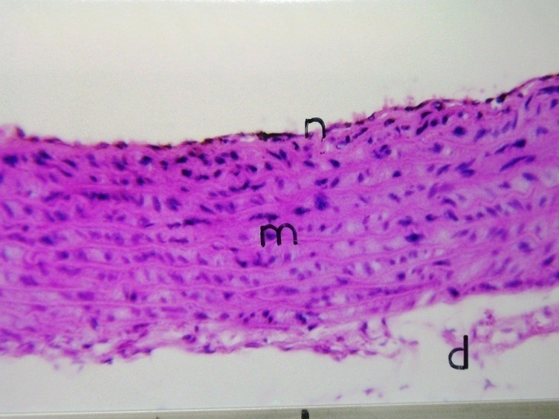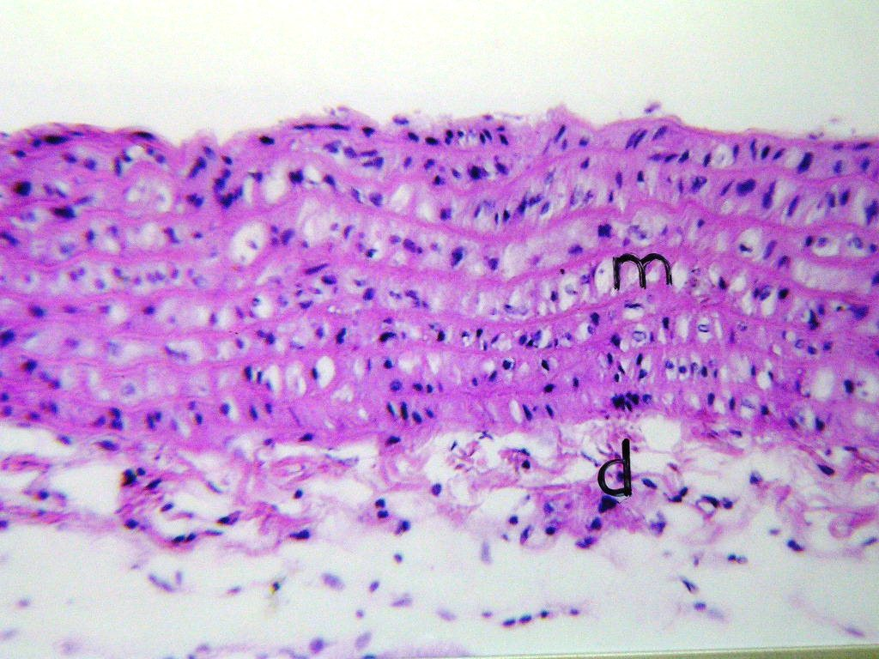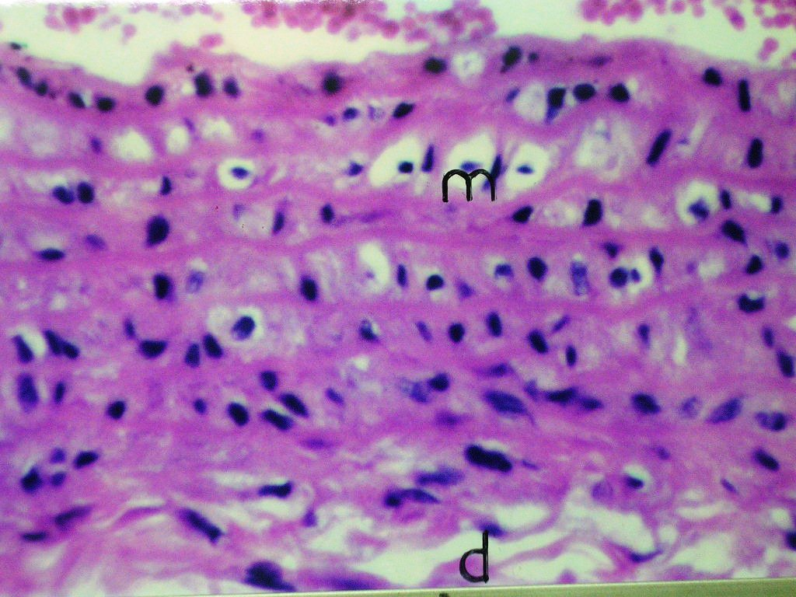
(A) Control (B) HL (C) Oat bran + HL-D
Figure 2. Histological sections of aortic tissue showing the prophylactic effect of oat bran on aortic tissue of albino rats.

(A) Control group showing normal appearance of the three layers: intima (n), media (m) and adventitia (d) of the aortic tissue. (H&E, x64)
(B) HL-group showing vacuolation in the cells of the tunica media (m) associated with oedema in the adventitia (d). (H&E, 64)
(C) (Oat bran + HL-D)-group showing vacuolar degeneration in the tunica media (m) with oedema in the adventitia (d) to lesser extent than that in the hyperlipidemic rats. (H&E, x160)

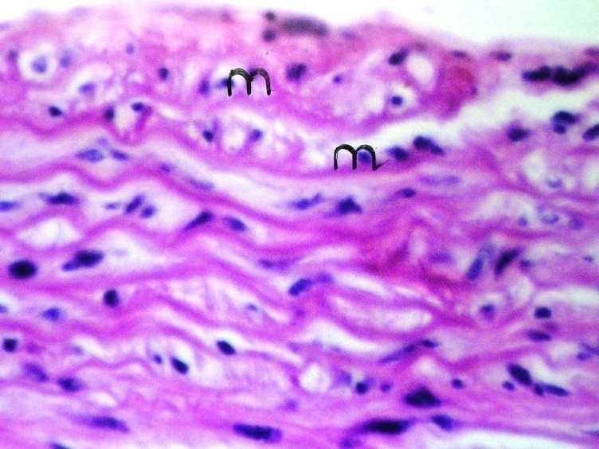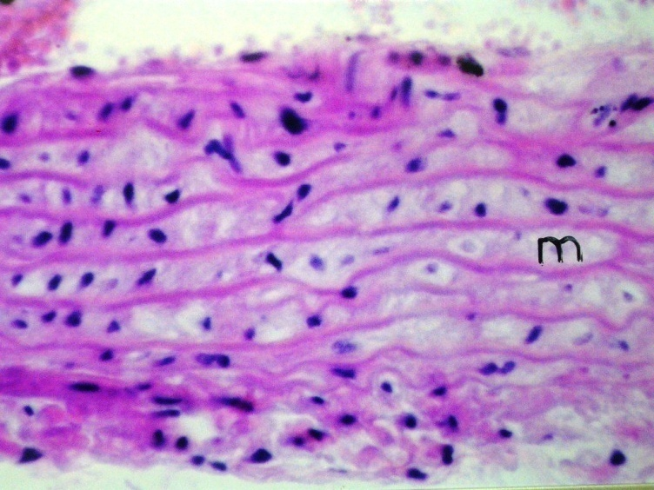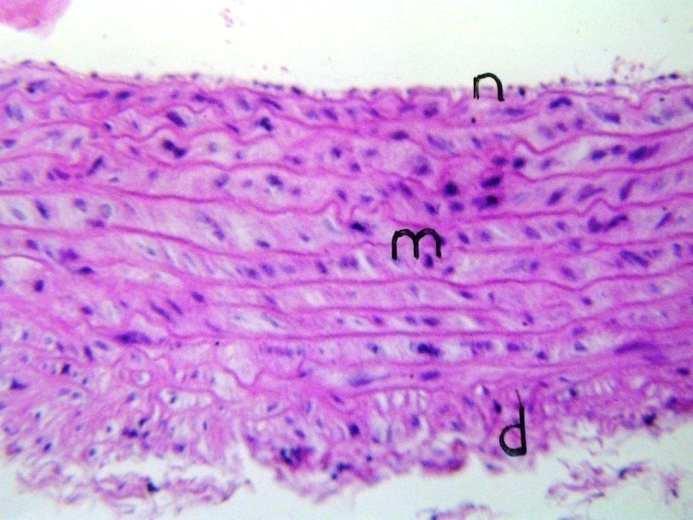
(D) HL (E) Oat bran (F) Simvastatin

Figure 3. Histological sections of aortic tissue showing the curative effect of oat bran and simvastatin on aortic tissue of albino rats.

(D) HL-group showing vacuolation and oedema with hyalinization in the tunica media (m). (H&E, x160).
(E) Oat bran treated-group showing mild oedema and fine vacuolation in the cells of the tunica media. (H&E, x 160)
(F) Simvastatin treated-group showing nearly normal histological structure. (H&E, x64)
Consistent with our results, Jadhav et al., (1996) showed that cholesterol oxidation could contribute to the development of a progressive thickening of the artery wall, due to the accumulation of cholesterol oxidation products in low-density lipoprotein (LDL) particles after they are oxidized. Vijayabaskar et al., (2008) proved that the significantly elevated levels of plasma cholesterol in rats fed with CCT diet might damage the endothelial cell membrane lining the large arteries such as aorta and might be the initial events in the etiology of atherosclerosis. Moreover, Prado et al., (2008) provide evidence that hypercholesterolaemia has been extensively associated with endothelial cell dysfunction, considered a key early step in the atherosclerosis and consequently, increased vascular production ⁄ release of nitric oxide and superoxide anions that interact to produce peroxynitrite, a powerful oxidant causing damage to multiple cells constituents. Also, in agreement with our results, Buil-Cosiales et al., (2009) demonstrated that dietary fiber intake is inversely associated with carotid intima-media thickness.
Based on the evidences from both previous and the current results, our study suggested that the health promoting capabilities effects of oat bran in these animal model of hyperlipidemia could be attributed to the antioxidant effects of its active ingredient as phenolic compounds and antioxidant vitamins (tocopherols, and ascorbic acid tocotrienols) along with the enhancement of the total antioxidant defense system of body. As preventative antioxidants, oat bran can direct intercept free radical before any significant oxidation can occur. As chain-breaking antioxidant, oat bran can retard or slow the oxidative processes leading to decrease MDA (the lipid peroxidation near normal level and thus inhibit the oxidative stress.
It was reported that the most of phenolic compounds of oat are located in the bran layer (Peterson and Dimberg, 2008). A wide variety of bioactive phenolic compounds and their derivatives have been identified from oats as hydroxycinnamic acids (caffeic, p-coumaric, ferulic acid and sinapic acid), avenanthramides family (ethylenic homologues of cinnamic acids) and tricin (a flavone belonging to flavonoids) (Nie et al., 2006; Peterson and Dimberg, 2008). All of them possess potential health-promoting properties because of their antioxidant activities and/or membrane-modulating effects (Brindzová et al., 2008).
In this concept, avenanthramides a family of 20 structurally unique to oats, was reported to has anti-atherogenic and anti-inflammatory effects since they can inhibit the adhesion of monocytes to human aortic endothelial cell monolayers and the secretion of proinflammatory compounds from macrophages (Liu et al., 2004). The avenanthramide 2C has been shown to increase the production of nitric oxide, in dose-dependent manners, which are two key factors in preventing atherosclerosis (Nie et al., 2006). In-vivo studies have indicated that the avenanthramides have been suggested to increase the antioxidant capacity in humans and to interact synergistically with vitamin C to protect LDL-oxidation in hamsters (Chen et al., 2007). Avenanthramides, polyphenols from oats, exhibit a potant antioxidant and anti-infammatory activities in various cell-types (Sur et al., 2008).
Furthermore, hydroxycinnamic acids reported to have antioxidative activities (Bratt et al., 2003). Caffeic acid has been found to inhibit LDL oxidative modification in-vitro (Nardini et al., 2006). Tricin is a compound classified as a flavone. In humans, flavones may be important health beneficial food compounds since they have been proposed to have antioxidative, antibacterial, antiviral, antiatherosclerotic, anti-inflammatory, antineoplastic and anticarcinogenic properties (Al-Fayez et al., 2006). Also, Ramesh et al., (2008) showed that dietary intake of phenolic compounds could inhibit oxidation of LDL and thereby reduce risk factors for cardiovascular disease.
Based on the evidences from both biochemical and histological results, our results suggested that the preventive and therapeutic effects of oat bran like several medicinal plants are usually attributed to its antioxidant compounds. Oat bran has nearly similar potent antioxidant effect as simvastatin. In conclusion, oat bran supplement is an effective non-pharmacologic means for reducing incidence, slow the progression of and prevent atherosclerosis through a reduction in oxidative stress, and recommended the incorporation of oat bran in the food products to improve not only the nutrition but also a therapy against CVD.

Acknowledgements

The authors are grateful to the department of pathology, Faculty of Veterinary Medicine, Cairo University, Giza, Egypt, for their valuable help in the histopathological examination.

References
- Aberoumand, A. & Deokule, S.S. (2008). Comparison of phenolic compounds of some edible plants of Iran and India. Pakistan Journal of Nutrition, 7 (4), 582-585.
- Aebi, H. (1984). Catalase in-vitro. In: Methods of enzymology. Packer L, (ed.) Vol. 105, pp. 121-126. San Diego, Academic Press Inc.
- AHA. (2005). American Heart Association. Heart disease and stroke statistics-2005 update. Dallas, TX: American Heart Association.
- Al-Fayez, M., Cai, H., Tunstall, R., Steward, W. & Gescher, A. (2006). Differential modulation of cyclooxygenase-mediated prostaglandin production by the putative cancer preventive flavonoids tricin, apigenin and quercetin. Cancer Chemotherapy and Pharmacology, 58, 816-825.
- Beutler, E., Duron, O., & Kelly, B.M. (1963). Improved method for the determination of blood glutathione. Journal a Laboratory Clinical Medicine, 61, 882-888.
- Blois, M.S. (1958). Antioxidant determinations by the use of a stable free radical. Nature, 26, 1199-1200.
- Bratt, K., Sunnerheim, K., Bryngelsson, S., Fagerlund, A., Engman, L., Andersson, R., & Dimberg, L. (2003). Avenanthramides in oats (Avena sativa L) and structure-antioxidant activity relationships. Journal of Agriculture and food Chemistry, 51, 594-600.
- Brindzová, L., Čertík, M., Rapta, P., Ibera, M., Ová, A., & Ová, M. (2008). Antioxidant activity, β-glucan and lipid contents of oat varieties. Czech Journal of Food Science, 26(3), 163–173.
- Buil-Cosiales, P., Irimia, P., Ros, E., Rivero, M., Gilabert, R., Martinez-Vila, E., Núnéz, I., Diez-Espino1, J., González, M. & Martìnez, M. (2009). Dietary fiber intake is inversely associated with carotid intima-media thickness, a cross-sectional assessment in the PREDIMED study. European Journal of Clinical Nutrition, 1–7.
- Butt, M., Nadeem, M., Khan, M., Shabir, R., & Butt, M. (2008). Oat: unique among the cereals. European Journal of Nutrition, 47(2), 68-79.
- Chen, O., Milbury, P., Collins, F. & Blumberg, J. (2007). Avenanthramides are bioavailable and have antioxidant activity in humans after acute consumption of an enriched mixture from oats. Journal of Nutrition, 137, 1375-1382.
- Corral-Aguayo, R., Yahia, E., Carrillo-Lopez, A. & Gonzălez-Aguilar, G. (2008).Correlation between some nutritional components and the total antioxidant capacity measured with six different assays in eight horticultural crops. Journal of Agriclture and Food Chemistry, 56, 10498-10504.
- Deepa, P., & Varalakshmi, P. (2006). Exogenous heparin-derivative affords protection against lipid anomalies and apoptotic DNA damage in experimental atherogenesis. Vascular Disease Prevention, 3(2), 107-115.
- Deng, R. (2009). Food and food supplements with hypocholesterolemic effects. Recent Patents on Food Nutrition and Agriclture, 1, 15-24.
- Desideri, G., Croce, G., Tucci, M., Passacquale, G., Broccoletti, S., Valeri, L., Santucci, A., & Ferri, C. (2003). Effects of bezafibrate and simvastatin on endothelial activation and lipid peroxidation in hypercholesterolemia: evidence of different vascular protection by different lipid-lowering treatments. Journal of Clinical Endocrinol and Metabolism, 88(11), 5341-5347.
- Engler, M.M., Engler, M.B., Malloy, M.J., Chiu, E.Y., Schloetter, M.C., Paul, S.M., Stuehlinger, M., Lin, K.Y., Cooke, J.P., Morrow, J.D., Ridker, P.M., Rifai, N., Miller, E., Witztum, J.L. & Mietus-Snyder, M. (2003). Anti-oxidant vitamins C and E improve endothelial function in children with hyperlipidemia. Endothelial assessment of risk from lipids in youth (EARLY) trial. Circulation, 108, 1059–1063.
- Erdinςler, D.S., Seven, A., Inci, F., Beğer, T. & Candan, G. (1997). Lipid peroxidation and antioxidant status in experimental animals: Effects of aging and hypocholesterolaemic diet. Journal of Clinica Chimica Acta, 265, 77-84.
- Fernandez, J., Perez-Alvarez, J.A. & Fernandez-Lopez, J.A. (1997). Thiobarbituric acid test monitoring lipid oxidation in meat. Food Chemistry, 99, 345-353.
- Frank, H., &Althoen, S.C. (1997). Testing hypothesis in many population means: Introduction to analysis of variance. In: Statistical concept and application. Low price edition, pp. 483-535. Cambridge university press, England.
- Giậo, M.S., Sanjose, G., Muniz, P., Perez, R., Kosinska, M., Pintado, M.E., & Malcata, F.X. (2008). Protection of deoxyribose and DNA from degradation by using aqueous extracts of several wild plants. Journal of Science Food and Agriculture, 88, 633–640.
- Gopichandchinta, Prashanthi, K., Pushpa kumari, B., Sujata, D., Ranganayakulu, D., & Venkateswarlu, M. (2009). Hypolipidemic activity of the aqueous extract from the Morinda citrifoloa leaves in triton induced hyperlipidemic rats. Pharmacologyonline, 3, 9-28.
- Gornal, A.G., Bardavill, G.J., & David, M.M. (1949). Determination of serum proteins by means of the Biuret reaction. Journal of Biological Chemistry, 177, 751-766.
- Habig, W.H., Pabst, M.J., & Jakoby, W.B. (1974). Glutathione S-transferases. The first enzymatic step in mercapturic acid formation. Journal of Biological Chemistry, 249(22), 7130-7139.
- Hamilton, C.A., Miller, W.H., Al-Benna, S., Brosnan, M.J., Drummond, R.D., Mcbride, M.W., & Dominiczak, A.F. (2004). Review srategies to reduce oxidative stress in cardiovascular disease. Clinical Science, 106, 219–234.
- Han, X., Shen, T., & Lou, H. (2007). Dietary polyphenols and their biological significance. International Journal of Molecular Science, 8, 950-988.
- Hodzic, Z., Pasalic, H., Memisevic, A., Srabovic, M., Saletovic, M., & Poljakovic, M. (2009). The influence of total phenols content on antioxidant capacity in the whole grain extracts. European Journal of Science and Research, 28(3), 471-477.
- Jadhav, S.J., Nimbalkar, S.S., Kulkarni, A.D., & Madhavi, D.L. (1996). Lipid oxidation in biological and food systems. In: Food antioxidants, Madhavi, D.L., Desphande, S.S., & Salunkhe, D.K., (Eds.), Technological, Toxicological, and Health Perspectives. Dekker, New York. 5-63p.
- Kiortsis, D.N., Filippatos, T.D., Mikhailidis, D.P., Elisaf, M., & Liberopoulos, E.N. (2007). Statin-associated adverse effects beyond muscle and liver toxicity. Atherosclerosis, 195(1), 7-16.
- Kumar, V., Khan, M.M., Khanna, A.K., Singh, R.S., Chander, R., Mahdi, F., Mahdi, A., Saxena, J., & Singh, R. (2008). Lipid lowering activity of Anthocephalus indicus root in hyperlipidemic rats. eCAM, 1-6.
- Liu, L., Zubik, L., Collins, F., Marko, M. & Meydani, M. (2004). The antiatherogenic potential of oat phenolic compounds. Atherosclerosis, 175, 39-49.
- Marklund, S., & Marklund, G. (1974). Involvement of the superoxide anion radical in the autoxidation of pyrogallol and a convenient assay for superoxide dismutase. European Journal of Biochemistry, 17, 169-174.
- Mansour, S.Z., Sherien, K.H., & Azza, S.A. (2009). Evaluation of the antilipidemic effect of polyoxyethylenated cholesterol on rats fed high fat diet. Journal of. Applied Science and Research, 5(6), 613-621.
- Nardini, M., Natella, F., Scaccini, C., & Ghiselli, A. (2006). Phenolic acids from beer are absorbed and extensively metabolized in humans. Journal of Nutrition and Biochemistry, 17, 14-22.
- Nie, L., Wise, M., Peterson, D., & Meydani, M. (2006). Avenanthramide, a polyphenol from oats, inhibits vascular smooth muscle cell proliferation and enhances nitric oxide production. Atherosclerosis, 186, 260-266.
- Nourooz-Zadeh, J., Smith, C.C., & Betteridge, D.J. (2001). Measures of oxidative stress in heterozygous familial hypercholesterolaemia. Atherosclerosis, 156, 435-441
- O'Driscoll, G., Green, D., & Taylor, R.R. (1997). Simvastatin, an HMG-coenzyme A reductase inhibitor, improves endothelial function within 1 month. Circulation, 95, 1126-1131.
- Ötles, S., & Cagindi, Ö. (2006). Cereal based functional foods and nutraceuticals. Acta Scientiarum Polonorum Technologia Alimentaria, 5(1), 107-12.
- Paget, G.E. & Barnes, J.M. (1964). Toxicity tests. In: Evaluation of drug activities: pharmacometrics. Vol. 1, p. 135, Laurence, D.R. and Bacharach, A.L. (Eds.), Academic Press, London, New York.
- Parra, J.L., & Reddy, K.R. (2003). Hepatotoxicity of hypolipidemic drugs. Clinical Liver Disease, 7(2), 415-433.
- Peterson, D.M., & Dimberg, L.H. (2008). Avenanthramide concentrations and hydroxycinnamoyl-CoA hydroxyanthranilate N-hydroxycinnamoyltransferase activities in developing oats. Journal of Cereal Science, 47, 101-108.
- Prado, C.M., Ramos, S.G., Elias, J., & Rossi, M. (2008). Turbulent blood flow plays an essential localizing role in the development of atherosclerotic lesions in experimentally induced hypercholesterolaemia in rats. International Journal of Experimental Pathology, 89, 72–80.
- Queenan, K., Stewart, M., Smith, K., Thomas, W., Fulcher, R., & Slavin, J. (2007). Concentrated oat β-glucan, a fermentable fiber, lowers serum cholesterol in hypercholesterolemic adults in a randomized controlled trial. Nutrition Journal, 6, 6.
- Ramesh, E., Elanchezhian, R., Sakthivel, M., Jayakumar, T., Kumar, R., Geraldine, P., & Thomas, P. (2008). Epigallocatechin gallate improves serum lipid profile and erythrocyte and cardiac tissue antioxidant parameters in Wistar rats fed an atherogenic diet. Fundamental and Clinical Pharmacology, 22, 275–284.
- Rehman, S., Mahdi, A., & Hasan, M. (2003). Trace metal induced lipid peroxidation in biological system. SFRR (Indian) Bull, 2, 12-18.
- Rice-Evans, (1996). Structure-antioxidant activity relationships of flavonoids and phenolic acids. Journal of Free Radicals in Biology and Medicine, 20, 933-956.
- Rotruck, J.T., Pope, A.L., Ganther, H.E., Swanson, A.B., Hafeman, D.G. & Hoekstra, W.G. (1973). Selenium: Biochemical role as a component of glutathione peroxidase. Science, 179,588-590.
- Said, M.M. & Zeinab, Y.A. (2009). Free radical scavenging capacity and inhibition of lipid peroxidation activity of some plants and natural herbs. Egyptian Journal of Biomedical Science, 29, 138-149.
- Samudram, P., Vasuki, R., Rajeshwari, H., Geetha, A. & Moorthi, P. (2009). Antioxidant and antihepatotoxic activities of ethanolic crude extract of Melia azedarach and Piper longum. Journal of Medicinal Plants and Research, 3(12), 1078-1083.
- Sevin, G., Yasa, M., AkÇay, Y. & Özer, A. (2004). Contribution of antioxidant property of fluvastatin in prevention of atherosclerosis in hypercholesterolaemic rabbits. Kocatepe Tip Dergisi, 5, 43-49.
- Shishehbor, M.H., Brennan, M.L., Aviles, R.J., Fu, X., Penn, M.S., Sprecher, D.L., & Hazen, S.L. (2003). Statins promote potent systemic antioxidant effects through specific inflammatory pathways. Circulation, 108, 426–431.
- Shyamala, M.P., Venukumar, M.R., & Latha, M.S. (2003). Antioxidant potential of the syzygium Aromaticum (Gaert.) Linn. (Cloves) in rats fed with high fat diet. Indian Journal of Pharma, I35, 99-103.
- Singelton, V.R., Orthifer, R., & Lamuela-Raventos, R.M. (1999). Analysis of total phenols and other oxidation substrates and antioxidants by means of Folin-Ciocalteu reagent. Methods in Enzymology, 299, 152-178.
- Sur, R., Nigam, A., Grote, D., & Liebel, F. (2008). Avenanthramides, polyphenols from oats, exhibit anti-infammatory and anti-itch activity. Archives of Dermatological Research, 300, 569-574
- Sweetman, S.C. (2009). Hyperlipidemia. In: Martindale the complete drug reference. 36th ed, pp. 1190-1196. Pharmaceutical Press, London, Chicago.
- Townsend, D.M., Tew, K.D., & Tapiero, H. (2003). The importance of glutathione in human disease. Biomedicine and Pharmacotherapy, 57, 145–155.
- Trifiro, G. (2006). Drug-drug interactions and statin therapy. Southern Medical Journal, 99(12), 1325-1326.
- Vijayabaskar, P., Sethupathy, S. & Somasundaram, S. (2008). A comparative study on the atheroprotective potential of heparin and atorvastatin in hypercholesterolemic rats. African Journal of Biochemistry Research (AJBR), 2(5), 120-127.
- Wierzbicki, A.S., Poston, R., & Ferro, A. (2003). The lipid and non-lipid effects of statins. Pharmacology and Therapeutics, 99, 95-112.
- Yang, R., Shi, Y., Hao, G., Li, W., & Le, G. (2008). Increasing oxidative stress with progressive hyperlipidemia in human: Relation between malondialdehyde and atherogenic index. Journal of Clinical Biochemistry and Nutrition, 43, 154-158.
- Zhang, J., Dou, J., Zhang, S., Liang, Q., & Meng, Q. (2010). Chemical composition and antioxidant properties of the essential oil and methanol extracts of rhizoma Alpinia officinarum from China in vitro. African Journal of Biotechnology, 9(27), 4264-4271.

9/12/2010

