Fluoride Content in Ground Water of Khurda District, Orissa, India

Nilakantha Dash¹, Gayatri Nahak³, Harmohan Das² and R.K. Sahu^{3*}

¹Department of Chemistry, Panchayat College, Dharmagarh, Orissa, India
²Department of Chemistry, Ravenshaw Junior College, Cuttack, Orissa, India
³B.J.B. Autonomous College, Botany Department, Bhubaneswar, Orissa, India
sahurajani@gmail.com, gayatri.science@gmail.com

Abstracts: Fluoride is a chemical element that has to shown to cause significant effects on human health through drinking water. Different forms of fluoride exposure are of importance and have shown to affect the body’s fluoride content and thus increasing the risks of fluoride-prone diseases. Fluoride has beneficial effects on teeth at low concentrations of 1mg/L of fluoride however have shown to intensify the risk of tooth decay. Fluoride can also be quite detrimental at higher concentrations exceeding 1.5-2.0 as skeletal fluorosis and osteoporosis. Skeletal fluorosis is a significant cause of morbidity. Fluoride has been known to be found most frequently in groundwater at higher concentrations, depending on the nature of rocks and natural fluoride-carrying minerals at certain depths. Fluoride concentration in different water points varies from 0.27-14.00 mg/L. Thus high fluoride concentrations generally can be expected from calcium-poor aquifers and where cation exchange of sodium for calcium occurs. International standards for drinking water have been placed by conditions determine the nature of the standards that are to be legislated by different countries, and thus fluoride limits in drinking water, as well as posing possible measures of mitigation to eliminate such harmful threats.
[Nilakantha Dash, Gayatri Nahak, Harmohan Das and R.K. Sahu. Fluoride Content in Ground Water of Khurda District, Orissa, India). World Rural Observations 2011;3(1):20-26]; ISSN: 1944-6543 (Print); ISSN: 1944-6551 (Online). http://www.sciencepub.net/rural.

Key words: Fluoride, Ground water, Khurda district and Defluoridation.

- Introduction
A country’s ability to collect, clean and distribute water to its users reflects the health of a country’s people. According to the world health organization(WHO), 1.1 billion people in low and middle-income countries lack access to safe water for drinking, personal hygiene and domestic use (WHO, Nov.2004). This numbers represents more than 20% of the world’s population. Of this 1.1billion people, nearly two-thirds live in Asia. In sub-Saharan Africa, 42% of the population is still without improved water. In order to meet the water supply MDG target for 2015, an additional 260,000 people per day should gain access to improved water sources.
It is noteworthy here to mention that by 2015, the world’s population is expected to increase every year by 74.8million people (WHO, Nov. 2004). The fluoride element is found in the environment and constitutes 0.06-0.09% of the earth’s crust. It is present in water, foods and air. Fluoride is commonly associated with volcanic activity and gases emitted from the earth’s crust. Thermal waters especially those of high pH, are also rich in fluoride. Fluoride has various uses in many industries including toothpaste, ceramics, tiles, bricks, etc. Fluoride is not found naturally in the air in large quantity. Fluorides found in the air are in the magnitude of ng/m³ (WHO, 2004). Fluoride is found more frequently in different sources of water. With higher concentrations found in groundwater due to the presence of fluoride bearing minerals. Average fluoride concentrations in seawater are approximately 1.3mg/L. As for foods it has been shown that vegetables and fruits have low levels of fluoride with ranges of 0.1 mg/kg to 0.4 mg/kg (WHO, 2004). Foods with higher levels of fluoride barley and rice with about 2mg/kg of fluoride. Fish can contain fluoride levels of ranges 2-5mg/kg; however canned fish and fish protein concentrations may contain fluoride levels up to 370mg/kg (IPCS, 2002). Dry tea leaves also have significantly high levels of fluoride of up to 400 mg/kg, however due to the ingestion of tea the fluoride exposure ends up ranging from 0.04 to2.7mg/person/day (Murray, 1986). In one study that was done, it was shown that 34% of the fluoride in black tea remains in the oral cavity (Simpson et al., 2001).
Toothpaste contains very high concentrations offluoride up to 1000-15000 mg/kg of toothpaste; however what is accidentally swallowed and ingested they range up to 3.5 mg/day. It has been shows that with all the human exposure to fluride that varies from region to region, drinking water are generally on average the largest single contributor to daily fluoride in take (Murray, 1986). Due to this fact, daily fluorides in takes (mg/kg of body weight) are based fluoride levels in the water and water consumption per day per lire. Fluoride problems are wide spread in nine states of India covering almost the entire country. Nearly 66million of people face the rick of which an estimated 6million are children. In view to look into the aspects of water quality and related health problems, the water quality date of Khurda district of Orissa, India, a highly fluoride effected village has been studied.

- Materials and Methods
  - Instruments & Chemicals
The fluoride analyses were performed using a Jenway 3040 model ion-meter in conjunction with a combination fluoride electrode (OIrion ISE 940900). Analytical-reagent grade chemicals (Merck, Darmstadt, Germany) were used without further purification. Distilled water was used throughout the experiments. The glassware was kept overnight in 5% nitric acid solution prior to being used. Fluoride stock solution (1000µgmL¹) was prepared from sodium fluoride and stored in polyethylene lab ware. Total ionic strength adjustment buffer (TISAB) solution contains 58g of sodium chloride, 57mL of glacial acetic acid, 4g of 1,2-cyclohexanediamine N,N,N’,N’–tetraacetic acid (CDTA) and approximately 150mL of 6molL⁻¹ NaOH in a volume of 1000mL (pH 5.0–5.5) (Christian, 1986; Dresler et al., 2002). The TISAB solution regulates the ionic strength of samples and standard solutions and adjusts the pH, and also avoids interferences by polyvalent cations such as Al(III), Fe(III) and Si(IV), which are able to complex or precipitate with fluoride and reduce the free fluoride concentration in the solutions (Instruction manual, 1983). CDTA forms stable complexes with polyvalent metal cations (e.g., Al (III), Fe(III) and Si (lV), which are more stable than metal-fluoride complexes (AIF₆³⁻, AIF₆³⁻ etc.) in solution. The CDTA preferentially complexes with polyvalent cations present in water and/or aqueous solution (e.g., Si⁴⁺, Al³⁺ and Fe³⁺). There are 6 complexing groups in CDTA and it forms metal-CDTA complexes in a metal- ligand ratio of 1:1 (Christian, 1986), freeing the fluoride ion from its complexes with the cations. The electrode is selective for the fluoride ion over other common anions by several orders of magnitude; only the hydroxide ion appears to offer serious interference.

  - Sampling
Drinking water samples were taken from different panchayats of Khurda district (Fig-1). After the water samples were transported to the laboratory, fluoride analyses were performed immediately.

  - Determination of Fluoride
A combination fluoride electrode was used to determine the fluoride concentrations in drinking water, juice and bottled water samples. The samples and fluoride standard solutions were diluted 1:1 with the TISAB, The solutions, which contained 25ml of the sample and 25mL of TISAB solutions, were mixed with a magnetic stirrer for 3mins. The electrode potentials of the sample solutions were directly compared with those of fluoride standard solutions.

- Results and Discussion
Environmental pollution due to fluoride contamination has serious consequences. Besides the immediately visible syndromes, the effect of this environmental problem can be a syndromes astheria, muscular atrophy, heartburn, joint pain, disfigured teeth, skeletal deformation, osteosclerosis and calcification of ligaments leading to such as hyphosis, stiffness of the spine and bony exostosis (Fig-2). Fluoride contamination in and around khurda district of Orissa, is a major threat to public health, agriculture and vegetation. Here, the concentration of fluoride is higher than the average tolerance limit of human beings 1.0mg/l (WHO). It was, therefore, felt necessary to focus on this environmental problem of the region having wide societal ramifications and a need for detailed investigation. More than 174 water samples were collected in cleaned polythene bottles from observation wells, set up for ground water quality monitoring (dug wells, shallow tube wells) scattered all over the district and analyzed for fluoride concentration.
Hot spring waters in Tarabalu in Puri district have also been found to contain 9.2 and 13.2mg/L of fluoride respectively which are traced to deep seated magnetic sources by various workers. The distribution of fluoride in ground water is dependent on number of factors, such as amount of soluble and insoluble fluorine in source rock, temperature, rainfall, vegetation, redox potential, pH and ion exchange processes.
Around Balasinghi and Singhipur in Bolagarh block, Khurda district occurrences of high fluoride in ground water have been noticed, causing severer fluorisis accompanied by skeletal deformities. The area is underlain by porphyritic granite gneisses. Occurrences of high fluoride concentration (1.4 to 8.2mg/L) have been recorded down to a depth of 60m below ground level. Studies point to fluorite, fluor apatite cryolite commonly occurring in the host rocks as the source of fluoride enrichment in ground water. The villages having high fluoride in ground water include Jariparha, Sagaragan, Singhpur-Balasinghi and Singjhipur (Table-3).
Fluoride is the most exclusive bone seeking element owing to its affinity for calcium phosphate. It is the component part of bones and teeth tissue contains about 0.02% of fluoride, its major part being in tooth enamel whose composition is close to the formulae CaF(PO)₄ Soluble Fluorides in the human body is absorbed almost completely (86-97%) regardless of the concentration in the drinking water (Irving, 1974). Some of the physiological effects of fluoride intake through drinking water are as follows.
When fluoride is naturally present in drinking water, the concentration should not average more than 1.0mg/L. The Indian Council of Medical Research (1975) has given the highest desirable limit of fluoride as 1.0mg/L and maximum permissible limit as 1.5mg/L. the Bureau of Indian Standards has recommended the limit of 1.5mg/L (1991). Manufacturers of products for internal consumption generally restrict the F concentration of water to about 1.0mg/L. the effect of F on livestock is same as in the case human beings and should not exceed 2.0mg/L, since excess concentration affects animal breeding and causes mottled teeth of the young animals. In a normal concentration it is not significant in irrigation water, but higher concentration in plants prevents the accumulation of chlorophyll ‘a’ & ‘b’ and photochlorophyll.
The environmental protection Agency (USA, 1973) recommended a limit of 1.0mg/L of fluoride in irrigation water for continuous use, but up to 1.5mg/L of fluoride for short term use of fine soils. In Orissa ground water is generally quite safe for irrigation purposes and as such no care is required for use of phosphatic fertilizers except in few cases. The defluoridation process includes costly techniques like reverse osmosis and electro dialysis, and also the hit and trial method like deep bore wells, which are not suitable in rural areas. The Nalgonda technique is an economical way for defluoridation (source: NEERI Manual on Defluoridation, 1987). The Nalgonda technique using alum and lime is easily applicable at both the domestic and community levels provided the TDS of water below 1500mg/L and hardness below 250mg/L. Prescribed quantities of alum and lime are added to raw water and vigorously stirred when fluorides settle as floes. The treated water contains permissible amounts of fluoride.
Probable source of high fluoride in Indian waters seems to be that during weathering and circulation of water in rocks and soils, fluorine is leached out and dissolved in ground water. Tile fluoride content of ground water varies greatly depending on the type of rocks from which they originate. Among the various minerals responsible for high concentration of fluoride, the flour-apatite 3Ca-3(Po-4)–2, CaF-2 and fluorite, CaF-2 are important. However, the most important being the fluorite, CaF-2 and the leaching of fluoride from the metamorphic rocks hornblende gneiss of proterozic age (Brown, 1979)III affects of high fluoride content in water are manifested in the form of ‘Endemic fluorosis’ which is an acute public health problem in India. Around 25million people of 150 districts are affected by this disease (Survey report-Rajiva Gandhi National drinking water mission, 1993). Medical advice recommends the drinking water should not contain more than 1.5ppm of fluoride (Handa, 1988) (Table-2). Concentrations of fluoride below 1.5ppm are helpful in prevention of tooth decay, and such level of fluoride also assists in the development of perfect bone structure in human 7 animals. However, a dose of fluoride above 1.5ppm increases the severity of tooth mooting and induces the prevalence of osteoporosis and collapsed vertebrae (Das et al., 1998).
The disease resulting from excessive consumption of fluoride. Fluorosis has no treatment and is considered to be deadly disease. High fluoride content in water even causes change in shape and colour of the fruits and vegetation. Unlike bacteriological pollution, the effect of the excess chemical constituents (that may be present in the groundwater, like fluoride) on human health is chronic in nature and manifest after consuming the water over a long period of time. Long term ingestion of drinking water having fluoride beyond a limit of 1.5ppm lead to dental and skeletal fluorosis as well as non skeletal manifestations (Table-1). The left hand side picture in (Fig-2) shows a person with normal teeth whereas the right one suffering from dental fluorosis from Orissa state having brownish yellow mottled teeth, a common feature in high fluoride states.

Table-2: Estimated safe requirement of Fluoride
(Handa, 1988)
Group | Age(Yrs.) | F(mg/L) Requirement
Infant | 0.0-0.5 | 0.1 -0.5
Infant | 0.5-1.0 | 0.2-1.0
Children | 1.0-3.0 | 0.5 -1.0
Children | 4.0-6.0 | 1.0-2.5
Children | 7 & Above | 1.5-25
Adults | 7 & Above | 1.5 -4.0

Table-1: Effects of excess Fluoride on human body
F (mg/L) | Physiological Effect
1.0 | Dental carries reduction
2.0 | Mottled enamel
5.0 | Osteoscleorosis
8.0 | 10% Osteoscleorosis
20-80 | Crippling Fuorosis
100 | J Retardation
125 | Kidney changes
2500 | Death

It is unfortunate that millions of people in India and neighboring States have no access to safe drinking water and they are compelled to consume the untreated water easily accessible to them without knowing the ill affects of such consumption. High fluorine consumption leads to the fluorosis of the bones which is generally found in Asian region but it is more acute in India. Hence, possibilities of reducing the high fluorine content of groundwater by defluorination process/dilution with the surface water is one very simple technique but addition of Ca⁺⁺ ions to solution in contact with fluoride when experimented in distilled water caused appreciable decrease in fluoride concentration which appears to be more suitable solution to high fluoride problem in an otherwise water scarce India (Bulusu et al., 1985). In areas of high concentration easily available local raw materials, such as clay, serpentine and marble can he used to reduce the fluoride content if geological and geochemical investigations be carried out prior to the implementation of water supply schemes. A much elevated concentration of fluoride, ranging from more than 1.5ppm to 20ppm in surface, subsurface and thermal waters in nine States in India, is beyond the permissible limit fixed by the WHO for human beings, the consumption of which is bound to yield the deadly fluorosis disease. It may also cause harm to the ecosystem and vegetation, if used for irrigation.

- Conclusion
High fluoride in ground water causes health hazard. In Orissa incidence of high fluoride content ground water (>1.5mg/L) is not uncommon in both shallow and deeper water bearing zones. The undivided districts of Bolangir, Kalahandi, Balasore, Cuttack, Dhenkanal, Phulbani, Puri, Sambalpur and Sundargarh need a special mention in this respect. High fluoride content up to even 16mg/L has been recorded in ground water in these districts. Although such occurrence of adverse water quality are generally met with it localized pockets allover the hard rock terrain of the state, high fluoride content up to even 16mg/L has been recorded in ground water in these districts. Although such occurrence of adverse water quality are generally met with it localized pockets allover the hard rock terrain of the state, high fluoride contents are also recorded from coastal alluvial aquifers. Studies so far conducted point to a geological source for the fluoride water necessitates defluoridation.

Acknowledgement
Authors are thankful to Principals of Panchayat College (Dharmagarh) and Ravenshaw Junior College, Cuttack, Orissa, for providing necessary infrastructure facilities.

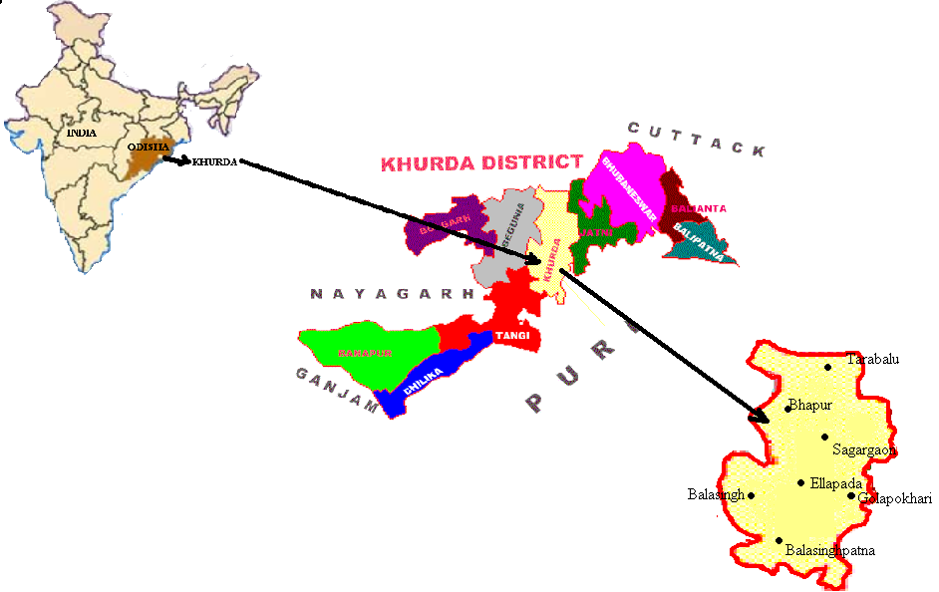

Fig-1: Location of Khurda district

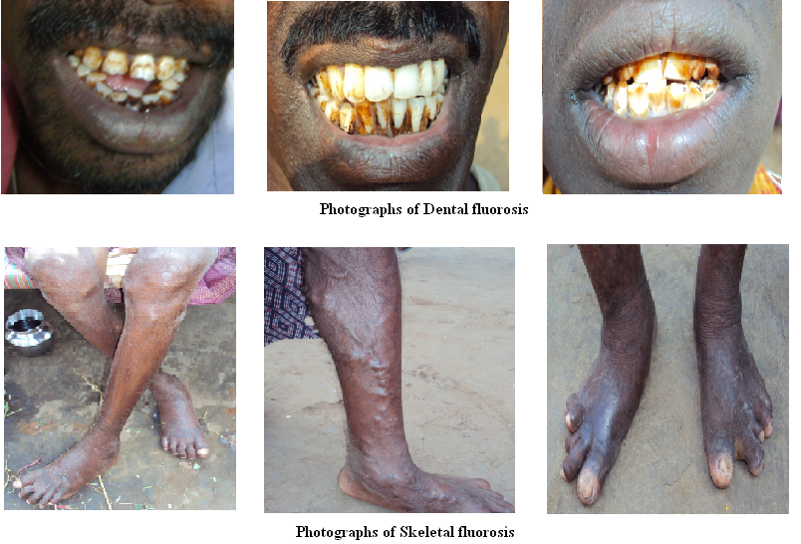
Fig-2: Photographs of Dental and Skeletal fluorosis

Table-3: Analysis report of water samples of Sagargaon panchayat, bolgarh block of khurda district, orissa

SL.NO | LOCATION OF SAMPLING | pH | F  mg/L | TH mg/L | CaH mg/L | Ca⁺⁺ mg/L | Mg⁺⁺ mg/L
Tarabalu hot spring area
01 | Left well near temple | 8.23 | 10.4 | 14 | 14 | 5.61 | 0.0
02 | Right well near temple | 8.24 | 9.19 | 26 | 26 | 10.42 | 0.0
03 | Tube well | 8.19 | 9.2 | 14 | 14 | 5.61 | 0.0
04 | Cultivated field south side | 8.2 | 9.19 | 24 | 24 | 9.61 | 0.0
05 | Bathing reservoir | 8.25 | 10.0 | 20 | 20 | 8.01 | 0.0
06 | Cultivated land north side | 8.29 | 14.0 | 22 | 18 | 7.21 | 0.98
07 | Hot Spring water near west side | 8.15 | 9.25 | 14 | 14 | 5.61 | 0.0
08 | Tube well sample near temple(Village) | 8.26 | 1.04 | 426 | 384 | 153.9 | 10.213
09 | Upstream of Kaligiri river water | 7.44 | 10.3 | 28 | 20 | 8.0 | 1.94
10 | Downstream of Kaligiri river water | 7.21 | 10.8 | 88 | 36 | 14.4 | 12.6
11 | FD/S of Kaligiri river water | 7.59 | 12.3 | 60 | 40 | 16 | 4.86
Sagargaon Village
12 | DeepTube well water (Supply water) | 8.52 | 1.6 | 244 | 232 | 92.98 | 2.92
13 | Dug well water | 8.57 | 3.2 | 104 | 60 | 24.04 | 10.72
14 | Tube well water | 8.57 | 0.48 | 116 | 82 | 32.86 | 8.28
Golapokhari village
15 | Tube well water | 8.4 | 1.32 | 92 | 52 | 20.84 | 9.74
Bhapur Village
16 | Tube well water near U.P. School | 8.58 | 0.446 | 248 | 34 | 13.62 | 52.15
Ellapada Village
17 | Dug well of Mr.Ramachandra Naik | 5.65 | 0.992 | 574 | 30 | 12.02 | 132.5
18 | Tube well near Mr.Ramachandra Naik | 8.24 | 0.268 | 414 | 10 | 4.008 | 98.45
Balasinghpatna Village
19 | Pond water | 8.17 | 0.27 | 52 | 40 | 16.03 | 2.92
20 | Supply water | 8.36 | 1.0 | 396 | 332 | 133.06 | 15.59
Balasingh Village
21 | Tube well | 8.42 | 0.866 | 294 | 272 | 109.01 | 5.36
22 | Dug well | 8.06 | 0.542 | 552 | 484 | 193.98 | 16.57
23 | Supply water | 8.34 | 1.1 | 278 | 132 | 52.9 | 35.5

Correspondence to:
R.K Sahu PhD
Dept. of Botany
BJB (A) College
Bhubaneswar - 751014, Orissa, India.
Email-sahurajani@yahoo.co.in

References
- Brown E., Skougsted M.W. and Fishman M.J.,Methods for collection and analysis of water samples of dissolved minerals and gases, 1970; chapter-1, Book No.5.
- Bulusu K.R., Nawalakha W.G., Kulkami D.M and Litada S.L., Fluoride. Its incidence in natural water and defluoridation methods. Silver jubilee commermoative volume, NEERI, Nagpur, 1985.
- Bureau of Indian Standards Indian Standards drinking water specification IS 10500, 1991.
- Das S.B.C. Mehta, Das P.K., Srivastava S.K., Samanta S.K., Source of High fluoride in Ground water around Angul, Dhenkanal district Orissa. (Pollution Research, 1998; Vol. - 17, No.3.
- Handa B.K., Chemistry of Fluoride in natural waters in Indian sub continent & its significance, (Proc. All India Seminar on ground water development, institution of Engineers, Lucknow, 1988.
- Hem J.D., Study and interpretation of the chemical characteristics of natural water (USGS water supply paper No.2254), 1991.
- Indian council of medial Research: Special report. Series No.44, 1975.
- Irvig.sex, Industrial Pollution (Von. Nostrand Reinhold Co.), 1974.
- Krainov S.R. and petrova N.G., Hydrogeochemistry of mineralized water proceedings. IAH, Warsaw, 1979.
- Christian G.D., Analytical Chemistry, 4th Ed., John Wiley and Sons, New York, 1986; pp.590-592.
- Dresler V.L., Pozebon D., Flores E.L.M., Paniz J.N.G. and Flores E.M.M., Anal. Chim. Acta, 2002; 466,117-123.
- Instruction Manual. Orion Research Incorporated, Cambridge, Massachusetts, 1983.
- Murray J.J. (Ed.) Appropriate use of fluorides for human health, World Health Organization (WHO), 1986.
- Simposon A., Shaw L. and Smith A.J. The bio-availability of fluoride from black tea. Journal of Dentistry, 2001; 29(1), 15-21.
- WHO (). Fluoride in drinking-water: Background document for development of WHO guidelines for drinking-water quality. World Health Organization, 2004; pp-2.
.http:/www.who.int/water_sanitation_health/dwq/chemicals/fluoride.pdf, june11, 2007.
- WHO Water, sanitation and hygiene. World Health Organization, Nov.2004.
http:/www.who.int/water_sanitation_health/dwq/chemicals/fluoride.pdf, june11, 2007.

1/6/2011

