Groundwater Exploration with D.C Resistivity Method In Maigamo Area of Kubanni River Basin Zaria, Nigeria.

Ameloko A Anthony¹, Omali Aurelius O²

¹Department of Petroleum Engineering Covenant University Ota, Ogun State, Nigeria
²Department of Earth Sciences Kogi State University Anyangba, Kogi State, Nigeria
aduojo2001@yahoo.com

Abstract: A geoeletric investigation of the Western part of Kubanni River Basin was carried out using the vertical Electrical sounding (VES). The survey was carried out with the aim of investigating the subsurface around the study area to delineate aquifer overlying the Precambrian basement complex in the area. The result of the Schlumberger array data suggests that the subsurface resistivity is not homogeneous, but varies from one place to another. Also, the interpreted VES data revealed that, most of the layers underneath are two and three layer cases, while the resistivities of the layers ranged from about 40.09 ohm-m to 1960.23 ohm-m, depending on the lithology. The geologic sections deduced from the geoelectric soundings suggest that the weathered basement most likely forms the aquifer in the area. This area is characterized by relatively low resistivity values 40.09 ohm-m – 100 ohm-m.
[Ameloko A Anthony, Omali Aurelius O. Groundwater exploration with D.C resistivity method in Maigamo area of Kubanni river basin Zaria, Nigeria. World Rural Observations 2011; 3(1):72-81]. ISSN: 1944-6543 (print); ISSN: 1944-6551 (online). http://www.sciencepub.net/rural.

Keywords: Electrical method, Interpretation, Basin, Acquisition, Aquifer, Basement complex

Introduction

The purpose of electrical surveys is to determine the subsurface resistivity distribution by making measurements on the ground surface. From these measurements, the true resistivity of the subsurface can be estimated. The ground resistivity is related to various geological parameters such as the mineral and fluid content, porosity and degree of water saturation in the rock. The survey was primarily carried out to determine the zones within the study area which have very good potential for groundwater development.
The component of the aquifer in the quaternary deposits which overlie basement rocks in the Kubanni basin have been identified by previous workers [Wright and Mc Curry, 1970; Olowu, 1967; Eigbefo, 1978] mainly from surface geological mapping. They consist of [I] The weathered laterites [older and younger], [II] The alluvial deposits found along the channels of the Kubanni river and its tributaries and [III] The weathered basement which is considered the major component of the aquifer in the area. Further more, Hassan 1987] carried out a geo-electrical investigation of part of the western half of the Kubanni basin and concluded that the bedrock in his study area is undulating with depths generally increasing towards the southern part of the study area.
The superficial deposits that cover most of the basement rocks in the basin act as recharge materials especially where they are underlain by the weathered basement [Eigbefo, 1978].
Tokarsky [1972] classified the quaternary deposits in the area to include the aeolian cover, lower upper savannah loams and the younger and older laterites.

Location of the study area

The Kubanni River basin, located between latitudes 11⁰ 4¹ 25¹¹N and 11⁰ 10¹ 46¹¹ N and longitudes 7⁰ 36¹ 55¹¹E and 7⁰ 44¹ 12¹¹E, has an area of about 105 km² (Eigbefo, 1978). It occupies the centre of the south-eastern sector of the Zaria sheet No 102 SW of the Nigeria Ordinance Survey Map (Figure.1.1).
The Zaria area is a dissected portion of the Zaria-Kano plain which developed on the crystalline metamorphic rocks of the Nigerian Basement Complex. Extensive exploitation and chemical weathering have produced residual granitic inselbergs such as the Kufena hill. They are low hills to the east of Kufena around Zaria city and Tudun Wada. North of Samaru and elsewhere, the granite outcrops form whaleback and low pavements (Tokarski, 1972).

   
13⁰ N
7º 44’ 12^{II} E
4⁰ N
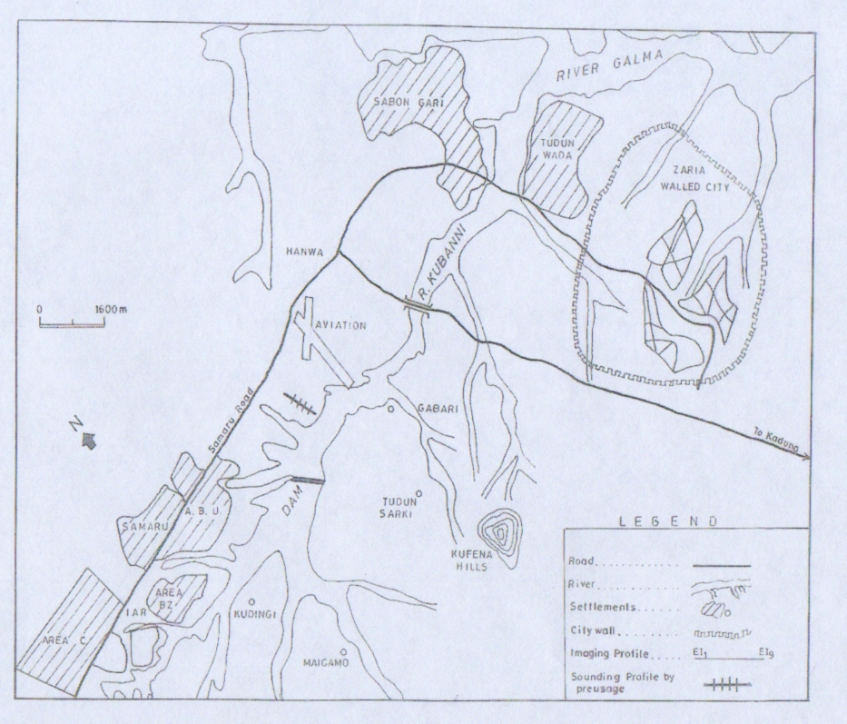
7⁰ 36’ 56“ E
11⁰ 10^{I} 45^{II} N
7⁰ 44^{I} 12^{II} E

                                                      

Figure 1.1: Location map of the Kubanni River Basin and study area

Geology of the study area

The Kubanni River basin is underlain by the Basement rocks of the Precambrian age. They are mainly granites, gneisses and schists.
Migmatite bands are mainly confined to the granite – gneiss boundary (Adamu, 1973). The Zaria crystalline rocks are part of the Nigerian Basement Complex. Oyawoye (1964) showed that there is structural relationship between this basement complex and the rest of the West African Basement. This is partly due to the fact that the whole region was involved in a single set of orogenic episode, the pan African Orogeny, which left an imprint of structural similarity upon the rock units.
Granite intrusion forms a suite of batholiths (The Zaria Batholiths), part of which outcrops as the Kufena hill. The gneisses are found as small belts within the granite intrusions, and are also found east and west of the batholith. The biotite gneiss extends westwards to form a gradational boundary with the schist belt. The gneiss continues eastward to some extent and is occasionally broken up by the older granite (Mc Curry, 1970).

The metasediment probably belongs to the sedimentary and granite facies that were formed in a geosynclinals trough which had earlier developed at the end of the pre-Cambrian orogeny (Tokarski, 1972).
The structural features in the area include the foliation of the gneisses and granites found in the outcrops around the institute of Agricultural Research, and Kufena hill respectively (Adamu, 1973). Also there are veins of microgranite found in areas around Ungwan Bature and Ungwan Kubanni.
The trends of foliation of the gneisses and granites and also the trend of the microgranite veins reveal that these structural elements have a general N-S trend, and also have steep to vertical dip angles.
Also there are joints and faults found in areas around Rafiu Magaji and Ungwan Maigamo respectively with similar trend with the earlier structures. The similarities of these structures can be attributed to the same tectonic forces that acted upon the various rock units at the waning phases of the pan African Orogeny.

Data collection and interpretation

The electrical resistivity method is one of the most relevant geophysical methods applied for groundwater studies in basement terrains (Olorunfemi Fasuyi, 1993). In groundwater studies for instance, the relevance of the method is based on the usually significant resistivity contrast between the weathered zone and or fresh column and the resistive fresh bedrock.
Apparent resistivity data were collected, using the Schlumberger array, from 21 vertical electrical soundings (VES Points) distributed over three profiles with 2 of them trending approximately N-S while the third, cuts across the first two profiles in almost E-S direction (Fig. 2).
Sounding along definite profiles, rather than sounding randomly were done in this survey so as to obtain a better image of the lateral variation in depths to the bedrock as well as the layering of the overlying quaternary deposits. The station interval was 100m on all the profiles and at each VES station the maximum separation of the current electrode AB (L) used was 100m.
Qualitative interpretation was carried out for each sounding curve using partial curve matching technique. These provided layer parameters which were optimized using computer iterative techniques for quantitative interpretation. To interpret the data collected at each VES points, a trial model determined from partial curve matching and from cumulative plots was first tried. The parameters fed into the computer for each model were the number of layers, the resistivity value for each layer and the thickness of each layer. The theoretical curve for the trial model was computed by the computer and automatically compared with the observed curve and the parameters subsequently modified to improve the agreement between the observed and the computed curves.
The numerical results of the VES are presented in tables 1, 2 & 3 while typical VES curves are presented in figures 2.1 and 2.2. Figure 2.1 for example shows the resistivity curve for station VES 2 on profile A. Most of the curves obtained represent the presence of at least three geoelectric layers.

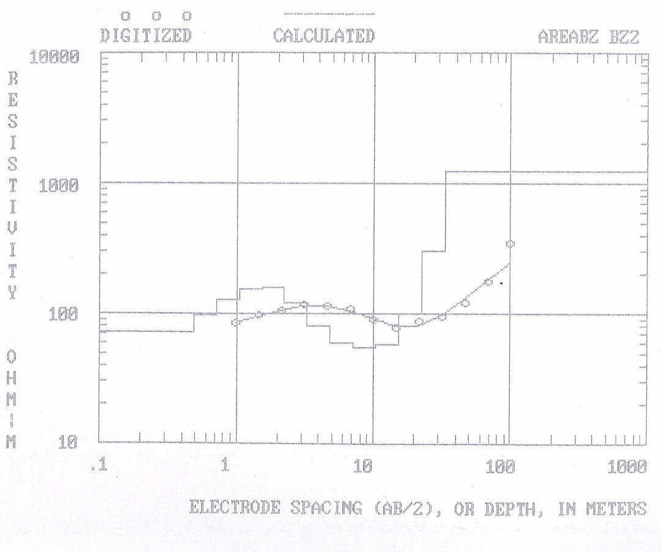
Figure 2.1; True resistivity layer model for station VES 2

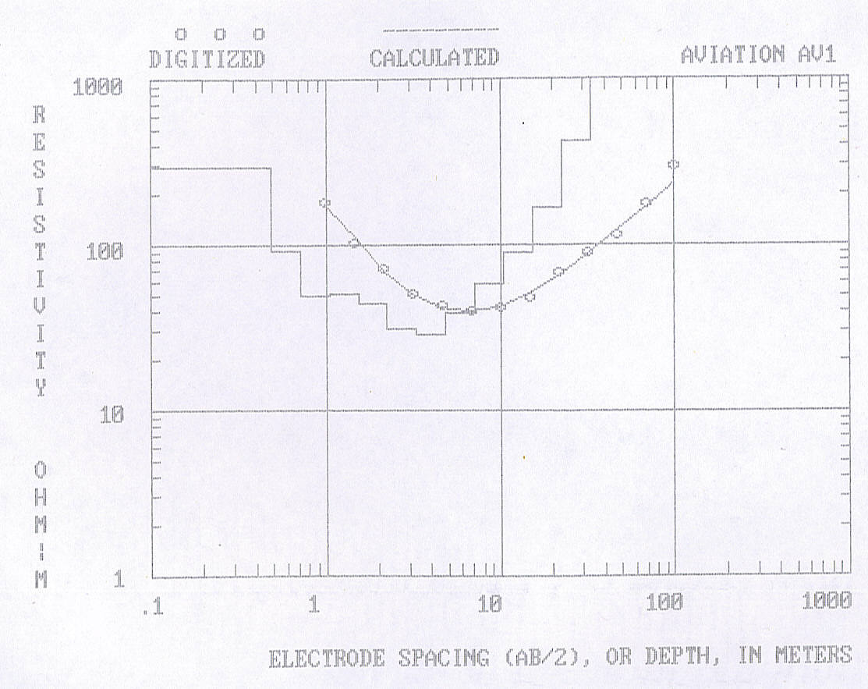
Figure 2.2: True resistivity layer model for station VES 19

Figure 2.1 for instance suggests the presence of three layers with the first having an estimated thickness of about 10 m with resistivity value of 121.87 Ωm while the second layer is about 13 m thick with resistivity value of 68.92 Ωm. The third layer has a resistivity of about 1149.49 Ωm and of infinite thickness. Since the resistivity value associated with the third layer is very high, the layer is considered to be made up of fresh basement rocks.
The VES results coupled with geological information were used to construct an interpretative cross section across the surveyed area as presented in Figures 3.2, 3.3 and 3.4. Combining this section with a geologic well-log (figure 3.1) obtained by M/S Preussag Ltd., Kaduna and published by Olufemi (1985); and from typical resistivity values of rocks in basement areas compiled from previous workers in Kaduna and Kaduna state, figure 2.1 can be interpreted as having a first geoelectric layer made up of sand, clay and silt while the lower resistivity value associated with the second layer suggests that the horizon is most probably made up of weathered basement. The third layer suggests that fresh basement rock most likely underlies the entire profile.

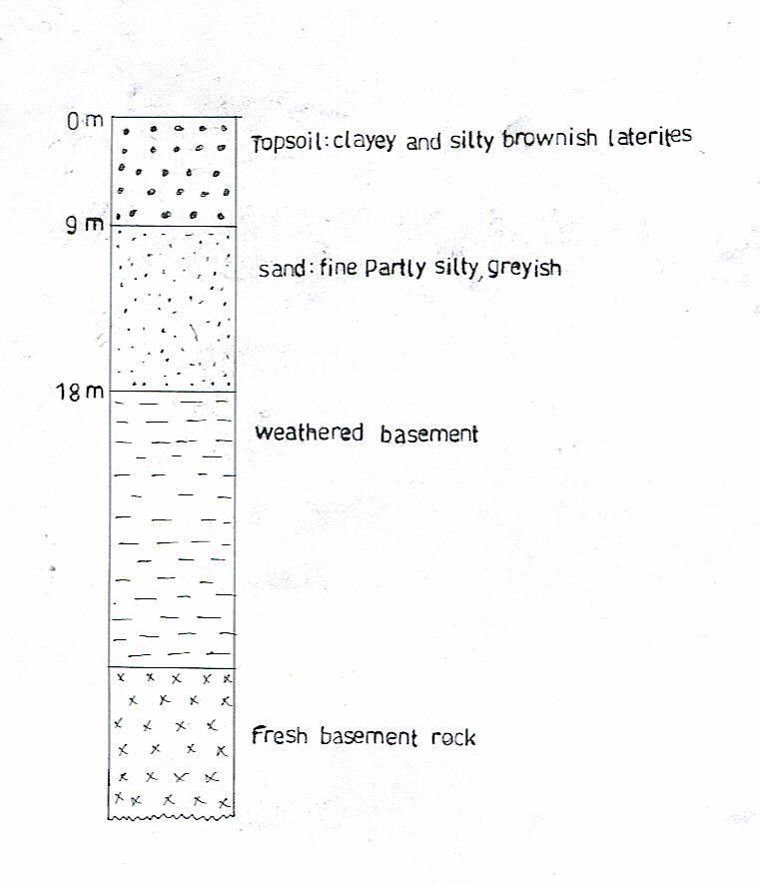
Figure 3.1: Geological well-log obtained by Preussag Ltd. [After Olufemi 1985]

Table 1: Interpretation of VES over Profile A

VES No |  | No. of Layers | Depth [m] | Thickness [m] | Apparent Res.  [Ωm] | Rock Types
1 |  | 1  2  3 | 4.0  26. 0  - | 4.0  22.0  - | 98.3  144.5  801.2 | Silt +sand  Weathered basement  Fresh basement
2 |  | 1  2  3 | 10.0  23.0  - | 10.0  13.0  - | 121.87  68. 92  1149.49 | Silt+ clay+ sand  Weathered basement  Fresh basement
3 |  | 1  2  3 | 12.0  22.0  - | 12.0  10.0  - | 117.38  58.43  959.73 | Silt + clay +sand  Weathered basement  Fresh basement
4 |  | 1  2  3 | 10.0  17.0  - | 10.0  7.0  - | 161.20  92.25  1273.71 | Silt +clay +sand  Weathered basement  Fresh basement
5 |  | 1  2  3 | 12.0  19.0  - | 12.0  7.0  - | 171.35  98.70  805.89 | Silt +clay+ sand  Weathered basement  Fresh basement
6 |  | 1  2  3 | 18.0  24.0  - | 18.0  6.0  - | 107.03  86.81  969.34 | Fadama loam  Weathered basement  Fresh basement
7 |  | 1  2  3 | 20.0  26.0  - | 20.0  6.0  - | 147.82  89.16  877.63 | Clay + silt  Weathered basement  Fresh basement
8 | 1  2  3 |  | 8.0  28.0  - | 8.0  2.0 | 119.02  88. 95  1139.25 | Silt +clay+ sand  Weathered basement  Fresh basement
9 | 1  2  3 |  | 18.0  24.0  - | 18.0  6.0  - | 150.23  83.35  1031.66 | Silt + clay + Sand  Weathered basement  Fresh basement

Table 2: Interpretation of VES over Profile B
VES No. | No. of Layers | Depth [m] | Thickness [m] | Apparent Res. [Ωm] | Rock Types
10 | 1  2  3 | 14.01  44.06  - | 14.01  30.05  - | 154.64  60.47  934.81 | Clay + silt +sand  Weathered basement  Fresh basement
11 | 1  2  3 | 13.1  41.01  - | 13.1  28.0  - | 162.50  98.34  1030.10 | Clay + silt +sand  Weathered basement  Fresh basement
12 | 1  2  3 | 18.1  45.21  - | 18.1  27.2  - | 185.58  58.71  994.82 | Clay + silt  Weathered basement  Fresh basement
13 | 1  2  3 | 19.30  46.30  - | 19.30  27.0  - | 142.11  79.0  1117.38 | Clay + silt  Weathered basement  Fresh basement
14  15 | 1  2  3  1  2  3 | 18.81  45.83  -  14.02  44.02  - | 18.81  27.02  -  14.02  30.00  - | 137.68  62.95  1687.45  156.21  83.46  1960.23 | Clay + silt  Weathered basement  Fresh basement  Clay + silt  Weathered basement  Fresh basement

Table 3: Interpretation of VES over Profile C
VES No. | No. of Layers | Depth [m] | Thickness [m] | Apparent Res. [Ωm] | Rock type
16 | 1  2  3 | 18.50  40.52  - | 18.50  22.02  - | 120.09  40.09  1552.60 | Sand + gravel  Weathered basement  Fresh basement
17 | 1  2  3 | 18.34  38.87  - | 18.34  20.53  - | 125.28  50.93  1038.0 | Sand + gravel  Weathered basement  Fresh basement
18 | 1  2  3 | 17.05  29.26  - | 17.05  12.21  - | 200.0  97.95  606.34 | Clay + silt + sand  Weathered basement  Fresh basement
19 | 1  2 | 16.01  - | 16.01  - | 200.95  1417.46 | Sand + gravel  Fresh basement
20 | 1  2 | 11.21  - | 11.21  - | 175.65  1044.02 | Sand + gravel  Fresh basement
21 | 1  2  3 | 10.93  16.93  - | 10.93  6.00  - | 98.52  302.91  1352.51 | Sand + gravel  Weathered laterite  Fresh basement

Figures 3.2, 3.3 and 3.4 show the geologic cross-sections obtained from the VES sounding curves along the profiles. Figure 3.2, for instance indicates that profile A is underlain at different places by three layers. The region occupied by the first station on the profile is underlain by three layers. The first layer here is made up of thickness of about 4 m, while the second is about 22 m thick. The third layer is of higher resistivity value and infinite in thickness. The thickness of loosed materials appears to be fairly uniform across the profile as seen on the section. As can be viewed also, the geologic cross-section along the entire profile indicates the presence of three layers of rock in the area.
On profile B, the top layer has resistivity value that range from 130-190 Ωm and thickness of about 13-19 m. The second layer has resistivity values that fall within 58-98 Ωm, while the third layer with relatively higher resistivity values is made up of the basement rocks.

N
S
VES1 VES2 VES3 VES4 VES5 VES6 VES7 VES8 VES9
- . . . . . . . . . . . . . . . . . . . . . .
Depth (m)
00.00
. . .
20.00

40.00

60.00

Distance (m)

KEY
. . . . . . .
Clay, silt and sand

Weathered basement

Fresh basement

Figure 3.2: Geologic section derived from profile A

VES10 VES11 VES12 VES13 VES14 VES15
N
S
0.00
. . . . . . . . . . . . . . . . . . . . . . . .. . . . . . . . . . . . . . . . . . . . . .

Depth (m)

20.00

40.00

Distance (m)
60.00

KEY
silt and clay
. . . .
 weathered basement

Fresh basement

Figure 3.3: Geologic section derived from profile B

W E
Depth (m)
VES16 VES17 VES18 VES19 VES20 VES21

. . . . . . . . . . . . .
0.00
. . . . . . . . . . . .
. . . . . . . . . . . . . .
. . . .
20.00

40.00

60.00
Distance (m)

KEY
. . .
Sand and gravel s
Weathered laterite
. . .
Weathered basement

Fresh basement

Figure 3.4: Geologic section derived from profile C

Profile C is equally underlain by three geologic layers except for regions under VES 19 and VES 20 where two layers are observed. Fresh basement is also seen underlying the entire profile. The first layer on this profile has varying thickness and is seen decreasing towards the end of the profile, and resistivity values between 98-200 Ωm. The depth to basement on this profile generally decreases towards the eastern part.

Discussion of results

The type of structures developed in rocks affect the occurrence of ground water. Some rocks have pore-spaces which are filled with water while others have dry pore spaces or non at all. In igneous rocks, porosity occurs primarily in the form of joints and fractures. Other non crystalline rocks may be naturally highly permeable. The criteria that make a formation a good aquifer include high effective porosity and permeability. These in turn depend on the degree of weathering and fracturing of the rocks.
The storages elements for groundwater in the Kubanni basin are the weathered laterites and the alluvial sands (Olowu, 1967; Eigbefo, 1978). According to Eigbefo (1978), the weathered basement is most important component of the aquifer in the Kubanni basin.
The geologic section shown in Figures 3.2-3.4 suggest that substantial component of the entire surveyed area is made up of these storage element, therefore, confirming the view of the previous workers. For instance, the thickness of this layer under profile B varies from 27 m around VES₁₃ and VES₁₄ and about 30 m in other places while the topsoil has an average thickness of about 16 m throughout the length of the profile.
On profile C, the thickness of the weathered basement is about 25 m around the western part of the profile while that of the topsoil is about 18 m. Although profile A is prominently underlain by basement rocks, it is seen that the thickness of weathered materials in less towards the southern part with the weathered basement thickness varying between 6 -30 m around the northern part.
Hassan (1987) and Ososami (1968) in their work suggested that bedrock generally gets deeper towards the southern part of the Kubanni basin. By implication, it means that the thickness of weathered materials increase in this direction. Results from this survey seem to agree with their view as shown by large thicknesses of weathered layers that characterized the three profiles.
The geologic sections derived from this survey suggest that the decomposed rocks formed from the basement form the main aquifer in the study area. This decomposed (weathered basement) is characterized by low to medium resistivity values. The other lesser aquifers are the sand and gravel with resistivity values between 98-180 Ωm and the alluvial deposit which consists of sand, silt and clay. This topsoil are mostly found along the river channels and for the fact that their hydraulic conductivity is most likely to be higher than that of the other surface soil type (weathered laterite), this soil type may be the main medium through which the weathered basement in the project area is recharged.
Since the areas along the profile B is underlain by substantial thickness of aquifer (20-30 m), and also the western part of profile C around Maigamo village has significant aquifer thickness (22 m), then it can be deduced that these zone is expected to be a major reservoir of underground water. Hence, it is the most highly recommended zone to site boreholes or even hand-dug wells.

Conclusion

This project was carried out with the ultimate aim of deducing from the sounding results and geoelectric sections, a better image of the basement geometry and aquifer thickness, within the study area, thereby revealing the areas of good groundwater potential. Bearing this at the back of the mind, we can conclude by saying that the geologic sections indicated by figures 3.2-3.4 shows that the layering in the study area vary from two to three layers and the bedrock is characterized by high resistivity values of >800 Ωm and generally increasing in depth towards the southern and western parts of the study area.
Of utmost importance is the fact that the sounding results suggests that the decomposed rocks formed from the basement constitute the main aquifer in the study area as its thickness varies from 10 m on profile A to about 30 m on profile B and C. The fact that the aquifer appears thickest along profile B and around the western part of profile C, make the area most suitable part of the study area for groundwater exploitation.

Acknowledgement

This research was carried out with economic and logistic support from the Department of Physics, Ahmadu Bello University Zaria Nigeria. I am grateful.

About the authors

Ameloko Anthony A attended the University of Jos, Nigeria where he bagged a Bachelor of Science degree (B.Sc.) in Geology and Mining. He earned his Master’s degree in Applied Geophysics from the prestigious Ahmadu Bello University Zaria in May 2006. He currently lectures geosciences in the department of Petroleum Engineering, Covenant University Ota, Ogun State. His research interests are in electrical imaging and seismic reservoir characterisation.

Omali Aurelius O is a Lecturer at the department of Earth Science, Kogi State University Anyangba, Nigeria. He is a registered member of the Nigerian Mining and Geosciences Society and Nigerian Association of Petroleum Explorationists. He holds a Master of Science (M.Sc.) in Hydrogeology from the Nnamdi Azikiwe University Oka, Nigeria. His research interests are in environmental geology and groundwater systems.

References
1. Eigbefo, C., 1978. Hydrogeology of the Kubanni Drainage Basin, Zaria, Unpublished M.Sc. Thesis, A.B.U., Zaria.
2. Tokarshi, A., 1972. Heterogeneous terrace arrangement West of A.B.U., occasional paper No 2, Dept. of Geology, A.B.U., Zaria.
3. Wright, J.B. and Mc Curry, P., 1970. The Geology of the Zaria Sheet 102 SW, in Zaria and its region (Ed. M.J. Mortimore), Department of Geography, occasional paper No 4, A.B.U. Zaria.
4. Olowu, J., 1967. Preliminary investigations of the groundwater conditions in Zaria sheet 102 SW, GSN Rept. No 1462
5. Hassan, M., 1967. Geoelectrical Investigations of the Western half of the Kubanni River Basin, Zaria, Nigeria, unpublished M.Sc. Thesis, A.B.U., Zaria.
6. Adamu, A.G., 1973. Basement Geology of Zaria – Samaru Area, Unpublished B.Sc. Project, Dept. of Geology, A.B.U., Zaria.
7. Oyawoye, M.O., 1964. Geology of the Nigerian Basement Complex, Journal of Nigeria Minign, Metallurgical Society Vol. Pg. 87-102.
8. Mc Curry, P. 1970. The Geology of Degree Sheet 21, Zaria. Unpublished M.Sc. Thesis, A.B.U., Zaria.
9. Olorunfemi, F., 1993. Geoelectrical Investigations of the Western half of the Kubanni River Basin, Zaria, Nigeria, unpublished M.Sc. Thesis, A.B.U., Zaria.
10. Olufemi, R.O., 1985. Hydrogeology of Jama’s Kubanni Area, Zaria (sheet 102 SW), Unpublished B.Sc. Thesis, A.B.U., Zaria.
11. Ososami, I.A. Assessment of the groundwater in the Kubanni Valley, Unpublished M.Sc. Thesis, A.B.U., Zaria.
12. Zohdy, A.A.R., 1989. A new methods for automatic interpretation of Schlumberger and Wenner sounding curves. Geophysics Vol. 54 No 2, Pg. 245-253.

2/4/2011

