Exploratory Survey Of Geochemical Aspects Of Underground Water In Ehime Mbano Area Se Nigeria

Onunkwo A, A¹ And Uzoije A.P.²

Department Of Geology¹,Department Of Environmental Engineering²
Federal University Of Technology, Owerri.

Abstract: The exploratory survey of geochemical aspects of underground water resource in Ehime Mbano area of Imo State South-eastern Nigeria has been carried out. Since the creation of Ehime Mbano Local government area in 2001, there is the need for sub surface water quality assessment since the surface water has been polluted due to population explosion. The study was carried out by acquiring geologic and topographic maps of the area for easy identification of sample population areas, and to identify geological boundaries. Spring outcrops, landuse elements, especially waste dump sites and agricultural projects were visited and examined. A total of 6 water samples, 2 from springs and 4 from boreholes were collected randomly and analyzed. Analysis was carried out using atomic absorption spectroscopy for major cations. Heavy metal analysis was undertaken using spectrophotometer, potassium was determined using flame photometer method, concentration of total iron (Fe²⁺) was determined calorimetrically using spekker absorption meter, while total dissolved solids (TDS) was determined using glass fiber filter. Turbimetric method was used to assess turbidity. Physical parameters like ph and dissolved oxygen were measured insitu in the field with appropriate standard meters. The result of geochemical survey shows that the water has high turbidity, high iron, slightly acidic, soft , portable and suitable for domestic, industrial and irrigation purposes. Above all the water has no bacteria presence, no heavy metals also no laxative effect. The average pollution index of 2.50 indicates a slight pollution though Ezeoke Nsu area (NE) is highly polluted. Remediation to the problems of slight water pollution is proposed.
[Onunkwo A, A¹ And Uzoije A.P. Exploratory Survey Of Geochemical Aspects Of Underground Water In Ehime Mbano Area Se Nigeria. World Rural Observations 2011;3(2):29-37]; ISSN: 1944-6543 (Print); ISSN: 1944-6551 (Online). http://www.sciencepub.net/rural.

Key Words: Exploratory Survey, ground water, quality, population, contamination, Subsurface

Introduction:
The political creation of local government in Nigeria caused a new population explosion in villages which were raised to urban status. Ehime Mbano area of Imo State, Nigeria witnessed an upsurge of population explosion since the creation of Ehime Mbano Local Government. This new trend calls for exploratory survey of the nature, usability and quality of the sub surface water resource, since the new trend of urbanization calls for industrial establishments and portable water.
Rock types, their weathered products and precipitation from rainfall contribute greatly to the chemistry and pollution trend of surface and ground water (Wilson, 1981). Man’s activities such as dumping of refuse, agricultural practices and animal dung also determine the pollution of surface and ground water (Horton, 1995). Groundwater pollution may also be caused by the disposal of solid or liquid wastes in pits, abandoned boreholes or even stream channels and land fills. Others are poorly constructed or designed septic tanks, sewage disposal systems (Ellis, 1988). Chemicals such as lead, arsenic and radioactive minerals derived from chemical waste disposal sites of factories and mining industries also contribute possible pollutants. The introduction of contaminant or pollutant into an aquifer system starts with the infiltration of the pollutant through a water medium induced by precipitation. Ground water pollution may be a point or diffuse source (Todd, 1959). Point source of groundwater pollution may result from the location of a disposal pits, ponds or lagoons, mines or industrial wastes, disposal points, direct into an unconfined aquifer system. Diffused groundwater pollution source are more complicated and hence difficult to identify and remediate since it is difficult to locate the origin and areas of impact of the contamination ( Raymond , 1979). Water related diseases from subsurface has been reported in the past. Feachem et al. 1998 reported high incidence of water-related diseases in thickly populated settlements with their sources traced to wells. Also Palmer and Holman (1997), observed that chemical pollutants such as heavy metals which constituted cancer and other related illnesses was traced to the underlying ground water from poorly managed waste source in a Delhi city of India. Therefore, the aim of the study is to examine the ground water contamination level in Ehime Mbano area of Imo state, south-eastern Nigeria. In the strength of these, the assessment of the ground water quality of the study are becomes imperative following the unprecedented population explosion occasioned by the movement of the people to the suburbs due to government policy.
Materials and Method
Description of Study Area
Ehime Mbano is located within Anambra / Imo sedimentary basin of South-eastern Nigeria. It is bounded by latitude 5° 37N to 5 °46 N and longitude 7° 14 E to 7° 21E Fig I. The drainage pattern is dendritic typical of sedimentary rock with uniform resistance and homogenous geology (Dever and James, 1985). The area has a tropical climate and experience two air masses, equatorial maritime air masses, associated with rain bearing South west winds from Atlantic ocean around March to September (Illoeje 1981). The other is dry and dusty hamattan wind from Sahara desert blowing around December to February. The annual total average rainfall is about 230mm while temperature ranges from 29°C during dry season to about 33°C in rainy season. Relative humidity lies between 65% and 75% (Illoeje 1981).
The physiography is dominated by a segment of Northern , South eastern trending Okigwe regional escarpment which stands at elevation of between 61m and 122m above sea level ( Alfred 1992). Vegetation in the area is tropical rain forest which is prevalent in the Southern states of Nigeria ( Oguntoyimbo, 1987). Due to great demand of land in the area coupled with other human activities especially over grazing, the rain forest has been replaced by some economic crops such as oil palm forest.
The soil of the area is loamy with scattered pebbles (Gorrel, 1990). Thick vegetative covers has prevented soil erosion , however, erosion is prominent in the areas where road cuts, forest clearing and over cropping have opened up the soil to erosion elements (Stephen 2004). The presence of Benin Formation is a contributory factor to soil erosion especially where they are exposed unprotected by vegetation (Onunkwo – Akunne and Ahiarakwem 2001). Ehime Mbano and environs falls within Anambra –Imo sedimentary basin of South-eastern Nigeria and is underlain by Benin Formation (–miocene – recent) (youngest) Ameki Formation (Eocene) and Imo Shale Formation (Paleocene) and oldest in the area (Reyment 1965). See fig 2 and table 1 for more explanation. The major aquiferous formation is Benin Formation (Parkinson, 1970).

Table I STRATIGRAPHIC SEQUENCE IN SOUTH-EASTERN NIGERIA (REYMENT 1965)
Neogene | Recent  Miocene-Pieostocene | Marine deltaic deposits; alluvium  Benin Formation
Neogene | Oligocene ? - Miocene | Ogwashi-Asaba Formation
Paleogene | Ledian | Not represented
Paleogene | Bartonian | Possibly upper part of Ameki Formation
Paleogene | Lutetian | Ameki Formation
Paleogene | Ypresian | Possibly lower most part of Ameki Formation |  | Nanka  sand
 | Paleocene | Imo Shale
Upper Cretaceous | Danian | Nsukka Formation
Upper Cretaceous | Maestrichtian | Ajalli Sandstone
Upper Cretaceous |  | Mamu Formation
Upper Cretaceous | Campanian | Enugu Shale | Nkporo shale
Upper Cretaceous | Coniacian-Santonian | Awgu Shale
Upper Cretaceous | Turonian | Eze-Aku Shale
Upper Cretaceous | Cenomanian | Odukpani Formation
Lower Cretaceous | Albian | Unnamed Formations | “Asu River  Group”
Lower Cretaceous | Albian | Abakaliki Shale

Data Collection
Data was acquired from field work, laboratory investigations and libraries. Topographic and geologic maps on a scale of 1: 250,000 was obtained from Nigeria geological survey department, Enugu. Spring out crops, geological boundaries landuse especially waste dump sites were visited and examined.
A total of 6 water samples were collected for organic and inorganic analysis Analysis was carried out using Atomic absorption spectroscopy for Ca²⁺, Na⁺, Mn²⁺, Cl⁻ , Pb, Cd, Zn and Cu were analyzed with the aid of spectrophotometer while K+ was determined using flame photometer method. pH was measured with standard pH meter while the concentrations of total Iron (Fe) were determined calorimetrically using Spekker absorption meter. Total dissolved solids (TDS) was determined using glass fiber filter. The concentrations of Ca²⁺, Mg²⁺ and Na⁺ in milli equivalent / litre were used to obtain sodium absorption ratio (SAR).Turbidimetric method was used to assess turbidity. Physical parameters like pH and dissolved oxygen were measured insitu in the field with the appropriate standard meters. While anions like HCO₃ were estimated by titrimetric method. All details of analytical procedures are reported in Omidiran (2000). Clean plastic containers were used to contain the water samples. They were rinsed several times with the same water samples to be analyzed , then covered with air tight cork and carefully labeled and sent to the laboratory for analysis, within 24 hours of collection. The parameters analyzed are Temperature, dissolved oxygen, turbidity, conductivity, total dissolved solid iron (Fe²⁺) Calcium (Ca²⁺) Chloride (Cl⁻), bicarbonates (HCO3⁻), total hardness and Sodium (Na⁺) etc. Coliform count was analyzed as to estimate possible bacteria presence. Physical parameters such as oxygen, pH , conductivity and temperature were measured insitu in the field.

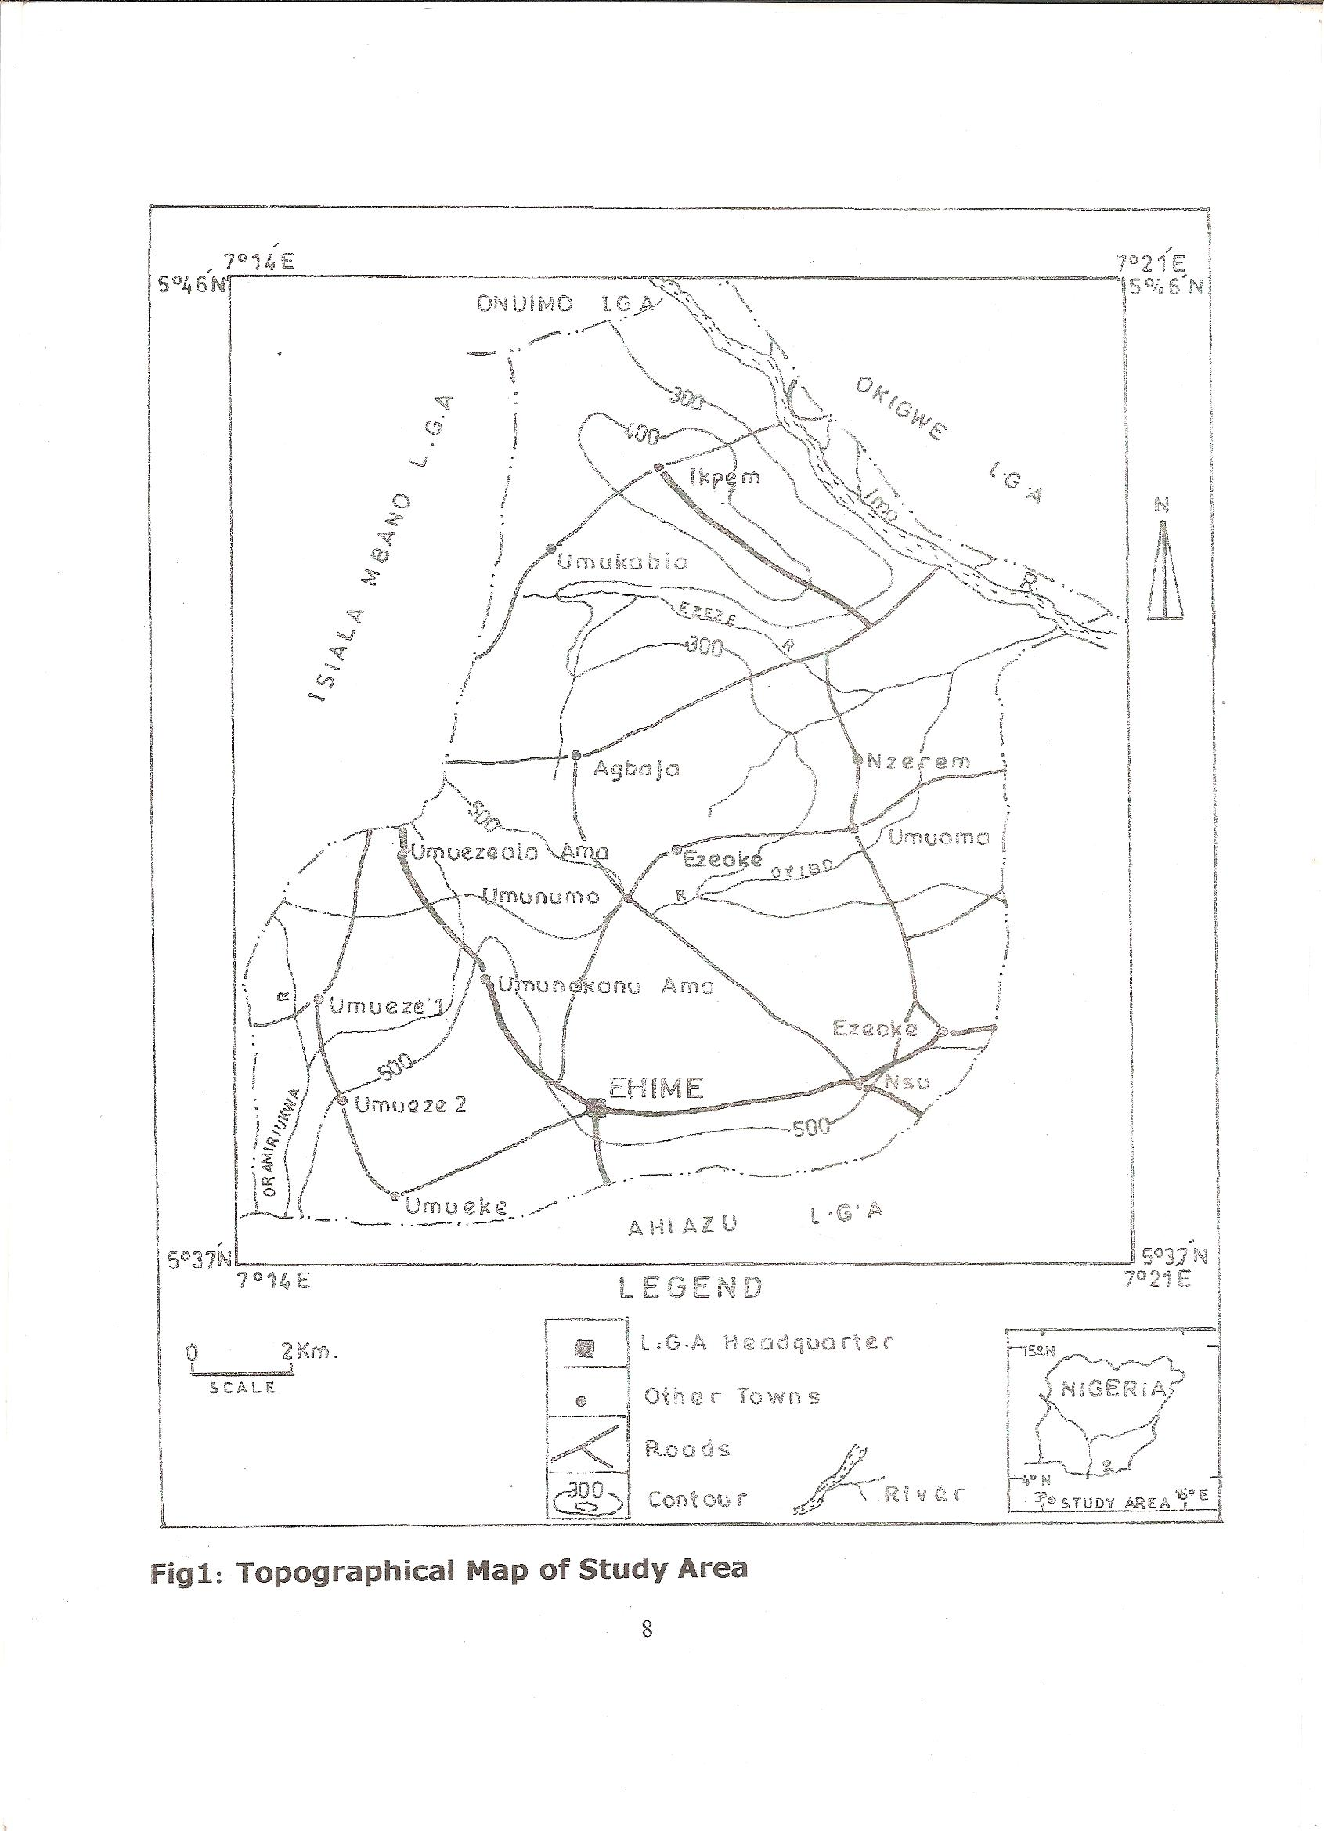

Fig. 1: Topographical Map of the Study Area

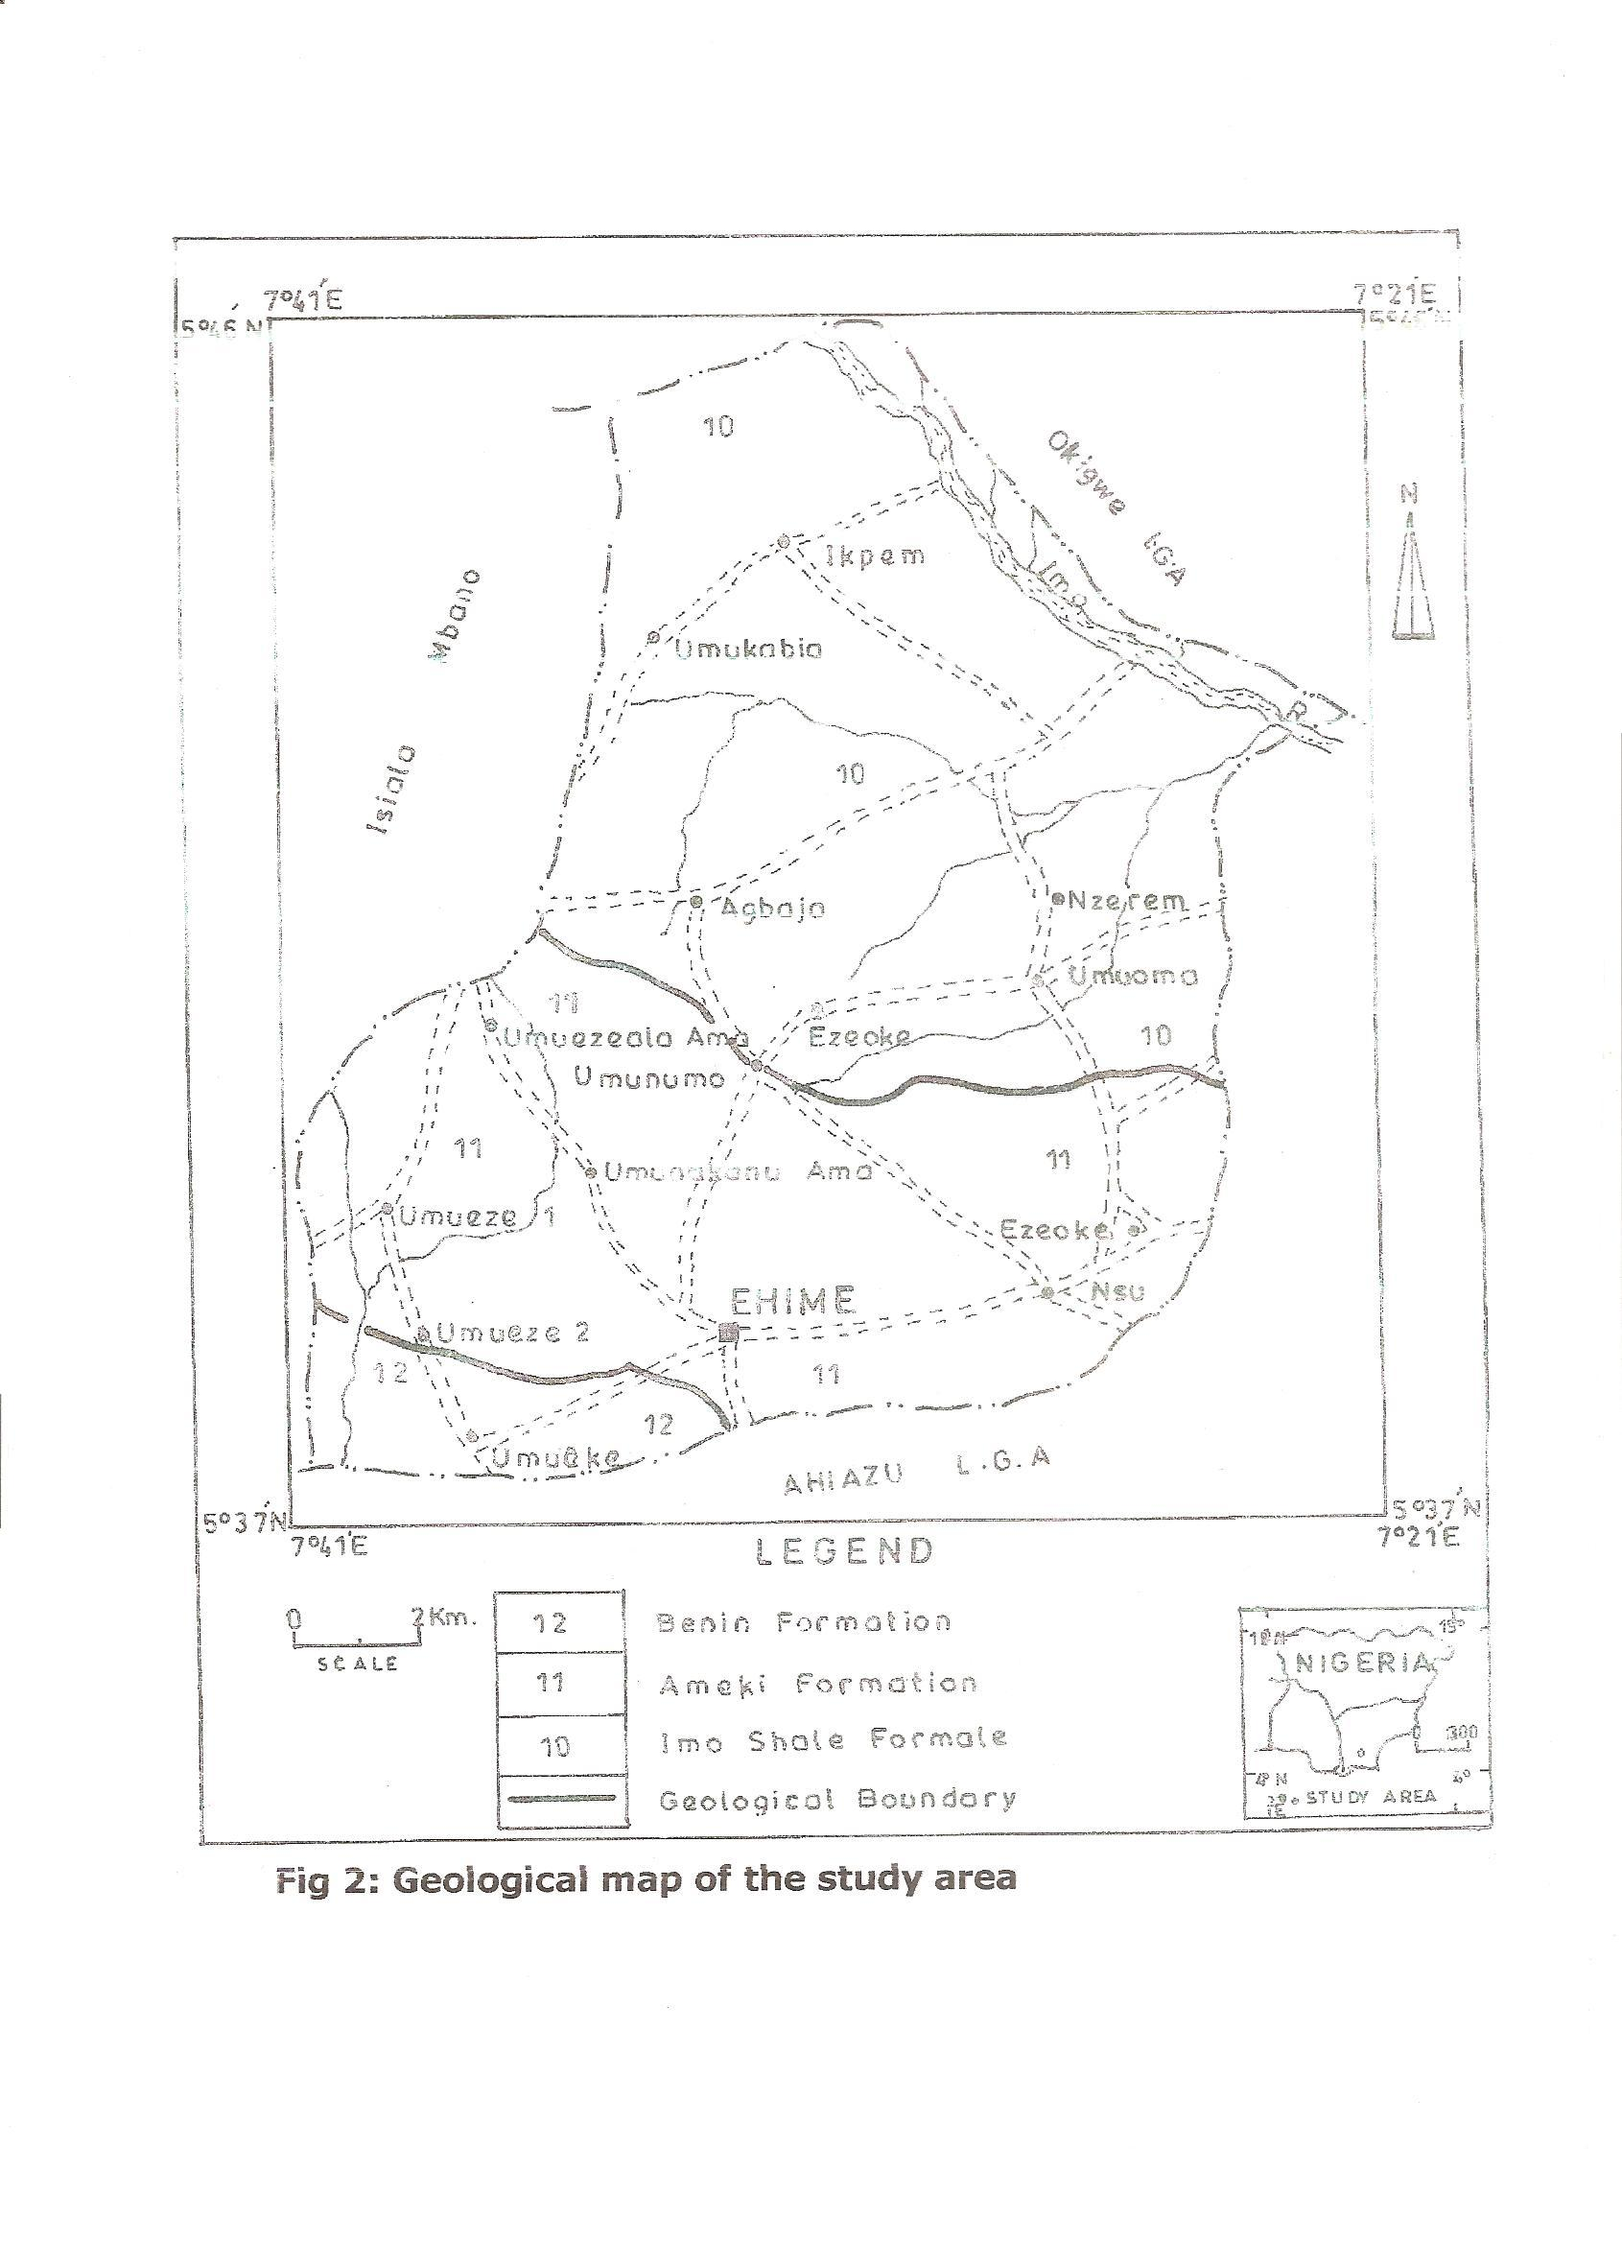

RESULTS AND DISCUSSION
The result of water analysis of the 6 water samples compared with WHO (1984) standard guidelines for acceptable water standard is shown in table 2.

Table 2 Result of water analysis

Parameters | S1 | S2 | BH₁ | BH₂ | BH₃ | BH₄ | Average | WHO  (2004) | LEGEND
Sodium (Na⁺) | 1.83 | 1.64 | 0.80 | 0.82 | 0.54 | 0.71 | 1.05 | < 200 | S1 Umuofor  Ezeoke Nsu  Stream/Spring
Potassium (K⁺) | 3.30 | 3.41 | 1.11 | 2.13 | 2.01 | 0.94 | 2.15 | < 50 | S1 Umuofor  Ezeoke Nsu  Stream/Spring
pH (at 29°C | 7.20 | 7.01 | 6.80 | 6.90 | 6.80 | 6.70 | 6.90 | 6.50-8.50 | S2 Umualumaku  Stream/Spring
TDS | 28.56 | 21.03 | 7.40 | 12.54 | 9.03 | 7.45 | 14.3 | <1000 | S2 Umualumaku  Stream/Spring
Calcium (Ca²⁺) | 9.64 | 8.02 | 3.68 | 2. 73 | 4.81 | 5.03 | 5.65 | <50.00 | BH1 Umualumaku  Alaili Borehole
Magnesium (Mg²⁺) | 6.41 | 3.99 | 1.35 | 1.68 | 2.82 | 3.00 | 3.21 | <50.00 | BH1 Umualumaku  Alaili Borehole
Total Hardness | 16.05 | 12.01 | 5.03 | 4.41 | 7.63 | 8.03 | 8.86 | <250.0 | BH2 Umuakanusi , Borehole
Chloride (Cl⁻) | 4.05 | 5.10 | 3.01 | 2.42 | 3.60 | 2.81 | 3.50 | <5.0 | BH3 Umueze I  Borehole
Conductivity (ms) | 26.80 | 24.40 | 5.01 | 12.40 | 7.03 | 6.62 | 13.7 | <2000 | BH3 Umueze I  Borehole
Phospahte  (PO₄²⁻) | 7.70 | 6.34 | 2.13 | 2.00 | 1.64 | 1.90 | 3.62 | <10.0 | BH3 Umueze I  Bore hole
Iron ( Fe²⁺) | 0.019 | 0.080 | 0.480 | 0.210 | 0.060 | 0.36 | 0.20 | <0.30 | BH3 Umueze I  Bore hole
Carbonates | 16.41 | 14.00 | 8.01 | 6.33 | 8.14 | 6.82 | 9.95 | <250.00 | *BH₄ Umelekezala Borehole
Turbidity (NTU) | 23.40 | 21.41 | 15.01 | 15.63 | 14.50 | 15.04 | 17.5 | < 5
Nitrates (NO₃⁻) | 1.26 | 1.34 | 1.20 | 1.11 | 0.39 | 1.21 | 1.09 | < 5.00
Sulphate ( SO₄²⁻) | 3.61 | 2.93 | 2.10 | 1.40 | 1.63 | 2.00 | 2.28 | < 250.0

The average pH value of the six water samples is 6.90 which indicates a slightly acidic condition. The average value of total dissolved solids (TDS) is 14.33. The principal constituents of TDS are chloride, sulphate , calcium, magnesium and bicarbonate. Sodium content was used to classify water quality for irrigation purpose because of its reaction with soil to reduce the permeability
(Etu Efeotor, 1981). Thus, the relation sodium absorption ratio

SAR = Na⁺ ( meq/L…………..(1)
( Ca²⁺ + Mg ²⁺ ) ½

was employed to determine the suitability of the water for irrigation purpose. According to Etu Efeotor 1981, water class based on SAR is classed as 0-10-excellent, 10-18-Good, 18-26 fair while > 26 is poor. Using equation 1, the SAR for components derived from table 3 for S₁ , S₂, BH₁, BH₂, BH₃ and BH₄ are 0.1121, 0.1181, 0.09, .07, 0.964 and .0484 respectively indicating that the water is excellent for agricultural purposes ( Etu-Efotor 1981). From Table 2 the average values in mg/L of Ca²⁺, mg²⁺, K⁺, Na⁺ among others are 5.65, 3.21, 2.15 and 1.06, these values conform with standard approved by WHO for portable water indicating that the 6 water samples are acceptable based on WHO scale.
The average proportion of the percentage concentration of anions – SO₄²⁻, Cl⁻ and Hco₃ also stood at 2.8 mg/l, 3.50 mg/l and 9.95 mg/l. these also conform with acceptable standard of WHO guidelines. The result of the conversion of the relevant cation and anion to milliequivalent per litre in shown in table 3

Table 3 Anion and Cation concentration to miliequivalent per litre.

CATIONS
Component | Conc | Atomic | Charge | Equiv | Conc | % of
Cations | Mg/l | Weight | ≠ | Mass (EM) | Mg/l | Component
Ca²⁺ | 5.65 | 40.08 | 2 | 20.40 | .2819 | 43.56
Mg²⁺ | 3.21 | 24.31 | 2 | 12.156 | .2641 | 40.81
Na⁺ | 0.06 | 22.98 | 1 | 22.989 | .0461 | 7.12
K⁺ | 2.15 | 39.10 | 1 | 39.102 | .0550 | 8.51
 |  | Total
 |  | Total |  |  | 0.647 | 100
ANIONS
Hco₃⁻ | 9.95 | 61.02 | 1 | 61.02 | .1658
No₃⁻ | 1.09 | 62.0 | 1 | 62.0 | .0176
So₄2⁻ | 2.28 | 96.06 | 2 | 48.03 | .0475
Cl⁻ | 3.50 | 35.45 | 1 | 35.5 | .0981
 |  | Total |  |  | .3296 | 100.002

Table 3 was employed to construct pipertrilinear plot as to assess the water class and portability. From fig3, the water plots within a calcium and bicarbonate type and also plots on the left side of the diamond shape of the pipers plot indicating a fresh water. Cation and anion relation in milliequivalent per metre shows that the basic cation constituents are in the following order
Ca²⁺ >Mg²⁺>Na²⁺ + K⁺. For the anion values the relation holds as Hco₃>cl⁻ + No₃⁻>So4²⁻. This indicates the dominance of calcium and bicarbonate, giving rise to CaHCO₃ water.
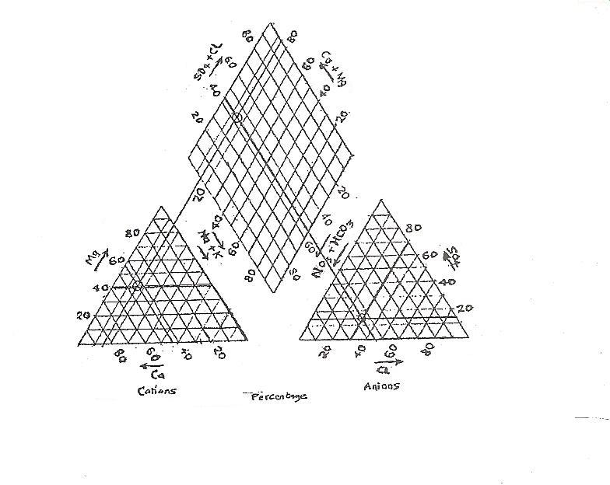

Fig. 3 Piper’s Trilinear plot (1944)

The result of biochemical analysis is shown in table 4. It shows the examination of the total coliform count that indicates absence or presence of bacteria in water (Martin 1977).

Table 4 Bacterial analysis of the Six Water Samples
Sample | Total Hetertropic plate count | Dilution | Organism | Faecal coliform count | Faecal stereoto coccii | E.coli count | cl. Welchi count
S₁ | 95 | 10² | 9.5 x 10² | - | - | - | -
S₂ | 80 | 10² | 8.0 x 10² | - | - | - | -
BH₁ | 75 | 10² | 7.5 x 10² | - | - | - | -
BH₂ | 18 | 10² | 1.8 x 10² | - | - | - | -
BH₃ | 24 | 10² | 2.4 x 10² | - | - | - | -
BH₄ | 25 | 10² | 2.5 x 10² | - | - | - | -
 |  |  |  | - | - | - | -

The result of the organic analysis of the ground water samples of table 4 indicates that there were no faecal coliform found in the water samples, therefore no pathogens in the water. On the whole, the high values of turbidity may be due to sediments from erosion and algae growth, urban run off and flooding as a result of climatic change (Offodile 1988). The high level of iron (Fe²⁺) could be as a result of corrosion of steel pipes (Barnes and Clarke 1980). The possible effect of high iron are red or yellow strining of laundry and house hold fixtures (Palme et al 1997). The possible health effects are high concentration of iron stored in the pancreas, livers, spleen (Oteze 1991). High concentration of iron in the body can cause liver and lung problems (Offodile, 1987). From the piper plot, the ground water in Ehime Mbano and environs is portable and of calcium bicarbonate type (CaH Co3)
The comparison of chemical analysis of Ehime Mbano subsurface water with American water works association standard (1991) for industrial water is shown in table 5

Table 5 Ground water analysis result from Ehime Mbano area compared with American water works Association (1991) (AWWA) standard for industrial water.

Parameters | Average value of sample analyzed | AWWA (1991) accepted standard
TdS | 14.3 | 50-1, 500mg/l
Toral hardness | 8.66 | 0-250mg/l
Iron (Fe+) | 0.20 | 0.1-1.0mg/l
PH | 6.90 | 6.5-8.3
Chlorides | 3.50 | 20-250mg/l
Manganese | - | 0-0.5mg/l

With reference to table 5, the groundwater in the area should be treated for iron before they are used for some industries eg. Laundry. In employing the pollution index scale of Horton (1995), it is possible to calculate the pollution index of the area as to assess the extent of pollution. The Horton scale is shown in fig 4 .

Fig 4: Horton scale (1995)
Critical or
Tolerable unity (1)
Not polluted
Polluted

-3
-2
-1
1
2
3
4

Unity value of (1) indicates a tolerable standard, but above this value (1) the water is polluted and below this (1) the water is not polluted. The pollution index is calculated using the formula propounded by Horton (1995) as shown in table 6.

The pollutional index of S1 is calculated as in table 6

Table 6 Computation of pollution index of S1
Parameter mg/l | Ai | Wij | Ai/Wij
pH at 29⁰C | 7.20 | 6.5-8.5 | 0.960
Turbidity (NTU) | 23.40 | 5.0 | 4.680
Conductivity (MS) | 26.80 | 100 | 0.268
TDS | 28.56 | 500 | 0.057
Iron (Fe+) | 0.019 | 0.3 | 0.063
Calcium Ca²⁺ | 9.64 | 75 | 0.129
Magnesium mg²⁺ | 6.41 | <30 | 0.214
Potassium (K⁺) | 3.30 | 200 | 0.017
Sulphate (So4²⁻) | 3.61 | 250 | 0.014
Phosphate (Po4²⁻) | 7.70 | - | -
Nitrate (No₃⁻) | 1.26 | 10 | 0.126
Chloride (Co₃²⁻) | 16.41
Total Ai/Wij |  |  | 0.5953
Total parameter |  |  | 6.584

Mean Ai/Wij = 0.5953
Max Ai/Wij = 4.080
Pollution index Piji =

(Max² + Ai + Wij)² + (Mean Ai + Wij)² ………… (2)
2

(4.680)² + 0.5953)² = 3.336
2

In the same way the pollution index of the other water samples S₁ S₂ BH₁ BH₂ BH₃ BH₄ are 3.336, 3.05, 2.155 2.156, 2.156 and 2.21. The total average for the six water samples gives 2.501. this value shows that the Ehime Mbano ground water is slightly polluted having a value of 2.50 which exceeded the critical and tolerable limit of unity (1) (Horton 1995)
The pollution index of 3.336 within Nsu area (S₁) shows that Ezeoke Nsu axis is the most polluted in Ehime Mbano NE area. The suitability of water for domestic purposes is based on total hardness, total dissolved solids (TDS) and portability (Davis and Dewest, 1996). The average value 8.86mg/l for total hardness and 14.3mg/l for TDS indicates that the water belongs to fresh and soft class. (Hem 1970, Carrol, 1962). The water therefore has no laxative effects (Oteze, 1991). The ground water in the area is slightly acidic (6.90). Acid level in water is an indication that there will be more of reduction than oxidation. ( Raymond 1979). This implies dissolution of metals leading to high TDS and consequent destruction of metal pipes. High pH causes bitter taste, while water, using appliances become encrusted (Hem, 1970). A comparison of the chemical result of the 6 water samples to American water works association (1991) shows that iron (fe²⁺) is 0.1 – 1.0 mg/l, mn²⁺ (20 – 250mg/l ), total hardness as Caco₃ (0 – 250mg/l, pH (6.5 – 8.3), chlorides (20 – 250mg/l) and TDS 50 – 1500mg/l). This indicates that ground water in the study area is suitable for use in most industries. From the organic analysis carried out, there were no bacteria presence in water. Thus the water can be consumed without fear of water borne diseases.

CONCLUSION AND RECOMMENDATION
In conclusion, the exploratory survey of the geochemical aspects of underground water in Ehime Mbano shows that the water has high turbidity, high iron, slightly acidic soft and suitable for domestic, industrial and irrigation purposes. Above all the water has no laxative effect and no bacterial presence (hence no water borne diseases). Pollution index of Horton indicates slight pollution. The pollution index of 3.336 within Ezeoke Nsu shows that the NE section of Ehime Mbano is most polluted.
To solve the minor problems of water standard, in the area, high turbidity can be solved by distillation and filtration. Problems of High iron can be solved by aeration, while the pH can be elevated slightly using alkaline fertilizer.
Borehole owners should be encouraged to test their water periodically. Water chemistry examination should be carried out seasonally, since groundwater is subject to surface geological changes (Offodile, 1987). Government should standardize the activities of various water agencies and drilling companies and ensure strict compliance to specified methods of water borehole construction. Water treatment facilities should be made available and accessible to the public. There should be good public orientation and awareness programme, enlightening the masses on the importance of portable water quality standards as well as the adverse effects of contaminated water.

Acknowledgement
Our profound thanks go to the Nigerian survey and geological department Enugu for providing the geologic and topographic maps. We are equally grateful to technicians in microbiological, chemistry and erosion units of federal university of technology Owerri for carrying out the microbial, physciochemical and soil analysis.

REFERENCES
- AIfred, P.C; 1992. Trace element in terrestrial environments 2nd ed. New York, Springer pp 92.
- Barnes, I and Clarike F.E. 1980. (US G.S Prof paper no 4980) chemical properties of ground water and their corrosion and encrustation effects on wells pp 58.
- Carrol, D (1962). Rainwater as a chemical agent of geological process, a review US Geological survey water supply paper n0. 3 , 15 , and 16 pp33-38.
- Davies and D.E Wiest (1985). Surface water pollutant and its control, Mac millan, London pp25.
- Dever and james (1985). Basic water requirements for human activities meeting basic needs. Water international paper vol.21, pp83-92.
- Ellis, C.A.1988. Ground water quality assessment of the central Oklahoma Aguiffer Published by G.P. Oklahoma pp 5 – 28.
- Etu Efeotor, J.O. (1988). Preliminary hydrogeochemiccal investigation of the subsurface waters in parts of Niger Delta. Min Geol. Pp 103-105.
- Feachem, R. Chem, M. and Duncen, M. (1998). Waste water and health in hot climates John Wiley and Sons Chichester, 4th ed. pp 164
- Gorrrel, H.A; 1990. Classification of formation of formation waters based on sodium chloride content. Amer. Ass of pet Geologists Bull. Vol 42 pp 275.
- Hem, J.D (1970). Study and interpretation of the chemical characteristics of natural water, 2nd edition. US Geological survey water supply paper 1459, 268.
- Horton, (1995). An index number rating system for rating water quality pollution control pp 37.
- Iloeje N.P 1981. A new Geolography of Nigeria (A new revised edition) published in Great Britian by William Clowes Beccles Ltd, London, pp 85-120
- Martin, C.H. 1997. Instruction to microbiology 2nd ed, Krieger publishing company pp. 21.
- Offodile, M.E (1987). Water resources management and the Nigerian groundwater system. Proceedings of Delegate conference of the Nigeria academy of science. Pp 23-35.
- Omidiran, P.C. 2000. Fundamentals of geology 3rd ed. W.B. standards company, Philadelphia pp 270.
- Onunkwo-Akunne, A and Ahiarakwem C.A, 2001. Hydrocarbon and environment, cape publishers, No 17 Alaenyi St. Owerri.
- Oteze, C (1991). Portability of groundwater from rima group aquifer in the Sokoto basin of Nigeria, for mining and geology. Pp 21 – 24.
- Palmer, RC. Holman L.P. Lewis M.A. 1997. Guide to groundwater vulnerability mapping in England and H.M.S. London Claredon Press, pp 210-215.
- Parkinson, 1970: The post cretaceous stratigraphy of southern Nigeria. jour. Geol. Surv. London, vol 63 pp 320.
- Piper, A.M. (1944). A graphical procedure in geological interpretation of water analysis Trans American Geophysics Union 25, pp 44-48.
- Raiment, R.A. 1965. Aspect of the geology of Nigeria, Ibadan University Press pp 25 – 38.
- Raymond C.L. 1979. Land application of wastes vol I, John Wiley and sons publishers pp 150 – 160.
- Stephen, F.O (2004). Groundwater quality production. A guide to water service companies, Manchester authorities and environment agencies, World bank publications pp250-280.
- Todd, D.K. (1959). Groundwater Hydrology, Wiley international Edition pp 28 – 40.

Date of submission of article - 1/3/2011

