Ergonomic Evaluation of an African Oil Bean (Pentaclethra Macrophylla Benth) Seed Slicer

Aremu, A.K.¹ and Iroakazi, G.U.²

1. Department of Agricultural and Environmental Engineering, University of Ibadan, Ibadan, Oyo State, Nigeria.
2. Department of Agricultural Engineering, Federal University of Technology, Owerri, Imo State, Nigeria.
Corresponding author’s e-mail: ademolaomooroye@gmail.com, Phone number: +234 8023843272

Abstract: An ergonomic evaluation of an African oil bean seed slicer was carried out. Ten married women aged between 42 and 57 years with over 10 years experience in the business of “ugba’ processing were used as subjects for the study. The heart rate index was used in quantifying energy requirements for operating the slicer. Results obtained showed that using the slicer resulted in a greater slicing output (1.32kg/hr), a higher slicing efficiency (83.5%) and an average energy expenditure per unit product of 0.67J/min (82.5% reduction in energy expended) compared to an expenditure rate of 3.83J/min with the conventional hand slicing method. The use of the slicer also resulted in reduced fatigue, reduced discomfort and body pains and led to an overall user satisfaction.
[Aremu, A.K. and Iroakazi, G.U. Ergonomic Evaluation of an African Oil Bean (Pentaclethra Macrophylla Benth) Seed Slicer. World Rural Observations 2011;3(2):44-48]; ISSN: 1944-6543 (Print); ISSN: 1944-6551 (Online). http://www.sciencepub.net/rural.

Key words: Ergonomic, African oil bean seed, Slicer, Heart rate index, Energy expenditure

- Introduction
The African oil bean (Pentaclethra macrophylla Benth) is a tropical tree crop found mostly in the Southern and Middle Belt Regions of Nigeria and in other coastal parts of West and Central Africa (Keay, 1989). The tree is recognized by peasant farmers in these parts of the country for its soil improvement properties and as a component of an agro-forestry system (Okafor and Fernandez, 1987). The tree provides economic products such as food, fodder and fuel. It protects the soil against erosion by wind and rain through its canopy and root systems and recycles plant nutrients from the deeper soil horizons to the top soil in the form of litter fall and decaying organic plant residues. The flat glossy brown edible seeds, averaging 8, (6-10) in number, are contained in a brownish flattened pod (Enujiugha, 2003), which explodes at maturity and disperses the seeds. Their edible seeds require tedious but careful processing and fermentation before they can be eaten as food supplement. The seed when cooked, processed and fermented is called ‘ugba’ (in Igbo language of Nigeria) and used for the preparation of many delicious African delicacies including African salad, soups and sausages for eating with different staples (Enujiugha, 2003). The seed is a source of edible oil; it contains more than 52% oil in its cotyledons (Enujiugha and Ayodele, 2003). It is rich in vitamins and minerals and in high demand for both local consumption and for export. It is a low-acid food which could be prepared into flour and explored in food fortification and confectionaries. The processing of the large brown glossy seeds of the African oil bean to obtain ‘ugba’ involves several processes which include deshelling, softening of the cotyledon, slicing, fermentation and packaging. All these processing operations are basically traditional and yet to receive any form of mechanization. Till date, the slicing of the cotyledon has been manual using some specially carved knives on the bare hand. In order to address some of the limitations observed with the hand slicing method which include drudgery, body discomfort, low work rate, low quality of slices, a manual slicer has been developed.
A necessary requirement for the introduction of this labour saving device is the thorough ergonomic evaluation. Ergonomics, also known as Human Factors Engineering is the discipline of applying what is known about human capabilities and limitations to the design of products, processes, systems, and work environments. Methods used to evaluate human factors ranged from simple questionnaires to more complex and expensive laboratory techniques. (Stanton et al., 2005). The objectives of developing the machine will no longer be justifiable but defeated if would-be operators are subjected to unnecessary and unanticipated stresses which may result in loss of efficiency, reduced output, lower productivity and any form of disability later in life. This paper presents the results of the study conducted to determine the energy requirements for operating the slicer.

- Materials and Methods
The slicer presented in Figure 1 comprises of a base for portability, stability and aesthetics, casted aluminium blocks, a set of moveable and stationary blades and a handle. The cutting process is by means of a moving and resting blade where the material is supported by the resting blade. The clearance between the blades is the desired thickness of the slices. The machine can be operated either in a standing or sitting position. This is to allow the operator change his/her posture as freely and as often as desired because constraining machine operators into a particular posture that must be maintained over considerable time periods often results in body discomfort which may be unbearable (Kroemer, 1987). An iterative design process also known as prototyping was adopted; this seeks to involve users at several stage of the design, in order to correct problems as they emerge (Carrol, 1997).

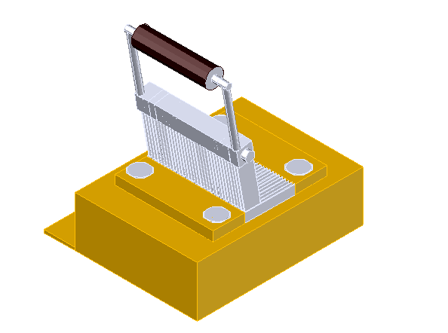
Fig. 1 The manual African oil bean seed slicer

Ten women in good state of health with experience in the business of ‘ugba’ processing were used as subjects for the study. Their personal data are as presented in Table 1. They were however chosen because they have some mastery of the art of ugba slicing thereby bringing the error and delay due to human factor to the minimum. Each subject was asked to operate the slicer at her slicing rate, first using the conventional method and later with the manual slicer after resting using cotyledons of sizes range of 7.93-9.05mm at 40% moisture content (wb).
Questionnaires were administered to obtain certain general information about the subjects used in the study. The use of questionnaires is a commonly used technique in ergonomic surveys, they have an advantage in that they can be administered to a large group of people for relatively low cost, enabling the researcher to gain a large amount of data (Wickens, 1997). Data collected include age, body weight, length of arm, body temperature, blood pressure and heart rate of the subjects. The body weight of the subject was measured with a portable weighing balance. Body height and arm length were measured with a 3meter tape. The body temperatures of the subjects were taken with the clinical thermometer. The clinical thermometer was placed in the subject’s armpit for between 1¹/₂ to 2 minutes and the corresponding temperatures in degree Celcius noted. The sphygmomanometer was used in the measurement of the blood pressure of the subjects. The metabolic data were taken before and after using both the conventional method of slicing and the manual slicer. The environmental conditions were taken as constant throughout the test duration.

2.1 Energy Expenditure Measurements
The heart rate index was used to quantify the energy requirements for each task reported by other researchers. (Leblanc, 1957; Sugg and Splinter, 1958; Nwuba, 1981 and Igbeka, 1993). The Energy Expenditure Rate (EER) was obtained using the equation developed by Saha, (1979).

EER = ---------------------------- (1)
Where H.R is the heart rate (Beats/min)

3.0 Results and Discussion
The results of data collected for the ten subjects used for the study are presented in Table 1. Data collected include age, weight, arm length, and height. The mean age of the subject was 48 (SD 4.84), range from 42 - 57; The mean height was 1.58m (SD 9.84), range of 141-170, the mean weight was 58.9kg (SD 7.22), the average arm length of respondent was 55.7cm (SD 3.82), and the range of their experience in the ugba processing of 10-21yrs averaged 15 yrs (SD 3.48). Results show normal data for an average person.

Table 1. Personal data of the subjects
Subject | Age(yrs) | Height(cm) | Weight(cm) | Arm  Length(cm) | Experience in  Ugba business
BS  AD  SH  AO  CN  MJ  FO  SY  CT  EU | 55  51  46  47  43  57  50  42  44  45 | 166  151  168  157  150  145  166  141  170  163 | 52  50  69  55  56  74  60  53  61  59 | 61  52  55  58  50  62  56  58  53  52 | 10  12  20  17  14  16  21  13  15  11

Table 2. Metabolic data (Manual slicing)
Subject | Body temperature(⁰C)  Before After Change |  | Heart rate/min  Before After Change | Blood pressure(mmHg)  Before After Change
BS  AD  SH  AO  CN | 36.0 36.6 0.6  35.4 36.0 0.6  36.8 37.2 0.4  36.8 37.2 0.4  35.6 36.3 0.7 |  | 73.0 80.0 7.0  66.0 76.0 10.0  68.0 79.0 11.0  79.0 88.0 9.0  72.0 81.0 9.0 | 6/5  4/8  5/3  9/5  4/2

Table 3. Metabolic data (Machine slicing)
Subject | Body temperature(⁰C)  Before After Change |  | Heart rate/min  Before After Change | Blood pressure(mmHg)  Before After Change
BS  AD  SH  AO  CN | 36.4 36.5 0.1  35.5 35.6 0.1  34.9 35.1 0.2  36.8 36.9 0.1  36.5 36.6 0.1 |  | 70.0 72.0 2.0  68.0 70.0 2.0  72.0 73.0 1.0  74.0 75.0 1.0  67.0 68.0 1.0 | 1/2  2/2  2/1  1/3  2/2

Results for the metabolic data were taken before and after each of the slicing operations as presented in Tables 2 and 3. Significant differences are seen between the data obtained for the manual and the machine slicing method. Basically, this is due to the more time spent with the conventional method as compared to the time saving machine method thereby increasing work rate and conserving energy.

3.1 Energy Expenditure Rate (ERR)
The energy expenditure for the two slicing methods are presented in Table 4. The result shows that the use of the slicer gave lower energy expenditure per unit of the slices. This shows that the use of the slicer is an energy conservation mode compared to the obviously high energy requirement with the conventional hand slicing method. The high energy rate observed with the fourth subject after using the manual method was as a result of high heart rate/min. Furthermore subjects were asked whether they felt pain or discomfort in some body parts. This was done to evaluate the musculoskeletal disorder associated with the slicing process as one of the most prevalent types of work-related injuries is musculoskeletal disorders. Work-related musculoskeletal disorders result in persistent pain, loss of functional capacity and work disability, but their initial diagnosis is difficult because they are mainly based on complaints of pain, undue strain, localized fatigue, discomfort and other symptoms (Isabel et al, 2008). All the subjects complained of pains especially at the shoulder joints, arm and back after using the conventional method but no complaints arose after the use of the manual slicer as slicing is faster unlike the conventional method where a longer duration is used in slicing same quantity of cotyledon thereby inducing strains on different body parts.

Table 4. Energy Expenditure Rate (ERR)
 | Energy Expenditure Rate(J/min)  Before After |  | Increase in Energy  Expenditure Rate(J/min)
MANUAL  BS  AD  SH  AO  CN  SLICER  BS  AD  SH  AO  CN | 2.92 5.83  0 4.17  0.83 5.42  5.42 9.17  2.50 6.25  1.67 2.50  0.83 1.67  2.50 2.92  3.33 3.75  0.42 0.83 |  | 2.91  4.17  4.59  3.75  3.75  0.83  0.84  0.42  0.42  0.41

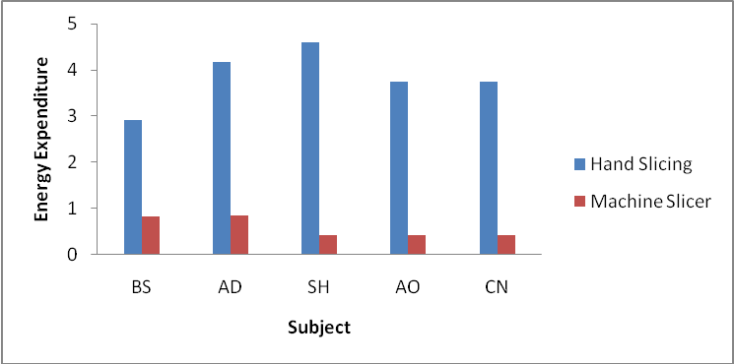
Fig. 2. Energy Expenditure profile of the subjects.

Fig. 2 gives a presentation of the energy expended during the slicing process using the manual and machine slicing method. The average increase in energy expenditure for the conventional hand method was 3.83K/min while the expenditure rate with the slicer was 0.67K/min. The differences in the energy expenditure rate experienced with the two methods are basically in the time duration used in the slicing operations. A higher rate indicates more energy consumption hence using the slicer is an energy conservation method which reduces fatigue, allows slicing for a longer period of time, leads to a higher work rate, improves user satisfaction and leads to higher productivity. The slicer which can be operated in either the standing or sitting position enabled more body parts to be involved in the operation especially intermittently which results in lower energy expenditure and prevents early fatigue. Improving the posture adopted to operate the machine resulted in a significant reduction in physical strain and incidence of body-part discomfort which further reduced the risk of musculoskeletal damage. From the classification of physical load as presented in Table 5, the slicing operation is grouped under the very light load.

Table 5. Classification scale of physical load
Grade of work | Energy expenditure rate (K/min)
Very light | Less than 10
Light | 12-Oct
Moderately heavy | 20-30
Heavy | 30-40
Very heavy | 40-50
Unduly heavy | More than 50

4. Conclusions
From the results obtained, the slicer gave significant improvement over the conventional manual slicing method. The average energy expenditure rate with the slicer was 0.67K/Min compared with 3.83 K/min, an 82.5% reduction in energy expended. This indicates effective energy conservation thereby reducing fatique, improving work rate, user satisfaction and comfort and an overall improved productivity. The work involved in operating the slicer using either method was a light load (Zander, 1975). However, best results were obtained with seed range of 7.93 - 9.05mm at a moisture content of 40 ± 0.2%(wb). Furthermore the problem of fatigue, discomfort, drudgery, waste of time and energy, poor quality slices encountered with the conventional hand slicing method were equally addressed by the study.

5. Refernces
- Carrol, J.M. 1997. Human-Computer Interaction: Psychology as a Science of Design. Annual Review on Psychology. 48: 61-83.
- Enujiugha, V. N. 2003. Nutrient changes during the fermentation of African oil bean (Pentaclethra macrophylla Benth) seeds. Pakistan Journal of Nutrition. 2.5: 320-323.
- Enujiugha, V. N. and Ayodele, O. O. 2003. Evaluation of nutrients and some anti-nutrients in lesser-known, underutilized oilseeds. Int. Journal of Food Science Technology 38.5: 525-528.
- Igbeka, J.C. 1993. Some Ergonomics studies of Nigerian women involved in agricultural processing. Proceedings of CIOSTA-CIGR Congress, Wageningen Netherlands.25.5: 183-189.
- Isabel, A. P., Jorge, O. Helenice, J. C. Gil, C. 2008. Clinical and functional aspects of work-related musculoskeletal disorders among active workers. Programa de Pósgraduação em Fisioterapia. Universidade Federal de São Carlos. São Carlos, SP, Brasil. 42.1: 1-3. Saúde Pública São Paulo.
- Keay, R. W. 1989. Nigerian Trees. United Kingdom: Claredon Press. 281 pp.

- Kroemer, K. H. 1987. Biomechanics of the Human body. Journal of applied physiology 10.1: 20-25.

- Leblanc, J. A. 1957. Use of heartbeat as an index of work output. Journal of applied physiology 10: 275-280.
- Nwuba, E.I. 1981. Human energy demand of selected Agricultural hand tools. M.Eng Thesis (Unpublished). Department of Agricultural Engineering, Ahmadu Bello University Zaria.
- Okafor, J. C. and Fernandez, E. C. 1987. Compound farms of Southeast Nigeria: A predominant Agroforestry home-garden system with crops and small livestock. Agroforestry Systems 5. 2: 153 – 168.
- Saha, P.N. 1979. An acceptable workload for Indian farming. Journal of Ergonomic Research Association. 22.9: 1059-1071.
- Stanton, N., Salmon, P., Walker G., Barber, C.and Jenkins, D. 2005. Human Factors Methods :A practical guide for Engineering and Design. Aldershot, Hampshire: Ashgate Publishing Limited.
- Sugg, C.W. and Splinter, W. E. 1958. Time and energy analysis of Agricultural tasks. American society of Agricultural Engineers 1.1: 50-52
- Wickens, C.D., Lee, J.D., Liu, Y. and Gorden, S.E. 1997. An introduction to Human Factors Engineering. 2nd Ed. Prentice Hall.
- Zander, J. 1975. Principles of Ergonomics . Agricultural University, Wageningen, the Netherlands.

3/5/2011

