An Overview of Rattan Distribution in Four States in South-South Part of Nigeria
(Akwa-Ibom, Balyesa, Cross-Rivers and River States)

Adewole A N.*, Onilude A. M.

Department of Agricultural and Environmental Engineering, Faculty of Technology,
University of Ibadan. Oyo State, Nigeria
*E-mail: dabukyo@yahoo.com

Abstract: Rattan, a non-timber resource in Nigeria’s South-South forests remains largely unexplored. To create schedule for unlocking its potentials, this study investigates its availability, distribution and current utilization pattern in Akwa-Ibom, Bayelsa, Cross-rivers and Rivers States in Nigeria. Information was collected using structured questionnaire and on-the-spot-assessment while data was analyzed using simple statistical tools. The four states has rattan in abundance but unevenly distributed. Ten rattan species belonging to Lascopermas, Eremosphata and Calamus genera was identified in the study areas. Apart from Bayelsa State, its commercialization has begun insignificantly and without standard grading rule. The available products made from it are household items (70%) and furniture (30%). The estimates of unexploited rattan in Bayelsa and other three states are about 95% and 80% respectively. The traditional harvesting technique still subsists while users rarely treated harvested rattan. About 3.7m length of rattan costs about N30 as at December 2009. The study establishes that rattan resource is in abundance, unevenly distributed and yet to be appropriately commercialized in all the four states.
[Adewole A N., Onilude A. M. Distribution of Rattan in Four States of South-South Part of Nigeria. World Rural Observations 2011;3(2):82-87]; ISSN: 1944-6543 (Print); ISSN: 1944-6551 (Online). http://www.sciencepub.net/rural.

Key words: Rattan, Availability, Distribution, Commercialization, Utilization, South-South Nigeria

1. Introduction
Nigerian forests are blessed with numerous minor forest resources (Redhead, 1971) but timber remains the major source of attraction to Nigerian forest exploiters. This over-dependency on timber has resulted in progressive depletion of timber resource thereby causing shortage in the supply to the wood-based industries in the country. Recent expansion in the industrial activities in these industries has further aggravated competition on already scarce wood raw material. This constitutes a major bane to the development and sustenance of both old and emerging wood-based industries in Nigeria (Onilude, 2006). Attention has in recent time diverted to identifying and developing minor forest resources that can adequately complement wood resources.
Rattan is among the minor forest resources found in considerable quantity in Nigerian forests. The inadequacy of information on the rattan availability in different parts of Nigeria constitutes impedance to its sustainable exploitation for use as raw material in the country. In some developing nations rattan has served as a veritable tool to bridge the gap occasioned by wood raw material shortage (Renuka, 1999). In addition, it has contributed to the annual income of the countries where deserved attention has been paid to it. The exportation of rattan products accounted for about 6.5% of Indonesian’s total annual export earnings from forest products (FAO, 1995). In Malaysia, where major attention has been given to rattan management and utilization, there is evidence that her formal economic sector generates considerable income from rattan (FAO, 1995). Like many parts of Nigeria, the South-South region is known to be blessed with numerous non-timber resources including rattan. It is envisaged that proper harnessing of this rattan resource is capable of creating employment opportunities for numerous un-employed but able hands in the areas. It will also strengthen income that is presently been generated from wood sub-sector in Nigerian (Cropper, 2006).
For the rattan potentials in South-South part of Nigeria to be unlocked, and, to contribute to human and environmental needs appropriately, a well thought plan is unavoidable. This opinion may be corroborated by the submission of Whiteman et al. (2006) that long-term planning is an important requisite to guarantee sustainable exploration of such a resource. The first step in long-term planning however is the compilation of relevant information on the general status of the resource in the area. This will afford the relevant body to create appropriate means of guaranteeing sustainable exploitation of the rattan resource for human needs. As a precursor to compilation of a full blown data, this study was initiated to compile relevant information on the current status and utilization of rattan resource in Akwa-Ibom, Bayelsa, Cross-Rivers and River States.
1.1 Objectives of the study
The broad objective of the study is to compile relevant information on the current status and utilization of rattan resource in Akwa-Ibom, Bayelsa, Cross-Rivers and River States, all in South-South region of Nigeria. The specific objectives include: (i) Investigation of the number of rattan species growing in the identified States and their level of availability (ii.) Investigation of their distribution patterns in these four States (iii) Identified constraints to the present utilization patterns and development, and, (iv.) Make recommendations on how to develop the present level of utilization.

2.0 Methodology
The Akwa-Ibom, Bayelsa, Cross-Rivers and River States were selected for the study because of their vegetation homogeneity, geographical boundary and centrality in the region marked South-South in Nigeria as depicted in Figure 1. Field exercise was the primary approach adopted. The tools used for collecting data on rattan inventory in the area are structured questionnaire, on-the-spot assessment and oral interview. In each State, 100 respondents were randomly selected and they include rattan harvester, processor and marketer. Rattan samples were collected and measured to determine the mean length and diameters for each of the identified species. Information obtained was compared with literature to identify the rattan species. Current utilization patterns, method of processing and available products from rattan were physically assessed.

3.0 Results and discussion
3.1 General information
Rattan resource was in abundance throughout the four States and the border towns in the adjacent States (Figure 1). Only in the areas along the creek of Brass, Nembe, Akassa and Frupa was rattan sparingly distributed because of the salt concentration of the Atlantic Ocean. This confirmed the findings of IUCN-UNEP-WWF (1980); Sutter, H (1979) Abbiw, D.K. 1990 about the habitat of some rattan species. Pattern of exploitation and utilization were similar in all the States.
In Bayelsa State, Laccosperma, Erymosphata and Calamu genera were identified while Laccosperma secundiflorum (Uga), Erymosphatha hookeri, and Eremosphatha macrocarpa were three distinct species that appears to be more abundant. Of the rattan in Bayelsa State, about 80% is estimated to be growing forest and fallow land while the rest grows in farmland where it can freely be harvested with permission. Half of the total respondents from Bayelsa State indicated that rattan growing on farmland is regarded as weed rather than resource of high value (Table 1). Local users are allowed to harvest free of charge while commercial user may be required to pay little royalty when there is surge in harvesting demand. More than 98% of the stock was estimated as yet to be tapped and it may remain so until a commercial use for it is developed in the State. Despite its abundance in Bayelsa, it is only being explored by non-commercial user till date.

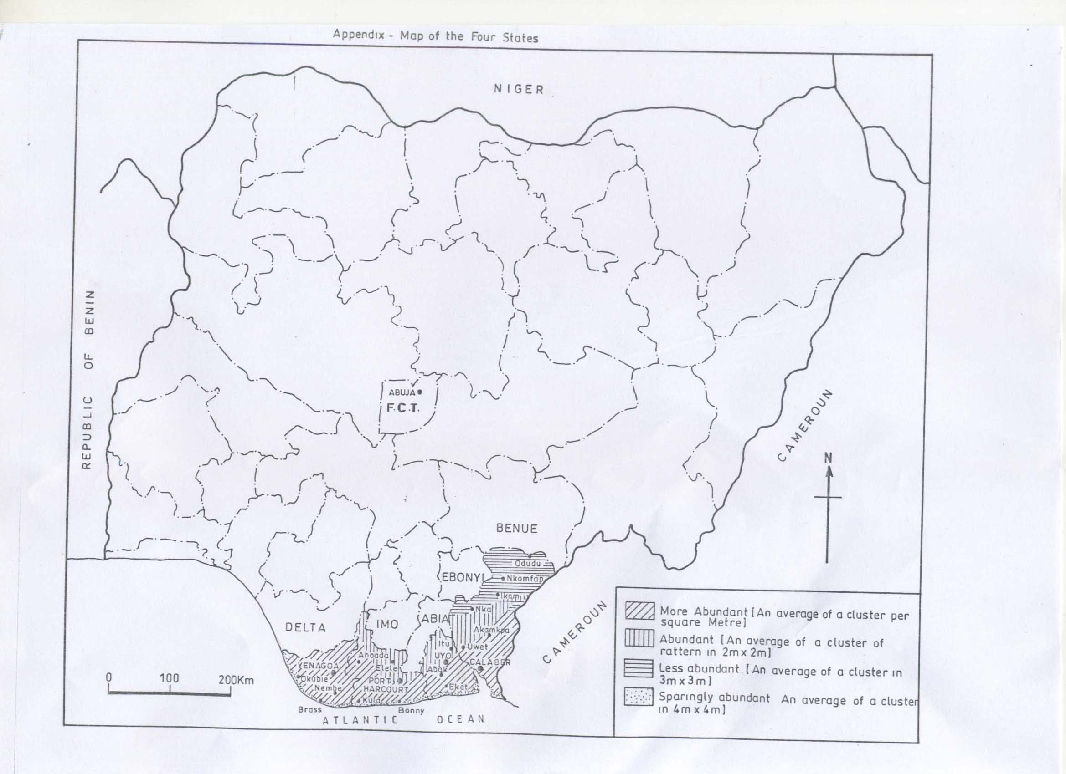
Figure.1: Map of South-South Part of Nigeria Showing Rattan Distribution in the Four Sampled States: Bayelsa, Rivers, Akwa-Ibom and Cross-River States.

In Rivers State, rattan resource scattered all over its geographical areas with Mbiama, Joinkarama, Ahoada, Iwowo and Degema, having similar concentration as found in Bayelsa State (Table 2). It occurs sparingly in Kula, Ifoko and Bonny: border towns to the Atlantic Ocean in the State. Unlike Bayelsa State, rattan concentration reduces from the river-rine areas toward Rivers State interior (Figure. 1). Few rattan processors sighted in the State were mostly non-indigene and are practicing where there is low concentration of rattan. The host in river-rine areas where the stock appears to exist in large quantity seems hostile to processors. Thin line of demarcation exists amongst rattan harvester, processor and marketer in the State. More than half of the total respondents (54%) conceded ownership of rattan to no one except that they are of opinion that families and communities may claim ownership if commercial users are interested in the exploitation. Throughout the fifteen study locations visited in River State, only Obrikom and Oyingbo area could boast of center where group of individuals were engaged in commercial activities using rattan to produce furniture and packaging products as daily work. And only two species of Laccosperma secundiflorum and Erymosphatha hookeri were species being utilized by these commercial users.

Table 1: Occurrence and Distribution of Rattan Resource in the Areas Surveyed in Bayelsa State
S/No | Location | L.G.A. | Occurrence | Ownership Pattern | Right to harvest
1 | Otegila | Ogbia | abundant | Community | Anybody
2 | Otueke | Ogbia | “ | Community | Anybody
3 | Otuogidi | Ogbia | “ | No one | Anybody
4 | Kolo | Kolo Creek | “ | Family | Anybody
5 | Sagbama | Sagbama | “ | Family | Anybody
6 | Oloibiri | Aleibiri | “ | Community/family | Anybody
7 | Zarama | O/Z/A* | “ | No one | Anybody
8 | Kaima | K/O** | “ | No one | Anybody
9 | Brass | Brass | “ | No one | Anybody
10 | Odi | Odi | “ | Community | Anybody
11 | Agudama-epie | Yenegoa | “ | Community/family | Anybody
12 | Eperemtos | Southern Ijaw | “ | No one | Anybody
13 | Oghoin | Oghoin North | “ | No one | Anybody
14 | Tarakiri | Tarakiri | “ | Family | Anybody
15 | Oporomor | Oporomor West | “ | No one | Anybody
16 | Tereke | O/T*** | “ | No one | Anybody
Legend: O/Z/A* = Okordia /Zarama /Biseni ; K/O** = Kolokuma /Opokuma; O/T*** = Okoroma/Tekere

Table 2: Rattan Occurrence and Distribution in Some Local Government Areas in Rivers State
S/No | Location | L.G.A. | Occurrence | Ownership | Sale
1 | Umuebele | Ethce | Abundant | Family | O/L
2 | Oyigbo | Oyigbo | Abundant | Community | O/L
3 | Port Harcourt | Port Harcourt | Less abundant | Family | O/L
4 | Rumuodara | Obio/Akpoh | Less abundant | Community | O/L
5 | Elele | Ikwerre | Less abundant | Community | L
6 | Obrikom | ONELGA | Abundant | No one | L
7 | Omoku | ONELGA | Abundant | Family | L
8 | Ahoada | Ahoada East | More abundant | Community/family | O/L
9 | Mbiama | Ahoada West | More abundant | No one | L
10 | Joinkara | Ahoada West | More abundant | No one | L
11 | Okogbe | Ahoada West | More abundant | No one | L
12 | Andoni | Andoni | Abundant | No one | L
13 | Degema | Degema | More abundant | No one | L
14 | Bonny | Bonny | Abundant | No one | L
15 | Bori | Ogu/Bolo | More abundant | No one | L
*O/L = Outsider and Local User

In Akwa-Ibom State, rattan is more prevalent in Southern part (Oron, Itu, Ikot-Ekpene, Abak and Eket) and reduces toward Abia State. Three species: Laccosperma secundiflorum (Uga), Erymosphatha hookeri and Eremosphatha macrocarpa were in use for commercial purpose. Itu Local Government area appears to be the natural headquarter of rattan utilization in the state. The use of rattan for craft work in Itu settlement was as old as the pre-colonial era. This may be true as all those involved in commercial activities with rattan in Rivers State migrated from Itu Local Government. Contrary to situations in Bayelsa and Rivers States, individual family laid claim to rattan ownership in Akwa-Ibom State. The right to harvest is reserve for indigene while non-indigene would require paying royalty before harvesting. There exists an established grading method for the traditional trading system in Akwa-Ibom State. A length of about 3.7 m is sold for between N25 and N30 (as at November 2010) depending on the maturity. More than 75% of the respondents opined that rattan collection activities were an exclusive work of men.
Southern part of Cross River state reflects the same pattern of occurrence of rattan with the river-rine area. Locations like southern and central Calabar, Akampa, Nwamba, Bakassi and border towns to the Atlantic Ocean provide natural habitat for different rattan genera (Figure 1). However, only two rattan genera: Laccosperma and Eremosphata appears to be well known to the users. A brown species of Laccosperma genus was peculiar to Bakassi region. Investigation revealed that rattan availability reduces as one moves toward the northern parts of Cross-River State. Rattan can be harvested by local dwellers only but local dwellers occasionally front for outsider having paid paltry sum. Community and family laid claim to the ownership of rattan and its utilization was still predominantly localized with only men involved in collection processes. About 4 m is sold between N15 and N20 amongst the local dweller while the same length is not less than N25 for the outsider. There is no line of division amongst the harvester, the processor and the marketer of rattan.

3.2 Rattan Growth and Harvesting
It is established by this study that rattan species in the four States grow naturally. However there was no evidence of re-planting effort to replace harvested ones because of its adventitious regenerating patterns similar to that of bamboo or banana. There were sufficient evidences that huge stock of rattan resources in the four States still remain untapped. Rattan exists mostly in the forest and fallow land and may be far or near to human settlements. There is no standard local regulation guiding rattan stock harvest in the four states. Opinion varies on factors that determine the rattan quality with overriding opinion by about 80% of respondents attributing quality to maturity rattan species (Figure 2). The same mode of harvest was in practice in all the states and the traditional methods (Figure 3) was adjudged to be tedious and hazardous because of its thorny nature and occasionally plays host to dangerous wild animals like reptiles. The major tools involved in rattan harvest are cutlass and files while hand gloves cap and protective shoe were necessary for safety reasons. Major constraints often faced when harvesting rattan include high probability
maturity
80%
species
5%
undecided
15%
maturity
b) species
c) undecided

Figure 2: Respondents Opinions on Factor

of sustaining injury, threat by wild and dangerous animals and insects like snakes, wasp or bee. The climbing nature of the plant also makes it more difficult to draw. The volume of rattan harvest depends on both harvesting method difficulty, season of the year, labor availability and the difficult terrain (distance) that harvester has to cope with before rattan can be harvested. Raining season was preferred by more than half of the respondent because canoe can be used for labor and rattan conveyance. However, rattan is harvested throughout the year in all the four states. The volume of rattan harvested was found to be mostly determined by the local needs than the capacity of the harvester. About 30% of the total respondents from the four states engaged in rattan trade often harvested up to 74 m length-wise per day. There was no form of trade association between rattan traders throughout the states while there was no division in the trade of rattan as the harvester is the same as processor and marketer of the rattan products. Greater percentage of the rattan, about 70%, was harvested for household purposes. Whenever trading of harvested rattan occurs, it is usually in a form of placing order. No standard grading rule has been adopted judging from the practices reported.

Cutting from the base
Pulling or Drawing
Cutting to size (mostly 12ft length)
Selection of rattan from the cluster

Figure 3 Four Stages involved in Rattan Harvesting

Utilization for Weaving
Bending with blue light
and assembly of furniture
Finishing of Furniture Products
Harvested Rattan
Store under water until one is ready to use
Scrapping of the
bark cover
Drying in sun
for few days
Slicing and smoothen to a malleable string-like nature
Cutting to dimensions

Figure 4: Flow Diagram of Traditional Processing Technique Developed for Rattan in the Four States.

3.3 Rattan Processing, Marketing and Utilization
There was no form of treatment carried out on rattan according to respondents except by a local trader of rattan products in Obrikom village, Rivers State, who uses local concoction for treating rattan against insect infestation. Knives, cutlass, file, wood mallet pliers, blue (blow) damp, hack saw, pincher and nails were the processing tools used for rattan irrespective of the products. Figure 4 shows the common steps involved in rattan processing as practiced in the four States. Most of the rattan harvested and processed, in the four states, goes into furniture making (70%) or local weaving of household items (30%). The waste generated during rattan processing (rattan shavings) is often burnt or used to landfill. Infested rattan would rather be abandoned than treated. Shrinkage rate of rattan is often used as parameter for grading its quality by the processor/user.
Rattan is occasionally used as rope in tying hamlet stakes etcetera. Rattan product marketing assumes commercial status only in Oyinbo (Oyingbo Local Government) and Obrikom in Onelga Local Government Area of River State. There exists a form of “Cartel” among the rattan products marketers. The products were available throughout the year sold to different local end users. Poor patronage and inadequate remuneration were major constraints hindering its market development. Income from rattan trade is unsatisfactory to marketers and there is neither regulation nor control by relevant Government Departments guiding rattan utilization in both the rural and urban settings in all the four States.

4.0 Conclusions
In conclusion, rattan resource was in abundance in Bayelsa, Rivers, Akwa Ibom and Cross-River States. The distribution pattern follows descending order from Bayelsa, Rivers, Akwa Ibom to Cross-River States.

Lascopermas Eremospata and Calamus were the common rattan genera in the four states. These three genera of rattan were still largely unexploited. The value attached to it in Bayelsa and Rivers State was that of weed. Household items like basket, fish traps, trays, and shelves amongst others and rattan furniture were the products been currently produced from it. Authorized person can harvest after paying royalty. Crude method of harvesting still persists while rattan is never subjected to any treatment against infestation of insects. About 3.7m length of rattan costs between N20 to N30 on average. There was no demarcation amongst the harvester, processor and marketer.

5.0 Recommendations
There is an urgent need to develop rattan industry sector in Nigeria to be harness the inherent economy gain particularly in the study area. Comprehensive geographical mapping system is required to generate detail inventory of rattan in Nigeria. As an interim measure, relevant organ of Government should immediately intervene by organizing training for rattan workers in the four states on modern means of rattan harvesting and processing. It is necessary to encourage rattan workers in the four states to form cooperatives to boost productivity.

Acknowledgement:
This study was carried out using the sponsorship of the Raw Materials Research and Development Council (RMRDC).

Correspondence to:
ADEWOLE Adedapo Nureni
Department of Agricultural and Environmental Engineering, Faculty of Technology, University of Ibadan. Oyo state, Nigeria
E-mail: dabukyo@yahoo.com
Mobile No: +234 803 396 3707

References
- Abbiw, D.K. 1990. Useful Plants of Ghana: West African Uses of Wild and Cultivated Plants. Intermediate Technology Publications and the Royal Botanic Gardens, Kew, 337pp.

- Cropper, A. 2006. Why we need African forest. The International Forestry Review.8 (1)1-3

- FAO, 1995. Forest Resource Assessment 1990. Global synthesis, FAO Forestry paper 124. Rome..

- IUCN-UNEP-WWF 1980. World Conservation Strategy. Living Resources Conservation for Sustainable Development, Prepared by the International Union for conservation of Nature and Natural Resources (IUCN) with support from the United Nations Environment Programme (UNEP) and the World Wild Life Fund (WWF). IUCN, 1196a Land, Switzerland.

- Onilude, M. A. 2006. Potential of Bamboo as Raw Material for Wood-based Industries. A paper presented at Raw Material Research and Development Council (RMRDC) of Nigerian, organized Workshop in Ikeja Lagos State. 10pp

- Redhead, J.F. 1971. Timber Resources of Nigeria. Nigerian Journal of Forestry 1 (1):7–11.

- Renuka, C., 1999. Indian Rattan distribution - An update. The Indian Forests 125 (6): 591-598.

- Sutter, H (1979). The indicative inventory of reserve high forest in Southern Nigeria 1973 – 77. MR/71/546 Technical Report I Prepared for the Government of Nigeria by F.A.O. of United Nations as executing agency for UNDP based on the work of Harold.

- Whiteman, A. and A. Lebedys, 2006. The Contribution of the Forestry Sector to African Economy. The International Forestry Review.8 (1)31-43.

4/9/2011

