Impact of ICT in Growth and Development of rural system in Uttarakhand

Rajeev Kumar¹, Dr. M.K. Sharma² , Mini agarwal¹ and Sandeep Kumar³

¹Assistant Professor in Computer Science Department, College of Engineering, Teerthanker Mahaveer University Moradabad (U.P.).
²Associate Professor & Head MCA Program, Department of Computer Science, Amrapali Institute -Haldwani (Uttarakhand)
³Information Technology Department PCTI Peetampura. E-Mail: rajeev2009mca@gmail.com

Abstract: In this paper I have used Information & Communication Technology for rural areas development and growth. It is the technology that is exchange the information, data is fast and easier way. Due to this technology the nations we provide every information easier one side to another side. Without information there can be no growth and no development in rural area. ICT provide the up to date information like agriculture news, health news & education news. And in this ICT helpful for treatment and up to date news for seeds for farmers and e learning technology for poor students. And in rural areas information helpful for developing information is penetrating into rural India because without its presence there, we cannot think about development of the entire country. For making uttarakhand rural area a developed country we will have to propagate information technology. It would be easier to achieve the goal in near future. ICT helpful in every field like transfer the money, research issues and every field. Rural area is main part of India.
[Rajeev Kumar, Dr. M.K.Sharma, Mini Agarwal and Sandeep Kumar. ‘Impact of ICT in Growth and Development of rural system in Uttarakhand’ World Rural Observations 2011;3(2):103-106]; ISSN: 1944-6543 (Print); ISSN: 1944-6551 (Online). http://www.sciencepub.net/rural.

Keywords: ICT system, Rural growth and development, rural networks, e- villages.

Introduction:
Information and communications technologies (ICTs) are playing an increasingly vital role in the daily lives of people, revolutionizing work and leisure and changing the rules of doing business. In the realm of government, ICT applications are promising to enhance the delivery of public goods and services to citizens not only by improving the process and management of government, but also by redefining the traditional concepts of citizenship and democracy¹.The effects of ICTs on societies are both far-reaching and uneven. On the one hand, ICT is fueling the transition from industrial-based economies to knowledge-based societies. On the other hand, ICT still has little or no impact in the lives of people in many countries. This wide disparity in the impact of ICT around the world today underscores the uneven progress of economic development. It also highlights the critical role of government in the information age². The impact of poor governance is felt disproportionately by those who are not organized, and those who do not have the means and capacities to access services from alternative channels, such as private sector and middlemen. Against this backdrop and belief, the DigitalGovernance.org initiative was founded in to understand how information and communications technology (ICT) can make a difference in lives of people living in developing countries. The initiative aims to inspire the youths, policymakers, technocrats, researchers, NGOs and UN and other development agencies worldwide to think innovatively and set up low-cost models which can promote good governance².We built the world’s most affordable, durable, audio device designed specifically for people who cannot read and who live without electricity. Local experts spread knowledge reliably and easily with no information loss. Rural teachers complement their lessons with interactive applications and audio books. The Talking Book shares vital knowledge among poor, rural communities³.The focus of this Initiative continues to be on developing countries where ICT can play a significant role in building accountable and democratic governance institutions. What is required is strategic application of knowledge and innovative use of available technologies to provide governance services within our society. And the focus has to be on those who have been mostly marginalized of benefits of good governance¹. Some important point areas can be inferred:
- ICT access, especially on poor and rural communities.
- ICT provide the online information for farmers of agriculture.
- ICT use on educational outcomes and the importance of school curricula in preparing students.
- ICT networks on health institutions and health outcomes.

Agriculture
Education
Health
ICT

Figure (a)

ICT Infrastructure for Rural e-Governance Applications:
The typical ICT infrastructure adopted by most of the rural applications is presented in the Figure below.

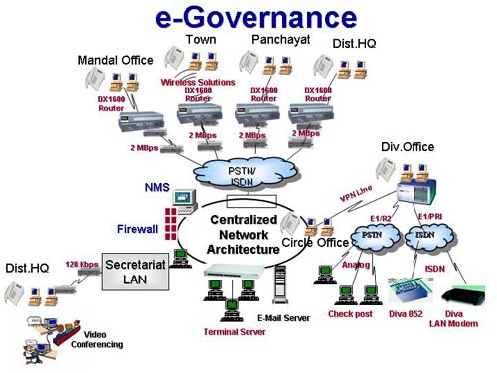
Figure (b) : ICT infrastructure in various Applications

Computer have become more effective, powerful, user friendly and less expensive. Computer built the world’s most affordable, durable, audio device designed specifically for people. Rural teachers complement their lessons with interactive applications and audio books. The Talking Book shares vital knowledge among poor, rural communities³. ICT provide the complete information to one person to other person. It very useful for rural areas for example if computer provide the complete information of seeds for farmers by experts it is very useful for farmers.

Applications for ICT:
In ICT computer perform the faster and easier provide the data and in this rural areas has take the growth and developed. If every person has the complete knowledge of every fields then rural areas are developed. It can take the growth.

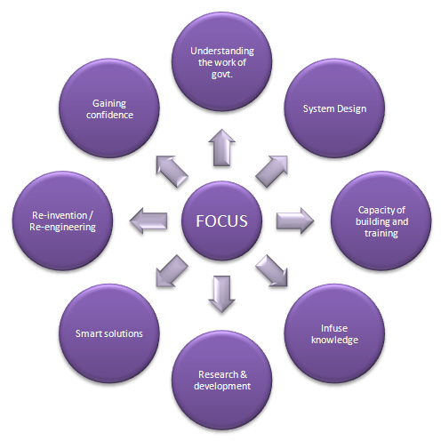
Figure (c)

ICT on governments:
- e-government development targets
- e-government strategies
- e-government coordination offices and structures
In these points of governments takes the different plan for developing of rural areas as project bhomi in this project The Department of Revenue in Karnataka has computerized 20 million records of land ownership of 6.7 million farmers in the state. Records of land ownership are required to facilitate sale and inheritance, or to provide proof of ownership to avail credit. Upon sale or inheritance of a land parcel, requests to alter land records had to be filed with the Village Accountant. Previously, farmers had to seek out the Village Accountant to get a copy of the Record of Rights, Tenancy and Cultivation (RTC). There were delays and harassment. Bribes had to be paid. The Village Accountant could afford to ignore or delay action on these "mutation" requests and delay the requests for certificates⁴.

ICT Governance and Best Practices:
The importance of this program lies in focusing on managing information technology for better decision making process in the fields of agriculture and rural development. The curriculum includes Agriculture Information Systems, Global Trends in World Bank and WTO and its impact, Agribusiness and Finance, Supply Chain Management, Land–Water Management Systems, Resource Mapping, Developmental issues in rural areas, ICT and Technology application, E-governance and related fields including the Public Information Systems database creation⁵.

Advantages:
- An electronic government is to move the online government services . which is very fast and successive.
- ICT provide the online registration and it is fast process for information sending or receiving (e.g. online government exam).
- Individual organizations’ efforts in developing the whole set of policies, processes and procedures are minimized could be met with minimum.
- ICT provide the fast information for high to poor in rural areas.
- Organizations could consistently assess the proposed performance performance against indicators.
- Governing bodies and the senior executives of the confidence in the ICT organizations will have more operations and ICT investments.

Disadvantages:
- An electronic government is to move the government services into an electronic based system. This system loses the person to person interaction which is valued by a lot of people.
- In addition, the implementation of an e-government service is that, with many technology based services, it is often easy to make the excuse (e.g. the server has gone down) that problems with the service provided are because of the technology.
- The implementation of an e government does have certain constraints. Literacy of the users and the ability to use the computer, users who do not know how to read and write would need assistance. An example would be the senior citizens. In general, senior citizens do not have much education and they would have to approach a customer service officer for assistance⁶.
- Studies have shown that there is potential for a reduction in the usability of government online due to factors such as the access to Internet technology and usability of services and the ability to access to computers.

Conclusion:
The Information and Communication Technologies have facilitated the design of solutions to deliver government services for social development at the door step of rural poor. And in it is provide the complete information. Which has every poor person success of it? In this development efficiency and transparency demonstrated in citizen services, improvement of convenience for citizens, improvement of back-end services, processes with front-end and web site, arrangement in the application development. So in this ICT provide growth and development of rural areas.

References:
- http://en.wikibooks.org/wiki/E-government/Introduction
- By Vikas Nath on http://www.digitalgovernance.org/
- http://www.literacybridge.org/talkingbook/?gclid=CIXGxvn3jqgCFUF66wodKRKQMw
- Public Affairs Center, Bangalore, “Report Card on service of Bhoomi Kiosks”,http://www1.worldbank.org/publicsector/bnpp/Bhoomi.PDF , World Bank, 2002
- http://www.daiict.ac.in/daiict/admissions/msitagri.html
- http://msg-itlg.blogspot.com/2008/01/advantagesdisadvantages-of-electronic.html
- Figure (b) http://www.daxnetworks.com/images/Solutions/e-governence.jpg
- Figure (c) http://www.uginfosystems.com/img/egov-focus.jpg

4/17/2011

