Influence of Rubber effluent on some soil chemical properties and early growth of rubber seedling

Waizah Yakub¹, Giroh, Yuniyus Dengle, Fred Ojiekpon, Haliru Umar and Edosuyi Austin Oghide.

Rubber Research Institute of Nigeria, P.M.B 1049, Benin City, Nigeria.
1=corresponding author: waizahyakub@yahoo.com and waizahyakub@gmail.com

Abstract: A field experiment was conducted to examine the effect of rubber effluent on the growth of rubber seedlings and soil chemical properties in an Ultisol. A randomized complete block design was adopted with two treatment replicated five times. T₁ received no soil amendment and served as the control, T₂ received 5, 3330 L /ha of rubber factory effluent. Results of the effluent analysis revealed that it is rich in some plant nutrients and the effluent also had effect on some soil chemical properties as well as the growth of rubber seedlings. Pre-cropping soil analysis showed that the area was loamy sand characterised by low pH, low ECEC and low water holding capacity. There were no significant differences in the height, leaf area, leaf number and girth of the seedlings among the treatments at early growth stage, at a later stage of growth, seedlings treated with rubber effluent performed better than the control. The use rubber effluent should be encouraged, since the general performance of the seedlings treated with rubber effluent is superior to the control.
[Waizah Yakub, Giroh, Yuniyus Dengle, Fred Ojiekpon, Haliru Umar and Edosuyi Austin Oghide. Influence of Rubber effluent on some soil chemical properties and early growth of rubber seedling. World Rural Observations 2011;3(3):82-87]; ISSN: 1944-6543 (Print); ISSN: 1944-6551 (Online). http://www.sciencepub.net/rural.

Key words: Rubber effluent; seedling growth; soil properties; fertilizer

1. Introduction
An important basis for increase in rubber (Hevea brasiliensis [Muell. Arg.]) latex production lies in the development and distribution of planting materials (seedlings) that are disease free, early maturing and vigorous that could ensure high field survival rate. This can only be achieved through proper soil fertility management in the nursery where these seedlings are produced. Rubber nurseries in the past were raised mostly in newly cleared forests which are quite rich in plant nutrients but over time the situation has changed, new forests became unavailable and rubber had to be raised on denuded and less fertile crop lands.
The utilization of industrial waste as soil amendment has generated interest in recent times. (Swamenathan and Vaidhee-swaran, 1991) reported that waste water produced continuously could cater for the needs of irrigated crops. Thus this will not only prevent waste from being an environmental hazard but also serves as an additional potential source of fertilizer for agricultural use.
The addition of sewage sludge to a coarse textured sandy and calcareous soils was reported to have improve the water holding capacity, cation exchange capacity, increase the availability of N, P, K, Cu, Zn, Fe, Mn, Na but with reduced biochemical oxygen demand (BOD) (Badary and EI-Moitaium, 1999). reported that controlled application of rubber effluent on land caused changes in soil properties and improved in soil water retention while Lim and (P’ng, 1983) recorded increase in pH, K, Ca, Mg and organic matter content with the application of palm oil mill effluent. (Valdes et al. 1996) observed an increase in the soil organic matter by 1% with sugar factory effluent applied to soils in Cuba taking into account the deficiency in the humic matter of the soil.
This study was conducted to assess the effect of Rubber factory effluent on some soil chemical properties as well as some agronomic character of early growth of rubber seedlings.

2. Methodology.
This study was conducted in 2008/2009 cropping season at Rubber Research Institute of Nigeria Iyanomo Main nursery near Benin City Edo State. The study area fall between latitude 6°00¹ and 7°00¹ North and longitude 5°00¹ and 6°00¹ East of the Equator. The rainfall pattern is bimodal with the peaks in the month of July and September but the highest in July and a short dry spell in August, figure (v). The soils of this humid forest belt are mainly Ultisols with pH range between 4.0 and 5.5, the soils have been described as the acid sands derived from unconsolidated grits and sand stones containing clay peds of varying proportions (Vine, 1956).
Randomized complete block design (RCBD) was adopted with two treatments in five replicates. Each plot measured 1.5×1m with 1m furrows in between the plots. T₁ (control), T₂(rubber effluent). T₁ received no soil amendment and served as the control and T₂ received 5,333.6 litres /ha of rubber effluent. The rate of application were based on the concentration of nutrient in the soil and the soil amendment and applied at the rates recommended by previous studies (Onuwaje and Uzu, 1982; Ugwa et al, 2005). Seedlings were planted at a spacing of 30 cm×30 cm in the beds.
Growth data (stem girth, plant height, number of leaves and leaf area) of the rubber seedlings were taken at monthly interval. Five seedlings per plot were carefully selected devoid of diseases and border effects.
Soil sampling was carried out before and after the application of the soil amendments. Ten (10) composite soil samples (0-15 cm depth) of the experimental area were collected by simple random sampling using soil auger and bulked to obtain a representative sample, and analyzed at the pre-treatment stage. Soil samples (0-15 cm depth) were also collected from the experimental plots three (3) months after the application of the soil amendments and finally samples were collected at six (6) months after the application of the treatments. All samples collected were carefully bagged and labelled. The soil samples were air dried and sieved through 2 mm mesh before being subjected to laboratory analysis.
Soil particle size was determined using the hydrometer method of (Bouyoucos, 1951). The soil pH was determined in a 1:1 soil to water ratio using the glass electrode pH meter while the organic carbon was determined using the chromic acid wet oxidation procedure as described by (Jackson, 1962) whereas the total nitrogen was determined by micro-kjeldal method as described by (Jackson, 1962). Available phosphorus was extracted using Bray No1 P solution (Bray and Kurtz, 1945) and the P in the extract was assayed colorimetrically by the molybdenum blue colour method of Murphy and (Riley, 1962). The exchangeable bases were extracted using l N neutral ammonium acetate solution. Calcium and magnesium content of the extract were determined volumetrically by EDTA titration procedure (Black, 1965). The calcium, potassium and sodium determined by flame photometry. Magnesium content was obtained by the difference. The exchangeable acidity was determined by the KCl extraction and titration method of (Mclean, 1965). The ECEC was calculated as the sum of exchangeable bases and exchangeable acidity.

3. Results and Discussion
3.1 Pre-cropping properties of the soil and rubber effluent used for the study
Some of the physico-chemical properties of the soil before the commencement of the experiment are as shown in Table 1. The soils of the study area was loamy sand in texture, characterised by low pH (5.7), with low base saturation and contained some amount of organic carbon, total nitrogen, available phosphorous and the exchangeable potassium. Exchangeable cations were generally low with Ca (1.15 cmol kg⁻¹) being the highest, and low water holding capacity similar finding have been reported by ( Juo, 1981; Kang and Juo 1986; and Waizah 2011,). Micro nutrients were somewhat high especially Mn. The sandy nature of the soils is principally influenced by the coastal-plain sand parent material that is inherently sandy (Ojanuga, 2006). This also explains why the soil have low potassium reserve as typical sandy soils has low ion exchange capacity, which determine the quantity of ion that a soil can retain against leaching (Edem, 2007). The fertility status of the soils is greatly determined by the capacity of the soil to hold and exchange ions (both anions and cations). Coarse textured soils are deficient in this quality and as such have low fertility status. In addition soil pH is a very important soil property and that tends to correlate with other properties like degree of base saturation, nutrient release and availability (Fitzpatrick, 1983). The acidic nature of the soils may be attributed to high rainfall in the region that makes the soil susceptible to erosion and leaching as the highly mobile basic cations are generally washed away leaving the sesquioxides, to occupy the exchange sites of the soil colloids ( Donahue, 1983 ). The presence of Aluminium (Al) and Iron (Fe) and their oxides and hydroxides increases P-fixation (Sample et al, 1980) resulting in low native phosphorus. Hue, (1992) reported that increasing the pH of acidic soils improve plant availability of macronutrient but reduces the solubility of elements such as Al and Mn. The percentage base saturation was expectedly low since the basic cations were low which is as a result of high precipitation leading to strong weathering and leaching condition of the area. The elemental contents of the rubber effluent (Table 2) showed that it is also acidic with pH of 5.00, low in available P and micronutrients but, relatively higher in N and K.

3.2 Chemical properties of the soil at three months after soil amendment
Table 3 shows the effect of the soil amendments on some soil chemical properties three month after application. There was general decrease in soil pH after application of the rubber effluent from 5.7 in the pre-cropping to 4.75 and slight decrease in the control plots from 5.7 to 5.22. Base saturation increased tremendously from 4.67 (%) in the pre-cropping to a mean of 9.36 (%) and 8.37 (%) for control and rubber effluent, respectively. The total nitrogen showed an increase in their mean values. Whereas the available phosphorous decrease from 8.03 mg kg⁻¹ in the pre-cropping to 7.5mg kg⁻¹ in the control plot, the plots treated with rubber effluent rose to 25.8 mg kg⁻¹ respectively. The monovalent cation such as K and Na did not show significant response to treatment (P ≤ 0.05). The divalent cations (Ca and Mg) increased from a mean value of 1.15cmol/kg in the control to 1.83 cmol kg⁻¹ for Ca while Mg rose from the 0.85 to 1.03 cmol kg⁻¹. The general improvement in soil chemical properties following effluent application could be ascribed to increase in the level of soil nutrient from the rubber effluent applied and a more conducive growth created environment for soil micro-organisms which aid in improving the soil status. The increase in above nutrients further confirms that applying rubber effluent is not problematic especially when the rate of application is aimed at supplying nutrients at levels corresponding to those in inorganic fertilizer normally applied to promote satisfactory crop performance. Controlled application of effluent have been observed not to causes detrimental changes in the soil environment rather it improves soil fertility.

Table 1: Some physico-chemical properties of the soil used for the experiment before cropping
Soil properties | Characteristic
Sand (g kg⁻¹) | 880.4
Silt ″ | 19.6
Clay ″ | 100.0
Texture ″ | LS
pH (H₂0) | 5.7
Organic. C ″ | 13.8
Total N ″ | 03.3
Available P (mg kg⁻¹) | 8.03
Exch Ca (cmol kg⁻¹) | 1.15
Exch Mg ″ | 0.85
Exch Na ″ | 0.1
Exch K ″ | 0.18
Exc. Acidity ″ | 2.6
CEC ″ | 4.88
Base sat. (g kg⁻¹) | 46.72
Extc. Mn (mg kg⁻¹) | 121.08
Extc. Fe ″ | 70.25
Extc. Cu ″ | 6.96
Extc. Zn ″ | 17.32

Table 2: Analysis of rubber effluent used in the experiment
Parameters
pH | 5.00
Nitrogen (%) | 2.10
Phosphorus (ppm) | 5.26
Organic carbon (%) | 0.14
Potassium (mg l⁻¹) | 12.25
Calcium ″ | 8.85
Sodium ″ | 1.54
Magnesium ″ | 2.29
Iron ″ | 0.04
Manganese ″ | 0.02
Zinc ″ | 0.91

Table 3: Effect of soil amendments on some soil chemical properties three months after application
Treatment | pH  (H₂0) | Base sat (%) | K  ←-------- | Na  -------- | Mg  ---------- | Ca  cmolkg⁻¹ | EA  ---------- | CEC  -------→ | N  g/kg | Org.C  g/kg | P  Mg/kg
Control | 5.22 | 9.37a | 0.180 | 0.107 | 1.03a | 1.833a | 0.267 | 3.320a | 3.3b | 1.38a | 7.50b
Rubber effluent | 4.75 | 8.37c | 0.170 | 0.083 | 0.780b | 1.033b | 0.467 | 2.430b | 4.8a | 0.73c | 25.80a
SE± | 0.092 | 1.344 | 0.008 | 0.124 | 0.063 | 0.093 | 0.084 | 0.137 | 0.015 | 0.029 | 2.28
Means with the same letters are not significantly different from each other according to Duncan Multiple Range Test at 5%level.

Table 4: Effect of soil amendments on some soil chemical properties six months after application
Treatment | pH  (H₂0) | Base  sat (%) | K  ←-------- | Na  ----------- | Mg  ----------- | Ca  cmolkg⁻¹ | Exch. A  ----------- | CEC  -------→ | N  gkg⁻¹ | P  gkg⁻¹ | Org.  mg kg⁻¹
Control | 5.20 | 8.639a | 0.193a | 0.11 | 0.943a | 1.300a | 0.467ab | 2.93c | 2.73ab | 4.75b | 9.9b
Rubber effluent | 5.09 | 3.851c | 0.163b | 0.08 | 0.760b | 1.030b | 0.267b | 5.14b | 2.03c | 7.69a | 8.4b
SE± | 0.123 | 0.392 | 0.005 | 0.141 | 0.039 | 0.049 | 0.069 | 0.115 | 0.018 | 0.042 | 0.048
Means with the same letters are not significantly different from each other according to Duncan Multiple Range Test at 5%level.

3.3 Chemical properties of the soil at six months after soil amendment
Table 4 shows some chemical properties of the soil as affected by soil amendments six months after application (6 MAA). Soil pH value though, still lower than the pre-cropping value of 5.7 has increased to 5.20 and 5.09 for control, and rubber effluent which are slightly higher than three months previously. The base saturation of the soil rose from 46.72% to 86.39 % in the control and to 88.26% in the soils treated with rubber effluent. The N showed decrease in the mean values for the treatment as compared to the value obtained in the pre-cropping and as well as soils analysed three month after application of soil amendments. The divalent cations (Mg and Ca) showed an increase over the control. Calcium recorded 1.300 cmol kg⁻¹, and 1.030 cmol kg-¹ for the control and rubber effluent as against the pre-cropping value of 1.15 cmol kg⁻¹. The effective cation exchange capacity decreased from 4.88 cmol kg⁻¹ at the pre-cropping to 2.93 cmol kg-¹ for the control but increased to 5.14 cmol kg⁻¹ with rubber effluent treatment. The exchangeable acidity reduced in the treatments which accounted for increases in base saturation signifying that the rubber effluent increased the cations in the exchange sites of the soil colloids in preference to reserved acidity. The organic carbon content of the soil however showed drastic reduction in the rubber effluent from the pre-cropping value The extractible micronutrients increased in value with soil rubber effluent especially in Zn and Mn. The general decrease in the chemical properties might have been as a result of nutrient uptake by plant and leaching caused by high precipitation in the area. This further confirm that the rubber factory effluent are not problematic to rubber seedlings, especially when the rate of application is geared to supply nutrient level corresponding to those in inorganic fertilizer which are applied to promote satisfactory crop performance and causes no detrimental change to the soil rather they improve soil fertility with no adverse effect in the environment as observed by Mohd and Abu (1989).

3.4 Effect of soil amendment on growth of Hevea seedlings.
The result of the effect of soil amendments on plant girth of Hevea seedlings is shown on Figure i. The results indicated that from 2 to 4 months after application of the treatments, rubber effluent accounted for higher values but showed no significant effect (P ≤ 0.05) on the girth of the rubber seedlings except at 3 MAA, when mean girth of 3.44 cm in rubber effluent treatment were significantly different from the 2.68 cm recorded for the control. At 5, 6 and 7 MAA, rubber effluent was superior to the control.
Figure ii shows the effect of soil amendments on plant height of Hevea seedlings. Applicationof rubber effluent had no significant effect on the mean height of rubber seedlings (P ≤ 0.05) in the second and third months after application (MAA), though at 3 MAA the mean height of rubber seedlings treated with effluent was higher (87.7cm) compared to those in the control with the mean was 82.2 cm. However there was significant difference (P ≤ 0.05) in plant height of rubber at 4, 5, 6 and 7 MAA. at 4 MAA, rubber effluent had the mean of 113.3 cm compared to an average of 98.9 cm for the control. This trend was maintained till the 5 MAA. At 6 MAA, as observed by Waizah (2011)
The average number of leaves on rubber seedling at different sampling period with respect to the application of rubber effluent (Figure iii) showed that at month 2 and 3 after application of rubber effluent, no significant effect (P ≤ 0.05) was observed. However, from 4 MAA the rubber effluent showed significant effects on the number of rubber leaves. In the 7th MAA, the plot treated with rubber effluent had 30 leaves per plant while the control plot had 23 leaves per plant.
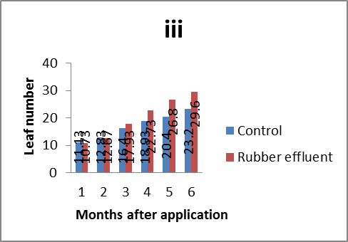
The effect of rubber effluent on the leaf area of Hevea seedlings is displayed in Figure . Though there was no significant effect of the rubber effluent (P ≤ 0.05) compared to control at 2 MAA, at 3, 4, 5, 6 and 7 MAA the seedlings treated with rubber effluent significantly larger leaf area than the control. The plots treated with rubber effluent recorded the largest leaf area with the value of 34.90 cm² while the control had 27.18 cm². At 6 MAA, leaf area in all the treatments dropped compared with 5 MAA. By 7 MAA, rubber seedlings treated with rubber effluent had the highest mean of 38.90 cm². The increase in the mean plant height, leaf area, girth and leaf number in seedlings treated rubber effluent could be attributed to increase in amount of micro and macro nutrients available to the seedlings from rubber effluent applied.

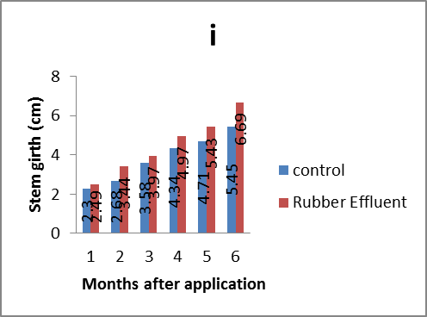
Fig 1: Effects of rubber effluent stem girth.

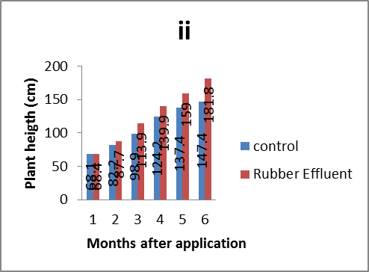

Fig 2: Effects of rubber effluent plant height

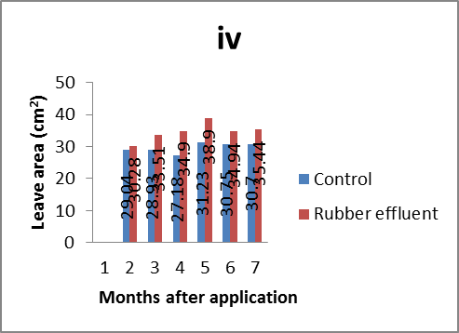
Fig 3: Effects of rubber effluent leaf number.
Fig 4: Effects of rubber effluent leaf area

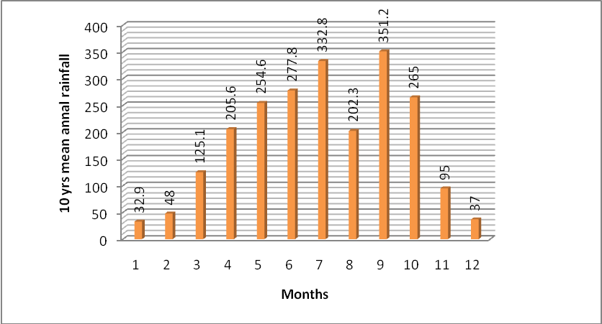
Figure 5. Ten years (1994-2003) mean annual rainfall of the study area (Rubber Research Institute of Nigeria Iyanomo).

4. CONCLUSION
In conclusion, the result showed that rubber effluent can favourably be used as an alternative source of fertilizer in improving the growth of rubber seedlings while the result of soil chemical analysis after application of the treatment showed improvement in general soil properties. The use of rubber effluent as a fertilizer material is very promising in rubber nurseries however long term implications of the effluent on the soil is recommended further investigation.

Correspondence to:
Waizah Yakub
Soil and Plant Nutrition Division
Research Operations Department
Rubber Research Institute of Nigeria Iyanomo
P.M.B 1049, Benin City, Nigeria
Email: waizahyakub@yahoo.com
waizahyakub@gmail.com
REFERENCES
- Badawy SH, El-motaium RA (1999). Effect of irradiated and nonirradiated sewage sludge application on some nutrient-heavy metal content of soils and tomato plants. 1st congress on recent Technology in Agriculture Bulletin of Faculty Agriculture Vol. IV. University of Cairo, Cairo 728-744.
- Black CA (1965). Method of soil analysis. Agronomy. No. 9 part 2. American Society of Agronomy, Madison, Wisconsin.
- Bouyoucos CJ (1951). A recalibration of the hyprometer mechanical analysis of soil. Agron J.43:434-438.
- Bray RH, Kurtz LT (1945). Determination of total organic and available phosphorous of soils. Soil Science 59:39-48.
- Donahue, R.L., Miller R.W and Schickluna, J.C (1983). Soils: An Introduction to Soil and Plant Growth. 5th Edition Prentice Hall Inc., Eaglewood, New York.
- Edem SO (2007). Soil: The Dynamic System. Minder international Publishers, Uyo, Nigeria. 111p (eds.)
- NSPFS/FAO/ FMA&RD, Abuja, Nigeria. Fitzpatick EA (1983). Deeply weathered rock of in Scotland, its occurrence, age and contribution to the soil. Journal of Science, 14:33-43
- Hue, NV (1992). Correcting Soil Acidity of highly weathered ultisols with Chicken manure and sewage sludge. Communication in Soil Science and Plant Analysis23: 241- 264
- Jackson ML (1962). Soil Chemical Analysis. Prentice Hall New York.
- Juo ASR (1981). Mineralogy of acid sands of southern Nigeria. Special publication. Monograph 1: 19-26.
- Kang BT, Juo ASR (1986). Effect of forest clearing on soil chemical properties and Crop performance. In: R. Lal, P.S. Sanchez and R.W. Cumming Jr. (Eds) land clearing development in the tropics. Rotterdam, Boston.
- Lim CA, P`ng TC (1983). Land application of digested palm oil mill effluent by sprinkler system. Proceeding of the seminar on land application of oil palm and rubber factory effluent. Serdang, Oct. 1983.
- Manurang, A (1993). The effect of TSP and some rock phosphate on the growth of rubber seedlings. Bull Perkonetan 2: 13 – 17
- Mclean EO (1965). Aluminium. In: Methods of Soil Analysis (Ed C.A. Black). Agronomy No. 9 part 2. American Society of Agronomy. 978-998.
- Mohd ZK and Abu TB (1989). Comparative study of rubber effluents and an inorganic fertilizer as source of plant nutrients for Hevea and their effect on soil properties. Journal of Natural Rubber Research. 4(4):260-272
- Murphy J, Riley JP (1962). A modified solution method for determination of phosphate in natural waters. Analyt. Chim. Acta, 27: 31-36.
- Nair, A.N.S, J. Cyriac, A. Philip, M. Karthikakuthiyama and K.I. Punnose. (1998). Effect of water soluble and water insoluble forms of phosphate fertilizer on the growth of Hevea brasiliensis during the immature period. Development in Plantation Crop Research 1998. Rubber Research Institute of India Kottayam India . Pp 230 232.
- Ojanuga AG (2006). Agro ecological zones of Nigeria manual (F. Berding and V. O. Chude
- Onuwaje OU, Uzu FO (1982): Growth response of rubber seedlings to N. P. and K fertilizers in Nigeria. Fertilizer Research 3: 167-175.
- Orimoloye JR, Omorusi VI, Ugwa IK, Idoko SO (2004) Effects of Dolomite, Rock Phosphate and Organic Manure on Indigenous Mycorrhiza fungi and rubber seedlings in an acid sandy soil. Journal of sustainable Tropical Agricultural Research 10: 83- 89.
- Sample EC, Soper RJ Racz G. (1980). Reaction of phosphate fertilizer in soils. science 11(2): 185-187.
- Swaminathan K, Vaidheeswaran P (1991). Effect of dyeing factory effluent on seed germination and seedling development of grountnut (Arachis hypogea) 1. Environ. Biol. 12(3): 253-258.
- Ugwa IK, Orimoloye JR, Esekhade TU (2005) Nutrient status of some soils supporting rubber in western Nigeria. The Nigerian Agricultural Journal. 36:169-176
- Valdes E, Obaya MC, Ramos J (1996). Ecology and the sugar industry Revista. 30: 214-229.
- Vine H (1956): Studies of Soil profile at the WAIFOR Main Station and some other sites of oil palm experiments, Journal of West African Institute of Oil palm Research 4: 8-59
- Waiza Y. (2011). Growth response of rubber seedlings to soil amendment in an acid soil at Iyanomo in Edo State. M.sc thesis, Department of soil science, University of Benin, Nigeria.

5/24/2011

