Bioremediation of Tannery Effluents by Diazotrophic Cyanobacterium Tolypothrix tenuis (Kuetz.) Schmidt

^{*1}V. Kannan, ¹M. Vijayasanthi, ²R. Ramesh and ¹A.P.Arumugam

¹PG & Research Department of Botany, National College, Tiruchirapalli – 620 001, Tamilnadu, India
²PG & Research Department of Geology, National College, Tiruchirapalli – 620 001, Tamilnadu, India
kannamala@sify.com

Abstract: Tannery effluents are of large scale environmental concern because they colour and diminish the quality of water bodies into which they are released. Their disposal into the environment creates adverse effects by altering the normal physiochemical properties of soil and water. Though many conventional physicochemical methods are currently being practiced, biotechnological methods are becoming attractive alternatives, as they are economical and eco-friendly. In this study Cyanobacterium, particularly Tolypothrix tenuis was employed for bioremediation of tannery effluents. The treated effluents from tannery industry were collected and added to the cyanobacterial growth medium in various proportions. The photosynthetic pigments and nitrogen status of T. tenuis were analyzed before and after the treatment with effluent. The present investigations showed that Tolypothrix tenuis can serve as the potential bioremedial organism for industrial pollution.
[V. Kannan, M. Vijayasanthi, R. Ramesh and A.P.Arumugam. Bioremediation of Tannery Effluents by Diazotrophic Cyanobacterium Tolypothrix tenuis (Kuetz.) Schmidt em. World Rural Observations 2012;4(1):56-60]. ISSN: 1944-6543 (Print); ISSN: 1944-6551 (Online). http://www.sciencepub.net/rural. 10

Key words: Tannery effluent, Photosynthetic pigments, cyanobacteria

1. Introduction
Water is one of the most important natural resources, essential for all forms of life. This resource is being contaminated every day by various anthropogenic activities such as rapid growth of populations, urbanization and industrialization that ultimately make the environment polluted (Mythili and Karthikeyan, 2011). Heavy metal pollution represents an important environmental problem due to toxic effects of metals, their recalcitrance and consequent persistence (Parvathi et al., 2007). The industrial effluents contain several types of chemicals such as dispersants, leveling agents, acids, alkalis, carriers and various dyes, phenols, carbonates, alcohols, cyanide, heavy metals etc (Cooper, 1995). The tannery effluent wastes are ranked as high pollutants among all other industrial wastes (Eye and Lawrence 1971). Waste water release from tannery industries leads to serious consequences from the pollution point of view for streams, Freshwater and land used for agriculture. The lack of awareness in the modern industrial practice has resulted in the discharge of tannery effluents which exhibit very high value for Cr, Sulphide, and chloride, total dissolved salts (TDS), total soluble salts (TSS), biological oxygen demand (BOD) and chemical oxygen demand (COD) in the water stream or land (Aneez Mohamed et al., 2011). Leather industries and tanneries generate massive by-products, solid wastes, high amounts of waste water rich in organic wastes with different loads of pollutants and emissions into the air (Sonil Nanda et al., 2010). Under these circumstances, a method using conventionally available resources, alternative to traditional methods, has to be evolved which will be effective in solving the pollution problem. Some of the plants can resist pollution caused by effluent released from tanneries and in fact utilize the dissolved salts for their growth. Several laboratories all over the world are currently involved in the cleaning of pollutants using microorganisms.
Microbes are reported to take effective part in bioremediation of wastes (Chipasa, 2003; Ahluwalia and Goya, 2007). They can neutralize the organic contaminants by oxidizing them to carbon dioxide. Heavy metals present in wastes are converted to a less toxic form by microbial action which in turn gets precipitated or volatilized from solution of by the chelating reaction of metal or siderophore or changed to the redox state (Sanhita Chowdhury et al., 2011). In recent years, cyanobacteria were used as bio-adsorbent for the removal of certain heavy metals from heavy metal polluted water (Jones et al., 1986).
Most of the conventional methods generate secondary effluent impacts on the recipient environment and are economically not feasible. In this context, the phytoremediation technology is considered as an emerging technology, which is favoured for the removal of heave metals in contaminated systems because of its cost effectiveness, aesthetic advantages and long-term applicability (Singanan and Singanan, 2007). In the present study, photosynthetic nitrogen fixing cyanobacterium, Tolypothrix tenuis was used to find out their efficacy in remediating the tannery effluent. It was grown in the normal growth medium amended with various dilutions of tannery effluent and the response of alga in terms of growth and nitrogen status of cells were used as an index of resisting the pollutants in tannery effluent.

2. Materials and Methods
2.1. Collection of Samples
Treated effluents were collected from sampling sites of tannery industries located at Trichirappalli, Tamil Nadu. The samples were collected in sterile borosilicate bottles protected from sunlight during transportation.

2.2. Maintenance of Cultures (Tolypothrix tenuis)
Axenic cultures of Tolypothrix tenuis was kindly provided by Algal Laboratory Culture Collection Centre, established maintained at Centre for Advanced Studies (CAS) in Botany, University of Madras. The culture supplied by Dr. N. Anand, Director, CAS in Botany, University of Madras, was obtained for the present work by Dr. V. T. Sridharan, Former Head of the Department of Botany, National College, Trichy. Axenic cultures of Tolypothrix tenuis were grown in Allen and Arnon’s medium (Allen and Arnon, 1955) that was free of nitrogen. For treatment, the growth medium was amended with tannery effluent at appropriate dilutions (1:10, 1:100 and 1:1000).

2.3. Analysis of Photosynthetic pigments
Photosynthetic pigments were determined in the samples according to the method described by Aron (1949) as modified by Mckinney’s procedure (1941). The estimation of Cartenoids was performed by Myers and Kratz, (1955). Total free amino acids and total sugars were determined in the samples using Jayaraman (1985). Total protein was assayed by the method of Lowery et al (1951). The estimation of total nitrogen was done according to Humphries (1956). Phycobiliprotein (Bennett and Bogorad, 1973), heterocyst frequency (Fogg, 1944), photosynthetic oxygen evolution and respiratory oxygen consumption were also evaluated in the samples by Winkler’s method.

3. Results and Discussion
In general, potential microorganisms can remove heavy metals from solutions by biosorption or bioaccumulation or both. A variety of mechanisms exist for the removal of heavy metals from aqueous solution by bacteria, fungi, ciliates, algae, mosses, macrophytes and higher plants (Mythili and Karthikeyan, 2011). In the present study, sustained growth and production of various biochemical constituents of cyanobacterium, Tolypothrix tenuis were used as an index of tolerance to tannery effluent.
The quantitative analysis of chloroplast pigments on the initial and 7th day of treatment revealed that the total chlorophyll & carotenoid (Fig – 1) pigments were continued to be synthesized by Tolypothrix tenuis under normal growth conditions. When the culture was grown in full effluent, there was hardly any synthesis chlorophyll & carotenoid (Fig – 1). Intracellular levels of these pigments indicate that supply of effluent at 1:10 dilution caused 55% decrease in Chl. contents over control (Fig 1A). Exposure of cultures to 1:100 and 1:1000 dilutions of tannery effluent caused only 38% and 28% decrease in chlorophyll content.
Carotenoid content was also analyzed to find out the effects of tannery effluent treatment. As shown in Fig. 1B, it was observed that the intracellular levels carotenoid was lowered by 30% upon growth in full effluent medium on the 7th day of treatment. There was no difference in carotenoid content between control cultures and the one treated with 1:100 and 1:1000 dilution of tannery effluent.
Treatment of cultures with full effluent and 1:10 dilution, dilutions caused the significant reduction in the cellular levels of phycocyanin (PC) . However, dilution of tannery effluent to 1000 times and addition in to the growing medium, maintained cellular PC content (Fig. 2A). A similar effect was observed when allophycocyanin (APC) as shown in Fig. 2B. In cyanobacteria, phycobiliprotein (PBP) constitutes the bulk of photosystem II reaction centre. PBP is made up of PE, PC and APC. Of these, PE is the dominant pigment in Tolypothrix tenuis and it was of interest to find out the effects of tannery effluent on their production. Analysis of PE in cultures of Tolypothrix tenuis (Fig. 2C) revealed that the effect followed a pattern similar to the one on APC.
After 7 days treatment, the dissolved oxygen showed that there was enhancement in photosynthetic rate of cultures treated with the 1:100 and 1:1000 dilutions of tannery effluent when compared to control and full effluent-treated cultures. Respiratory activity was greatly reduced in cultures of Tolypothrix tenuis grown in tannery effluent diluted with medium to get 1:1000 dilutions when compared with cultures treated up to 1: 100 dilutions (Fig 4). Heterocyst frequency was measured as % of vegetative cells and the results obtained is indicated in Fig. 4C. It was observed that the cultures grown in effluent alone showed low (10%) heterocyst frequency after 7 days of treatment. It remained constant in control cultures. The supply of tannery effluent a one after diluting 100 and 1000 times did bring about notable changes in heterocyst frequency of cultures. The heterocyst frequency was brought to 16% and 15% from the initial value of 18%.
Heterocyst is the site of nitrogen fixation in cyanobacteria and the changes in heterocyst frequency must be associated with the total nitrogen content of cells. Hence, the total nitrogen content was also checked up during the study. Assay of total nitrogen content of cells revealed that there was no correlation between heterocyst frequency and the intracellular nitrogen content of cultures. As shown in Fig. 4D, the cultures continued to maintain high total nitrogen content, when grown in normal N-free medium. It remained significantly high over control cultures after treatment with tannery effluent. Supply of all the dilutions of effluent, enhanced the total nitrogen content of cultures. It is inferred that the supply of effluent in various dilutions such as 1:10, 1:100 and 1:1000 maybe good for the growth of the cultures as revealed by the continued increase in total nitrogen content of cells. The quantitative analysis of aminoacids on the initial and 7th day of treatment was also followed and reported in Fig. 4E. The total amino acid content of cells remained at a lower level, when the cultures of Tolypothrix tenuis were grown completely in effluent. But supply of effluent in diluted form prevented this decrease and their amino acid contents were comparable to that of initial. Aminoacids were however, continued to be synthesized by Tolypothrix tenuis under normal growth conditions.
The quantitative estimations of total protein (Fig – 4F) reveals that it decreased drastically on the 7th day of treatment when the cultures were grown 1:100 and 1:1000 dilutions of tannery effluent. When effluent was diluted 10 times with the sterile medium and supplied to the cultures of Tolypothrix tenuis enhanced protein levels of cells even over control cultures.
Studies performed at various laboratories indicate that algae and blue green algae could serve as effective biosorbant for removing heavy metals from contaminated waters (Khakil, 1997; Mishra and Nanda, 1997). The growth of Tolypothrix tenuis is affected when it was grown in full effluent as revealed by the constriction of contour of the filaments. But the dilution of effluent to 1:10, 1:100 and 1:1000 and addition to growth medium, did bring about the growth of Tolypothrix tenuis as evidenced from Plate-I. The cultures have the capacity to somehow utilize all the available nutrients in tannery effluents when it is diluted and provided in the gwoth medium. The ability to actively transport the metals in to the cells is already reported in several investigations (Bender et al., 1994). The present study is of preliminary nature checking the ability of Tolypothrix tenuis to grow in effluent at various dilutions. Further studies have to be done in order to understand the mechanism of tolerance of Tolypothrix tenuis and check its suitability as a bioremediator.

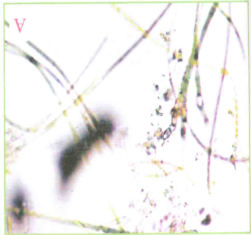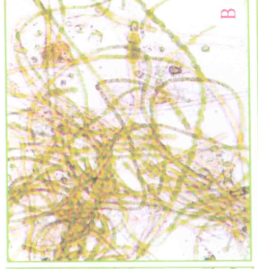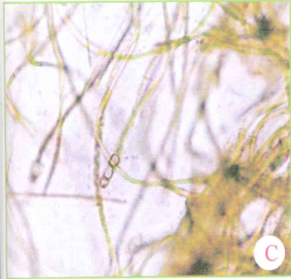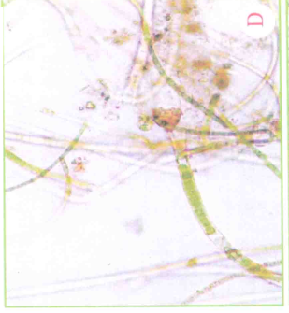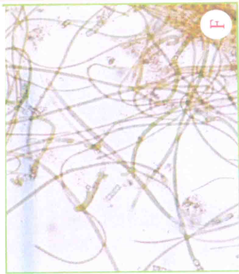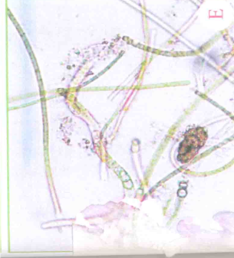
Fig. 1. Microscopic observation of Tolypothrix tenuis on the 7th day
(A) Initial; (B) Control; (C) Full effluent treatment
(D) 1:10 dilution; (E) 1:100 dilution; (F) 1:1000 dilution

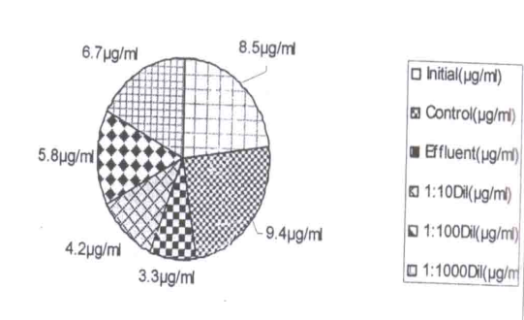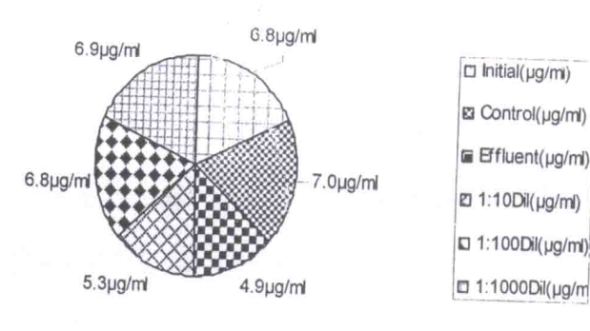
Fig: 2 Total chlorophyll
(A) Carotenoied; (B) content of Tolypothrix tenuis cultures exposed to tannery effluent treatments.
A. Chlorophyll
B. Carotenoid

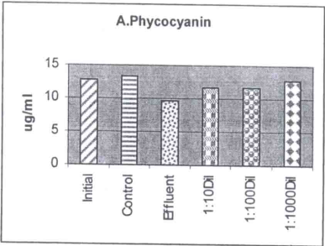

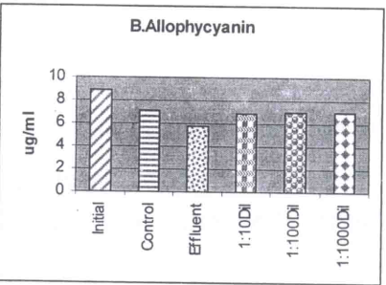

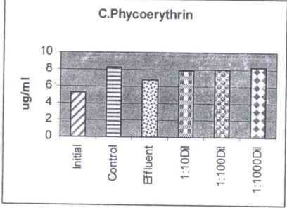
Fig-3: Phycobiliprotein content of Tolypothrix tenuis cultures exposed to tannery effluent treatments.

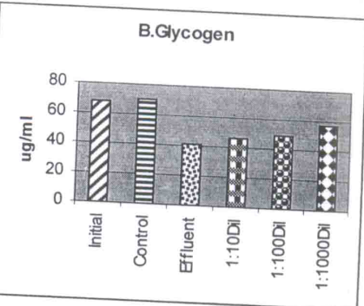

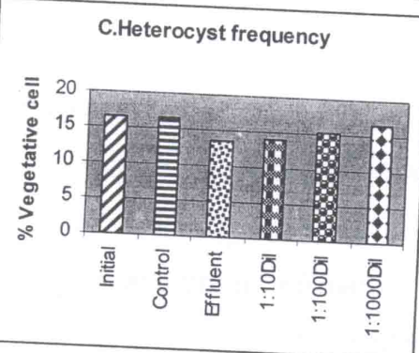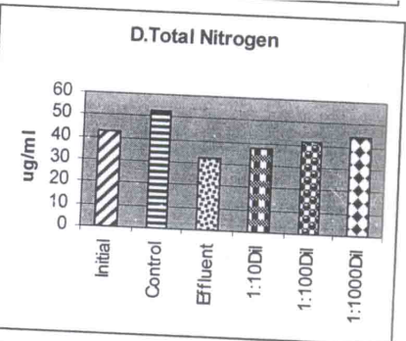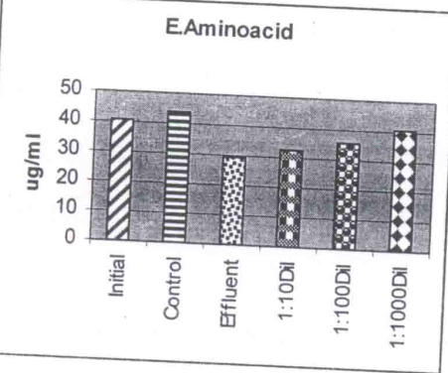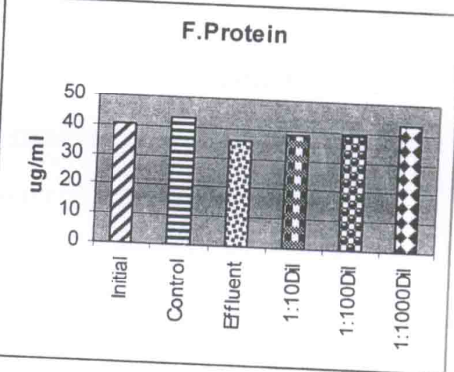

Fig-4: Intracellular leval of Sugar (A), Glycogen (B), Total Nitrogen (D), Aminoacid (E), Protein (F) , contents and Heterocyst frequency (C) of Tolypothrix tenuis cultures exposed to tannery effluent treatments.

Correspondence to:
Dr. V.Kannan, Head, PG and Research Department of Botany, National College, Tiruchirapalli – 620 001, Tamilnadu, India.

References
- Ahluwalia, S.S., Goya, D. Microbial and plant derived biomass for removal of heavy metals from waste water. Biores. Technol. 2007 (98): 2243-2257.
- Allenm, M.B., Arnon, D.I. Studies on nitrogen fixing blue green algae. I. Growth and nitrogen fixation by Anabaena cylindrical Lemm. Plant Physiol., Lancaster 1995 (30): 366-377.
- Aneez Mohamed, M., Sekar, P., George John. Efficacy of Microbes in Bioremediation of Tannery effluent. Int. J. Cur. Res. 2011 33(4): 324-326.
- Arnon, D. I. Copper enzymes in isolated chloroplasts: Polyphenol oxidase from Beta vulgaris. Plant Physiol. 1949 24(1): 1–15
- Bender, J., Washington, J.R., Graves, B., Philips, P., Abotsi, G. Deposit of zinc and manganese in an aqueous environment mediated by microbial mats. Water Air Soil Poll. 1994 (75): 195 – 204.
- Bennet, A., Bogorad, L. Complementary chromatic adaptation in a filamentous blue green alga. J.Cell Biol. 1973 (58): 419 – 435.
- Chipasa, K.B. Accumulation and fate of selected heavy metals in a biological wastewater treatment system. Waste Manag. 2003 (23): 135-143.
- Cooper, P. Colour in dyehouse effluent. Society of dyers and colourists, The Alden Press, Oxford, 1995.
- Fogg, G.E. Growth and heterocyst production in Anabaena cylindrica Lemm. New Phytol. 1944 (43): 64 – 175.
- Humphries, E.C. Mineral components and ash analysis. In: Modern Methods of Plant Analysis. Vol 1 : 469 – 502. Peach, K and Tracey, M. V. (Eds) Springer Verlag, Berlin, 1956.
- Jayaraman, J. Laboratory Manual in Biochemistry. Wiley Eastern Ltd., Chennai, India, 1985.
- Jones, G.B., Thomas, F.G., Burdon Jones, G. Est. Coas. Shelf. Sci. 1986 (23): 387 – 401.
- Khalil, Z. Toxicological response of a cyanobacterium, Phormidium fragile to mercury. Water Air Soil Poll. 1997 (98): 179 – 185.
- Lowry, D.H., Rosebrough, N.T.F., Farr, A.L., Backer, R.R. Protein measurement with folin phenol reagent. J.Biol. Chem. 1951 (193): 267 – 275.
- Mckinney, G. Absorption of light by chlorophyll solution. J. Boil. Chem. 1941 (140): 315 – 322.
- Mishra, B.B., Nanda, D.R. Reclamation with cyanobacteria: Toxic effect of mercury contaminated waste soil on biochemical variables. Cytobios., 1997 (92): 203 – 208.
- Myers, J., Kratz, W. Relations between pigment content and photosynthetic characteristics ina blue green alga. J. Gen. Microbiol. 1955 (39) : 11 – 22.
- Mythili, K., Karthikeyan, B. Bioremediation of Cr (VI) from Tannery effluent using Bacillus spp and Staphylococcus spp. Int. Multidisciplinary Res. J. 2011 (11): 1/6:38-41.
- Parvathi, K., Nagendran, R., Nareshkumar, R. Effect of pH on chromium biosorption by chemically treted Saccharomyces cerevisiae. J. Sci. Ind. Res. 2007 (66): 675 -679.
- Sanhita Chowdhury, Ashoke Ranjan Thakur, Shaon Ray Chaudhuri. Novel Microbial Consortium for Laboratory scale lead removal from city effluent. J. Env. Sci.Tech. 2011 4(1): 41 -54.
- Singanan, M., Singanan, A.A.V. Studies on the removal of Hexavalent Chromium from Industrial wastewater by using biomaterials. Electronic J. Env. Agri. Food Chem. 2007 6 (11): 2557-2564.
- Sonil Nanda, Prakash Kumar Sarangi, Jayanthi Abraham. Cyanobacterial remediation of industrial effluents I. Tannery effluents. New York Sci. J., 2010 3(12): 32 -36.

3/1/2012

