Utilizing Chemical, Anatomical and fingerprinting based on proteins polymorphism in classification of some Populus species

M.S. Shehata¹, M.M. Mansor² and I.M.M. Barakat²

¹ Horticulture Research Institute Agriculture Research Center.
² Department of Botany and Microbiology, Faculty of Science, Al-Azhar University.
baracat.potany@yahoo.com

Abstract: The current investigation was performed on the genus Populus in Egypt. This studied on four species of Populus to identification the differences among of these species based on pigment, anatomy and protein based on gel electrophoreses. The result recorded that the pigments which content chlorophyll A, B and carotenoids in P. alba was highest value, and the chlorophyll A and B in P. euroamericana was lowest value. This resulted cleared the significant differences among for four Populus species and can be used this characters as differenced among of Populus species. The significance of anatomical characters is of a diagnostic value to facility the identification and might serve in the solution of some puzzling relationships among different species of the genus Populus. The protein used as the genetic studied to determined differences among the four Populus species, the genetic similarity ranged between 66% and 96% which P. deltoides and P. euroamericana represent 96%. Similarity matrix shows that there’s a great variation between P. alba sample with P. nigra, P. euroamericana and P. deltoides samples since the similarity was 66, 73 and 70%, respectively.
[M.S. Shehata, M.M. Mansor and I.M.M. Barakat. Utilizing Chemical, Anatomical and fingerprinting based on proteins polymorphism in classification of some Populus species. World Rural Observations 2012;4(1):74-85]. ISSN: 1944-6543 (Print); ISSN: 1944-6551 (Online). http://www.sciencepub.net/rural. 14

Key words: Populus; protein; pigments; chlorophyll A & B and carotenoids; anatomy; gel electrophoreses; fingerprinting.

1. Introduction
Measurements of chlorophyll a fluorescence, concentration of leaf carbohydrates and their translocation have been used in research on the impact of air pollution on plants (Lichtenthaler and Rinderle, 1988; Bücker and Ballach, 1992).
The autumn coloration of temperate deciduous forests, particularly in the eastern USA, is a spectacular and yet poorly studied phenomenon. Anthocyanin synthesis in vegetative organs is induced by different environmental factors (Mol et al., 1996; Chalker-Scott, 1999).
The role of anatomical data in traditional taxonomy has been recognized since the variation within a species, genus or family is usually reflected in anatomical features as well. The comparative anatomy of leaves has also shown to be of considerable significance in taxonomy by several workers such as Hickey (1973), Cutler (1984), and Afolayan & Meyer (1995). Little microscopic details have been published on the anatomy of Salix L. genus apart from the work of Metcalfe & Chalk (1957) on the family Salicaceae. This family was divided into Salix and Populus when it was originally described by Linnaeus (1753). Salix is by far the larger of the two genera of the family (Azuma et al., 2000).
The primary function of xylem is the transport of water and minerals (Satoh, 2006). However, xylem sap also contains many organic compounds including carbohydrates (Escher et al., 2004; Lopez-Millan et al., 2000; Satoh et al., 1992), amino acids (Dickson, 1979), and proteins (Aki et al., 2008; Biles and Abeles, 1991; Buhtz et al., 2004; Djordjevic et al., 2007; Kehr et al., 2005; Rep et al., 2002). The presence of proteins in xylem sap is not widely appreciated, since tracheary elements, the specialized cells involved in xylem transport, are dead at maturity and incapable of protein synthesis. Proteins are present in xylem sap at very low concentrations (10–300 µg/mL) (Alvarez et al., 2006; Biles and Abeles, 1991; Buhtz et al., 2004; Satoh et al., 1992); nevertheless, hundreds of protein spots can be detected in xylem sap from Brassica napus and Zea mays using two-dimensional gel electrophoresis (2-DE) (Alvarez et al., 2006; Kehr et al., 2005). Until recently, little was known about the identity of xylem sap proteins, but advances in genomics and proteomics are now facilitating their characterization. To date, xylem sap proteomes have been reported for annual plants including B. napus, Brassica oleracea, Cucurbita maxima, Cucumis sativus, Zea mays, Lycopersicon esculentum, Glycine max, and Oryza sativa (Aki et al., 2008; Alvarez et al., 2006; Buhtz et al., 2004; Djordjevic et al., 2007; Kehr et al., 2005; Rep et al., 2003; 2002). Several proteins have consistently been reported in proteomic studies of xylem sap, including peroxidases, pathogenesis-related (PR) proteins, and proteases (Aki et al., 2008; Alvarez et al., 2006; Buhtz et al., 2004; Djordjevic et al., 2007; Kehr et al., 2005; Rep et al., 2002). While PR proteins were originally discovered due to their strong expression following pathogen infection, they also occur constitutively in many plant organs, in particular flowers and fruit. Of the 17 families of PR proteins (Van Loon et al., 2006), PR-1, b-1,3-glucanases, chitinases, and thaumatin-like proteins (TLPs) are among the PR proteins previously described from xylem sap (Aki et al., 2008; Alvarez et al., 2006; Buhtz et al., 2004; Djordjevic et al., 2007; Kehr et al., 2005; Rep et al., 2002). Other common protein constituents of xylem sap include cell wall proteins and cell wall enzymes, such as glycoside hydrolases and polygalacturonases (Aki et al., 2008; Alvarez et al., 2006; Djordjevic et al., 2007; Kehr et al., 2005). These proteins are typically involved in degrading primary cell walls, a process that occurs in developing tracheary elements during cell death (Turner et al., 2007). Cell wall localized glycine-rich proteins and arabinogalactan-rich proteins have also been identified in xylem sap of various plant species (Aki et al., 2008; Alvarez et al., 2006, 2008; Buhtz et al., 2004; Djordjevic et al., 2007; Kehr et al., 2005). The common occurrence of these types of proteins in xylem sap suggests that they have fundamental roles within the xylem.
There is some evidence that xylem sap proteins may be important for protecting plants against environmental stresses. For example, several PR proteins were found at higher levels in tomato xylem sap after infection by the pathogen, Fusarium oxysporum (Rep et al., 2002). Maize xylem sap has also been found to inhibit fungal growth (Alvarez et al., 2006). This antifungal activity was abolished when xylem sap was pre-treated with proteases, suggesting that the antifungal activity is due to one or more xylem sap proteins. Xylem sap proteins may also play a role in a biotic stress response, as 39 xylem sap proteins were found to be differentially regulated in maize in response to water stress (Alvarez et al., 2008). Many of the unregulated proteins were cell wall metabolism enzymes, which may function by reinforcing the secondary cell walls of xylem vessels during periods of drought.

2. Materials and Methods
2.1. Pigments
Chlorophyll a, b and total carotenoids were calorimetrically determined in leaf samples of four Populus species (mg/100g fresh matter) according to Saric et al. (1976). The determination was conducting using acetone (85%v/v) as a blank at wavelengths of 662, 644 and 449 nm, respectively elicitation.
Chl A.=9.784*E 662-0.99*E644=X1
Chl B.=21.426*E644-4.65*E662=X2
Carotene =4.695*E440-0.268(X1+X2)
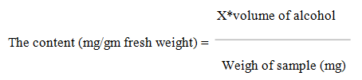

2.2. Anatomy

The anatomical features of four Populus samples leaves were investigated identification of the selected Populus specific according to hortus (1976) was carried out.
Sections of four Populus species leaves (Cut leaves from the top branches of developing studied species of the leaves number 3 to number 5) were stained by alcoholic safranin and light green as a counter stain dehydrated in alcohol-xylol series and finally mounted in Canada balsam. These sections after that, photographed by binocular phase contrast with built-in camera (zeiss model 2845). The microscopic descriptions of these sections were carried out according to Johanson (1940); O'brien and McCully (1981).

2.3. Protein
2.3.1. Leaf protein
SDS-polyacrylamide gel electrophoresis was performed in 12 % acrylamide slab gels following the system of Laemmli (1970) to identify their protein profiles.

2.3.2. Gel preparation
The following stock solutions were prepared:

2.3.2.1. Acrylamide stock solution (30 %)
The solution was prepared by dissolving 30 g acrylamide and 0.8 g N, N, methylene bis–acrylamide in about 70 ml distilled water, then the volume was completed to 100 ml by distilled water. The stock solution was kept at 4ºC.

2.3.2.2. Resolving gel buffer (1.5 M Tris-HCl, pH 8.8)
The buffer was prepared by dissolving 18.15 g Tris in 50 ml distilled water, shacked well with magnetic stirrer, and then pH was adjusted to 8.8. Then the volume was completed to 100 ml with distilled water and kept at 4°C.

2.3.2.3. Stacking gel buffer (0.5 M Tris-HCl, pH 6.8)
The buffer was prepared by dissolving 6.05 g Tris in 50 ml distilled water, shacked well with magnetic stirrer, and then pH was adjusted to pH 6.8. Then the volume was completed to 100 ml with distilled water and kept at 4°C.

2.3.2.4. Sodium dodecyl sulfate (SDS 10 %, W/V)
Stock solution was prepared by dissolving 10 g SDS in 70 ml distilled water. Then the solution was completed to 100 ml by distilled water. The solution was stored at room temperature.

2.3.2.5. Ammonium persulfate solution (APS 10 % W/V)
The solution was prepared by dissolving 1.0 g ammonium peresulfate in 10 ml distilled water. The solution is unstable and must be immediately prepared before use.

Table 1. Composition of separating and stacking gels.
Stock Solutions | 12% separating gel | 4% Stacking gel
Acrylamide | 40 ml | 2.6ml
Separating gel buffer | 25 ml | -
Stacking gel buffer | - | 5.0 ml
Distilled water | 33.5 ml | 12.2 ml
10 % SDS | 1.0 ml | 0.2 ml
10 % APS | 0. 5 ml | 0.1 ml
TEMED | 60 μl | 25 μl

2.3.3. Sample buffer
Reagents | staining | destaining
Commassie Brilliant blue R-250 | 1 gm | -
Methanol | 455 ml | 455 ml
Glacial acetic acid | 90 ml | 90 ml
Distilled water | 455 ml | 455 ml
This buffer was prepared by mixing the following components:
2.5 ml of 0.5 M Tris buffer (pH 6.8)
4 ml of 10 % SDS.
1 ml of 2 mercaptoethanol.
1 g of Sucrose.
1 ml Bromophenol blue (0.4 %).
Up to 10 ml by distilled water.

2.3.4. Extraction of leaf proteins
Protein extraction was conducted by mixing 0.4 g of four Populus species leaves (Cut leaves from the top branches of developing studied species of the leaves number 3 to number 5) with an equal weight of pure, clean, sterile fine sand.
The leaves were then ground to fine powder using a mortar and pestle and homogenized with 1 M Tris-HCl buffer, pH 6.8 in clean eppendorf tube and left in refrigerator overnight. Then centrifuged at 10.000 rpm for 10 min. The supernatant of each sample (contains protein extract) was kept in deep-freeze until use for electrophoretic analysis. Then boil for 5 minutes in water bath before loading in the gel.

2.3.5. Application of samples
A volume of 80 μl of the protein extract was loaded on the gels. Control wells were loaded with standard protein marker Medium range from 14.20 KDa to 66.00 KDa (Fermentas.Com).

2.3.6. Gel running and staining
Lower and upper buffer tanks were filled with the running buffer (electrode buffer). This buffer was prepared by adding 15.0 g Tris, 72.0 g glycine and 5g SDS to 1 liters distilled water and shacked well with magnetic stirrer. Then the volume was completed to 5 liter with distilled water and kept at 4ºC.
The polyacrylamide gels were fixed between the two tanks in a suitable position. The electrodes were connected to the power supply. The run was performed at 100 volt until the tracing dye (bromophenol blue) entered the separating gel. Then the voltage was increased to 200 volt until the bromophenol blue dye reached the bottom of the separating gel. Gels were removed from the apparatus and placed in plastic tanks, then covered with the staining solution. Gels were agitated gently overnight. The composition of the staining and distaining solutions was as following:
Then the staining solution was removed and the gels were covered with distaining solution. The distaining solution was changed several times until the gel background became clear.

2.3.7. Gel Analysis
Gels were photographed scanned, analyzed using Gel Doc Vilber Lourmat system.

3. Results and Discussion
3.1. Pigments
As shown in table (2) it is evident that P. alba exhibited the highest value of chlorophyll A where it was 1.373 mg/100g fresh weight (f.w) followed by P. nigra. 1.180mg/100g (f.w) then P.deltoides was the intermediate value 0.980mg/100g (f.w) while P. euroamericana cleared the lowest value of 0.758mg/100g (f.w).
It can be resulted that the used four Populus species cleared a significant differences in values of chlorophyll A.
In this respect the chlorophyll B content ranged between 0.994 mg/100g (f.w) and 0.695 mg /100g (f.w) where the highest value recorded by P. alba 0.994 mg/100g (f.w), followed by P. deltoides 0.813 mg/100g (f.w), then P. nigra was the intermediate by 0.713 mg/100g (f.w), while P. euroamericana cleared the lowest value of 0.695mg/100g (f.w).
It can be resulted that the used four Populus species cleared a significant differences in values of chlorophyll B. Where the carotenoids content ranged between 0.527 mg/100g (f.w) and 0.139 mg/100g the highest value 0.527 mg /100g (f.w) was recorded by P. alba, followed by P.nigra 0.361mg /100g (f.w), then P.deltoides was the intermediate by 0.236 mg/100g (f.w), the lowest value 0.139 mg/100g (f.w) was recorded in P. euroamericana. It can be resulted that the used four Populus species cleared a significant differences in values of carotenoids. The most striking difference between sun and shade leaves of the two species was observed for chlorophyll a &b. For P. tremuloides, shade leaves consistently had higher chlorophyll a/b whereas for P. balsamifera, sun leaves almost always had the higher chlorophyll a/b. Since previous studies have shown a tendency for chlorophyll a/b to decrease with decreasing light availability Oberbauer and Strain, (1986), Givnish, (1988) and Lei et al. (1996), our results for P. tremuloides are contrary to the norm.
So the chlorophyll A , B and carotenoids in P. alba was highest value and the chlorophyll A and B in P. euroamericana was lowest value this resulted cleared the significant differences among for four Populus species.

Table 2. determination of chlorophyll A,B and Carotenoids of Populus spp
Characters  Species | Chl. A. mg/100g | Chl. B. mg/100g | Carotenoids mg/100g
P. nigra | 1.180 B | 0.713 C | 0.361 B
P. alba | 1.373 A | 0.994 A | 0.527 A
P. euroamericana | 0.758 D | 0.695 D | 0.139 D
P. deltoides | 0.980 C | 0.813 B | 0.236 C
The values have the same letter in all characters are not significant different at 0.05 probability level according to Duncan's Multiple Range Test.

3.2. Anatomy
3.2.1. Populus nigra
Stricture of leaf
A transverse section shown in fig (1-A) reveal that the upper epidermis as well as the lower one composed of a single layer of nearly compactly arranged rectangular cells. The outer walls are cutinised and possess thin cuticle. Stomata occur on both sides of the leaf and trichomes are not observed.
Leaves are distinctly dorsiventral where the mesophyll is differentiated into columnar palisade parenchyma on the adaxial side and irregular sporngy parenchyma on the abaxial side. The palisade tissue consists of two layers of chlorenchyma cells which elongated perpendicularly to the surface of the blade and occupies one-half of the whole thickness of the mesophyll. The spongy tissue is composed of two to three layers of chlorenchymatous loosely arranged cells with many wide intercellular spaces.
The midrib is rounded at both adaxial and abaxial surfaces of the leaf. Collenchymas is present in the vein rib, on both sides of the vein beneath the epidermis. There is a large collateral vascular bundle which is oriented with the xylem directed towards the adaxial surface and the phloem towards the abaxial one in crescent shape around the xylem. Xylem consists of vessels arranged in radial rows which embedded in lignified parenchyma cells. Moreover, at the end of xylem tissue toward the adaxial surface of the leaf , there are two small vascular bundles with phloem directed toward the adaxial side, each of them surrounded by fibre sheath which being in conection with main bundle sheath that surrounded the main vascular bundle of the midrib.

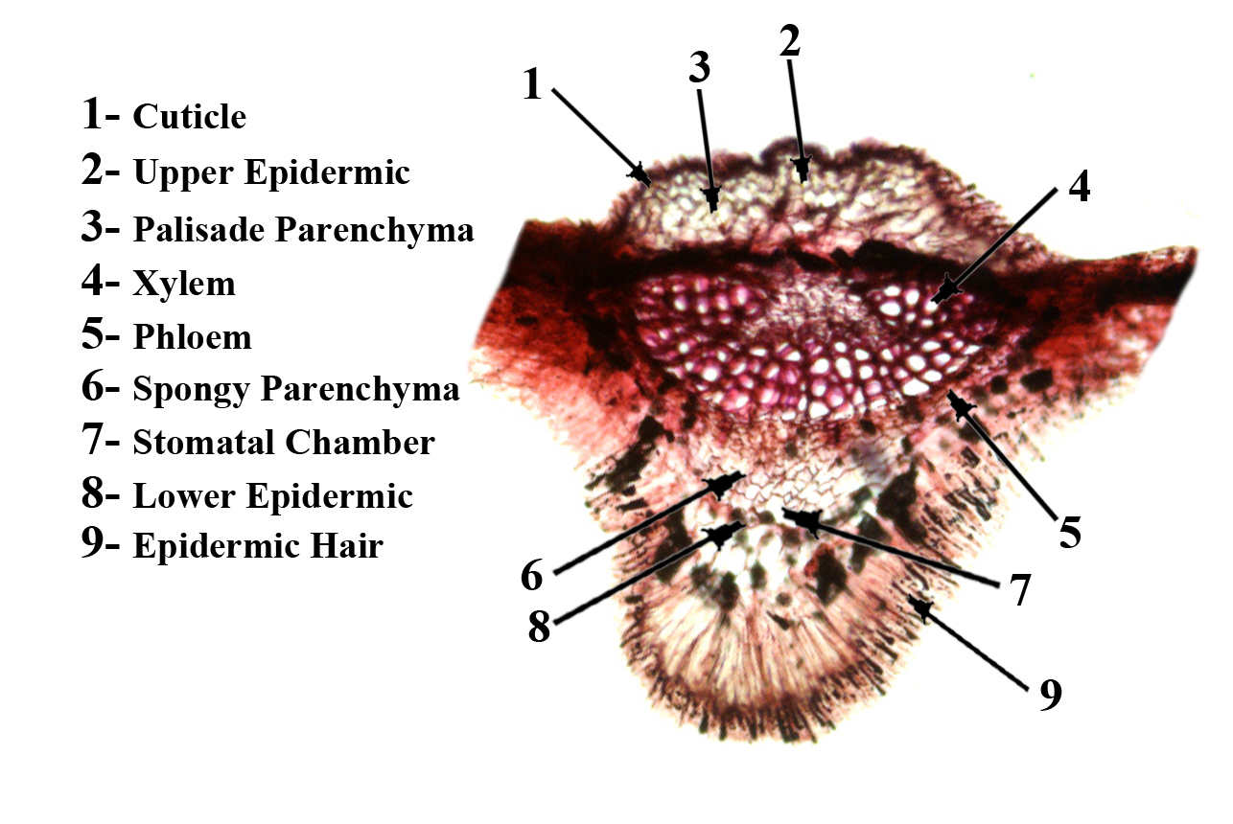

Figure 1-A. Transverse section through a leaf blade of P. nigra.

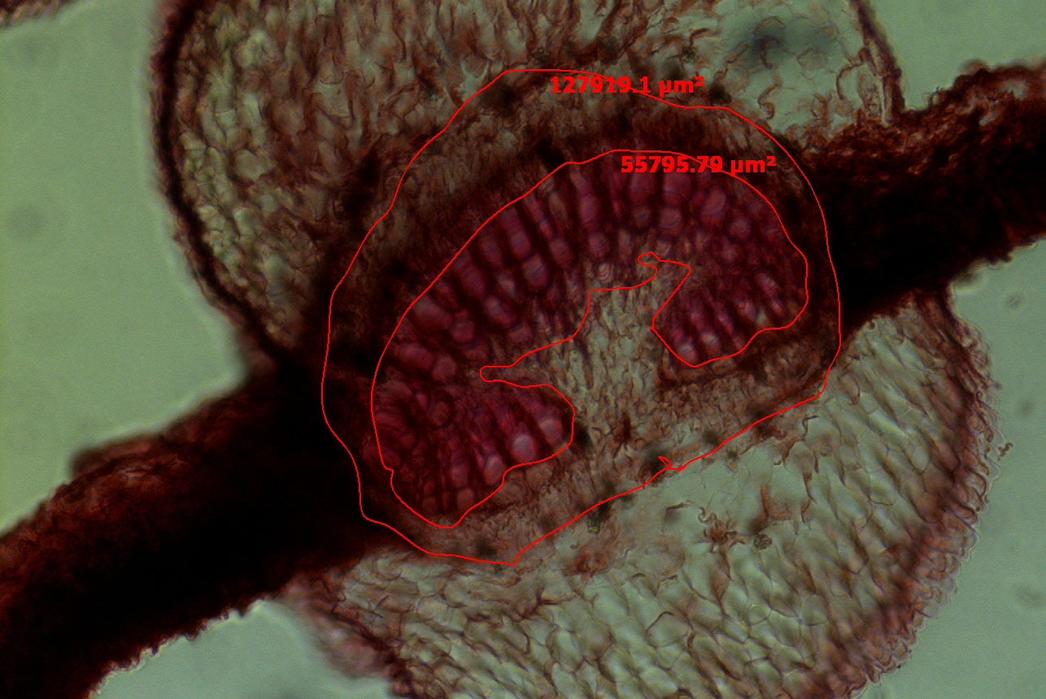

Figure 1-B. Transverse section through a leaf blade of P. nigra with determined the area.

The previous report of Metcalfe and Chalk (1950) indicated that leaves of the genus Populus are usually dorsiventral, but isobilateral structure was recorded in P. nigra, being in contradiction with the present findings. Such contradiction could be attributed to the variation in climatic condition between Europe and Egypt, Faten et al., (2000).

3.2.2. Populus alba
Stricture of leaf
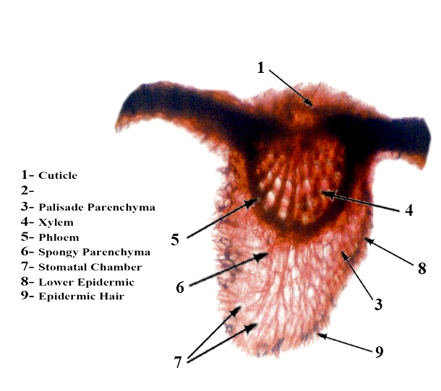
Transverse section through a leaf blade of P. alba were examined. A microphotograph illustrating blade structure is shown in Fig. (2-A). The upper epidermis is uniseriate, composed of a row of compactly-set tabular large cells, the outer walls are distinctly cutinised and possess relatively thick cuticle. The lower epidermis is also uniseriate, the epidermal cells are small in size and free from cuticle as compared with the uppe ones. Unicellular simple hairs are present only on the abexial surface.
Mesophyll is differentiated into columnar palisade parenchyma on the adaxial side and irregular sporngy parenchyma on the abaxial side. The means that the leaf is distinctly dorsiventral. The palisade tissue consists of two layers of chlorenchyma cells which occupies 65% of the whole thickness of the mesophyll.

Figure 2-A. Transverse section through a leaf blade of P. alba.

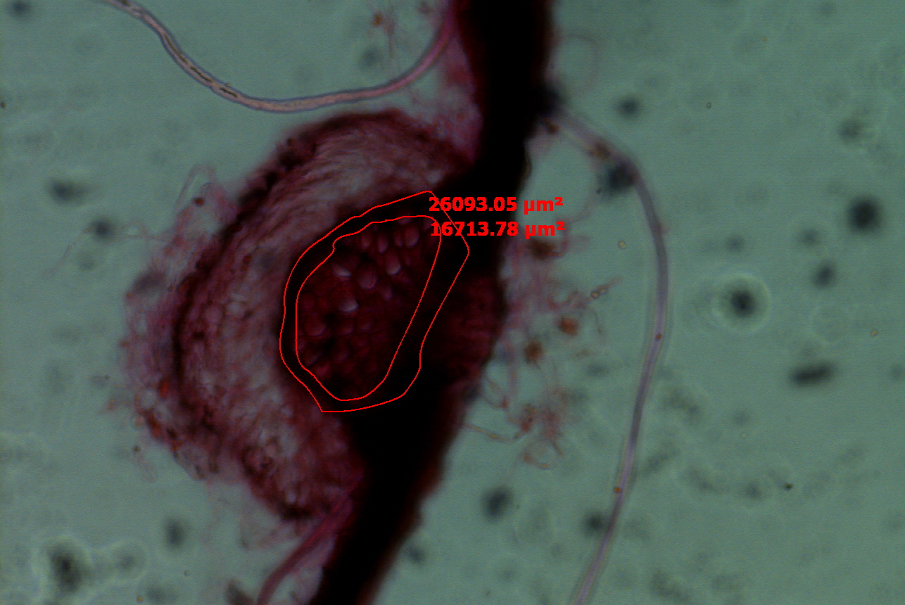

Figure 2-B. Transverse section through a leaf blade of P. alba with determined the area.

The midrib is slightly convex at adaxial surface and being strongly rounded at abaxial one. Collenchymas is present in the vein rib, on both sides of the vein beneath the epidermis. The vascular bundle of the midrib is larger in size and oriented with the xylem directed towards the adaxial surface and the phloem towards the abaxial one. The bundle is surrounded by a sheath of two to three layers of well-developed lignified fibre cells.
As far as the authors are aware no detailed study dealing with anatomical structure of vegetative organs of P. alba was carried out. However, Metcalfe and Chlk (1950) stated that leaf is usually dorsiventral. Faten et al. (2000).

3.2.3. Populus euroamericana
Stricture of leaf
A transverse section shown in fig (3-A) reveal that the upper epidermis as well as the lower one composed of a single layer of nearly compactly arranged rectangular cells. The outer walls are cutinized and possess thin cuticle. Stomata occur on both sides of the leaf.
The mesophyll is differentiated into columnar palisade parenchyma on the adaxial side and irregular sporngy parenchyma on the abaxial side. The palisade tissue consists of three layers of chlorenchyma cells which elongated perpendicularly to the surface of the blade and occupies one-half of the whole thickness of the mesophyll. The spongy tissue is composed of two to three layers of chlorenchymatous loosely arranged cells with many wide intercellular spaces.
The midrib is rounded at both adaxial and abaxial surfaces of the leaf. Collenchymas are present in the vein rib, on both sides of the vein beneath the epidermis. There is a large collateral vascular bundle which is oriented with the xylem directed towards the adaxial surface and the phloem towards the abaxial one in crescent shape around the xylem. Xylem consists of vessels arranged in radial rows which embedded in lignified parenchyma cells. Moreover, at the end of xylem tissue toward the adaxial surface of the leaf, there are two small vascular bundles with phloem directed toward the adaxial side; each of them surrounded by fibre sheath which being in conection with main bundle sheath that surrounded the main vascular bundle of the midrib.
The previous report of Metcalfe and Chalk (1950) indicated that leaves of the genus Populus are usually dorsiventral, but isobilateral structure was recorded in P. euroamericana, being in contradiction with the present findings.

3.2.4. Populus deltoides
Stricture of leaf
The anatomical structure of leaf blade representing P. deltoides was investigated through transverse section shown in fig (4-A) reveal that the upper epidermis as well as the lower one composed of a single layer of nearly compactly arranged rectangular cells. Stomata frequently present on both sides of the leaf and trichomes are absent. The mesophyll is relatively homogeneous where the palisade tissue occurs on both sides of the leaf. Therefore, the leaf is distinctly isobilateral.
At the midrib region, both upper and lower epidermis are convex; i.e. the midrib is rounded at both adaxial and abaxial surfaces of the leaf. The vascular bundle of midrib consisting of central xylem enclosing some pith. The xylem being surrounded by a nearly heart shaped phloem; i.e., the two kinds of vascular tissues occur in a collateral arrangement with the phloem located outside the xylem. A nearly continuous cylinder consists of about two to three layers of well lignified fibres occur on the periphery of phloem.
The previous report of Faten et al. (2000) indicated that leaves of the genus Populus are usually dorsiventral, but isobilateral structure was recorded in P. deltoides, being in contradiction with the present findings.

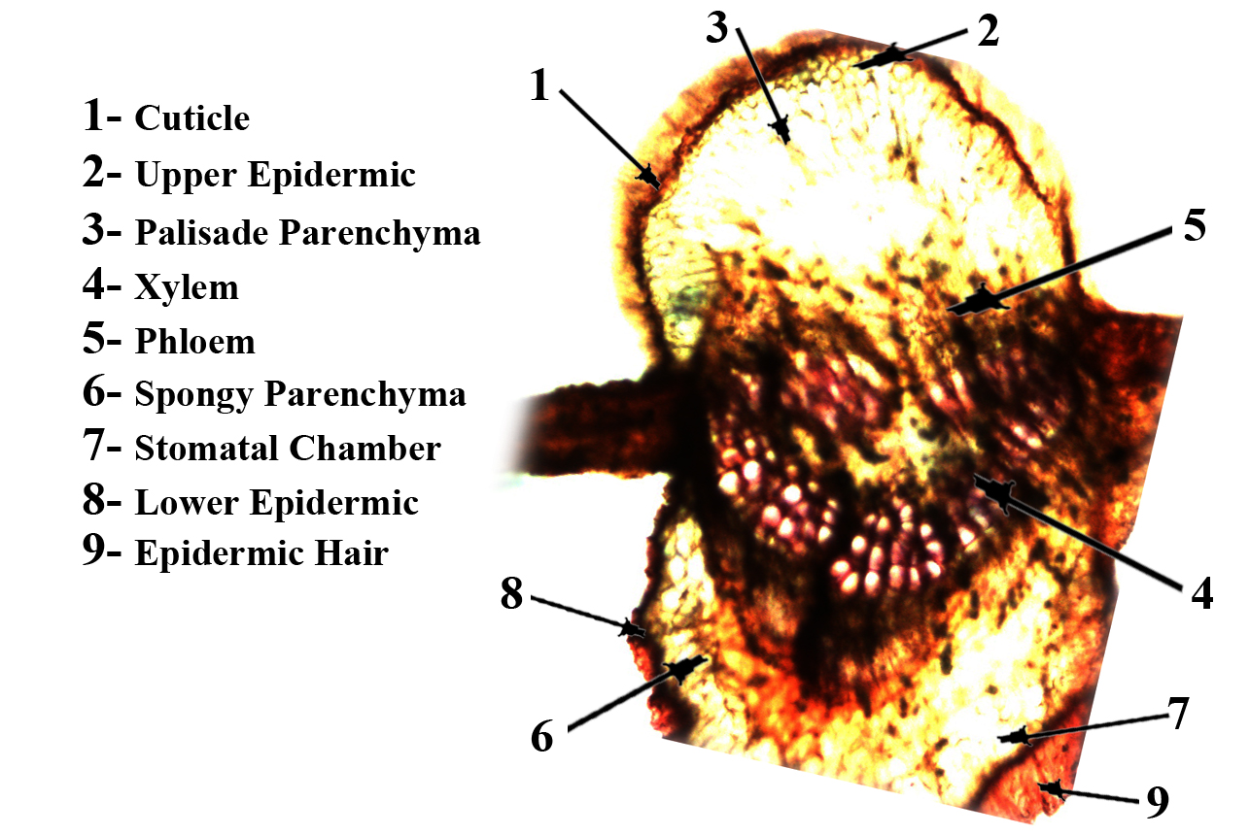

Figure 3-A.Transverse section through a leaf blade of P. euroamericana

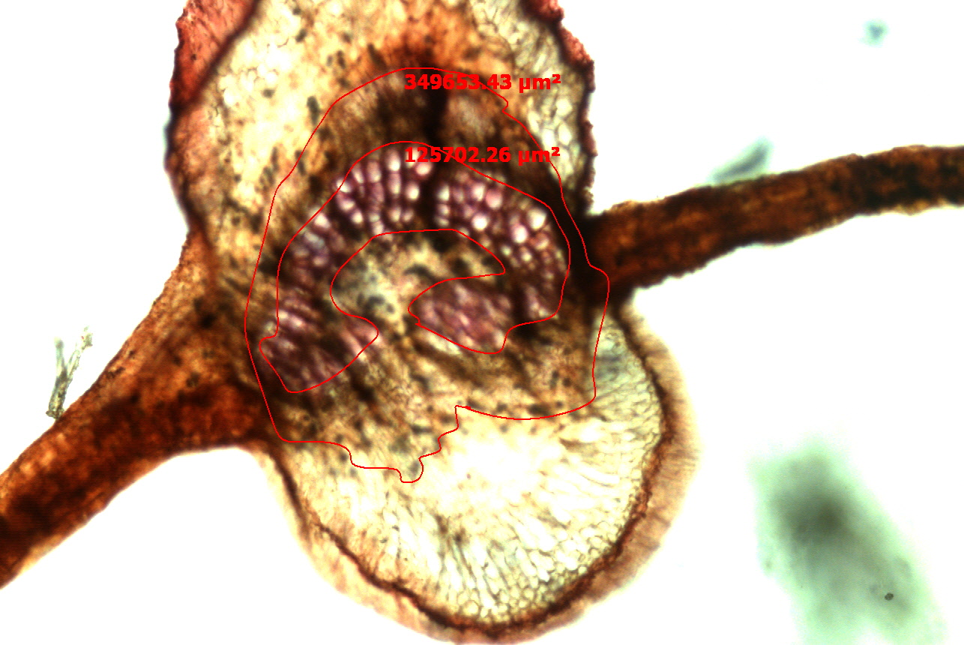

Figure 3-B. Transverse section through a leaf blade of P. euroamericana with determined the area.

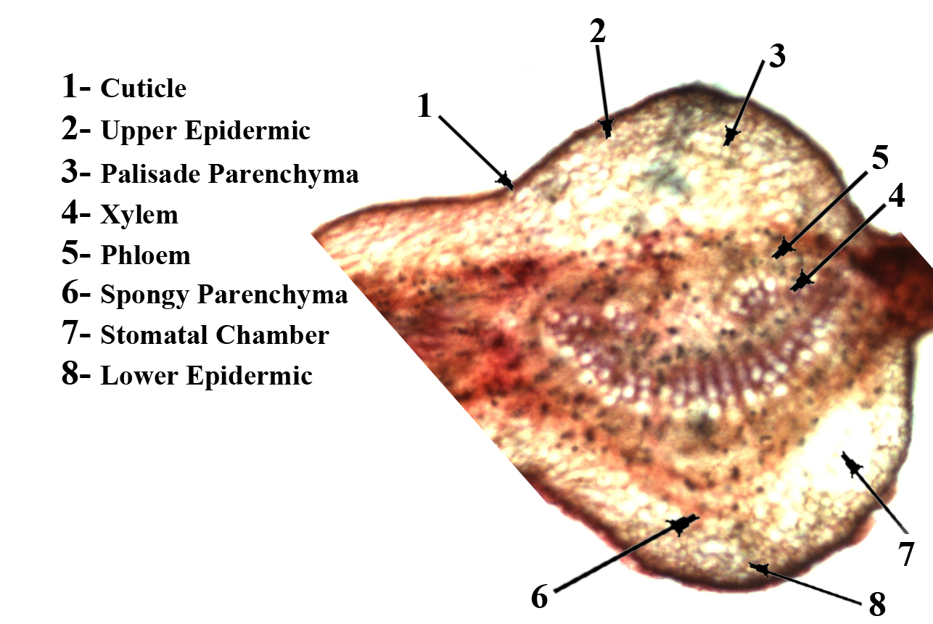

Figure 4-A.Transverse section through a leaf blade of P. deltoids.

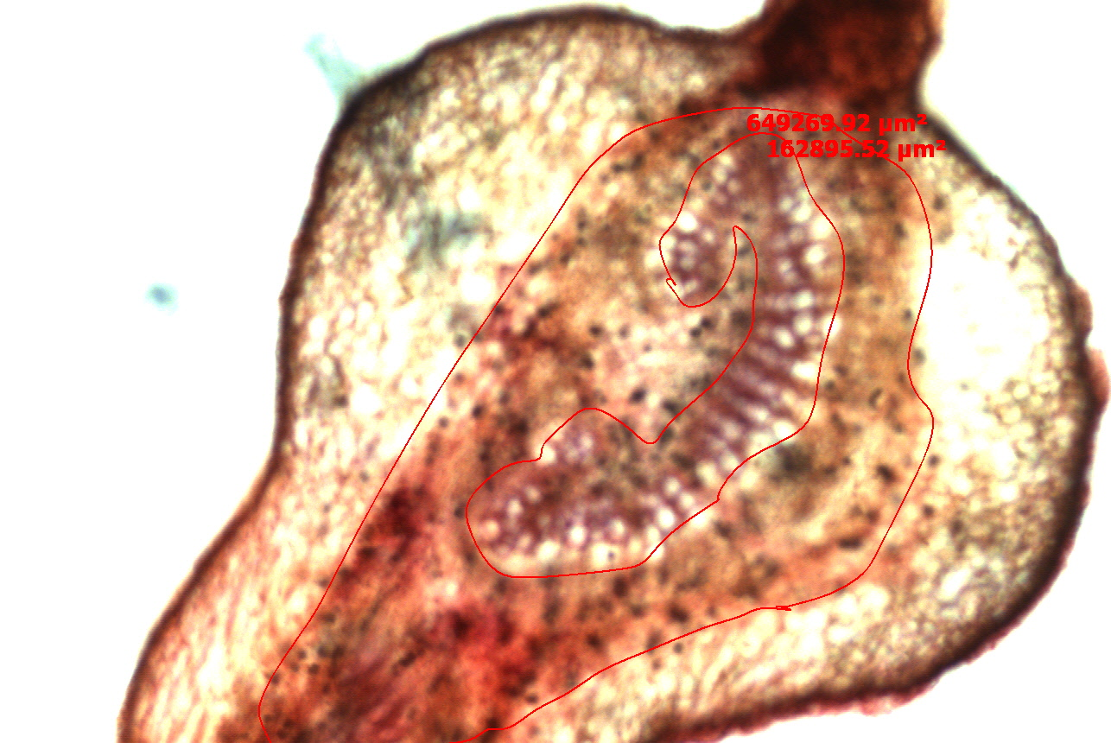

Figure 4-B. Transverse section through a leaf blade of P. deltoides with determined the area.

The area of vascular bundles and xylem was differencing between all species as in table (3) and Figs. (1,2,3,4-B).
Regarding the area of vascular bundles it can be observed from the results of table (3) that P. deltoides induced the maximum area (649259.9 µm²) followed by P. euroamericana which gave the area of (349653.4 µm²), while P. nigra deduced the intermediate area (127919.1 µm²), then P. alba had the lowest one in average value of (26093.05 µm² ).
The area of xylem differed among the four species of Populus where P. deltoides recorded the highest value of (162895.5 µm²), followed by P. euroamericana which gave the area of (125702.3 µm²), while those P. nigra resulted the intermediate area in average value of (55795.79 µm²), and the late one was where value of (16713.78 µm²).
The previous obtained results from the table (3) obviously cleared that the area of vascular bundles and xylem were the majority in P. deltoides comparing with those obtained from the other species, where P. euroamericana have been the middle area, then P. nigra, after that P. alba was the later in arrangement.

Table 3. Area of vascular bundles & area of xylem for four species of Populus.

Area of xylem | Area of vascular bundles | Characters  Species
55795.79 µm² C | 127919.1 µm² C | P. nigra
16713.78 µm² D | 26093.05 µm² D | P. alba
125702.3 µm² B | 349653.4 µm² B | P. euroamericana
162895.5 µm² A | 649259.9 µm² A | P. deltoides
The values have the same letter in all characters are not significant different at 0.05 probability level according to Duncan's Multiple Range Test.

3.3. Protein
3.3.1. Genetic diversity using SDS-PAGE
The electropherogram of the leaves collected from four Populus plant, in different species, exhibited the presence of 13 protein bands with molecular weight ranged between 12.5 – 104 KDa.
The protein bands of four species for Populus plant were varied in number and density of bands. The variability analysis of four species showed some polypeptides bands absent or/and present in some species (7 polymorphic band number & M.Wt (KDa) of it (‹4,65› ,‹6,60› ,‹7,52› ‹9,43› ,‹10,32›, ‹11,28› and ‹12,22›) with percentage 53.8%. Since 1 polymorphic band was recorded in both P. nigra and P. deltoides number 4 with M.Wt 65 KDa. Also, 4 polymorphic bands were recorded in P. nigra, P. euroamericana and P. deltoides with number and M.Wt (KDa) (‹6,60›, ‹7,52›, ‹9,43› and ‹10,32›). As well as, 2 bands were recorded where one band in P. alba, P. euroamericana and P. deltoides with M.Wt 28 (KDa) number 11 and the other band in both P. euroamericana and P. deltoides with M.Wt 22 (KDa) number 12. Results in table (4) and Fig. (5) revealed that, Populus species characterized by the presence of 6 monomorphic common polypeptide bands with number and M.Wt (KDa) (‹1,104›, ‹2,87›, ‹3,76›, ‹5,63›, ‹8,47› and ‹13,12.5›) with percentage 46.2%. The aforementioned result demonstrated that there were an adverse in molecular weight and number for the used four Populus species since Populus exhibited.
Genetic distance was measured as the difference revealed among of four Populus species. Since the highest genetic distance was detected between P. alba and P. nigra as well as between P. deltoides and P. alba which represent 0.2449, followed by genetic distance between P. alba and P. euroamericana which represent 0.2236, then genetic distance between P. nigra and P. euroamericana intermediate when recorded 0.1732, also genetic distance between P. nigra and P.deltoide which recorded 0.1414. On the other hand, the lowest distance was 0.1000 between P. deltoides and P. euroamericana. The obtained results showed that, there’s a great variation between four Populus species in genetic content (Table 5).
Also, Genetic similarity ranged between 66% and 96% where P. deltoides and P. euroamericana represent 96%. Similarity matrix shows that there’s a great variation between P. alba sample with P. nigra, P. euroamericana and P. deltoides samples since the similarity was 66, 73 and 70% respectively (Fig. 6).
The result which being compatible with the obtained result by RAPD analysis, since the integration between results may be regarded to the fact that, protein molecules are directly coded by genes as indicated by Stegmann et al. (1980).

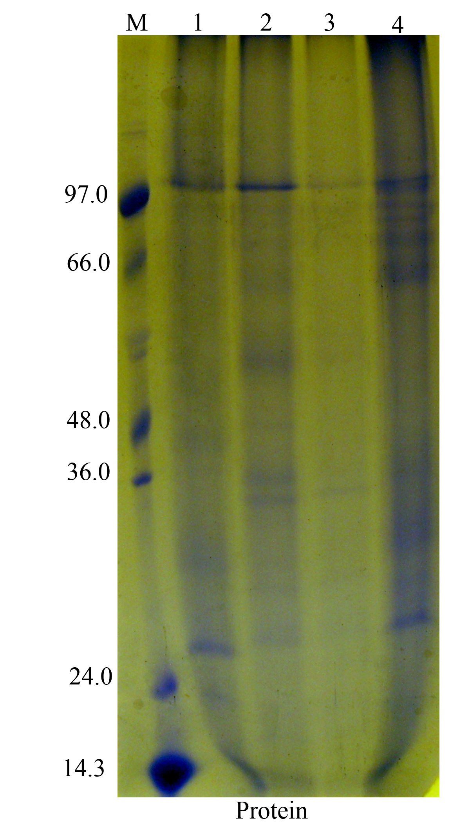

Figure 5. SDS-PAGE protein patterns of four Populus species. Lane M: Protein marker, Lanes 1 to 4: 1- P. nigra,2- P. alba,3- P. euroamericana, and 4- P. deltoides.

Table 4. Scoring sheet of protein bands in the electrophoregram of the studied Populus species.

Band No. | M.Wt | P. nigra | P. alba | P. euroamericana | P. deltoides | Polymorphism
Band No. | M.Wt | Band score | Band score | Band score | Band score | Polymorphism
1 | 104 | 1 | 1 | 1 | 1 | Monomorphic
2 | 87 | 1 | 1 | 1 | 1 | Monomorphic
3 | 76 | 1 | 1 | 1 | 1 | Monomorphic
4 | 65 | 1 | 0 | 0 | 1 | Polymorphic
5 | 63 | 1 | 1 | 1 | 1 | Monomorphic
6 | 60 | 1 | 0 | 1 | 1 | Polymorphic
7 | 52 | 1 | 0 | 1 | 1 | Polymorphic
8 | 47 | 1 | 1 | 1 | 1 | Monomorphic
9 | 43 | 1 | 0 | 1 | 1 | Polymorphic
10 | 32 | 1 | 0 | 1 | 1 | Polymorphic
11 | 28 | 0 | 1 | 1 | 1 | Polymorphic
12 | 22 | 0 | 0 | 1 | 1 | Polymorphic
13 | 12.5 | 1 | 1 | 1 | 1 | Monomorphic
Total band score |  | 11C | 7D | 12B | 13A

Table 5. Genetic distance between different samples detected by qualitative of the protein pattern of four Populus species.
species | P. nigra | P. alba | P. euroamericana | P. deltoides
P. nigra | 0
P. alba | 0.2449 | 0
P. euroamericana | 0.1732 | 0.2236 | 0
P. deltoides | 0.1414 | 0.2449 | 0.1000 | 0

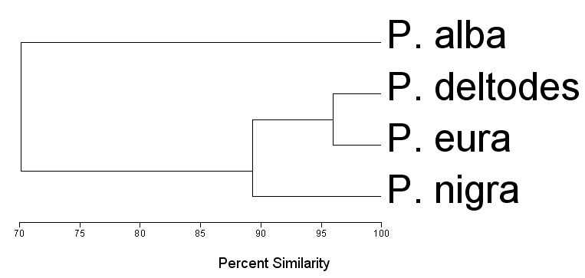

Figure 6. Dendrogram obtained by cluster analysis based on presence/absence matrix for protein.

Correspondence to:
I.M.M. Barakat
Department of Botany and Microbiology
Faculty of Science, Al-Azhar University
Emails: baracat.potany@yahoo.com

References
- Afolayan, A. J. & Meyer, J. J., 1995: Morphology and ultrastructure of secreting and insecreting foliar trichomes of Helichrysum aureonitens (Asteraceae). -Int. J. Plant Sci., 156 (4): 481- 487.
- Aki, T., Shigyo, M., Nakano, R., Yoneyama, T., Yanagisawa, S., 2008. Nano scale proteomics revealed the presence of regulatory proteins including three FT-like proteins in phloem and xylem saps from rice. Plant Cell Physiol. 49, 767–790 Alberdi M, Corcuera L J. Cold acclimation in plants. Phytochemistry. 1991; 30:3177–84.
- Alvarez, S., Goodger, J.Q.D., Marsh, E.L., Chen, S.X., Asirvatham, V.S., Schachtman, D.P., 2006. Characterization of the maize xylem sap proteome. J. Proteome Res. 5, 963–972.
- Alvarez, S., Marsh, E.L., Schroeder, S.G., Schachtman, D.P., 2008. Metabolomic and proteomic changes in the xylem sap of maize under drought. Plant Cell Environ. 31, 325–340.
- Azuma, T., Kajita, T., Yokoyama, J. & Ohashi, H., 2000: Phylogenetic relationships of Salix (Salicaceae) Based on RBCL sequence data. -Am. %RW±
- Biles, C.L., Abeles, F.B., 1991. Xylem sap proteins. Plant Physiol. 96, 597–601.
- Bücker J., Ballach H.J. 1992. Alterations in carbohydrate levels in leaves of Populus due to ambient air pollution. Physiologia Plantarum 86: 512–517.
- Buhtz, A., Kolasa, A., Arlt, K., Walz, C., Kehr, J., 2004. Xylem sap protein composition is conserved among different plant species. Planta 219, 610–618.
- Chalker-Scott L., 1999. Environmental significance of anthocyanins in plant stress responses. Photochemistry and Photobiology 70: 1–9.
- Cirelli, D., Jagels, R., Tyree, M.T., 2008. Toward an improved model of maple sap exudation: the location and role of osmotic barriers in sugar maple, butternut and white birch. Tree Physiol. 28, 1145–1155.
- Cutler, D. F., 1984: Systematic Anatomy and Embryology-Recent Developments: In V. H. Heywood & D. N. Moore Current Concepts in Plant Taxonomy, 108-125. -Academic Press, London, U. K.
- Dickson, R.E., 1979. Xylem translocation of amino-acids from roots to shoots in cottonwood plants. Can. J. Forest Res. 9, 374–378.
- Djordjevic, M.A., Oakes, M., Li, D.X., Hwang, C.H., Hocart, C.H., Gresshoff, P.M., 2007. The Glycine max xylem sap and apoplast proteome. J. Proteome Res. 6, 3771– 3779.
- Escher, P., Eiblmeier, M., Hetzger, I., Rennenberg, H., 2004. Seasonal and spatial variation of carbohydrates in mistletoes (Viscum album) and the xylem sap of its hosts (Populus x euamericana and Abies alba). Physiol. Plant 120, 212–219.
- Faten M. REda , Magida C. Ibrahim and Mona A. Darwish (2000). Botanical studies on some Populus species in Egypt. J. Agric. Res ., Tanta Univ., 26(2):242-261.
- Givnish, T. J. 1988. Adapatations to sun and shade: A whole-plant perspective. In Ecology of Photosynthesis in Sun and Shade; Evans, J. R.; von Caemmerer, S.; Adams III, W. W., (Eds.); (CSIRO: Australia, pp. 63-92,.
- Hickey, L. J., 1973. Classification of the architecture of dicotyledonous leaves. -$ P %RW±
- Hortus third 1976: acncise dictionary of plants cultivated in the United States and Canada.
- Johanson d a 1940. Plant microtechnique (ed 2) tata mcgraw hill publishing co ltd Bombay naw delhi.
- Kehr, J., Buhtz, A., Giavalisco, P., 2005. Analysis of xylem sap proteins from Brassica napus. BMC Plant Biol. 5, 11.
- Laemmli, U. K. (1970). Cleavage of structural proteins during the assembly of the head of bacteriophage T4. Nature, 227: 680-685.
- Lei, T. T.; Tabuchi, R.; Kitao, M.; Koike, T. 1996. Functional relationship between chlorophyll content and leaf reflectance, and light-capturing efficiency of Japanese forest species. Physiol. Planta. 96, 411-418.
- Lichtenthaler H.K., Rinderle U. 1988. The role of chlorophyll fluorescence in the detection of stress conditions in plants. Critical Reviews in Analytical Chemistry 19: 29–85.
- Linnaeus, C. 1753: Salix in Species Plantarum vol. 2: ± + ROP LDH
- Lopez-Millan, A.F., Morales, F., Abadia, A., Abadia, J., 2000. Effects of iron deficiency on the composition of the leaf apoplastic fluid and xylem sap in sugar beet. Implications for iron and carbon transport. Plant Physiol. 124, 873–884.
- Metcalfe, C. R. & L. Chalk 1950: Anatomy of the Dicotyledons, Vol.1, Oxford University Press, London., P. 1315-1320.
- Metcalfe, C. R. & Chalk, L., 1957: Anatomy of the Dycotyledons, 2: 1041-1053. -Clarendon Press, Oxford.
- Mol J., Jenkins G., Schafer E. & Weiss D. 1996 Signal perception, transduction and gene expression involved in anthocyanin biosynthesis. Critical Reviews in Plant Science 15: 525–557.
- Oberbauer, S. F. and Strain, B. R. 1986. Effects of canopy position and irradiance on the leaf physiology and morphology of Pentaclethra macroloba (Mimosaceae). Am. J. Bot. 73, 409-416
- O'brien, T.P. and McCully M.E. 1981. the study of plant structure principles and selected methods Blackwell Scientific publications.
- Rep, M., Dekker, H.L., Vossen, J.H., de Boer, A.D., Houterman, P.M., Speijer, D., Back, J.W., de Koster, C.G., Cornelissen, B.J.C., 2002. Mass spectrometric identification of isoforms of PR proteins in xylem sap of fungus-infected tomato. Plant Physiol. 130, 904–917.
- Rep, M., Dekker, H.L., Vossen, J.H., de Boer, A.D., Houterman, P.M., de Koster, C.G., Cornelissen, B.J.C., 2003. A tomato xylem sap protein represents a new family of small cysteine-rich proteins with structural similarity to lipid transfer proteins. FEBS Lett. 534, 82–86.
- Saric, M., Kastrori, R., Curie, R., Cupina, T. and Gerie, I. 1976. Chlorophyll determination. Univ. Unoven Sadu Parktikum is fiziologize Bibjoke, Beagard, Hauncna, Anjig, pp. 215.
- Satoh, S., Iizuka, C., Kikuchi, A., Nakamura, N., Fujii, T., 1992. Proteins and carbohydrates in xylem sap from squash root. Plant Cell Physiol. 33, 841–847.
- Satoh, S., 2006. Organic substances in xylem sap delivered to above-ground organs by the roots. J. Plant Res. 119, 179–187.
- Stegemann, H., A. M. R. Afifiy and K. R. F. Hussein 1985. Cultivar identification of dates (Phoenix dactylifera ) by protein patterns. 2nd International Symposium of Biochemical Approaches to Identification of Cultivers. Braunschweig, I. Forestre-Research, 10 (2):95-98.
- Turner, S., Gallois, P., Brown, D., 2007. Tracheary element differentiation. Ann. Rev. Plant Biol. 58, 407–433.
- Tuskan, G.A., DiFazio, S., Jansson, S., Bohlmann, J., Grigoriev, I., Hellsten, U., Putnam, N., Ralph, S., Rombauts, S., Salamov, A., Schein, J., Sterck, L., Aerts, A., Bhalerao, R.R., Bhalerao, R.P., Blaudez, D., Boerjan, W., Brun, A., Brunner, A., Busov, V., Campbell, M., Carlson, J., Chalot, M., Chapman, J., Chen, G.L., Cooper, D., Coutinho, P.M., Couturier, J., Covert, S., Cronk, Q., Cunningham, R., Davis, J., Degroeve, S., Dejardin, A., Depamphilis, C., Detter, J., Dirks, B., Dubchak, I., Duplessis, S., Ehlting, J., Ellis, B., Gendler, K., Goodstein, D., Gribskov, M., Grimwood, J., Groover, A., Gunter, L., Hamberger, B., Heinze, B., Helariutta, Y., Henrissat, B., Holligan, D., Holt, R., Huang, W., Islam-Faridi, N., Jones, S., Jones- Rhoades, M., Jorgensen, R., Joshi, C., Kangasjarvi, J., Karlsson, J., Kelleher, C., Kirkpatrick, R., Kirst, M., Kohler, A., Kalluri, U., Larimer, F., Leebens-Mack, J., Leple, J.C., Locascio, P., Lou, Y., Lucas, S., Martin, F., Montanini, B., Napoli, C., Nelson, D.R., Nelson, C., Nieminen, K., Nilsson, O., Pereda, V., Peter, G., Philippe, R., Pilate, G., Poliakov, A., Razumovskaya, J., Richardson, P., Rinaldi, C., Ritland, K., Rouze, P., Ryaboy, D., Schmutz, J., Schrader, J., Segerman, B., Shin, H., Siddiqui, A., Sterky, F., Terry, A., Tsai, C.J., Uberbacher, E., Unneberg, P., Vahala, J., Wall, K., Wessler, S., Yang, G., Yin, T., Douglas, C., Marra, M., Sandberg, G., Van de Peer, Y., Rokhsar, D., 2006. The genome of black cottonwood, Populus trichocarpa (Torr. and Gray). Science 313, 1596–1604.
- Van Loon, L.C., Rep, M., Pieterse, C.M.J., 2006. Significance of inducible defenserelated proteins in infected plants. Ann. Rev. Phytopathol. 44, 135–162.

3/13/2012

