Application of GIS best path algorithm in Harbin Roads

Sui Min, *Wang Wei-fang

College of Forestry, Northeast Forestry University, Harbin, Heilongjiang 150040, China
*Corresponding author. E-mail: weifangwang@126.com

Abstract: Using Harbin traffic road picture as the base map, we established a complete spatial databases of roads and surface features in Harbin, completed the spatial database and attribute database connection. From the actual situation of GIS network shortest path algorithm and the achievement of Dijkstra algorithm search technology, we used VB language based on MapX for secondary development and to complete the realization and application of the best path Dijkstra optimization algorithm in Harbin roads.
[Sui Min, Wang Wei-fang. Application of GIS best path algorithm in Harbin Roads. World Rural Observations 2012;4(1):86-90]. ISSN: 1944-6543 (Print); ISSN: 1944-6551 (Online). http://www.sciencepub.net/rural. 15

Key words: The shortest path; Dijkstra algorithm; MapX

1 Introduction
In recent years, with the development of urban-scale, urban area expands gradually, transport system becomes more complicated, and frequency of people’s activities increases, traffic network in modern life plays a more and more important role. So, how to find a shortest path in complex urban traffic roads to reach the destination quickly is an important issue to solve urban traffic problems. The shortest path problem is a classic topic in graph theory research, a map can analyze traffic problems, and then people can use the shortest path method to calculate the shortest distance, the lowest cost and the shortest time between two places.
As one of the main functions of geographic information system, network analysis plays an important role in electronic navigation, traffic tourism, urban planning, electric power, communication and other designs of pipe network and layout. In network analysis, the most fundamental and the most critical problem is the shortest path problem. The shortest path means not only the shortest distance in general geographical sense, but also can be extended to other measures, such as time, cost and line capacity. In practice, the shortest path problem is usually used in car navigation system and other kinds of emergency systems (such as 110, fire alarm and medical emergency system); these systems often need to calculate the shortest path. In fact, the core algorithm of the shortest distance, the fastest time and the lowest cost is the shortest path algorithm^{[1]}.

2 Data Collection and Processing
In this paper, we use classic Dijkstra algorithm as principle, according to the shortest path method and the characteristics of urban road network combined with geographic information system theories, analyze connected relation among roads based on MapX by VisualBasic. Through the research validation, we can implement the shortest path inquiry in urban traffic, and conclude the feasibility of the algorithm. It has very important significance for inquiry and analyze shortest path in city traffic road, and provides services for community.
MapX is a tool for application developers, it provides the most relaxed and most efficient way to embed drawing function in new and existing applications. MapX is a DLL, it can use object-oriented language to integrate the client applications rapidly, such as Visual Basic, Delphi, Visual C++ and other languages. Using MapX, developers can choose the most familiar development language for them to add map function to any application system quickly and easily, thus, can enhance spatial analysis ability of the systems and achieve the value-added of system applications^{[2]}.

2.1 Data Preprocessing
This paper uses Harbin urban roads map combined with building designs and photographs as primary data. Spatial data include coordinates of each building, plane area, names and lengths of roads. The data can be storage as need forms according to the point layer, line layer and polygon layer. And then the data can be easily accessed, inquired, analyzed and managed by MapX in Visual Basic environment. From the actual situation of GIS network shortest path algorithm and achievement of Dijkstra algorithm search technology, based on MapX and network topology establishment, we can ultimately achieve the application of Dijkstra shortest path algorithm in urban traffic roads.

2.2 Spatial Database Establishment
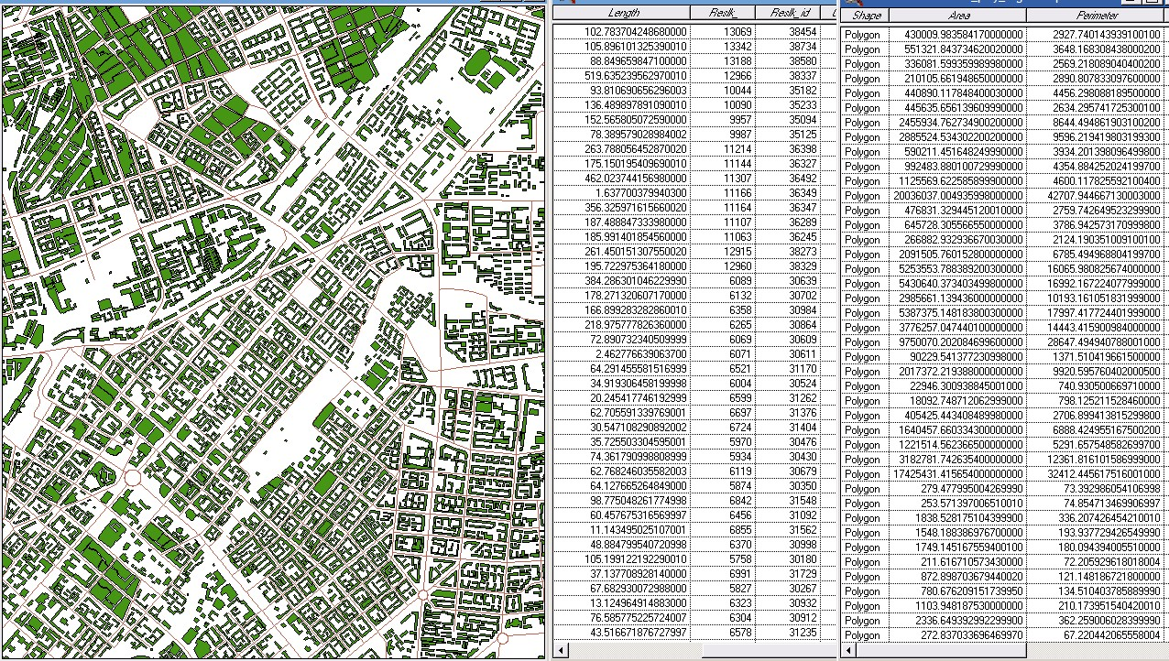
Use the picture of Harbin urban roads as the base map, we can do vectorization of roads and other surface features, generate the vector files of main features and roads, establish spatial databases, and do the best path analysis based on these. After finishing roads vectorization, we should calculate the length of each road in the property sheet. While doing the polygon feature vectorization, we enter its name in the property sheet whenever we complete a polygon feature vectorization, and then finish the connection of graphic data and attribute data (Figure 1):

Figure 1 the connection of graphic data and attribute data

3 Best Path Algorithm Analysis
3.1 Summary of the Dijkstra Algorithm
According to statistics, there are 17 kinds of shortest path algorithms currently. F. Benjamin Zhan et al tested 15 of them, the result showed that three of them were better. They are: TQQ (graph growth with two queues), DKA (the Dijkstra's algorithm implemented with approximate buckets), DKD (the Dijkstra’s algorithm implemented with double buckets). Figure Growth theory is the basis of TQQ algorithm. And this algorithm is more suitable to calculate the shortest distance from single-source point to other points. The latter two algorithms based on Dijkstra algorithm, are more suitable to calculate the shortest path between two points. Overall, due to the development level of computer hardware, space storage problem stands a very important position. In order to achieve space saving at the expense of time efficiency, these algorithms development speed will be limited. Currently, the problem of space storage has been resolved. Based on Dijkstra algorithm, many scholars from different countries have completed the shortest path algorithm on different platforms^{[3]}.
The traditionally accepted shortest path algorithm is Dijkstra algorithm, it is raised by Holland famous computer scientist Edsger Wybe Dijkstra, and it can be used to find out the shortest distance from specified node to other nodes. The main idea is that we calculate the shortest path from the source point, and then through the path length iteration to obtain the shortest path from source point to other target node ^{[4]}.

3.2 Algorithm Steps
The Dijkstra algorithm is used to calculate the shortest path from one node to other nodes, its main characteristic is that make starting point as the center and extends to the outer, until to the end point^{[5]}.
Dijkstra algorithm description:
First step: initialization. We can let S = {F}, V = {1, 2, ... , N}, D [I] = L [F, I] = +∞, Y [I] = F. Among them, I = 1, 2, ... , N; Element I means a vertex in network, N means the number of all vertexes in network, S means vertex set in network, and it is used to record marked vertexes, F means the starting point, V means vertex set of the rest vertexes in network, D means an array contains N elements and this array is used to store the shortest distance from vertex F to other vertex, L [F, I] means the distance from vertex F to vertex I, Y is an array of N elements to store the last vertex before vertex I that the shortest path from the starting point to vertex I.
Second step: we may find a vertex T from the set V-S, make D [T] be a minimum, mark T and add it to the set S.
Third step: we adjust the value of I in arrays Y, D: vertex I which is adjacent to vertex T in sets V, S, if D [I] > D [T] + L [I, T], then Y [I] = T, D [I] = D [T] + L [I, T].
Fourth step: if set V-S is empty, then it means all of the vertexes are marked, operation ends. Otherwise return to the second step until the set V includes all the vertexes.
The key part of Dijkstra algorithm: we constantly find vertex that the estimated distance from it to starting point is shortest and add the vertex to set S. The new estimated shortest distance from the rest vertexes to the starting point in set V-S should be updated at the same time ^{[6]}.

3.3 Principle of Shortest Path Algorithm
The method of search for the minimum weight vertex efficiently is the key to optimize the shortest path algorithm. Searching for the minimum weight after the weights of vertexes are sorted can greatly reduce scan time^{[7]}.
First, we sort array of the shortest path values according to the addresses by quick sort function, and make the location pointer point to the location of the minimum weight in the address array, then modify the unlabeled vertex as weights in Dijkstra algorithm.
For the directed graph, the average out-degree of vertexes can be obtained according to the numbers of vertexes and edges in the graph: e=m/n, m is the number of edges, n is the number of vertexes.
The values represents the degree of connection, for example, in a general GIS network diagram, e[2,5] shows that every time through the adjacency table the modified weights in the shortest path array are generally less than 5 above, the path values of the addresses point to in the address array are mainly arranged in positive order. Quick sort is an unstable ordering method. If quick sort is still used, the sort performance will be degenerate; the time complexity will degenerate to O (n²). If the records in waited series are arranged in order or the value of n is less, direct insertion is the best way to sort. If the waited series are arranged in positive order, the time complexity of direct insertion sort can be improved to O (n). Therefore, do address sort to shortest path array with binary insertion sort function in order to achieve the purposes of reducing search times and improving sort efficiency ^{[8]}.
Weights of addresses point to in the address array will be in the positive order, move the location pointer to the vertex address of the minimum weight, enter the next operation of modify unlabeled nodes weight.

4 The Results
4.1 Achievement of Shortest Path Algorithm
Parts of the codes of shortest path algorithm as follows:
For i = 1 To maxno
yc(i) = False
ycd(i) = False
rs1(i)=1E+38
Next i
ss = startno
yc(ss) = True
j = 0
For aa = 1 To maxno
For i = 1 To indexa1 (2,ss)
result1 = b1 (indexa1 (1,ss) – i + 1)
s1 = c1 (indexax (1,ss) – i + 1) + result (2,ss)
If yc(result1) = True Then GoTo 200
If ycd(result1) = True Then
If rsl(result1) >= s1 Then
rsl (result1) = s1
result(1,result1) = ss
result(2,result1) = s1
GoTo 200
Else
GoTo 200
End If
End If

The algorithm implemented in the traffic roads of Harbin, the number of total selected roads is 5246, the number of nodes is 10148, algorithm logic control is implemented by VB according to programme with VB+MapX, the shortest path can be showed in the graphic window(Figure 2, Figure 3).

4.2 Best Path Algorithm Auxiliary Model
Because the straight line is shortest between two points, if we know starting point A, ending point B, the ideal shortest path is a straight line from A to B, this line should be the shortest among all arcs between A and B. In real life, the possibility of this line as a real road is very low. But the straight line which from the starting point A to the ending point B represents a trend of path. From the point of probability, along this direction some sets of roads can make up the shortest path with great possibility (Figure 4). Which should be noticed is that not all the nodes of roads set along the direction are the necessary vertexes of the final shortest path, but the most possible nodes become the shortest path vertexes.

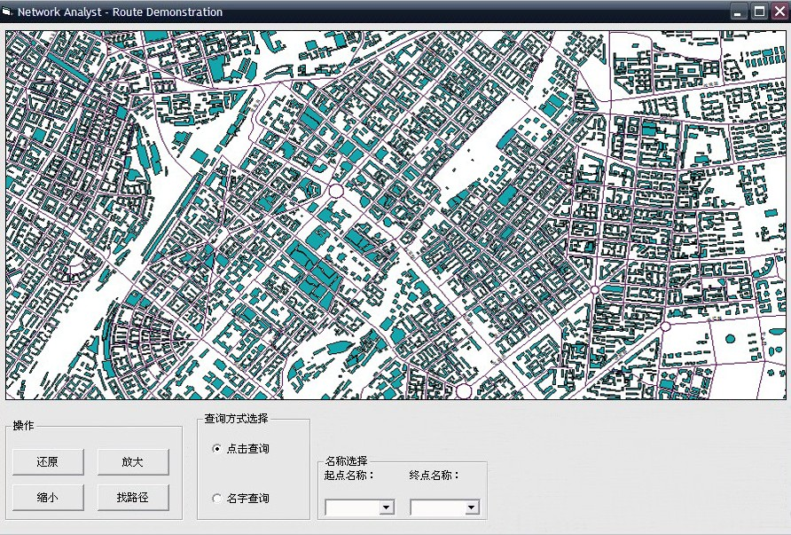
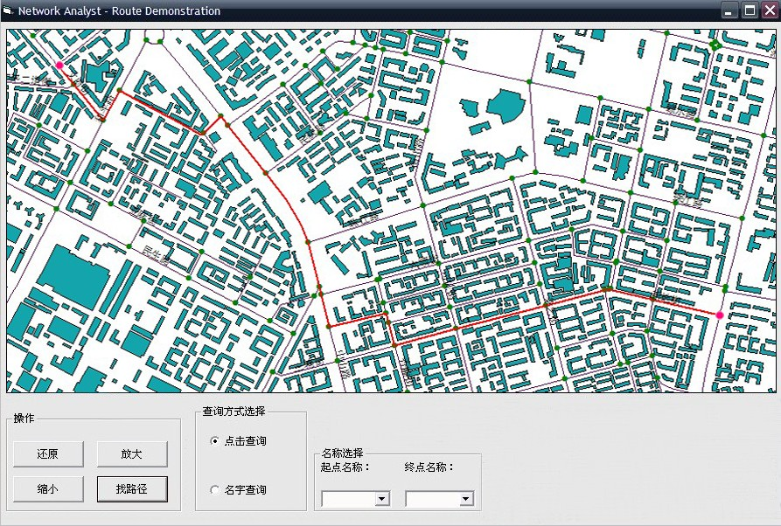
Figure 2. Overall map displays
Figure 3. The shortest path display

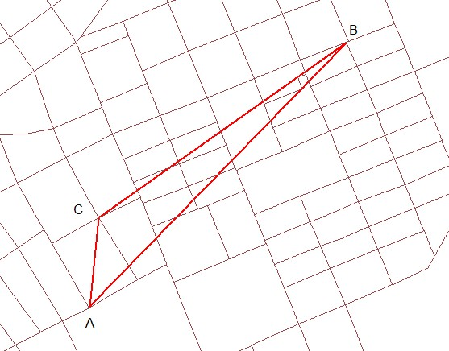
Figure 4 the path between A and B

5 Conclusions
The GIS development and application based on MapX are becoming more and more popular, the shortest path of network analysis is one of research emphasises. This paper discusses the establishment of the roads spatial database, describes the shortest path algorithm with MapX, and the algorithm has been applied in practice. There is improvement room for various aspects of the shortest path algorithm optimization, and the defects will be improved in the future research.

Acknowledgement:
Foundation item: Northeast Forestry University graduate thesis funded project.

Correspondence to:
Wang Wei-fang
Northeast Forestry University, Harbin, Heilongjiang 150040, China
Cellular phone: +86-13946078984
Email: weifangwang@126.com

References
- Jing Xiaoqiang. Bi-directional Dijkstra algorithm and the acceleration of intermediate list. Computer Simulation, 2004, 9: 79-81.
- Luo Yunqi, Zeng Kun, Luo Yi. Digital geographic information system and Mapinfo advanced applications. Tsinghua University Press,2003.
- Qi Xin, Yang Taiping, Duan Yongkun. Realization of Dijkstra algorithm on urban traffic query base on MapX.Geomatics & Spatial Information Technology, 2010, 33(2): 136-139.
- Ma Dongling. Research of the the shortest path algorithm of urbanized public traffic networks.Science and Technology Information,2008,26:15-16.
- Li Jian. Optimization studies based on shortest path algorithm of Dijkstra.Journal of Weinan Teachers University, 2009, 24(5): 61-64.
- Wang Yijian. The research of the shortest path algorithm in the field of GIS.Computer Knowledge and Technology, 2009, 5(1): 182-183.
- Lu Feng. The best path algorithm: classification system and research progress.Surveying and Mapping, 2001, 30(3): 269-275.
- Wang Li, Li Wenquan. Public transport system path algorithm. Southeast University, 2000,26(5):210-215.

2/2/2012

