Vocational Efficiency and Academic Achievement of Rural, Urban and Semi-urban Secondary School Students

Dr. Kounsar Jan

Assistant Professor, Department of Education, University of Kashmir, India
E-mail: showkat80ahmad@gmail.com

Abstract: The present study was carried out to find out the vocational efficiency and academic achievement of rural, urban and semi-urban secondary school student. A sample of 720 student was drawn randomly from Govt. High and Higher Secondary Schools. The age of the subjects was 16-18 years. Data was collected with the help of DR. (Mrs) Manju Mehta vocational attitude maturity scale. Mean, S.D. and test of significance were calculated to find out the differences between the mean scores of rural, urban and semi-urban students on vocational efficiency. The results revealed that rural urban and semi-urban students have shown almost same attitude towards vocational efficiency.
[Kounsar Jan. Vocational Efficiency and Academic Achievement of Rural, Urban and Semi-urban Secondary School Students. World Rural Observ 2012;4(2):13-18]. ISSN: 1944-6543 (Print); ISSN: 1944-6551 (Online). http://www.sciencepub.net/rural. 3

Key words: Vocational Efficiency, Academic Achievement, Rural, Urban, Semi-urban, Secondary Students.

- Introduction
Education has always been intimately connected with the world of work. Through the ages man has worked for his livelihood, has learned through accumulated experiences how to face and control natural forces and how to live within the limited physical resources for the good of all. All this mass of human experience achieved through work has stimulated man to seek means and methods of increasing his efficiency in work. Vocational education is education for productive purposes or socially useful productive work. As the individual seeks and finds new and improved way of working through education or training, he increases his vocational efficiency. Gainful pursuit, regular occupations or vocations are becoming increasingly important in our industrialized society. A good system of preparing young people for a wide range of diverse vocations or occupations thus call for organized and coordinated efforts in integrating vocation education and training. The main aim behind vocationalising any education is to provide that education and training to students which allows them to contribute their best to employ the skill so developed to their own satisfaction as well as towards building up of the society in which they live. This is possible only by developing vocational efficiency among students.
Researchers have revealed that education is the most single factor in achieving rapid economic development and technological progress in creating a social order founded on the values of freedom, social justice and equal opportunity. Although early years of life are of great importance but the foundations of future adult personality are laid in the age of 11 – 17 years. It is the stage where a proper understanding of work ethos and values of a human and composite culture are provided to future citizens of the country.
We have to bear in mind that secondary education is a complete unit by itself and not nearly a preparatory stage. At the end of this period, the students should be in a position, to enter on the responsibilities of life and take up some useful vocation. It should, therefore, be periodically re-viewed in the light of the role of secondary education in the total programme of national development, so as to make education relevant to the socio-economic needs of the society.
The secondary education commission has suggest vocational bias to the secondary education. But, unfortunately, we find that only 12 percent of the students who go to the secondary schools take up vocational courses. In other countries, the percentage is 60-70. Hence, there is need for a vocational bias to secondary education. An important trends allied to the concept of linking education to national education to national development, and indeed implicit in it, is the increasing emphasis on education. It is high time researchers came forward to undertake studies on the concept, rationale, policies and programmes of vocationalisation and disseminate the findings so as to evolve viable alternative models of vocationalisation of courses.

- Review of Related Literature
Some studies have focused on shared decision making and job satisfaction. Lenard, Earl, J. (1993). Das, Lakshadera Panda (1995) found that there was a significant positive correlation between Job Satisfaction and shared decisions – making for the vocational teachers. No significant difference was found in the degree of job satisfaction of higher secondary and college teachers. Shukla, Prabha. Karen P. Lese and Steven B (1994) found that students expressed carrier, work and family goals that were positive in effect and individual in nature, acculturation was not significantly related to the academic achievement. Increase in general mental ability of the pupils there existed a positively of enhancing his level of vocational interest. Romatinagam, Panch (1995) found that students significantly differed in their vigilance, defensive avoidance rationalization and procrastination styles of decision making. Kusum Singh, Mahmood, Ali’s Ajitha, Nayar (1998). The findings reveal positive relationship between occupational status of mother and nuclear family. Academic achievement correlated significantly and positively with socio-economic status and occupational aspiration. Besides, attempts have been made to study vocational Preferences of adolescent students in relation to their intelligence and achievement. Dr. Raj Kumar Yadav (1999), Kane, Jan; Waton (2002), Neeraj (2002). The findings reveal that there was no significant differences between boys and girls in vocational and academic streams. Achievement also influences the vocational preferences to a great extent High Schools showed that low achievers in vocational education had greater increase in self-concept. M. I. Mattoo (2003) study yield that high and low creative students differ significantly in their vocational interest. Brown, Duane; Trusty (2005) suggest that school counselors can use strategic intervetion’s to improve academic achievement. Matto M. I. and Sugra M. (2007) Mattoo M. I. and Nazima (2011) revealed that socio-economic class has no effect on the vocational preferences of the student.

- Need and Importance
As the advancement of science and technology is taking place at a very fast speed the number of occupations is increasing and most of the school leaves and college leaves do not have any idea about vocational plans according to their potentialities and needs of the society. The result is that they fail to get suitable vocation and get frustrated and maladjusted. If vocational aim of education is not fulfilled then education becomes worthless. Human power data available provide little guidance on the extent of vocationalisation of education at the secondary stage level. Student population in terms of products of vocational or technical schools or centres, craft–training institutes are not represented in the work studies and forecasts. Thus there is inadequacy of the available data about vocational or occupational education. The lack of data and studies adds to the already difficult task of planning effective courses of vocational educational for the future.
Vocational preferences are the most important decisions in the life of every person. Inadequate choices lead to failure and suitable ones to promising returns. Preferences are modifiable; therefore, every precaution is to be taken while developing interests in several vocations which finally help a person to make a steady progress and enjoy prosperity. Hence, research in this area can be of tremendous help to the students for placing them on right jobs.
In modern technological age one of the objectives of education is to enable an individual to choose an occupation for which he is most suitable. Education, thus, should lay emphasis on vocational efficiency and later seems to be productive in contributing the social life of the society. This explains that right choice of an occupation is very important for an individual to lead socially useful life. Vocational choices are nothing but making a decision for preparing and entering upon a particular job. If the individual succeeds in developing himself properly and prepares for a vocation which suits him and is in harmony with his all round development, he is able to contribute towards the general economic growth and development.

- Objectives of the Study
To find and compare the vocational efficiency of rural, urban and semi-urban secondary school student.
To find and compare the academic achievement of rural, urban and semi-urban secondary school student.

- Variables
Vocational Efficiency:- Vocational efficiency for the present study means to assess both rate and level of an individual’s development with respect vocational choice and vocational designs.

- Academic Achievement
Academic Achievement for the present study referred to the average of aggregate pass percentage obtained by the students in the 10th and 12th class, final year examination, conducted by the B.O.S.E, J&K for the year 2004-2005.

- Methodology and Procedure
Sample
Seven hundred twenty students reading 10th and 12th grade identified on the basis of systematic sampling from Govt. High and Higher Secondary Schools of the three viz. Rural, Urban and Semi-urban of the Kashmir Division served as the sample for the present study.

Tools
In order to assess the vocational attitude among secondary school students. Vocational attitude maturity scale by Dr. (Mrs.) Manju Mehta was taken into consideration. Vocational maturity is one of the primary construct of vocational psychology, which allows to assess both rate and level of an individual’s development with respect to vocational choice.
Its consists of 20 items and eight (8) factors, i.e., Vocational Aspiration level, influence and money in job choice, Altruism and Passivity in job choice, lack of job awareness and change in job performance, indecisiveness in vocational choice, vocational understanding, lack of independence and chance factor in vocational choice.

Analysis and Interpretation
In order to achieve the objectives formulated for the present study the data collected was statistically analyzed using mean, S.D. and t-test.

Table 1: Showing overall percentage comparison of secondary school students on vocational efficiency.
N | Excellent | Average | Poor
720 | 33.47 (N=241) | 37.50 (N=270) | 29.02 (N=209)

The above table clearly reveals that of all sample secondary school students a least proportion 29.02% students has been found to possess poor vocational efficiency. 37.50% of the students were categorized as average and only 33.47% possessed the excellent vocational efficiency.

Table 2: Percentage comparison of rural, semi-urban and urban students on vocational efficiency (N = 240 in each group).
 | Rural | Semi-urban | Urban
Excellent | 33.75 (N = 81) | 33.33 (N = 80) | 33.33 (N = 80)
Average | 35.83 (N = 86) | 36.66 (N = 88) | 40.00 (N = 96)
Poor | 30.41 (N = 73) | 30.00 (N = 72) | 26.66 (N = 64)

The sub-group analysis in terms of demographic background indicates that out of 240 rural students (33.75%) show excellent vocational efficiency, (30.41%) show poor vocational efficiency. Likewise out of 240 semi-urban students (33.33%) show excellent vocational efficiency, (30.00%) show poor vocational efficiency. Similarly out of 240 urban students, (33.33%) show excellent vocational efficiency (26.66%) show poor vocational efficiency. The table clearly indicates that the semi-urban students and urban students are at par. Both show equal excellent vocational efficiency.

Table 3: Comparison of rural, semi-urban and urban students on vocational efficiency (N = 240 in each group)
S.No. | Area | Mean | S.D | t-value | Level of significance
1 | Rural | 24.59 | 4.60 | 0.17 | Not significance
1 | Urban | 24.65 | 3.45 | 0.17 | Not significance
2 | Rural | 24.59 | 4.60 | 4.33 | 0.01
2 | Semi-urban | 26.15 | 3.70 | 4.33 | 0.01
3 | Semi-urban | 26.15 | 3.70 | 5.00 | 0.01
3 | Urban | 24.65 | 3.45 | 5.00 | 0.01

A persual of the above table reveals that out of three groups (i.e.,) rural students v/s urban students, rural v/s semi-urban students and semi-urban students v/s urban students on vocational efficiency two comparisons have been found to be significant. The mean difference being significant at (0.01 level. The table clearly indicates that the rural students v/s urban students are almost at par and show no difference on vocational efficiency. Whereas rural students with mean value (24.59) in comparison to semi-urban students showing highest mean value (26.15) show lower vocational efficiency. The mean score favours the semi-urban students (26.15) in comparison to urban students with mean score (24.65). This implies that semi-urban students are highest on vocational efficiency).

Table 4: Percentage comparison of rural, semi-urban and urban 10th class students on academic achievement for the year 2004- 05.

 | 2004 (%age) | 2005 (%age) | Average pass %age
Rural | 32.20 | 42.81 | 37.50
Urban | 44.61 | 54.43 | 49.52
Semi-urban | 53.32 | 59.60 | 56.46

The overall view of the table indicates that of all the three groups rural, urban and semi-urban students, semi-urban students achieved the highest average of pass %age.

Table 5: Percentage comparison of rural, semi-urban and urban 12th class students on academic achievement for the year 2004-05.

 | 2004 (%age) | 2005 (%age) | Avg. pass %age
Rural | 39.16 | 43.95 | 41.55
Urban | 55.86 | 50.9 | 53.38
Semi-urban | 50.58 | 46.78 | 48.68

The overall view of the table indicates that of all the three groups, rural, urban and semi-urban, urban students showed the highest average of pass % age.

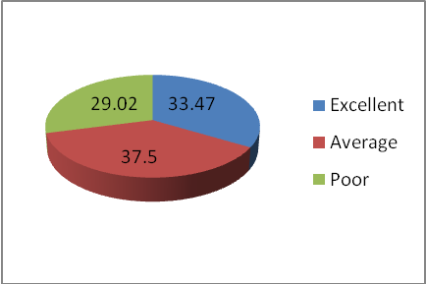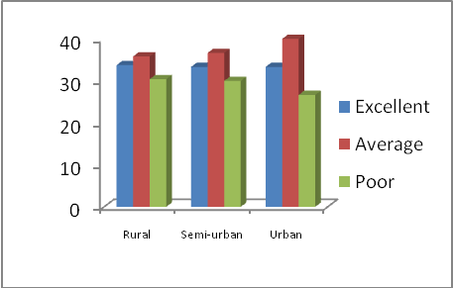

Fig. 1: Showing overall percentage comparison of secondary school students on vocational efficiency. | Fig. 2: Percentage comparison of rural, semi-urban and urban students on vocational efficiency (N = 240 in each group).
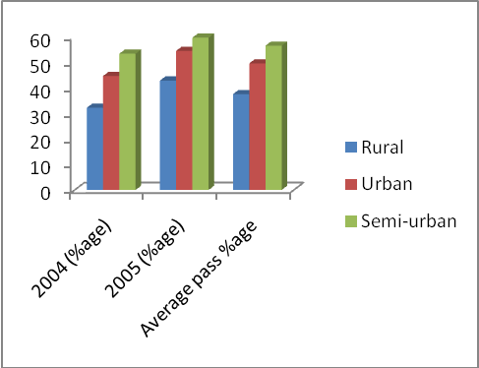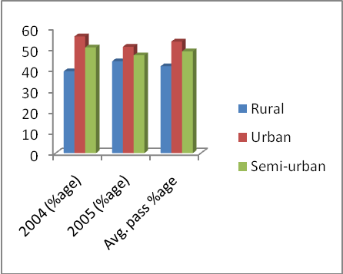

Fig. 3: Percentage comparison of rural, semi-urban and urban 10th class students on academic achievement for the year 2004- 05. | Fig. 4: Percentage comparison of rural, semi-urban and urban 12th class students on academic achievement for the year 2004-05.

- Conclusion
- The overall analysis on vocational efficiency of students enrolled in Govt, secondary schools has shown that a significant proportion possessed "Average' vocational efficiency.
- During the area-wise analysis on vocational efficiency the results reveal that rural, semi-urban and urban students have shown almost same attitude towards vocational efficiency.
- The area-wise mean difference has shown that no difference was found in the mean scores of rural and urban students.
- The semi-urban students showed better attitude towards vocational efficiency than rural students
- The semi-urban students also showed better vocational efficiency than urban students.
- It has been found that of all the three groups i.e., rural, urban and semi- urban 10 class students, semi-urban students have shown good academic achievement for the year 2004'also for the year" 2005 of all the three groups semi-urban students achieved good academic 'pass' percentage.
- The results reveal that for the year 2004 and 2005 of the three groups viz., rural, semi-urban and urban, urban 12th class students have shown good academic achievement.

- References
- Anand, (1997). Trend report on secondary education. Fifth Survey of Educational research. Trend reports (1988-1992) Vol. 1: NCERT, New Dehli.
- UK Singh, K. N. Sudarshan (1996): Vocational Education.
- Kushal Kumar (2001): Vocational Education.
- Thomas James (2005): Encylopaedia of Technical and Vocational Education Vol. 2.
- J. S. Rajput (2004): Encyclopaedia of Indian Education Vol. 2.
- Lenard, Earl, J. (1993): A comparative study of shared decision – making and job satisfaction among selected secondary vocational teachers. (Dissertation Abstract International, Vol. 55, No. 1).
- Brown, Duane; Trusty, Jersy (2005): School Counsellors Comprehensive School Counseling Programs and Academic Achievement. (Journal of Professional School Counseling, Vol. 9, No. 1, P. 1).
- M. I. Mattoo (2003): Creative thinking ability and vocational interest a study. (Insight Journal of Applied Research in Education, Vol. 9, No. 1).
- Dr. Raj Kumar Yadav (1999): The vocational Preferences of adolescents in relation to their intelligence and achievement. (Journal of Educational Research and Extension, Vol. 37).
- Manju Mehta, Sadhana Bajaj (2006). Effect of Personality Intervention and Career Intervention Programme on Vocational Indecision among adolescent boys. (Indian Education Review, Vol. 42, No. 2 pp. 81-98).
- Kane, Jan; Warton, Pamela (200@): The effects of employment preparation programs on self-concept in low academic achieving students (Australian and New Zealand Journal of Vocational Education Research, Vol. 10, No. 1, pp. 23-37).
- Mattoo, M. I. and Sugra M. (2007). Vocational interest of rural and urban secondary school students in relation to academic achievement (Insight Journal of Applied Research in Education Vol. 13(1).
- Mattoo, M. I. and Nazima (2011). Vocational Preferences and academic achievement of secondary school students with special reference to the type of institution. (Journal of Applied Research in Education, Vol. 15, No. 1).
- Deo, J. M., Singh, A. K. (2004): Variation in Job involvement with age among government and Private High School Teachers. (Indian Educational Abstract Vol. 4, No. 2).
- Anil Kumar, A. K. (2004): Perceived stress of teachers in relation to job satisfaction and certain personality characteristics (Indian Educational Abstract, Vol. No. 2).
- Ramalinagam, Panch (1995): Comparison of decision – making styles among higher secondary student. (Indian Educational Abstract, 1996-1998, Vol. 1).
- Lewis, William (1994): A comparison of the beliefs of secondary academic teachers with the beliefs of secondary vocational teachers towards the integration of vocational and academic education (Dissertation Abstract International, Vol. 56, No. 2).

4/20/2012

