Assessment of the Performance of Condensation Irrigation System: First Results

Bagher Yousefi ¹, Saeed Boroomandnasab ¹, M. Thameur Chaibi ²

¹ Irrigation and drainage Engineering, Shahid Chamran University, Ahvaz, Iran
² Rural Engineering, Pan African University, Tunis, Tunisia
bagher.yousefi@gmail.com

Abstract: Condensation Irrigation (CI) is a combination of desalination and irrigation and/ or drinking water production, simultaneously. With the evaporation of saline water in solar still and transferring of humidified air into the system of underground pipe, fresh water will condense on the inner the pipe surface as the air is cooled by the ground. By using drainage pipes in the ground for transportation of humidified air due to existence of perforations in the pipe, it enables the condensation water to percolate into the soil. In this study of CI, the goal was to obtain drinking water which was produced by using buried common pipes. Condensed water was collected at the end of the pipe and used for drinking. Observations and calculations result in a mean water production capacity of 4 liters for 8 hours over a 25m long pipe in a diurnally system.
[Yousefi B, Boroomandnasab S, Chaibi MT. Assessment of the Performance of Condensation Irrigation System: First Results. World Rural Observ 2012;4(3):14-17]. ISSN: 1944-6543 (Print); ISSN: 1944-6551 (Online). http://www.sciencepub.net/rural. 2

Key words: desalination; condensation Irrigation; drinking water; humid air

1. Introduction
The world is suffering from shortage of soft water resources. The increase in the world population and the loss of existing water supplies threaten two-third of world population with the access to fresh water by the year 2025 (UNEPb, 2003). Because the demand of 7.9 billion of people for food must be met, 47% more lands must be put aside to produce cereals by the year 2025 (Rosegrant et al. 2002). The areas that are more in danger of shortage of water are those warm and arid countries distributed between the latitude of 15 to 35°N which comprises the North Africa and the southern Asia (Hussain, 2003). Having all these facts in mind, the only thing that lends a helping hand to make the things different is the use of the desalination.
The regions which have the most solar radiation are those with an extreme need for more fresh water. Due to the fact that these areas abound with solar radiation, the thermal solar energy seems to be the promising and renewable resource for applying the desalination technique to seawater (Garcia, 2002). However, only 0.02% of the global desalination is carried out by the renewable energy systems (Garcia, 2002).
Due to population growth, further development of agricultural lands is essential, although in many regions, agricultural water for irrigation competes with non-agricultural sectors in economic gains from the use of water (Sundquist, 2004). Increasing costs of water need to be answered by new ways to produce fresh water. The only useful way to produce more fresh water is desalination of saline waters e.g. seawaters. 23×10⁶ m³ of fresh water is produced by reverse osmosis, multi stage flash and multi effect distillation, every day (Garcia, 2002) but these structures have been working with nonrenewable energies.
This paper outlines the combined system which used for solar desalination and drinking water production where the earth acts as a condenser, and the name for the system is Condensation Irrigation (CI).

1.1 Condensation Irrigation
The saline water which is used to humidify the ambient air in Condensation Irrigation (CI) system causes the combination of desalination and irrigation that desalination and humidifying are occurred in the solar still and dehumidifying it is occurred in pipes in the ground. Drainage pipes buried are used for subsurface irrigation and for Drinking water, common pipes are used. Condensed water and humid air infiltrate the soil through the holes of pipe and Irrigation and aeration are done with the practice otherwise common pipes are used for Drinking water production. In the common pipe, the condensed water can be collected at the pipe ending and used for drinking.

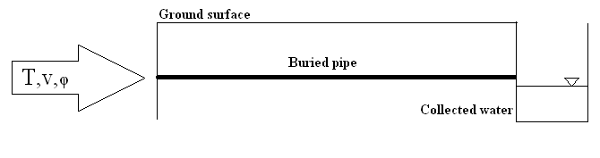

Figure 1. Outline of the water production pipe system. Heat and humid air enters the pipe then it will cool and vapor will condense. Specifications of humid air describe by the air temperature, T, the air humidity, φ, and velocity, c.

Pervious studies of condensation Irrigation (CI) exist. Work and Studies related to the Condensation Irrigation system began at the Luleå University of Technology (LTU) as a series of Master’s Theses (Widegren, 1986, Göhlman, 1987, and Gustafsson et al., 2001) and the technology was used by Nordell in the construction of a greenhouse climate control facility in Övertorneå, Sweden (Nordell, 1987). Also in an independent study, a CI plant was constructed where seawater had evaporated in plastic tubes, with the condensation occurring in buried drainage pipes by the Swiss company Ingenieurbüro Ruess und Hausherr. The study showed the water consumption of tomato plants was decreased 50% in the system (Hausherr et al., 1993).
The theoretical results have been published by Lindblom (2006) show that the steady state irrigation water production rate (after 90 days of operation) was approximately 3 kg/m of pipe and day. When the ground was used for drinking water production – in plain pipes – the corresponding water production was reduced to about 1.8 kg/m of pipe and day. So, for a 50 m pipe the total daily water production was 150 Lit and 100 Lit per day respectively.
According to previous studies, the purpose of this research was the feasibility and obtaining of drinking water.

2. Methodology
2.1 Installation
The test was performed at Shahid Chamran University in Ahvaz, Iran, in co-operation with the Irrigation and drainage Department in winter of 2012.
In the first step to perform this research, three parallel ditches with a length of 25 m and 40 cm depth were excavated. Then common pipes installed through them with very low slope and refilled with loam soil. Two side pipes were placed only for the experiment done in a controlled environment.
After installation, air was passing on saline water in the solar still. Then humid air was driven into the pipes by a fan for 8 hours a day but measurements should only were made on the center pipe, such as humidity and air flow rate and temperature at the inlet and outlet. In addition produced drinking water was collected at the end of pipe and was compared with calculated drinking water. It should be noted, in this experiment, Saline water into the solar still was heated to 70°c.

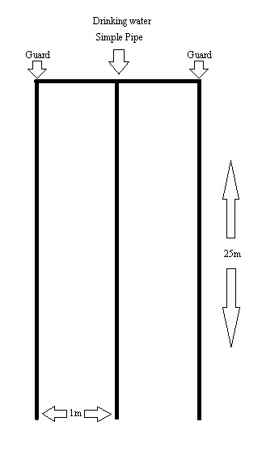

Figure 2. Overall system experimental design

2.2 Calculation of produce water
Suppose humid air is heated to a temperature of 70ºC in the solar still and cooled to 40ºC in the pipes, then both water vapor and air assumed to behave as an Ideal gases under normal pressure at the inlet and outlet and the amount of condensation water can be obtained from the ideal gas law:

m = (p.V)/(R.T) (1)

Where m is the partial mass, p is the partial pressure, V is the partial volume, R is the universal gas constant and T is the temperature. In equation (1), the ratio of partial masses between vapor and dry air, expresses the weight of water contained in per unit weight of dry air. In other words this ratio mv/mda is called the absolute humidity and is denoted x [kg water/kg dry air]. By assuming air is saturated with vapor in the condensation irrigation system and for cases where the total pressure is equal to the atmospheric pressure (101325 Pa), x equation is expressed by:

x = (0.622 .p_{v,sat} .φ)/(101325 – p_{v,sat} .φ) (2)

Where pv,sat is the partial pressure of saturated vapor (Pa), thus x70ºC=0.27504 kg water/kg dry air and x40ºC=0.04869 kg water/kg dry air, respectively. Difference between specific humidity shows the amount of condensed water.
For a mass flow of e.g. 0.150 kg humid air/s in one pipe, the condensation rate is 0.027 kg water/s and the average drinking water amount would be 972 kg/day for 10 hours (lindblom et al, 2006).

3. Results and discussion
This section intends to compare the amount of water that is obtained from theory and experiment. The amount of produced drinking water from the pipe end, collecting and measured that results in the figure below. Nearly 10 liters was evaporated of saline water every day.
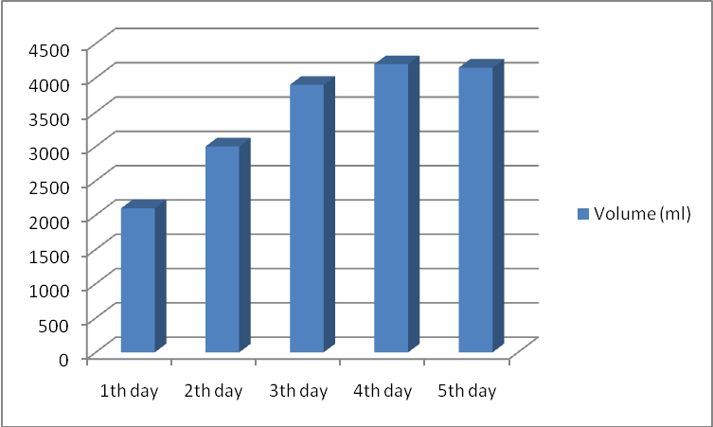
Figure 3. Drinking water collected in the CI system

As it can be seen in Figure 3, Minimum amount of drinking water produced in the first day, and the greatest amount of drinking water production has occurred in the fourth day. The first day of production is minimal because the inner surface of the pipe is dry and some of drinking water produced as a thin layer covered the inner surface pipe. The wetting process was resumed in the second day, because the amount of drinking water produced is less than other days. Also another reason for the difference in the production of drinking water is the impact of environment on this research. After 3 days, the system reached a steady state and the amount of water produced was approximately equal to 4100 mm at the end of pipe. In other words, rate of drinking water production was 0.5 lit/h.
Also theoretically, the amount of drinking water produced is shown in Figure 4.

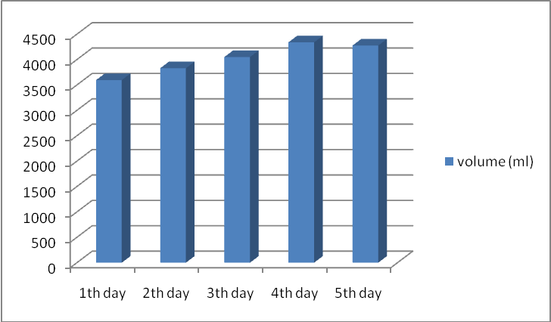
Figure 4. The calculated amount of drinking water at CI system

The water production versus time-8 hours per day- is plotted in Figure 4. Also in this figure, like Figure 3, there is an initial slope with this difference that this graph is less steep. The reason for this phenomenon is that when the condensation water is calculated, it is assumed all of condensation water is removed from the pipe. As it can be seen in Figure 4, the average of drinking water production is 4 liters per day. If the test period will increase, this average will be increased too.
According to these results and comparing these results with previous work, it can be found that the drinking water is produced less than previous work. One reason was that selected fan did not have enough power for more transferring flow of humid air. Also the negative impact of environment on the experiment was high.

4. Conclusions
In the described condensation irrigation system for production of drinking water, humid air condensed when flowing through the buried pipe. Also this system is used for Irrigation while drainage pipes are used instead of common pipes. This project is focused on the drinking water production where common pipes are used for collecting water at the pipes ending. Comparing the results of the produced water with experiment and calculation showed that after three days these are closed to each other. Also this project showed that environment was effective on the efficiency of production hence with the reduction of inlet temperature, production of drinking water was reduced.
Efficiency of the scientific research nearly was good -40 percent- and further studies can be done about the condensation irrigation system to increase the efficiency in this region.

5. Future work
- Using a pipe with more length and bigger diameter
- Using this system with a longer duration
- Modeling system, according to Iran conditions
- Using this system in subsurface irrigation
- Study of heat transfer in a loam soil

References
- Garcia-Rodriguez L, et al. Comparison of solar technologies for applications in seawater desalination. Desalination 2002:142, pp. 135-142.
- Garcia-Rodriguez L. Seawater desalination driven by renewable energies: a review. Desalination 2002:143, pp. 103-113.
- Göhlman A. Heating of frozen ground. (Uppvärmningavfrusen mark), Master Thesis. Luleå University of Technology, Sweden (in Swedish). E 1987:030.
- Gustafsson AM, Lindblom J. Underground Condensation of humid Air – a Solar Driven System for Irrigation & Drinking-water production, Master Thesis 2001:140 CIV, Luleå University of Technology, Sweden. 2001.
- Hausherr B, Ruess K. Seawater desalination and irrigation with moist air, Ingenieurbüro Ruess und Hausherr, Switzerland. 1993.
- Hussain A.K.M. Solar energy utilization in Libya for seawater desalination.Proceedings at the ISES Solar World Congress 2003, Gothenburg.
- Lindblom J, Nordell B. Water Production by Underground Condensation of Humid Air, Desalination 189:248-260. 2006.
- Lindblom J. Condensation irrigation: simulations of heat and mass transfer. Licentiate thesis / Luleå University of Technology; 2006:08.
- Nordell B. Design of Climate System for Greenhouse in the North of Sweden. (Dimensioneringavklimatsystem vid HietalasväxthusiÖvertorneå), Luleå University of Technology, Sweden (in Swedish). 1987.
- Rosegrant M.W, Cai X, Cline S.A. World Water and Food to 2025: Dealing with Scarcity. International Food Policy Research Institute. 2002.
- Sundquist B. Irrigated lands degradation — A global perspective, 3rd ed., 2003, http://home.alltel.net/bsundquist1/ir0.html. June 29, 2004.
- UNEPb (United Nations Energy Programme) http://www.unep.org/geo2000/english/0046.htm. 2003-06-09.
- Widegren M. Condensation Irrigation, a desalination-irrigation system, Master Thesis 1986:002E, Luleå University of Technology, Sweden. 1986.

5/29/2012

