Utilization of Satellite Imagery for Drought Monitoring in Egypt

Abdrabbo M. A.; A.A. Farag; M. Abul-Soud; Manal M.H. Gad El-Mola; Fatma S. Moursy; I. I. Sadek; F. A. Hashem; M. O. Taqi; W.M.S. El-Desoky and H.H. Shawki

Central laboratory for Agricultural Climate (CLAC), Agricultural Research Centre, Giza- Egypt
Fadl_hashem@yahoo.com

Abstract: Terrestrial water storage (TWS) consists of groundwater, soil moisture, surface water, and wet biomass. Drought may be defined as a period of abnormally dry weather long enough to cause significant deficits in one or more of the TWS components. Thus, along with observations of the agricultural socioeconomic impacts, measurements of TWS and its components enable quantification of drought severity. Current remote sensing instruments are able to detect variations in one or more Terrestrial water storage (TWS) variables, including the Advanced Microwave Scanning Radiometer (AMSR) on NASA's Aqua satellite and the Moderate Resolution Imaging Spectroradiometer (MODIS) on NASA's Terra and Aqua. Their dynamic character challenges our ability in planning, monitoring, and providing relief to the affected areas. Meanwhile, the spatial and temporal variability and multiple impacts of droughts, the tools and data available for mapping and monitoring this phenomenon on all scales should be improved. The collected images on a scale of 1:1000000 were collected twice monthly (every 15 days) during the winter cultivation season in Egypt from November to April for all over the Egyptian governorates within the time series from 2001 to 2010. These types of satellite images (Modies) are using to determine the Vegetation Health Index (VHI) that have been utilized in calculation the drought rates. The aims of this study were detecting of drought-related vegetation stress and estimation of drought parameters, from 2001 to 2010, all over Egyptian governorates, during the winter season. Detecting of drought-related vegetation stress was done from 2001/2002 to 2009/2010 seasons respectively all over Egyptian territory during the winter season. Coastal areas mainly depend on winter annual rainfall. The results of the monitoring drought during 9 winter seasons showed that, Northern Coastal zone was the highest affected area by drought in Egypt, and supplementary irrigation needed for improve the drought status, during winter season especially in the months December, January and February to improve the winter crops productivity and enhance the food security. Furthermore, In 2009/2010 season had the longest drought period; while 2006/2007 season considered the lowest drought status season.
[Abdrabbo M. A.; A.A. Farag; M. Abul-Soud; Manal M.H. Gad El-Mola; Fatma S. Moursy; I. I. Sadek; F. A. Hashem; M. O. Taqi; W.M.S. El-Desoky and H.H. Shawki. Utilization of Satellite Imagery for Drought Monitoring in Egypt. World Rural Observ 2012;4(3):27-37]. ISSN: 1944-6543 (Print); ISSN: 1944-6551 (Online). http://www.sciencepub.net/rural. 4

Keywords: remote sensing- satellite images- drought- Vegetation Health Index (VHI).

1. Introduction
Egypt lies in the North-Eastern of the African continent, the Sinai Peninsula forming a land bridge in Southwest Asia. Egypt bordered in the North by the Mediterranean Sea, East border by Palestine and the Red Sea, in the South by Sudan and in the West by Libya. Egypt lies between latitudes 22° and 32°N, and longitudes 24° and 36°E. The majority of Egypt's landscape is desert (Cia. Gov., 2012).
The average rainfall in Egypt about 40-60 mm per year, But in the Northern Coast area the average about100–200mm per year, therefore, some winter crops can be grown (El-Shaer et al., 1997 and Abd El-Rahman, 2009). The cultivated areas in Egypt have been increased over the past three decades. The government policy intends to increase more reclaimed lands for agriculture. According to the FAO (2002), the great challenge for the coming decades will therefore be the task of increasing food production, with limited water resources, especially in arid and semi-arid regions (Abouzeid, 1992 and FAO, 2003).
Remote sensing techniques allow monitoring the vegetation cover possible to obtain and distribute information rapidly over large areas by means of sensors operating in several spectral bands. A satellite, which orbits the Earth, is able to explore the whole surface in a few days and repeat the survey of the same area at regular intervals. The spectral bands used by these sensors cover the whole range between visible and microwaves. Rapid developments in computer technology and the Geographical Information Systems (GIS), help to process Remote Sensing (RS) observations from satellites in a spatial format of maps both individually and along with tabular data and “crunch” them together to provide a new perception - the spatial visualization of information of natural resources. The integration of information derived from RS techniques with other datasets - both in spatial and non-spatial formats, provides tremendous potential for identification and monitoring of droughts (Jeyaseelan, 2003).
Satellite based monitoring of vegetation plays an important role in drought monitoring and early warning. Many studies have shown the relationships of vegetation index and agricultural drought. (Thenkabail et al., 2004) developed methods that allow two generations of sensors (AVHRR and MODIS) to be combined beneficially for drought assessment and monitoring on a regional and a near-real-time.
MODIS is a 36-band sensor from which 10 by 10 degree products cast in the Sinusoidal projection are derived at 1-km spatial resolution. In addition to being available globally at no cost to the public, the products generated from MODIS are superior to AVHRR because they provide higher spatial and spectral resolutions, more precise geolocation, and improved atmospheric corrections (Brown et al., 2008).
The Vegetation Health index (VHI) is based on a combination of products extracted from vegetation signals, namely the Normalized Difference Vegetation Index (NDVI) and from the brightness temperatures, both derived from the NOAA Advanced Very High Resolution Radiometer (AVHRR) sensor. VHI users rely on a strong inverse correlation between NDVI and land surface temperature, since increasing land temperatures are assumed to act negatively on vegetation vigor and consequently to cause stress (Karnieli et al., 2006).
The main objective of this study was monitoring the effect of drought parameters (satellite images) on the vegetation coverage allover Egypt during the last ten years period by using MODIS Satellite image1-km spatial resolution.

2. Material and Methods:
The green cover of the cultivated crops always exist during the winter agriculture season in Egypt is from November to April. The recommended seeding period for the most winter crops from middle of October till the end of November, and green cover of the winter crops (Wheat, clover, Faba Bean, … etc) continue from November until the end of April every year (MALR, 2008). According to, that MODIS satellite, monthly images were collected at the same cultivation period approximately was six months.
The study express drought parameters, during the winter seasons from 2001/2002 to 2009/2010 season. Two types of satellite images were downloaded from NASA's organization Web page (https://wist-ops.echo.nasa.gov/api/). First type of image was the mean Normalized Difference Vegetation Index NDVI (MODIS/Terra Vegetation Indices 16-Day L3 Global 1km SIN Grid V005) to estimate Vegetation Condition Index (VCI), the Normalized Difference Vegetation Index(NDVI); images contained the mean of NDVI data each 15 days in a particular area. Second downloaded image was the Brightness Temperature BT (MODIS/Terra Land Surface Temperature/Emissivity 8-Day L3 Global 0.05 Deg CMG V005) to estimate Temperature Condition Index (TCI), BT images contained mean BT data for 8 days in particular area. Both types of satellite images were processed by using software of ERDAS imagine package V9.2 and ArcGIS Package V9.3. The ERDAS software was used for projection, mosaic, compressed and classification of the images. The ArcGIS was used for convert the raster to shape file.
MODIS/Terra Vegetation Indices 16-Day L3 Global 1km SIN Grid V005 is Characterize with; Area (10 degrees x 10 degrees lat/long), Size (1200 x 1200 rows/columns), File Size ( ~0.5 MB), Resolution(1000 meters spatial), Projection (Sinusoidal), Data Format (HDF-EOS), Science Data Sets SDS HDF Layers (12).
MODIS Land Surface Temperature/Emissivity 8-day data is Characterize with; Area (Global), Dimensions(3600 x 7200 rows/columns), File Size ( ~70 MB compressed), Resolution (0.05-degrees 5600-meters at the equator), Projection (Lat/Lon), Land Surface Temperature (LST) Data Type (16-bit unsigned integer), Emissivity Data Type (8-bit unsigned integer), Data Format (HDF-EOS) and Science Data Sets SDS HDF Layers (17).
The Vegetation Health Index (VHI) was monitoring the drought situation which is based on estimation of green canopy stress or no stress from NOAA's Advanced Very High Resolution Radiometer (AVHRR-derived index), characterizing moisture, thermal conditions and total vegetation cover.
The VHI was derived (equation 1) from using particularly time series under this study (2001-2010) every 15-days (24 images per year) mean Normalized Difference Vegetation Index (NDVI) as the background value, then the background value is subtracted by currently year every 15-day NDVI data to obtain value of vegetation index, then the drought could be classified according to the value of VHI.
This procedure was formalized by equations 1-3, where climatology was represented by the difference between 10 years absolute maximum and minimum NDVI and BT values for each pixel.

Where;
VCI (Vegetation Condition Index),
TCI (Temperature Condition Index)
α is the relative contribution of VCI and TCI in the VHI. In most published analyses α has been assigned a value of 0.5, assuming an even contribution from both elements in the combined index, due to the lack of more accurate information (Kogan, 2000).
The VCI values (equation 2) range from 0 to 1, the low values representing stressed vegetation conditions, middle values representing fair conditions, and high values representing optimal or above-normal conditions.
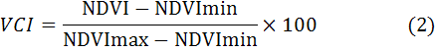
Where;
NDVI (Normalized Difference Vegetation Index),
NDVImax, and NDVImin are the smoothed weekly NDVI, its multi-year absolute maximum and minimum, respectively.
The TCI values (equation 3) range from 0 to1, the value close to 0 indicates harsh weather conditions (due to high temperatures), relative to the composite period, middle values reflect fair conditions, and high values close to 1 reflect mostly favorable conditions.
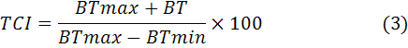
Where; BT (Brightness temperature), BT max, and BT min are similar values for BT.
After estimation of VHI projection of each month, map was done the coordinate system was converted from sinusoidal to WGS 84. Next step was extracting the satellite image within shape file for whole Egypt, to emphasis the study areas which the green cover of winter crops was existed during winter period. The images were reclassified on a monthly level into 6 recognized classes of VHI Pixel: 0- 10- 20- 30- 40- 100 Where; (0=sever drought), (10= High drought), (20= drought), (30= moderate drought), (40= little drought), (100= no drought). The last step was reclassified the gained images again for all seasons of winter crop into two levels (0= drought), (1= no drought). Finally the output images were used for determine, the monthly frequency of drought during each season and consecutive of all studied life-span winter seasons as following:
Monthly Frequency in One Season=
(M.Nov x 1)+(M.Dec x 10)+ (M.Jan x 100)+ (M.Feb x 1000)+ (M.Mar x 10000)+ (M.Apr x 100000) (4)

There are two kind of the maps output; the first output was the frequency maps, it's illustrate the monthly comprised maps for the whole studied time series; the second maps output was the consecutive maps which illustrate the seasonally comprised maps for each year.
The consecutive seasons were comprised in one map and the same thing for the frequency maps, then these maps were saved as a shape file, resulting in value for each pixel in the maps from 9 to 9000 (9 indicates number of winter seasons). The classified of the pixels number of the comprised consecutive maps was based on the distribution of the drought during the season, by another words, when the drought was exist for long period during the season, it means there was drought season in all the winter season. So that each pixel in these seasons' maps were ranged from 0 to 6, means the number of drought months Zero Value under the two concepts of drought "consecutive and frequency" separately in two maps.
Data were statistically analyzed using FREQ procedure (SAS, 2000) according to the following formula:
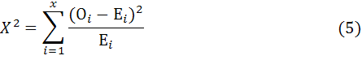
Where;
X² is a calculated chi square
O_{i} is an observed value for each group
E_{i} is an expected value for each group
Also, Chi coefficient (Fleiss, 1981) was used to measure the association derived from the Pearson chi square statistic. It has a range of 0 ≤ Φ ≤ ($\sqrt{R−1}$ ,$\sqrt{C−1}$) where; R is the number of rows and C number of columns (Liebetrau, 1985). The chi coefficient is computed by the following equation:
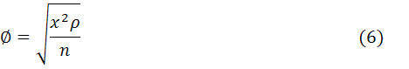
Where; X_{2:} is a chi square, P: is a contingency coefficient and, n: is a total number.

3. Results and Discussion:
Analysis of drought situation during the winter seasons:-
Data in Figures (from 1 to 9) are showing the seasonally drought, during the seasons from 2001/2002 till 2009/2010. The data concerned about the period from November till April (time of green cover of winter crops) of each year, which is known commonly as the winter season.
Referring to the drought during the November month all over the studied seasons, the highest drought cause was recorded on 2008/2009 season, while the lowest drought was recorded in 2006/2007 season.
Meanwhile, the drought scale during December on 2001/2002 season was recorded the highest drought in comparison with the other studied months in 2006/2007 season, whereas, the lowest drought was found during the same season.
On January, season 2009/2010 was recorded the highest drought, whereas the lowest drought was found in 2007/2008 season for the same month.
The drought scale on February month had another trend, the highest drought was recorded in 2009/2010; the lowest drought was recorded in 2002/2003 season.
The severe drought during March of the studied season was recorded in 2009/2010 season; the lowest for the same month was found in 2002/2003 season.
Finally, the drought wasn't occurred during April on 2006/2007 while it was severe drought during 2008/2009 season.
Furthermore, from the drought data during the study period, it's clear that, most seasons were faced drought in one or more of its months; it means that rainfall agriculture for winter cultivating crops need supplemental irrigation for covering the water requirements for each crop (Abd El-Maaboud, 2004).
On the other hand, coastal areas mainly depend on winter annual rainfall of 100 to 250 mm and sometimes supplemented with underground and harvested water with various methods (Hadi Radhi, 1992). From the Figures from 1 to 9 it could be noticed that, the Northern coastal region is considered the most vulnerable area to drought cause because it doesn't depend on the irrigation from Nile water such as the Nile Valley and Nile Delta. Rainfall during the first two months of the winter season(November and December) consider a critical issue of the drought event because delay the rainfall on November and December mean lose the agriculture season because of delay the sowing date of the winter field crops especially wheat, barley and clover.
Figures (1 to 9) reveal that, the Northern coastal zone area suffering from drought cause during December, January and February of the all studied seasons (2001/2002 – 2009/2010). It means the rainfall during the winter season of the studied seasons were delayed till the temperature decreased during the winter season, by another words, the vegetative growth of plants delayed to cover this area till the first of March. Moreover, by visual comparison between the green and red color on different Figures, the 2008/2009 and 2009/2010 seasons, consider the most drought season for the Eastern and Western desert, as well as Sinai especially during the December, January and February (2001-2002).
The above results could summarized that Egypt should concentrate on the agriculture activity in the Northern coastal zone by supplementary irrigation during the winter season to improve the crop productivity of this area (Yousif, 2011), to increase the food security in case of cultivating wheat, barley, feeders and etc. For strategic action, the supplementary irrigation could calculate annually depending on the potential cultivated area, the crop, climatic data (perception and ET_{o}).

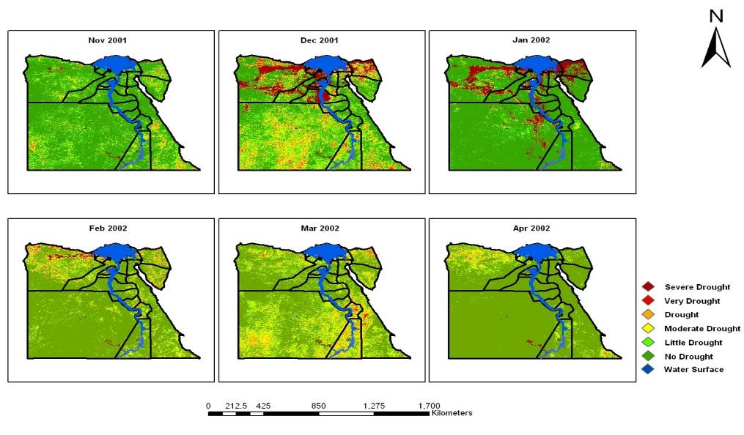
Figure (1): Monthly VHI classes during winter season 2001/2002 in Egypt.
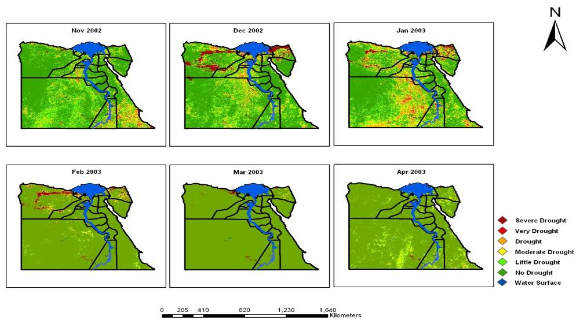
Figure (2): Monthly VHI classes during winter season 2002/2003 in Egypt.
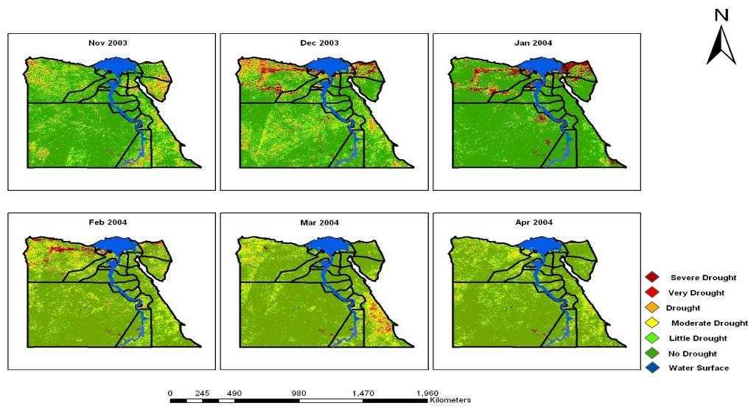
Figure (3): Monthly VHI classes during winter season 2003/2004 in Egypt.
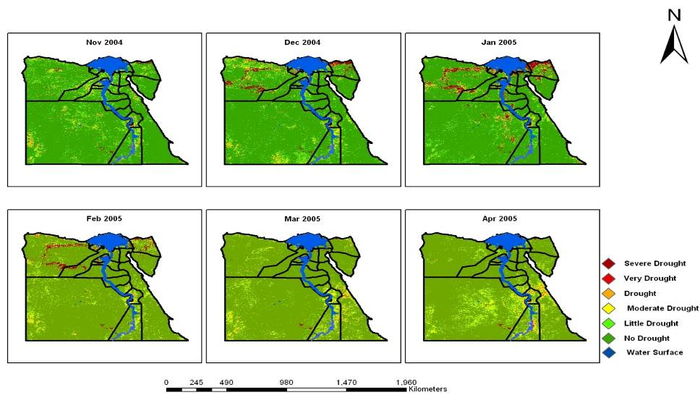
Figure (4): Monthly VHI classes during winter season 2004/2005 in Egypt.
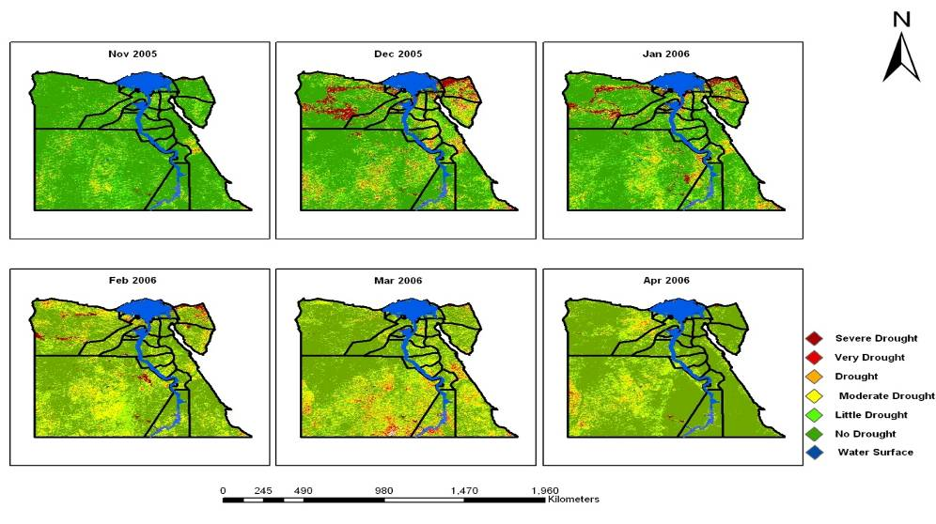
Figure (5): Monthly VHI classes during winter season 2005/2006 in Egypt.
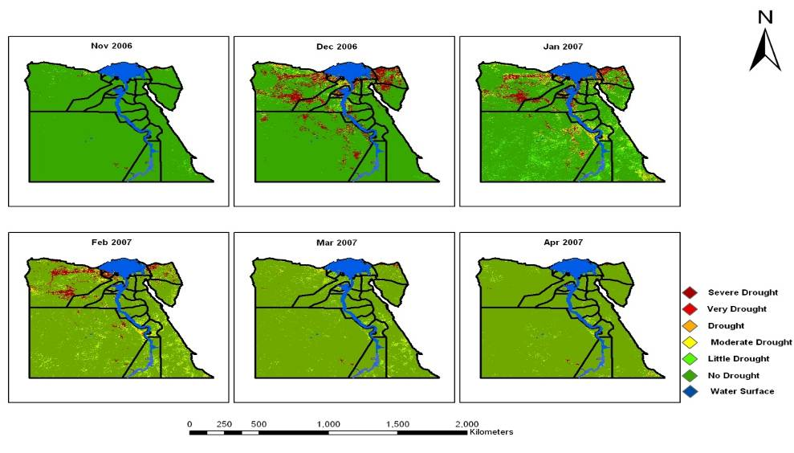
Figure (6): Monthly VHI classes during winter season 2006/2007 in Egypt.
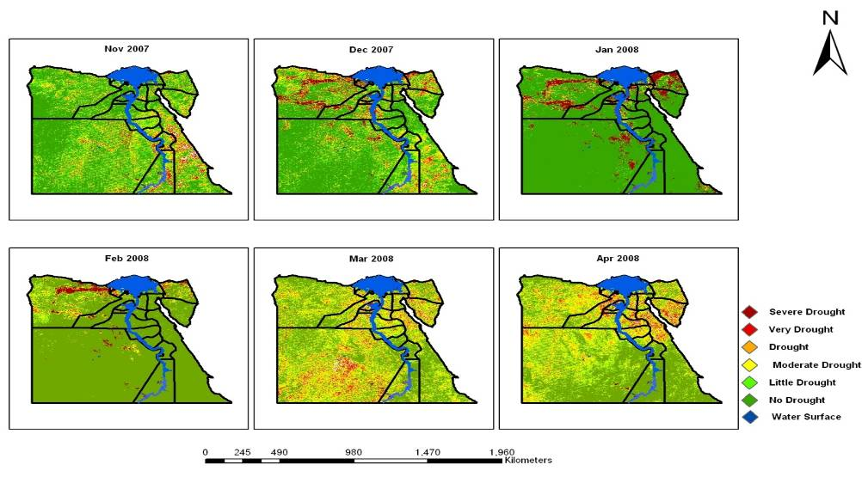
Figure (7): Monthly VHI classes during winter season 2007/2008 in Egypt.
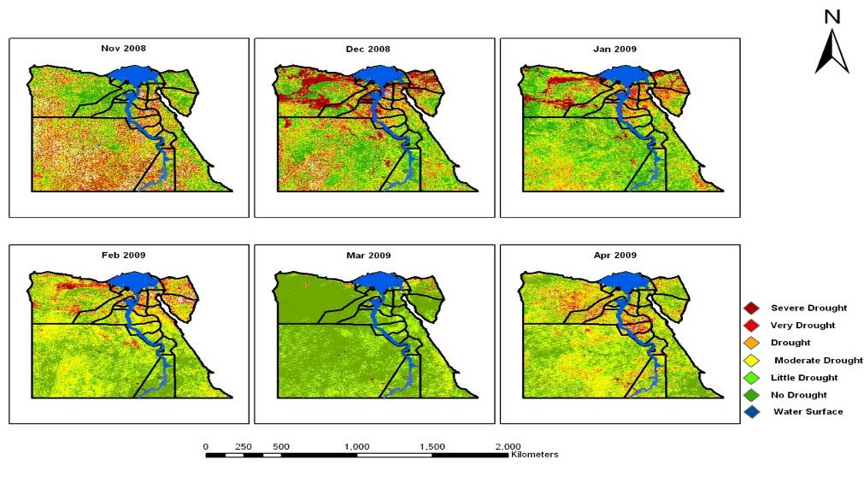
Figure (8): Monthly VHI classes during winter season 2008/2009 in Egypt.
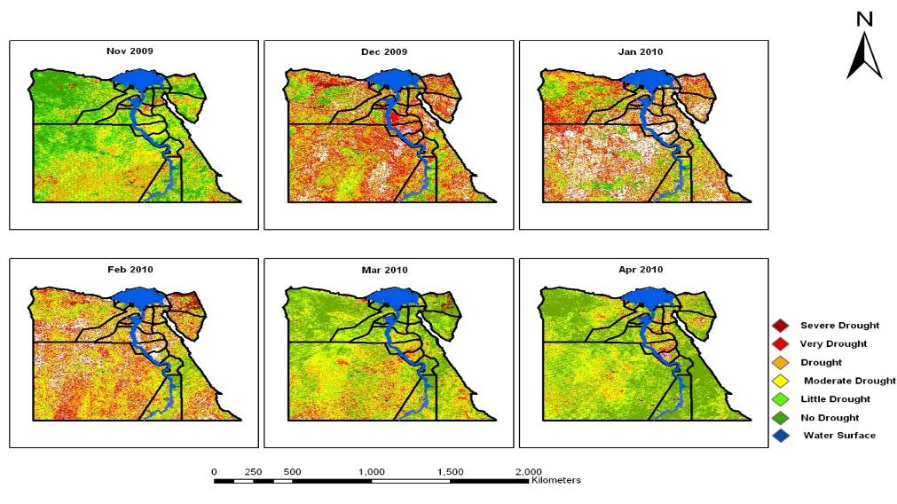
Figure (9): Monthly VHI classes during winter season 2009/2010 in Egypt.

Analysis of drought situation during the studied winter seasons from 2001/2002 till 2009/2010:-
The distribution of drought situation of winter for each season:
According to the illustrated results in Table (1), VHI data for the studied winter seasons (November – April) 2001/2002 to 2009/2010 show that there were no significant differences among the VHI values during the first seven studied seasons (from 2001/2002 to 2007/2008 season). Table (1) show that, There were significant differences among the first seven seasons in comparison with 2008/ 2009 to 2009/2010 seasons.
Concerning, VHI data show that the most severe drought conditions during at 2009-2010 season as it has the less total number of VHI frequencies =2958828 followed by season 2008/2009 season while, the best conditions were in the seasons 2006/2007 and 2004/2005 recorded the highest total VHI frequencies =3238661, 3237498 respectively.
The VHI classes were collected, the values from (zero to 100) to take zero value means drought, whereas the value of 100 took the 1 value means no drought; this reclassification was to facilitate the judgment of the drought during the different seasons where each month within the season took the value of zero or one.
Figure (10) shows the number of drought months during each winter season compared to the other seasons. The data revealed that the two 2009/2010 and 2008/2009 seasons were the less number of total drought pixels (means highest number of drought months). The data show also, there was no drought in the irrigated area; the drought was happened at the desert areas which depend on the rainfall on the crops cultivation.
Figure (10) shows season 2006/2007 was recorded the highest number of total drought pixels (means the most months were has no drought) followed by 2004-2005 during the winter season. The drought scale here was based on the NDVI and TCI which affected by the rainfall rate and the temperature during the season, it's very clear that 2006/2007 and 2004/2005 seasons not affected by the both parameters (NDVI and TCI) and were the best winter seasons for vegetation coverage in Egypt. The results in agreement with McKee et al., 1995 and Agnew, 1999 who mentioned that primary cause of a drought event is the lack of precipitation over a large area and for an extensive period of time, from the data in Figures from (1 to 9) it could be noticed for an long period of time as season 2009/2010 was recorded that there were six drought months during the season, the same trend of drought was found during the season 2008/2009; there were five drought months.
The high drought case during 2008/2009 and 2009/2010 seasons mean low precipitation rate during these months; then there were drought all over the 2008/2009 and 2009/2010 winter seasons in comparison with the other studied seasons. Thus, the highest drought events were recorded in 2009/2010 followed by 2008/2009 season in comparison with the other studied seasons (Table 1 and figure 10). In contrary, the lowest drought case were recorded during 2006/2007 season followed by 2004/2005 season for the same reason.
The data presented the interaction between the green cover of the satellite image and the heat stress, all the satellite image show in this study reflect the heat stress or temperature stress and the green cover at the same time.
Breshears et al., 2005 reported that, high temperature results in severe drought and low green coverage area, the same results was obtained in the current study; during 2008/2009 and 2009/2010 seasons the green cover (Satellite image NDVI data), was lower than the other studied seasons as well as the temperature was higher than the other studied season (Satellite image temperature data as mentioned in the material and methods), the precipitation rate was lower and temperature was higher than the other seasons.
At the same time, each of the satellite images compared with other image in the time period of different years to identify drought condition (green cover and temperature). We conclude that from the whole data, the irrigated area not affected by higher temperature or low precipitation because the water supply is available, but the areas which depend on the rainfall such as the Western, Eastern Desert and Sinai Peninsula were affected by the drought events during the studied seasons.

Table (1): Total VHI values of the studied seasons from 2001/2010
Season | VHI Classes |  |  |  |  |  | Total | Percentage%
Season | 0 | 10 | 20 | 30 | 40 | 100 | Total | Percentage%
Season 2001-2002 | 131161 | 40261 | 116338 | 258767 | 418495 | 2270517 | 3235539 | 11.24ª
Season 2002-2003 | 73980 | 47634 | 110131 | 214379 | 346726 | 2440182 | 3233032 | 11.23 ª
Season 2003-2004 | 77178 | 40345 | 97586 | 215712 | 379590 | 2424310 | 3234721 | 11.24 ª
Season 2004-2005 | 68964 | 15064 | 41285 | 113754 | 244764 | 2753667 | 3237498 | 11.25 ª
Season 2005-2006 | 77069 | 39363 | 126644 | 305208 | 484600 | 2202212 | 3235096 | 11.24 ª
Season 2006-2007 | 127555 | 7597 | 16214 | 47382 | 120091 | 2919822 | 3238661 | 11.25 ª
Season 2007-2008 | 90348 | 90901 | 207705 | 365442 | 453207 | 2018313 | 3225916 | 11.21 ª
Season 2008-2009 | 96707 | 225265 | 396532 | 620780 | 640162 | 1198897 | 3178343 | 11.04^{b}
Season 2009-2010 | 34312 | 453977 | 579164 | 613341 | 488270 | 789764 | 2958828 | 10.28^{c}
Chi-Square Value | 6673828 (DF=40)
Chi-Square probability | <0.0001
Phi- Coefficient value | 0.48157
Where; VHI class (0=Severe Drought, 10=Very Drought, 20=Drought, 30=Moderate Drought, 40=Minor Drought and 100=No Drought).

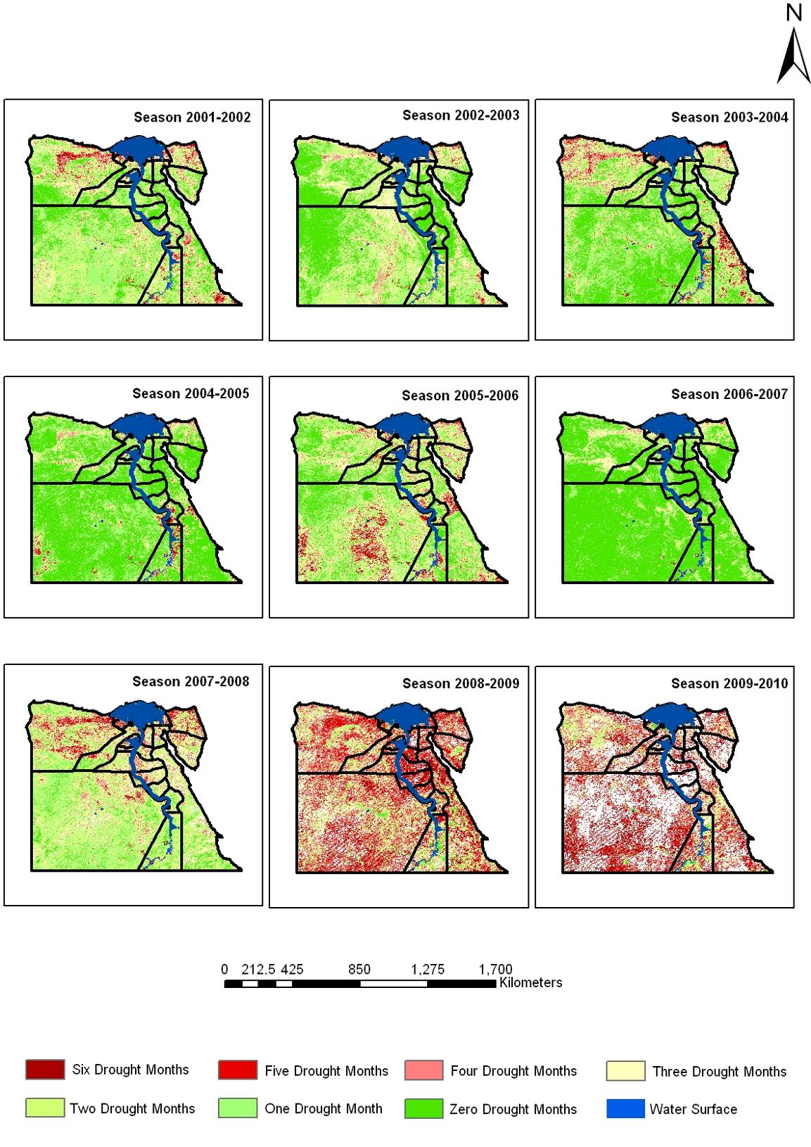
Figure (10): Consecutive of seasonal Drought Months from 2001/2002 to 2009/2010 on Egyptian map.

Conclusion
Monitoring drought by remote sensing technique, reflect the dynamic changes of the Land coverage area. In this study, a research was done to utilize satellite images for drought monitoring of cultivating winter season in Egypt from season 2001/2002 to 2009/2010 seasons using Vegetation Health Index (VHI).
Results indicated that, the remote sensing technique a significant change can be monitored for the vegetation coverage on a specific area. The Northern coastal zone was the highest affected area by drought in Egypt, supplementary irrigation was needed to improve the green cover during the winter season. On the other hand, season 2009/2010 had the highest drought situation in Egypt during the studied months of the winter season; season 2006/2007 was the lowest drought situation in most months of the winter season. Further studies on the drought monitoring by connecting the data from these satellite images could be compared with actual field survey.

Recommendation
The food security is the most important challenges that the agricultural sector at present has to face and that are very likely to grow in importance, especially under future conditions of climate change. This study recommended on strategic action level to concentrate on the agriculture activity in the Northern coastal zone by supplementary irrigation during the winter season to improve the crop productivity of this area, expended the cultivated area (the potential cultivate area is estimating about 6 million acre) and to increase the food security.

Acknowledgment

The study team extends their deep gratitude and sincere thanks to Arab Center for the Study of Arid Zones and Dry Lands (ACSAD), (Syria) for advice, valuable assistance, and faithful attitude during the preparation of this study.

Correspondence author
F. A. Hashem
Central laboratory for Agricultural Climate (CLAC), Agricultural Research Centre, Giza- Egypt
Fadl_hashem@yahoo.com

5. References
- Abd El-Maaboud M.S., M.A. Medany, M. Edriss, and A. F. Abou-Hadid. (2004). Climate change and productivity of some wheat cultivars under rainfed and supplementary irrigation conditions. In: Cantero-Martínez, C. (ed.) and Gabiña D. (ed.). Mediterranean rainfed agriculture: Strategies for sustainability Workshop. Zaragoza (Spain): CIHEAM-IAMZ. PP: 139-146.
- Abd El-Rahman G. (2009). Water use efficiency of wheat under drip irrigation systems at Al-Maghara area, North Sinai, Egypt. American-Eurasian J. Agric. And Environ. Sci.5 (5):664-670.
- Abouzeid M. (1992). Study on irrigation. Water Res. Centre, Ministry of Irrigation and Water Resources, Cairo, Egypt.
- Agnew C. T. (1999). Using the SPI to Identify Drought. Drought Network News. 12: 6-11.
- AQUASTAT - FAO’s Information System on Water and Agriculture. http://www.fao.org/nr/water/aquastat/main/index.stm
- Brown J., C. Jenkerson, and G. Yingxin. (2008). Using eMODIS Vegetation Indices for Operational Drought Monitoring. NIDIS Workshop on Remote Sensing.
- David D. Breshears, Neil S. Cobb, Paul M. Rich, Kevin P. Price, Craig D. Allen, Randy G. Balice, William H. Romme, Jude H. Kastens, M. Lisa Floyd, Jayne Belnap, Jesse J. Anderson, Orrin B. Myers, and Clifton W. Meyer (2005). Regional vegetation die-off in response to global-change-type drought. 102: 42.
- El-Shaer H.M., C. Rosenzweig, A. Iglesias, M.H. Eid, and D. Hillel (1997). Impact of climate change on possible scenarios for Egyptian agriculture in the future. Mitig. Adapt. Strategies Global Change 1: 233-250.
- FAO. (2003). Strategy of Agricultural Development in Egypt Up To 2017. MOA. May 2003, Cairo, Egypt (In Arabic).
- Fleiss J. L. (1981) Statistical methods for rates and proportions. 2nd ed. (New York: John Wiley) pp. 38–46 and 59-60.
- Hadi Radhi M.A. (1992). Water Resource in the Present and the Future. In: Towards a Strategy for Egyptian Agriculture in the Nineties. Conference on A strategy for Egyptian Agriculture in the Nineties, MOALR, 16–18 February 1992, Cairo.
- Jeyaseelan A.T. (2003). Droughts and Floods Assessment and Monitoring using remote sensing and GIS. In: Satellite Remote Sensing and GIS Applications in Agricultural Meteorology. pp.291-313.
- Karnieli A., M. Bayasgalan, Yu. Bayarjargal, N. Agam, S. Khudulmur, and C.J. Tucker. (2006). Comments on the use of the Vegetation Health Index over Mongolia. International Journal of Remote Sensing. 27: 2017-2024.
- Kogan F.N. (2000). Satellite-observed sensitivity of world land ecosystems to El Nino/La Nina. Remote Sensing of Environment, 74: 445–462.
- Liebetrau Albert M. (1985). Measures of association. 2nd printing. Quantitative Applications in the Social Sciences (no. 07-032). Sage Publications: Beverly Hills. 95p.
- McKee T. B., N. J. Doesken, and J. Kleist (1995). Drought monitoring with multiple time scales. Proceedings of the Ninth Conference on Applied Climatology; pp. 233–236. American Meteorological Society, Boston.
- Nasa WIST website https://wist-ops.echo.nasa.gov/api/
- SAS (2000). Statistical Analysis System, SAS User’s Guide: Statistics. SAS Institute Inc. Editors, Cary, NC.
- Thenkabail P.S., E.A. Enclona, M.S. Ashton, C. Legg, M. Jean De Dieu (2004). Hyperion, IKONOS, ALI, and ETM+sensors in the study of African rainforests. Remote Sensing of Environment 90: 23–43.
- World Factbook area rank order. Cia.gov. Retrieved 21 February 2012.https://www.cia.gov/library/publications/the-worldfactbook/geos/eg.html
- Yousif M. (2011). Exploitation of the Wasted Nile Water in the Mediterranean Sea. European Water 33: 29-32.

7/2/2012

