Weighting of infiltration parameters in the furrow irrigation

Haghnazari, F.¹, Boroomand-Nasab, S.¹, Naseri, A.¹, sheinidashtegol, A.²

¹Department of Irrigation and Drainage, Shahid Chamran University of Ahwaz, Iran
²Employee of the Irrigation and Drainage Sugarcane Research And Training Development and By-Products Khuzestan, Iran.
Farzad.nazari.85@gmail.com

Abstract: The most important physical characteristic of the agricultural soil is infiltration. Infiltration depth in each functional area of wetted perimeter, the final infiltration rate and permeability properties of the soil is an opportunity time to influence and change each of these parameters will influence variations. In this study for survey effects of wetted perimeter, the final infiltration rate and the opportunity time to influence the amount of infiltration in a furrow irrigation during the crop season and infiltration tests for sugarcane crop during the growing season for four irrigated farm inflow to the outflow method ARC-2 agro units located in 50 km south of Ahwaz Amirkabir done. To evaluate the effect on these parameters infiltration the amount of branching equation Kostiakov - Lewis was used. The spatial and seasonal variations wetted perimeter, the final infiltration rate, cumulative infiltration and infiltration coefficient b in the equation was calculated to determine variations in the furrows. The results indicated is spatial and seasonal final infiltration rate variation in during the furrow is Aligns the cumulative infiltration of spatial and temporal variations are significant at 5% significance level. The spatial and seasonal variations wetted perimeter with spatial and seasonal variations the amount cumulative infiltration that not aligns Being a non-aligns of the impact of two wetted perimeter reduces the amount of cumulative infiltration. Also spatial and seasonal coefficient b variations a have decrease been a in the 5% significance level means is significant. Reduce of this coefficient of the amount wetted perimeter that impact on the cumulative amount reduces. Also The three parameters to determine the effect of wetted perimeter, opportunity time and final infiltration rate of the cumulative infiltration of the Levine test is used, this test was significant at the 5% significance level and its impact factors for the parameters in wetted perimeter, final infiltration rate and opportunity time the respectively 0.17 and 0.72 and 0.474 is a parameter that indicates that have the greatest impact on the amount cumulative infiltration is final infiltration rate.
[Haghnazari, F., Boroomand-Nasab, S., Naseri, A., sheinidashtegol, A. Weighting of infiltration parameters in the furrow irrigation World Rural Observ 2012;4(3):46-56]. ISSN: 1944-6543 (Print); ISSN: 1944-6551 (Online). http://www.sciencepub.net/rural. 6

Keywords: Furrow Irrigation, Infiltration rate, Infiltration Variation, Cumulative Infiltration.

1. Introduction
Surface irrigation is used all over the world extensively as an inexpensive and technologically simple irrigation method (Elliot and Walker 1982). From the physical point of view, the irrigation event is composed of free flow of water above the ground, and of the infiltration (and distribution) of the water in the subsurface .Furrow irrigation is one of several methods of surface irrigation (Abolfazl NASSERI et al.,2004). In surface irrigation, soil is not only the water destination but also the means by which water is distributed over the irrigated field. Infiltration is one of the most important soil parameters in the design and evaluation of the surface irrigation methods (Karmeli et al., 1978; Walker and Skogerboe, 1987; Elliot and Walker, 1982; Zerihun et al., 1996; Oyonarte et al., 2002). In furrow irrigation, water flows along small channels without covering the entire soil surface. Infiltration through the wetted perimeter occurs from the moment water reaches a given point in the furrow until it recedes. The infiltrated depth at a given point will therefore be a function of opportunity time, wetted perimeter, and soil-intake characteristics, and its variability along the furrow will depend on the variability of these factors. Other variables, such as slope and roughness, will also have an influence through their effect on the previously mentioned factors. Notwithstanding the multiplicity of variability sources, opportunity time is frequently considered as the only variability source in the evaluation and design of furrow irrigation. Variability of the opportunity time along the furrow may be small if the advance time is a small fraction of the application time, as often occurs in soils with low infiltration rate. In this case, the overestimation of irrigation uniformity could be particularly important when other variability sources are neglected.
Jaynes and Clemmens (1986) used a combination of variance technique in border irrigation, distinguishing the variance due to the heterogeneity of soil-intake characteristics and that due to differences in opportunity time. With opportunity-time coefficients of variation less than 0.15 (representing well-irrigated borders), Jaynes and Clemmens (1986) found that the variance of infiltration caused by the variance in opportunity time across the border was virtually insignificant for their numerical examples, whereas soil-intake characteristics variability accounted for most of the variance. Childs et al. (1993) also showed the relevance of soil-intake characteristics on the determination of infiltration variability. Wallender (1986) found that simulated uniformity assuming an average infiltration equation was much higher than the uniformity obtained assuming a uniform opportunity time. In addition, when the average infiltration depth rose, the influence of soil variability on irrigation uniformity was maintained, whereas the influence of opportunity time decreased. Since infiltration is related to wetted perimeter (Fagmeier and Ramsey 1978), wetted perimeter variability should have an effect on infiltrated depth variability. Izadi and Wallender (1985) used a correlation analysis to evaluate the effect of variability of wetted perimeter on infiltrated depth variability. They found that a third of the infiltration variability was accounted for by wetted perimeter differences. Spatial variability requires that a field representative infiltration function is modified to reflect the variations in hydraulic factors (for example, wetted perimeter and inflow) and soil intake characteristics across the field (Clemmens 2000; Strelkoff et al. 2000; Oyonarte et al. 2002).
2. Methodology
Sugarcane is an important crop of tropical areas such as Iran. It has a fibrous root system which can penetrate as deep as 2.5 m in well-drained soils. Thus, the crop utilizes most of the moisture stored in the root-zone. The life cycle of sugarcane is divided into four distinct phases namely germination phase (from planting to 60th day); formative phase (from 60th to 130th day); grand growth phase (from 130th to 250th day) and maturity phase (250th to 365th day). The total water requirement for sugarcane varies from 200-300 centimeters. The crop requires an average of 7 irrigations; however, this may increase to 8 to 10 irrigations in drier climate and light soil textures. In each irrigation , 3 acre inch of water should be applied. This research was carried out in ARC2-7 farm from January 2010 to December 2011. As one of the research fields of Sugarcane Research Center in Amir Kabir Sugarcane Planting and by products company of Khuzestan, the farm is located southwest of Iran. The soil had silty-loam texture with 28% sand, 43% silt, and 24% clay. The field work was conducted on one set of furrow irrigation. In this set had five furrows 1.8 m wide and 140 m long. The middle furrow in this set was used to take measurements, while the side furrows were used as buffering area. By measuring inflow, outflow, and calculating surface water storage, the volume of infiltrated water was determined. The advance and recession times were recorded at 14 points at 10 m intervals along each furrow. Four irrigation events were examined. Taking soil samples from the furrows at three depths (0-30, 30-60 and 60-90 centimeters), soil water content were measured, using weighing method, to determine infiltration depth and irrigation time and volume, one day before and two days after each irrigation events. In this set was used to study the spatial and temporal infiltration variability along a furrow and during planting season. Thus, using five fiberglass flumes, a furrow was divided into four reaches each 35 m long (variable furrow). Five flow meters were installed at the beginning of each reach (0, 35, 70, 105 and 140 meters away from the inlet) of each furrow. The four reaches were in series; thus the inflow to one reach was the outflow from the previous one. For each irrigation event, the flow depth in each flume was measured in order to determine the discharge in the flume by:
Q = cWH3/2 (1)
Where Q is the discharge (in m3/s), W is the width of opening (in meter), H is the depth of flow (in meter) and c is a coefficient of discharge which depends on the geometry of the culvert. A typical value is 0.6.more precise can be taken from tables such as in USDA-ARS (1979).
The surface runoff ,average water infiltration for each furrow were taken from inflow and outflow hydrographs. Then, infiltration rate values were obtained for each reach and the coefficient of variation of final infiltration rate (CV fo) was obtained for total length of furrow.
2.1. Infiltration Equation
Soil infiltration characteristics are usually expressed in a time-dependant infiltration equation (Bavi et al., 2012). Cumulative soil water infiltration has been commonly represented by Kostiakov and Kostiakov–Lewis equations (Holzapfel et al., 2004). One of the shortcomings of the first one is that when opportunity time is high, infiltration rate tends to zero, which is known to be incorrect. On the other hand, the Kostiakov-Lewis equation may lead to an overestimation of cumulative infiltration at high-opportunity times. These shortcomings may be eliminated with a modification of the Kostiakov-Lewis equation, the branched infiltration equation (Clemmens 1981):
Z_r=kT^a for T≤T_f (1)

Z_r=kT_f^a+(T-T_f ) for T≥ T_f (2)

Where Z (m^3 m^(-1)) is the cumulative infiltration for a reference wetted perimeter, f_0 (m^3 m^(-1) 〖min〗^(-1)) is the final infiltration rate, T (min) is the opportunity time, T_f (min) is the opportunity time from which the infiltration rate is equal to the final infiltration rate, and k (m^3 m^(-1) 〖min〗^(-a)) and a (non dimensional) are empirical parameters.
Using Eqs. (1) and (2) to describe infiltration, the variability sources are opportunity time and soil intake characteristics, given by k, a and f o . In order to consider the relationship between wetted perimeter and cumulative infiltration, Eqs. (1) and (2) were modified according to Eq. (13) in Strelkoff and Souza (1984) and according to Blair and Smerdon (1985)
Z=Z_r (WP/〖WP〗_r )^b (3)

Where 〖WP〗_r (m) is the reference wetted perimeter, WP (m) is the current wetted perimeter, and Zr is the reference infiltration, empirically determined under a reference wetted perimeter. The exponent b was assumed equal to 1.0 by Strelkoff and Souza (1984) and determined empirically for several soils by Blair and Smerdon (1985). These authors obtained b values of 1.5, 1.6, and 1.0 for a sandy loam, a silty clay loam, and a fine sandy loam soil, respectively. However, note that our infiltration model [Eqs. (12) and (14)] differs from the models of Strelkoff and Souza (1984) and Blair and Smerdon (1985). Because, these authors used the Kostiakov equation, while we used the branched Eq. (1,2).
2.2. Furrow Infiltrometer
Criddle et al. (1956) suggested, infiltrometer for estimating the infiltration rate, which required measurements of inflow and outflow at the inlet and outlet of the furrow as well as the length and the wetted perimeter of the furrow. Infiltration rate is calculated as follows:
fo = Qin – Qout /L (4)

where Qin and Qout are the inflow and outflow rates in m3 s-1 after a long time (more than 4 h at basic infiltration rate) and L the furrow length in m. It should be noted that the infiltration rate decreases as the soil gradually becomes saturated. Ultimately, the supply rate exceeds the capability of the soil to absorb the water; for which, the infiltration rate approaches the final infiltration rate f0.
2.3 Weighting of infiltration parameters
The weighting parameters to obtain the most impact on the amount cumulative infiltration, means to determining which of these parameters has most impact on the amount of cumulative infiltration. For weighting infiltration parameters, spatial and seasonal the cumulative infiltration, opportunity time, wetted perimeter, the final infiltration rate and coefficient b in Equation (3) variation was evaluated. Analysis of variance and Tukey test for spatial variation was used, also for assess the seasonal variations of comparing paired samples T test was used. To obtain most impact on infiltration parameters of the cumulative infiltration of two-way analysis of variance and covariance were used. The SPSS was used to test software.

3. Results and discussion
Table (1, 2) field data and Kostiakove-Lewis parameters used for weighting infiltration parameters shows
Where f0 is final infiltration rate, Qo is inflow rate, wetted perimeter, T is opportunity time, b is coefficient variation in Equation 3, L is reach length, S0 is field slope, n coefficient Manning,s and W sepration between furrow.
3.1. Spatial and Seasonal Wetted Perimeter Variation
According to the table (3) and (4) is observed that spatial and seasonal wetted perimeter Variations was significant at 5% significance level. The spatial wetted perimeter variation is a process decrease, but the seasonal variations has it increased (Figures 1 and 2).
3.2. Spatial and Seasonal coefficient b variation in Equation 3
According to the table (5) and (6) is observed that spatial and seasonal coefficient b variation was significant at 5% significance level. And according to the figures (3 and 4) the spatial and seasonal variations is a reduction process. Reduce the value of this coefficient represents the effect of reducing the amount of wetted perimeter is cumulative infiltration (Oyonarte 2002).
3.3. Spatial and Seasonal Final Infiltration Rate Variation
The final infiltration rate at 5% significance level spatial variation meaningless, but seasonal it variations the significance level of 5% is significant (Table 7 and 8). According to Figure 5 and 6 is observed that the spatial and temporal variations the final infiltration rate is a decreasing process.
3.4. Spatial and Seasonal Cumulative Infiltration Variation
The Cumulative infiltration at 5% significance level spatial variation meaningless, but seasonal it variations the significance level of 5% is significant (Table 9 and 10). According to Figure 7 and 8 is observed that the spatial and seasonal variations the cumulative infiltration is a decreasing process.

3.5. The most effective infiltration equation parameters on the amount of the cumulative infiltration
To investigate the most effective parameters on the infiltration equation for cumulative infiltration in the furrows of the results above are evaluated, and finally using two-way ANOVA for the effects of four irrigation show. As explained variation infiltration depended on to the main factor final infiltration rate, opportunity time and wetted perimeter. Cumulative infiltration with these parameters variation will change, parameter that variations is aligns with the cumulative infiltration variations will have the most influence on the amount of cumulative (Oyonarte).
The contents told in parts 3.1 to 3.4 turns out to be the final infiltration rate with are collinear spatial and seasonal cumulative infiltration variations and other parameters are not aligned with a cumulative infiltration.

Table (1) field data and Kostiakove-Lewis parameters
Parameters | Irrigation 3 |  |  |  | Irrigation 4
reach | reach 1 | reach 2 | reach 3 | reach 4 | reach 1 | reach 2 | reach 3 | reach 4
f0(m³/m/min) | 0.000144 | 0.000121 | 0.00011 | 0.000079 | 0.00014 | 0.000111 | 0.000108 | 0.00008
Q (Lit/s) | 1.55 | 1.22 | 0.92 | 0.63 | 1.55 | 1.24 | 0.97 | 0.696
Wp (m) | 0.862 | 0.848 | 0.831 | 0.811 | 0.865 | 0.85 | 0.833 | 0.8125
T (min) | 549 | 535 | 498 | 438 | 523 | 500 | 432. | 348.5
b | 0.42 | 0.35 | 0.27 | 0.21 | 0.41 | 0.35 | 0.26 | 0.21
L(m) | 35 | 35 | 35 | 35 | 35 | 35 | 35 | 35
S0(m/m) | 0.0004 | 0.0004 | 0.0004 | 0.0004 | 0.0004 | 0.0004 | 0.0004 | 0.0004
n(ml/6) | 0.04 | 0.04 | 0.04 | 0.04 | 0.04 | 0.04 | 0.04 | 0.04
W(m) | 1.8 | 1.8 | 1.8 | 1.8 | 1.8 | 1.8 | 1.8 | 1.8

Table (2) field data and Kostiakove – Lewis parameters

Parameters | Irrigation1 |  |  |  | Irrigation 2
Reach | reach 1 | reach 2 | reach 3 | reach 4 | reach 1 | reach 2 | reach 3 | reach 4
f0(m³/m/min) | 0.000205 | 0.00017 | 0.00012 | 0.000116 | 0.000155 | 0.00012 | 0.00011 | 0.000088
Q_{o}(Lit/s) | 1.55 | 1. 13 | 0. 73 | 0.35 | 1.55 | 1.18 | 0.84 | 0.51
Wp(m) | 0.854 | 0.839 | 0.823 | 0.801 | 0.861 | 0.842 | 0.826 | 0.804
T(min) | 661 | 633. | 513 | 375. | 497 | 483 | 466 | 383
b | 0.68 | 0.55 | 0.45 | 0.34 | 0.53 | 0.36 | 0.29 | 0.23
L(m) | 35 | 35 | 35 | 35 | 35 | 35 | 35 | 35
S₀(m/m) | 0.0004 | 0.0004 | 0.0004 | 0.0004 | 0.0004 | 0.0004 | 0.0004 | 0.0004
n(ml/6) | 0.04 | 0.04 | 0.04 | 0.04 | 0.04 | 0.04 | 0.04 | 0.04
W(m) | 1.8 | 1.8 | 1.8 | 1.8 | 1.8 | 1.8 | 1.8 | 1.8
Table (3) spatial wetted perimeter Variations used test Tukey HSD

Test | (I) Sec | (J) Sec | Mean Difference (I-J) | Std. Error | Sig.
Tukey HSD | 1 | 2 | 1.57500* | 0.35795 | .004
Tukey HSD | 1 | 3 | 3.22500* | 0.35795 | .000
Tukey HSD | 1 | 4 | 5.50000* | 0.35795 | .000
Tukey HSD | 2 | 1 | -1.57500* | 0.35795 | .004
Tukey HSD | 2 | 3 | 1.65000* | 0.35795 | .003
Tukey HSD | 2 | 4 | 3.92500* | 0.35795 | .000
Tukey HSD | 3 | 1 | -3.22500* | 0.35795 | .000
Tukey HSD | 3 | 2 | -1.65000* | 0.35795 | .003
Tukey HSD | 3 | 4 | 2.27500* | 0.35795 | .000
Tukey HSD | 4 | 1 | -5.50000* | 0.35795 | .000
Tukey HSD | 4 | 2 | -3.92500* | 0.35795 | .000
Tukey HSD | 4 | 3 | -2.27500* | 0.35795 | .000

Paired Samples Test
Pair | Section | Paired Differences |  | t | Df | Sig. (2-tailed)
Pair | Section | 95% Confidence Interval of the Difference |  | t | Df | Sig. (2-tailed)
Pair | Section | Lower | Upper | t | Df | Sig. (2-tailed)
Pair 1 | Sec1 - Sec2 | 1.22217 | 1.92783 | 14.206 | 3 | .001
Pair 2 | Sec1 - Sec3 | 2.92379 | 3.52621 | 34.073 | 3 | .000
Pair 3 | Sec1 - Sec4 | 4.81251 | 6.18749 | 25.460 | 3 | .000
Pair 4 | Sec2 - Sec3 | 1.55813 | 1.74187 | 57.158 | 3 | .000
Pair 5 | Sec2 - Sec4 | 3.57217 | 4.27783 | 35.403 | 3 | .000
Pair 6 | Sec3 - Sec4 | 1.87719 | 2.67281 | 18.200 | 3 | .000
Table (4) Seasonal wetted perimeter Variations used Paired Samples Test
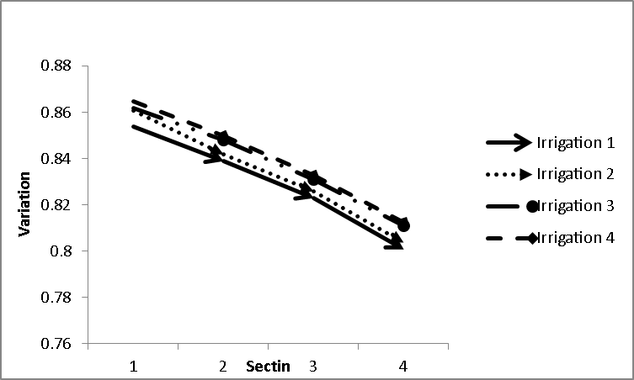

Figure (1) spatial wetted perimeter Variations
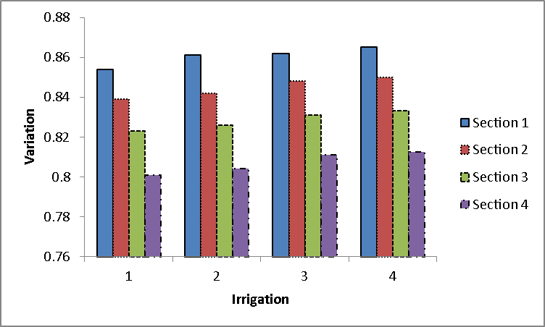

Figure (2) Seasonal wetted perimeter Variations

Table (5) spatial coefficient b variation used Tukey HSD test
Test | (I) Sec | (J) Sec | Mean Difference (I-J) | Std. Error | Sig.
Tukey HSD | 1 | 2 | 0.109058000 | 0.067273163 | 0.404
Tukey HSD | 1 | 3 | 0.193607750 | 0.067273163 | 0.058
Tukey HSD | 1 | 4 | 0.263244750* | 0.067273163 | 0.010
Tukey HSD | 2 | 1 | -0.109058000 | 0.067273163 | 0.404
Tukey HSD | 2 | 3 | 0.084549750 | 0.067273163 | 0.605
Tukey HSD | 2 | 4 | 0.154186750 | 0.067273163 | 0.154
Tukey HSD | 3 | 1 | -0.193607750 | 0.067273163 | 0.058
Tukey HSD | 3 | 2 | -0.084549750 | 0.067273163 | 0.605
Tukey HSD | 3 | 4 | 0.069637000 | 0.067273163 | 0.733
Tukey HSD | 4 | 1 | -0.263244750* | 0.067273163 | 0.010
Tukey HSD | 4 | 2 | -0.154186750 | 0.067273163 | 0.154
Tukey HSD | 4 | 3 | -0.069637000 | 0.067273163 | 0.733

Table (6) seasonal coefficient b variation used Paired Samples Test
Paired Samples Test
Pair | Section | Paired Differences |  | t | df | Sig. (2-tailed)
Pair | Section | 95% Confidence Interval of the Difference |  | t | df | Sig. (2-tailed)
Pair | Section | Lower | Upper | t | df | Sig. (2-tailed)
Pair 1 | Sec1 - Sec2 | .028334359 | .189781641 | 4.299 | 3 | 0.023
Pair 2 | Sec1 - Sec3 | .116701386 | .270514114 | 8.012 | 3 | 0.004
Pair 3 | Sec1 - Sec4 | .157485504 | .369003996 | 7.921 | 3 | 0.004
Pair 4 | Sec2 - Sec3 | .065583966 | .103515534 | 14.187 | 3 | 0.001
Pair 5 | Sec2 - Sec4 | .101058211 | .207315289 | 9.236 | 3 | 0.003
Pair 6 | Sec3 - Sec4 | .030210124 | .109063876 | 5.621 | 3 | 0.011

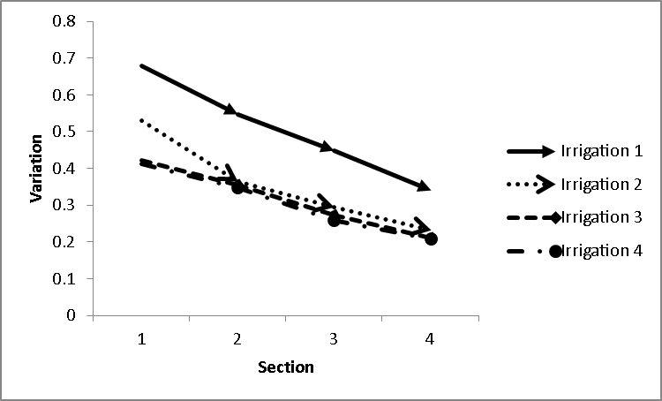

Figure (3) spatial coefficient b Variations

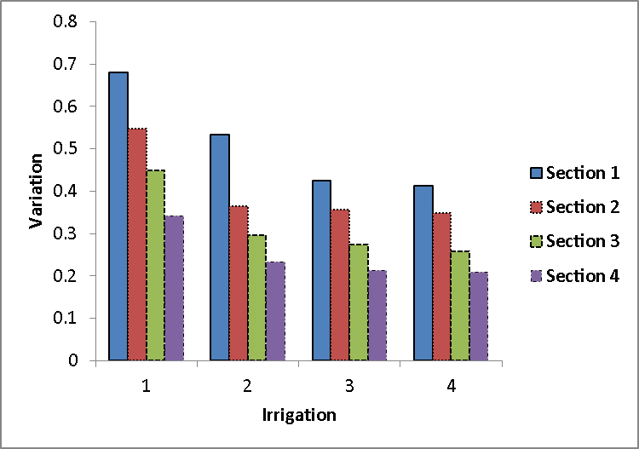

Figure (4) Seasonal coefficient b Variations

Table (7) spatial final infiltration rate variation used Tukey HSD test

Test | (I) Sec | (J) Sec | Mean Difference (I-J) | Std. Error | Sig.
Tukey HSD | 1 | 2 | 0.000007500 | 0.005236941 | 0.967
Tukey HSD | 1 | 3 | 0.000010000 | 0.005236941 | 0.928
Tukey HSD | 1 | 4 | 0.000020000 | 0.005236941 | 0.631
Tukey HSD | 2 | 1 | 0.000007500 | 0.005236941 | 0.967
Tukey HSD | 2 | 3 | 0.000002500 | 0.005236941 | 0.999
Tukey HSD | 2 | 4 | 0.000012500 | 0.005236941 | 0.872
Tukey HSD | 3 | 1 | -0.000010000 | 0.005236941 | 0.928
Tukey HSD | 3 | 2 | -0.000002500 | 0.005236941 | 0.999
Tukey HSD | 3 | 4 | -0.000010000 | 0.005236941 | 0.928
Tukey HSD | 4 | 1 | -0.000020000 | 0.005236941 | 0.631
Tukey HSD | 4 | 2 | -0.000012500 | 0.005236941 | 0.872
Tukey HSD | 4 | 3 | -0.00001000 | 0.005236941 | 0.928

Table (8) seasonal final infiltration rate variation used Paired Samples Test

Paired Samples Test
Pair | Section | Paired Differences |  | t | df | Sig. (2-tailed)
Pair | Section | 95% Confidence Interval of the Difference |  | t | df | Sig. (2-tailed)
Pair | Section | Lower | Upper | t | df | Sig. (2-tailed)
Pair 1 | Sec1 - Sec2 | .028334359 | .189781641 | 3 | 3 | 0.042
Pair 2 | Sec1 - Sec3 | .116701386 | .270514114 | 2 | 3 | 0.048
Pair 3 | Sec1 - Sec4 | .157485504 | .369003996 | 5 | 3 | 0.015

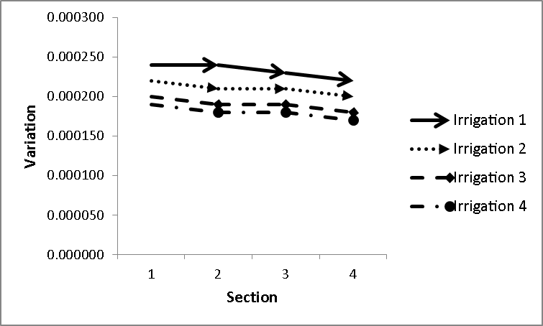

Figure (5) spatial final infiltration rate Variations
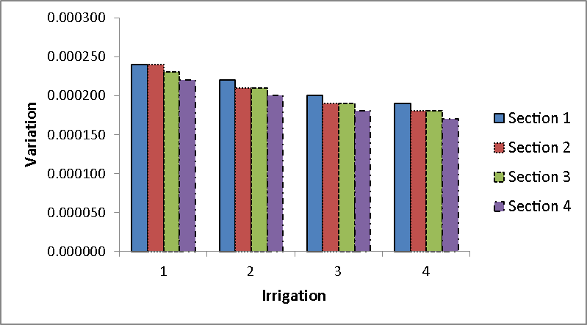

Figure (6) Seasonal final infiltration rate Variations

Table (9) spatial Cumulative Infiltration variation used Tukey HSD test
Test | (I) Sec | (J) Sec | Mean Difference (I-J) | Std. Error | Sig.
Tukey HSD | 1 | 2 | 0.005359750 | 0.009939010 | 0.948
Tukey HSD | 1 | 3 | 0.008224250 | 0.009939010 | 0.840
Tukey HSD | 1 | 4 | 0.013787500 | 0.009939010 | 0.530
Tukey HSD | 2 | 1 | -0.005359750 | 0.009939010 | 0.948
Tukey HSD | 2 | 3 | 0.002864500 | 0.009939010 | 0.991
Tukey HSD | 2 | 4 | 0.008427750 | 0.009939010 | 0.831
Tukey HSD | 3 | 1 | -0.008224250 | 0.009939010 | 0.840
Tukey HSD | 3 | 2 | -0.002864500 | 0.009939010 | 0.991
Tukey HSD | 3 | 4 | 0.005563250 | 0.009939010 | 0.942
Tukey HSD | 4 | 1 | -0.013787500 | 0.009939010 | 0.530
Tukey HSD | 4 | 2 | -0.008427750 | 0.009939010 | 0.831
Tukey HSD | 4 | 3 | -0.005563250 | 0.009939010 | 0.942

Table (10) seasonal Cumulative Infiltration variation used Paired Samples Test
Paired Samples Test
 |  | Paired Differences |  | t | df | Sig. (2-tailed)
 |  | 95% Confidence Interval of the Difference |  | t | df | Sig. (2-tailed)
 |  | Lower | Upper | t | df | Sig. (2-tailed)
Pair 1 | Sec1 - Sec2 | .003221802 | .007497698 | 7.978 | 3 | .004
Pair 2 | Sec1 - Sec3 | .004754415 | .011694085 | 7.543 | 3 | .005
Pair 3 | Sec1 - Sec | .009924560 | .017650440 | 11.359 | 3 | .001
Pair 4 | Sec2 - Sec3 | -.002636488 | .008365488 | 1.657 | 3 | .0496
Pair 5 | Sec2 - Sec | .002649379 | .014206121 | 4.642 | 3 | .019
Pair 6 | Sec3 - Sec | .004796746 | .006329754 | 23.098 | 3 | .000
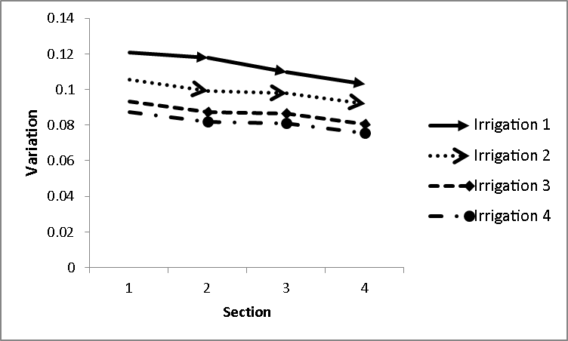

Figure (7) spatial Cumulative Infiltration Variations
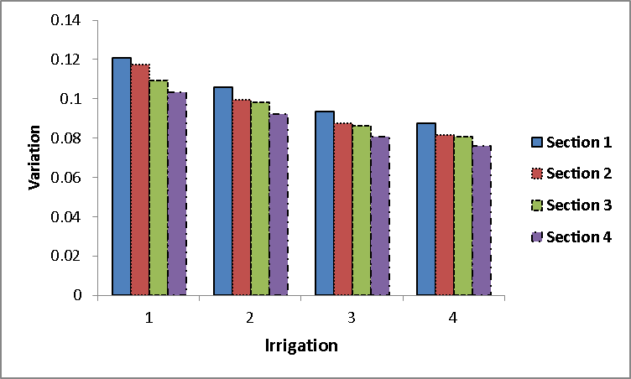

Figure (8) Seasonal Cumulative Infiltration Variations

Table (11) shows the effect parameters final infiltration rate and the opportunity time the cumulative infiltration
Tests of Between-Subjects Effects
Dependent Variable:z
Source | df  10  1  3  3  1  1  1 | F | Sig. | Partial Eta Squared
Corrected Model | df  10  1  3  3  1  1  1 | 297.072 | 0.000 | .999
Intercept | df  10  1  3  3  1  1  1 | .080 | 0.791 | .020
Ir | df  10  1  3  3  1  1  1 | 1.697 | 0.304 | .560
sec | df  10  1  3  3  1  1  1 | .623 | 0.637 | .318
f0 | df  10  1  3  3  1  1  1 | 10.282 | 0.033 | .720
T | df  10  1  3  3  1  1  1 | 3.612 | 0.042 | .474
wp | df  10  1  3  3  1  1  1 | .069 | 0.065 | .017
T * wp | df  10  1  3  3  1  1  1 | 3.819 | 0.033 | .488

4．Conclusion
The survey that described in the above we reached result to this that final infiltration rate has the most influence on the cumulative infiltration. And its sensitivity to the final infiltration rate is more of the wetted perimeter an opportunity time. Opportunity time and wetted perimeter variations on the cumulative infiltration variation is little. To show effect of each of these parameters on the cumulative influence of two-way analysis of variance and covariance is used. The results showed in the table (11). Table 11 shows the effect parameters final infiltration rate and the opportunity time the cumulative infiltration is significant at the 5% percent significance level. But the effect of wetted perimeter on the amount of cumulative infiltration is meaningless 5% percent significance level. The next option on the table (11) test of effect of parameters on the amount of cumulative infiltration is E impact factor the effect shows each of these parameters on the cumulative infiltration. According to the table (11) the most effective respectively is related to the final infiltration rate, opportunity time and the wetted perimeter. The coefficient value of E for the final infiltration rate equal to 0.72 and for the opportunity time and wetted perimeter is 0.017 and 0.474, respectively. Resulted that obtained by Oyonarte (2002) is similar to this study.

Acknowledgments:
The authors should like to acknowledge the Excellency of Water Sciences Engineering of Shahid Chamran University of Ahvaz (Iran) for their financial support and assistance and the Sugarcane Research and Training Development and By-Products Khuzestan, Iran.

Correspondence to:
Farzad Haghnazari Department of Irrigation and Drainage, Shahid Chamran University of Ahwaz, Iran
Farzad.nazari.85@gmail.com

References
- Blair, A. W., and Smerdon, E. T. (1985). ‘‘Evaluation of empirical equations describing the effect of wetted perimeter on infiltration in furrows.’’ ASCE Irrig. and Drain. Specialty Conf. Proc., San Antonio.
- Strelkoff, T., and Souza, F. (1984). ‘‘Modeling effect of depth on furrow infiltration.’’ J. Irrig. Drain. Eng., 110(4), 375–387.
- Clemmens, A. J. (1981). ‘‘Evaluation of infiltration measurements for border irrigation.’’ Agric. Water Manage, 3(4), 251–267.
- Clemmens AJ (2000) "Measuring and improving irrigation system performance at the field level". Water - Essential for Life, Proceedings of Irrigation Australia 2000, Irrigation.
- Oyonarte NA, Mateos L, Palomo MJ (2002). " Infiltration variability in furrow irrigation". Journal of Irrigation and Drainage Engineering 128(1): 26-33.
- Strelkoff TS , Clemmens. AJ, Bautista E (2000). " Field- parameter eestimation for surface irrigation management and design". Watershed Management 105(142)
- Furman ,A. Warrick, A. Zerihun, W. D. and Sanchez, C. A.(2006)" Modified Kostiakov Infiltration Function: Accounting for Initial and Boundary Conditions ". 10.1061/(ASCE)0733-9437(2006)132:6(587)
- Abolfazl NASSERI et .al. (2003). "Field-Measured Furrow Infiltration Functions " Turk J Agric For 28 (2004) 93-99.
- Karmeli, D., Salazar, L.,Walker,W., (1978)." Assessing the spatial variability of irrigation water application".Office of Research and Development US Environmental Protection Agency, Oklahoma, USA.
- Walker, W.R., Skogerboe, G.V., (1987). "Surface Irrigation Theory and Practice". Prentice-Hall, Englewood Cliffs, NJ.
- Elliot, R.L., Walker, W., 1982. Field evaluation on furrow infiltration and advance functions. Trans. ASAE 25, 396–400.
- Zerihun, D., Feyen, J., Reddy, J.M., 1996 . " Sensitivity analysis of furrow-irrigation performance parameters." J. Irrig. Drain. Eng. ASCE 122, 49–57.
- Jaynes, D . B ., and Clemmens, A. J. (1986). ‘‘Accounting for spatially variable infiltration in borders irrigation models.’’ Water Resour. Res., 22(8), 1257–1262.
- Childs, J. L. , Wallender, W. W., and Hopmans, J. W. (1993). ‘‘ Spatial and seasonal variation of furrow irrigation.’’ J. Irrig. Drain. Eng., 119(1), 74–90.
- Izadi, B., and Wallender, W. W. (1985). ‘‘Furrow hydraulic characteristics and infiltration.’’ Trans. ASAE, 28(6), 1901–1908.
- Wallender, W. W. (1986). ‘‘Furrow model with spatially varying infiltration.’’ Trans. ASAE, 29(4), 1012–1016.
- Fangmeier, D. D., and Ramsey, M. K. (1978). ‘‘Intake characteristics of irrigation furrows.’’ Trans. ASAE, 21(4), 696–700.
- Holzapfel, E. A., Jara, J., Zuñiga, C., Mariño, M. A., Paredes, J., and Billib, M.(2004). "Infiltration parameters for furrow irrigation." Agricultural Water Management 68 (2004) 19–32.
- Bavi, A., Boroomand-Nasab, S., Naseri, A., and Meskarbashi, M.(2012). " Impacts of Infiltration Variability on Furrow Irrigation Performances." New York Science Journal;5(6).

