Application of Geographic Information System (GIS) for mapping agricultural land use in Muyongwe sector,
Gakenke district, Northern province, Rwanda

Alphonse Nahayo ¹, Gaetan Niyirora ¹
¹ Higher Institute of Agriculture and Animal Husbandry (ISAE)
Department of Forestry and Nature Conservation, P.O.Box 210 Musanze, Rwanda
Nahayalfa@gmail.com

Abstract: The purpose of this study was to apply Geographic Information System (GIS) to map agricultural land use. The study was conducted in Muyongwe Sector of Gakenke district in Rwanda from October to November 2011 where agricultural land use management practices are not well applied. This has the negative impact on farmer’s income and the environment. The study provides information on how land should be adequately used for agriculture in order to increase farmer’s income. Global Positioning System (GPS) and Slope triangle were used to collect data and Arc map GIS 9.2 software was used for data analysis. Results showed that agriculture land use types in Muyongwe sector are cropland and forestland. The cropland occupies 83.83% of sector’s area and forestland occupies 16.17%. The monoculture in cropland was mainly observed in valleys with a range of 16.09% of the sector area. The mixed-farming system was frequently observed in the areas not considered as valleys where there is no technical assistance to farmers. The agroforestry trees are not abundant except the presence of Grevillea robusta trees in few places. A small part of forests (43.92%) is located on the land suitable to crops. Concerning the agricultural land suitability, Muyongwe sector has a big area suitable to crops (68.99%) and another suitable to forests (31.01%). Farmers are advised to expand their activities in the valleys where larger free space not occupied by houses is available and the removal of forests from the suitable agricultural land to hilly environment. [Nahayo A, Niyirora G. Application of Geographic Information System (GIS) for mapping agricultural land use in Muyongwe sector, Gakenke district, Northern Province, Rwanda. World Rural Observ 2012;4(3):71-75]. ISSN: 1944-6543 (Print); ISSN: 1944-6551 (Online). http://www.sciencepub.net/rural. 9

Key words: Geographic Information System (GIS), Agricultural land use, Gakenke district, Rwanda

- Introduction
Agricultural land denotes the land suitable for agricultural production. In the context of zoning, agricultural land refers to plots that may be used for agricultural activities, regardless of the physical type or quality of land. Agricultural land includes areas suitable for agriculture, forests and mountains (FAO, 1976). Agricultural land use changes are generally conscious, responses by human societies to changes in biophysical or societal conditions. It is a response indicator, therefore, reflecting how and to what extent society is responding to meet its changing needs of food security. Good agricultural land use provides a vision for the future possibilities of development in neighborhoods, districts, cities, or any defined area (FAO, 1995). At present, climate changes and rapid population growth cause increasing pressure on the highlands. The results of that pressure are the decrease of forestland, loss of biodiversity, intensified land degradation and soil erosion. These consequences introduce high demands on land use (Pellikka, 2004). The scarcity of arable land and other natural resources have forced the local communities to move further up the hills. Both dominant subsistence farming and high population pressure have caused dynamic changes in land use patterns and have led to serious land degradation (e.g. deforestation, soil erosion, lowering of water). Geographic Information System (GIS) is one of the tools used to record and map the distribution of agricultural land uses, to monitor, update, plan and predict the agricultural land use changes (Engelen, 1999). In Muyongwe Sector, there is a problem of unsuitable use of land that led the insufficient agricultural food production and degradation of the environment. This study provides information on how the land should be adequately used by farmers in order for them to get increased income.

  - Objective of the study
The main objective of this study is to apply Geographic information system (GIS) to assess agricultural land use in Muyongwe sector of Gakenke district and the specific objectives of the study are: (i) to identify and map agricultural land use practices in Muyongwe sector; (ii) to determine and map where agriculture could be more beneficial to farmers of Muyongwe sector; (iii) to assess the impact of slope on the current agricultural land use in Muyongwe sector

  - Hypotheses
(i) Land use practices in Muyongwe sector do not respect the land vocation; (ii) there is a forestland in Muyongwe Sector that could be suitable to crops; (iii) the slope influences the current agricultural land use in Muyongwe sector.
2. Methodology

Muyongwe sector is one of 19 sectors that form Gakenke District in Northern Province, Rwanda. It is enlarged on the area equals to 40.5 sq. km with 16,308 population number of which 8,762 are women and 7,546 are men. The population density of Muyongwe sector is 402 inhabitants per sq. km. Muyongwe sector is composed of five cells and 27 agglomerations. The agriculture in Muyongwe sector is mainly characterized by crops such as maize, beans, wheat, coffee and banana. The vegetation is generally made up of grasses of various sizes (long and short). The grass which is prevalent is especially the Eragrostis sp. (obvious sign of the high degree of soil impoverishment in nutrients).

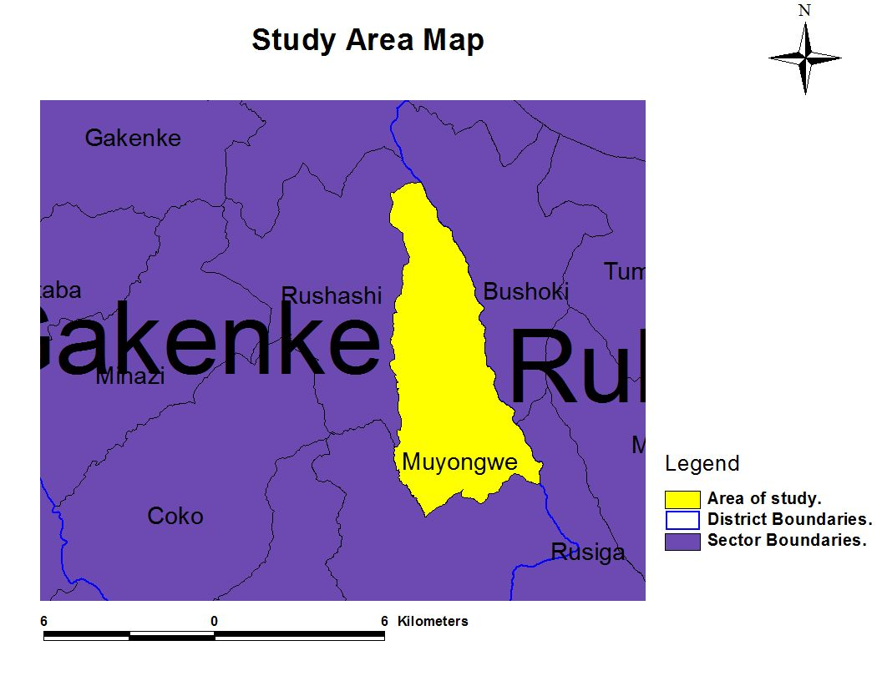

Figure 1: Study area : Muyongwe Sector; Source: Rwanda topographic map, 2011

On the hills, the vegetation mainly consists of food crops disseminated a little everywhere near or far from the dwellings. From here and there on the hills one also notices few timbering trees of Eucalyptus sp. The relief seems to include/understand two more or less distinct areas which are an area of high altitude with up 1950 m a.s.l and another of low altitude reaching on average 1600 m a.s.l. The Climate is generally wet. Precipitations are relatively abundant per annum ranging from 1100 to 1500 mm of rains. Concerning data collection, field observation was primarily done in order to get the image of Muyongwe sector, to observe the agricultural land use types being practiced, and to observe consequences of the current agricultural land use practices on the environment. Data were collected using Global Positioning System (GPS) to get the data on Geographic coordinates, perimeters and surface of different land use types and slope triangle was used to measure the slope including lower slope areas, higher slopes areas and forests. Rwanda topographic map was also used. Data were analyzed using Arc Map GIS 9.2 software.

3. Results and discussion

Current Agriculture land use in Muyongwe sector
Agricultural land use types in Muyongwe sector are cropland and forestland as shown by the figure 2

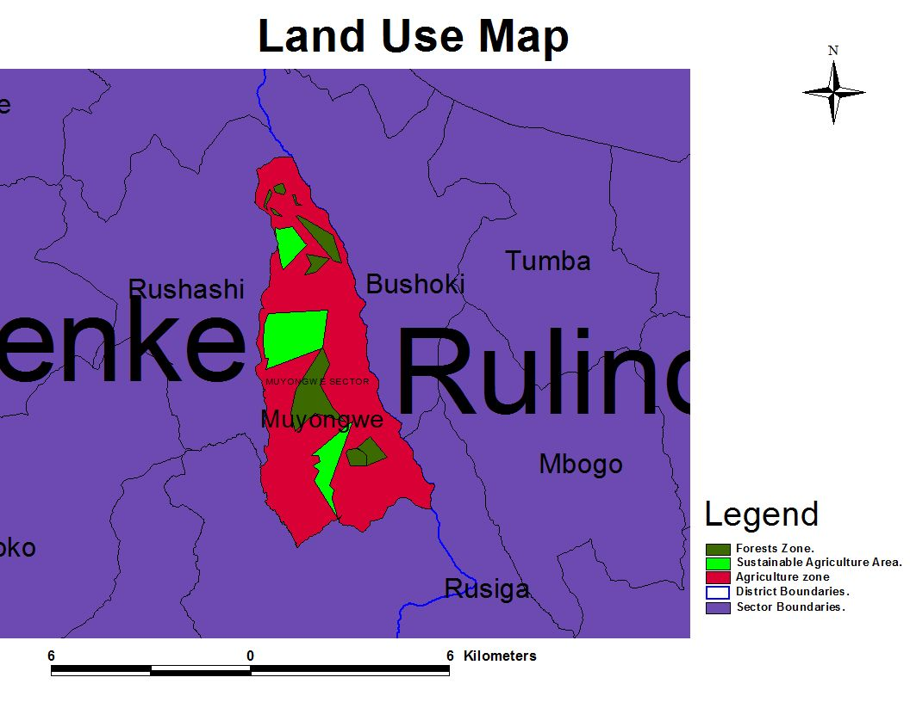

Figure 2: Current agricultural land use in Muyongwe sector

This figure 2 shows that 83.83% of land in Muyongwe is occupied by crops (agricultural zone and sustainable agricultural area) and 16.17% is used for forests. The cropland is the land used for growing crops. It is the largest part (83.83%) of sector’s total surface. The crops occupy 64.77% of the whole sector surface especially on unprotected hilly land and larger mountains that contour the Eastern part of this sector. The agriculture is still applied on hills with high slope. The main crops found in Muyongwe sector were maize, beans, coffee and banana.
The cropping system on the hills and mountains caused lower income to farmers and contributed to the increase of soil erosion risk.

Monoculture in Muyongwe sector

The sustainable agriculture area is used for one crop plantation (monoculture).

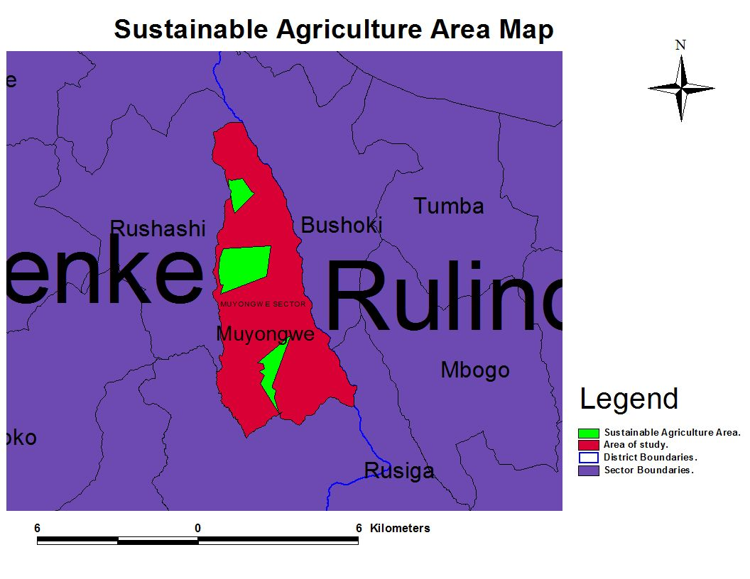

Figure 3: Land consolidation system in Muyongwe sector

The figure 3 shows land used for one selected crop in suitable wide area (19.06 % of the whole sector surface). Such agricultural practice was mainly observed in valleys.

Mixed farming in Muyongwe sector
Growing multiple species and a wide variety of crops at the same time within same place was observed. This method is frequently observed in the areas not considered as valleys. The problem is that there is no technical assistance on the practice of this method. However, there are advantages of applying mixed-farming system in this area where the land is small, scarce and its consolidation could be complicated by the presence of scattered houses and many banana plantations.

Agroforestry trees in Muyongwe sector
Agroforestry trees are not abundant in cropland in Muyongwe sector. A low number of Grevillea robusta trees were observed. There is a need to combine agroforestry trees and crops in Muyongwe sector in order to protect the soil against erosion and to increase soil fertility.

Forestland in Muyongwe sector
Forestland in Muyongwe sector is characterized by the presence of forests in both lower and higher land of the sector and the figure 4 shows the situation.

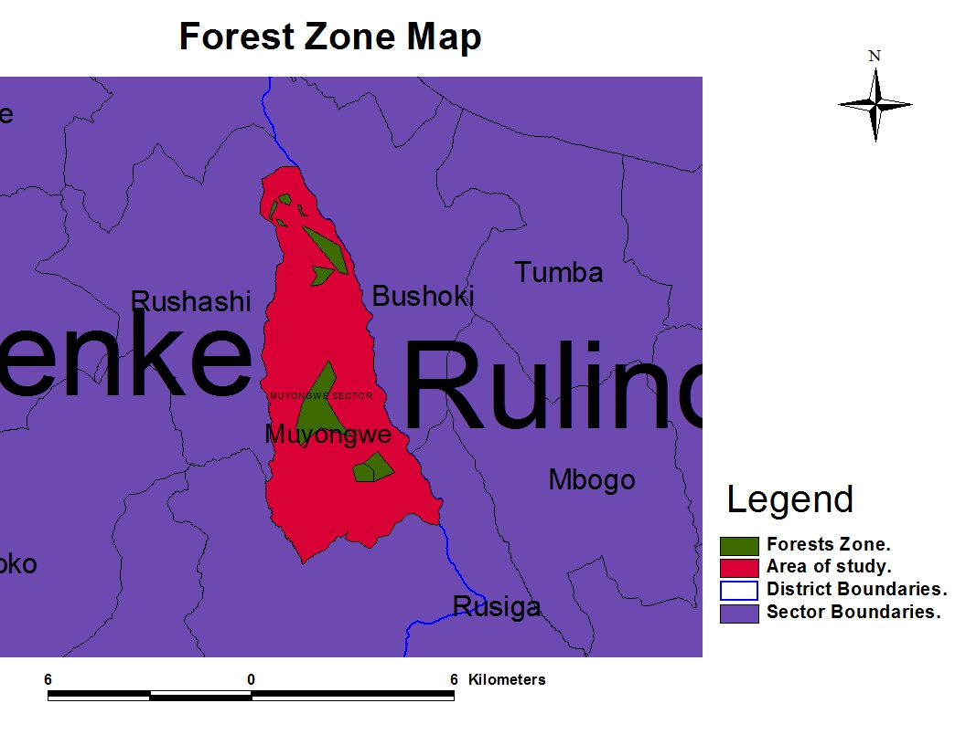

Figure 4: Forestland in Muyongwe sector

The figure 4 shows that 16.17% of the whole sector surface is used as forestland. A part of this forestland (43.92%) is located on the land suitable to crops, therefore, the removal of these forests to reforest hills and mountains should be more beneficial to the cropping system. This situation also justifies that the current land use practices in Muyongwe sector do not respect the slope because the area suitable to crops was used for forest plantations.

Suitable agricultural land in Muyongwe sector

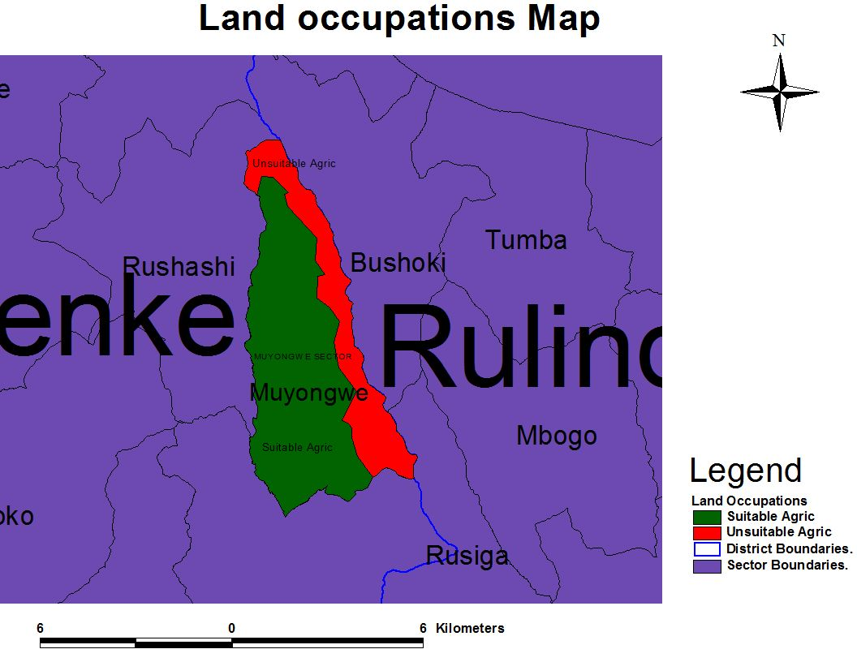
Figure 5: Suitable agriculture land in Muyongwe sector

The figure 5 shows that Muyongwe sector is divided into two parts according to its slope. The red part with high slope (>55%) is suitable to forest plantation. This part is located to the topside of tare mountain that contours the Eastern region of this sector. The green part has lower slope (<55%) and It is suitable to crops because is located on the foot of tare mountain. This part also contains all valleys and other lower land of Muyongwe sector. 68.99% of Muyongwe lower land with the slope <55% should be used as cropland with a combination of agroforestry trees and other part that occupies 31.01 % with slope >55% should be used as recreational sites. In this regard, forests in suitable area (lower slope area) should be removed to be grown in the area located on the hills and tare Mountain with high slope. Referring to the figure 2, agriculture occupies 83.83% of the whole sector surface but the suitable surface is 68.99%. This shows that there is 14.84% of misused land mainly located on higher slope. In addition, 43.92% of whole forestland is suitable to crops. Therefore, this area should be used for crops.

4．Conclusion
This study on the application of GIS to map agricultural land use in Muyongwe sector has shown that land users in this sector do not respect the land allocation system. This is illustrated by the cropland on the hills and mountain (high slope) and the presence of forests in areas suitable to crops. For farmers and district managers, the main focus was on the areas occupied by the monoculture (valleys). For better agricultural land management practices, agroforestry areas should be extended and technical assistance on mixed farming system should be provided to farmers living in places with many houses and banana plantations. 68.99% of the whole Muyongwe sector surface is suitable to agriculture. Even though the slope should be considered in agricultural land use management, this condition is not respected because the agriculture is done on higher slope area and some forestlands are still remaining in lower land areas suitable to crops.

Acknowledgements
We acknowledge the financial and technical support provided by the Higher Institute of Agriculture and Animal Husbandry (ISAE)-Busogo for the completion of this study

Correspondence to
NAHAYO Alphonse
Higher Institute of Agriculture and Animal Husbandry (ISAE) – Busogo
Department of Forestry and Nature Conservation.
P.O.Box 210 Musanze, Rwanda
Email: nahayalfa@gmail.com

References
- Engelen G., et al 1999. Dynamic GIS and strategic physical planning support, London, Springer, pp.87-lll.
- FAO,1995. Forest resources assessment, 1990; Global synthesis. Forestry Paper, 124. FAO, Rome pp21-29
- FAO, 1976. A framework for land evaluation. Soils Bulletin 32. FAO, Rome pp 31-43.
- Pellikka P and Sirviö T, 2004. Farming and high population pressure, Department of Geography, University of Helsinki, Finland,pp14-18

9/2/2012

