Comparative study between Global Positioning System (GPS) surveying methods and Geographic Information Systems (GIS) - based flood volume for reservoir capacity determination in Makera marshland, Muhanga district, Rwanda

Alphonse Nahayo^{1,*,} David Nkurunziza², Fidele Nsabimana¹

- Higher Institute of Agriculture and Animal Husbandry (ISAE)- Busogo; Department of Forestry and Nature Conservation; P.O.Box 210 Musanze, Rwanda; email: nahayo1@yahoo.fr
- Ruhengeri Institute of Higher Education (INES), Department of Land Survey, P.O.Box 155 Ruhengeri, Rwanda

Abstract: The main objective of this study was to compare the results got through the use of Global Positioning System (GPS) and Geographic Information Systems (GIS) to determine the reservoir capacity of Makera Marshland, Muhanga District in Rwanda. This study also aimed at collecting and identifying the flood volume capacity by using GPS, conducting GIS- based flood volume capacity of Makera marshland based on existing digital topographic map, investigating and identifying differences in the proposed techniques. The GPS surveying method revealed that the plannimetric area of Makera marshland is 447,840.122 m² with the reservoir capacity of 9,703,452.75 m³ calculated above the base height of 1733 m. The GIS- based flood volume capacity of Makera marshland based on existing digital topographic map gave a plannimetric area of 1,914,988.688 m², while the volume capacity was 7,537,512.812 m³. Then, the difference was 2,165,939.938m³. Results indicated that there is a significant difference between the results obtained from GPS surveying and the existing digital map due to the atmospheric fluctuations, the multi path interferences and poor satellite signals. Therefore, the use of GIS- based flood volume is better than using GPS as far as reservoir capacity determination is concerned.
[Nahayo A, Nkurunziza D, Nsabimana F. Comparative study between Global Positioning System (GPS) surveying methods and Geographic Information Systems (GIS) - based flood volume for reservoir capacity determination in Makera marshland, Muhanga district, Rwanda. World Rural Observ 2012; 4(4):29-35]. ISSN: 1944-6543 (Print); ISSN: 1944-6551 (Online). http://www.sciencepub.net/rural. 4

Keywords: Global Positioning System, Geographic information Systems, reservoir capacity determination, Makera marshland, Rwanda

1. Introduction
The hydrological regime of the marshlands in Rwanda is directly dependent on the particular drainage basin. An attempt to regulate the surface flow in a certain drainage basin should consider the entire basin and not only its separates area such as the marsh. The marshes play the role of natural storage reservoirs and maintain a stable base flow during the dry season. Marshes in Rwanda are divided into 3 categories as follows: marshes in high altitudes, medium and low altitudes. As the number of marshlands used as croplands continues to increase in Rwanda, the irrigation is considered as a very important factor for increasing the production (MINAGRI, 2010).
The estimated total area of marshes in Rwanda is 275,169 ha, of which 55,896 ha are fully protected, 204, 198 ha are not protected but with limited access while 15,595 ha are not protected without any limited access. The latter two categories are added up to 219,793 ha covering the marshland potential for irrigation. 41% of the aforementioned marshlands are covered by natural vegetation, 53% (148,344 ha) are under cropping and about 6% are fallow fields (Muhanga master plan, 2010).
Flash floods occur periodically in Makera marshland, due to several factors including its rugged topography and geological structures. Hence, precise assessment of floods becomes a more vital demand for its management. Therefore, a GIS-based flood volume method has been used for quantifying and spatially mapping the flood characteristics. Additionally, the computation of flood volumes was carried out by digitizing the existing soft topographic map containing Makera marshland. Digitizing is the process of encoding geographic features in digital forms as x, y coordinates. It is carried out in order to create special data from existing hard copy or soft copy maps (Davaine, 1999).
For irrigating such a marshland, it requires the hydraulic structures and canal supply. Among irrigation structures, reservoir should be included and its capacity has to be determined (Meigh, 1995; Mugabe et al., 2004). The methods to be used include GIS- based flood volume or Global Positioning System (GPS). A reservoir or an artificial lake is used to store water. Reservoirs can be used in a number of ways to control how water flows through downstream waterways. Makera marshland management was initiated in 1987 by the PAG (Programme Agricole de Gitarama) and QWMDP (Quick Win Marshland Development Project) inaugurated in 2011 aiming at rehabilitating these hydraulic structures. The main purpose of two projects was to design and construct the hydraulic structures excluding the design and construction of reservoir capacity to store water for irrigation and the flood volume. In Makera marshland, there is a problem of water stress for crops during dry season because the storage reservoir is not adequately determined nor exceeding flood volume during the rainy season because they have not been designed. Water distribution canals and reservoirs are required to distribute, raise and divert water in the farmers’ plots (Muhanga, 2010). Unfortunately, the reservoir is not provided in that project. Another issue is that the surveying techniques used during the design of Makera marshland management were various and gave different results. All techniques used did not solve the problems of water stress for crops and the flooding. This led to the mismanagement of the marshland which caused problems to designers (main canal and secondary canals). Therefore, this study aims at determining the reservoir capacity which can be used to store water by using GPS surveying technique and GIS- based flood volumes by digitizing the existing soft topographic map.

2. Materials and methods
Study area description
Makera marshland is located in Muhanga district, Southern Province of Rwanda. Muhanga District occupies an area of 647.7 km². The rain fall ranges between 1100 mm and 1200 mm per year and it is at 1733-1782 m a. s. l. This area is characterized by two major seasons: a short rainy season (September to December) and long rainy season (February to May).

Materials
The materials used include the topographic map of Rwanda, Arcview GIS 3.2, Covadis software, and Global Positioning System (GPS).

Methods
(1). Determination of volume capacity by using Geographic coordinates taken by GPS. This operation consisted of creating the contour map (generating triangulated Irregular Net work (TIN) to grid data for Digital Elevation Model (DEM), determining the volume of contained water by establishing the proposed levels as datums).
(2). Digitizing the contours of topographic map with Arcview GIS 3.2: This operation consisted of obtaining the contours and determining the contained water from digitized map.
(3). Comparing two volumes

3. Results and discussion

3.1 Determination of flood volume capacity by using data collected by GPS
The figure 1 below shows different geographic positions taken from Makera marshland.

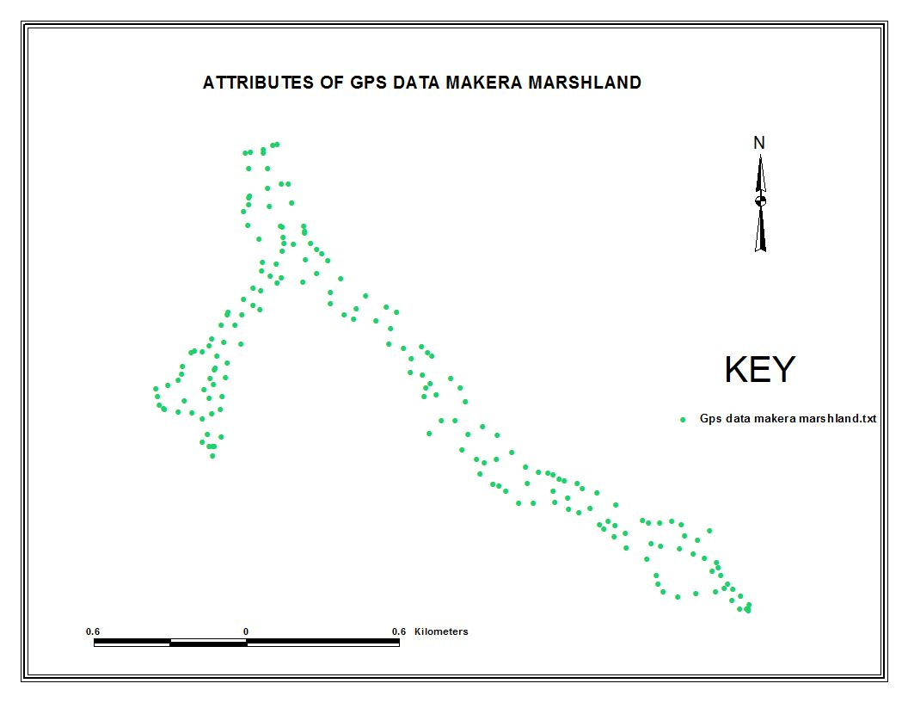
Figure 1: GPS-based attribute data in Makera marshland

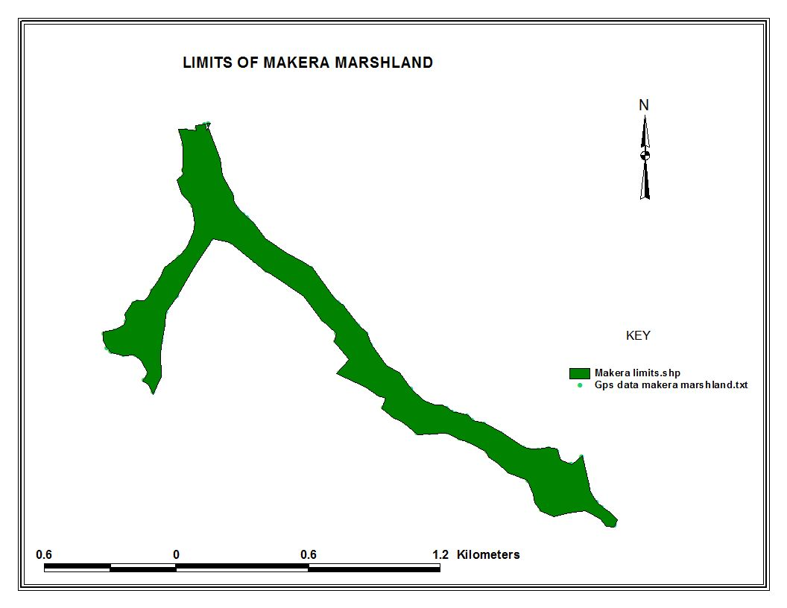

Figure 2: Boundaries of Makera marshlandThe highest level of the elevation of the Makera marshland is 1782 m and the lowest is 1733 m and the interval between contours is 1 m.

Contour map of Makera marshland
The contours are added to the map as shown in the figure 3.
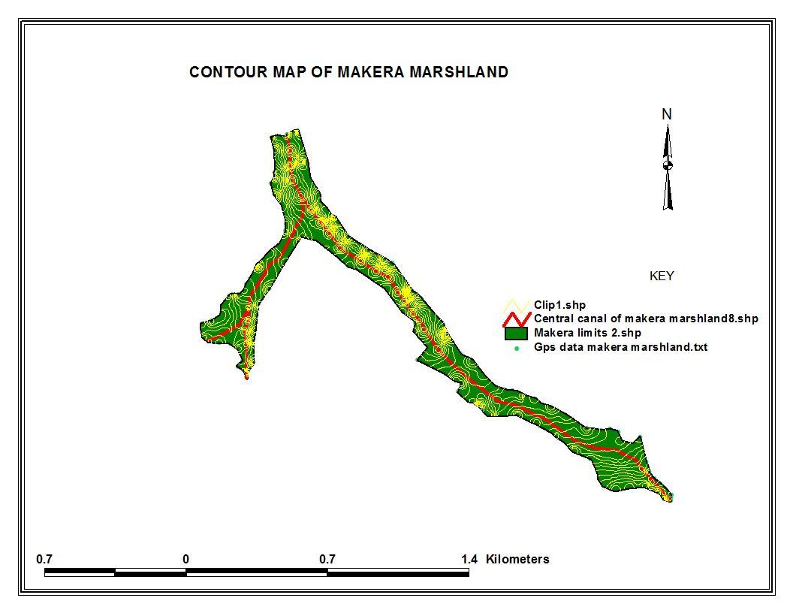

Figure 3: Contour map of Makera marshland

The corresponding areas calculated were 1,759,360 m² but the corrected areas were 447,840.1223m².
The figure 4 shows that the highest elevation is located between 1776.556 and 1782 m while the lowest is between 1733 and 1738 m. The green color indicates the area with lower elevation whereas the whole areas covered by the Gray colors occupy the higher elevation in the marshland. This topographic map was used to determine the reservoir capacity of Makera marshland. The corrected plannimetric area of Makera marshland is 1,914,988.688 m², and reservoir capacity of 30,150,051.248 m³. By using Covadis software, we obtained 447840.1223 m² representing the limit covering polygon area of the Makera marshland. The TIN covering polygon area is known (1,759,360 m²). For obtaining the factor of difference: N=1,759,360 m²/ 447840.1223 m²=3.928 ≈ 4 times. Therefore, the volume = V_{TIN}/ N=38,813,811m³/4= 9,703,452.75 m³ which is the reservoir capacity of Makera marshland calculated from GPS surveying method.

Determination of water volume
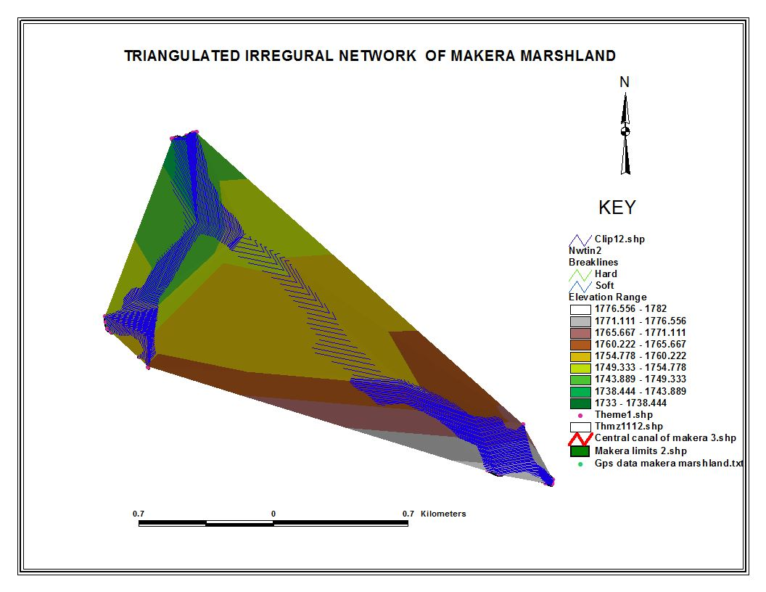
Figure 4: Triangulated irregular net work

Grid map of Makera marshland
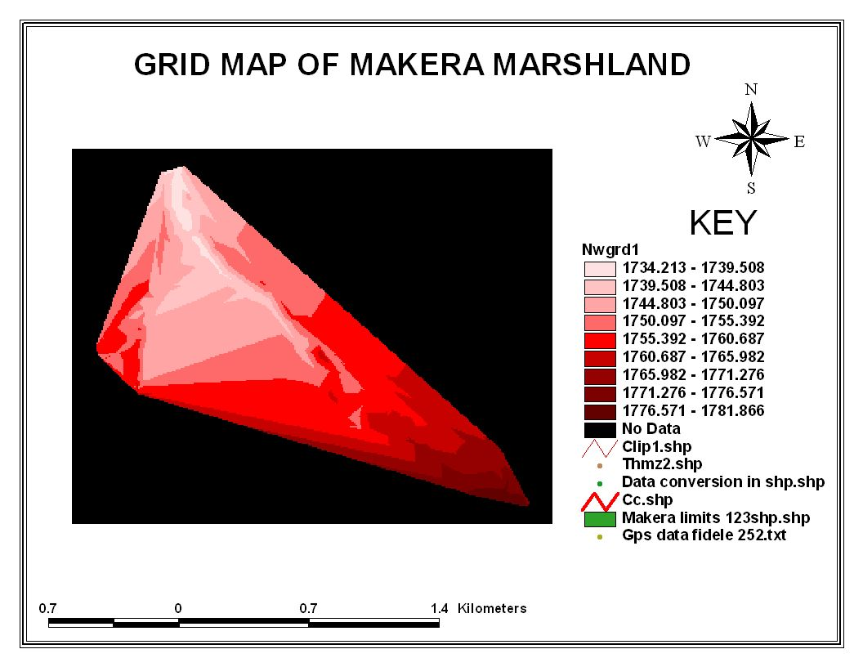

Figure 5: Grid map of Makera marshland

Final layout of topographical map of Makera marshland
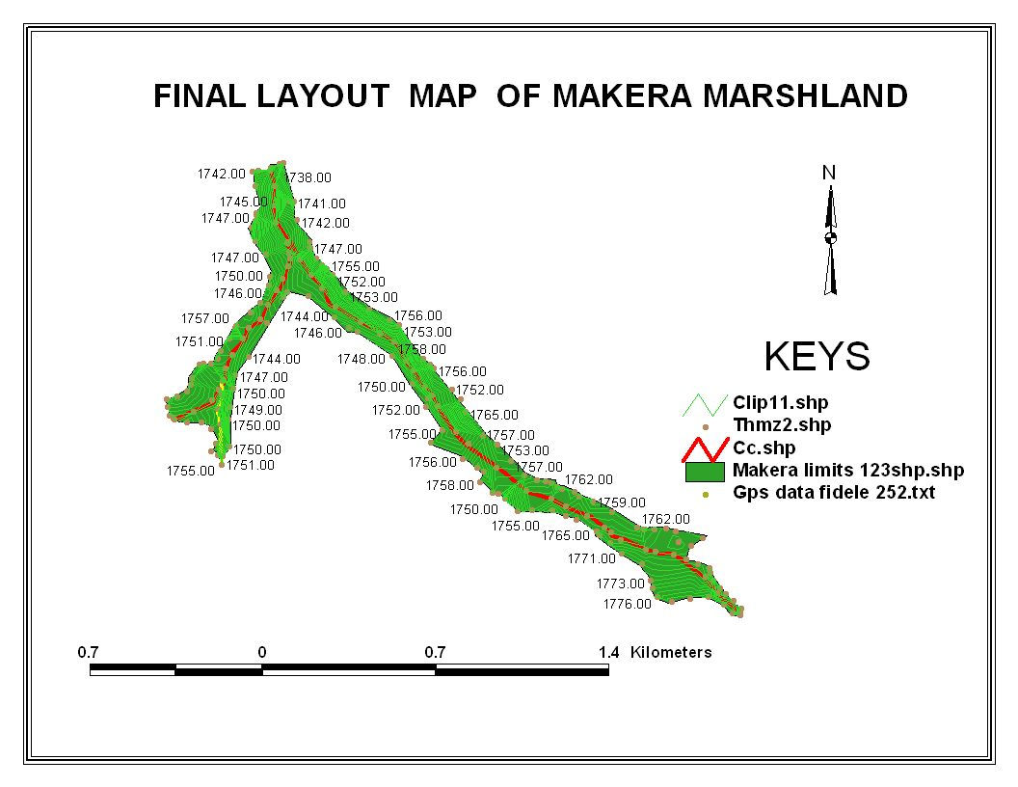

Figure 6: Final layout of Makera marshland

3.2 GIS- based flood volume capacity of Makera by using existing digital topographic map.

Topographic map showing the area of study (Makera marshland)
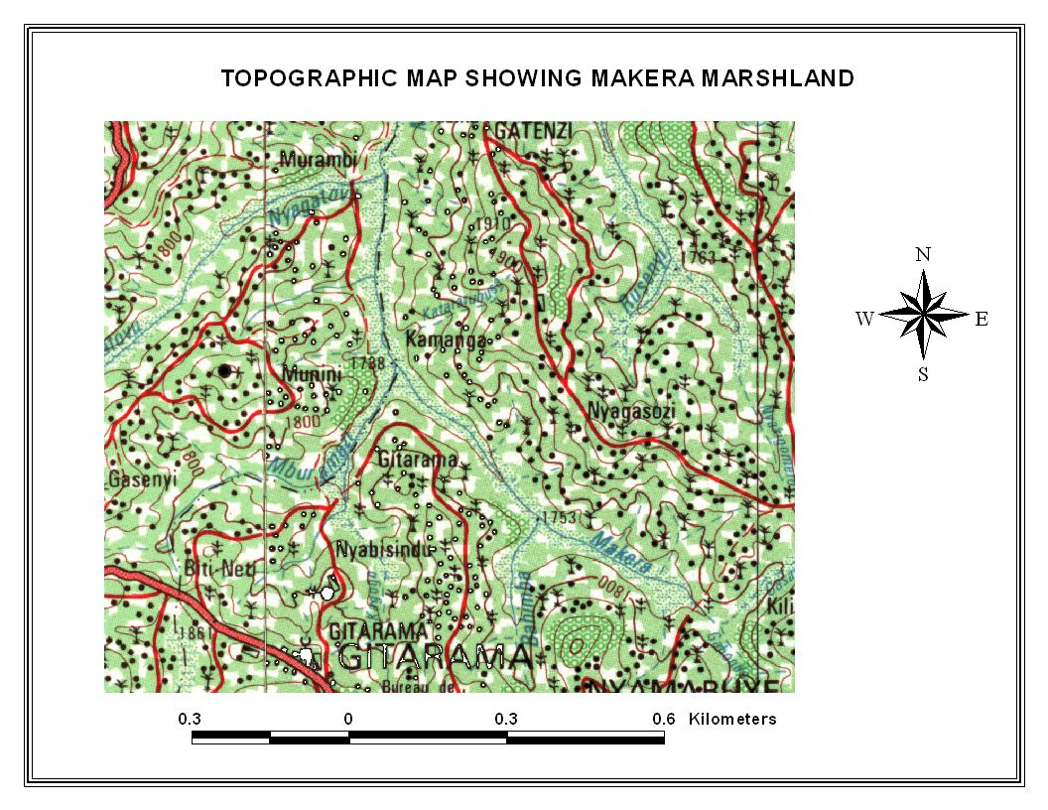
Figure 7: Topographic map of Makera marshland

Digitizing Makera marshland
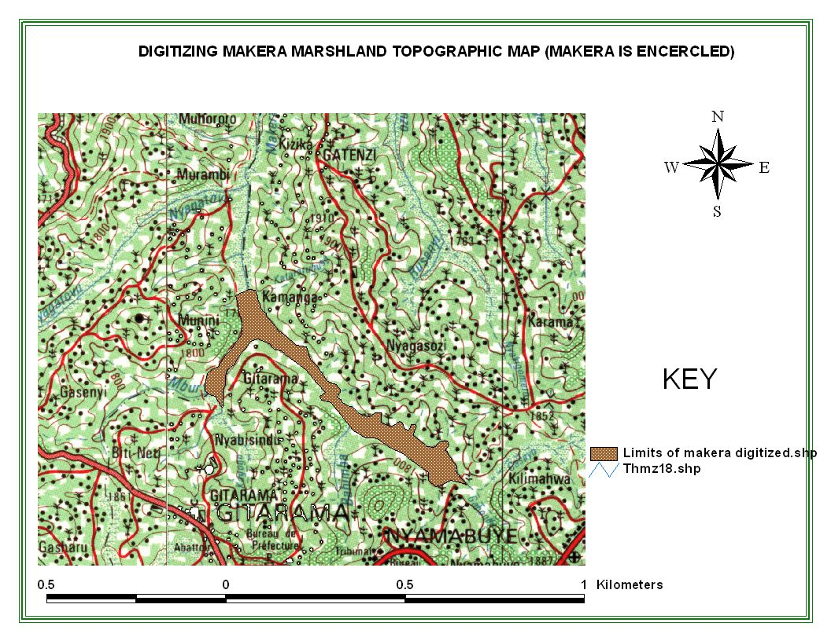
Figure 8: Makera marshland overlaid on topographic map

Digitized contour map

The planimetric area calculated was 1,914,988.688 m²

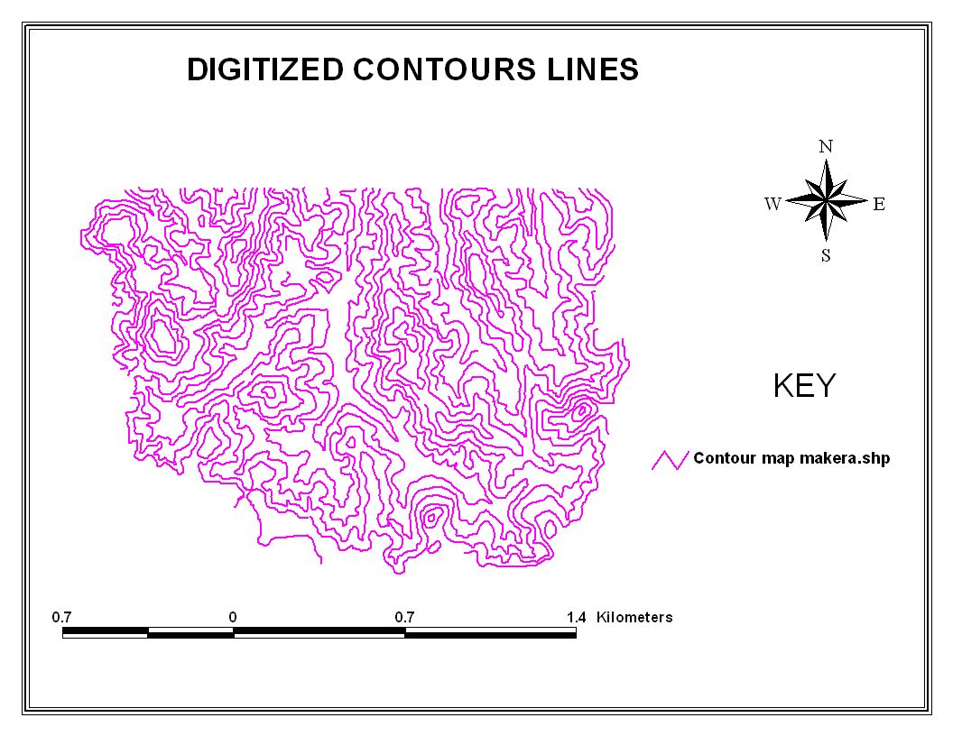
Figure 9: Digitized contour map

Determination of contained water from digitized map
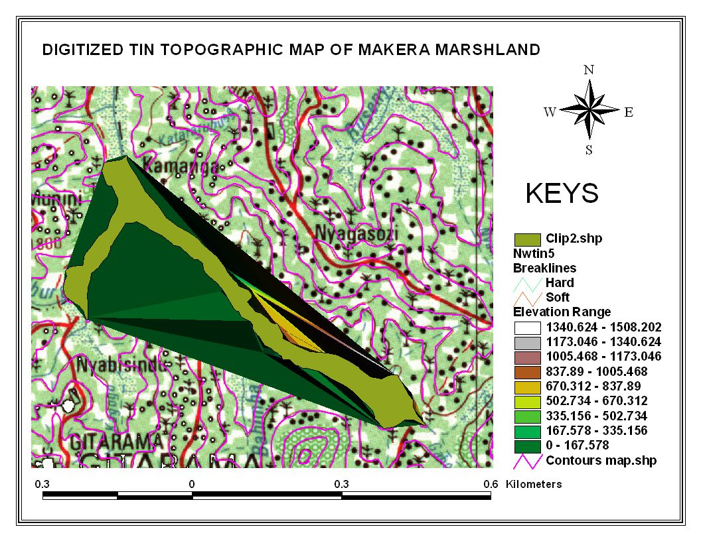
Figure 10: Digitized TIN of topographic map of Makera marshland

The flood volume of Makera marshland was about 30,150,051.248 m³ and the planimetric area occupied by the flood volume was 1,914,988.688 m². Therefore, the planimetric area was calculated from the TIN covering all the limits of marshland and the external field as shown in the figure 10 above. 447840.1223 m² was found to be the limit covering polygon area of the Makera marshland. As the TIN covering polygon areas is known (1,914,988.688 m²), to obtain the factor of difference N=1,914,988.688 m²/ 447,840.1223 m²=4.27 ≈ 4 times. Therefore, the volume = V_{TIN}/ N=30,150,051.248 m³/4= 7,537,512.812 m³ which is the reservoir capacity of Makera marshland calculated from digital topographic map.

4. Conclusion
This study revealed that the plannimetric area of Makera marshland is 447,840.1223 m², and reservoir capacity of 9,703,452.75 m³ calculated above base height of 1733 m. The results also showed that the flood volume capacity of Makera marshland got from the existing digital topographic map was 7,537,512.812m³calculated from the plannimetric area of 1,914,988.688 m^{2.} Those parameters were calculated above base height of 1733 m. By comparing two volumes, the difference was 2,165,939.938 m³.

Acknowledgements:
We acknowledge the financial and technical supports provided by the Higher Institute of Agriculture and Animal Husbandry (ISAE)-Busogo for the completion of this study.

*Corresponding author
Alphonse Nahayo
Higher Institute of Agriculture and Animal Husbandry (ISAE) – Busogo; Department of Forestry and Nature Conservation; P.O.Box 210 Musanze, Rwanda; Mobile phone: +250 725 806 305; Email: nahayo1@yahoo.fr

References
1. Davaine Jean Jacques, 1999. Geographic Information Systems (GIS). National water research institute of Canada.
2. Meigh, J. 1995. The impact of small farm reservoirs on urban water supplies in Botswana. Natural Resources Forum, Vol, No. 1, pp. 71-83
3. MINAGRI. 2010. Rwanda irrigation master plan, p 50.
4. Mugabe, F.T. Hodnett, M.G. Senzanje, A. (2004). Opportunities for increasing Productive water use from dam water: A case study from semi-arid Zimbabwe. Agricultural Water Management 62 (2003) 149-163.
5. Muhanga District (2010). Plan de Développement du District de Muhanga. p26-58.

10/4/2012

